A Daisy-Full Life & Some Encouraging Words
By the time Friday evening rolled around, I was feeling a little overwhelmed at so many things going on and overlapping with each other the past several days. I didn't realize the extent of just how stressed I was, until I ordered some sandwiches at Firehouse Subs . . .
I had been researching and networking and trying to make decisions regarding our water softener and water heater, both of which were breaking down. I had just spent an hour at Lowe's trying to get some questions answered about their water heaters, when instead, I ended up finding most of the information myself by using Mr. Google. It was also 8:30 p.m. and I hadn't had any dinner yet. While I was waiting for some answers in the store, I was texting back and forth with my son, Jake. When he found out I hadn't eaten dinner yet, he strongly encouraged me to get out of that store and go get some food. A few minutes later, I had the information that I needed and, even though I was very tired, I drove over to my area of town to find something simple that I could pick up to eat.

I felt guilty that I hadn't planned ahead and made something earlier. I felt guilty that I hadn't prepared something amazing that Benson and I could share together. After all, isn't that what my job was as a Mom? To feed my kids? We had put in a valiant effort doing several things that day and now I had nothing to feed myself or my child. I tend to do that a lot when I'm by myself . . . I go through the day doing so much "stuff" that dinner is merely an afterthought.

For whatever reason, I decided to stop in at Firehouse Subs instead of Wendy's, which was right next door. The teenaged girl at the counter made me break down into tears. Literally.

First, she asked me if I was ready to order. I was having trouble deciding what to order, so she offered to help me narrow down my focus, which I sincerely needed. Then, once I had paid for the items, she asked me how my day was going and how my evening was . . . I told her I had lots of things breaking down at my house and that it was all getting a bit stressful. She asked if I had someone to help me, to which I replied, "Well, normally my husband would be here to help me, but he's overseas with the military right now . . ." (tears then started to well up) She was genuinely concerned at this point, asking me how long has he been gone? I didn't want to get into the whole explanation of how I get to see him every 90 days, so I just choked out the words through my blubbery mess, " . . . a long time".

She proceeded to engage me in some very helpful conversation. First, she offered these encouraging words: "It'll be okay" and "You'll be alright". She offered sympathy for my husband being across the world, and asked me if he was in the military full-time. This changed the trajectory in our conversation to how he is a math teacher most of the time. I learned that she is a high school student here in town and that she does better in math when she actually pays attention in class, ha ha.

She acted like she had all the time in the world to just brighten my day. As I left with those two tasty sandwiches a few minutes later, I turned back and told her, "Thank you for your ENCOURAGING WORDS". What a sweet young lady. She had no idea that her simple questions and friendly conversation would end up meaning so much to me. I cried a little more as I drove home.

And then I cried a little more when I walked into the kitchen and Benson was waiting for me. He saw that I had been crying and he came over to give me a hug. I told him everything that had happened and then he, too, was grateful that the girl was so kind to me. He also added in, "Mom, you don't need to feel guilty about dinner. I am the most simple of simple guys when it comes to eating. And I am certainly capable of feeding myself. That's not something you need to worry about." XOXO

So we ate our Firehouse sub sandwiches at 9:00 p.m. at night and then got ready for bed. :)

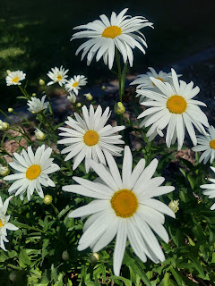

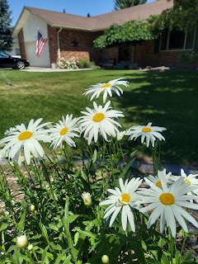

I have SO MANY things to be thankful for. Here are some of the standouts:
My daisies are in bloom right now and they are so darn cute. I wish they would last longer than they do, but I'll take whatever they can give.
Jake, Hannah, and Jack just called to say they will be coming up to spend next weekend with us here at my house!! Hooray!!
Avery will be spending next weekend with us as well, so there will be a party to look forward to!!
I got the bedroom downstairs all painted.
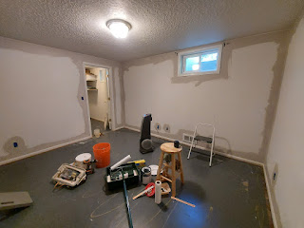

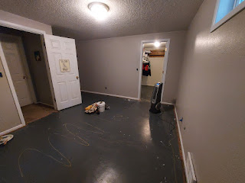

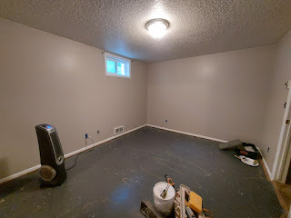
New carpet was installed successfully.
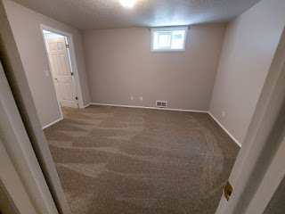

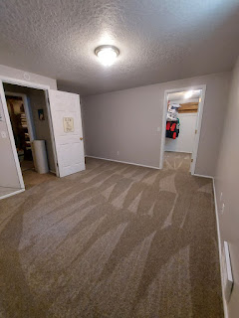
Scott has helped me numerous times over the phone this week. He is my BEST FRIEND!!
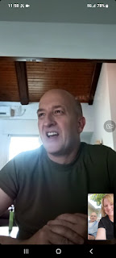

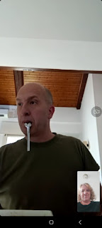
I had a nice visit with my father-in-law, Phil on Thursday.
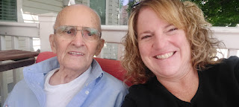
Avery came over to play on Friday. (more on that in a minute)



Amber and the girls got home safely after their family campout in Manti, Utah and another 3-day drive across the country to Louisiana. The only real trouble she had was in the Albuquerque area on Day 2. There was a wreck somewhere ahead of her, which stopped all the eastbound traffic on I-40 for TWO+ HOURS . . . Thankfully, the girls did great and nobody needed a potty during that time.
Benson and I got to watch the 30th Anniversary of the Melaleuca Freedom Celebration together. This is the biggest fireworks show west of the Mississippi and it's right here in Idaho Falls!! (more on that in a minute)




The struggles that I had this week were relatively few, but each one felt pretty big to me.
Before I could paint, Benson and Ben Parkinson were able to collaborate and fix the hole in the wall together. I was so grateful to them that I made 3 loaves of jalapeno cheese bread (2 for Ben and his family + 1 for Benson and me).
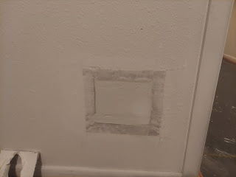

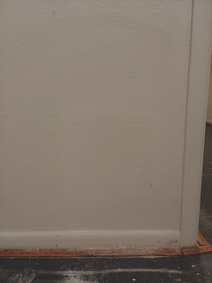

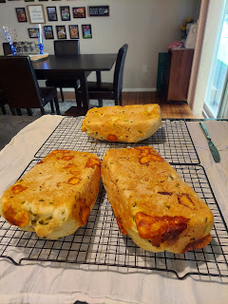
The water softener suddenly got all gross. Well, first, my face broke out in teenage-reminiscent acne, which is always an indicator that the water softener is not up to par. When I went down to the utility room to check on the brine tank, it had brown sludge floating on top of the water and more sludge down in the very bottom. Ewww. I spent a long time researching causes and solutions, made several phone calls, and finally got brave on Saturday to tackle it.
It involved a lengthy video call with Scott on the other side of the world, talking me through the process step by step. I had to shut off the main water, turn on the utility faucet down the hall to empty out the pipes, unhook water softener pipes and tubes, and get a little bit of help from Benson.

He rigged a brick and a siphoning tube together using a rubber band and got it situated on the bottom of the brine tank. If you look closely, you can see the disgusting sludge around the white cylinder and around the water level.

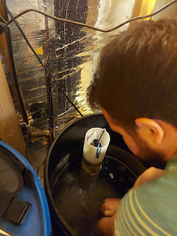

Then, he tried 3x to siphon the water out before he had success. There is a drain hole in the floor of the utility room where the water could drain out.

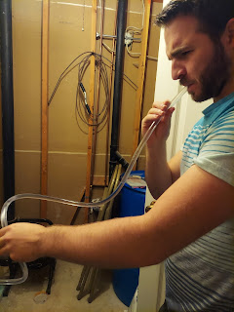

Next, he carried the tank up the stairs and out to the curb for me. It had about 3 inches of yuck in the bottom, mostly water, plenty of chunky salt, and some dirt. He dumped it out and then I cleaned it thoroughly with the garden hose and sprayer attachment before carrying it back downstairs myself.

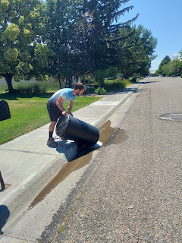

A local professional helped me identify the actual problem: While Scott was here with me after his mom's funeral, he purchased several bags of cheaper water softener salt from Winco (a grocery store). Apparently, this kind of salt (coarse instead of pellets) doesn't get screened for impurities in the mining process, so it has some dirt and other particles in it. This is what made all that sludge and mess in the brine tank and ultimately caused the disaster on my face. Lesson learned: go to Sam's Club for the salt pellets and not to Winco for the cheaper version.

I made another video call to Scott so he could be my cheerleader as I hooked everything back up in reverse. Tubes, pipes, etc. and then sloooowwwly turn the water main back on. I got the tank to fill back up and dumped 2 bags of salt PELLETS into it, ha ha. I felt very accomplished. But it took a lot of prep and support to get the job done. It's all clean and fresh now. Hallelujah! Now I just need my face to settle back down . . .

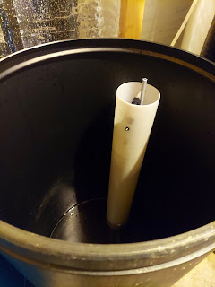
While I was working on the water softener, Benson spent about 7-8 hours installing the new garage door opener on Saturday. He worked tirelessly on it, even though there were plenty of frustrating components. Things like: the instructions were vague at best; the instructions told him to use a 7/16 wrench when in fact that size didn't work at all; the buttons on the ceiling-mounted motor did NOT meet up with the mother board behind the buttons (someone fell asleep on the assembly line) - which made for a time-consuming process until he and Ben figured out the issue behind the buttons; etc. It was a long day for him, but he refused to stop until the job was complete! This included mounting the motor, along with the track, all the wiring, programming the remotes and the remote keypad, AND connecting the functions with my car. While this wasn't super stressful for ME, it was definitely stressful for Benson, so I was in and out with support & encouragement for him during the rest of the day after I got the water softener working again.
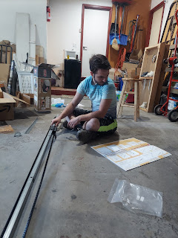

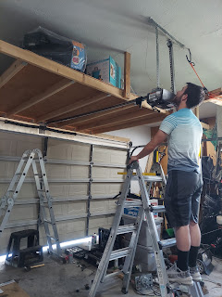
After 17 years, I finally got up the courage to form an official complaint against my next-door neighbor, Ellen. I was reluctant to do it, because I just don't like those kinds of things. But after a month of getting rid of mice, which were likely due to her jungle and piles of rotting garbage sitting out in the open next door, I decided I was finally ready. I had to make several phone calls to get to the right place, and also had to register an account with the City and then use their code enforcement complaint form to type everything up. We'll see what happens in the near future, but I'm not going to hold my breath. Hoarding is a serious thing, it's a form of mental illness and/or addictions. There are also a lot of gaps in the system, which makes the process less than perfect.
I had also been asked to give a family history lesson after church, so I had to put in some effort to prepare something meaningful to teach the class members. I dug out some of my family history totes so I could go through them in search of a good story or two that had some teaching moments to share. I ended up sharing the following two examples:
1. The Hockmans. In 2008, Scott and I took a trip back east and visited the Shenandoah Valley of Virginia among other things. We stopped at a local historical society near Strasburg, VA so I could make some copies of information pertaining to my Snider ancestry. While going through all the books and letting Scott know what pages to copy for me, I saw a whole chapter on the Hockman family!! I asked him to copy that - just in case . . .

At that point, I didn't know who my 2nd great grandmother's parents were. I just knew that Mary Anne Hockman was born in Clermont County, Ohio in 1835. I didn't even get to that packet of pages until almost a year later, but as I went through it with a fine-toothed comb, I eventually found her grandparents, who were married in Clermont County, Ohio. I was able to expand my Hockman genealogy by several generations - all because of a little historical society (and the Spirit drawing my attention to that chapter on the Hockmans).

Because I was able to expand my Hockman line, I could see several other new surnames as wives married into the Hockman family. These names included Funk, Stickley, Yoder, and Denlinger. I began studying these lines over time, learning about their Mennonite origins and how they were persecuted so badly in Switzerland that they fled to Germany for a time. Eventually they came to America, arriving first in Lancaster, PA and later the Shenandoah Valley.

To bring this story full circle, I was able to visit some of the places of my ancestors in 2021 when I traveled to Switzerland and Germany. I showed the class a picture of Dandlikerstrasse ("Dandliker Street") in Hombrechtikon, near Zurich. I walked 45 minutes each way to find this particular street and area out in the country where my Denlinger ancestors came from. (Dandliker became Denlinger over time, once they arrived in America.) None of this would have been possible if it weren't for that little historical society.

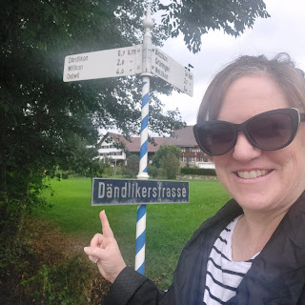

Historical societies have a GOLDMINE of info just sitting there in many towns across the U.S. Most don't have the staff or the funding or the equipment to get all of their items digitized and available on the internet, so you have to contact them directly or go there yourself, if possible. In many cases, they can make copies for you, or email you digital copies. In some cases, they can do research for you as well.

2. It's okay to hire a professional genealogist once in a while. Just be sure to specify your research needs very clearly and work closely with them to figure out your budget and exactly how much they can accomplish within that budget.

I hired my first professional genealogist a couple months before my sister, Charmaine, and I traveled to England and France in 2018. Her name was Kylie Brown and she was amazing. I was definitely spoiled by her because she did a LOT for me and charged me very little. She went way above and beyond my expectations, making several trips to the archives to get info and copies, putting together a hardcover book with everything organized for me, and she even took Charmaine and me on a full day's trip to see quite a few of our ancestral sites in Kent, England. All of this she did, and more, for about $225.

L to R: Kylie Brown, Charmaine, and me in Tenterden, Kent, England (Sept 2018)

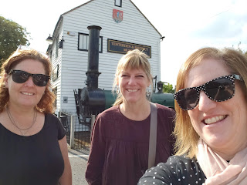

My only other experience was with Karen Jauch, a German genealogist, back in 2021. She was meticulous about every detail and every everything, charging me for how many kilometers it took to drive to an archive and back, there was a fee for her to get into the archive and that got passed on to me, and if she needed to translate something from German to English it took some extra time and that went on the tab, too. I had to drastically slim down my "Wish List" because my budget was getting eaten up so fast with all of these fees adding up. My mom helped chip in quite a bit for this project because it was apparent up front that it would be quite a bit more than what Kylie Brown had charged me a few years prior. Overall, I went over the initial agreed-upon budget, which was supposed to be capped at $500. What we failed to communicate to each other is that euros tend to be a higher amount than US dollars. It ended up being closer to $600 when all was said and done . . . yikes.

BUT - Karen gave me some crucial information that was priceless. She was able to correct a set of parents on my direct line that we had mistakenly put on our tree years ago. She had definitive proof that what she found was correct. I was so grateful for that! She also made some copies for me and put them in a little blue folder for me to bring home. She also took me on a tour around Moessingen, Germany, starting at this beautiful old church, where my 3rd great grandparents were married, and where their children were christened. She was super knowledgeable, very amiable, and it was a delight to spend an afternoon with her. (She was just pricey . . .)

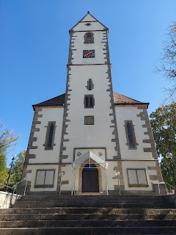

Karen Jauch and me sipping (non-alcoholic) cider in Moessingen, Germany (Oct 2021)

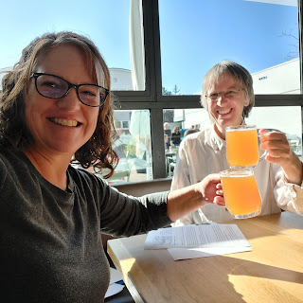

3. I taught the class how to look on FamilySearch.org to see what your contributions have been to the worldwide family tree over the past few years.
Login to FamilySearch
At the top left, click on "Family Tree" and choose "My Contributions" on the drop-down menu
It will first show you a list of all the things you've done, such as adding so-and-so or changing a date. That view is listed in the middle of the page as "My Changes".
Just to the left of "My Changes", click on "Stats"
It will show you in bar graph format the things you've done over the past few years. You will be seeing ALL of the categories lumped together, but next to "ALL" you can single the categories out. You can see how many people you've added to the tree over time, for example.
I also encouraged everyone to work on these 5 things per year:

1. Index at least one batch of names per year.
2. Attach a record to someone in your tree.
3. Add a memory to someone in your tree. (Add a photo, a story, a document, etc.)
4. Add a new name to your tree.
5. Submit an ordinance for someone in your tree. (For temple work)

It all went well, and a couple people contacted me after church to ask additional questions about how to do something that we had discussed in class. I like to light a fire underneath people and get them motivated to try something in Family History. There are always people to help if you need it, including ME. :)

4th of July . . .

Benson and I worked hard on some projects during the day (he worked on his car and I painted the trim downstairs), and then we went to the Fireworks that night. We found a great parking place to be able to get home easily later on, and then we walked about a mile down to the Snake River and set up our chairs to wait.

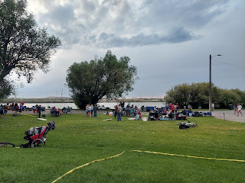

We had about 2 - 2.5 hours to wait before the fireworks began, but that's how it is here. It's the greatest fireworks show west of the Mississippi, so there are typically about 200,000 people who come to watch. You gotta get there early to get a good spot. They launch 591 shells per minute on average, according to their website. (
https://www.freedomcelebration.com/
)

But then it got COLD. The wind picked up, where sometimes it felt like a small hurricane, and we wished we had worn an extra layer of jackets . . .

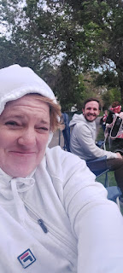

At one point, we turned our camp chairs around backwards so the wind and little bit of rain wouldn't be so ferocious in our faces. It felt a little better once we did that. I checked the weather and it didn't look good.

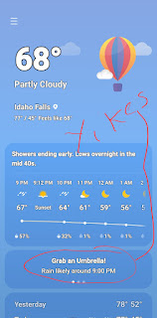

We were worried that there wouldn't even BE a show to watch!! But we bravely stuck it out the entire time. Miraculously, there was only a 10 minute delay and then BOOM . . . the sky lit up and then moments later the 30th Annual Melaleuca Freedom Celebration began. It did not disappoint.





I have way too many videos that I took, but I'll share a few of the best ones. Keep in mind that the whole show was 30 minutes in length, and was narrated and synchronized to several patriotic songs. We could faintly hear the music across the river where they had several large speakers set up, but we didn't have a radio nearby. It's always better if you can hear the music, but you can turn on your own accompaniment or just imagine some of your favorite patriotic songs to go along with the show. (God Bless the USA, or Coming to America perhaps . . .)

Fireworks Videos:

Video #1: (37 seconds)
https://photos.app.goo.gl/biHZQWQZBLkCmaJ49

Video #2: (45 seconds)
https://photos.app.goo.gl/3VXeYP8AWqAt3Ajt7

Video #3: (37 seconds)
https://photos.app.goo.gl/sYVNsUsEEaU1LuZC8

Video #4: (28 seconds) With the wind still in play, some of the embers would float clear across the river and land right where people were sitting! We could see them jumping up and running away . . . wowza.
https://photos.app.goo.gl/hhUQ3Zjv3xbnXJL37

Video #5: (54 seconds) Just prior to the Finale
https://photos.app.goo.gl/wbE9tkACe22Jmc7J9

Video #6: (1 min, 14 seconds) THE FINALE
https://photos.app.goo.gl/fLdU8TTqzebbbJJGA
It was QUITE THE SHOW and we were super glad that we stayed through the cold and the wind and the sprinkles. And now we have a great spot to go to next year, too.

My Sweet Grandchildren . . .

We had the honor of watching Avery all day on Friday, and we get to spend Monday and Wednesday with her again this week, in addition to having her all of next weekend.

Again, she just LOVES her daddy, Benson. She was so happy to see him!!

We got Benson's childhood set of cars out so they could play together.

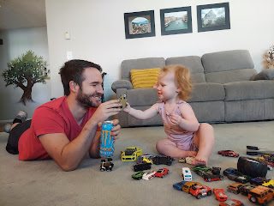

We hung out in the back yard for quite a while.

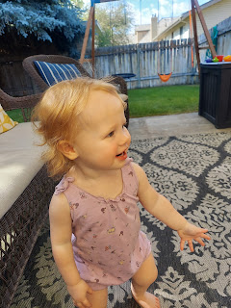

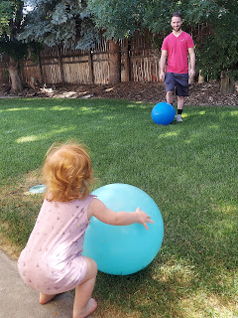

Video of them playing kick the ball: (43 seconds)
https://photos.app.goo.gl/kUctmKbbTamJkK139

Video of Avery following Benson everywhere and doing what he did: (45 seconds)
https://photos.app.goo.gl/ahfoFrfncDQiv2bb9

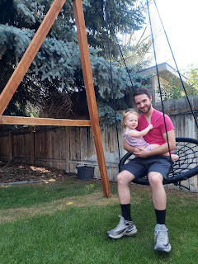

Video of them swinging together: (36 seconds)
https://photos.app.goo.gl/pmkk63M31ojr68Kt5

We fed her a tasty lunch of Uncle Ben's microwaveable rice w/ veggies and some chicken nuggets.



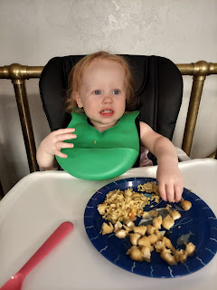

After her nap, we played out back again, this time with the water table.

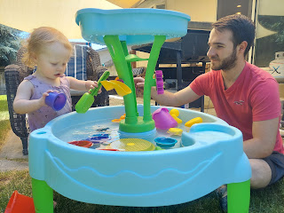

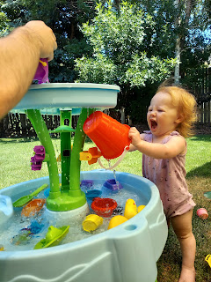

Below: He was not making an angry face at her, he was more just mimicking her expression after she dumped a bucket full of cold water on herself, ha ha.

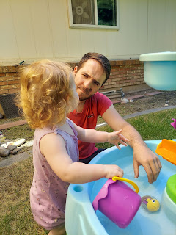

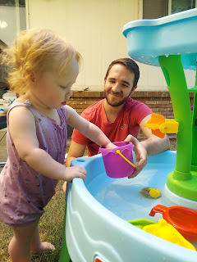

Video of her dumping the water down her front: (28 seconds)
https://photos.app.goo.gl/rM3YqWU5vWBiioNH8

Video of her being silly: (21 seconds)
https://photos.app.goo.gl/rCTtSGfe5XUgJRrf8

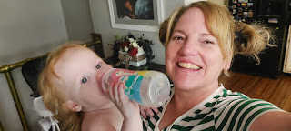

We had a GREAT day with her on Friday and we look forward to making more memories with her this coming week.

Amber sent me a few photos that she took from their time with Weston's family. They had so much fun!

Weston and Abby . . .

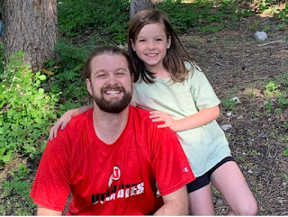

Gwen and Abby on their Great Grandma Bone's porch in Manti, Utah . . .

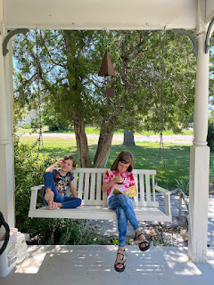

A cute photo of Weston and Benson from when we met them for lunch in Farmington, Utah prior to their campout in Manti . . .

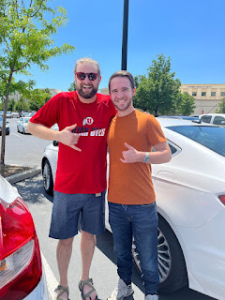

Gwen and Abby on the 4th of July in Manti, Utah (you can see the temple in the background)

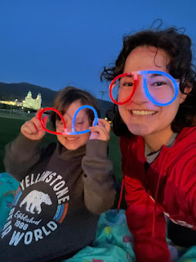

Jack on Independence Day in Minneapolis . . .

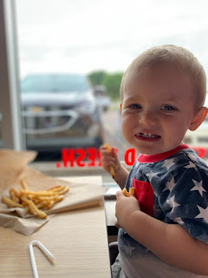

Jake and Hannah got a new family car - a 2011 Honda CRV. Jack's ready for a road trip . . . Hit the road, Jack! ha ha

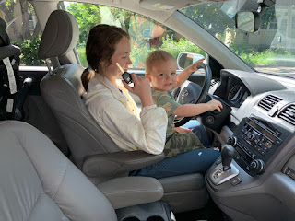

Just a few minutes from their house is the Mall of America . . .

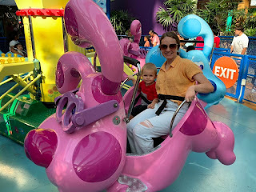

It is absolutely GINORMOUS! Jacob said it's 7 stories high, with things like this in the middle . . .

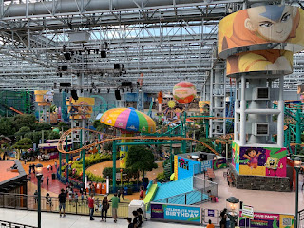

They are having a good time in their new place, finding some good grocery stores, they love their new ward at church, the zoo is free and has lots to offer, and they have A/C at their apartment. What a lifesaver!!

I chatted with Jack on a video call today. He sure has a lot of new words now! He is so cute to talk to.

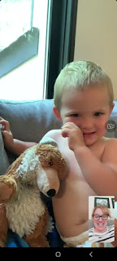

His parents set up a "kitchen" for Jack next to the real kitchen. His shelf full of supplies is the 2nd shelf up from the bottom on this organizational rack. They gave him some noodles to stir in his little pot, and a few other odds and ends. He loves doing what they do, knowing that it's gonna be something good once it's ready!

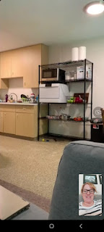

Jake and Benson have quite the beards going on. Jake's is a bit fuller, though, while Benson's is more distinguished-looking.

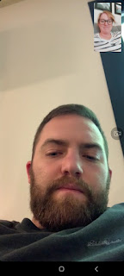

Lastly, a couple of bonus photos of Benson working on his car. He's pretty handy and knowledgeable, that's for sure.

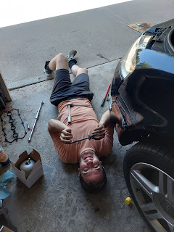

Benson and his buddy from when he was a teenager, Isaac Smith, who still calls me "Mama Harmon".

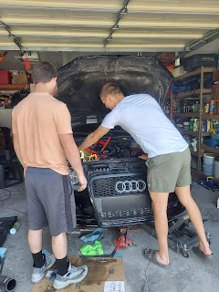

I am feeling much better as I get ready to begin another busy week. With God, all things are possible. :)

