California Adventures: Week Two
Just as I was learning the art and craft of laying bricks, my trip to CA has come to a close . . . I've never had an opportunity to do this before and I learned a lot through trial and error.
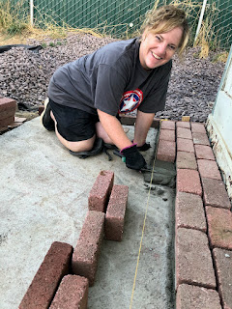

During the last few days, I've helped with a few bigger-than-usual jobs. Michelle and I loaded a ginormous 2x4 into their Honda Element and used some creativity to secure the rear hatch door with doggy leashes . . . I held onto the 2x4 so it didn't move around up front, especially since it was super close to the front windshield.

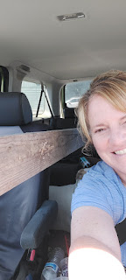

I carried and hand-trucked 30 bags of cement from the back patio to the front yard at the Margie house. They were 60 lbs each. I hefted them onto the hand truck and drove them out front and then stacked them. At the end of the job, we only used 21 of the 30 bags (more on that in a minute), so I transported the remaining 9 bags back to the rear of the house. I guess that equals 39 bags that were moved . . .

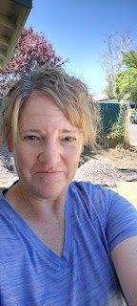

I sure got some good workouts in this week, that's for sure! I think my triceps won the prize for Most Improved.

As part of our prep to pour cement, we had to dig a trench where the fitted form boards would go. It took some extra effort because the ground was so parched.

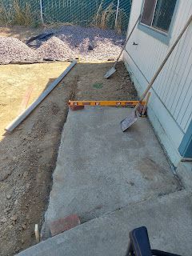

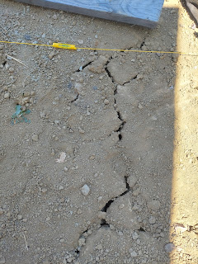

We used a heavy pounding bar, similar to a crow bar, to pound into the dry ground to break it up enough so we could dig down and do what we needed to do. It helped somewhat, but again, those triceps got a pretty good workout.

Over the course of two days, we got the form boards in place and did all the prep. In the photo below you can see the "screed" that my Dad built. It's the elbow-jointed board in the center of the photo, built to slide along the little ledge on the front of the house. Its main job is to slide along and smooth out the cement at the correct height, based on the form boards that we secured around the perimeter.

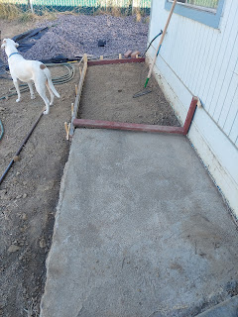

Michelle's oldest son, Craig, came over after work one evening to help us out. His day job is working with concrete, so he made mincemeat of this "little" job for us. His efforts can best be described as "magical". The way he cut into those bags of concrete and opened them up like two super lightweight egg shell halves, to then dump into the mixer . . . Dang.

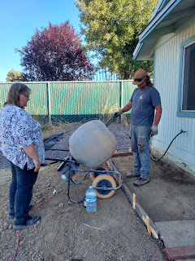

He had that cement pad taken care of in no time at all.

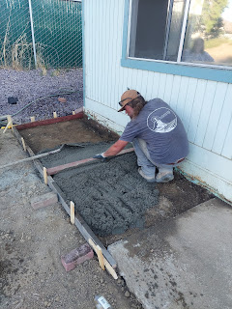

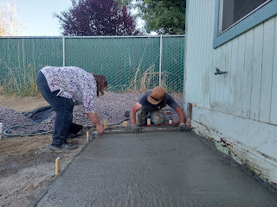

L to R: Me, Michelle, and Craig

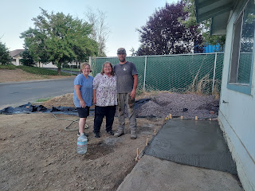

We were originally planning to cover the entire area with cement, including over the top of the already-existing pad, because the bricks on top would need to be flush with the sidewalk. But Craig told us to just use mortar to get the bricks at the desired height, instead of more cement. So we went with that advice.

Two days later, I went with my Dad to get a few supplies for laying the bricks. He likes to go to this one particular hardware & lumber store in Willits because of this nice accessory that they have just inside the entrance . . .

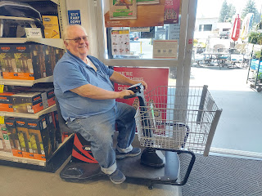

We took turns spraying off debris and dirt clods from the bricks so they would adhere better to the mortar.

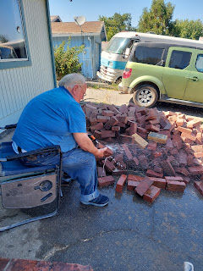

And just as they promised two days earlier, the missionaries (from The Church of Jesus Christ of Latter-day Saints) came to help us with the brick project. The missionary on the left is from Maricopa, Arizona, and the one on the right is from Los Angeles, but his parents came from American Samoa. They were both very nice to chat with as we worked and got the process more figured out and refined. We appreciated their willingness to help us, and we especially appreciated their strong muscles.

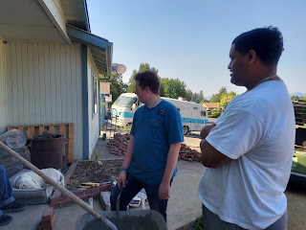

This is as far as we got that first night. I wish I could stay longer to help for at least another week, but I have weeds to pull back in Idaho (among other things) before I go back to Italy, and I miss my son, Benson, too.

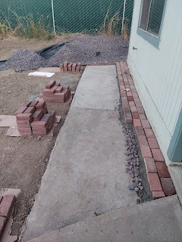

Brick-laying is no joke. It takes a lot of figuring out in order to have a little bit of success. You have to mix the mortar just right - it can't be too sloppy or too dry. It should end up like a toothpaste consistency or creamy peanut butter. If it's more like pudding or gelatinous Jell-o, then it won't work. It can't be crumbly either. It definitely takes some finessing.

Then there is the matter of getting the brick at the correct height. If you slopped too much mortar down, then you have to tamp the brick down to match the height of the string. It takes some practice to get in the "zone" and then you can start moving along. Two thirds of the way through the second row, I think I finally got in the "zone". The missionaries took turns during the first couple of rows, too. And then Michelle brought up the rear, once my knees started complaining about kneeling for too long . . .

It was a great experience, though. I feel like I am more connected to the Third Little Pig in the story of the Three Little Pigs. He worked hard and didn't do much play, play, playing like his "frivolous" brothers. While I do make some time occasionally to play, I appreciate how hard Mr. Pig worked during such a laborious task, and I, too, like to work.

Speaking of Play . . .

In between long days of working together with Dad and Michelle, I took some time to visit with my Mom, my niece, Ana, and a couple of friends during the week.

Midweek, I originally intended to go swimming again with Mom and Ana, but then Mom wasn't feeling well. She had been sick for a few days and was near the tail end. We visited just a little bit and then she needed to rest. My friend Jill came over to the house to visit me, since we really didn't have any other time that would work before I leave on Monday to head home. After we talked and talked for about an hour, we walked outside because Ana and I needed to head off to the new Barbie movie. Turns out, Jill has a bright PINK car!! ha ha

Ana and me (pretending like we're actually gonna drive that cute car) . . .

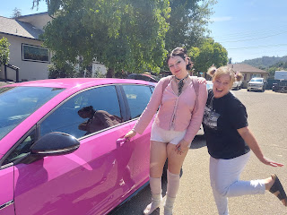

Jill and me . . .

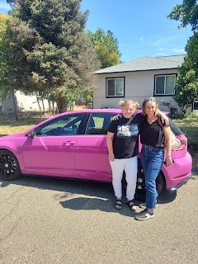

The Barbie movie was AMAZING, by the way. I laughed a ton, and was surprised that I even cried a couple of times. The thing that got me choked up the most was how they portrayed how powerful it can be when women love and support other women in nurturing roles: as a mother, as a grandmother, etc. It made me really appreciate all the women in my life that are so kind and caring and who make the world a better place.

I also loved the message that You are Enough. And that it's okay to take the time to find yourself - figure out what you enjoy, what makes you happy, and what makes you "you". There were so many good messages and great takeaways from the movie . . . I feel like I will need to see it multiple times to get everything out of it that needs to "be got".

On another day, later in the week, I went down to Ukiah again - and this time Mom and I were able to go swimming together a second time. We spent the most wonderful afternoon, swimming, floating, resting and chatting. After several hours, we got ourselves gussied up to go out to dinner at A Taste of Nepal, a local Indian restaurant.

I ordered Chicken Farci - bite-sized chicken breast with a puree made from pumpkin and cream. It was really good, but my favorite was the Lemon Rice. It had a hint of lemon flavor, with peas and carrots mixed in (one of my favorite things ever).

Clockwise from bottom center: Chicken Farci, Lemon Rice, Butter Chicken, and white rice.

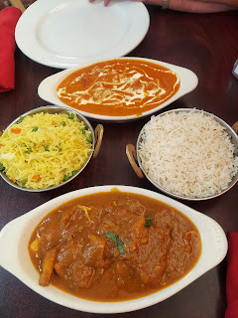

We really enjoyed the day together. XOXO

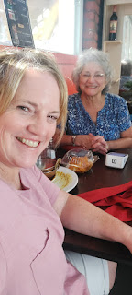

Earlier in the week, Dad and Michelle had their good friends, Catherine and Stephen over for dinner, along with their grandson, Carson. They are a hoot, and they are also great at conversation. We had enchilada casserole for dinner, and we played Zilch, a really fun dice game. I ended up winning! Yay!

Below: A very animated Catherine, explaining how to put together her tasty little lettuce wraps . . .

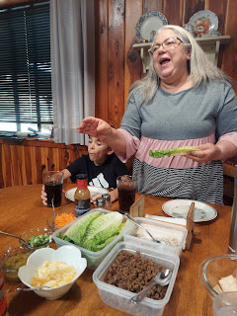

This was the Thai version: romaine lettuce, ground chicken, feta cheese, shredded carrots, green onions, and a really good drizzle of Thai peanut dressing. Then roll it up. Yum!!

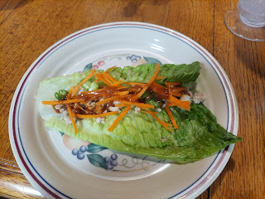

I made a dessert with the blackberries we picked recently. Per Michelle's instructions, I rinsed the berries, then mixed them with some sugar and cornstarch.

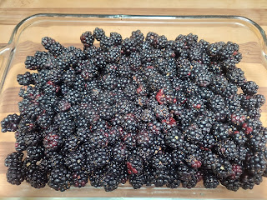

Next, I mixed together a yellow cake mix (just the powder) and a cube of butter. This was then sprinkled on top, like a crumble topping.

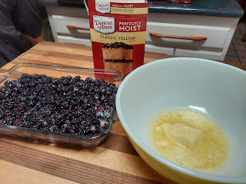

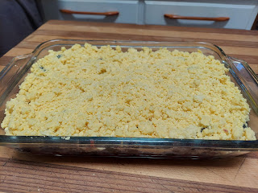

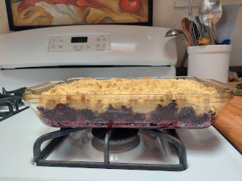

I really enjoyed the berries at the bottom, but I wasn't a fan of the cake mix topping. I think it would have been better to combine some oats, brown sugar, butter, and maybe a little nutmeg. The cake mix was not the right flavor combination (in my opinion) and it was too sweet for my taste. 'Twas a good learning experience, though.

At the end of the week, we had a wonderful Rawles Family Picnic at the Vinewood Park in Ukiah. We had a solid 15 attendees, which would have been more if my cousin Cara Anstead and her family could have come. Some last minute health concerns popped up and they weren't able to make it, which was so sad because Cara wanted to do this so badly!!

We found a comfy spot in the shade to hide from the 96 degrees outside . . .

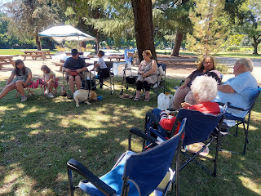

Below: Michelle, Dad, and my cousin Barbara McCulloch. She is the eldest ("wisest") Rawles relative right now at 91 years old. She is blind, but her mind is still amazingly sharp!

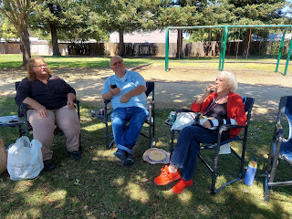

My brother, Ryan, was also able to drive up with his 3 kids, something I was so grateful for. He lives about 2 hours away from Ukiah so I don't get to see him very often . . . His kids decided to attack him with tickles at one point, ha ha . . .

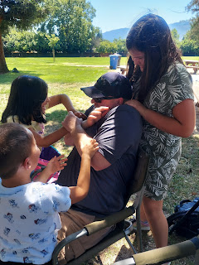

Ryan's daughter, Lily, had bright red lips to match her bright red popsicle . . .

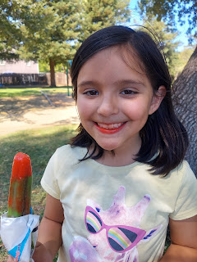

Saturday night, I also had a good chat with my son, Benson, who is still up to his eyeballs in trying to get his car fixed and ready for the open road. I had been trying to reach him for a few days, but obviously he was a little busy making a big mess . . .

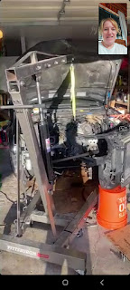



He's hoping that in the next few days everything will be taken care of and that his car will be all put back together. (Crossing fingers)

Welp, I'm in my final hours here in CA and I'm looking forward to getting home to Benson, as well as taking care of some things that I left behind. (like the weeds?)

