Chioggia: My New Favorite Place
Scott and I spent a half-day in Chioggia on Saturday, and we both came away feeling like this is our new favorite place in Italy. Pronounced like "kee-YOH-jah", it is also known as Little Venice because of its similar canal systems and definitive charm. The biggest difference between Chioggia and Venice is that in Chioggia you don't feel like a sardine, squished in with all the other million visitors that day. Even though we arrived just before noon on a Saturday, and even though there was a ginormous cruise ship docked a little ways out in the harbor, it had a small town feel, along with a quiet and very relaxing atmosphere.

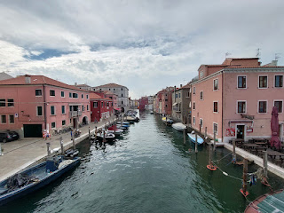

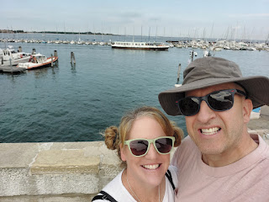

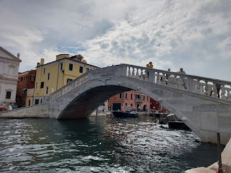

I promise you, these photos were NOT taken in Venice . . . ha ha

We found a great parking garage with multiple levels (Parcheggio Giove) and only had to walk about 8 minutes to get to this beautiful bridge (above), known as Ponte Vigo.

Here are a few of the quiet scenes we discovered on our walk to Ponte Vigo, which was along a road adjacent to one of the many canals. There were several fishing boats in the canal, parked for the weekend. There were also several family-owned boats, with people getting on board to cruise around for a while on that gorgeous Saturday afternoon in September.

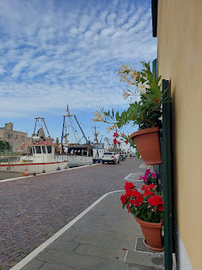

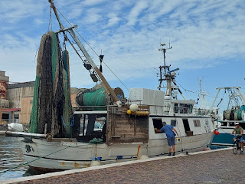

On this canal street, people would just park their car directly next to their boat, and then hop in and go.

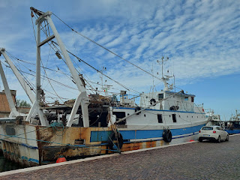

At the end of this street, it curved slightly to the right, and then we could see all the boat docks ahead for the cruises, water taxis, shuttles, etc. This public dock area was directly next to Ponte Vigo.

I would say that these boat stops are similar to a bus stop. This is where we bought tickets for a one-hour cruise around Chioggia and Sottomarina (more about that in a minute). The tickets were very reasonably priced at 10 euros per adult and 5 euros per child.

The map on the poster below shows the route that we took, which also helps to see how Chioggia is "connected" to Sottomarina. (click on the photo to enlarge)

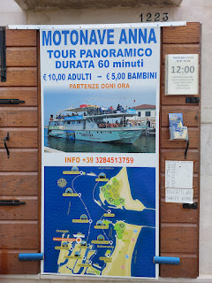

We had about 20 minutes to explore before our cruise began, so we went up and over the Ponte Vigo bridge and I took some photos from a few different angles. Ponte Vigo was built in 1685. How? We don't know . . .

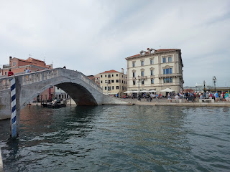

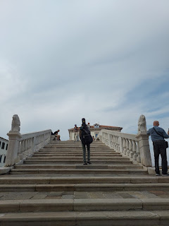

Funny story that I read online about these "lion" statues on the bridge . . . supposedly they were made to symbolize power and magnificence, but Venice, sort of a nearby rival, made fun of them, calling them a "gato" (cat). Scott thought the one lion looked more like a monkey, but maybe some of its original luster has been lost over time . . . ha ha.

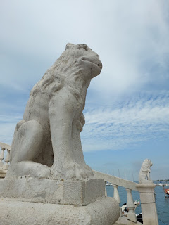

I love a good blue-sky-mixed-with-clouds kind of day for photography. It makes the photos appear more "moody" and dramatic. And I love the sparkle that the water captures and reflects . . .

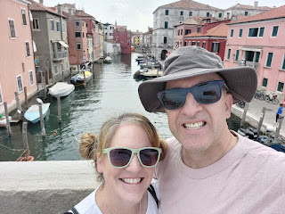

It was almost time for our boat cruise, so we walked back over to our "boat stop".

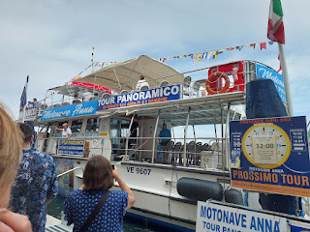

Below: Scott and I marveled at this ginormous cruise ship (Viking) off in the distance, but we didn't see any huge crowds of people at Chioggia. It wasn't until I mentioned it to someone at church this morning, that I learned the real deal. Cruise ships aren't allowed to dock at Venice anymore, so they now dock at Chioggia and then shuttle all the guests from Chioggia to Venice in smaller boats. While I'm sad to see so many troubling reports on the news about how terribly crowded Venice has become, and some of the steps that are being taken to maintain order and structure, I was selfishly grateful that everyone had gone to Venice instead of crowding Chioggia while we were there.

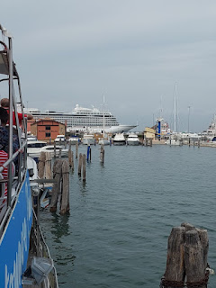

The weather was so perfect for a one hour cruise. It was maybe in the low 70's or so. Not too hot, and not too cold. Our huge boat went partway up the same canal that Scott and I had walked down earlier, and it was fun to see things from another perspective.

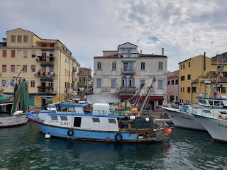

This boat is actually a restaurant floating on the canal . . .

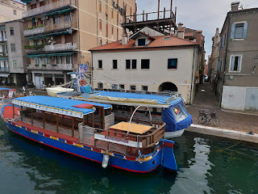

Video #1 during our cruise down the first canal: (21 seconds)
https://photos.app.goo.gl/yKsj8qUSN724X5LY8

The narrator did a good job of sharing stories and fun facts in Italian as well as English, and we also had an English pamphlet with photos to help us know what we were seeing.

Video #2 in the first canal, where I thought the captain was going to attempt to squeeze down a very narrow side canal, but thankfully he just used it as a turnaround spot!! (31 seconds)
https://photos.app.goo.gl/FcyvsA6siBzGN4og9

We then cruised past Ponte Vigo and headed around the tip of Chioggia to the east.

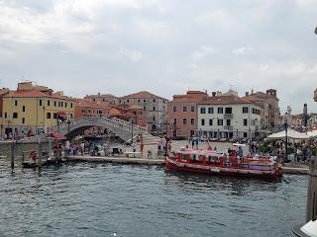

You can see Sottomarina in the distance (on the left) . . .

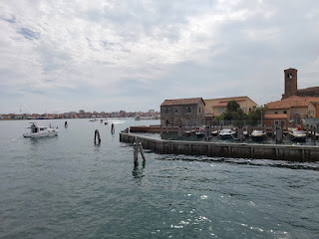

This is a very old church in Chioggia, named San Domenico, originally established in 1287, but was rebuilt in 1745.

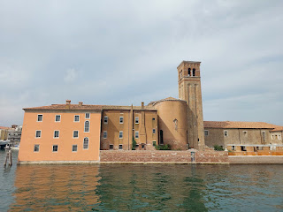

Chioggia is a fishing town, and their fish market is one of the largest in all of Italy. We didn't come early enough in the day to visit the market, but next time we go, I'd love to check it out. It was still interesting to slowly cruise by all the big fishing boats in a separate canal.

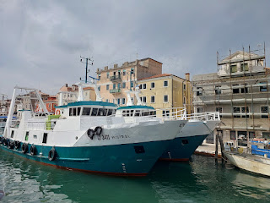

Video #3 as we passed by some of the large fishing vessels: (22 seconds)
https://photos.app.goo.gl/8Cd3G7zQ6Z1Lg1Dp7

Moody and gorgeous . . .

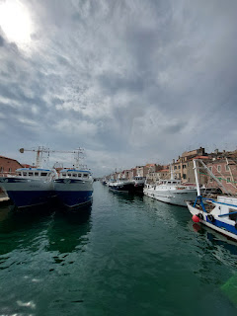

There were the occasional smaller fishing boats, with all their nets and collection baskets in piles . . .

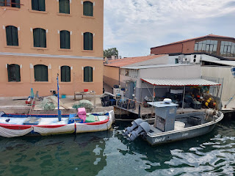

Next, we got up close to the connecting bridge that joins Chioggia and Sottomarina. (We later drove over this bridge.)

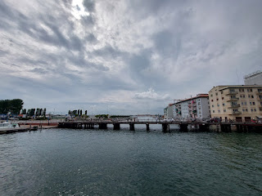

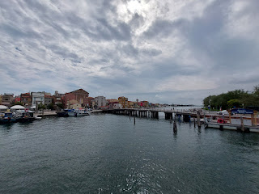

We cruised down the west side of Sottomarina, where the harbor meets up with the narrow peninsula and stretches along for about 11 km (6.75 miles). The "back side" is where the homes are, in the form of several large, colorful and fun apartment buildings. Bright coral, subdued periwinkle, and everything in between.

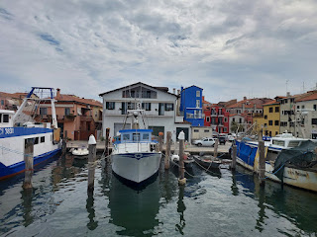

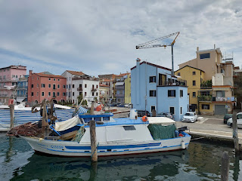

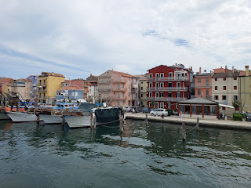

Near the north end of Sottomarina, a fancier marina exists . . . home to the wealthier yacht owners.

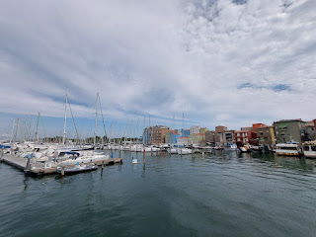

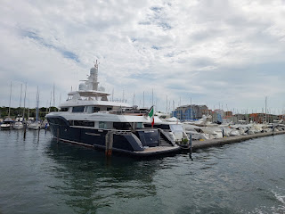

The fish that are harvested around Chioggia are mainly: gilthead bream, sea bass, sole, sardines, anchovies, prawns, crabs, shrimps, etc. There is also a large industry for clams and mussels in the area.

Next, we headed out a little ways in the sea to see (do you see what I did there) the Fort of San Felice.

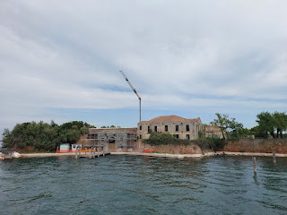

The Fort is like a six-pointed star, if viewed from above. According to our brochure: "It was built in 1538 by the Serenissima, the Venetian Republic, to protect the venetian lagoon from enemies. In modern times, it was used as a naval garrison and later abandoned before the end of the last century. For a short period it was open to the public but later entry was forbidden and, once again, it became an impenetrable military zone. It is now in a state of total deterioration. Currently, the fort is a candidate as a UNESCO world heritage site."

We saw a crane and other evidence that work is being done on some of the buildings there, so that's a good thing. Maybe this is in conjunction with it being renovated to some extent for becoming a UNESCO world heritage site, one that would undoubtedly draw in some tourism.

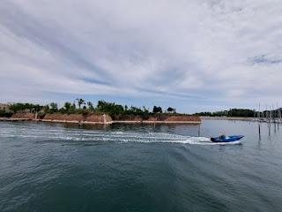

Off in the distance, on the other side of the Fort, we could see another island. We thought it might be Venice, but it turns out Venice is farther away. If you click on the next photo and scrutinize the island off in the distance, this is Pelestrina. Just north of Pelestrina is Lido, a long and narrow island (close to and across from Venice) where the recent Venice Film Festival just took place (and where I was hoping to see George Clooney when I got off the plane on Aug 31).

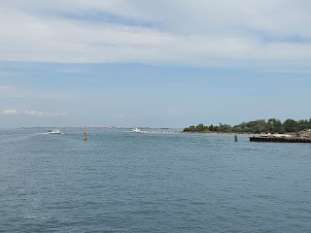

These wooden structures are Mussel Farms. According to our brochure: "These structures comprise poles driven into the lagoon bottom with hanging ropes attached containing bags. Here mussels grow and reproduce."

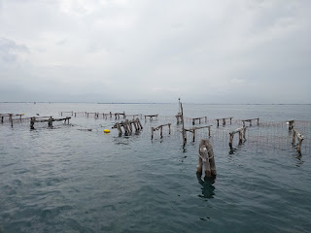

I don't know about you, but I could eat a giant bowl of mussels if given the chance . . .

Finally, our cruise made its way back to the docks. Again, there was that monstrous cruise ship . . .

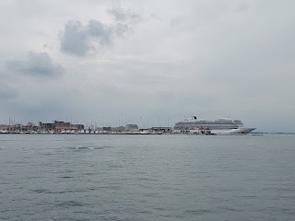

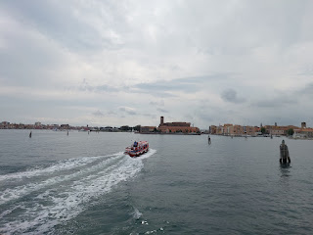

Below: According to the brochure, this is known as the Fishermen Virgin.

"The fishermen virgin is called Stella Maris. It is situated before the harbour mouth and it represents a symbol of devotion. Fishermen before going fishing, pray the Virgin for a good fishing and for a safe comeback." (Some words get tangled up when translated and printed into tourist pamphlets, ha ha)

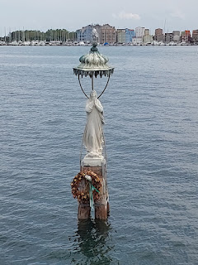

Video #4 as we came back into port - Chioggia on the right and Sottomarina on the far left: (24 seconds)
https://photos.app.goo.gl/DqVXgrJhVT51fjwU9

As we got off the boat, we saw a wedding party near the Ponte Vigo bridge. How beautiful to see something so unique and random! Their cute little VW Beetle was all decked out with bows, too.

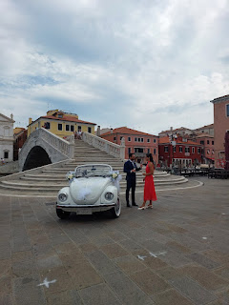

That may have been the groom talking to a family member or a bridesmaid, but the bride was actually in the small crowd right next to us.

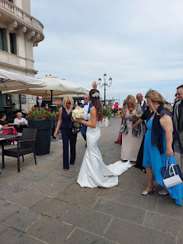

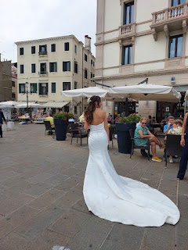

Scott found us a good spot for a lunch break on Google Maps, so we began walking in that direction, passing some Mediterranean-vibed souvenir shops on the way . . .

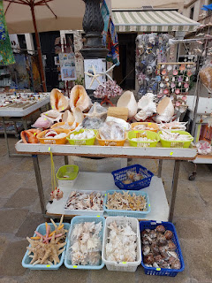

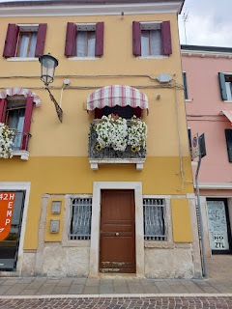

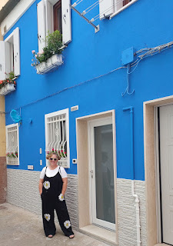

Whenever a baby is born, ribbons are adorned all over the family's home and even their car to indicate the gender. Pink or blue. This gate that we passed in an alleyway was decorated for a baby shower, with the announcement attached as well.

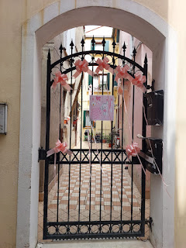

As it turned out, the highly-rated Blu Lantern was not only right back next to our parking garage, but it was completely full (and extremely hot inside). The lady at the counter suggested we come back in at least 30 minutes for a table to open up. But we decided to find another place to eat. So we headed BACK into the main shopping area of Chioggia and found this place by using our eyeballs to spot it as we walked by. It's called Gastronomia Gallo, situated on the busiest street in town, Corso del Popolo.

Inside, there are refrigerated glass cases with all sorts of unidentifiable delectables in each one. You just indicate to the server on the other side what you want and how much (uno, due, etc). They weigh it to let you know how much it costs, then they heat it up for you and you can take it outside to eat while sitting at a table.

I chose a square of my favorite Pasticcio (messy lasagna) and a piece of eggplant with maybe a fish cake of some sort baked on top and some melted cheese. (in the photo below it's in the lower right, "Melanzane Ripiene")

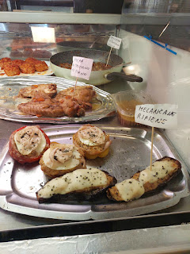

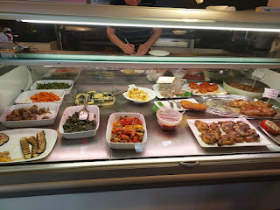

There were several things on the menu listed on the wall, but I'm not sure if all of these were offered during the lunch hour or if some were reserved for dinner later in the day. All very affordable prices, though.

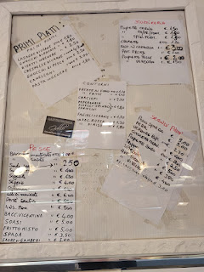

We had to go next door to the "bar" to get some water.

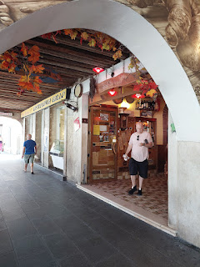

Clockwise from the upper left: Scott's choice of a crepe with what looked like chicken cordon bleu on the inside, my cheesy eggplant extravaganza, and the always delicious pasticcio. Buon appetito!

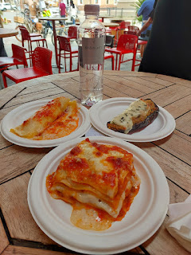

The one other place I wanted to visit (for now) in Chioggia was to see their famous clock tower, which professes to be the oldest clock in the world. It was just up the street, maybe a 3 minute walk. But first we wanted to see the old church across from where we ate our lunch.

The Church of Saint Giacamo was built in the mid-1700's. (click photo to read the English explanation)

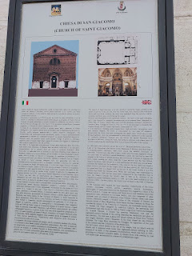

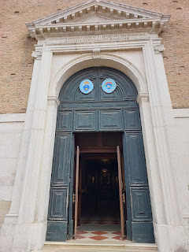

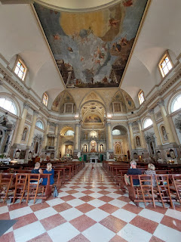

Beautiful artwork inside this church . . .

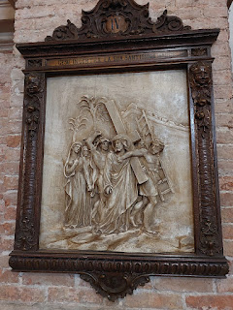

This was perhaps a place to wash (or be washed by the priest in ancient times) as you enter the doors of the church - -

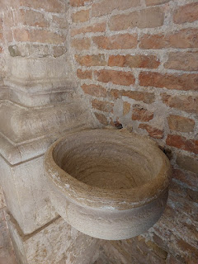

The artwork on the ceiling was beautiful . . . but I'm not sure if this is a scene out of the scriptures or something else.

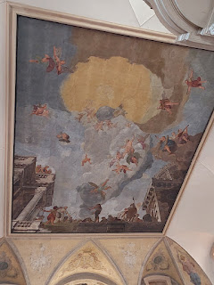

Around the chapel were several statues dedicated to Christlike attributes: Charity, Fidelity, Justice, Prudence, Temperence, Patience, etc.

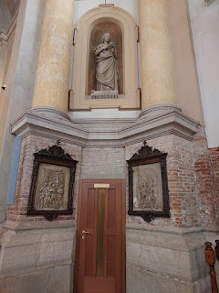

Just down the street, a hop, skip, and a jump, is the Museo della Torre dell'Orologio. Or, more simply, the Museum of the Clock Tower. The tower dates back to 1386!!

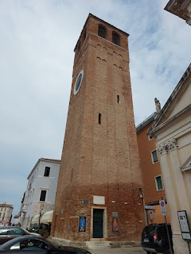

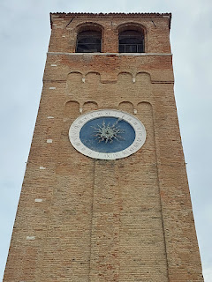

We didn't go inside (this time), because we only had so much time to spend in Chioggia that day. So we began our walk back to the parking garage. I love seeing Italian laundry hanging out to dry, fluttering in the gentle breezes of the alleys.

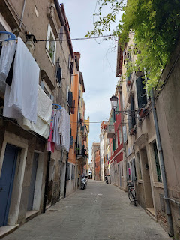

Care to come take a walk with me down this alley for one minute?

Video of the alley, down to the cute little red truck at the other end: (1 min, 5 seconds)
https://photos.app.goo.gl/3CjBBgqKw48C7qUx6

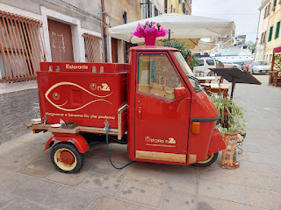

Back down the canal street one more time . . .

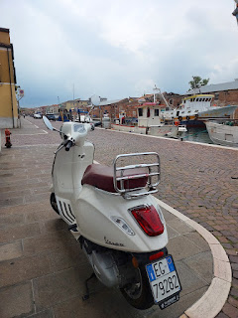

We parked at the very northern tip of Sottomarina, in a parking lot known as InDigo. It was a very short walk to the beach, maybe 3-4 minutes.

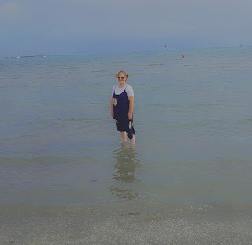

Video of the Sottomarina beach: (15 seconds)
https://photos.app.goo.gl/BHNYMebGq3Qe9cos7

What I was surprised, but happy to see, was that the water was so shallow for a long ways out. I saw people way out in the water, and it was only up to their shins!

Next to this north beach is a dyke that goes out for what feels like miles. Several people were walking along the paved path, bicycling, sunbathing, and even fishing off the sides.

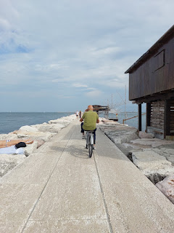

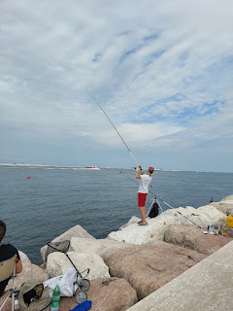

I stopped to watch a couple of snorkelers for a few minutes, to see what they were trying to find. Turns out, they were fishing for crabs!

Video of the crab fisherman: (25 seconds)
https://photos.app.goo.gl/QC7T8hwfRkAZ7sVZ6

He got one! I watched him add it into his netted bag with the pincher/grabbers (his tool).

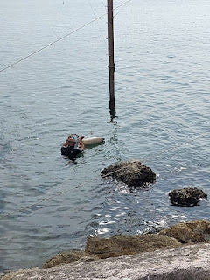

Scott was on the other side of the dyke and he motioned for me to come over to see something . . . look closely and you'll see some dark colored crabs on the rocks below . . .

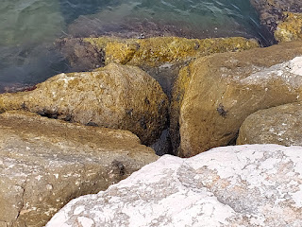

Here's my handsome guy. XOXO

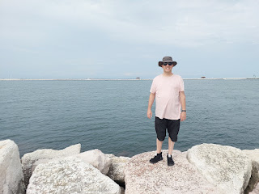

Eventually, we walked back along the path to head on home.

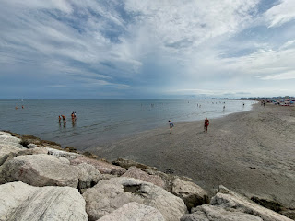

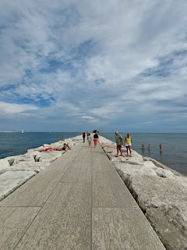

Chioggia, you were wonderful!! I haven't felt so relaxed and refreshed in a while, but thanks to you, that has all changed. I hope to see you again very soon . . .

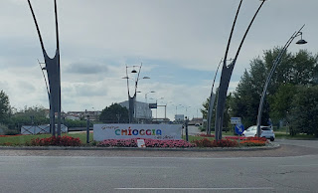

On our way home, we stopped at IKEA in Padova so I could get a couple of things. And besides, 1) it's right next to the freeway, and 2) we could have a little bite to eat in the cafeteria upstairs. Who doesn't love Swedish meatballs with lingonberry jam and gravy? Seriously, who?

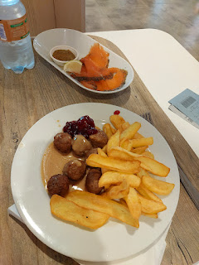

I have an important story to share. Some of you may recall my visit down to Agadir, Morocco last June and how I met a new friend, my Moroccan son, Abdo. This is me with my two young friends, Imane (on the left) and Abdo (on the right) last summer. Abdo is the same age as my daughter, Amber. In fact, he was born just a few weeks ahead of her!

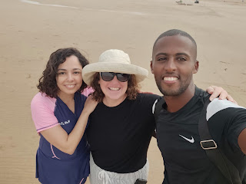

While I was in Agadir, we would sometimes hang out and talk about the many things going on in the world, and some of them were very deep topics. I kept in touch with Abdo for several months, and then we lost contact for a while. With the recent tragic earthquake in Morocco, I reached out to him again to make sure he was okay. He was okay, but he sustained a very bad injury because of the earthquake and he was in the hospital when I texted him.

The epicenter of the earthquake was centered between Marrakesh and Agadir, up in the mountains. Here is a screenshot that was helpful to me. (click photo to enlarge)

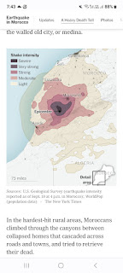

Abdo had just received a surgery to repair his broken right leg, and it would be a few more days before he could go home. We chatted every day from that point on, mostly with texts, but we did do a video call one day.

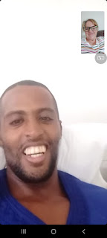

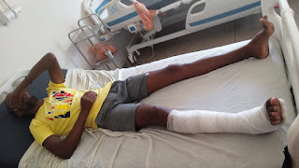

While he had to stay in the hospital for so many days, he is a person who does not like to sit still. He likes to exercise and have adventures and meet new people and have interesting conversations. So, even though he was in some pain, he would still get up and move around a few times each day. He told me about a little 4-month old baby girl who was in the same ward of the hospital where he was. She had lost her parents and two brothers in the earthquake, and was the only one in her family who survived. Two of her aunts came to the hospital to help care for the baby, and Abdo would go check on her as often as he could, every few hours. He said she was very cute, and that her name is Firdaws. It means "paradise".

He also mentioned another young man that he met in the hospital. This young man broke his femur bone in a motorcycle accident as he was driving from Casablanca to Agadir. There were local people who would come to the hospital every day, bringing food, drinks, and even money to those who were suffering after the earthquake. Abdo would share some of what little he had been given with this young man, such as milk, water, and food. He is one of the kindest people that I know and is always thinking about others. He is really quite remarkable.

Here he is, before his injury.

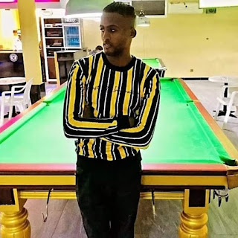

This photo was taken during a religious feast. Abdo is wearing the dark blue.

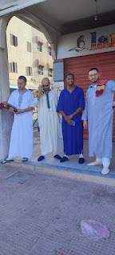

I also read online recently about another devastating earthquake that hit Agadir back in 1960, killing 1/3 of all the residents! Thankfully, no one in Abdo's direct family died, although his grandmother's cousin died in the tragedy.

ANYWAY . . . I finally got all of the details about his experience during the earthquake during our texting conversation today. Here is Abdo's story, in his own words. (I have permission to share) Keep in mind that his two main languages are French and Arabic. He is getting much better with his English, though.

"On Friday 09/08/2023 at 22:55, I was sitting alone in the dining room in which with my parents and my sister gathered. My parents and my sister were out of the house at that time, and I was only with my uncle in the house, and my uncle was in the basement of the house. I was on the top floor, and while I was sitting alone in the dining room in which I gathered with my parents and my sister, suddenly and exactly at 23:00, I felt everything around me moving in an unusual way, and even continuously and increasingly, suddenly and quickly.

"I realized that it was a sudden earthquake, and I was confused about my situation, while the earthquake continued and increased, and I said to myself, should I go down the stairs or should I throw myself out of the window, because I was in a moment of great panic and fear, and I said to myself again, “If I go down the stairs, I might... It is too late and the whole house falls on me and I die. Suddenly, the only solution and the last option is to jump out of the window from the upper floor. When I wanted to jump out of the window, I saw my uncle near the door and he said to me, “No, do not jump,” and I told him, “I will jump.” I have no other choice) and suddenly I jumped out of the window without wearing shoes and suddenly my right leg broke at the level of the leg. My uncle and I were the first two people to quickly leave the house in the neighborhood in which we live. Then all the people and neighbors, old and young, left. They were screaming, and some of them went out without clothes, and everyone was screaming and crying, and I too was crying hard from the heat of the fracture in my leg until my uncle and a young man from one of the neighbors came and carried me to the middle of the street.

"I saw a young man I know riding on a motorcycle and I said to him, “Is it possible?” To take me to the hospital and he said to me, “Yes, come on.” As we were walking on our way to the hospital, we saw many people, families, and young children screaming and crying out of fear, sitting in front of their homes. After I arrived at the hospital, a security guard came and carried me in a wheelchair and stood up. They admitted me into the hospital, and the hospital was full, and then the doctor came and examined me, and he saw my legs through the screen and told me that he needed an operation as soon as possible, and the next day I had the operation, and thank God it was successful."

Poor Abdo. I'm so sorry that he was hurt during all the chaos and confusion. He told me, too, that he is famous in Agadir as being the only person to jump from an upper story window and that also got hurt because of it.

Scott just landed in Agadir this evening, after a long day of travel. He left the house at 2:00 a.m. last night and has traveled from here to Venice, then to Madrid, then to Casablanca, and finally to Agadir. He will check on Abdo this week in person, which will help me feel some relief.

God is good, and God is kind. Sometimes bad things happen to good people, but that doesn't mean He loves us any less. He is always with us, no matter what we are going through.

As for the rest of the week . . .

My sister, Melanie, and her family stayed at my house back in Idaho so they could visit their married daughter who lives nearby. Melanie reported that she enjoyed feeing "chilled" up north, instead of dealing with the intense Arizona heat that they have endured for several months.

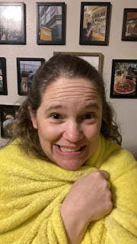

Her son, Caleb, enjoyed sitting out on the back patio in the evenings, and also crushing his mother in Phase 10. (after she had already won . . . ha ha)

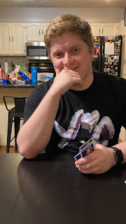

I baked pumpkin chocolate chip cookies for a youth activity on Tuesday, while I chatted with Abdo off and on during the day.

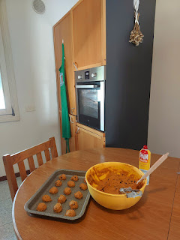

Scott and I have been going to the Gym together 5 days a week lately. On Friday, however, we decided to just walk to and from the post office on the base so I could mail a birthday card to my mom (surprise - ha ha). Her birthday is in a couple of weeks, but it also takes about 2 weeks to mail something from here. On the way back, we stopped at the library on base to rest for a few minutes (it was very hot outside).

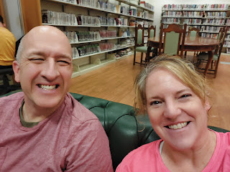

I saw the most beautiful flowers during our walk that day. I think they are some type of passionflower . . . Scott looked it up for me while I took some photos.

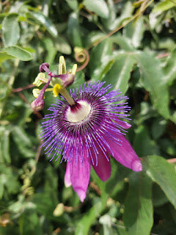

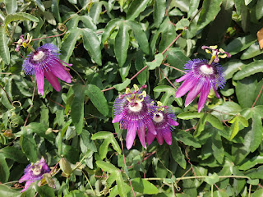

I finally got some cute photos of Avery recently. I hope to see her soon while I'm in Italy.

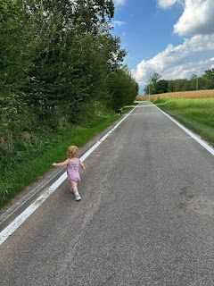

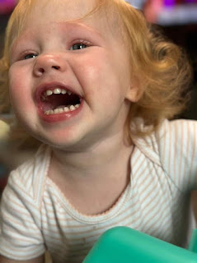

Here is the cutest video of Avery brushing Mocha's fur, while she (the dog) patiently allows herself to be groomed: (36 seconds)
https://photos.app.goo.gl/nWTbE9f2TZYzeDPd7

Meanwhile Jack is doing all of his chores, and seems pretty happy while he works! ha ha

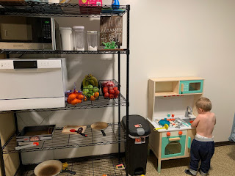

Video of Jack learning how to wash dishes in his new toy sink: (22 seconds)
*His attention to detail is incredible. I can tell he's been watching his parents very closely . . .
https://photos.app.goo.gl/VSkEiH9U4yrDYZ428

Sometimes he takes a day off from working to go to the zoo.

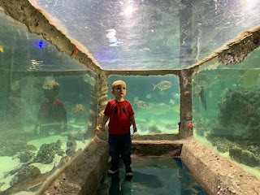

Jacob shared this handsome photo with us, taken by the University of Minnesota as part of his program.

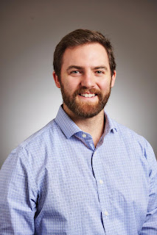

Abby and Gwen are cuter than ever down in the South. Less than 2 weeks and they'll be here WITH ME!!!

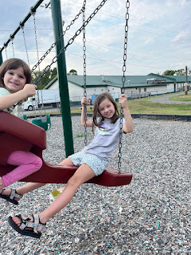

And Chelsea celebrated her 2nd wedding anniversary with Garret by visiting Moab, Utah and doing some hikes together.

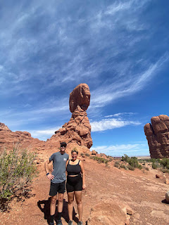

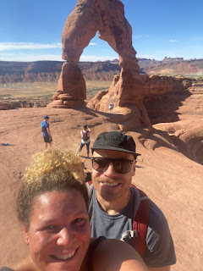

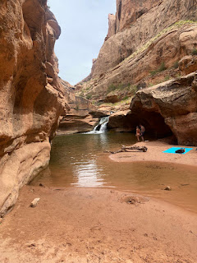

Aaannnd that's a wrap. May God bless you all this coming week.

