The London Temple, Cranbrook, and Lionel Richie
We had the BEST TIME in England over the weekend. During the course of 4 days, we visited the London Temple, drove down to Cranbrook in Kent, took the train up to Greenwich, went to a Lionel Richie concert, went on a tour of the St. Alfege Church crypt, visited the Royal Observatory - which also included a Planetarium show, and did some shopping in the Greenwich Market. We hit a lot of categories - - which is why I will only be covering half of them in this blog post!
We tried a new airport to fly over to England this time: Verona. Since we moved to the NW part of town, Venice is more like an hour's drive now, which makes Verona a little closer (only 45 minutes). Surprisingly, Verona offers some great non-stop flight destinations, and we have gotten really fond of flying on EasyJet lately.

Day One:
(Thursday, June 5th) We drove 45 minutes to get to the Verona Airport, parked right outside the entrance to the smallish regional airport, and had no problems with either end of our flights (going and coming back). Once we landed at the London Gatwick Airport, we navigated quickly to their rental car lot (on site), and then we only had a 15 minute drive to get to our hotel near the London Temple. It was all pretty simple, really!

With the exception of making sure that you drive on the correct side of the road . . .

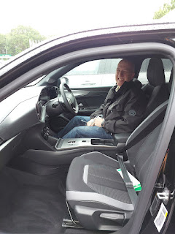

Scott did a really good job, even though there were some stressful minutes on the drive down to Cranbrook the following day.

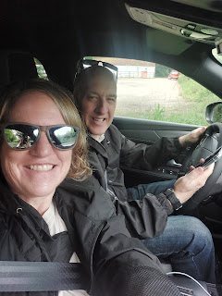

We had an Opel Mokka car assigned to us, which we had never heard of before. It's an SUV crossover made by a German company. We loved it! It was super comfortable and enjoyable.

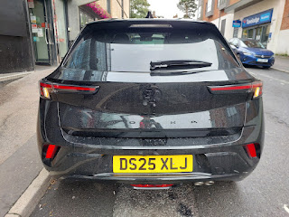

We made sure that we booked our rental car as far in advance as we could so there was an automatic one available for us. I just can't imagine driving stick-shift AND staying on the "wrong" side of the road. You'd have to shift with your left hand and I can't even
begin
to wrap my head around that . . .

We found a place for lunch that was close to our lodging - Tammy's Thai Restaurant. It was rated very high and was a good place to relax for a bit until we could check into our hotel.

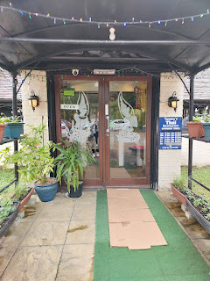

Scott wasn't very hungry (he doesn't usually eat any lunch), so I ordered the Mixed Starter plate for us to share (#1), along with the Tom Kha Gai Soup (#18), a coconut based soup and one of my favorites.

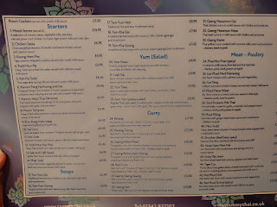

Everything was DELICIOUS!! The basket of "crackers" was highly unusual, something I'd never seen before. The white "crackers" looked like styrofoam but tasted like sweet shrimp, ha ha. The brown "crackers" tasted like a fish market and weren't very pleasant.

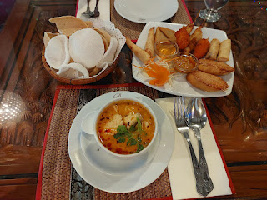

We weren't sure if we would need to get a British SIM card for our phones or not, but after an hour of being in England, we decided it wouldn't hurt. Our T-Mobile plan has great coverage everywhere we go, but sometimes our phones are slow and the information we need just won't load. We noticed that our service was pretty spotty after we left the airport, so Scott found us a store to pop into and get some SIM cards in the nearby town of East Grinstead.

Something interesting we learned as we chatted with the young man who helped us inside the Vodafone store, was that there's a gang in the area and they are unpredictable and potentially violent. He had to unlock the door to let us in, and then he promptly locked up again once we were inside. When I asked for more information a few minutes later, he explained that sometimes the gang members will just storm into a random shop and start stealing everything inside - in broad daylight. Many shops have adopted the practice of keeping their doors locked during the day, only unlocking to let someone in and then quickly locking back up afterwards. This is a smallish town of approximately 26,000 residents.

It reminded me a little bit of the town where I grew up in Ukiah, CA, but not so extreme of course. When I stayed there for 4 months back in 2019, I would get my hair done in a salon on State Street close to downtown. The hairstylist instructed me to text her when I was at the door and then she would come and unlock it for me. She immediately locked the door after I was inside. The reason why, she explained, was because there was an abundance of homeless population milling about during the day, and she worked alone. One day, a homeless man had come inside to get out of the rain, and he refused to leave for several hours. It made her very uncomfortable, so she made it a practice to keep the door locked from that point on. This was in the months that followed several fires in the area, which made the homeless numbers climb even more than they already were, unfortunately.

Even though it was rainy, Scott and I walked around East Grinstead a little bit, just to stretch our legs and get some exercise. I saw this real estate listing in a store window, so I sent it to my kids to see if anyone wanted to go in on the property with me. Amber was the only taker, ha ha. She offered to go "halvsies".

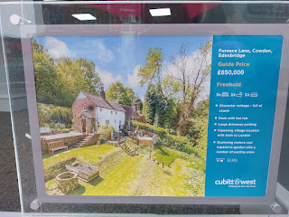

The Wire Mill Hotel sits on a lake and is within walking distance of the London Temple. If the weather had been more cooperative, we would have walked later that evening. It was quite rainy and blustery, so we opted to relax in our room for a couple hours before going upstairs for dinner at 5:00. (We had a reservation.)

The Wire Mill has an interesting history, which you can read below . . .

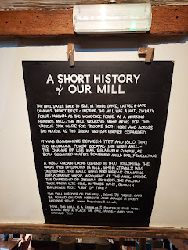

Our room was very comfortable . . .

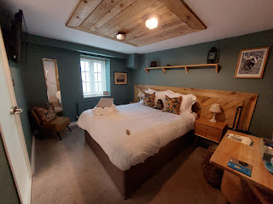

There was even a darling little hedgehog on the bed, waiting to snuggle with us . . .

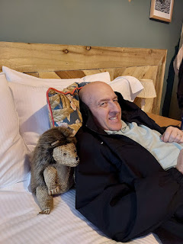

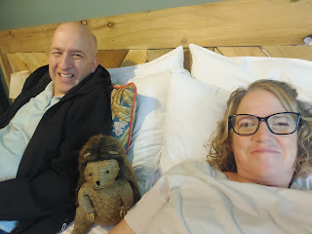

The onsite restaurant is popular in the area, with many who come for lunch or dinner on most days. That's why we made a reservation, also because we had an appointment at the temple and didn't want to be late for that.

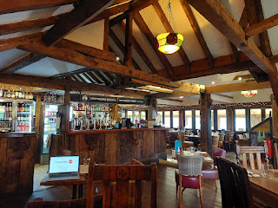

I ordered the most beautiful appetizer: a beetroot tartare with goat cheese, pumpkin seeds, and hot honey. It was so good!!

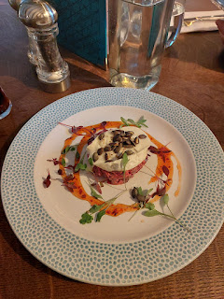

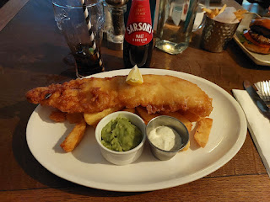

The dish that I really wanted - they were out of, sadly. So my back-up was the standard fish & chips with mushy peas. Scott ordered a simple burger with fries. His was smallish and mine was ginormous, so I shared almost half of my slab of fish with him. :)

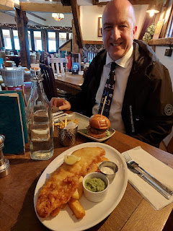

The London Temple is located near Lingfield, UK, quite a ways south of London proper. But it was super convenient for us as we flew into the nearby London Gatwick Airport. Something special I learned about this temple is that it was built in the same county of Surrey where the Magna Carta was signed on 15 June 1215. Technically, it was signed in Runnymede, a distance of 39 miles away, and approximately 45 minutes by car. The temple was built on an ancient property known as Newchapel Farm, and was also listed in the Domesday Book of William the Conqueror.

The London Temple was the first to be built in the United Kingdom, and only the second temple in Europe (the first was in Bern, Switzerland). The Idaho Falls Temple was dedicated in 1945, whereas the London Temple was dedicated in 1958.

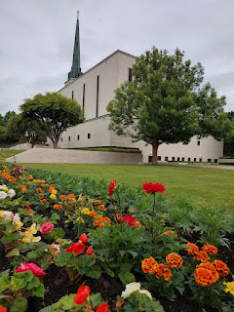

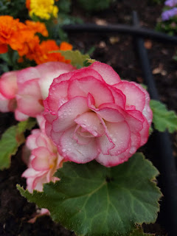

It sits on a very beautiful 10-acre property, with an old manor house across the lawn that has served as a missionary training center and, more recently, temple patron housing.

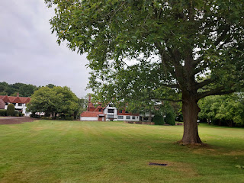

A temple selfie before we went inside for our session . . .

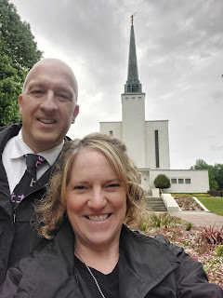

After the session, I was quietly visiting with a young lady that I happened to sit by during our instruction upstairs. Her name was Mina and she was from Korea. Her husband, Alec, is from Burley, Idaho (near Twin Falls) and works as a lawyer in NYC. I learned that Mina is an aspiring artist and wants to start a family. She was the sweetest and smiliest person I've come across in a while. I wish I had exchanged contact information with her because she left such an impression on me and I have thought of her many times since we met on Friday evening.

We took turns taking pictures with our husbands in front of the temple afterwards. Alec marveled that anyone from Idaho made it out of Idaho, ha ha. He was super impressed that we live in Italy and that we've had so many wonderful experiences outside of the U.S. together. They had been visiting England for 10 days and this was their last night before flying home to NYC.

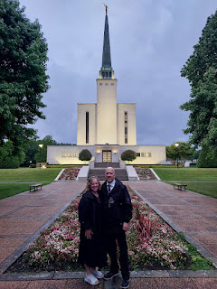

What a beautiful sight as dusk settled in and the temple became a beacon of light . . .

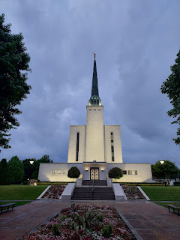

We took the long way around the temple back to our car after we said goodbye to our new friends. There is a creek that quietly meanders along a paved path, and there are a couple of footbridges to get you from one side to the other.

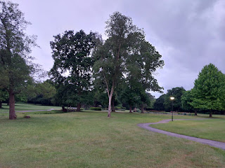

In 1990, the temple was closed for 2 years as they did some extensive renovations inside. This included adding a fourth floor (!) and updating the mechanical systems, replacing worn furniture, painting the inside, and cleaning the entire exterior.

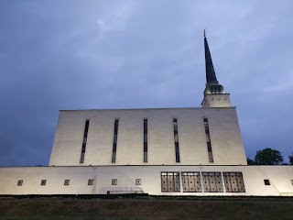

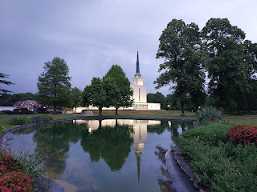

What used to be the Visitor Center is now a waiting area for those who aren't attending the temple for whatever reason. (Children, for example, who might be part of a wedding group but aren't old enough to participate inside the temple yet.)

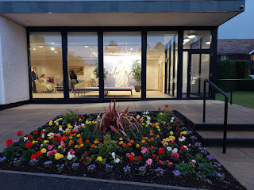

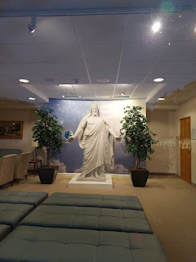

There was a little family of ducks who came waddling over to me when I paused to take a couple of photos from the edge of the parking lot, ha ha.

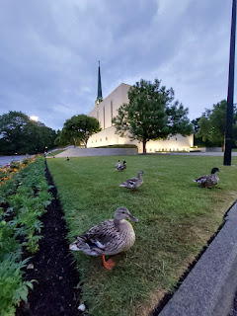

Video of the duckies: (13 seconds)
https://photos.app.goo.gl/o2UELsQ4no735FCt5

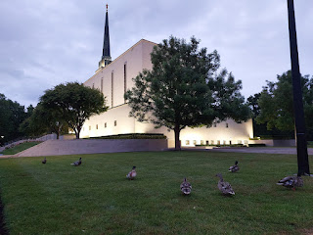

And that was a wrap on our first day in England together. I say "first day together" because I've been there 3 times but never with my own husband!
1) With my sister Charmaine in 2018.
2) With Amber and her family in 2023.
3) June 2025 with SCOTT. :)

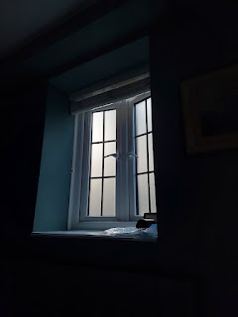

Day Two:
(Friday, June 6th) We got up early to drive down to Cranbrook in Kent, about one hour's drive southeast. The rental car needed to be returned around noon, so we spent one hour driving down, a little less than 2 hours there, and then one hour driving back. The drive down took a little longer than expected because of some construction and a one-way road where we had to wait a while for our turn to pass through.

After driving the first bit on the freeway earlier, the roads then became very narrow with tall hedges on either side; it was raining; and Scott had to pay 100% attention every single second. We found ourselves on back country roads, and while some of them had painted lines down the center, many did not. My job was to be Scott's cheerleader during those stretches. :) I offered to drive more than once, but he said that would be even more stressful for him because he would not have any control of the situation. He felt like he would be a worse passenger than a stressed-out driver, poor guy. But we made it in one piece and all was well.

We had some lofty goals for less than two hours in Cranbrook, but where there's a will, there's a way!

~ Visit the Union Windmill
~ Get breakfast
~ Get some fabric
~ Find some postcards
~ Visit St. Dunstan's Church
~ Mail a birthday package to Lauren Parker from her parents (more on that in a minute)

We passed through Royal Tunbridge Wells and Goudhurst on our way. We also passed through Sissinghurst (the town) where Charmaine and I visited Sissinghurst Castle & Gardens on her birthday back in 2018.

Video from the top of Sissinghurst Castle in 2018, overlooking all the lovely landscape below:
(46 seconds)
https://photos.app.goo.gl/RjZaK9xya7JXBkhCA

On our way to Cranbrook, I felt occasional feelings of excitement to see the town again, but at the same time I was trying to soothe Scott while he was so stressed from driving on those narrow roads.

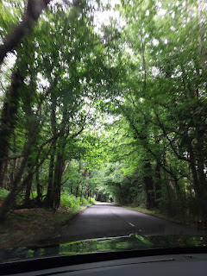

As we came into one of the tiny towns along the way, things became even more tight to get through some of the streets . . .

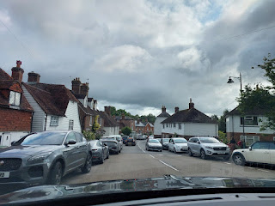

Parking is hard to find in many small towns throughout England, and there is no law against people parking ON the street, which is already super narrow to begin with. This turns many two-way roads into one-way roads. You have to wait for a small string of cars to pass from the opposite direction, and then a car will flash its lights at you to indicate that it's now your turn and they will wait.

It's an everyday thing for the Brits, but to Scott it didn't make sense and his growing sense of frustration was palpable. I did my best to help him stay calm, but it was hard to do while he was still behind the wheel . . . He's usually so even-tempered and calm, but if something doesn't make sense + is not efficient + he is stuck dealing with it = his blood pressure begins to rise.

Video of us taking turns with the traffic coming into town: (28 seconds)
https://photos.app.goo.gl/qQYMn6AC881VwNum6

Video as we passed what's known as an Oast House on the way: (8 seconds)
https://photos.app.goo.gl/NVzaYLKdPSg7veLE7

Video #1 coming into Cranbrook: (43 seconds)
https://photos.app.goo.gl/Ypw4vL3MpXMgZMYT9

Video #2 coming into Cranbrook: (30 seconds)
https://photos.app.goo.gl/ZCGkuzTP7wW47DCs7

We found a place to park and while Scott stayed behind to breathe and exhale and get all of "it" out, I walked down the street to see the Union Mill, an impressive sight! I passed a cute little driveway entrance to someone's home on the way . . .

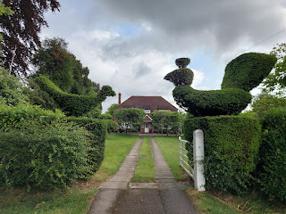

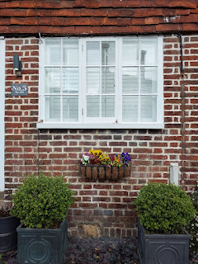

I also passed an old burned out red telephone booth . . . video here (6 seconds):
https://photos.app.goo.gl/CxAccmXH4SDCA1KN7

And here it is . . . the old Union Windmill.

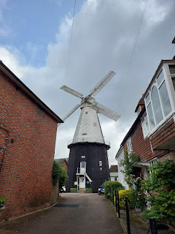

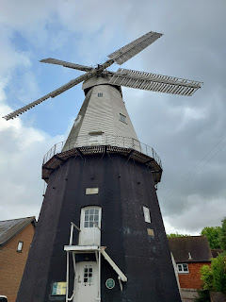

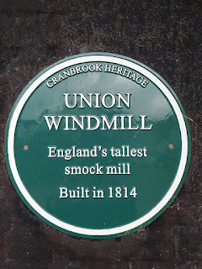

This next photo explains more about it, but essentially it is a wind-powered mill that can grind flour.

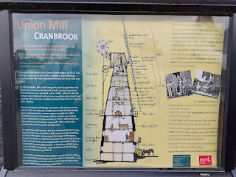

It was open for tours on the
following
day (Saturday) so I just did a quick loop around it, took a few photos of the area and then walked back to where Scott was.

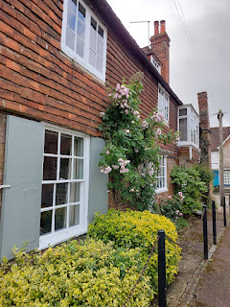

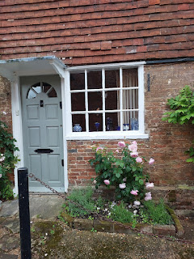

He was feeling much better by this point, thank goodness. It's definitely a stressful thing to drive on those country lanes in England. I remember all too well my adventures with Charmaine in 2018 and the instinctual (and repetitive) feelings of wanting to go into a fetal position as cars - and even a big dump truck - hurtled by within centimeters of our car. We wisely alternated days of driving on that trip and it helped a lot to find peace (and relief) in being the navigator vs the actual driver.

From where we parked to see the windmill, it would have taken 8 minutes to drive to "the" parking lot in town OR just 9 minutes to go on foot. Yep, ha ha, we chose to leave our car there in that same spot and to walk instead. It was refreshing to get out and walk some more anyway.

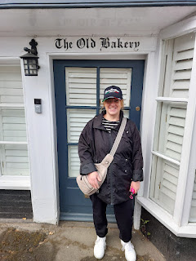

The significance of Cranbrook is this:

On my mother's side of the family, going up the tree on her mother, Grandma Doris' branches, we get to the Tilden Family. They were clothiers and lived in Tenterden, Benenden, and a few other villages throughout Kent, England. This was during the 1400s-1600s time frame.

Any of the towns that end in "-den" were places that sheep and pigs were able to graze during certain seasons. The sheep were significant to my ancestors because they were part of the process to make broadcloth, which in turn made them very wealthy.

Per A.I.:

In 15th and 16th century Cranbrook, England, sheep's wool was transformed into broadcloth
through a series of steps, starting with the wool being carded and spun into yarn.
This yarn was then woven on a broad loom to create a wider fabric, and finally, it was fulled (felted) in a fulling mill to create the dense, smooth texture of broadcloth
.
Detailed Process:
1.
Shearing and Cleaning:
Sheep were sheared, and the raw wool was cleaned to remove dirt, grease, and other impurities.
2.
Sorting:
The wool was sorted by its length and quality, with longer fibers being used for the warp (the lengthwise threads on the loom) and shorter fibers for the weft (the crosswise threads).
3.
Carding and Spinning:
The wool fibers were then carded (aligned) and spun into yarn using either a spinning wheel or a drop spindle.
Shorter fibers were often carded to create a fluffy, airy yarn suitable for the weft.
4.
Weaving:
The yarn was woven on a broad loom to create a wider cloth, which was usually a plain weave or twill.
5.
Fulling:
The woven fabric was then fulled, a process where the wool fibers were felted together using water, soap, and sometimes human labor (walking on the cloth) to create a denser, more durable fabric.
Large, water-powered fulling mills were also used.
6.
Teasing and Trimming:
After fulling, the matted surface of the cloth was teased to raise the nap (the surface fuzz) using a brush made of dried thistles (fuller's teasel).
Finally, the nap was trimmed with shears to create a smooth, neat appearance.
Tenterden partially got its name because they would stretch sections of the woollen fabric out to dry, forming "tents". My 10th great grandfather, Nathaniel Tilden, came from a long line of fabric-makers. His mother, Alyce Bigge, was an integral part of this trade and her family had deep roots in the area.

Cranbrook was at the center of all the action. In the outlying communities like Tenterden and Benenden, animals were grazing and being sheared, fabric was being stretched to dry, etc. In Cranbrook, the fabric was being distributed and sold, among other things.

A historical society in Kent wrote about the clothing industry in greater detail here: (an easy read and very enlightening) (also makes you appreciate the clothes you're wearing right now)

https://evmt.org.uk/wp-content/uploads/2024/02/Clothmaking-Exhibition.pdf

Unfortunately, in the early 1600s, things began to change and the broadcloth industry declined significantly in the Weald of Kent. A combination of cheaper and more efficient methods for producing the broadcloth elsewhere, along with a shift in market demand (for lighter-weight fabric) both led to a portion of the industry's demise. But there was a bigger issue that ultimately contributed the most to the decline of the broadcloth industry in Kent: iron production. With civil wars and other problems throughout the region, weaponry needed to be produced. To make these weapons, iron needed to be formed into swords and other defensive materials, and therefore timber was needed for fire. Timber was in direct conflict with the clothing industry workers, because they, too, needed timber. Numerous complaints were sent up to London over the course of many years, but it wasn't enough.

In the 1620's and 1630's, the decline in being able to produce and then sell broadcloth was significant and the damage had been done.

I wonder if this was one of the primary reasons why our Tilden ancestors began looking into the idea of traveling to the New World and starting fresh over there. Nathaniel Tilden had served as Mayor of Tenterden in 1622 and obviously, there was a lot going on during that time. He and a handful of others, who were in similar circles of influence, collaborated and made plans to immigrate to America. They arrived in Scituate, Massachusetts in 1634. Scituate is just 21 miles north of where the Pilgrims landed at Plymouth Rock a few years earlier. Scituate is also 29 miles south of central Boston.

Brief Timeline for Nathaniel Tilden

1583: Born in Tenterden to Thomas Tilden and Alyce Bigge
1608: Married to Lydia Huckstep
1622: Served as Mayor in Tenterden
1634: Sailed to New England on the ship Hercules with his wife, 7 children, and 7 servants
1634: Was made the Ruling Elder of the first Church in Scituate, MA. His home was on Kent St. (!)
1637: Was a Commissioner to fix the boundary between Plymouth and the Massachusetts Bay Colony.
1641: Died in Scituate. Buried in the Men of Kent Cemetery.
1641: His will mentions 10 swarms of bees, the earliest mention of beekeeping in New England.

*Note: His younger brother, Joseph, was a merchant "adventurer" in London and helped to "fit out" the Mayflower.

Scituate, MA holds great significance in our Tilden ancestry. They even have a pine chest (dated 1689) that was made by Nathaniel Tilden's grandson, Joseph Jr.

https://scituatehistoricalsociety.org/coll_highlights/tilden-chest/

Now that there is some context as to why I chose Cranbrook as our quick little detour down to Kent, let's get on with our adventure. :)

Short video of my walk up Stone Street toward High Street: (7 seconds)
https://photos.app.goo.gl/CCY7nsWLb4axNiqJ9

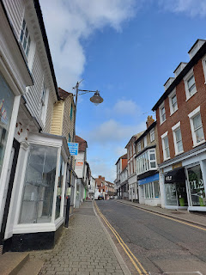

Cute little shops and the shop names everywhere . . .

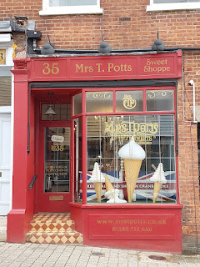

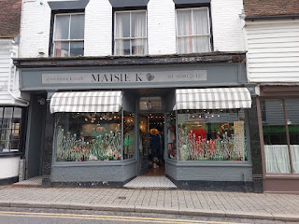

Homes for sale in the area . . .

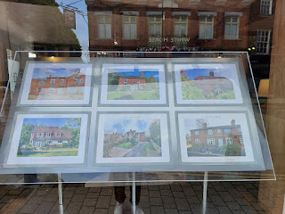

We stopped at the local post office to mail a package for my friend, Marnie Parker. Her daughter, Lauren, is serving as a missionary in the Bristol England Mission, although she is currently in Wales as part of that same mission. Her birthday is coming up soon, and so her family put together a package to send with all kinds of goodies in it. The problem is that sending it from Vicenza, Italy means that they are not only paying to ship it, but then Lauren has to pay an expensive tariff to pick it up on her end, too! Missionaries are not allowed to have a ton of extra money to throw around, they are encouraged to be very frugal and stick to a very tight budget (which is a good thing for anyone to do).

To resolve this issue, we acted as a courier by scuttling the package in our suitcase to England and then mailing it from within the UK, which cuts out those nasty tariff costs. We mailed the package from Cranbrook and it only cost us about $5 total, with a shipping time of approximately 48 hours to get to Lauren. Fantastic! I wrote a little note to Sister Parker on the bottom of the box - one of the only patches left where her family had not filled the space with love notes of their own. XOXO

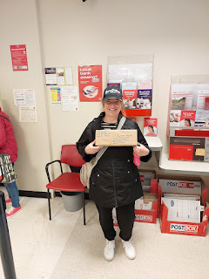

Next up: Breakfast
. We were both pretty hungry at this point! I had already researched ahead of time where we could eat, and I figured this restaurant (Food for Thought) would appeal more to Scott since it offered MEAT and not just cutesy avocado toast with microgreens on top, ha ha.

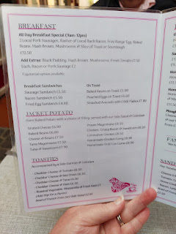

We both ordered the All Day Breakfast Special. The only difference was that I asked for a tomato and sourdough toast. He didn't need a tomato and he chose white toast. It really hit the spot! I ate everything except for the beans. I'm not a huge bean fan . . . (or, rather my innards are not a huge bean fan)

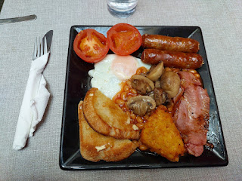

Next up - Find the fabric store on High Street. Only actually, I found some local postcards first and THEN I found the fabric store. High Street could be compared to any Main Street in Smalltown America. Super cute and filled with charming little shops.

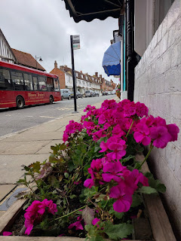

The fabric store is called Bell House Fabrics & Interiors. I visited this store once before when Charmaine and I came to Cranbrook in 2018.

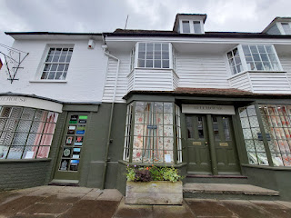

Their bolts of fabric are all one meter tall, and some of them were a little pricy. But I found two discounted sections and was delighted with the offerings.

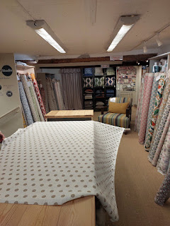

The three little bundles of scraps I chose were just 1 pound each (roughly $1.30 in USD). I also purchased one meter each of two other fabrics that were 50% off. My grand total was 24 pounds, or roughly $32. The middle fabric has Christmas-y colors and I'm excited to make it into something later this year. :)

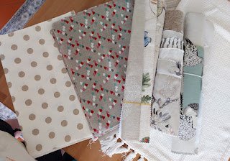

This is when it started POURING outside . . . The shopkeeper encouraged us to wait inside her shop until it subsided, but we knew that we were on a time crunch. So we bravely stepped outside and made our way down the street to St. Dunstan's Church, our final stop in Cranbrook.

While the Church doesn't have specific ties to our family history, it's still at the heart of where our ancestors would have been mixing and mingling. They would have known people who attended here. And it's just a great excuse to see another really old church!

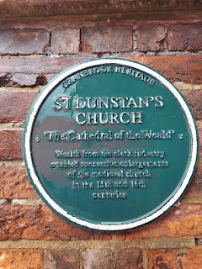

The caption on the plaque above says: "St. Dunstan's Church, The Cathedral of the Weald. Wealth from the cloth industry enabled successive enlargements of the medieval church in the 15th and 16th centuries."

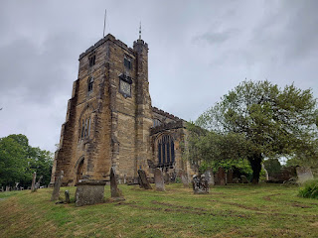

Video approaching the church: (12 seconds)
https://photos.app.goo.gl/TPY1T9rSA374LtVN9

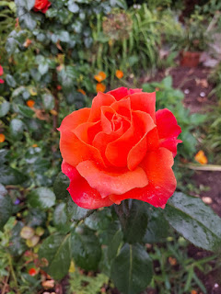

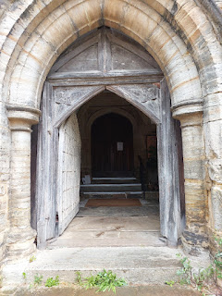

A welcoming note was attached to the main door on the side of the church . . .

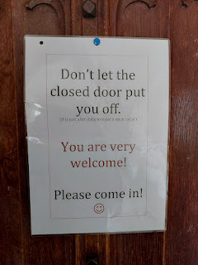

Even though the interior was a bit cluttery (with stacks of things here and there, as though there was no other place to stash them) and a church committee was having a small meeting at a table in the middle of the chapel, and a few other ladies were putting together flower arrangements at the front of the chapel - - even though all of these things were going on (and I tried to be quiet so I didn't intrude), I appreciated that there were plenty of signs around to explain several fascinating features.

They had a total immersion font . . . (click photo to read the explanation)

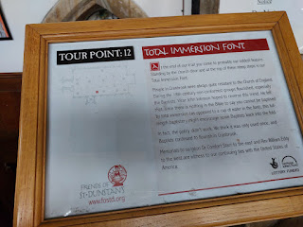

Scott and I tried to envision how someone could have been immersed in this tall font. While it could have worked for one person to go under the water, I doubt two people could have fit in there together, where one person would have gently submerged the baptizee and then bring him/her back up again. Still fascinating to think about, though.

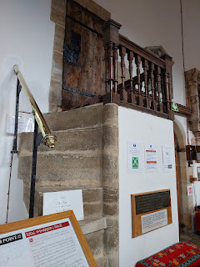

Below: The St. Thomas Chapel - in a corner section of the church. St. Thomas refers to Thomas Becket, a beloved Archbishop who worked at the Canterbury Cathedral until he was martyred in 1170 because he refused to follow an order by the King.

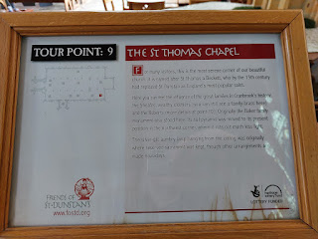

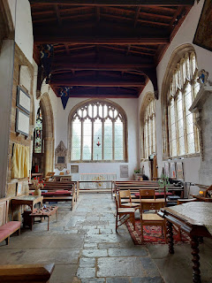

Since I am prone to going down rabbit holes in my natural curiosity for knowledge and perspective, if you are interested, here is a great link to a short article (with photos!) about the Thomas Becket Church, a small and very simple church out in the middle of Romney Marsh.

https://www.rob-tomlinson.com/places/church-st-thomas-becket-fairfield

When Charmaine and I were touring Kent in 2018 with our professional genealogist at the time, Kylie Brown, Charmaine really wanted to see this special church, so we varied only slightly from our scheduled tour to see it. It has been pictured in BBC's Great Expectations (2011, 2012) and also Canterbury's Tales (1972).

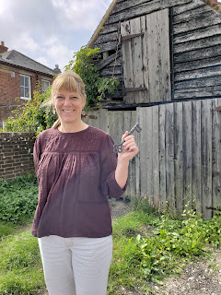

Charmaine retrieved the giant key to the Thomas Becket Church at a nearby cottage. You are able to grab it off the key ring to unlock the church, and then using the honor system you are expected to return it when you're done.

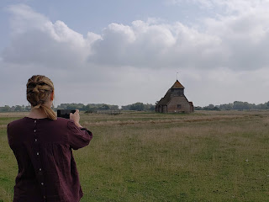

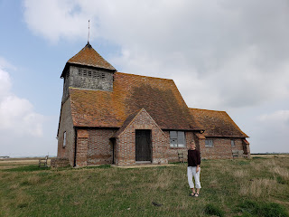

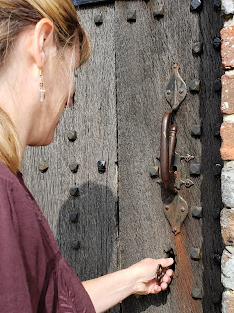

Kylie Brown and Charmaine . . .

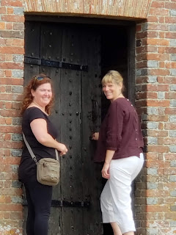

That was perhaps the greatest family history trip I've ever been on - within a 2-week period at the end of the summer of 2018. I can't believe how much we were able to pack into our trip . . . I would 100% do it all over again, too!!

This next "Tour Point" sign in St. Dunstan's Church was something I'd never seen before: A family tree for someone who was important to the church.

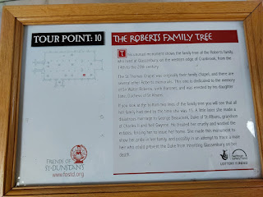

I wish this were my ancestor because
wow
- what a whopper of information this would have provided!

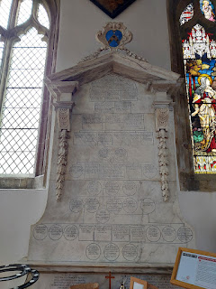

Sir Walter Roberts was highly regarded in the Cranbrook community, and was described as being affectionate, good-natured, and benevolent. Because the Roberts Family lived in the area from the 14th to the 20th century, there is a good chance that the Tildens. the Bigges, and the Roberts knew each other and were, perhaps, friends.

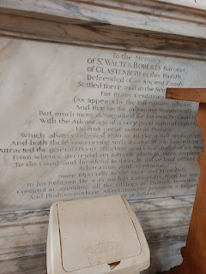

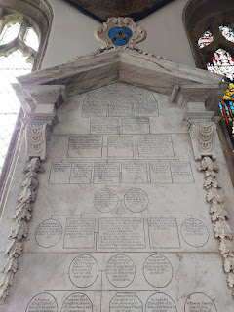

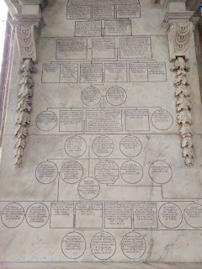

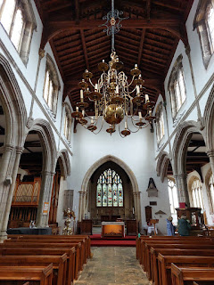

The silver-gilt chandelier was especially impressive . . . and in one of the earlier tour signs, it mentioned that they used to keep the Sacrament supplies up there back in the olden days.

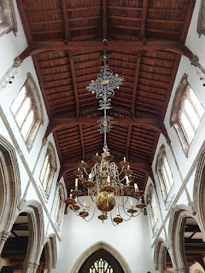

In our church, The Church of Jesus Christ of Latter-day Saints, we have a separate Nursery room for young children (18 months - 3 yrs old) where they can play, read, do puzzles, sing songs, and have snacks while their parents attend the adult classes after Sacrament meeting.

Here in St. Dunstan's Church, however, they installed a sort of nursery right in the middle of the chapel pews . . . you can also see the small committee meeting going on in the background . . .

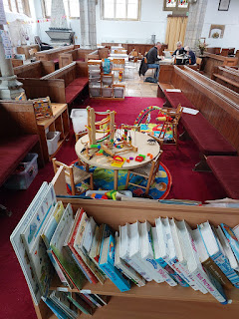

I would have loved to venture down to the Vault, but we were out of time . . .

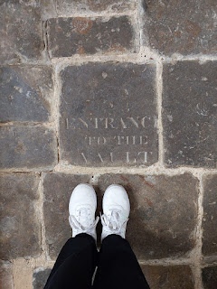

Video showing more perspective of the chapel: (5 seconds)
https://photos.app.goo.gl/PnqmtQgmP52UeTCv9

The clock built for St. Dunstan's was the trial model for what later became "Big Ben" in London. That's pretty cool!!

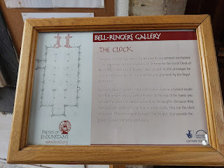

A memorial for Thomas Webster, a Royal Academician. Born 1800, Died 1886.

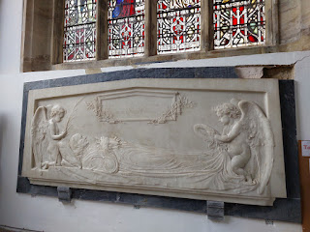

A description of the Tower above the church, the original was built in 1425 . . .

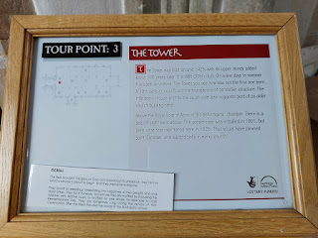

An explanation of the "Green Men" . . . (you'll just have to read for yourself, lol)

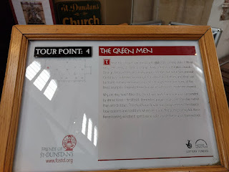

Next to the "Green Men", a grand Royal Arms is situated. It was a gift to St. Dunstan's in 1756 by the wealthy apothecary, Thomas Basden, whose family used to be wealthy clothiers from Cranbrook.

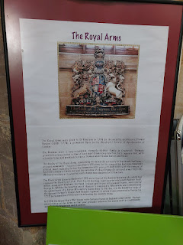

Here you can see the Royal Arms and the Green Men . . .

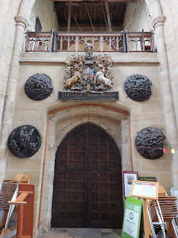

Roses smell 100x better in England than they ever have in Italy . . . I wonder why that is . . .

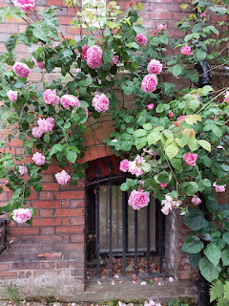

I had to giggle at this sign as we hustled back to our car in the rain . . .

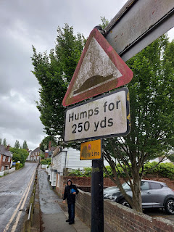

On our way back to the rental car return at the Gatwick Airport, we passed by this very old church a second time.

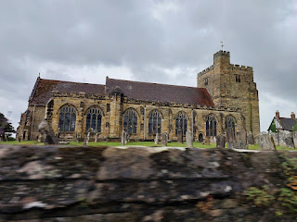

The church is called St. Mary's Church of Goudhurst, with origins dating back to 1119 AD. The church we see today can be dated back to the 13th century, with additions and renovations occurring over the years since.

I was drawn to the church both times we passed by, although I'm not entirely sure what the significance is. I know that at least one of our ancestors had ties to Goudhurst, but I'm not sure how long they lived there. It's not far from Cranbrook. My 11th great grandfather, Reverend Robert Twisden, married his wife, Sarah Walter, in Goudhurst in the year 1576. It's very possible that they were married in this exact church!

(Rev. Robert Twisden's granddaughter, Elizabeth, married Joseph Tilden - the son of Nathaniel Tilden.)

The drive back to the airport was a little less stressful than the drive to Cranbrook, mainly because we were able to take advantage of being on the freeway for a good portion of the time. Yay for Scott!

We used the Omio app to purchase train tickets to the London Bridge Station, where we purchased another ticket from there to get us over to Greenwich. The tickets from Gatwick to London Bridge were $21/each and took about 30 minutes. The tickets from London Bridge to Greenwich were about $6/each and took about 9 minutes.

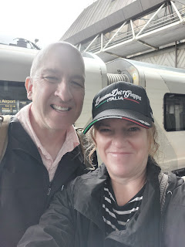

Video of a young man singing "What a Beautiful Name It Is" in the London Bridge Station:
(Just under 2 minutes)
https://photos.app.goo.gl/9eyavACzfnrYfCb29

I love this song and I have it on one of my playlists on Spotify. It's talking about the name of Jesus and how nothing else compares to Him. I loved how in the busy train station, people had stopped to not only listen and admire this guy's talents, but some were familiar enough with the song to sing along, too!

Here are the lyrics:

…
You were the Word at the beginning
One with God the Lord Most High

Your hidden glory in creation

Now revealed in You our Christ
…
What a beautiful name it is

What a beautiful name it is

The name of Jesus Christ my King

What a beautiful name it is

Nothing compares to this

What a beautiful name it is

The name of Jesus
…
You didn't want heaven without us

So Jesus, You brought heaven down

My sin was great, Your love was greater

What could separate us now
…
What a wonderful name it is

What a wonderful name it is

The name of Jesus Christ my King

What a wonderful name it is

Nothing compares to this

What a wonderful name it is

The name of Jesus
…
Death could not hold You

The veil tore before You

You silenced the boast, of sin and grave

The heavens are roaring the praise of Your glory

For You are raised to life again
…
You have no rival

You have no equal

Now and forever, God You reign

Yours is the Kingdom

Yours is the Glory

Yours is the name, above all names
…
What a powerful name it is

What a powerful name it is

The name of Jesus Christ my King

What a powerful name it is

Nothing can stand against

What a powerful name it is

The name of Jesus
…
What a powerful name it is

The name of Jesus

What a powerful name it is

The name of Jesus
And here's a link to Hillsong Worship singing it: (I get all tingly when I listen)
https://www.youtube.com/watch?v=nQWFzMvCfLE

We got checked into our Ibis London Greenwich Hotel, where I hurried to shower and wash my hair. We had hustled down to Cranbrook super early that morning, but I knew I'd have time to slow down and get freshened up once we got to our next hotel. I wanted to look GOOD for our concert that evening!

After my hair was sufficiently dry, we went outside for an explore and to find some dinner. Scott chose a restaurant this time, with traditional British food - namely a selection of pasties filled with different types of meats and veggies. (Pasty is pronounced like PASS-tee)

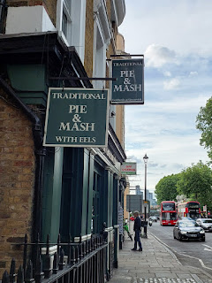

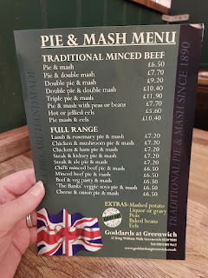

I ordered the Beef & Veg Pasty and Mash. Scott ordered the Chicken & Ham Pie & Mash.

In the photo below, we accidentally thought that my pie had the green herby sauce, but mine was actually the other plate with the dark brown gravy over the "mash". I took a bite of his pasty before I realized that it didn't have beef inside, ha ha. I liked mine better anyway!

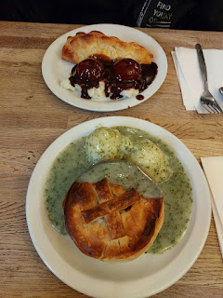

When it was time to start heading to the concert venue, we only had a 5 minute walk to get to the bus stop next to the Old Royal Naval College. Google helped us to know that we needed Bus 188 and which stop was closest to the O2 - where the concert would take place. We just used our credit card to tap and pay as we entered the double-decker bus. Super convenient.

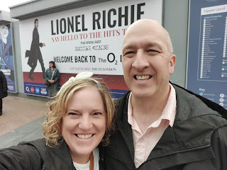

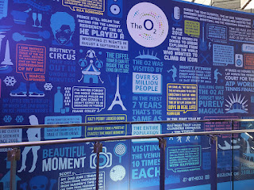

The O2 Arena is the coolest shape on the outside - it's looks like a giant white dome next to the Thames River. Many BIG NAMES have performed here, including Taylor Swift, Ed Sheeran, Celine Dion, The Rolling Stones, Janet Jackson, The Spice Girls, etc.

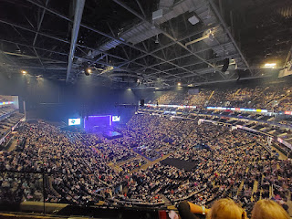

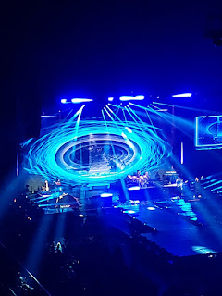

Lionel is 75 years old, soon to be 76, and he had SO.MUCH.ENERGY!! He was incredible. He was everything we hoped he would be and more. XOXO

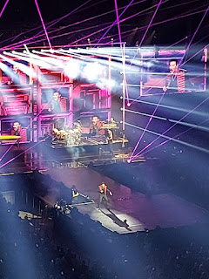

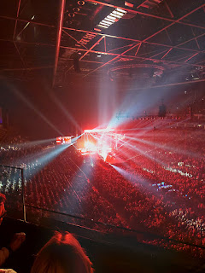

I will share a link to the album of videos that I took during the concert - not just videos of him singing, but also the entertaining bits he did in between the songs, too. I apologize in advance for when you can hear me singing - and it sounds a little flat . . . But you can still hear him at the same time, thank goodness, so just focus on him and less on me. :)

Link to the album:
https://photos.app.goo.gl/KgxwGweL4jxu7TnH7

If there's only one thing you choose to watch from the concert, please watch this: (1 minute, 51 seconds)

https://photos.app.goo.gl/58YMESobuKZXF8mb6

When Lionel and Michael Jackson co-wrote "We Are the World", I emphatically feel that it was inspired by God for them to do so. I have a hard time listening to the song without crying - every single time. There is a great documentary about the background to how this all came together, and I've mentioned it before. It's on Netflix and it's called, "The Greatest Night in Pop". I love how so many celebrities joined hands and joined voices to help curb hunger in the world and to bring a spirit of unity and connection to the entire earth.

Well, that's all I've got for now. I'll share the rest in next week's blog.

Stay tuned for details on:
Greenwich Market
Crypt tour underneath St. Alfege Church (where our ancestors are buried)
The Royal Observatory, and the origins of the Prime Meridian
The Planetarium
And a walk under the Thames River

Have a great week. XO

