A Beautiful Baptism & Back to Italy
What a joy and an honor it was for me to be there for Abby's baptism the day after Easter! She is truly a remarkable girl, with such a sweet spirit. She is cheerful and kind, she is helpful and hard working, she is gifted and intelligent, she has an incredible memory and serves as sort of a family secretary, and she understands very well the nature of the Gospel and what it means to choose to be baptized into Jesus Christ's Church.

(Photo credit: Amber Whitworth)

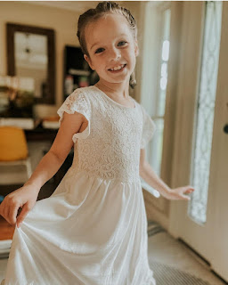

Last Monday:
This was not only the day of Abby's baptism, but it was also her father's 31st birthday! It was a very busy day, but in all the best ways. The girls woke up early, as usual, for school, but this time it was with the cutest and bounciest curls from the curlers I had put in their hair the night before.

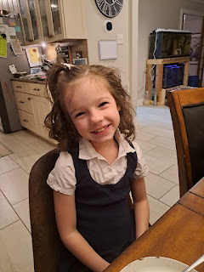

Gwen was in a good mood, even though this photo might suggest otherwise . . .

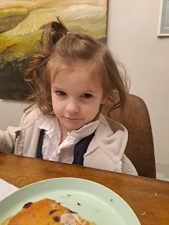

While the girls were at school, I helped around the house and running to get some additional groceries. It is customary in Amber's ward that when there's a baptism, there is also food for all the attendees. The baptism was scheduled for 6:30 p.m. which is also very close to the dinner hour. She thought it would be nice if we could provide fixings for little sandwiches, along with some fruit, chips, and desserts.

Meanwhile, out in the yard, Weston and his Dad were hard at work all day. Mike pulled off all the sheet metal that belonged to an old shed in the middle of their huge back yard. The goal is to make that space into an outdoor eating area, since there is a nice cement slab and a roof over the top. I didn't get any pictures of what he did by the time he finished . . . I'm so sorry.

Weston worked on a variety of other projects around the yard - I lost track of all that they were doing out there . . . but Kathy and I worked on loads of laundry inside the house, and prepared the food for the refreshments that evening.

Around 5:45 we left to drive to the church. When we arrived, no one else was there and the church was locked . . . Weston has a key, but didn't realize that he needed to bring it, so he drove home to get it. In the meantime, while Amber was on the phone trying to get ahold of someone who could tell us if the font had been filled, Kathy suggested we use this time to take some photos. What a great idea!!

Grandpa Mike Whitworth and Abby - Abby had asked him to baptize her, since she doesn't get to see him very often.

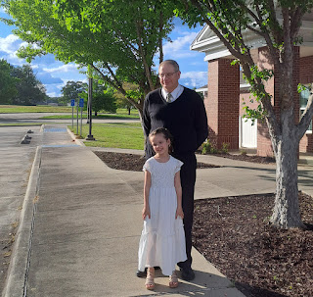

Gwen did a couple laps around the church, feeling quite glorious in her sequined "mermaid" dress . . .

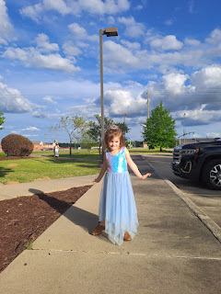

Me, with those two darling girls, Abby and Gwen

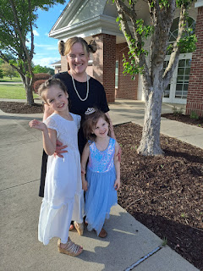

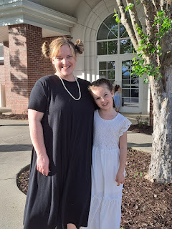

Me, Abby, and Amber

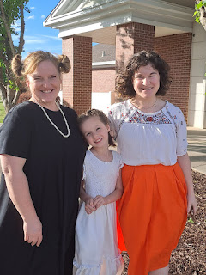

Soon, Weston returned with a key to get into the building, and we all went inside. There was a small "oopsie" in that Weston was supposed to fill up the font, but no one had communicated that to him . . . so as soon as we went inside, he hurried off to get that started. Thankfully, it didn't take too long and the baptism wasn't delayed for very long. (maybe 15 minutes or so)

I took photos of the program. It wasn't just Abby that was getting baptized that day. Another little boy named Leland had chosen to be baptized as well.

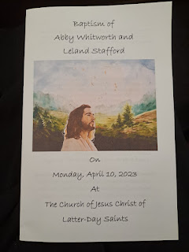

The words to the opening and closing songs . . .

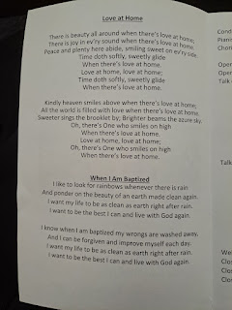

And the outline of the program - which included ME as a speaker. :)

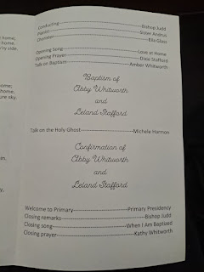

After Amber gave a wonderful talk about the nature of baptism, why we choose to be baptized and what we promise to God, along with His promises to us . . . we all walked across the hall to the room with the font. All the little children love to kneel on the floor up front, right next to the plexiglass window so they can see up close what happens in the font.

Abby was baptized first, by her grandfather, Mike. They had practiced together the night before, how it would all take place. Mike showed her how to hold onto his forearm and how he would dunk her under the water, teaching her how to bend her knees so she would go completely under. During her baptism, she did great. She didn't seem nervous at all, which was a relief. When I had walked around the church with her and Gwen earlier, while waiting for Weston to get back with a key, I had a moment with Abby where I asked her how she was feeling. She was doing pretty well, but when I asked her if she had had a chance to say a quiet prayer before her baptism, she replied that she had not. I invited her to take a moment right there and pray, which she immediately did. We were on the other side of the building from everyone else, so it was nice and quiet. She folded her arms and closed her eyes and said a silent prayer on her own. I just waited for her to finish, and then we started walking again to catch up to Gwen. I hugged her and asked her again how she felt. Her response: "better". :)

When it was Leland's turn to be baptized, he was a little more stiff when his father tried to lay him back to go under the water. His elbow did not go under the water, and they needed to repeat the baptism so that he was 100% immersed. Everything went perfectly the second time and he came up smiling.

Everyone returned to the chapel and we waited quietly for Abby and Mike, and Leland and his father to change into dry clothes and meet us back in there.

I loved this little exchange between Weston and Abby, once Abby returned to her seat in the chapel. He hugged her and had a big smile on his face. They had some quiet conversation together and it was just so sweet. I snuck a little photo to try to capture the moment . . .

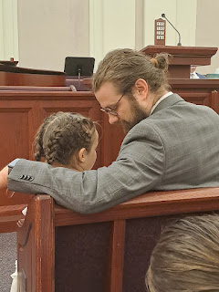

Soon, it was my turn to speak. I only had the weekend to prepare for my talk on the Holy Ghost, but I prayed several times that it would go well and that I could invite the spirit into the room with my words.

Here is the essence of my talk:

1. Jesus loves you! Heavenly Father loves you! One of the ways they communicate with you is through the Holy Ghost. Heavenly Father wants to tell you things, but it's up to you to listen.
Open your ears. Open your mind. Open your heart.
Last week when I was saying my morning prayer, I had a feeling welling up inside me that seemed to be very urgent. When I paused my "list of things" I was asking for, I got a sense that the Holy Ghost wanted to tell me something, but that I needed to prepare myself to listen. I quickly wrapped up my prayer so that I could quietly clear my mind and just listen.
2. President Dallin H. Oaks (currently serving as a counselor in the First Presidency of the Church with our Prophet Russell M. Nelson) shared a few ways that we can hear our Heavenly Father and Jesus Christ through the Holy Ghost.
A feeling that Jesus loves us and that the Gospel is true.
A feeling of comfort when we are sad or lonely. I shared how when I was in a terrible car crash several years ago, I climbed up the embankment after rolling my car about 100 feet down and began walking down the road to get help. It was very dark during those early morning hours, and I began to be very afraid. I was worried that a mountain lion might be lurking in the forest next to the mountain road, among other things. I silently prayed as I walked, and then a feeling of peace and comfort filled me and reassured me that everything would be okay. And it was.
A happy feeling after we have repented. Repenting regularly is JOYFUL and helps to make our burden lighter through the Savior.
A good feeling when we hear beautiful music or see inspiring art. I mentioned the artwork (of Jesus) in the cultural hall that had been displayed on Easter Sunday, some of which was still there.
A peaceful feeling that something is a good choice. When I asked Scott what he wanted me to relay to Abby in my talk, this is what he said: The Holy Ghost makes Papi cry. When he sees someone doing something REALLY good to help another person, he gets a little emotional. Through the Holy Ghost, he is able to feel what Christlike love is. The Holy Ghost is training and teaching him to know what "Good" looks like and how to share the love of Jesus Christ with others.
A warning feeling that something is wrong. Per Kathy's suggestion, I shared the following story from a previous prophet, Harold B. Lee, from when he was a young boy. (It's a very short read.)
https://www.churchofjesuschrist.org/study/friend/2002/01/from-the-life-of-president-harold-b-lee/heeding-the-holy-ghost?lang=eng
3. I finished by saying that the Holy Ghost won't tell us everything to do or not do in our life, but we don't need to worry. If we try to choose the right and listen to the Holy Ghost, then we will receive the love and help that we need from Heavenly Father and Jesus Christ right when we need it.

The only time I choked up was when I was trying to relay the message from Scott . . . I wish he could have been there with me.

I tried to speak as if I were just speaking to Leland and Abby, who were seated in the front row. They were both very attentive and I relished the sweet spirit that Leland had as I spoke. He nodded several times and just had such a purity in his eyes and I knew that he was taking the words I spoke straight into his heart.

Weston confirmed Abby and blessed her to have the gift of the Holy Ghost with her always. Then it was Leland's turn. And then the meeting was all done. We sang the closing song, Kathy gave the closing prayer, and then everyone moved into the gym for refreshments. It was a lovely evening and there was a sweet spirit there that we all felt. Approximately 35-40 people were in attendance.

When we finally got home, we still had a couple of important things to accomplish, even though it was late and everyone was tired. In all the hubbub from earlier, there had not been a chance to get a Whitworth family photo of Abby's baptism day. So we paused and took some photos in the dining room.

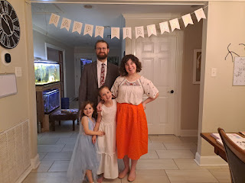

And then it was time to sing Happy Birthday to Weston and eat some cake. (Even though we were full from all the food at the church . . . ha ha)

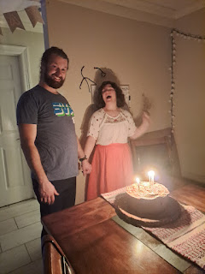

Kathy's gift to Abby for her baptism was a scripture bag with all kinds of pockets for pens and notebooks, etc. Abby was thrilled because she is a very organized girl at heart. She immediately went to locate some marker pens to tuck into the little pockets and get it all loaded up. XOXO

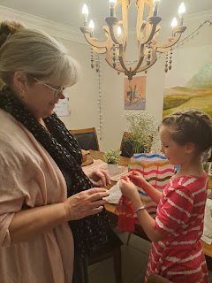

What a sweet photo of Kathy and Abby together. :)

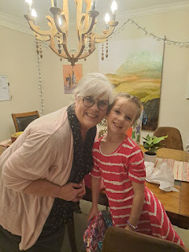

Tuesday:
The day began with getting the girls off to school and then mapping out all the things we grownups wanted to do. We were all running a little slower because of all the MANY events through the holiday weekend (me arriving from Italy, Abby's birthday party, Easter festivities, and then a baptism and Weston's birthday - to name a few . . .). Kathy was having some tummy issues, but we still managed to help take care of some laundry so that Amber could catch up on other things, the men worked outside most of the day again, and the ladies helped to paint an accent wall in Amber & Weston's bedroom.

Amber got us started, and while Kathy painted above the trim with a neutral beige to cover up some spots, I eventually helped to fill in the rest. You can see some of the paint colors that Amber used a while ago to help make the decision on what color to settle on.

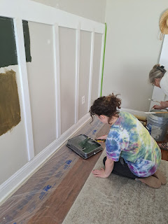

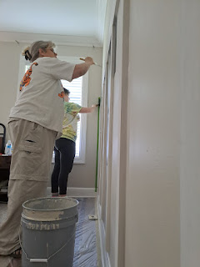

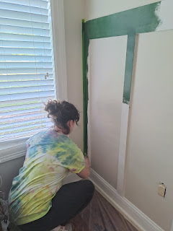

This was after one full coat of paint. I later went back and added a second coat. It is such a handsome color and I really loved how it turned out. Weston built and installed the trim himself and did a great job!

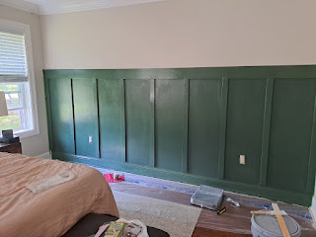

Amber was outside for a good portion of the afternoon helping to map out where she wanted her garden beds to be built and placed. We also had a power outage for a few hours, which meant we had to be patient and creative in order to get our tasks done. While the paint was drying, and when the power finally came back on, I sat down to work on my blog from the previous week, which I was already behind in doing.

Sadly, soon after the power came back on, the water was then shut off for the entire street! We're not sure exactly what the reason was, but we did know that some road work was being done not too far from the neighborhood where we were. Still, it's nice to let people know in advance if you're going to shut off the water for a while . . . we had supplies to make dinner at home, but with no water it's kind of hard to cook and clean up as you go. So we decided to go out to dinner. Which is what Weston wanted anyway - for his birthday celebration. He wanted us all to go to Gibbons again, which was just great!

I ordered the stuffed shrimp. They weren't technically stuffed, it was more like the shrimp were just wrapped around the little mini crab cakes and were fried up together. It was extremely delicious!!

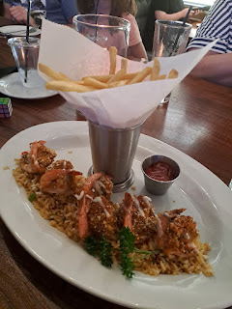

Gwen had a hard time again with ordering something she'd actually eat. Last time she ordered a cheeseburger, but all she wanted was Abby's pasta. This time, Gwen ordered the pasta, but then she was offended that the creamy cheese sauce was ON the pasta and not on the side, like Abby's was. (We didn't think to ask the waitress to do that for Gwen this time . . .) She ate all of her fries and wanted samples of things from other people's plates, but she refused to eat her pasta.

I got her to LICK a noodle at one point, ha ha. Amber picked up where I left off and turned it into a game. She held the fork with a noodle speared onto it, and told Gwen that it was some fish bait and Gwen was the fish . . . and then Amber just continued on with whatever conversation was taking place, without looking to see if Gwen would "take the bait".

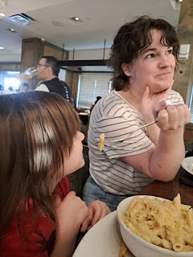

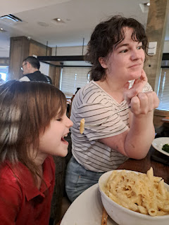

She bravely ate ONE bite, tried not to gag, and then that was it. Pasta is her favorite thing in the world, but heaven forbid there should be a sauce on it.

As we left the restaurant, I took this sweet picture of Mike and Kathy with Gwen and Abby in tow.

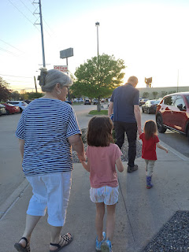

Back home, the water was turned on once again, thank goodness, but there was a standard "boil order" in place until further notice. We began drinking bottled water for the next couple of days . . .

Wednesday:
We still had way too many leftover tomatoes and red onions from the refreshments at the baptism. Kathy suggested that Amber dig out the food dehydrator that she had bought them for Christmas and that we could dry the tomatoes and onions while she was there.

This is the brand that she had purchased for them.

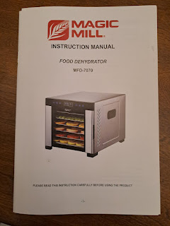

Amber took it out of the box and began prepping the racks to go inside the dehydrator.

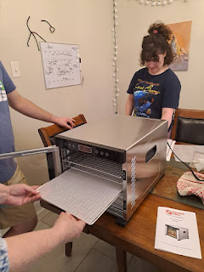

It only took a few minutes to get all the tomatoes and onions onto the trays.

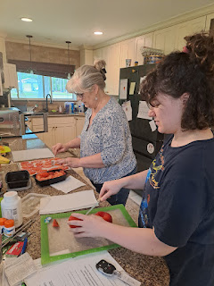

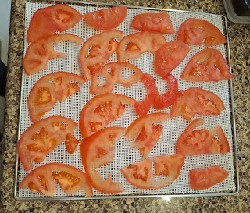

Kathy explained to Amber that she uses her dehydrator all the time. If she sees something on sale at the grocery store, she buys a fair amount and then dehydrates most of it to store away for later. If she bought something for a dinner and then realizes that she and Mike cannot possibly eat it all before it will go bad, she dehydrates the rest (i.e. mushrooms, fruits, vegetables, meats, etc.). Something she does often is to dehydrate eggs, tomatoes, or onions and then blend them into a powder. Tomato powder takes up minimal space, and can be used in many ways, such as rehydrating it into tomato sauce, or adding it to a soup, etc. Onion powder that you've made with a dehydrator is going to be a lot cheaper than buying spices from the store. And dehydrated eggs are easy to work with, she told us. They just need a little bit of water and can be added into baked goods (cakes, cookies, etc.) or reconstituted into breakfast eggs to serve and eat. The racks in the dehydrators "nowadays" have silicone mats to prevent any leaking or spillage if you're trying to dry a liquid.

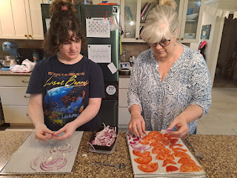

This particular model took up less space than a full size microwave and sat right on the kitchen counter. I loved that it had a glass window in the front so you could see everything shriveling up throughout the day.

Before Mike and Kathy needed to leave for the airport and fly back to Idaho, Mike built Amber two garden boxes for the back yard. He used some of the sheet metal that he pulled off the shed on Monday for the sides of the raised beds. This one had not been "pounded in" yet, but you can see the angled legs to help it go into the ground more easily.

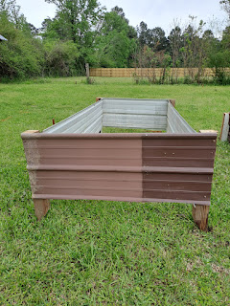

Here's a view that shows the one that had been pounded in already. Amber had researched how to layer the "fillers" in the garden bed. First, she laid down cardboard and some of the drywall that Mike had pulled down from the shed. He told her that as the drywall decomposes, it adds calcium into the soil, which will add more nutrients. I thought that was so cool!

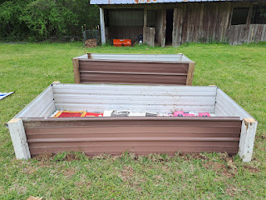

I came out to help at this point. Amber and I dug up some old rotting pieces of wood from the barn at the back of their property. It was already decomposing and would add some nice layers. We also scrounged around the yard for some tree branches that Mike and Weston had made into piles as they worked outside the past couple of days.

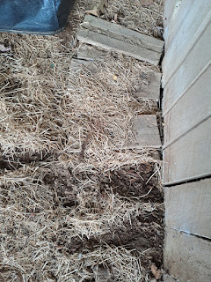

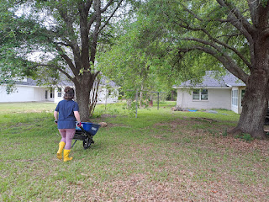

Here, you can see the barn at the back of the property behind the garden beds.

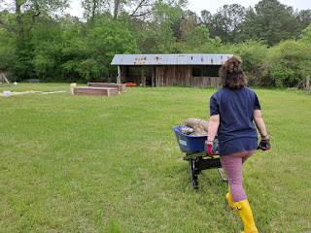

"Bro-ski" the cat lazily watched us pass by with the wheelbarrow numerous times, while he thought about how to jump on the trampoline without getting his claws stuck . . . Also - if you click on the photo and zoom in, you can see the stripped shed on the far right, the one that Mike removed all the metal and drywall from.

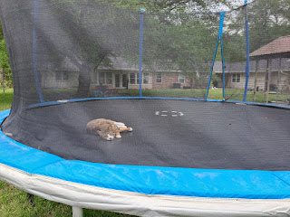

Plants don't need several feet of soil in order to thrive, so placing some branches in the bottom will not only help keep the plants warm as things continue to decompose, but now Amber and Weston won't have to buy as much soil to fill up the garden beds.

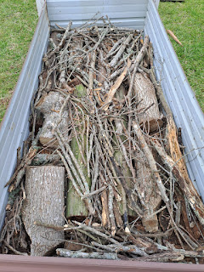

We also found a huge bag of soft wood shavings that had been left behind in the barn by the previous owners. Amber marveled that what they had been so annoyed by at first (all the mess that got left on the property when they bought it), is now proving to be quite valuable! We laid the wood shavings down on top of the branches, along with some dead leaves and dirt from the barn. It felt really good to work alongside my daughter to help make one of her dreams come true. She has been wanting a garden of her own for a really long time.

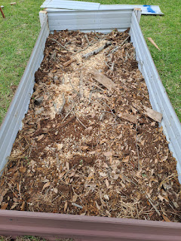

Funny story: as Amber and I were breaking down some of the sections of drywall, we stood this one up and Amber said, "Ohhh, I guess this will be the end of the caterpillar." She pointed to the center, and I leaned WAY in, trying to find a tiny little caterpillar . . . only actually - it was large and easy to spot, ha ha.

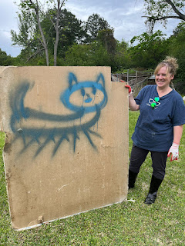

That evening, I tended the girls while Amber and Weston went out on a date. I fed them some random leftovers from the fridge and we watched a show together before they went to bed. We all went to bed a little earlier than usual that night, which was so nice.

Thursday:
Gwen got a fun hair-do for school early in the morning, because it was "Crazy Hair Day" for all of the Pre-K students. A few adjustments were made, but this series of photos will surely make you smile.

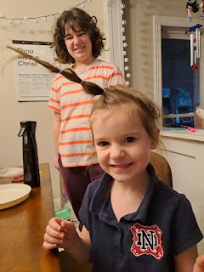

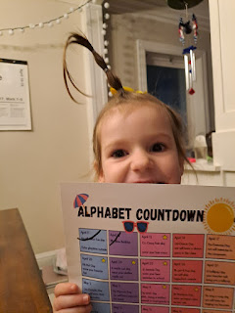

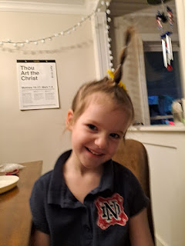

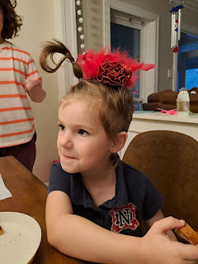

Eating her Nutella Toast . . .

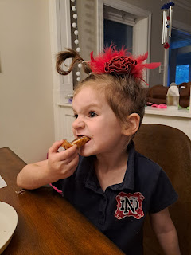

I was so tired the night before, that I didn't do any packing or organizing my things, thinking that I would have plenty of time to do it the following day. I didn't need to start my drive back to the Dallas Airport until 2:00 p.m. But a few minutes after I got out of the shower, I learned that there was a work party with all of Weston's coworkers and that we would need to leave in just a few minutes!! All of a sudden, I was scrambling to dry my hair, put my face on, and get out the door in 15 minutes with no breakfast . . . Amber and I drove to the party location, where Weston was already deep in a very competitive foosball game. We hung out for about 90 minutes before leaving to run the one errand that I needed to take care of before my flight back to Italy.

The party was inside a huge shop in Dr. Judd's back yard. They had foosball, basketball, shuffle board, and corn hole going on. Each of the 25 or so employees were trying to rack up as many points as they could by playing each game and scoring as high as possible, in the hopes of earning a prize by the end of the morning. Outside, there was croquet, volleyball, and a softball toss area. Burgers were being grilled up, and everyone was having a great time.

Amber and I mingled with various people and visited for a while with each of them, before we left. We drove to "Dillas" and had sort of a brunch, since I hadn't had breakfast yet . . . It was fantastic!!

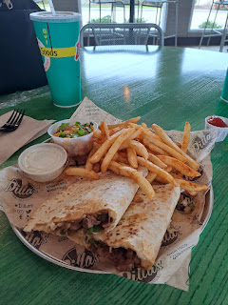

I chose the "Founder" quesaDILLA.

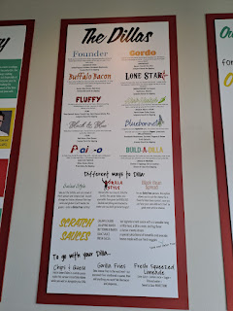

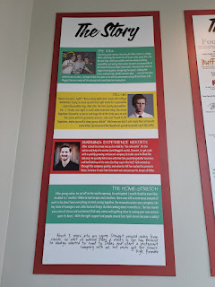

Then we stopped at TJMaxx to find me a shirt or two, since my favorite shirt (one that I bought there a few weeks ago when I visited in March) SHRUNK in the dryer at Amber's house . . . I needed a replacement shirt . . . Hooray - I found success again at the TJMaxx store in Shreveport. They have some great items there, with a much better selection than the one in Idaho Falls, I'd say.

By the time we got back to the house, I had just about one hour to pack up and get on the road.

Amber helped me pack up a little, and then all too soon, it was time to hug goodbye. We had had some meaningful conversations together throughout the morning, and I was sorry that it had to end. She is a wonderful daughter, but she is also a wonderful friend.

The drive to Dallas was long but reasonable. I really had to go to the bathroom by the time I dropped off the rental car, ha ha. I had been in the car for almost 4 hours and had worked through some rush hour traffic during the last 25 miles or so. But I enjoyed chatting with my Dad for a while, and listening to plenty of music.

I ALMOST had a tragedy as I was checking in my luggage. I'll have to share more about that next week because it involves a surprise birthday gift for Scott, and even though he mostly just looks at the pictures in my blog and doesn't read all the words ("there are so many" . . .) I don't want him to know what his gift is until later this coming week when it's his ACTUAL birthday!!

Everything turned out okay in the end, thank goodness, and I had a good flight from Dallas to Istanbul. We were about an hour late getting out of the gate because the plane had arrived late from somewhere else to begin with. The food was good on the flight, and I actually got some sleep this time. I was worried for a while, though, because the lady who was sitting behind me didn't understand airplane sitting etiquette . . . everything she did was overly bonky, clonky, bumpy and thumpy to my seat in front of her. If she needed to get up, she would grab the top of my seat back and it felt like she pulled it (and me) almost down into her lap each time . . . if she wanted to choose something to watch on her TV screen then she would practically pound each selection with her fist. At one point, I looked over my shoulder to see what in the heck was going on back there. I must have had a "smidgey" of a scowl on my face because she said in her cute little Middle Eastern accent, "Oh, sorry, sorry." (sounded like soddy, soddy) The best time for me was when it was meal time because she was much more calm in order to keep her food tray stabilized.

So yes, it was somewhat of a miracle that I slept for a little while during the night. Probably because SHE slept at the same time . . .

Friday:
Several people were tracking our flight on the TV screens, especially those of us with tight connections. Even though the view was constantly turning and showing us our flight from every angle, this next photo gives you some idea of the places we flew over to get to Istanbul.

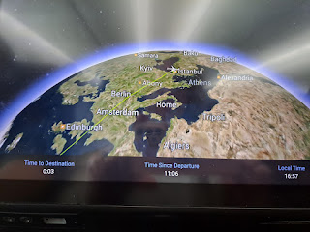

At one point, I noticed what it said in the lower right hand corner. (2.5 minutes until prayer time.) Ah yes, we were coming into a Muslim country and they had very specific prayer times.

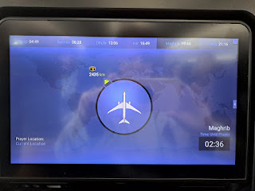

Matter of fact, as we began our descent into Istanbul, a handful of people were getting up out of their seat because it was time to pray. The flight attendant helped them find a spot on the floor in the little kitchen galley area where they could lay down their prayer rug and pray. How amazing is that. When I told Scott about this, he said, "Some things are just more important than others." He thought it was wonderful that they practiced their faith so devotedly.

On my tray table that was folded up, I took a picture to show just how different the Turkish language is from English.

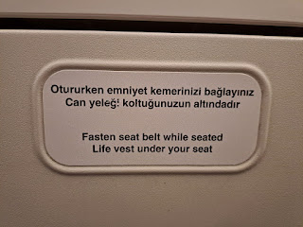

In Istanbul, I only had a few minutes to get from my plane over to my next gate, which was CLEAR ACROSS the airport. I hustled as fast as I could, passing all the "I love Istanbul" t-shirts and hoodies, and all the interesting looking snacks and treats that I could have bought to share with company this next month in Italy. But nope. I couldn't stop for anything! By the time I reached my next gate, I was a sweaty mess. If you add in the fact that I hadn't washed my face since the day before or even brushed my teeth . . . you could say I was a HOT MESS. But I made it!

I watched a good movie on the flight from Istanbul to Venice during the 2.5 hours. It is called "Devotion" and it's based on a true story that happened during the Korean War. Here is the trailer on YouTube:

https://www.youtube.com/watch?v=NCDEGP6VjYY&ab_channel=SonyPicturesEntertainment

A young lady in my row helped me capture a photo of the sunset coming into Venice, since she had the window seat.

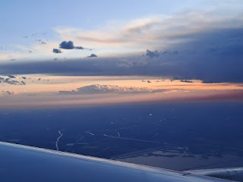

It didn't take me very long in the Venice Airport to get my luggage and have my passport stamped and then I could hug this handsome guy. I was extremely grateful that my suitcase made it to Venice on my flight, since the connection was so tight. It did help that my Venice flight had been delayed about a half hour . . . so that was nice.

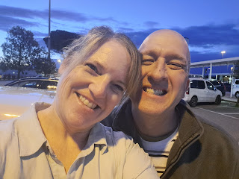

Saturday:
I woke up feeling rested and refreshed. It certainly helps when you have a BED to sleep on.

We walked up to Monte Berico and back so that I could get some circulation going in my legs again. My ankles weren't as fat and swollen after my travels because I wore COMPRESSION SOCKS for the first time. And they were cute, too. Black knee-highs with little white polka dots. (Amazon.com)

We had a lot to accomplish in just one day: finish unpacking, get the house clean, make a menu plan for the week (company coming), get groceries, do laundry, and go on a double date to dinner at 7:30.

As we drove to the store, we came around the corner and saw this . . .

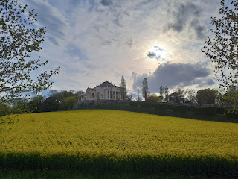

This beautiful building is called Villa La Rotonda and it was designed by Andrea Palladio over 500 years ago. Those beautiful yellow flowering fields are crops of canola that are in full bloom right now.

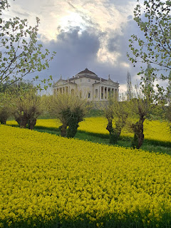

We got almost everything done that we set out to do for the day. And we hurried home to put our groceries away just in time to make it to dinner with Jason and Chiara. Scott works with Jason and says Jason is his "best friend". They both like math/computer nerd stuff and if there is something new that Scott has learned to do, one of the first people he seeks out is Jason.

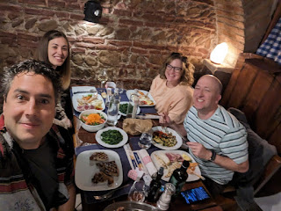

Jason was in the Navy for 20 years and then he retired. He said that he and my Dad would have much in common to discuss, as my Dad was a linguistics guy and kept a close "eye" on Russia a few years back. Jason did something similar for the Navy. Now he is a contracted civilian who works with the US Military here in Vicenza. He's lived in Italy for 15 years now and speaks really good Italian.

Chiara is his girlfriend as of 2 years ago. She is really nice. Her name is pronounced "Kee-yarrah". She is Italian, but speaks really good English. She is currently working on her Master's Degree in Psychology at Padova University. Something interesting that I learned at the end of our meal is that she goes to riding school every Monday at a nearby horse stable and arena. She told me I could join her whenever I'm available. The instructors don't speak any English, so she would need to help translate for me . . . I'm excited to try to squeeze this in before I go home in June.

Scott, Chiara, and I all ordered the Grilled Mixed Fish. It needs to be at least 2 people to order, but in our case it was 3. The waitress divided it all up onto 3 plates for us. Jason ordered the Grilled Mixed Meat. Everything was delicious.

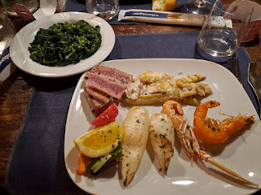

And on the way home, my wonderful husband stopped so I could get some gelato. One of the many reasons why I love him so much. XOXO

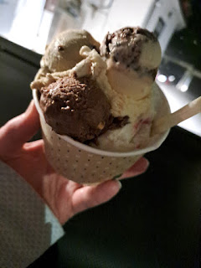

Sunday:
Church was wonderful, as usual. One of the speakers was a young man who just returned from a mission to Uganda. He said his favorite thing about the 2 years he spent there was the people. He loves them very much.

I chatted with a few young mothers after church to ask them what they do locally with their small children. Their answers were much the same: go to all the playgrounds. They also mentioned a large park in Vicenza that has dozens and dozens of wild bunnies hopping around. You can even feed them, which sounds super fun. I was inquiring about this because my grandson JACK will be here in TWO WEEKS!! I just want to make sure we don't have a missed opportunity while he's here. :)

As for this coming week, Scott's brother Gordon, and his wife Pam, will be arriving at noon tomorrow (Monday). They will be staying with us for about 10 days and we have lots of fun plans. We'll be celebrating Scott's birthday on Thursday (20th), Gordon's birthday on Sunday (23rd), and Benson's birthday on Monday (24th). Hannah's birthday is also coming up on April 26th . . . but we'll celebrate it with her when they arrive to Italy on April 30th.

So many fun plans to look forward to!! I hope you all have something fun to wake up for as well. XOXO

