A Celebration of Life and then Off to Italy
I stayed behind for an extra week instead of flying back to Italy with Scott so that I could attend my Grandma Lillian's Celebration of Life up in Portland first. I'm so glad I did!

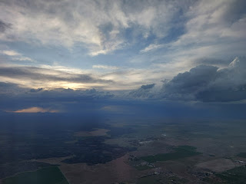

Seeing the world from several thousand feet up never gets old.





The Columbia River coming into Portland . . .



I drove myself over to Amber's house in my 2025 Toyota Rav 4 rental car. It was past 9:00 p.m. so it was dark and the city looked so magical as I drove across bridges and past skyscrapers. Even though it was late when I arrived, at least it was a Friday night so the girls didn't get in trouble when they snuck out of bed to give me a giant hug.

Abby announced that she would be providing all of my meals during the weekend, and then she showed me a handwritten menu that she made just for me!! You can click on the photo below to see all the adorable options she created.

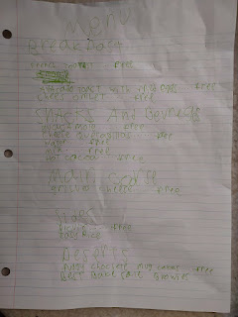

Before I tucked myself into bed, I let Abby know that I would absolutely love to have some avocado toast the following morning. As soon as she woke up she got right to work, grabbing her apron and setting everything out on the kitchen counter.

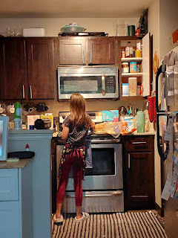

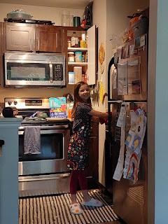

Amber assisted her a teensy bit, consulting with Abby on a method or two, and helping her deal with anything that was hot to the touch. The final result: avocado toast with a fried egg on top and a few sliced cherry tomatoes.

Video of Abby presenting breakfast to me: (9 seconds)
https://photos.app.goo.gl/JoFhQybRP9nVZzLk9

Mid-morning, we all piled into the Whitworth-mobile to take Gwen to her soccer game. Prior to each game, the small team does a 30 minute warmup and practice session. Gwen paid very good attention and demonstrated some great dribbling skills, too!

Video of Gwen warming up: (4 seconds)
https://photos.app.goo.gl/iwsuAoZCV72Q6Nc16

Video of Gwen doing drills down the field: (8 seconds)
https://photos.app.goo.gl/Qz2bXmECH67G8mp7A

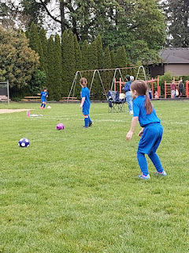

Charmaine and Scott met us at the soccer game (my sister and her husband), where we sat on camp chairs and blankets to visit and cheer for Gwen at the same time. Charmaine realized that she hadn't seen Abby since she was a little baby and she had never met Gwen in person before either. What a treat to finally get a chance to spend time with her two grand-nieces!

After the game and a lunch break, Amber and I drove over to Tualatin where we met Charmaine and Scott at the church where Grandma Lillian's Celebration of Life was to be held. Aunt Sherry Barless (formerly Sherry Moore when she was married to Lillian's son Gary), did 99.9% of the work putting everything together for the rest of us.

She had set up several tables with some of Grandma's favorite things, photos of the entire family, and many, many items that once belonged to Grandma and were now available for anyone to take home and enjoy.

I remember this painting so well, as it hung in Grandma's apartment in West Salem for many years. She had an unsung talent for oil painting, something that was passed down to her son, Tim, and possibly others. I have a rustic painting of hers back in Idaho Falls, with a scene of a barn on a ranch during autumn.

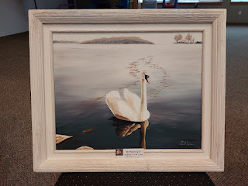

There are so many artists in my family, but sadly none of their talent was passed down to me. (Or maybe it was and I just haven't tapped into it yet...) Grandma Lillian, Grandma Doris, Great Grandma Christina and Great Grandpa Leon (in wood form), my mother, and my sister Charmaine were all blessed with the gift of art, even my brother Ryan with his woodwork creations. Somehow my daughter Amber inherited a very large portion and I got nothing, ha ha.

The table filled with many of Grandma Lillian's Favorite Things . . .

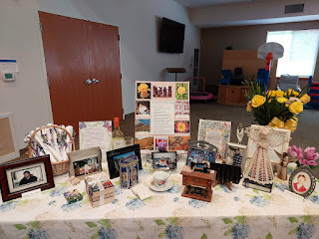

Video of the favorites table: (10 seconds)
https://photos.app.goo.gl/8jQ4uF2qTogw1p8T7

Video of the full length of the table with misc. items to grab and take home: (21 seconds)
https://photos.app.goo.gl/257rAGmL3ST4Yo8D8

Items included: little paintings, books, jewelry, crochet kits, embroidery kits, bookmarks, note cards, crocheted hats that she had made, sewing notions, photo albums, and cookbooks.

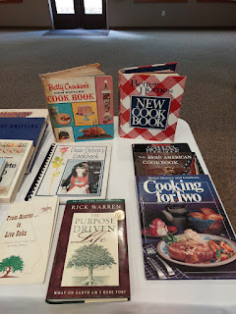

I brought home a quilt kit that she had done significant work on, but was never completed. It has denim blues and light blues and creamy whites. It will be waiting in Idaho for me to work on some day. I also have a set of CD's that include several of her favorite artists: Dean Martin, Elvis Presley, and tons of old-school country singers that I've never heard of but I'm happy to dig in and give them a listen anyway.

Tables were set around the cultural hall of the church, with floral centerpieces and note cards for friends and family to write down their favorite memories of her. I have the collected papers here in Italy, and will be typing them up soon to share with the extended family.

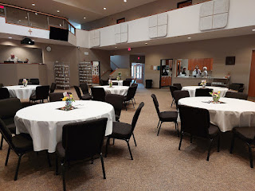

Amber chose this delightful bird cage basket for all the sachet bags of Grandma's jewelry that I had put together and hauled in my suitcase. My instructions were simply to choose something that she could use in her home afterwards. I'm told that Abby will be the proud recipient of the bird cage now.

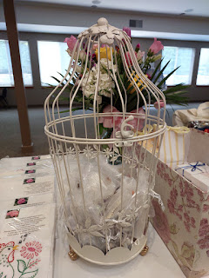

The centerpieces and notes to record favorite memories of Grandma . . .

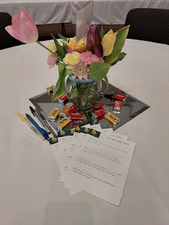

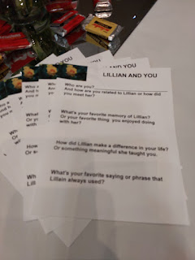

I loved seeing all the photos of Grandma and Grandpa Linton, along with other family groupings that are part of Grandma's posterity.

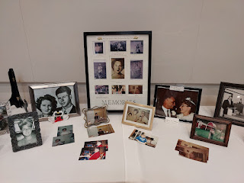

Video of the photo table: (1 minute, 17 seconds)
https://photos.app.goo.gl/mADYHacwS2zfMap68

I tried so hard to be sneaky and take a couple photos of everyone while they were seated and eating or talking.

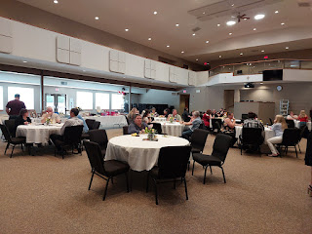

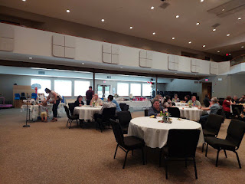

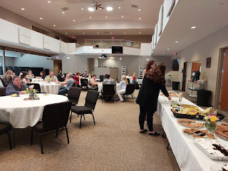

Speaking of the food . . . Sherry had organized a luncheon that included many of Grandma's favorite things: lunchmeat sandwiches with her favorite pickles and Lay's potato chips on the side, potato salad, rolls, and some of the famous desserts she always made - snickerdoodles, cookie bars, chocolate cake**, and jello cake.

**I didn't know this, but apparently she loved chocolate cake with NO FROSTING!! For the guests, however, Sherry had tasked someone with adding a thin layer of cool whip to the top.

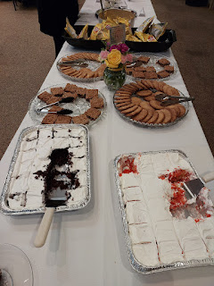

When I took my first bite of the jello cake, I was instantly taken back to my childhood. I'm not sure if my mom used the same recipe or not, but I absolutely LOVE jello cakes. Basically, you bake the cake in 2 or 3 round cake pans, then poke some holes in each one and drizzle some jello "glaze" over the top of each one and refrigerate for a bit. I say "glaze" because you don't use all of the water that you would normally use for jello. It needs to be thicker. I always enjoy choosing colors and flavors for each layer of the cake, depending on what the occasion is. Maybe I'll use a white cake mix, with a red jello for one layer and blue jello for the other = Fourth of July. Or if it's for one of my grandchildren, I'll ask what colors they want, and then I choose a flavor that represents each of the colors. LOTS of cool whip is key - both in between the layers and slathered on top, too.

Yes, the lunch was pretty carb-heavy, but I tried to choose carefully and exclude as much as I could convince myself to do. My stomach was still all messed up afterwards, though . . .

Sherry even had a pretty banner made with a timeline of Grandma's life . . .

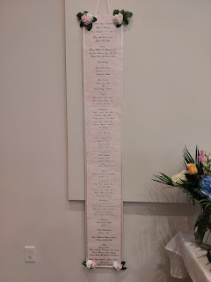

Video of the banner, if you prefer something medium-quick to view: (21 seconds)
https://photos.app.goo.gl/ygtNpSXV4vJfHAQf8

Or you can look at each section below . . .

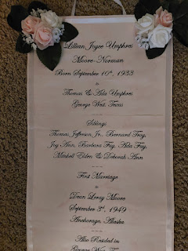

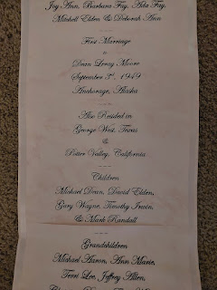

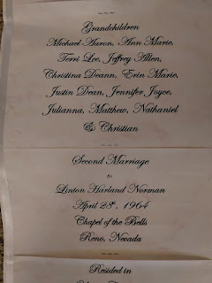

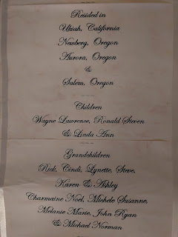

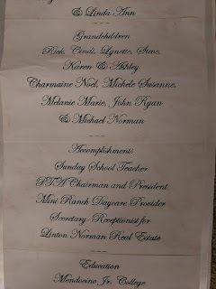

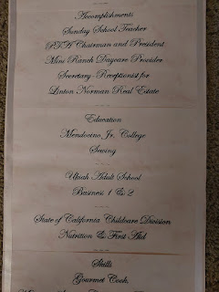

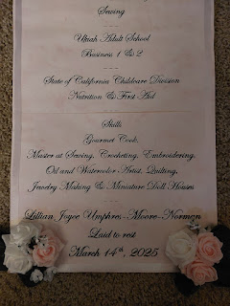

Charmaine noticed this little book on the table of Grandma's favorites . . . When I opened it up, she (Grandma) had written a few things on the first couple of pages, but unfortunately the rest of the booklet was blank.

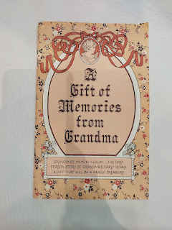

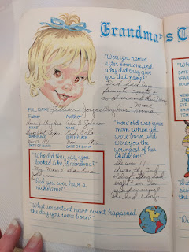

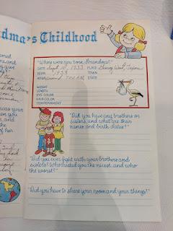

A closeup of the poster that summarizes Grandma's Favorite Things . . .

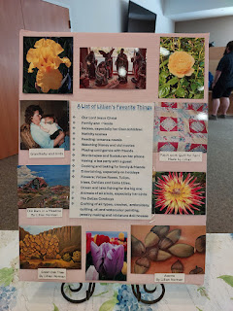

Aunt Sherry said that Grandma had this poem on her fridge for many years and always strove to live by it . . . Because it was so representative of Grandma's life, Sherry printed several copies of the poem and rolled them up like a scroll with a ribbon tied around each one for guests to take home.

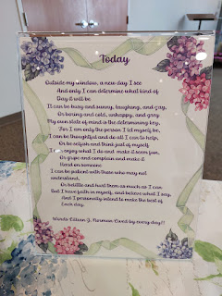

I won't include ALL of the family group photos here, but I'll include this one. This one encapsulates a big portion of my childhood. With the exception of Mike Jr. on the left, the rest of us spent many hours, days, and summers playing together on the ranch in Ukiah, CA. Grandma ran a daycare for several decades, and this included many of her own grandchildren. How she had the patience to take care of so many of us all the time is beyond me . . .

L to R: Mike Moore Jr., Charmaine, Me, Terri Moore Tuttle, Erin Moore, and Christina Moore Burklund.

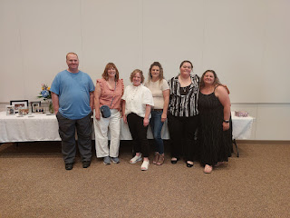

If you'd like to see more photos of the family groupings, you can click here:
https://photos.app.goo.gl/fEH6ZnqN14pjYQR47

(Aunt Sherry added a few photos to the same album. You'll see her name as Charlotte Barless, but she goes by Sherry.)

This was the floral arrangement that our Snider family contributed to the Celebration of Life. It turned out so pretty!! Grandma's favorite rose was the yellow rose (of Texas), so I made sure to include some of those when I placed the order. For many, many years, my favorite flower was also the yellow rose. I'm thinking it had something to do with the fact that it was Grandma Lillian's favorite and I loved her very much, plus my 2 favorite colors have always been yellow and green, PLUS I was also born in Texas. :)

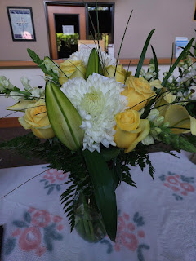

The lilies were a concern if we brought the vase back home to Amber's house - I guess they are very dangerous to cats. So Charmaine and Scott took it over to their AirBnB for the night, until we could place the flowers at the cemetery the following afternoon.

We all went to dinner at one of the nearby McMenamins restaurants. This is a fun chain in Oregon where some of the menu items are the same at each location, but some are slightly altered or even uniquely different altogether. The ambiance at each establishment is fun to explore. The chain offers a McMenamins Passport with an incentive: when you get it stamped at each location you visit, you can earn things like a free appetizer or drink, etc. The Whitworth family takes this very seriously and it's a win-win for all four of them. Amber and Weston get to have the fun of discovering a new location and seeing what it's all about, while the two girls can always have their favorite (and very predictable) meals. Gwen likes to order the Scooby Snacks - essentially chicken nuggets with fries on the side, along with a root beer soda. Abby likes to order the 2 mini cheeseburgers (they fit on those cute little Hawaiian rolls), with truffle fries and often a hot chocolate on the side.

Church on Sunday morning was beautiful. The lady who taught the lesson in Relief Society led a discussion from a recent conference talk given by Elder Patrick Kearon, entitled "Welcome to the Church of Joy". At one point, after discussing how we can better serve the needs of the people in our ward (by greeting them, having meaningful conversations with them, serving them, helping them to feel loved/wanted/needed), she encouraged us to start a chain of what this might look like as we went person to person down each row. She suggested we could smile and greet the person next to us warmly, offer a fist bump, a hug, or whatever felt appropriate at the time. We were the second row to "pass it on" and when it was Amber's turn to greet me in some way, she reached out to hug me and proceeded to weep in my arms. It was so precious. All the ladies were so moved by this that they started to cry, too, and we kind of held up the "chain" for a few minutes because we hugged for so long. It was so worth it, though, and clearly my sweet Amber was in need of that long hug. After church, we all had lunch together back at their apartment, where Charmaine and Scott joined us. Once they got a tour of the place, we set off in two cars to have a fun adventure in the forest.

At dinner the previous evening, Amber had given us some great options on things we could choose to do as a group activity on Sunday afternoon. Everyone loved the idea of hiking to "The Witch's House", deep in the forest near downtown Portland.

There is a sad history to the story, which is essentially this: A young couple wanted to marry, but the father of the bride refused to give his permission. They eloped, and when months later they returned, the father (Danford Balch) shot the groom in the face, killing him instantly. Balch was the first person to be convicted AND hung in the state of Oregon as a form of the death sentence.

Sounds pretty horrible, right? But the photos of the trail through the forest won us over and we decidedly chose to make the one-mile trek to see the house for ourselves.

If you want to know a few more details, these two web pages are both a very quick read:

Brief details of the story and the background of those involved:
https://www.reedquest.org/articles/2024/11/1/haunted-oregon-the-witchs-castle

Even briefer details of the story, but some great info on how to access the hike:
https://www.secrethike.com/post/the-remains-witchs-castle

At the beginning of the trail, there is a set of rainbow stairs that lead up to a pedestrian bridge. The girls were the only ones with enough energy to dart up to the top and then trot back down, just so they could say they did it!

Short video as they came down the rainbow steps: (3 seconds)
https://photos.app.goo.gl/V5TEMv7pNCj9V3Hn7

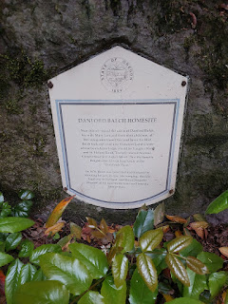

There is a lovely creek that runs adjacent to the trail pretty much the entire time.

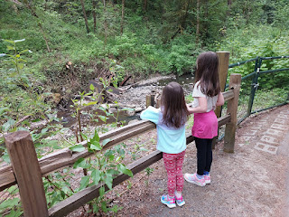

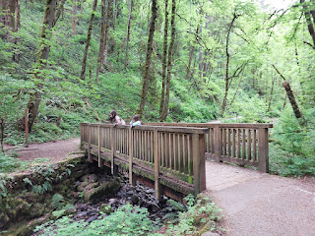

Charming bridges to cross . . .

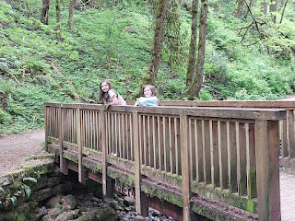

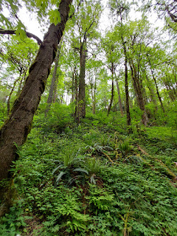

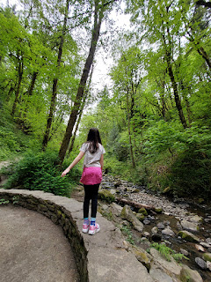

Wide and mostly smooth walking trails . . .

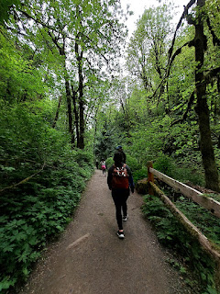

Abby and Miss Gwen with hands on her hips, ha ha . . .

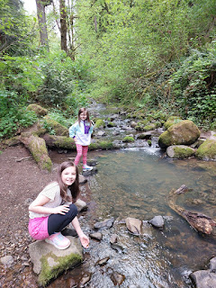

Video of the girls exploring near the pretty little cascades: (4 seconds)
https://photos.app.goo.gl/ZnBMpHX2UXjS9Cwc8

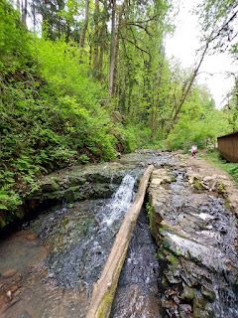

Abby bravely clambored up the entire length of this felled tree with seemingly no effort at all, so naturally Gwen wanted to follow suit.

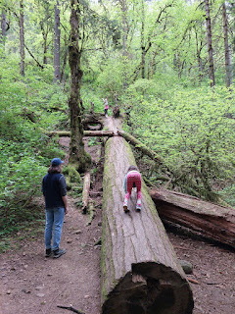

There have been studies conducted that show that allowing your children to do risky things actually helps to aid them in their development. If we constantly hover and tell them "that's too dangerous", then they don't gain any perspective of their own. But if we let them try something risky and they fail, then they gain valuable insights into what they should do differently the next time.

I'm not saying we should never protect our little ones from harm. What I'm saying, though, is that it makes sense to allow them to learn some things from natural consequences.

Video of Gwen slowly making her way up the length of the tree: (6 seconds)
https://photos.app.goo.gl/KBaqDH8bStUyaFCT7

The result was her feeling so incredibly proud that she made it all by herself!! You can see the joy on her face in the next two photos . . .

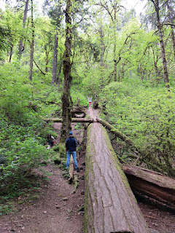

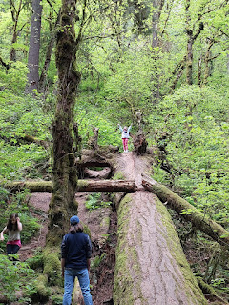

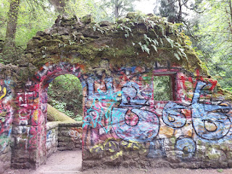

When we made it to the remains of "the witch's house", Amber told the girls the story of Danford Balch. They were intrigued and a little bit shocked, but overall not too disturbed by the details. They were having too much fun exploring around the very colorful walls that still remained.

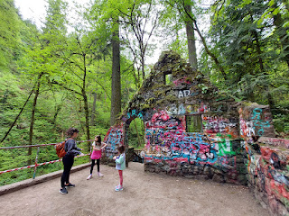



At one point, they noticed that they could make a decent echo in the old chamber below the house. They got a big kick out of making loud and maniacal declarations and listening to the echoes.

Video of them here: (5 seconds)
https://photos.app.goo.gl/bKHSs9t5abVJyQUJ9

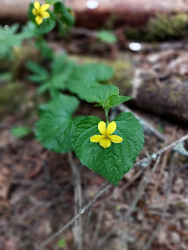

Amber took the time to count all the rings on this old tree that had been chopped down. I think she counted roughly 180 ring-years for its approximate age.

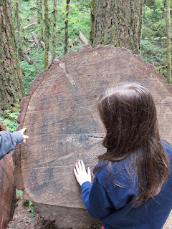

We had the best time!! The girls wished they could have stayed several hours longer, and I did, too.

Video of Abby coming back across the log she had carefully shimmied along to get across the creek:
(21 seconds)
https://photos.app.goo.gl/2sYuyu5PFkoJ4w996

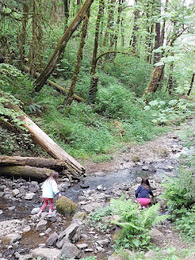

We had another errand to do, though, and we needed some time for that. Our next stop was to visit the Willamette National Cemetery to place flowers on a couple of graves. Find-a-Grave has a great search feature to help you find the location of the plot you are looking for. I put in the name of the cemetery and then I added my Grandpa Linton Norman's name. If you click on the next photo, you can see that he is buried in Section E, Site #914. We did the same for my Uncle Mark Moore, Lillian's youngest son, who is also buried here. He is located in Section X, Site #20.

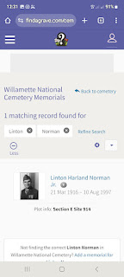



From there, I pulled up a map of the cemetery on my phone, which further helped in navigating us while driving within the cemetery. We could see ahead of time where Sections E and X were located and then we could watch for intersecting streets that were close and look for a place to park.

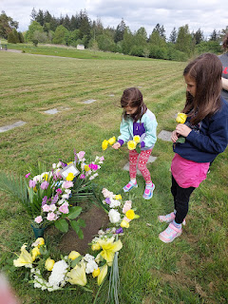

We weren't 100% sure how to arrange the flowers from our vase and also from the arrangement that Mike and Suzy Moore had purchased. But it all came together rather nicely. I snipped shorter lengths of each stem and the girls helped to form a flower border around where the headstone used to be.

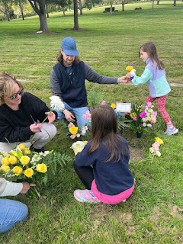

I say "used to be" because they recently removed the original headstone that was made for my Grandpa Linton, and now it is being remade to include Grandma Lillian's name, too. It takes a while, though, to get it all done. Probably because it's a cemetery run by both the military and the government . . . um, need I say more?

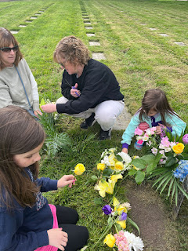

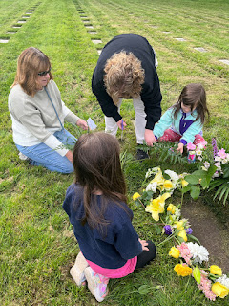

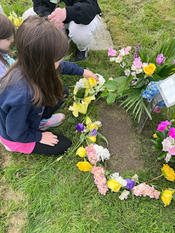

You're about to see what appears to be the same exact photo - four times in a row. Only actually, I found it so hilarious when I checked the photos later that evening - - - if Abby was smiling and her eyes were open, then Gwen's eyes were shut or half-shut. If Gwen's eyes were open and she was smiling, then Abby's eyes were shut. They didn't coordinate that photo shoot very well at all, ha ha. And I should have checked the photos better while we were still there . . . I just figured that with 4 photos, one of them would surely turn out . . .

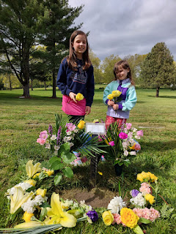

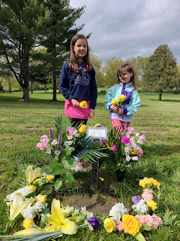

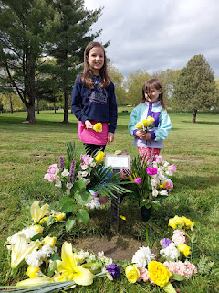

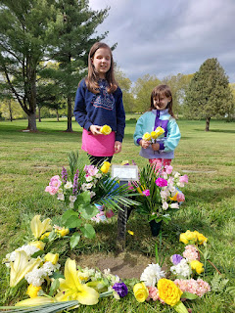

There is a paper signifying whose remains are here until the new headstone arrives eventually.

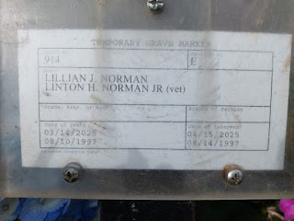

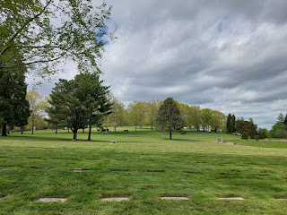

Next, we drove over to place a few flowers on Uncle Mark's grave . . . the girls decided to lay a single yellow rose on either side of his headstone and then keep 1-2 roses for themselves. That was just fine with us. XOXO

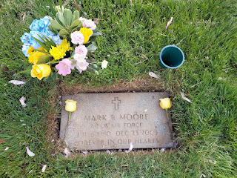

There was a beautiful tulip tree in bloom next to Mark's grave . . .

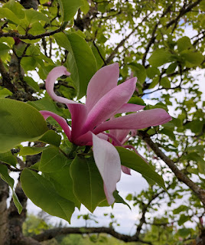

Back at home for the remainder of the evening, we laid low and just relaxed, preparing an easy supper of French Toast and scrambled eggs (much to the girls' delight).

On Monday morning, I got up early to shower before the girls woke up to prepare for school. That way I could let it air dry while the morning progressed. I walked with the girlies to the bus stop and we hugged several times before they boarded the bus and drove off. We all had the "morning puffy eyes", ha ha.

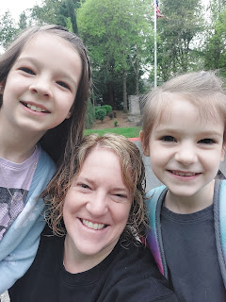

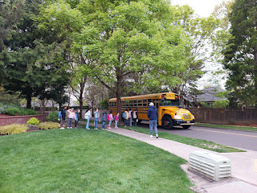

Amber and I finished getting ready and then we went out to breakfast together at a cute place that she chose. I can't remember the name of it now, but they had fancy avocado toast which made me happy.

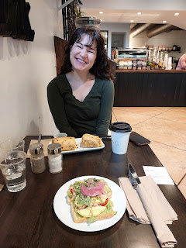

After breakfast, we changed into workout clothes and did some exercise in the fitness center of their apartment complex. It always feels so good to push myself a little, whether it's with handheld weights, a Pilates workout, or this time I tried some kettlebells - something I've been wanting to try for a long time. I really enjoyed using them! They are easier to hold than dumbells and you can do some really cool things. I pulled up a link to a simple workout that I could follow and then I got my sweat on! My favorite new move with the kettlebell is called the Halo. Look it up. :) IT WORKS.

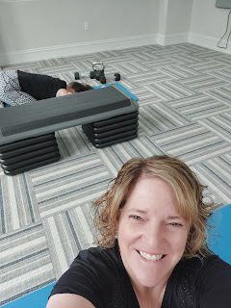

Not too long after we finished our workouts, it was time to load up my suitcase and get myself over to the airport. I had arranged to meet up with Charmaine and Scott once we all got through security, having made plans to eat some lunch together. We ended up with gates that were really close to each other (C9 and C13), so we found a food court in the C Gates area to hang out and relax for a while. We shared our thoughts about the weekend and about Grandma's Celebration of Life, seeing so many cousins from our childhood and also connecting with Amber and her family again. It was a perfect way to bring closure to our time in Portland together.

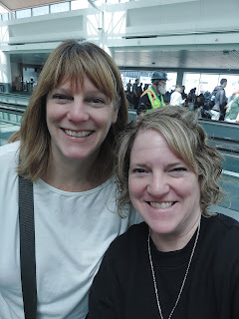

Looking down on Idaho on my way home . . .

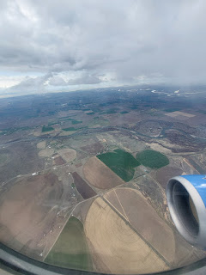

The next 36 hours were an absolute blur and a whirlwind. I had weeds to pull, a suitcase to unpack and then repack, laundry to wash, toilets to clean, tidying to do. I needed food from the grocery store after having been gone for 4 days, but not TOO MUCH, because I would be leaving in 1.5 days . . .

I squeezed in a quick visit up to Rigby to see my nieces and to meet my GREAT GREAT NIECE, Andalynn (also called "Andee" for short). We met at the "pirate park" next to the fairgrounds so Bethanne's two little boys, Harrison and Everett, could play while we visited and kept watch. Harrison is an amazing 4.5 year old - he can ride like a 20 year old on his bicycle WITHOUT training wheels! He'd do swoopy curves right and left down the paved path, even looking over his shoulder to holler at us to hurry up - all without ever crashing!!

Here's the breakdown of how we're related:
Scott has an older sister named Bev.
Bev has a daughter named Vanessa.
Vanessa is the mother of Caleb, Hunter, and Taylor. (1 boy + 2 girls)
Caleb is married to Bethanne.
Bethanne just gave birth to Andee on April 12th, making me a Great Great Aunt.

Taylor had watched a video or two recently on how to make a crown from dandelions, so she began working on that while the boys rode their bikes nearby and rolled themselves repeatedly down a hill.

Taylor, Bethanne, and Andee . . .

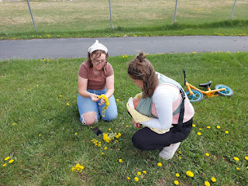

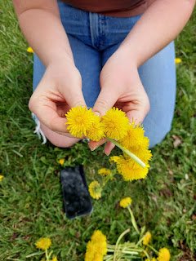

Harrison picked little bundles of brightly colored dandelions for each one of us, including a few for his new baby sister . . .

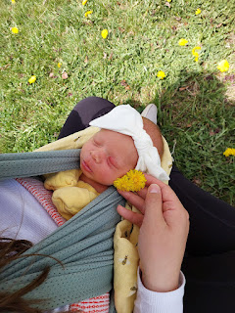

L to R: Taylor (my grand-niece), Vanessa (only a few years younger than I am, but still my niece), Bethanne (my grand-niece), and me. They are the happiest, sweetest, cheeriest bunch and I love them oodles.

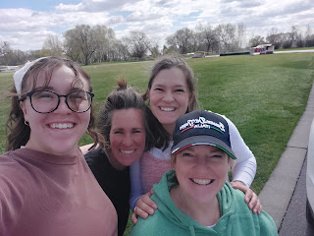

After getting a key made at Lowe's and taking my car through the car wash - and canceling my monthly membership, I stopped by to hug Mari and visit her for a few minutes before dashing home to get some things crossed off my list.

I was so grateful to have a few more hours the following morning to finish everything before I left. I was still working on squeezing out postcards to send to Abby and Gwen when my neighbor, Helma, arrived to take me to the airport. While I quickly scribbled out the last sentences, Helma hauled suitcase #1 out to her car and hefted it into the trunk like it was nothing. I finished in time to haul suitcase #2 out, thank goodness, because it was quite a bit bigger and heavier than the first one.

Goodbye beautiful house and empty living room . . . I'll miss you . . .

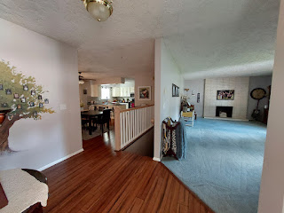

My bigger suitcase weighed in at exactly 50 lbs, while the smaller one came in at 35-ish lbs. Normally I don't take two large suitcases when I travel, but since I'm moving to Italy, I needed to haul some extra stuff. The new employer said they would reimburse us for the cost of the extra suitcase, so I decided to make good use of the offer.

Everything appeared to be fine as we boarded our United flight from Idaho Falls. But once we pushed back from the gate and headed out to the runway, we sat there for a long while. An uncomfortably long while. Eventually, the pilot let us know that there was some questionable weather happening in Denver, which is where we were headed. The pilots that hadn't left the ground yet were being asked to stay on the ground until further notice. We ended up sitting there for 90 minutes, just hanging out, with many of us wondering if we would make our connecting flights from Denver to somewhere in the world . . .

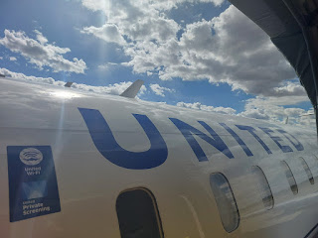

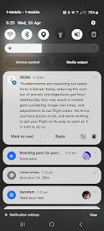

Finally, we were on our way. I had been worried about missing my overseas flight to Munich, but then it turned out that the Munich flight was delayed, too! I was sending lots of updates to Scott, even though he was asleep in Italy during this time. I figured that if he woke up in the night and wanted to see what my status was, I'd better keep him in the loop as best as I could.

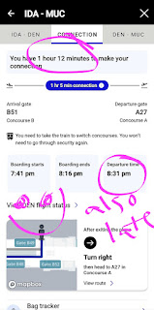

The dinner meal on my flight to Munich was just "meh" this time. The brownie was yummy, but oh so evil. The chicken and rice was "okay". I only ate a tiny bit of the rice, but I ate all of my tiny little salad with the accompanying oil and vinegar packet. I offered my roll to the people sitting next to me, but they politely declined, so it ended up getting tossed when the crew came along to collect our food trays.

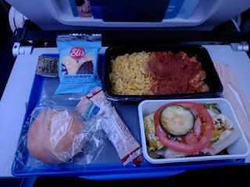

I was so tired from all the hype that came with preparing to leave my house for several months, but it also helped me to get a little bit of sleep, surprisingly. I think I slept for about 3 hours or maybe a little bit more. I made the mistake of choosing a seat in front of the bathrooms - something I will never do ever again. All I could hear was the loud flushing of the toilet behind my seat all night long. The only thing that helped to mute the sound was when I used ear plugs PLUS my noise-canceling headphones over the top. That's when I got the 3-ish hours of sleep.

My last flight from Munich to Venice was also delayed, making 3 out of 3 flights delayed. I've never had that happen before.

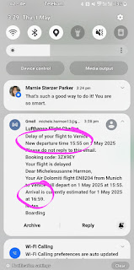

Coming into Venice . . .

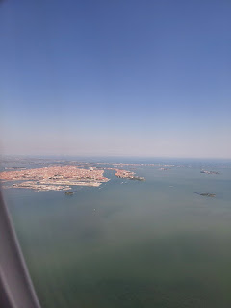

And back together once again . . .

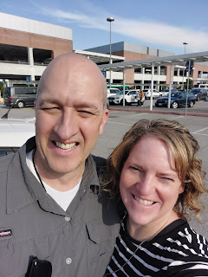

The sunset that evening was a lovely welcome to our new home . . .

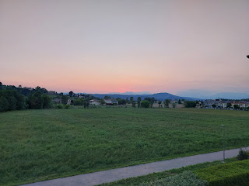

I slept for a solid 8 hours, which was FANTASTIC. The next morning I was so excited to put our new bedding set on the bed. It's a style that we have seen time and time again in Europe, and it's known as the Scandinavian Sleep Method.

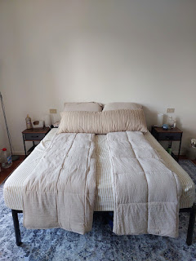

Consisting of separate comforters, they provide an opportunity to customize your sleep experience while still sharing a bed with your partner.You can toss and turn without disturbing the person next to you. Having your own individual comforter also allows you to regulate your own temperature. For example, I tend to sleep a little hotter than Scott, so I'm always kicking the covers off at some point in the night. He tends to hog the blankets, so when I do want a piece of the comforter back, I have to tug and pull to retrieve my portion from him. The twin size, super soft comforter that I bought provides enough warmth if I am cold, but it also feels nice and cooling when I am a little overheated. It is very lightweight, which I love for many reasons. Overall, it has helped me to get a better night's sleep. Most nights I sleep wrapped up in the comforter, all except for my feet which are usually sticking out at the other end, ha ha. In the morning when I make the bed, I fold each comforter into thirds lengthwise, the same way I've seen them arranged in places like Croatia, Italy, Iceland, etc.

The twin size is very ample for each of us, and the two comforters together have plenty of overlap in our queen-sized bed. I bought them on Amazon and here is the link:
https://www.amazon.com/dp/B08CXLS8VZ?ref=ppx_yo2ov_dt_b_fed_asin_title&th=1

The dining table that Scott put together from IKEA sure feels like the nucleus of our home. I love to just stand and stare at it sometimes . . . is that weird?

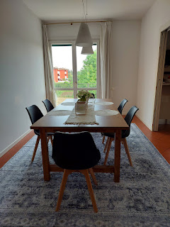

We've started going on a walk every single evening after dinner. I need to do a little better by aiming for an earlier dinner time so that we have plenty of time for a nice long walk before it gets too dark. There are several walking paths around us: we can walk up the hill that we see out our windows every day; we can hop on the paved trail behind our house; or we can venture into the fields between our street and Del Din (the base where Scott works) where there are several gravel trail loops.

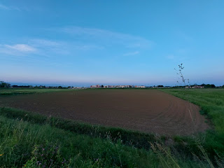

Short video of the perfectly lined fields in between us and Del Din: (6 seconds)
https://photos.app.goo.gl/PTbCYot6TEuAcc9z7
This is reminiscent of my love for vacuum lines in the carpet . . .

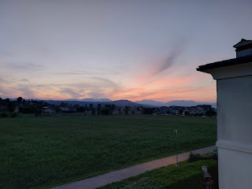

I've been taking photo of flowers again since they are in magnificent bloom right now - and they're everywhere!

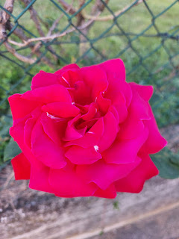

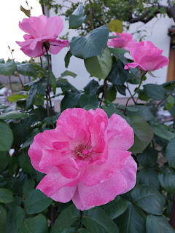

A heart-shaped calla lily . . .



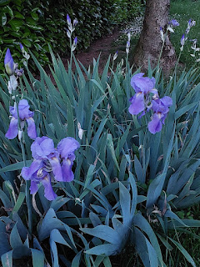

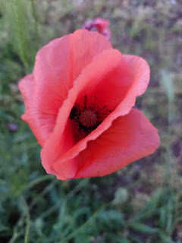

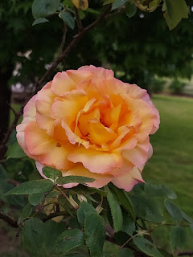

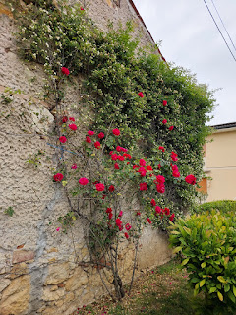

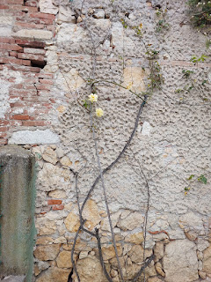

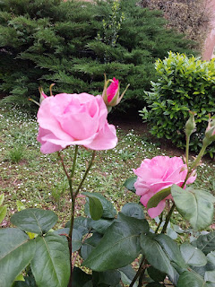

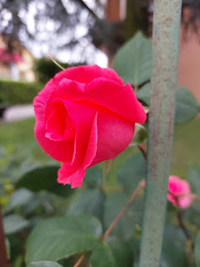



Scott took me to a new grocery store nearby called Iper Tosano last Saturday. It is so huge! It felt like a Super Walmart size but with 100% grocery items. No clothing section, automotive section, sporting goods or hardware section. Just groceries. It took us a good long while to circulate the entire store, but it was nice to get a feel for what is available there. And it's only about 10 minutes away by car.

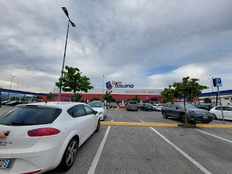

I was able to get everything on my list with the exception of red grapes. They are not in season right now, so they are not available in the Italian grocery stores. I had to go get them at the Commissary a couple days later. I was super impressed with their ethnic aisle - they had very ample offerings of Mexican foods, Asian foods, Arabic foods, Middle Eastern foods, and more. I was particularly impressed because I wanted to make some tostadas for Cinco de Mayo and I figured that I would have to get those items at the Commissary. But no! I found corn tortillas, jalapenos (!), fresh cilantro (!), and avocados here. Good job, Iper Tosano!!

The one thing I struggled to find in the store was dijon mustard so I could make some tuna melts. I typed my query into Google Translate and a young lady who worked there was able to direct me to the right aisle.



We were surprised to see a large package of already-shelled mussels (1 kg!!) for just $6.50. What a bargain!! They were frozen, but that's okay.

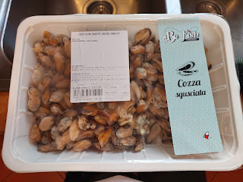

I sauteed some garlic, added a little chicken broth and lemon juice, and voila! They turned out fantastico!! I cooked up two artichokes on the side and we had a very filling meal. There were even enough mussels leftover to make a delicious lunch the following day.

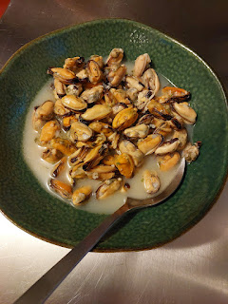

Beautiful vineyards on one of our evening walks . . .

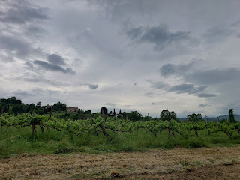

Video of some chickens we saw in the ditch as we walked by: (12 seconds)
https://photos.app.goo.gl/AVcxgNSNsQtbQQbm9
*We were also on the phone with Jake and Jack back in Minneapolis at the same time.

I found a new recipe that we absolutely loved! It's called Chickpea and Sweet Potato Grain Bowls.
Recipe here:
https://www.eatingwell.com/chickpea-sweet-potato-grain-bowls-8703855

We skipped the grain part, but we added a fried egg to the top of each of our bowls. It was so filling and full of fiber and delicious!!

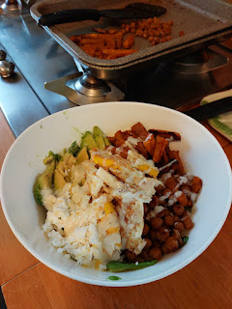

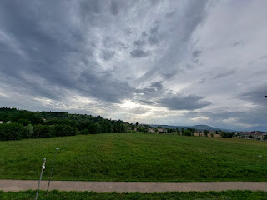

Life is good over here so far. We had an attack of ants a couple days ago, but we are now winning the battle. Sometimes I'll walk into a room and be surprised by some random spider or furry bug just sitting there. I'm getting better at not melting into a curled-up ball of fear . . . I'm glad we have a vacuum now - that's all I have to say about that.

I've been working on a to-do list with things like:
~Contact the London Temple regarding patron housing
~Work on Maisie's quiet book
~Haul stuff to the thrift store on base
~Type up Gma Lillian's memories to share
~Work on my blog
~Laundry
~Plan out a small garden with some potted plants
~Clean the bathrooms
~Etc.

It feels so good to SLOW DOWN and just hang out at home most days. I'm doing some new strength training exercises and wowzers, I am pleasantly sore and feeling improvements already.

We watch a favorite TV show when Scott gets home from work, we make dinner together, and then we go for a walk. I love creating a routine, but I'm also adaptable and ready for just about any adventure. When I'm alone, I'm more of a homebody and that's okay. I'm happy, content, well-rested, and I'm trying to just soak it all in right now. :)

