A Consulate Miracle & Arriving in Minneapolis
Picking up where I left off last week . . .

Friday, March 28th:
While visiting our daughter, Amber and her family up in Portland, Oregon, we had a fun outing while Weston had the day off work. We drove in 2 cars over to Tillamook and then on to the coast. Abby and Gwen rode in our car (of course!), while Amber and Weston had a very quiet and relaxing time in their car.

We had fun pretending all sorts of things in our car, like: What color of house do you want when you grow up? Then it turned into what animals we would like on our individual farms and why. It was a lot of fun!

This is the Oregon Coast at Tunnel Beach near Tillamook . . .
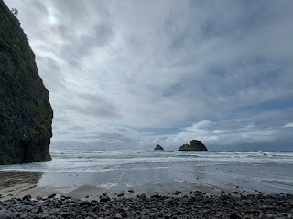

Amber and Weston had never been to the Tillamook Cheese Factory (also known as Tillamook Creamery), but I had gone with Grandma Lillian several years ago. It was MUCH quieter when we went all those years ago . . . This time it ended up being super busy on the last day of spring break for the entire state of Oregon, it was also a rainy day, too, which meant everyone was looking for something to do indoors.

I could not believe how many people were inside the factory once we got in. We decided to get lunch first so that everyone had happy tummies before we went upstairs for the self-guided tour. Amber and I got in the long line to order, while Scott took Abby upstairs to look at some things and Weston took Gwen to find us a table and hold our spots.

We ordered some grilled cheese sandwiches (with locally made cheese of course) and tomato soup, fried cheese curds (!), and a small cheesy pizza. Everyone was happy with the selections and we gobbled everything down.



Our first stop upstairs was the cow-milking station. Abby went first, needing to hook up the udder "cups" in the specified time (I think it was either 21 or 25 seconds).

Video of Abby: (18 seconds)
https://photos.app.goo.gl/6wBKWDABNHY9FeYz5

Video of Amber and Gwen teaming up: (24 seconds)
https://photos.app.goo.gl/rpy4UAWaeuFR6mJTA

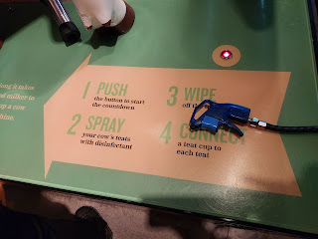

Sweet Gwennie, feeding the baby cow . . .

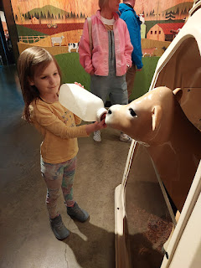

Video of Scott giving Gwen a nice back scratch on the cow-cleaning brush: (5 seconds)
https://photos.app.goo.gl/9YeUQAJhpaw9S8JT8

There are several viewing windows where you can look down into the factory below and watch various stages of cheese processing. You can see the cheese being cut, sliced, packaged, inspected, etc.

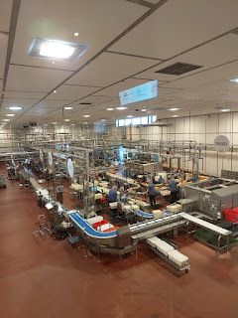

Video of the cutting area: (18 seconds)
https://photos.app.goo.gl/6wn5uozwXzpS7BiC6

Video of the quality control area: (14 seconds)
https://photos.app.goo.gl/VSXYWbBAc931w9mw6

We grabbed some cheese samples upstairs before heading down for some Tillamook ice cream. Another long line, but well worth the wait. I think my favorite flavor was the salted caramel pretzel ice cream. :)

Once we cleaned up our sticky faces and fingers, we piled back into our cars and headed for the coast. It wasn't far this time, maybe 20 minutes further. (The drive to Tillamook was close to 1.5 hours)

Amber and Weston had recently taken their family to Tunnel Beach and loved it so much that they wanted to share it with us. I borrowed a pair of comfy waterproof shoes from Amber, which, in addition to the multiple layers we each had on, I managed to stay nice and warm. It was a blustery and very cold, rainy, day, but hey - we punched through those obstacles and had a lovely time.
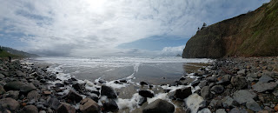

Video overview of the beach leading to the tunnel (at the far end near the beginning of the video):
(10 seconds)
https://photos.app.goo.gl/Ne9N9NVeze5VM7sD9

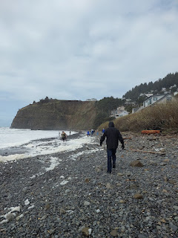

It was slow-going to get down the beach to the tunnel because the tide was still pretty high and was only just beginning to recede. We had to pick our way carefully over the large rocks on the upper part of the beach, although I did use some of the wet sand
briefly
to make a mad dash before the waves drove me back up into the rocks again.

There was a lot of white foamy stuff on the beach, and I'm not sure exactly what it consisted of . . .

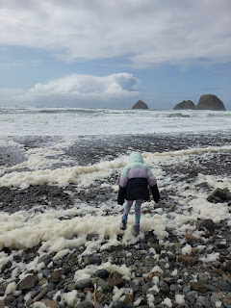

Amber - standing in the entrance to the tunnel that leads to another beach on the other side.

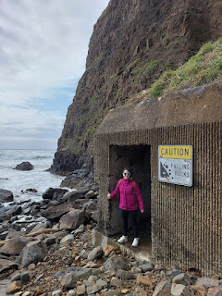

The tunnel is about 100 feet long, with a small section that is in complete darkness. I pulled out my cellphone to use the flashlight feature, but had to tuck it away moments later because it was so precarious that I needed both hands to hold onto the walls or whatever rocks were closest as I clambered across the puddle-ridden rocky section at the end.

This is the exit on the opposite side with a very inviting view . . .

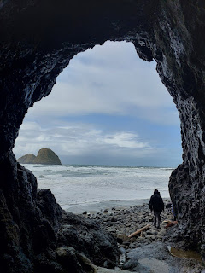

Gwen set up a little "barrier" to the waves, consisting of some sticks and rocks on the beach. She was ecstatic when it held its ground a short time later, after a larger wave came rumbling up and over her structure.

Gwen's "barrier": (23 seconds)
https://photos.app.goo.gl/HHeoqwUWaDL9gN5P9

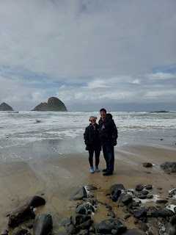

Scott stayed with Gwen for a long while, carefully walking out as far as they dared, and watching for a stronger wave to chase them back to safety.

Video of the two of them: (15 seconds)
https://photos.app.goo.gl/RM3Yt4eBZLXAThi5A

Abby did a little exploring on her own, noticing a trickling waterfall coming down the side of the cliff above her.

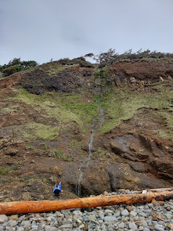

She also had fun taking a few pictures with her new Polaroid camera. We brought a small ziploc bag with us to keep the printed photos dry and protected.

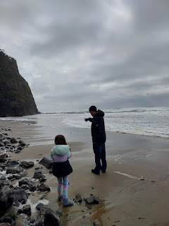

More wave chasing as a Grandpa/Granddaughter Duo . . .

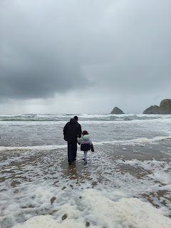

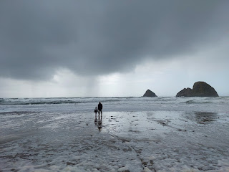

All of a sudden, a burst of pounding rain started pummeling the beach - which included us! Everyone started running for the tunnel again . . .

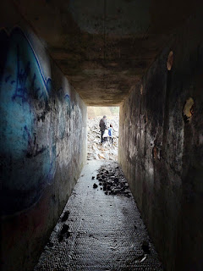

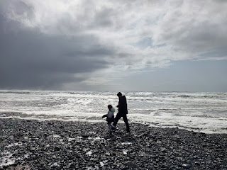

Thankfully, it was a short burst of rain, and was over pretty quickly as we made our way back to the car together.

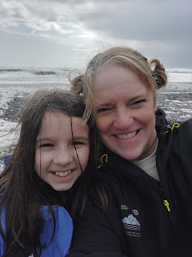

Next stop: Cape Meares Lighthouse, just a little bit north of Tunnel Beach.

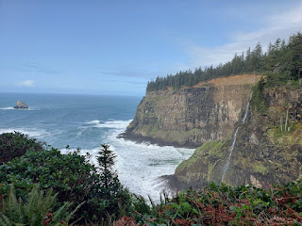

From the parking lot, there is an easy and forested loop trail that goes out to the lighthouse, with views of the ocean from the short cliff trail. You can go either way on the split trailheads, as they both lead out to the lighthouse.

Scott, Amber, Weston, Abby, and Gwen . . .

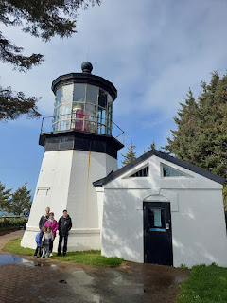

The drive back to Lake Oswego was quiet and uneventful. The girls were content after our coastal expeditions so they were okay with just looking out the window and relaxing for the most part. After dinner, everyone came over to our hotel to swim in the pool and soak in the hot tub.

Saturday, March 29th:
While our laundry was in the dryer at Amber's place, we all went to OMSI (pronounced "Om-zee"), one of their favorite places. OMSI stands for Oregon Museum of Science and Industry and is located close to the Willamette River in downtown Portland.

There are several exhibits to explore: dinosaurs and geology, chemistry, engineering and building, weather and nature, math, etc.

I thought this cross-cut section of a rock was especially beautiful . . . sorry I can't remember what it was called!

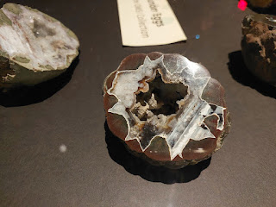

Video of Abby and Gwen matching up various animal feet with their footprints: (14 seconds)
https://photos.app.goo.gl/G5Q5Guf4gS8qYBqq9

Gwen spent a good deal of time working on all the math stations with me. Scott joined us at one point, helping Gwen with this impossible puzzle.

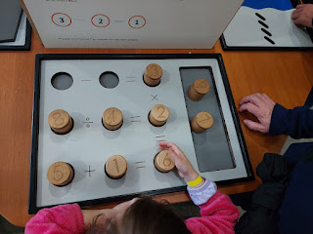

Video of the instructions and Gwen getting started: (11 seconds)
https://photos.app.goo.gl/T33KaKXuqS4m3kGx7

After SEVERAL minutes of trying, Gwen moved on to something else while Scott sat down in her spot to give it a go. He tried and tried, but could not figure it out! He was a little irritated, ha ha. He'd get mostly everything worked out, all except for one number each time.

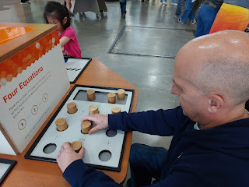

But he did ace a nearby station . . . Also, at the bottom of each instruction panel it said, "Please don't leave the answer for the next person". So we would mess it all up before we left to do something else.

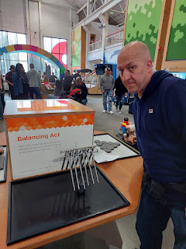

Abby did a fantastic job building a lego structure that was earthquake-proof. There are several lego pieces available on a large table-top surface where you can build something and then test its strength. You can push the button at the front edge of the table and then adjust the dial for a mild, moderate, or severe earthquake replication. The table will shudder and vibrate for the appropriate amount of time that you selected with the dial. Abby's structure had a nice wide base which passed each level of testing, while everyone else's structures quickly toppled over. Way to go, Abby!

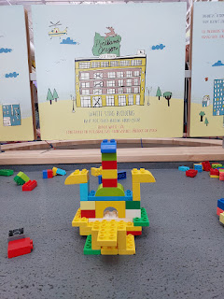

After a couple of hours at the OMSI, we left in search of some lunch to bring back to their house. Amber and Weston picked up some Mexican food, while we took the girls to Sonic per their request. Surprisingly, Gwen can eat an entire footlong hot dog!

Just before we left the OMSI, the girls practiced their tree climbing skills next to the parking lot . . .

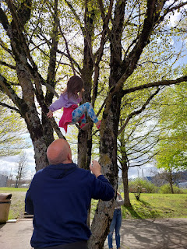

Video of Gwen up in the tree: (1 minute) *Just like I always did in my childhood, she got stuck at one point and needed help coming down. Scott had some amusing advice for her.
https://photos.app.goo.gl/az1hMDzCDpWUqPeRA

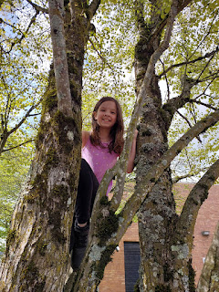

After lunch, Abby came with me on a couple of errands, while Amber and Gwen went shopping for Abby's birthday. First, we went to Penzey's Spices in Beaverton, the same store where Grandma Lillian took me several years ago, and it's also the closest one to Amber's house.

Abby selected a couple small jars of cinnamon, after she carefully smelled each one of the testers. There are several varieties of cinnamon, including: Vietnamese cinnamon, Ceylon cinnamon, Korintje cinnamon (from Indonesia), etc. Some smell slightly more lemony or nutmeg-y, or they might smell a bit more mild or strong.

I was there because I was low on my favorite seasoning called Fox Point. I use it in homemade ranch dip, mashed or baked potatoes, soups, avocado toast, eggs, fish, baked or pan-fried chicken, and many other dishes. The ingredients include: salt, freeze-dried shallots, chives, garlic, onion, and green peppercorns. In the past, I've just ordered some online, but when you're close by, you might as well just go get what you need in the store and save on some shipping costs. I think if you order $49 worth of goods from their website, then you'll get free shipping. It used to be just $30 of goods to qualify for free shipping, but now it's quite a bit more.

Next, we went to the fabric store. I was on the hunt for two main purposes: cute flannels that I can take to Italy and make a few more of those rag baby quilts, and some fabric to make a quilt for my niece, Mari. She had recently asked me if I could make her one. It won't be anytime soon, but I'll be happy to work on that sometime later this year!

Unfortunately, we got to the fabric store with not a whole lot of time before they closed, so it felt pretty rushed. Plus, Abby got caught up in the whole candy-store atmosphere of colors and wanted to choose a few fabrics as well. She convinced me (quite easily to be honest) to make her a smallish quilt for her stuffies. XOXO

The reason I wanted to look at fabric in Portland is because Idaho Falls is running out of options here with the recent closing of JoAnn's. Portland has several quilting shops up there, so I wanted to see if I could stock up on a few things for future projects. I'll need to try again in a couple of weeks, since I didn't have enough time to properly look with Abby that day. (I'm going back up to Portland the last weekend of April for Grandma Lillian's Celebration of Life.)

We did find a few nice things, though. And once things feel a little more settled here in Idaho Falls, I will crank out a mini-quilt for Abby's stuffed animals and then I'll deliver it in person by the end of the month. :)

Scott and I picked up our own dinner that evening, walking a short ways to get some soup and crab rangoons at a nearby Thai restaurant. We spent some time afterwards getting everything nice and organized before our next phase took us down to San Francisco, where it would be much harder to tidy the car and get our suitcases rearranged.

Sunday, March 30th:
Church was at 9:00 a.m. in Amber's ward, and they met us there in the chapel. There are so many wonderful people around the world, and this was true in Lake Oswego as well. It was a Fast and Testimony meeting and also a 5th Sunday. Usually the Fast & Testimony meetings are held on the first Sunday of each month, but twice a year General Conference is held on the first weekend in April and October, so local leaders need to adjust the schedule to accommodate. Fifth Sundays are rare each year, and typically the Bishopric and Ward Council members choose a special topic to discuss when all the adults can meet together. Sometimes a guest speaker is even brought in. Topics might include: family history, pornography and how to help loved ones dealing with addiction, missionary work, etc.

Amber got up to share her testimony during Sacrament Meeting and it was so sweet! She talked about "generational wealth", comparing how baby seals get "rich" by receiving fat and blubber from their mama for survival - with how she received spiritual nourishment from her parents while growing up, which has given her a thick layer of you-can-get-through-anything in her adulthood. I had tears rolling down my face at the same time as a smile from ear to ear, because Amber is just plain wonderful - through and through. It is an honor and a joy to be her mother. After the meeting was over, I reached over to hug her, and said, "I'm so glad to know we passed on some good blubber to you!"

After church, Scott and I changed into more suitable travel clothes at the hotel and got checked out of our room before driving the one mile back to Amber's place. We ate lunch together and then I spent a little time helping Abby get started on her first cross-stitch design. I showed her how to thread the needle with multiple strands from the embroidery floss and how to count everything carefully on the pattern and also on her fabric. I showed her how to do a row and how to "tie it off" by tucking the tail into the final stitches. I'll check on her progress when I go back up there in a couple weeks.

Sigh . . . now it was time for all the goodbye hugs . . . 'Til we meet again my loves . . .

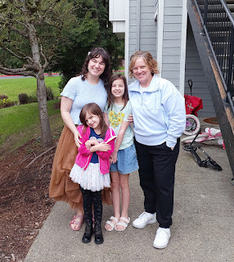

We made a brief stop at my Uncle Mike's and Aunt Suzy's home in Salem on our way south, because Suzy had a couple more things to send with me. She only had one copy of this darling photo, so I took a picture of it. Her daughter, Annemarie is in the center, I am the one with dark hair and my sister, Charmaine, is the blond on the right. This was at Grandma Lillian and Grandpa Linton's home on their ranch in Ukiah, CA. It looks like someone had a birthday that day. Seeing all the books in the background, I remembered reading through their set of Childcraft encyclopedia books regularly as a young girl, and playing countless games in that room. Such happy memories.

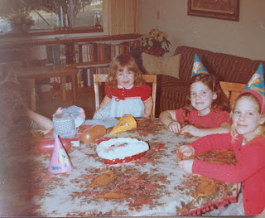

We continued on to Grants Pass, Oregon to stay with our dear friends, Josh and Kelly Richardson. Josh and I grew up in Ukiah together and we attended Ricks College at the same time up in Rexburg, Idaho (now BYU-Idaho). I'm so grateful we have kept up our friendship with them for so many years.

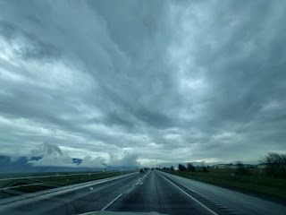

The clouds and the light filtering through was spiritually mesmerizing . . .

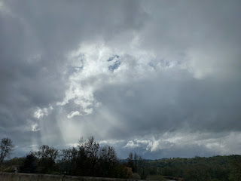

Josh, currently serving as the Stake President (overseeing multiple wards/congregations), was not above helping someone on the Sabbath Day. Their next door neighbors, who are both retired and getting up there in years, had a large tree topple down in a recent storm. Josh was just finishing up with the chainsaw as we pulled up, and it was just in time, too, because the rains came almost as soon as he was done!

Kelly put together a simple meal with leftovers of pulled pork that they had made the day before, laying out several additional fixings for a refreshing taco salad dinner. We visited for a few hours before turning in for the night.

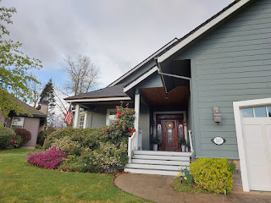

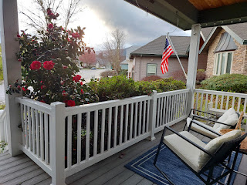

There is always such a beautiful spirit in their home. They love each other and are kind to each other and they have the perfect amount of humor without crossing over into any sarcasm. They love their children and take time to listen to them, teach them, work and play with them, and help them to know and understand their relationship with God and Jesus Christ.

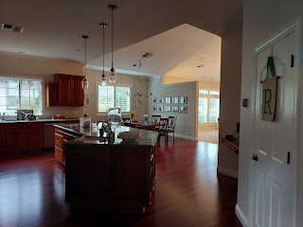

Upstairs, they have a long wall entitled, "Richardsonisms." They have created a space for family art, quotes, important events, and their family motto - which is seen on the left in the photo below.

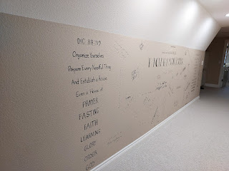

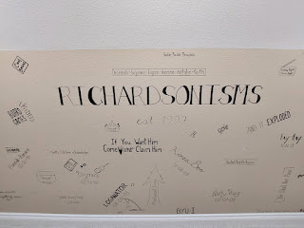

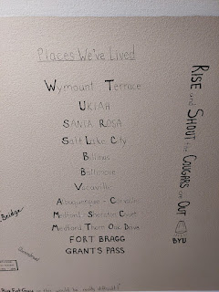

Monday, March 31st:
Early the next morning, we packed up and headed out once more, this time around 7:45 a.m. We had a LONG day ahead of us and many miles to go.

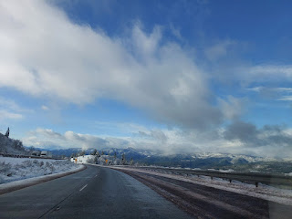

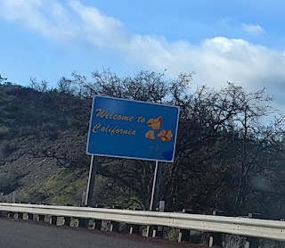

Mount Shasta was breathtaking! The sheer size of it . . . and the snow, and the hovering clouds at the top. Wow.

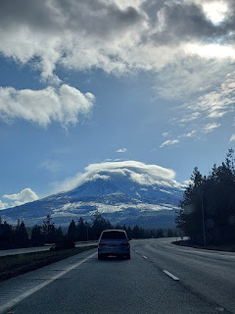

We took turns driving the 6.5 hours down to San Francisco. I wanted to drive the last portion where we would be going into the city, knowing that my husband is a little more skittish in heavy traffic and huge cities.

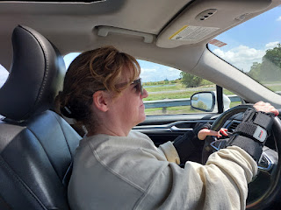

We navigated with no problems into San Francisco, got checked into our hotel, and had a few minutes to rest before it was time to go again. We had made some carefully laid out plans in advance to meet up with several family members in one location: Napa. My younger brother, Ryan, is a police sergeant and works really long hours. But he had a little bit of time this one evening and I'm so glad it all worked out! Originally, we had planned to attend his daughter Emily's softball game, but then rain was in the forecast so it was canceled. We met at their favorite pizza place in Napa instead, called Fazeratti's.

Charmaine's younger daughter, Ana, lives and works in San Francisco, so we made plans to scoop her up and bring her with us to see everyone. It was a lucky break for us that she lives just one mile from where our hotel was! And it was also a lucky break that we now had THREE people in the car, which meant that we could use the carpool lane to get out of the city, too! We gleefully jammed past all the other cars that were backed up in all the other lanes . . .

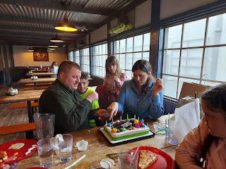

Because there are so many family birthdays happening between late March and early May, we turned it into a collaborative birthday bash at the same time! Ryan's birthday was the previous week, his son Blake's birthday was in 2 days, his daughter Lily's birthday was the following week, then Scott's on April 20th, and my Dad's on May 6th. We even sung to Ana, even though her birthday isn't until the end of May. :)

Thus, there was a long list of people to celebrate while singing the Happy Birthday song . . .

Video here: (28 seconds)
https://photos.app.goo.gl/kuX4zuCRrQ9WMUPz8

Ryan, who is 10 years younger than I am, and me . . .

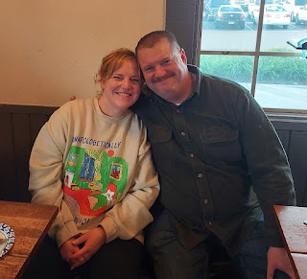

After several slices of pizza and slabs of cake, we parted ways. But not before taking a few group photos first!

L to R: Scott, my step-mom Michelle, my dad John, Ana is behind me, my mom Linda, Ryan and his girlfriend Amanda, Lily (red shirt), Amanda's youngest daughter (?), Blake, Emily (pink shirt), and Sophie, Amanda's oldest daughter.

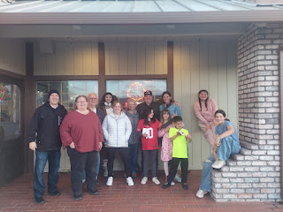

My parents drove roughly 2.5 hours each way to get together for a couple hours in Napa. I am so grateful that they sacrificed their time to come all that way! It was so wonderful to see them and to hang out for a little while. Ana even told me later that seeing everyone was "good for my soul". XOXO

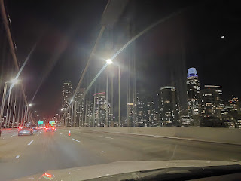

We drove the 1.5 hours back down to San Francisco, dropped Ana off at her apartment, and then we set our sights on getting ready for bed as fast as possible. We had to park the car first, and parking availability is next to nothing in San Fran. The hotel had advised us to use the parking garage about a half mile away, so that's what we did. Signs were everywhere in the garage, warning, "If you love it, then don't leave it!" We cleared everything from the interior of the car and tucked it all into the trunk and out of sight, hoping and praying that it would stay safe. (And it did.)

I loved the half-mile walk back to our hotel in the dark, giving me a chance to stretch my legs a bit after so much sitting all day, both in the car and at the pizza parlor. Some of the older homes are just SO PRETTY, especially at night.

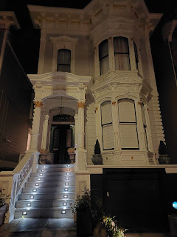

Tuesday, April 1st:
Do or Die Day. April Fool's Day. Everything Hinges on our Appointment at the Italian Consulate Day. Crossing Fingers Day.

Our appointment wasn't until 12:30, but we had some work to do beforehand - such as getting the bank certified checks for our visas and getting a prepaid flat-rate envelope from the post office to bring with us. Scott had already gone on a walk the day before, scoping out the route between our hotel and the Consulate. He knew that there was a post office and a Chase Bank on the way, but we still needed a little bit of pertinent information.

1. How much did he need to get bank-certified checks for, exactly? On the Consulate website, the rates change slightly throughout the year and get updated at the start of a new quarter. Well, the new quarter happened to also coincide with the day of our appointment on April 1st. He doesn't like to wait until the last second, though, so he was getting more anxious about not knowing the amount ahead of time.

2. Did he need to get 2 separate checks? Or just one for the both of us . . .

He decided to get up early and walk to the Consulate and ask them in person since they don't answer phone calls and their website isn't very helpful. He walked the mile to get there (while I stayed behind to work on my previous blog post) and pushed the buzzer outside the building. An impatient male voice answered on the other end of the intercom. Scott asked what the new rate was, since he couldn't go inside. The man tersely answered that the information is already available on the website and to basically stop bothering them with stupid questions.

Humbled and feeling a bit scolded, he headed off to the bank next. He was able to find the information on the website after all, because he is a very capable guy, and per the advice of the bank clerk, he decided to get two separate checks for $121.80 each.

He purchased a pre-paid mailing label for a flat-rate express envelope at the post office and returned to the hotel. I was all gussied up and ready to head out for something to eat at this point, and while he was a little distracted and thinking about 100 things in his head, I chose a nearby cafe for us to walk to.

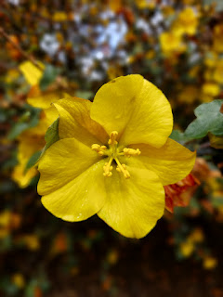

The walk took us up a short, but steep section of Grove Street that led directly to a spacious park and the famous Painted Ladies row of houses.

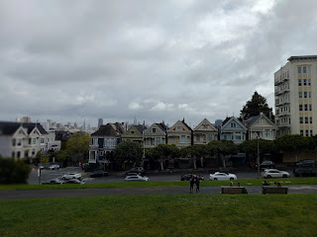

The Painted Ladies have been featured in numerous movies and TV shows, including:
~ The Five-Year Engagement (2012)
~ Shut Up, Little Man (2011)
~ Bicentennial Man (1999)
~ So I Married an Axe Murderer (1993) *This is the one we knew about - a comedy with Mike Meyers.
~ Full House (TV show - 1987-1995)
~ The Woman in Red (1984)
~ Invasion of the Body Snatchers (1978)
~ The Conversation (1974)
~ Dirty Harry (1971)

I didn't realize until I looked this up that Full House was connected to the Painted Ladies!!

We didn't spend too much time sightseeing - although I would have liked to - because we had more important things to get to! Lucky for me, though, the walking route to Eddie's Cafe took us right through the pretty park that sits on top of a hill. I marveled at how far we could see across San Francisco from this one hill, taking a quick photo here and there and then scurrying to catch up to Scott.

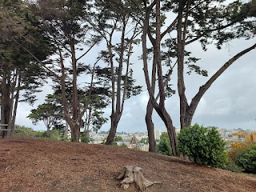

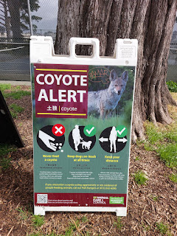

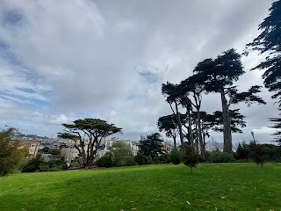

On the opposite side of the park there was another colorful row of houses . . .

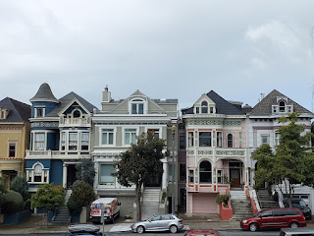

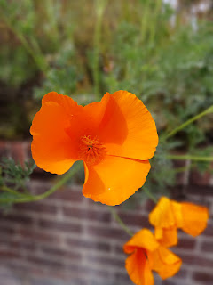

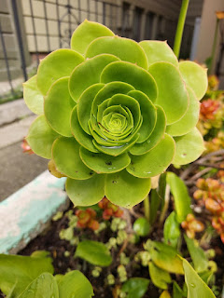

We got two of the last seats in Eddie's Cafe, a breakfast diner, and those seats happened to be right up at the counter. The swivel seats were a little too far away from the counter and my short little legs had a hard time reaching the foot rung to stay seated on my stool and not slide off, ha ha.

Scott was pretty stressed out at this point and didn't want to order anything at all. He didn't feel like eating, but I wanted him to have something in his tummy to help him think and function. I ordered him two pieces of French toast and a small omelet for myself.

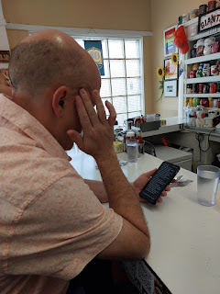

I convinced him to smile into the mirror behind the counter so I could take a picture of this all-important day.

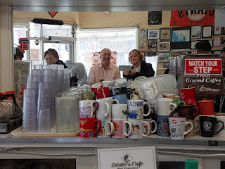

While we were eating our food, suddenly I had an overwhelming feeling that his mother, who died two years ago, was with us and was prepared to do all she could to help us from heaven that morning. It was such a powerful thought that tears began stinging my eyes as I leaned over to share it with Scott in quiet whispers.

A few minutes later, we started our journey on foot to the Consulate. Scott panicked when Google Maps on his phone said that it was a 59 minute walk to get there, which would make us LATE!! I was like, Whaatt?!? As we doubled our pace and even started jogging on every downhill stretch of those hilly streets, I told him I didn't think that was right. How could a simple one mile walk suddenly take 59 minutes? Eddie's Cafe was less than 10 minutes from our hotel . . . and it just didn't add up.

He checked his phone again and realized that Maps was guiding us to some other Consulate, instead of the Italian one. Whew! Now the ETA was much more reasonable, a mere 25 minutes or so. We stopped jogging and hustling, and walked a more normal pace at this point.

A few minutes later, I had another distinct impression that Coy was with us and the thought that was conveyed to me went something like this: "Okay . . . they're still making their way there . . . I'll go check on ____ and I'll circle back in a little bit."

Ana had told us about the Waymo cars that are everywhere in San Francisco. They are driverless cars that are also loaded with cameras and computers. You can book a ride using an app similar to Uber or Lyft, and Ana and her friend tried it once. She said it was a little creepy since there is no driver, but also because you are basically locked in until you reach your destination.

We saw several on our walk to the Consulate . . .

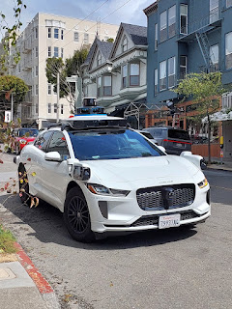

Video of one of the cars making a lefthand turn in front of us: (12 seconds)
https://photos.app.goo.gl/nxkzr5QjdMc2HXiPA

We saw a man getting out of a Waymo, and we asked him how did he like it. He said they are very efficient and he doesn't mind them. He said it was a little unnerving the first time, but now he's used to using their service. He added that for every
one mile
that
one car
drives, the cameras and computers are collecting information and data that is shared simultaneously with the entire fleet, so they are all "learning" collectively. That is both scary and kinda cool at the same time! Reminds me of the movie I-Robot with Will Smith . . .

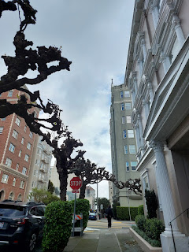

We got to the Consulate super early, so we paused to rest and collect ourselves for a few minutes. If you could see what was surrounding me as I took this next photo, you'd see that the Consulate was behind me. From here, you could see all the way down to the Marina District, with Fort Mason, Black Point, and Fisherman's Wharf (slightly out of the photo on the right).

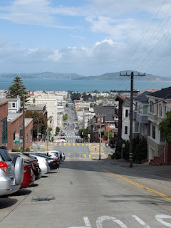

This is the front of the Italian Consulate building . . .

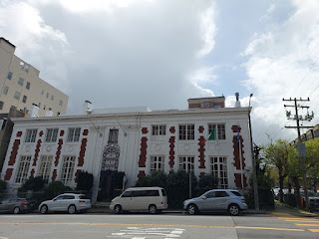

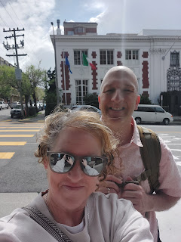

This shows the steepness of the hill directly across from the Consulate that goes down toward the Marina District . . . I cannot fathom how cars are able to be parked on such an incline.

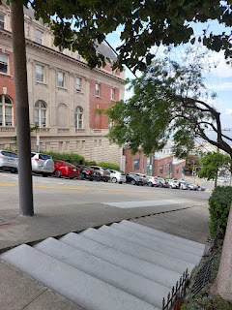

Scott was so anxious and worried while I felt calm and happy and peaceful. We were polar opposites, but neither of us was "right" or "wrong" in how we felt. He had experienced the wrath of the guy earlier and was therefore justified in his concerns. What if he forgot something? I reassured him of how careful and meticulous he had been in recent weeks, double and triple checking every single form, file, and set of instructions. I told him that lots of people were praying for us, and that all would be well. I suggested we say another prayer as we waited outside, since the streets were quiet and hardly anyone was around.

I felt again that his mother was there and watching over us . . .

A young lady came out of the Consulate a couple minutes later, so I asked her how did her appointment go. Fine, she answered. Did she press the buzzer early at all? Yes. How early? About 15 minutes. Did she get in trouble for pressing it too early? No, she answered. They let her in and everything went just fine.

That was good information and turned out to be a huge help for us a short time later.

Promptly at 12:15 I pushed the buzzer.

Man's voice: Yes?
Me: Hi, we have a 12:30 appointment for visas.
Man: (in an irritated voice) What do you mean, "we"? This is an INDIVIDUAL appointment only. What is the name of the individual for the appointment?
Me: Kenneth Scott Harmon . . . ?
Man: (as he buzzes us in) Again, this is an INDIVIDUAL appointment.

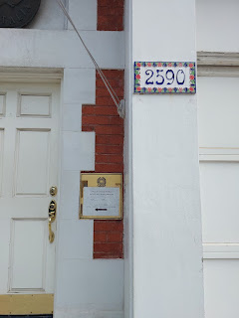

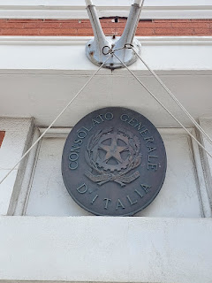

This is the spot where we prayed one last time and where you can see the buzzer above the steps . . .

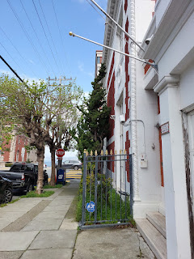

Scott told me later that he was praying over and over in his mind for whoever would be helping us inside, that their heart would be softened in our behalf.

We proceeded to the counter with a plexiglass window, much like a small DMV lobby. There were only 3 windows - the left one was unoccupied, the middle one had a lady behind the glass that was speaking Italian with a couple next to us, and then we got the grumpy guy on the far right.

Man: Paperwork?
Scott: (slides both sets of our forms through the slot.)
Man: I don't need these. (hands all of my paperwork back through the slot)

Scott and I exchange worried glances at each other and just stand there in silence as the man starts looking everything over.

Man: slides a few forms back through, tells Scott, "You didn't sign this." "This was left blank." "Fill this part in."
Scott: (after taking care of each thing, slides the papers back through)
Man: Passport.
Scott: (slides it through)
Man: Driver's license.
Scott: (slides it through)

Me: Excuse me . . . we thought this was an appointment for both of us.
Man: (Stops everything and gives me a hard stare) Proceeds to give me 3 condescending examples - of which I only remember the last one because I was in so much shock. "Say you and your husband need to see the dentist for a cleaning and you book your appointments on the same day. You wouldn't expect to sit in the same chair at the same time, would you? So why would you think anything different for this appointment?" Another example that he gave was something to do with how through the years, an immigrant would file his paperwork first, but his spouse had to wait a while before she could join him, so why should I expect anything different?
Me: Fuming on the inside, quickly thinking of how I can retort something back. Silently, I go through several scenarios in my rapid-fire brain, forming something like this: "You know, this is our FIRST time ever coming to a Consulate and our first time applying for a foreign visa. You, on the other hand, have been witness to thousands of applicants, I'm sure. Maybe this is all very familiar to you, but it's not familiar at all to us, so maybe a little bit of patience and kindness would be in order instead of the rudeness."

Ultimately, I held back. I bided my time, carefully weighing out all the pros and cons of how to reach through that open slot so I could squeeze his little neck.

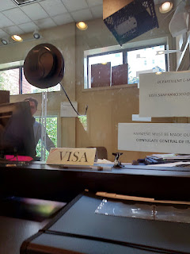

After a few minutes of silence as he stamped various forms and used a glue stick to adhere Scott's passport photo to one of pages, I crafted a different approach, one that I'm certain was inspired.

Me: May I ask you a clarifying question?
Man: (without even looking up) Sure.
Me: On the website, when we were booking the appointment, was there an option that we may have missed, where we could select one person or two persons?
Man: Nope. All of our appointments are individual only. That's all they've ever been.

While that didn't exactly help us in that moment, I felt it was important for Scott to know that he hadn't done something wrong when heoriginally booked this appointment slot. He would have been beating himself up for months if he knew that he could have selected an appointment for the both of us, but didn't.

I started thinking of all the possibilities for me at this point:
~ First, though, I whispered to Scott that at least he would get HIS paperwork taken care of today, and how this was truly what mattered the most. We could take care of mine at some point.
~ If they weren't going to process my paperwork, then at least I would be able to walk out with my passport still in my possession. This would mean that I could still travel back and forth to Italy for 90-day segments until whenever we could get my visa taken care of.
~ And maybe - if I got lucky - I could get another appointment to coincide with my coming to CA in August for a family reunion. I could go to the Consulate in SF again, and all the paperwork would already be filled out from this appointment.

And then the surprise happened.

When he came back from making some copies in the back room, he announced:
"I spoke with my supervisor and it looks like we'll be able to work on your paperwork as well. Normally we don't do this, but as long as we can get it all finished before 1:00 - which is when we close to the public for the day . . . after all, you did come all the way here from Idaho."

Shock. Tears springing to my eyes. Scott shooting me glances that said, "Don't cry...hold it together..."

We couldn't believe it. What a complete turnaround. What a miracle. What an answer to prayer.

The whole entire mood of the room lightened from that point on. He was a little more chatty and a lot less rude.

I turned on the charm - the charm that Scott says is one of his favorite things about me - and tried to get him to open up a little bit.

Me: Do you speak Italian?
Man: Rapid Italian sentences come flying out of his mouth, words that I can't even comprehend, ha ha.
Me: Omigosh. That was so fast! How did you learn Italian so well?
Man: My parents are both immigrants from Italy.
Scott: What brought them to the U.S.?
Man: Well, my dad came over here chasing a job, and my mom came over here chasing him. They both got what they wanted! (I even saw a small SMILE on his face. Like, what???!!!)
Me: That's so cool. Blah blah blah. We made a little more small talk and then he went back to make copies of my documents.

There was one final moment of panic when he asked if we had a second pre-paid mailing envelope for my stuff. I carefully - and very gently suggested that maybe we could just use the same envelope? He shrugged and just simply said, "Yeah, okay." I frantically hoped that they didn't also require separate mailing envelopes and that if we didn't have two, then it was all a big fat failure. I was also thinking, we sleep in the same bed, so maybe we could share an envelope . . .

While he was in the back room, Scott and I hugged and marveled and quietly celebrated this miracle of all miracles. After all, if they weren't able to process his visa, then the job would have to go to someone else. The company would most likely not wait around for several more months for him to get his ducks in a row.

We each had to get fingerprinted on a small digital fingerprint reader. When it was my turn, the reader started having some issues. He had to reboot the system twice. We started worrying that 1:00 would creep up all too soon and that we'd run out of time. I just held onto the hope that everything would work out. And it did. Third time WAS the charm, and my fingerprints were captured and saved successfully.

Within two minutes or so, we were done and out the door, calling out a couple more "Thank you's" over our shoulder as we exited.

As soon as we got outside, I lost it. And for good reason. Tears of joy came pouring out of me and I simply could not stop them.

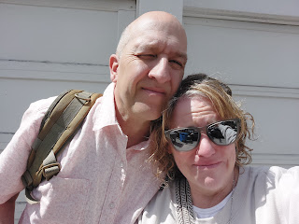

Every single piece of the puzzle of how that whole thing came together - they ALL mattered. Every last detail was crucial.

~ Scott's meticulous preparation ahead of time.
~ Checking the map of the area to find a post office and a bank ahead of time.
~ The bank clerk suggesting two checks instead of one. If we had only done ONE check, then Scott's application might have been rejected because it would not have been for the correct amount.
~ Scott having that first abrasive early morning interaction actually helped to prepare us mentally for the appointment.
~ Me keeping my anger in check instead of lashing out in my intense frustration.
~ Me being prompted to ask a "clarifying question" instead. Also, I think because I waited a little while to ask, it may have carried a bit more weight, quietly indicating that we were worried about our predicament and we needed to find a solution. I believe this is part of why he inquired on our behalf to his supervisor.
~ The other likely part of why he reached out to his supervisor, was that it was an answer to Scott's prayers. I didn't know this until afterwards, but he said that the whole time we were waiting to ring the buzzer, he was silently praying for this guy's heart to be softened so he would help us. Wow.
~ Feeling that Scott's mom (and whoever else) was there with us, and feeling that she probably contributed a great deal to the diffusing of that man's antagonism and hostility.

Looking up at the sky, I said "Thank you" out loud for the absolute miracle of that day.

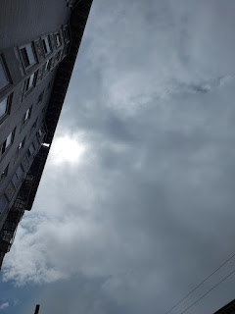

Everything felt lighter and happier from that moment on. Even the flowers seemed more vibrant as we walked back to the hotel.

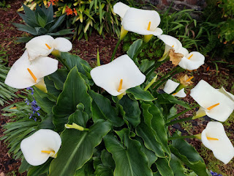

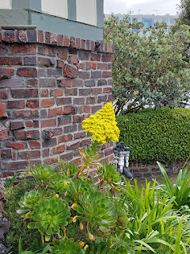

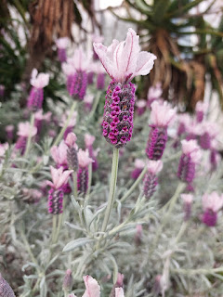

We rested and watched a show to relax for a while. Eventually, our tummies began rumbling. I suggested that Scott find us a place to eat since he was the big hero of the day in my eyes. He chose a fabulous place called Souvla, a Greek restaurant on Hayes Street and just under a half mile away.

Look at how happy he was now . . . a much different man than I saw that morning.

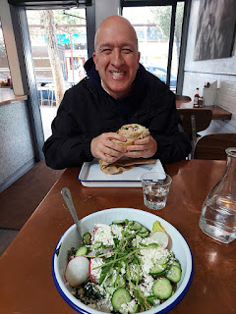

After my delicious and healthy salad, I balanced that out with some Greek frozen yogurt with a Baklava topping. It was sinfully delicious.

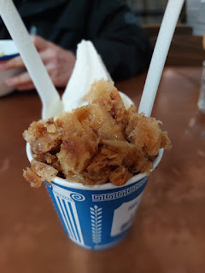

And the message on their cups was a nice extra . . .

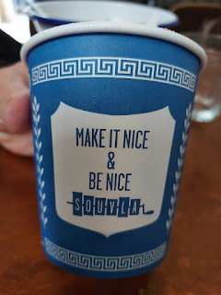

We went on a walkabout after the early dinner.

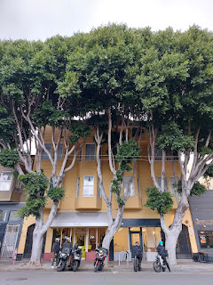

The City Hall building had some lovely and ornate gold touches . . .

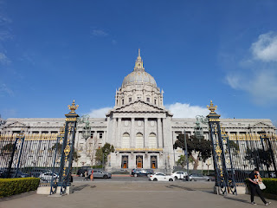

Across the street was a series of impressive sites: the War Memorial Opera House (which might have been the same place where I went on a field trip to see an opera in 4th or 5th grade), the War Memorial Performing Arts Center, and this poignant Veterans War Memorial.

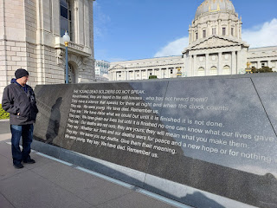

The view on the north side of the Veterans Memorial, looking west . . .

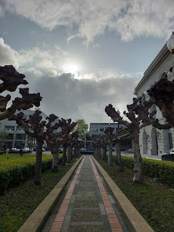

The view of City Hall from the east side looking west (the War Memorials are on the opposite side).

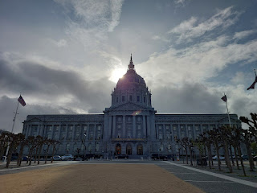

We wandered through Fulton Plaza, with various memorials to early settlers and the like. This is also where a large Farmers Market is held. It is surrounded by the UN Plaza and the main SF Public Library.

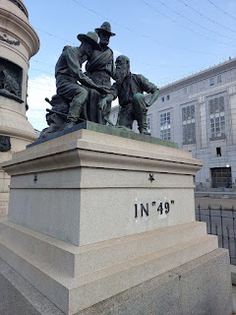

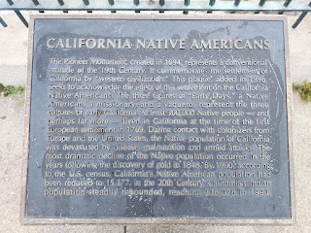

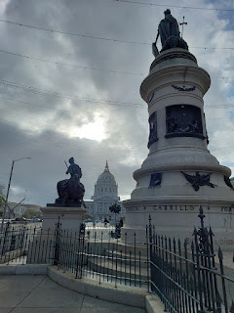

On our way back to the hotel, we walked past the Tenderloin People's Garden, what looked to be a publicly tended garden where tours can also pass through on certain days/times. I really loved walking around and exploring on foot. It's a much better way to visit San Francisco than trying to navigate in a car and trying to find places to park.

Wednesday, April 2nd:
After checking out of the hotel around 8:30 a.m., I drove us south to the SFO Airport. We reserved a spot in advance at the nearby SFO Parking Garage and then hopped on a shuttle to the airport.

We flew off to Minneapolis to spend a few days with our grandchildren, Jack and Maisie (and their parents). I'll share more about them in the next post.

But here are a couple of pictures to tide you over. XOXO

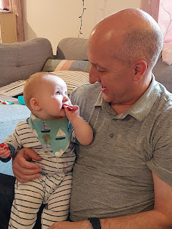

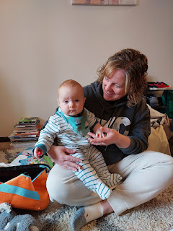

After all the playing and keeping up such a fun - yet hectic - pace, sickness has finally caught up to me. I hope that after a good night of sleep tonight (April 10th), things will be better tomorrow.

