A Downed Tree + A Whole Lotta Work
Heigh Ho! Heigh Ho! It's off to work we go . . .
It has been a VERY busy week, with only a few days left before I have to walk away and leave more things unfinished, yet again . . . (nervous laugh)

I'll start with the highlights:

1. Friday - I drove to Burley, Idaho (about 2 hours SW of Idaho Falls) to meet Benson for lunch.

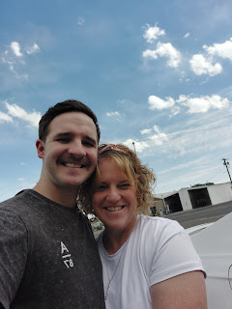

The first place we drove to was called Riviera's Kitchen in Rupert, but when we got there, it was clearly abandoned and closed. I sent an update to Google that this establishment was closed, and then we looked for another restaurant. Rupert and Burley are just a few minutes apart, so it wasn't a big deal to drive to Burley instead. Benson found us a new favorite place, called El Toro. The food was so delicious that we decided to make this a regular meeting place! It's only 2 hours of driving for each of us, so it will be a perfect halfway point!

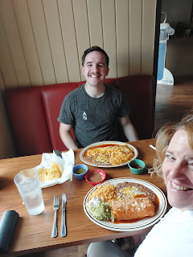

Benson ordered a "small" nachos to go with his chicken burrito, but after he ate the nachos, he was so full and couldn't even start to eat the giant burrito, lol. Well, at least he had some nice leftovers to take home!

I ordered something called a Chimichanga Jarocha - with crab and shrimp and pico de gallo, with a little bit of gooey Jack cheese inside. It was AMAZING.

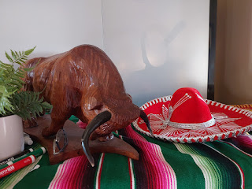

We had a great visit and a lovely mother-son date. I'll miss that face until I get back in December . . .

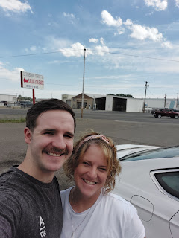

2. My monthly massage with Marie. I found out that she has just been diagnosed with ovarian cancer, but she doesn't know yet how bad it is. She meets with the oncologist next week, I believe. We hugged and cried together, but I have a feeling she caught it pretty early. She is very intuitive and tuned in to her body, and she is the one who instigated getting a few things checked out this summer. She is about 60 years old, and I've been going to her for over 10 years now. She is not only an amazing massage therapist, who can fix just about any issue that I show up with (especially my carpal tunnal in my forearms/wrists), but she is just an all-around wonderful person. She is so kind and compassionate, and we always have lots to talk about whenever I come.

3. I got my haircut on Wednesday. It always feels so good when you have a reliable hairstylist and she can make you feel like a million bucks!

4. I made a very tasty dinner with my niece, Mari, on Monday evening. First, we went shopping together to get all the groceries and bring them over to my house. Then we made the butternut squash soup and ate it while sitting outside in the back yard. It was a lovely evening and the soup was delicious! Mari toasted some pumpkin seeds and pecans in melted butter for a nice garnish.

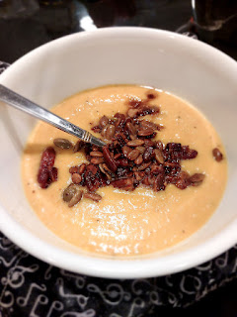

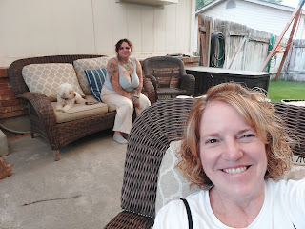

Here is the recipe we used, with notes from my sister Charmaine (Mari's mother): We just used the main recipe but not any of the variations this time. We also just used heavy cream to stir in at the end, instead of sour cream or coconut milk.

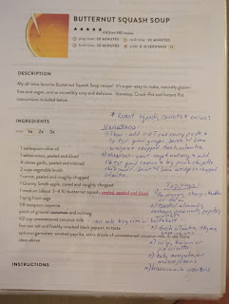

5. Talking with Scott on the phone every day. He is VERY excited for me to return to Italy so we can be together again. It's been a stressful week, and Thursday morning I was crying and couldn't even say hello when he called. He asked what was wrong, and all I could do was write down the phrase, "I'm feeling overwhelmed" on a piece of paper and then I held it up to the phone screen. He let me talk it all out and was a very kind and supportive friend. The main thing that was stressing me was that I was struggling to write a very important talk, or presentation, that was to be given that evening. I had been working on it for a few days, and it just wasn't coming together. My brain has been so full of details and urgency to get everything else done, and I was having trouble focusing and concentrating on just that ONE thing.

I have recently been called to serve on the Stake Temple & Family History Committee for our church, and the presentation I was asked to give was for a Leadership Training Meeting on Thursday night. My topic was how to help our youth and young adults to get more involved in family history work. It wasn't until I was relaxed during my massage with Marie that I finally got the inspiration that I had been praying earnestly for. The guidance that I received from the Holy Ghost was to cut out the "fluff" and just focus on the nuts and bolts.

The "fluff" was essentially an analogy that I wanted to share about redwood trees and their amazing root system, how they link up and hold each other up, and how they nourish and help each other. I had photos from my recent travels that I wanted to share and I wanted to talk about the symbolism of the root systems and how they relate to family history work.

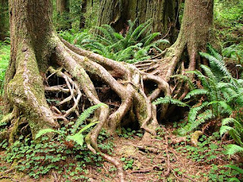

The nuts and bolts consisted of some ideas that I had prepared to get the youth more involved. I was struggling to put these two ideas together. But when I received the counsel to forget the "fluff" and just focus on the nuts and bolts, I didn't know then how pertinent this would end up being!

At the meeting, the people that spoke ahead of me went a little bit over their allotted time, and I knew that President Hunsaker wanted to keep the meeting to one hour, but it was clear that this would just not be the case. When it was my turn, I focused on those nuts and bolts that I had been inspired to prepare, and I kept my message to the 10 minutes that I had been assigned. I felt really good about what I shared, and I got some great feedback after the meeting was over. If I had even tried just a little bit to insert the analogy of the redwood trees, I would have dragged the meeting out even more, and perhaps even wasted everyone's time. But it all turned out well in the end.

6. I went to the temple on Wednesday afternoon. This is always a highlight for me whenever I go, and I was so grateful to be there.

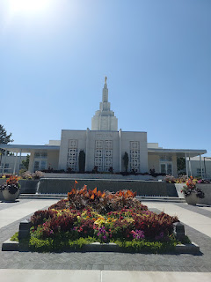

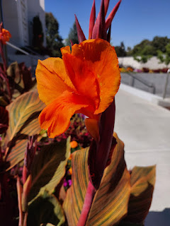



The rest of the week was WORK, WORK, WORK.

The biggest thing that happened this week was my pine tree getting chopped down on Tuesday. I went out at 7:30 a.m. to take a "before" picture, and no sooner had I walked back inside the house than the tree-cutting crew pulled up out front.

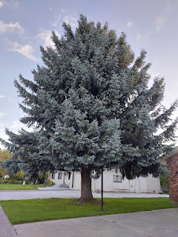

They made very short work of the whole thing. First they cut off all the branches on the left side of the tree, using a cherry-picker truck with an aerial lift.

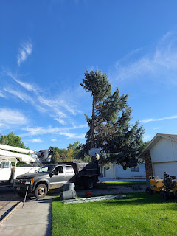

After they trimmed off the rest of the branches on the other side, all that was left was the little "tuft" at the very tippy-top.

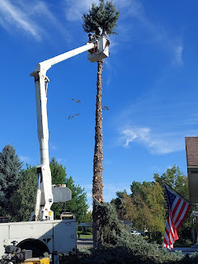

Then, they started chopping the trunk into firewood chunks for me.

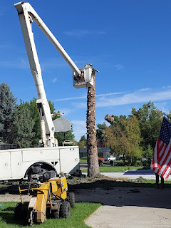

Lastly, they ground up the stump and cleaned everything up really nice.

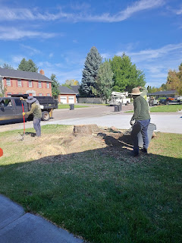

There are plenty of huge pieces of firewood that I'm waiting for a friend to help me take care of in a week or so. I'm thinking that if we can just cut those massive pieces in half, then they should stack pretty nicely up against the side of the house.

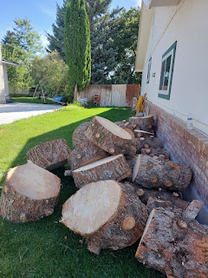

It looks completely different now!! Kind of bare, but kind of nice at the same time.

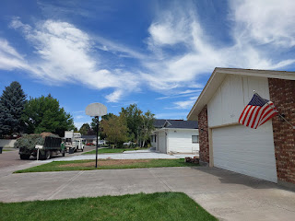

And the basketball hoop isn't hiding in the forest anymore . . .

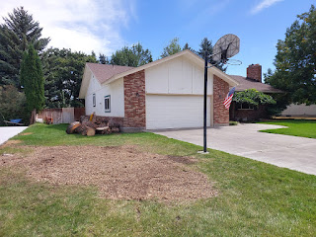

Video #1 of the tree crew, chopping down the trunk: (14 seconds)
https://photos.app.goo.gl/Lh9GzmH67Xe34rRcA

Video #2 of the tree crew, trying to get the thicker base to fall: (57 seconds)
https://photos.app.goo.gl/5GtsB2bhqR9szifG8

Video #3 - a shorter version of the last video, with just the exciting ending: (6 seconds)
https://photos.app.goo.gl/ft3MX31EWFowZzAu8

Video #4 of the stump grinding process: (23 seconds)
https://photos.app.goo.gl/TU84AjY4KbebcKPW8

I also helped Mari on Wednesday evening with cleaning and organizing her kitchen. She's been having a hard time lately, and needed not only some motivation, but a buddy as well.

After washing two sinks full of dirty dishes, and lining her shelves with a pretty liner so she could put everything away, this was the finished result:

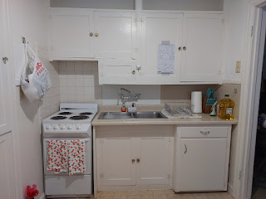

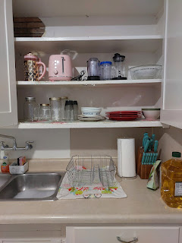

I took her out to dinner afterwards and we had a nice time.

I've been washing bedding, putting beds back together, pulling weeds, trimming perrenials, preparing some packages to send to my grandchildren, running miscellaneous errands, and trying to get to the gym as often as I feel up to going.

Even though my Johnny Tree (Zestar Apples) looks ready to harvest, we weren't home in time to spray the tree early enough in the season to prevent worms this time. We did spray the tree once we got home at the end of June, but I think it was just too late. All of the apples have worm holes in them, darn it. We'll get home sooner next spring and we should be able to have a good harvest at the end of next summer.

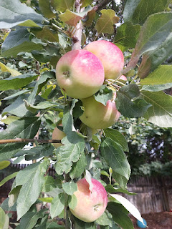

I trimmed down the rhubarb, pulled all of the weeds along the back of the house, and slimmed down my cilantro patch. The back yard looks ready for winter now.

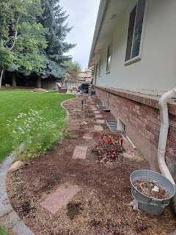

I did manage to go to the Farmers Market with Mari on Saturday morning. She has a hard time walking for very long or very far, so we left after one hour. She enjoyed seeing all of the booths, with their offerings of recycled glass jewelry and home decor, gem stones, all of the goats milk products like cheese, lotions, and soaps, fresh sourdough breads, watercolor paintings, and food vendors.

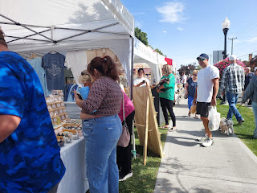

I've never seen so many pretty colors and varieties of mushrooms before . . .

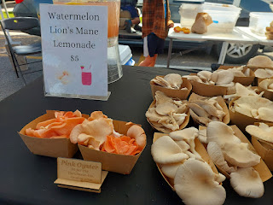

She didn't get anything (even though I gave her a little bit of money to spend), but I bought a loaf of jalapeno & cheddar sourdough bread, a super cute dress, and a burrito to take home for lunch.

My neighbor, Kim, brought home a new puppy on Friday. Her name is Millie, and she is the daughter of their older dog, Milo. Millie is just the sweetest little thing. She will come and lay down next to you so she can snuggle with you, and she is SO SOFT!! She is 8 weeks old.

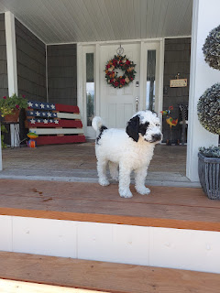

Below: Kim, in the background, and Millie trotting over to see me. Millie's sister, Sadie, came over to visit, since she belongs to Kim's Mom. Sadie is smaller and has the same golden-brown color as her mother.

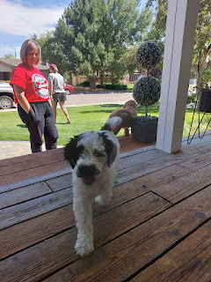

Video of Millie and Sadie trotting around the yard, with Millie wanting to bite her sister's tail, LOL:
(11 seconds)
https://photos.app.goo.gl/iN4C7EiD8io5c2Pb6

And lastly, my good friends, Neal and ReNae Cunningham, came over to help me with a couple of things that I would have struggled to do on my own.

1. We got the sun shades down in the back yard. They are all tucked away in the garage for the winter.
2. Neal helped me move a couple of heavier things around in the garage, by hefting them up onto the high shelves while standing on a ladder.
3. He also hopped up onto the roof to fix a chimney cap that had been dislodged.

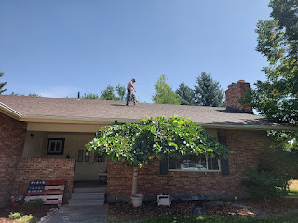

What a good friend! I could have done it, but I would have been scared to get up on that ladder by myself, especially when the ladder needed to be propped right in and amongst all the huge pieces of tree chunks that the crew left behind.

I still have plenty to accomplish in the next 4 days before I leave, but it feels like it's very doable. I've gotten the yard pretty much taken care of now, and that was a huge undertaking. Now I can focus on cleaning the house and getting packed. I'm excited to be reunited with my bestie in Italy!!

