A Nice Long Date With Avery + Top 3's of 2022
We had the privilege of taking care of Avery from Monday evening until Thursday evening. What a joy it was to spend all that time with her!! She is very sweet most of the time, and she is definitely full of personality, too!
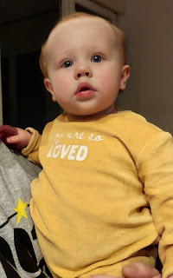

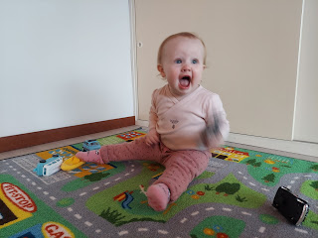

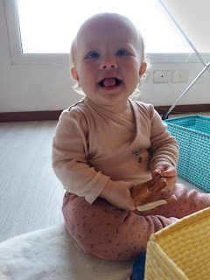

We drove halfway to Aviano on Monday evening to meet with Kylie and to pick up Avery. It was nice for both of us to only drive about 50 minutes each way this time. It's usually about 90 minutes (each way) if one person drives the whole way.

She hadn't had her dinner yet, so since we met at a Burger King parking lot, it seemed appropriate that we should go in and find something to eat. I'm not usually a fan of Burger King, but when in Rome . . . and it actually tasted pretty good! I ordered a chicken sandwich and we got some nuggets and fries for Avery.

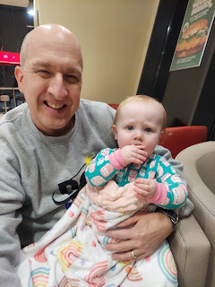

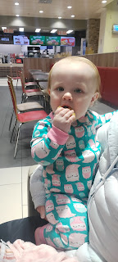

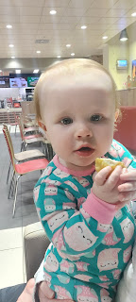

I sat in the back seat with her for the drive back to our house. She appreciated that. Especially since we had bought her a new carseat and she was unfamiliar with it, and therefore upset when we tried to buckle her in . . .

Scott only had to work half days Monday through Thursday, so we looked forward to him coming home around lunch time each day. In the meantime, I enjoyed getting her up and going in the mornings, and playing with her after she was done with her breakfast.

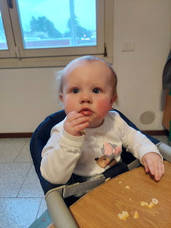

We borrowed a stroller from a family in our ward here so that we could take Avery on some walks. It was a very good decision to do that! Sometimes, if she was a little fussy, or if we weren't sure how to fill the next hour of the day, we would just load her up and take her for a walk. She absolutely loves watching everything and everyone as we pass by.

There aren't a lot of houses with Christmas lights in Italy, and the houses that do tend to have just one string of lights on their balcony. This house had an additional sign that was illuminated with the Nativity scene, and I liked that. You won't find any blow-up lawn decorations here in Italy. Everything is very subtle, if anything at all.

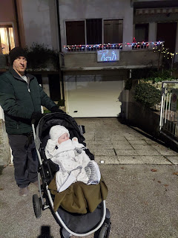

The air was crisp and cold this week. Highs in the 40's and lows in the 30's.

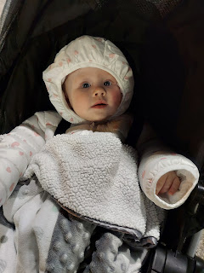

Poor Abby was battling a horrible ear infection down in Louisiana. She had a prescription for some ear drops as well as an antibiotic to take each day. She was in a great deal of pain and discomfort early in the week, but thank goodness for modern medicines. She is feeling much better now, and just in time for Christmas!!

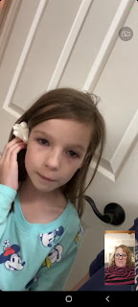

Our days with Avery revolved mainly around mealtimes, ha ha. This girl LOVES to eat!! Each morning, I would take a photo of Avery to send to Kylie.

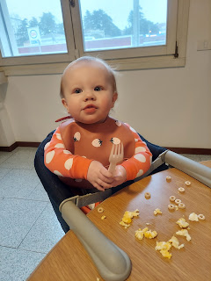

If we needed a "filler" at any point in the day, a good solution was always to take another walk. :)



Avery was excited to have TWO pizza crusts, one in each hand, ha ha.

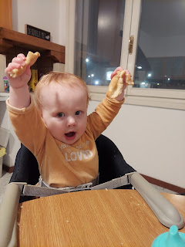

Here is a sweet sequence of photos with Avery offering some of her food to Poppa, and then touching his eyes, his nose, his chin, etc.

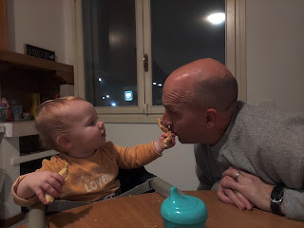

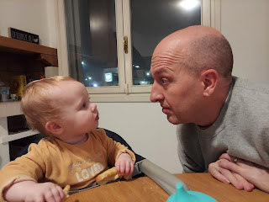

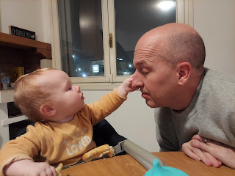

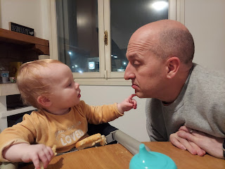

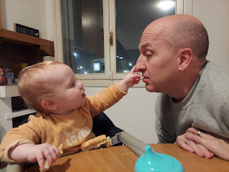

Mealtimes would often get a little messy, so it was off to the bathtub afterwards. She was always happy to splash around in the warm water for a little while.

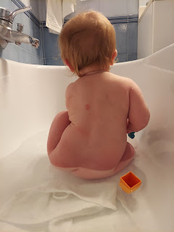

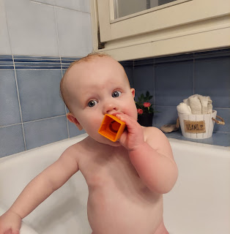

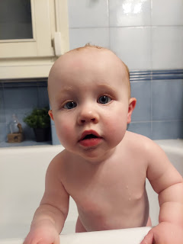

That face, LOL



Taking her upstairs to play in the guest room makes her very happy. She likes the cars and the other toys I've collected. Plus I think there's something about the sunny room and the soft rugs that are so lovely and inviting . . .

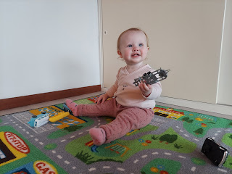

When she saw this little doll on one of the rugs, she giggled and was so mesmerized by the doll's face. It was so darling to watch her wonderment. I decided right then and there that she needed one more Christmas present from Mimi and Poppa: a baby doll of her own.

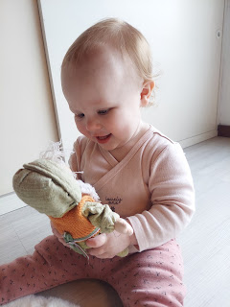

She also enjoyed my reenactment of various animal sounds, like this horsey . . .

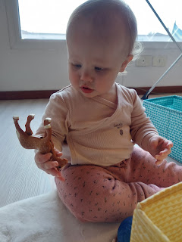

Later that afternoon, we took her to the Bimbo Toy Store so she could pick out a doll. We showed her a few different ones, and I just watched to see what her reaction was with each one.

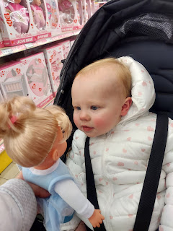

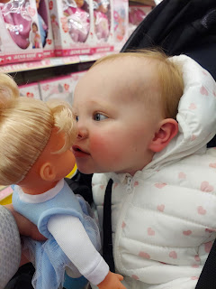

Eventually we settled on this one.

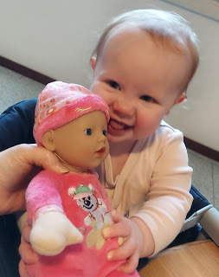

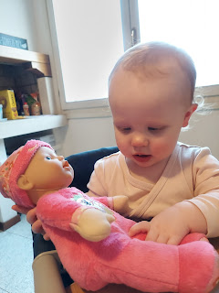

Video of her enjoying the new baby as she ate some Cheerios: (13 seconds)
https://photos.app.goo.gl/pJkMWBmKq2H3VeK48

Another video of her with the new baby at home: (17 seconds)
https://photos.app.goo.gl/xQQXNhBHaL1recqE7

When we finished picking out a doll at the toy store, we walked a short distance away to see some goats and geese. I had seen them the day before when I went shopping for Nativity sets at Viridea, a local garden shop. There is a large enclosed pen and small pond on the north end of the huge store.

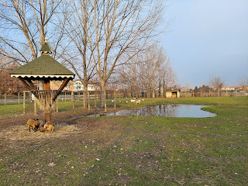

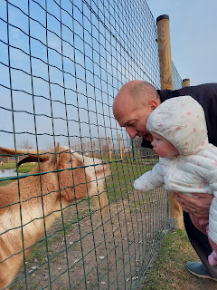

The facial expressions of this billy goat just cracked me up!!

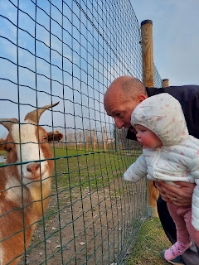

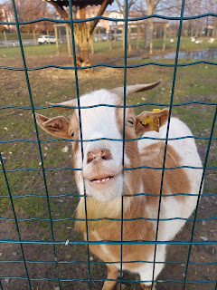

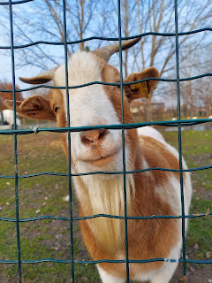

He was ECSTATIC when Scott fed him a few of Avery's Cheerios . . . LOL

Video: (16 seconds) *Right after I stopped filming him, he head-butted one of the very small goats to keep him away from the stash of Cheerios . . .
https://photos.app.goo.gl/kgmTEMtFpuAA4ooF7

We walked down to the other end of the pen to see the other large billy goat. He also loves Cheerios, apparently!

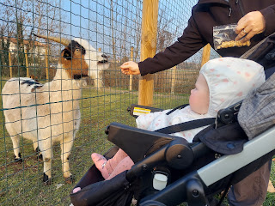

Can you see how excited he was? ha ha

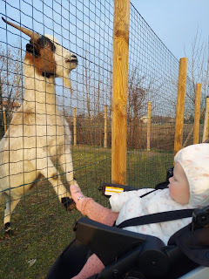

Avery was unfazed by the goats . . . she just sat there watching them. She is such a great personality. Most of the time she just wants to hang out wherever the people are, only occasionally needing a quiet (solo) break for 20-30 minutes. She is extremely observant and watchful of everything going on. She gets the most hilarious little bursts of energy from time to time, where she clenches her fists and gives a little shout or an excited and forced giggle. Sometimes she is snuggly, and those times are always welcome!!

Benson said something that really impressed me when he was here on Christmas Eve. We were talking about Avery and her fun personality, when he told us of a time recently when she was fussy and how he patiently helped her to work through that. When she is tired or cranky, she tends to just chuck whatever you offer to her. She wouldn't even settle down enough to take her bottle this particular time . . . He knew that she likes the ping-pong balls in their house, so they just sat on the floor of her room together. He would hand her a ball and let her throw it across the room, over and over and over. He would retrieve the ball and hand it back to her. Eventually, she was satisfied, and was more calm and receptive to taking her bottle and then taking a nap. He said, "I think she just needed to get her aggression out by chucking those ping pong balls until she felt better." I complimented him on being so intuitive and patient with her. He is a good father to her and I'm so grateful.

Thursday evening, Scott and I drove up to the half-way point again to drop off Avery. This time, Benson met us at the McDonald's in Creta (near Treviso). As I sat at the table with Avery while we waited for Benson to arrive, it hit me that this will be the last time I see her for a long time. I'm not sure when Kylie and Avery will fly back to Idaho Falls to settle in with her parents, but it will likely be around the time that I fly back to Italy in March. It's possible that they might fly back to Idaho Falls sooner, in which case I will be in town to see them. But it's also possible that they might fly back to the States as I'm flying back to Italy, in which case I wouldn't see her until I get back to Idaho in June . . .

Anyway, it made me very sad.

I tried to take a couple of selfies of me and Avery while Scott was helping transfer all of her luggage to Benson's car outside. I didn't realize until later that these are the only pictures of Avery and me for the entire FOUR DAYS that she was with us!! I'm always the one taking the photos, but rarely am I also in them . . .

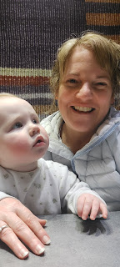

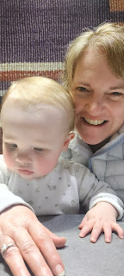

I will miss that sweet, spunky, and energetic girl!! XOXO

We all got home safely to our homes that night and tucked ourselves into bed. :)

Friday meant shifting gears quickly from playing with Avery to cleaning the house, getting organized to leave Italy soon, and figuring out the right amount of groceries to get with only 3 days left . . .

After several hours of taking care of business, we went on an evening excursion up to Monte Berico - the focal point of Vicenza that sits up on a hill near the center of town. We rode the bus again so we didn't have to find a parking spot, choosing to disembark at the Vicenza train station. After a short (10 min) walk, we arrived.

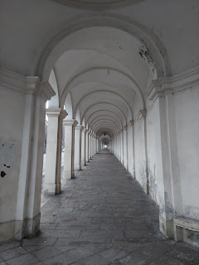

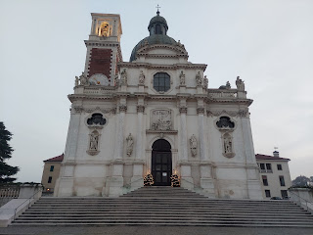

The view looking out toward the sprawling city of Vicenza.

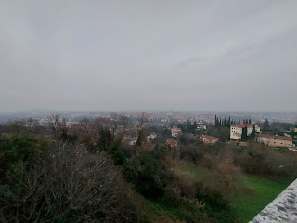

We caught the sunset just in time! It wasn't a huge or lengthy sunset, but it was pretty for the few minutes that it lasted.

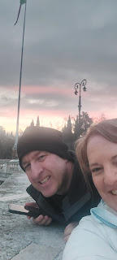

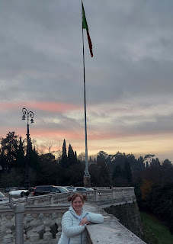

We walked around for a little while, just enjoying the views. That's when the church bells began to play some Christmas carols. It was spectacular!!

Video of the first verse of Silent Night, with singular bells: (56 seconds)
https://photos.app.goo.gl/F8nwpYwmmJ8x93ku6

Video of the next verse of Silent Night, with multiple chords of bells: (39 seconds)
https://photos.app.goo.gl/esXDcZvjR7XNJGd86

They also played The First Noel and Angels We Have Heard on High.

I happened to notice a couple of people walking inside an entrance that led to an inner courtyard at Monte Berico and I wanted to see where they were going . . . so we followed them . . .

Video of the courtyard as the bells were finishing up a song: (27 seconds)
https://photos.app.goo.gl/YKckdYhuT93GpqP89

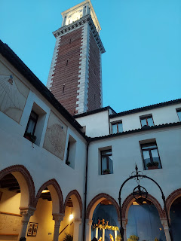

They had a lovely Nativity scene in the courtyard. I noticed that there was no Baby Jesus in the manger. I wondered if they intended to place Him in the manger on Christmas Eve or Christmas morning . . .

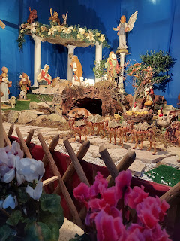

We headed down the hill back to where we could catch a bus home. The views were getting prettier and prettier as darkness fell and the lights came on throughout Vicenza. You may recall our visit to the Vicenza Christmas Market last weekend, with the tall tower and festive lights that were strung from the tower. You can see them in the photo below if you look off in the distance.

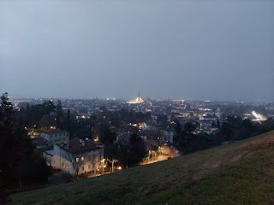

We came DOWN the many steps that lead up to Monte Berico. Very smart decision I'd say . . . especially since I still have a bit of a cough from my lengthy sickness. I had to use my inhaler to go up the steep graded path earlier in the evening, an alternate route to get up to the Basilica on top of the hill (besides the steps).

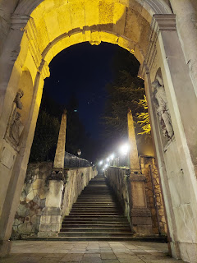

When we got to the bottom of the steps, Scott looked on Google to see if there was a closer bus stop to get home instead of walking back to the train station. Sure enough, there was! Instead of a 10-12 minute walk, we only had to go about 3 minutes.

When you buy a bus ticket using the MyCicero app, your ticket is good for ANY bus rides within 90 minutes in the city of Vicenza. We were down to the last few minutes that our ticket was good for, but we figured we had plenty of time to get to the bus stop and catch the next bus before our ticket expired.

It just so happened that the bus was running very late, which is very unusual. Our ticket expired while we stood there waiting for over 15 minutes, so we started walking home instead. Yes, we could have bought another ticket, but it was only a mile to our house, so we decided to just walk since it was a lovely evening and wasn't too freezing cold. About 20 seconds after we left the bus stop, that's when Bus 19 drove by . . . ha ha oh well. We decided to laugh about it and just chalk it up to getting a little more exercise for the day.

Early in the morning on Christmas Eve, I baked some festive cookies and did some more cleaning around the house.

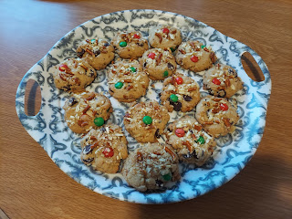

The cookies are kind of addicting . . . here is the recipe - - - but beware of the addictive tendency:
https://www.delish.com/cooking/a50432/santas-trash-cookies-recipe/

We got a video call from Jack late in the afternoon. He likes to show us his stuffed animal friends, and we sometimes "chat" about one of his books.

I showed him our sunset up on the roof.



With some encouraging from Jacob, Jack participated in some yoga stretches.

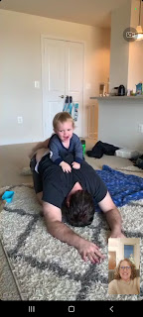

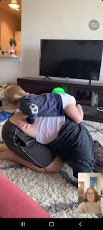

And then he got an airplane ride at the end. :)

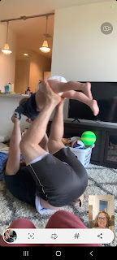

After we chatted with Jake, Hannah, and Jack, I hurried to prepare dinner for Benson, who would be arriving in about 45 minutes. I made him some maple-glazed salmon, with orzo pasta and cooked carrots for the side dishes.

We had such a nice visit with Benson. I'm so glad he was able to come down for the evening! After we cleaned up the kitchen a bit, we took him over to see Monte Berico, something he had never seen before. He really enjoyed the beautiful architecture and the magnificent views of the city.

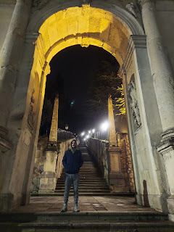

Gosh I sure love this kid of mine. He's a good guy. Whenever I'm with him, I just thoroughly enjoy visiting with him and hanging out. Whenever we're apart, that's when I worry and hope that he's doing okay.

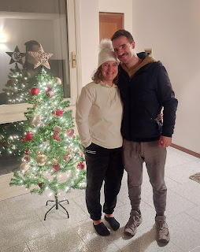

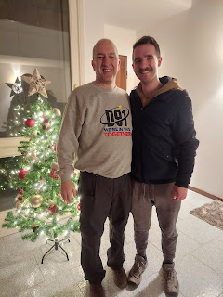

When I was sick for all those days in December, I began making a list of my favorite things from 2022. Here's what I came up with.

Top 3's of 2022

Top 3 Highlights:
Meeting Avery in April, visiting NYC with Amber in February to see her painting on display at the Center Gallery, and meeting the kind and amazing people of Morocco in June.

Top 3 Places in Italy:
Asiago, Vatican City, and Monte Baldo. (Honorable Mentions: Sirmione and Road of 52 Tunnels)

Top 3 Accomplishments:
Converting 2100 of my Dad's slides to a digital format, digitizing the Rawles Family Big Book, and making TWO quiet books for my grandchildren this year.

Top 3 Foods I've Tried:
Jacob's Birria Chicken, Italian Pasticcio (messy lasagna), and Nutella gelato.

Top 3 Movies I've Watched:
Top Gun, 100 Foot Journey, and The Monuments Men.

Top 3 Spiritual Lessons:
Singing powerful primary songs in our Vicenza Ward - both in preparation for the Primary Program and at a recent baptism program for Landon Miguel (8 years old); connecting with my new friend Andrea, being led by the Holy Ghost in many instances; and praying with my niece Mari over the phone when she needed some heavenly help, and having her tell me that it made her cry. :)

Some final photos . . .

Jacob, Hannah and Jack when they visited the Washington DC Temple last week. How beautiful!!

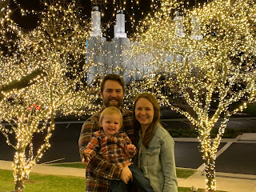

Jack's special gift to wake up to today on Christmas Day. :)

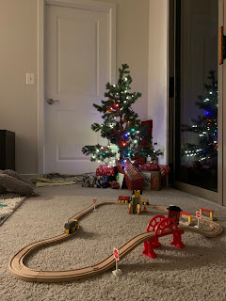

And Amber's beautiful tree in Louisiana, complete with a darling tea party set for the girls when they wake up.

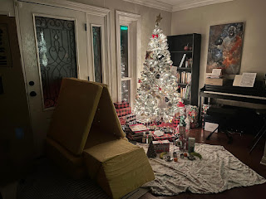

Merry Christmas everyone!!

My heart is full as I think about how that sweet and perfect Baby Jesus in the manger grew up to be a perfect Man. His story did not end in Bethlehem. He grew in wisdom and stature and fulfilled his destiny as the Son of God as He performed the most loving act in all of history, the Atonement. Because of Him, we can change. Because of Him, we can improve. Because of Him, we can have everlasting peace and forgiveness. Because of Him, we can be with our families forever. Because of Him, we can have true and meaningful joy. All because He was born . . . and then because He became a Man, but most importantly because He became our Savior.

This Christmas is different than any other that I've ever experienced. We are in a foreign country, with no gifts to unwrap under the tree (our Christmas this year is to see all of our children and grandchildren), I spent most of the month sick in bed, and we only have a handful of Christmas decorations. Everything feels slightly underdone . . . but that means that I've had to try extra hard to feel the spirit of the season and to connect with our Lord and Savior, Jesus Christ. I'm still working on that, but I'm getting there. The journey is pleasant as I find a way to connect to the Lord of Lords, the Lamb of God, the Prince of Peace. I don't hate the process one little bit.

