A Season of Snow and Service
It has been a week of snow, snow removal, more snow, and more snow removal. There has also been some additional snow, and then some subsequent snow removal. :) My right forearm is particularly achy from all the shoveling, but thank goodness for ibuprofen and essential oils in between rounds. I'm also grateful for my good neighbors, the Parkinsons, who have come over to help me a few times. I have made it a Harmon Family Habit to always take care of Ellen's snowy driveway next door for the past 17.5 years, but I no longer have teenagers at home to help me with that. However, Kim Parkinson has two able-bodied boys who have come over to assist when I'm out there shoveling, usually with Kim at the forefront of the operation.

Kim's son, William, has enjoyed being old enough to run their snowblower and he's doing a great job for being just 12 years old. You can see him in action in the photo below, as he clears his own driveway.

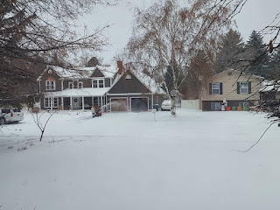

The snow is piling up more and more each day . . .

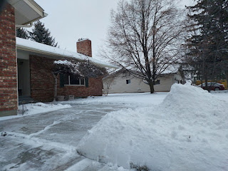

I got a phone call from my friend, Marnie Parker, back in Italy at the start of the week. She was worried about her daughter, Lauren, who recently arrived back at BYU-Idaho for another semester of college after the holidays. After a recent change in Lauren's medication, there was some fallout with the side effects and she was very sleep deprived and felt like she was imploding. Marnie wanted me to go check on Lauren and give her a big hug from her mom on the other side of the world, which I happily agreed to do.

I arranged to meet Lauren at Emily's apartment, so I could see the both of them at the same time. I also had some grocery items from Costco to bring to Emily, so it worked out nicely for everyone. We visited for about 2 hours, with lots of hugs throughout. I encouraged Lauren to write some positive affirmations and post them where she could see them regularly each day, to combat the negative thoughts that kept creeping into her mind, unsolicited . . . I also talked to her about praying for specific things that would be helpful for her, and even offered to pray with the girls, which they gratefully accepted. We knelt on the bedroom floor of Emily's room and I humbly prayed for each of them. It was a beautiful experience.

Here we are: Lauren (on the left) is holding the little baggie of Tylenol PM pills that I brought for her to help her get a better night of sleep, I'm in the middle, and Emily is on the right. They are some amazing girls and I am grateful to be included in a small part of their lives.

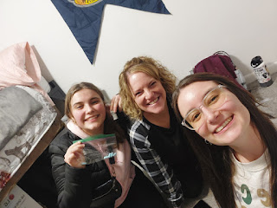

Scott and I spent some time on Google Meet in order to buy my next ticket to Italy (March 19th). It was nice because he shared his computer screen with me through the app, and then we could look at the airline tickets together and fill out the information with two sets of eyes when we actually made the purchase. We ended up getting his round trip ticket at the same time - for June - so that we could choose seats next to each other as we fly back to the U.S.

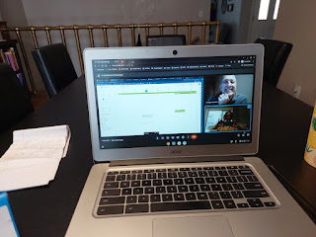

He will join me in flying back to Idaho Falls on June 25th, where he will visit for about 2 weeks before flying back to Italy after Independence Day.

I went to the temple in Idaho Falls this week, too, which was so nice. I was doing the temple work for one of Scott's ancestors, Elizabeth May Weaver, when I got all choked up. The temple worker paused to let me try to compose myself, and she even reached out to give me a long, warm hug. I love it when there is some sort of acknowledgement, or validation on the spot - that the person for whom I am performing this sacred ordinance is there in spirit and they are grateful for what I'm doing on their behalf. It is such a special experience and definitely sets the tone for the rest of the day. It also reminds me that this life is temporary here on the earth, but that everything we do has eternal consequences and blessings. There is so much to look forward to in the life to come, and I am excited to meet all of my ancestors one day.

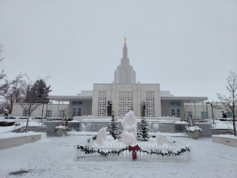

As I checked on Lauren with a text message, I shared the photo I had taken at the temple that morning. She loved it so much that she made it her screensaver on her phone!

I drove up one more time to Rexburg in the middle of the week so we could celebrate Emily's birthday. Yes, there was a big storm that day - a blizzard in fact, but the roads were surprisingly decent for my 40 minute drive north. I picked both girls up, Emily and Lauren, and we went out to eat at Millhollow, a cute little restaurant in town. We all ordered a hot, toasted pulled pork sandwich on sourdough, but with differing fixings inside each of our sandwiches. Mine was incredibly delicious! We sat and visited for a good long while and it was really fun! Lauren is doing a LOT better, especially now that she is sleeping better. It's amazing how something so simple can make such a huge difference. Lauren is a musical artist and even has some music that has been released on Spotify. You can find her listed with her 2023 album, Apollo. (Lauren Parker) She is also in a band while she's in Rexburg, and they are playing at various gigs. She writes her own songs and is quite talented. I was just so grateful to see that she was more like her usual cheerful and energetic self.

Lauren (left), Me, and Emily (right)

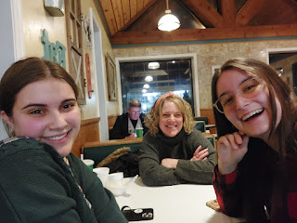

Scott and I have had some good chats this week. One of the things we've decided to do is to go through a Self-Reliance course together, using Google Meet on our computers. The Church of Jesus Christ sponsors several Self-Reliance courses (for free), including: Personal Finances, Starting & Growing a New Business, Education for Better Work, Find a Better Job, and Emotional Resilience. We chose to participate in the Personal Finances class on our own because when I tried to hook up with a local class here in Idaho Falls, the time that they chose to meet in person didn't work for me at all.

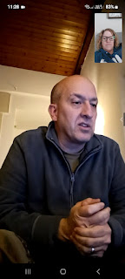

I've been wanting to take this class for the past 2 years, but the timing never seems to work out on my end. It's a 12-week course, and you need to be there at least 90% of the time. Well, when I'm back and forth to Italy every 90 days, my life hasn't ever lined up with the class schedule at all. This time, our schedules matched up, but the time of day and the day of the week weren't good for me, so unfortunately I was not able to participate. But my sweet husband stepped up and now this will be our weekly Friday Date. At 10:00 a.m. every Friday morning in Idaho, which is 6:00 p.m. his time in Italy, we will hop on our computers using Google Meet and we will go through the curriculum together.

One of the things I'm already impressed by in the lesson manual, is how temporal things and spiritual things are so intertwined. There is a quote in the introduction that says, "Like two sides of a coin, the temporal and spiritual are inseparable." (Dieter F. Uchtdorf, 2011) It goes on to teach the following: In the scriptures, the Lord declared, "All things unto me are spiritual, and not at any time have I given unto you a law which was temporal." (D & C 29:34)

The discussion question that follows those statements is: How can finding a job and earning a living be both a temporal and spiritual matter?

Answers that we came up with are: As you are looking for a new job, prayer can be a great boost to your process. Inviting Heavenly Father to be a part of your search can be powerful and intuitive as you listen to promptings that you may receive. As you earn a living and can provide for your family, you are laying a foundation where - after the basic needs are met - love and joy can permeate the home, which is part of God's great plan for us.

I'm excited to go through this class with Scott because I think we will grow together in future decisions that we make when it comes to our personal finances. He is the saver and I tend to be the spender. He tends to want to hold on tightly to his earnings, while I want to make memories and enjoy life. We have had a good financial relationship thus far, but there is always room for improvement. I am eager to see what I will learn during the next 12 weeks.

Don't let the blue skies and sunshine fool you. It's been brutally cold up there this week.

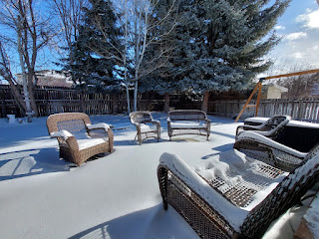

On Saturday morning, I woke up early because I needed to go help clean the church with a group of friends and other ward members. I checked the weather to see what kind of layers of clothing I might need for the day. It said it was -7 degrees, but that it "feels like -16". Yikes!!

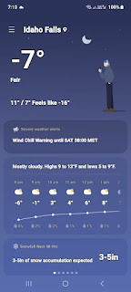

After I helped clean the bathrooms with my friends, Trudy Roberts and Michelle Going, we checked with Mary Kay Tall to see how much more she had left to do with her job of cleaning the windows. She asked for our help with a little issue she had while trying to clean the outer doors . . .

She had sprayed the cleaning spray onto the window panes when it immediately FROZE!! She couldn't use the squeegee at all, and suggested that we get a bowl of warm water and some extra cleaning rags to try to defrost the residue.

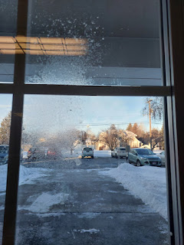

I was the first to try her suggestion, but it failed as well. As soon as I applied the warm rag to the window and moved it around, it merely created a bunch of frozen smears all over the place, ha ha. I kept at it a little bit longer, digging my fingernails into the rag to try to scrape the frozen smears and frozen cleaner off. It gave way just enough that I got excited, but then Michelle Going had an even better idea. She ran to grab an ice scraper from her car . . . and it WORKED!!

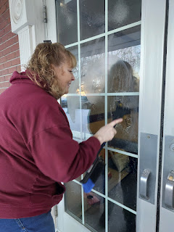

We scraped all the residue off the window panes with her ice scraper and got the windows looking ship-shape for church on Sunday. What a hilarious experience . . . But this is what happens when it dips down below zero degrees in the wintertime . . . LOL

I visited with Scott once I got home, and he was hard at work cooking up some chicken in the frying pan while we chatted. He's getting pretty good at cooking a few more things for himself, making a larger amount on one day that can last him throughout the week in various meals. Good for him!

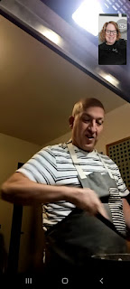

Yes, this blog post is considerably shorter than usual. And that's okay. Some weeks are going to be more "boring", or more "normal", depending on how you look at it. Not every week is going to be as exciting as some of the places I've been able to visit in Italy . . .

This week has been mostly filled with snow removal, but I've also worked on Jack's construction playmat quite a bit. It's ready now to start sewing everything onto the background fabric and I'll probably start that on Monday. I've had numerous phone calls with family members near and far, including a few conversations where I've been gathering information for another Rawles Family Blog & Newsletter. I've been washing some bedding and putting the beds back together. I had a nice long conversation with my sister, Charmaine, on Saturday evening where we discussed the spreadsheet that she built to help us plan out her upcoming trip to Italy in the fall. And I made a big pot of soup for myself, too. It's a repeat of the Swiss Beef Stew that we made for our Swiss Ancestor Night in December.

I have also been up to check on my father-in-law every other day this past week, bringing groceries and supplies to Dad and Vernetta, including a pair of winter boots for Vernetta. I have shoveled their driveway a few times, too, because the people they have been paying for years aren't doing a very good job. I would give them a "D-" grade . . . After a few phone calls, Scott's sister Bev has lined up a better situation for the snow removal. There is a young man in Phil's ward at church (in Rigby) that has his own snowblower and he goes around to take care of a few places during the winter months. They will hire him instead, which should save my right arm and simplify my life, too.

It's been a good week, and even though it shouldn't be that busy, it kinda still was. I guess that just makes the time go by faster . . .

Here's Abby and a couple of her friends - Amber cleverly labeled them as parts of a burger based on the colors they were wearing, ha ha.

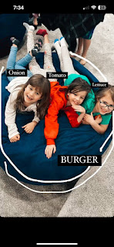

Video of Jack, running around and around endlessly, as he chases the remote-controlled car that Benson gave him for Christmas: (43 seconds)
https://photos.app.goo.gl/53ywSM81DvRLjvJb9

What a great way to get some exercise, ha ha.

