A Week of Reflection
It's been a quieter week than normal. Perhaps it was because there were fewer activities going on, and perhaps it was because I spent so many hours just thinking about a lot of things. Either way, I found joy in some of the little things that matter most.
For starters, I love this veteran of mine. There's nobody else I'd rather go get free food with on Veterans Day. :)

He is so kind to me and I always love to spend time with him. We laugh together, we cry together, we work together, we exercise together, and we spend time in the great outdoors with each other. I am so grateful for all his many years of military service! He has been a blessing to the United States of America because of his intelligent and organizational mind. He has created computer programs to keep more people safe when large shells are fired from the field artillery equipment. He also found a way to help soldiers be more accurate in their GPS location during field exercises. He is just so darn smart! His brain is always working on something and I love that about him. :)
I appreciate how his military service has been a blessing to us and to our family over the years. Even though it has meant far too many years spent apart, it has taught us how to love more deeply because of the separations. I have a greater appreciation for what sacrifice really means. You go where you are asked to go and you do what you are asked to do no matter what else is going on in your life. Life goes on in spite of the deployments and the Army schools, and we have to find creative ways to hold our head up high and adapt and look for the good in each day. If we don't look for the positives, then the darkness wins. And that's not something I can live with.
I went with a few friends from my ward to help serve at the Soup Kitchen this week. I hadn't been there in a while, and things were being done a little differently this time because of Covid-19.
Below: my friends Barb Vance, along with Del and Trudy Roberts. The lady on the right, Kathleen, we had just met while serving there.
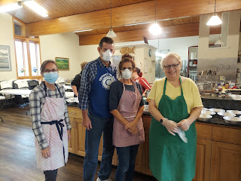

Instead of serving everyone indoors like they've done in the past, they now prepare individual meals to go. This particular day, the meal was a sort of Mexican goulash, served with a tortilla, some chips, garnished with cheese, lettuce, and tomatoes, along with some applesauce on the side, a dessert, and a couple of protein/granola bars.

Everything was prepared in To-Go containers. My job was to sprinkle some cheese and lettuce on top of the shredded chicken and beans mixture and then pass it on for the ladies to add a lid and pass it on again.

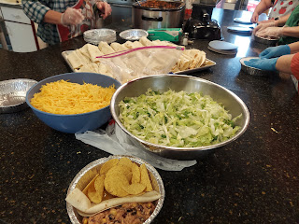

Barb, Trudy and Del helped bag up the meals and made sure they were ready for distribution when patrons came to the Soup Kitchen door.

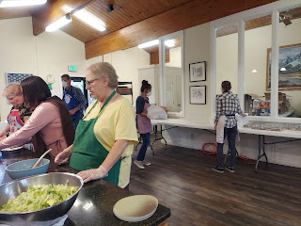

I thought it was a small miracle when we barely squeaked out the
last
meal for the
last
couple of patrons. The cooks had been told to prepare enough servings for 150 people. Well, they scraped all the sides of that last roaster oven clean and got just enough of a scoop of the goulash to serve the very last person! Wow. And thank goodness! It was so nice to serve here and be a part of something great in our community.

We had a great young women activity on Tuesday night and it was a really big turnout. All we did was bake pumpkin chocolate chip cookies together, but I guess that was enough of an incentive for them to come and have fun socializing while the cookies were in the oven. I guess I was having too much fun as well, because the only photo I got was after everyone left and these were all the cookies that were left, ha ha.

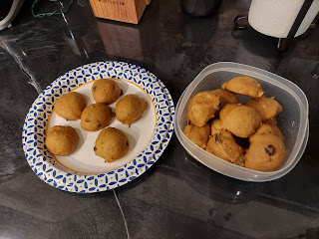

We took the last remaining plate of cookies over to our neighbors, and then Scott and I have been slowly nibbling the last few cookies during the week.

I had a really lovely experience going with my mother-in-law, Coy, to take flowers to Jonny's grave up in Rexburg. It's hard to believe that he would have been 5 years old this week! My, how time flies. I had messaged Amber to ask her if there was anything she wanted me to do on her behalf, since she lives so far away. She asked if I could find some sunflowers to put on his grave. I was happy to go on the hunt and do something for her that she could not do for herself.

I found some beautiful sunflowers at Albertson's for a phenomenal price, so I ended up sending a bunch of money back to Amber. I went to a couple of stores looking for a cute container or basket to put the flowers in, but didn't find anything I liked. I came home, instead, to look for something down in my miscellaneous supplies downstairs and ended up finding a sturdy and circular Christmas popcorn container from years past. I covered it with wrapping paper, added a bow, and voila! (I placed a little plastic dish inside to hold the water.)

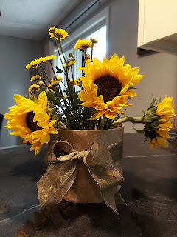

Coy brought some beautiful fall wreaths and leaves to decorate Jonny's headstone, her son Philip's headstone, and also Grandma and Grandpa Harmon's headstones nearby. (Helen & Wesley)

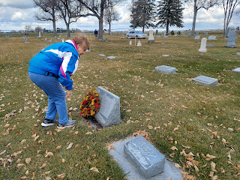

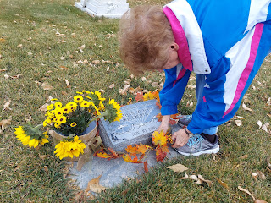

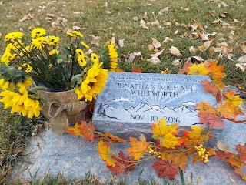

Our sweet little aging Grandma hands, together, to show our love for Jonny.

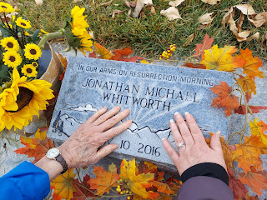

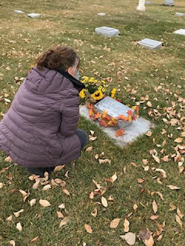

I'm so grateful that we spent that precious afternoon together. I needed the company and the friendship that day.

As for the rest of the week, I've been working on a baby quilt, doing a lot of early Christmas shopping (so I can hopefully get mailed packages to their intended recipients in time for Christmas), and working around a gimpy ankle that's been tight and uncooperative.

Jacob sent me this cute picture of him and Jack, halfway into their 90 minute bike ride to the Jefferson Memorial on Friday morning.

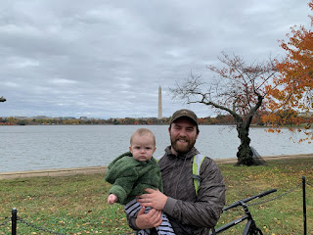

Jack loves to ride in his little bike trailer, chewing on a toy along the way, or just falling asleep. What a sweetie. :)

And Abby was Student of the Week at her school in Louisiana. She's been having a great school year, Amber reports, and is enjoying the curriculum as well as the socialization. I love seeing her little left hand hard at work in this photo! The only other Lefty in the family that I'm aware of is my Dad. :)

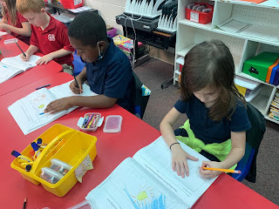

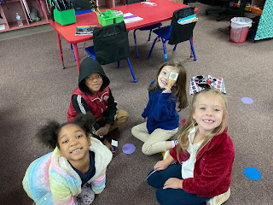

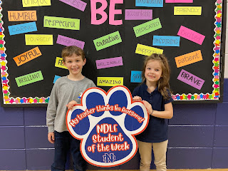

Way to go Abby! We're so proud of you! You're a great little student and you're so incredibly smart!

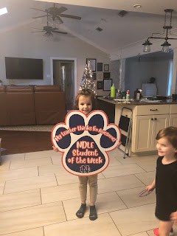

Scott and I went on a double date with our friends, Scott and Jen Anderson, on Friday night. We tried out a new place, a locally owned restaurant called The Bacon & Bleu. Jen ordered their signature bacon & bleu burger and I got a California chicken burger, which we both cut in half and swapped so we could sample two things in one visit. I liked the beef burger more than the chicken one, but the fries were my favorite, ha ha. It was nice to be out with friends, to laugh and visit and uplift one another.

After dinner, Scott and I settled into our arctic basement with some colorful quilts to watch a movie and just relax.

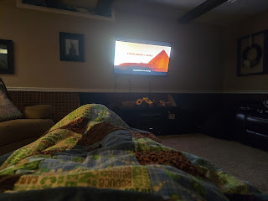

We haven't hung out in the basement in a while, so the heat was pretty much non-existent, ha ha. The room temperature said it was only a "toasty" 55 degrees . . . so yes, we turned the heat up and then just piled the blankets on. It was a very comfortable cocoon.

On Saturday, we worked on a few things around the house for the morning, and then after lunch, we drove up to Rigby to visit Phil and Coy. Coy had mentioned recently that her living room window was less than stellar, so we brought our boys' old window washing equipment (squeegees, etc. with telescoping handles) to clean that window for her.

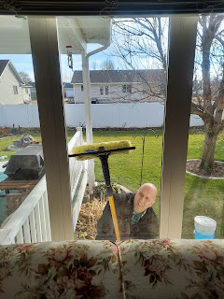

After a lovely and delicious early supper together (clam chowder, cheesy bread, and mixed fresh fruit), we cleaned up the kitchen and then sat down to visit for a bit. Coy has always had such a great sense of humor and a super quick wit, so it's no surprise that her son got those genetics. He loves listening to Dry Bar Comedy every day and laughing his head off. :) Dry Bar Comedy is basically just clean comedy, or family friendly comedy, which is right down our alley.

Here, Coy is reading some Pickles comic strips with Scott, and then they would laugh and laugh. So sweet. :)

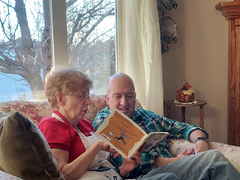

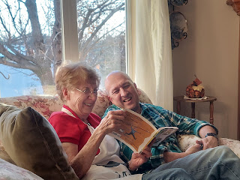

Eventually it was time to head home. I can't believe that the sun is setting at 5:00 p.m. now! Sheesh. It gets dark so fast! But what a beautiful sunset.

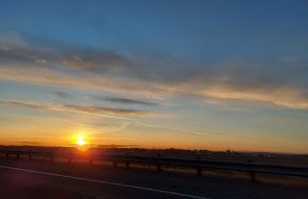

This coming week, I'm looking forward to finishing this baby quilt, finding more information about my family history, choosing what items to put on the menu for Thanksgiving here at our house, and using the rowing machine again at Planet Fitness (my new happy place).

