All Smiles for Thanksgiving
Avery is literally the most smiley baby I have ever seen! I'm told that all you have to do is just talk to her while she's in that half-asleep state, and she will start smiling. :) What a sweetheart!!








Things are going well for her little family over in Italy so far. Avery is eating well, but has her days and nights backwards. Ah well, that is the fate of almost every new parent in the world it seems. The babies seem to figure it out eventually.

Kylie is doing a good job of setting up Benson for success as a first time dad, too. The other day, she needed to go lay down and rest, so she put Benson in charge of caring for Avery. But she was meticulous about laying every single thing out in advance for Benson so he could just move down the couch assembly line: from feeding Avery, to changing her diaper, and finally to changing her into pajamas. He reported that even the container of wipes was open and ready . . . :)

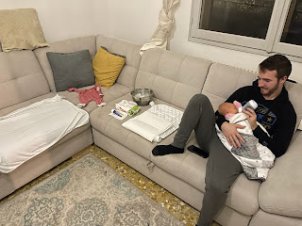

When they shared this photo of Avery with us in our family group chat, Jacob quickly located a photo of Benson when he was a little boy for comparison. From the side, they definitely have some similarities! I think that for the most part, though, she looks like her mother.

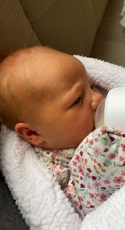

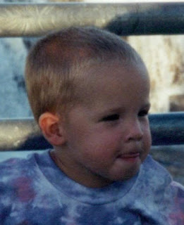

Here are a few more photos of Avery, along with a variety of her sweet newborn expressions. You're welcome. :)







And a few tender moments with her mom and dad.

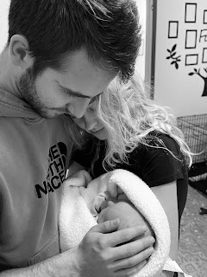





And finally some pictures with her eyes open!! She is such a darling.







For Thanksgiving this year, our family was spread out all over the world. Amber had big plans for their dining table and all the fantastic foods that would cover it, but then sickness hit their home on Thanksgiving Eve. Gwen had a fever of 103 degrees, and Abby got the stomach flu during the night. Amber didn't feel that great either, so they ended up having a more simplified Thanksgiving spread. Thankfully, a couple days later, everyone was doing great.

The girls (Abby & Gwen) reveled at the deer outside in their yard on Thanksgiving Day. They've been watching the deer since they were little babies, and now they're getting so grown up!

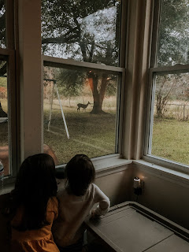

Jacob hosted a tasty feast at their apartment with two other young couples. He went all out with prepping and baking a large pork roast, as well as several sides, and rounding it all out with a beautiful burnt cheesecake. This is the same burnt cheesecake that he made for Hannah's birthday a couple years ago, and it is now a family favorite. It's not really "burnt", it's more like it's just baked until it's light golden brown on top. It's seriously amazing.

In Idaho Falls, we had a total of 9 family members at our table. Scott and me, his parents, and his niece, Marissa, with her husband Assan, their two little girls, and Assan's cousin, Tido (also from Togo).

Even though I was running a little late with getting the food on the table, it all turned out scrumptious. Scott came up with a brilliant plan to bake the stuffing in our Instapot so we didn't have one more thing that had to bake in the oven after the turkey came out. It turned out to be my absolute favorite dish of all! In the Instapot, we sautéed the onions and celery. Then we added the "day old" and "stale" bread that I cut up a couple days earlier (I used a soft sourdough as well as a nice buttermilk loaf), plus the liquids, and then we let it do its pressure-cooker thing. It cooked super fast, and we ended up doing a double batch. All we had to do at that point was spread it all out in a casserole dish and let it crisp up in the oven for a few minutes while the other things were getting finished up. Super easy!

Here is our all-you-can-eat-buffet just prior to digging in. From the bottom left: mashed potatoes w/Parmesan cheese, crescent rolls, stuffing, Assan's native chicken and rice (uh-mazing!!), homemade cranberry sauce with orange zest and juice, sliced turkey, roasted Brussels sprouts w/ butternut squash & cranberries, green bean casserole, and the appetizer - sweet potato rounds with herbed ricotta, toasted walnuts, and dried cranberries. So good! My mother in law also brought some yummy caramelized almonds to snack on.

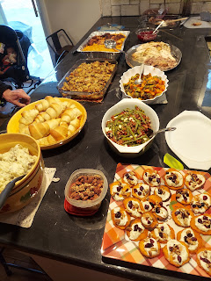

A better view of Assan's de-LISH-ous chicken thighs and Spanish rice.

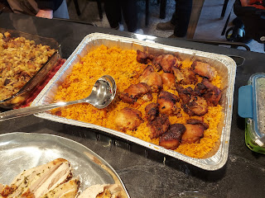

And a better view of the appetizers.

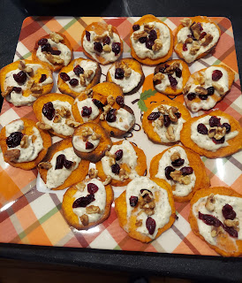

For the turkey, I chose to do a lemon-garlic version, and found a Gordon Ramsey recipe online to use. (He's a pretty famous chef) It wasn't hard, but it used a LOT of butter ha ha. It turned out to be really tender and delicious. I wonder why . . .

Softened butter, salt & pepper, lemon zest and fresh lemon juice.

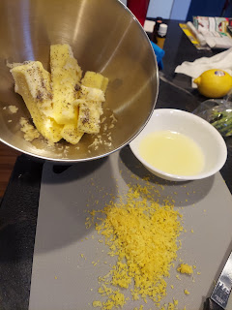

Washed and dried turkey all ready to go.

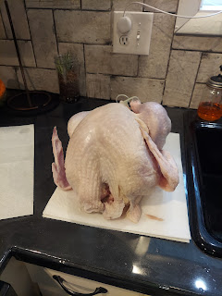

Herbed butter all ready to spread.

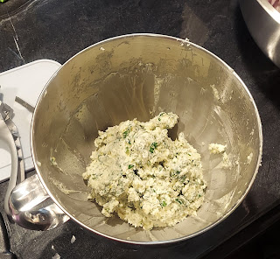

It didn't exactly spread. But it happily glopped and stuck here and there, both underneath and outside the turkey skin. Inside the cavity are some onion halves, a lemon cut in half, and an entire bulb of garlic sliced in half horizontally.

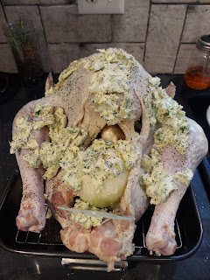

I couldn't have pulled off Thanksgiving this year if it weren't for Scott. He was my right-hand man.

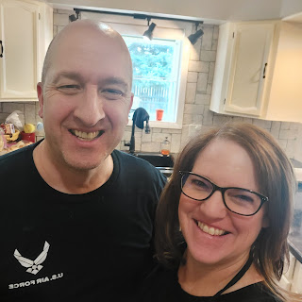

Here are the recipes I grabbed from online for my feast:

https://www.theroastedroot.net/sweet-potato-rounds-with-herbed-ricotta-and-walnuts/

https://www.abeautifulplate.com/roasted-brussels-sprouts-squash-dried-cranberries-dijon-vinaigrette/

https://www.gordonramsay.com/gr/recipes/roast-turkey-with-lemon-parsley-and-garlic/

https://www.onceuponachef.com/recipes/fresh-cranberry-orange-sauce.html

After dinner, we hung out and visited for a bit until we found some room in our tummies for pie. Coy brought a beautiful apple tart, and I made pumpkin pie. Marissa and Assan stuck around to play some games with me, along with Assan's cousin, Tido. And their daughter, Azure, was happily occupied in Abby & Gwen's old room, with all the toys I keep on hand. She didn't even want to eat dinner because she was having so much fun! ha ha

Here we are playing Sequence together. From the left: Assan, Marissa, Tido, and me - holding baby Rayma.

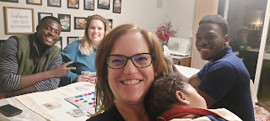

Rayma feels light as a feather compared to Jack. (LOL) And at 3 months old, she is very adept at rolling from her back to her tummy. She is very quiet and calm as well.

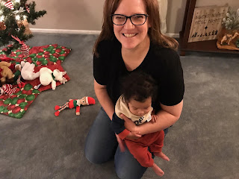

Jacob sent us all a funny video that he made about 5 years ago. The scenario was basically this: on Thanksgiving Day (5 years ago), he and Benson were helping Scott hang up all the Christmas lights. Then at some point, Scott moved the ladder while the boys were on the roof. The boys found themselves to be devastatingly stranded.

So here is the video: (10 seconds) Enjoy! I watch it over and over and just laugh and laugh.
https://photos.app.goo.gl/zbEguGAChyH9Y9Bu9

My mom took this darling photo of my sister, Charmaine, working in the kitchen with her daughter, Mari. Mari has really taken an interest in cooking over the last year or so. She told me on the phone recently that she prefers cooking over baking. :) It's a fun hobby to dabble in, that's for sure.

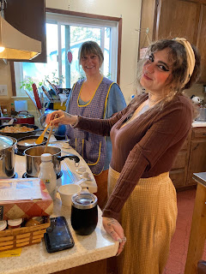

As for the rest of the week . . .

We had Sophie all week, our friend's little doggy. She was a great houseguest and kept us company in between all the goings on. We took her for a few walks, which she gratefully acknowledged. I swear, it's like she knows English a little too well, ha ha. Sometimes I would be in a conversation with Scott about the errands I was about to go on, and she would show up at my feet, doing excited circles! She understood that I was going somewhere soon, and she wanted to come too! And if I mentioned that I might take Sophie on a walk with me, she was right there at my feet again, super excited and eager to head out immediately!



We've had the most beautiful sunsets every single night lately!



Scott installed all the new kitchen backsplash tiles early in the week. He's such a good worker!

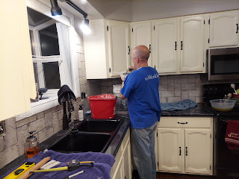

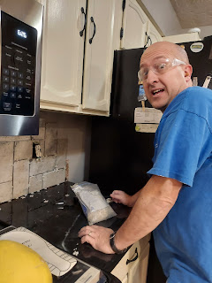

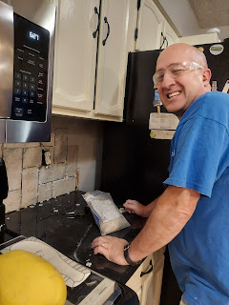

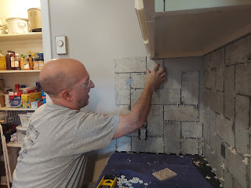

I was stunned at how beautiful it looks. I told him it looks like something out of a magazine! (This was before we applied any grout)

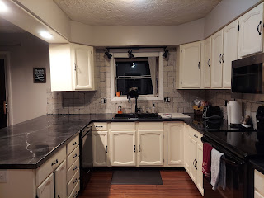

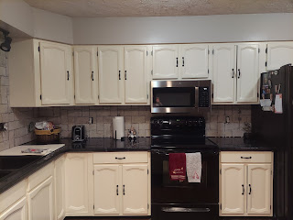

After all the Thanksgiving festivities were over, we have now completed about 2/3 of the grouting. It is quite the messy job.

Getting ready with the drop-cloth . . .

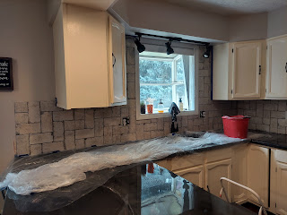

Scott did all the slathering of the grout into the grooves between each tile.

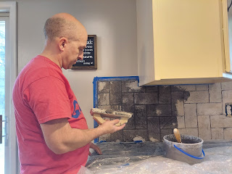

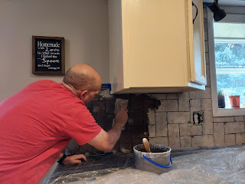

Then, after about 10-15 minutes, I would come behind him with a giant grout sponge to wipe down all the excess mess on the surface of each tile. Lots of wiping, lots of rinsing and squeezing, and lots of dumping buckets of silty water out under the trees in our back yard.

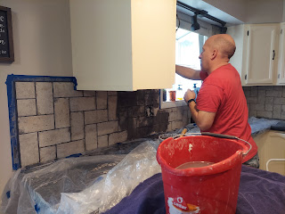

And now, a couple days later, here is what it looks like so far. We ran out of steam to do any more this weekend. But we don't have much more to do, thank goodness. We can probably knock it out in one evening, I bet.

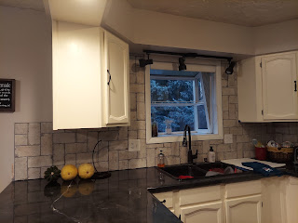

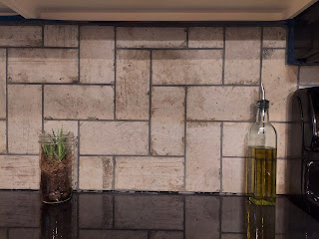

The grout color is a nice medium gray, which goes well with the countertops too. When the grouting is completed sometime later this week, our last step is to caulk along the edge of the counters. You'll notice in the photo above that there is a slight gap where the backsplash meets up with the countertop. Amazingly, someone smart has made tinted silicon caulk that matches the grout! So that's what we'll do at some point this week.

We are extremely pleased with how the kitchen is finally coming together. It's been years in the making!! YEARS.

On Saturday, I finally finished putting up a small amount of Christmas decorations for the season. I usually put up a LOT more, but since we're heading down to Louisiana for Christmas, I figured why go through all the trouble?

As I was setting up the tree earlier this week, my worst fear came true. I've always been suspicious of buying pre-lit Christmas trees, wondering what happens if the strand(s) of lights suddenly stops working. What then?

This tree is only about 2 or 3 years old. But look at the lighting situation.

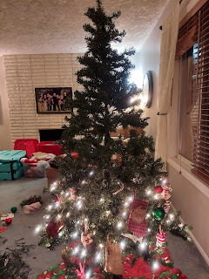

By the next day, another tiny section further up the tree miraculously came alive, but not the entire strand. So what to do? My neighbor across the street says she just adds another strand of lights on top of the dead ones. But I didn't want to load up the tree with dead and useless cords. So I decided to take the old strands off. Ha ha - good one. Only actually, they don't want to come off. They were so snugly clipped on, and in some places even zip-tied, that I had to get wire snippers in order to get everything removed!!

Here is the Dead Strand Graveyard on my living room floor.

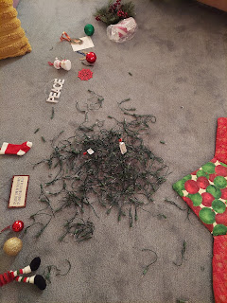

Fortunately, I was able to get some more lights and put everything back together. (*Note: I just noticed today that there is another section of dead lights at the bottom of the tree . . .)

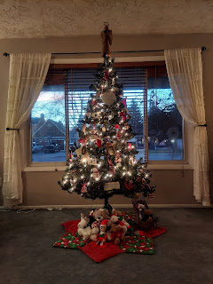

My daughter, Amber, is the most wonderful daughter a mom could ever have. One of her many gifts is being a very talented artist. She painted several Christmas ornaments over the past month or so, and as soon as she listed them on her website, they were GONE in an instant!! I had to fight to get these two.

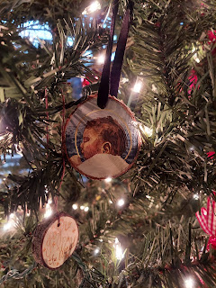

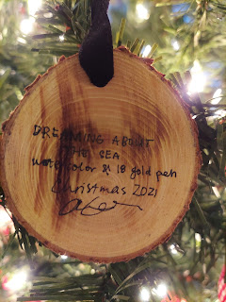

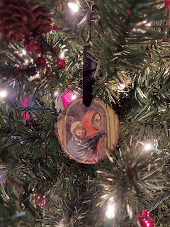

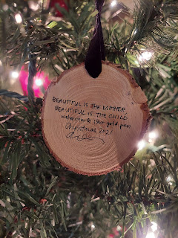

Her website is:
www.amberwhitworth.com
in case you want to see her work. :)

Since the week was so boring and nothing was really going on (!), I went to the urgent care clinic mid-week - not because of an emergency, but mainly so I could get a referral for physical therapy. It seems that I have plantar fasciitis in my left foot. I noticed it when I was in Europe doing all that walking. Some days it is really quite painful in the heel and I wanted to make sure I didn't have a stress fracture. (I don't)

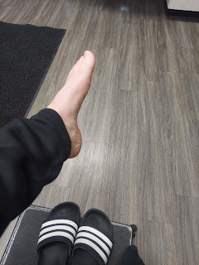

The Dr. said I have a perfect looking foot. Except for the pain . . .

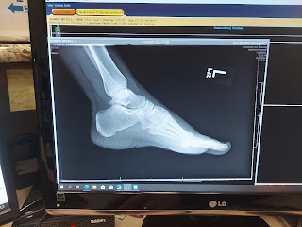

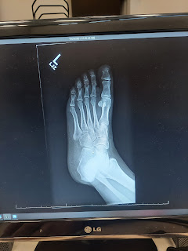

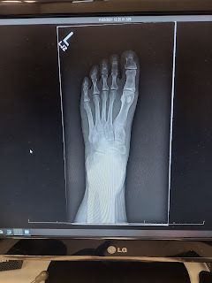

He gave me a written referral for physical therapy and I will be starting that up this week. Yay! Sometimes when I get out of bed, it hurts in my heel to the point that I have to limp in order to get around. But then my ankle starts to seize up from all the careful and strategic limping. Then I'm REALLY limping!! I don't want to be in pain, and I don't have the time to be in that kind of pain! So I'll see what they can teach me to do to fix the problem, and then I'll do it.

Here is a precious video of Jack, mesmerized by the tree branches blowing in the breeze and the shadows that were cast through the window. (40 seconds)

https://photos.app.goo.gl/V9NBr6Xg4dBvF69Y8

And here he is, munching on a green bean in the grocery store.

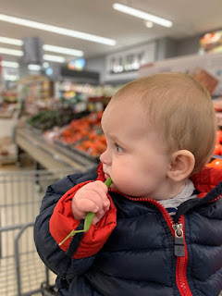

He's getting so big and so grown up looking! XOXO

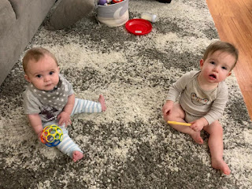

We got an invitation - last minute - to claim 2 tickets to see Ryan Hamilton on Saturday night. Who is Ryan Hamilton you ask?? Well, he is a hilarious comedian and he's from just up the road in Ashton, Idaho! He currently lives in New York City and has appeared on The Tonight Show with Jimmy Fallon, he's been on the Stephen Colbert show, and he's worked with comedians Jerry Seinfeld and Jim Gaffigan.

He had us in stitches - especially with all the Idaho jokes he had. You can find him on Netflix with his massive hit "Happy Face". Empty your bladder first. Just in case.



Our friends, Jen & Scott Anderson had 2 extra tickets that they offered to us. We were happy to snatch them up! Their daughter, Megan, can be seen photo-bombing in the background, ha ha. She works with me in our class of young women and she's a ton of fun!!



Partway through the show, Ryan Hamilton mentioned that his mom was in the audience. They had her stand up and she was sitting just two people in front of us! After the show was done, I was able to compliment her on what a great son she has. She was super nice! It is a slightly blurry shot, but here she is below.

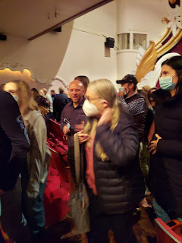

And lastly, today in our young women's class, Megan had the girls - well, all of us - come up to the chalkboard and draw pictures or write words of things we are thankful for. I took a picture because it was so fun!

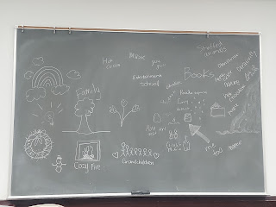

Here are a few of the things I'm thankful for this year:

My husband and my children and grandchildren
My parents, my in-laws, my siblings, and all of my extended family
The comfortable life that I have, no major health issues, and a roof over my head
The gospel of Jesus Christ that keeps me anchored and pointed in the right direction
Technology that allows me to keep in touch with my family sprinkled all over the globe
Wonderful friends (Jenn C., Jen A., Kim P., Barb V., and Andrea G. to mention a few)
Beautiful and colorful food to enjoy
Gorgeous scenery and all the creations on this earth that our Savior made for us
A temple nearby
The spirit of goodwill and peace that the Christmas season brings - and blankets the earth
A Savior who died for me, who understands me, who invites me and teaches me, and who loves me unconditionally

