Bassano del Grappa & A Sausage Toe
Another laid back week has gone by . . . time seems to pass all too quickly when I'm in Italy and I wish it would slow down even more. With all of the big holidays coming up soon, Fall just disappears before you know it and then I'll have to go back to the brutal cold in Idaho once again.

I've been working steadily on Avery's Quiet Book and making some good progress. I only have 2 pages left to do and then I can put everything together and put those finishing touches on.

Scott bought me a crafting table to work on (instead of our dining table). He set it up in the guest room for me and I quickly loaded it up with all the supplies I'm currently using for Avery's birthday gift.

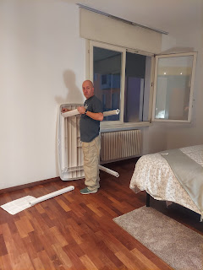

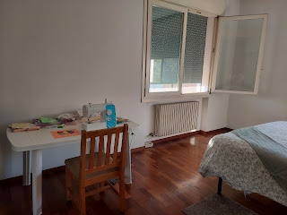

This week I have been trying to finish up these pages:

For the crocodile, all that is left to do is to find a cute little toothbrush and then make a loop to hang it on the page.

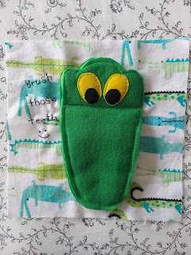

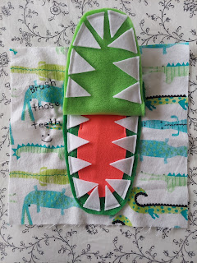

For the matching flowers, I just need to sew on the rest of the velcro and attach some cute ribbon to the flowers so they don't fall off the page.

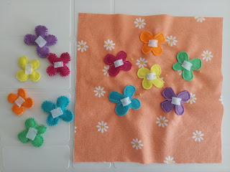

I'm also working on a two-page spread with a doggie: he will have a house, a pet bed, and plenty of toys to play with. It still has a ways to go since I just barely started . . .

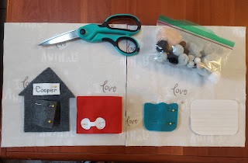

I even managed to go into my first Italian craft store and find an item that I needed. It's a bit overwhelming when you first walk in . . .

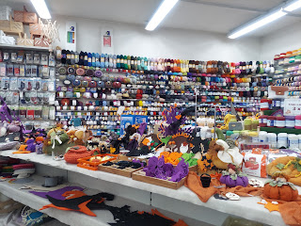

There's just SO MUCH STUFF in there. I had to hunt all over the store for ribbon. They have a lot of embroidery floss and yarns, but it took me a while to find any ribbon. The ribbons are all on spools and you have to measure and cut the length yourself. They do provide a meter stick and scissors, so that's nice.

The amount of ribbon that I needed only cost me 75 cents. I didn't stay too long in there because my foot was hurting . . .

Part of why I was able to accomplish so much on this project over the past few days is because of my sausage toe. Yes, a sausage toe.

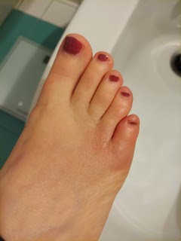

I'm not exactly sure what happened, but over the weekend my pinky toe started getting really itchy. I thought, Wow, maybe it's athlete's foot. Not the kind of thing that a lady wants to talk about, but I knew that Scott had some treatment cream. He gets issues from time to time because he has to wear his army boots all day every day and his feet don't get as much fresh air as mine do. I usually wear my Birkenstocks or my Adidas flops, so I get lots of fresh air. I put the cream on for about 2 days with no results. Instead, things continued to worsen. Substantially!!

My pinky toe was so swollen and inflamed and itchy that I wished I could just amputate it and be done with it. Peppermint oil, tea tree oil, or my Benadryl anti-itch ointment (for bug bites) would all provide some temporary relief, in addition to my keeping it elevated and cool in temperature, but it was becoming unbearable!

We began to wonder if I had been bit by something and that maybe I was having an allergic reaction to it. It wouldn't be the first time I've had an extreme reaction to a bug bite . . . sometimes I get hives or blisters around the location of the bite. It's really hard to see anything up close when it's your pinky toe . . . It's not like I can just hold it up close to where my eyeballs are . . .

It hurt to walk anywhere in the house. It was so swollen I couldn't even bend my toes. Any type of shoes were unbearable. I had trouble sleeping at night because it would get too warm under the covers and would wake me up multiple times. I finally decided to ask Scott for a priesthood blessing Wednesday night.

I didn't want to just ask for a blessing so that I wouldn't have to suffer. I was prepared to suffer a little bit longer if needed. But our car was in the shop and I was due to meet my new friend, Andrea, on base for lunch on Thursday, and I didn't want to miss that. I would have to walk to and from the base, which is about a 20 minute walk each way. I didn't think I would be able to do that under my current circumstances. Yes, I could just reschedule our lunch date, but I didn't want to. I felt like I needed to be a good friend to her since her husband is gone right now. So that's why I decided to ask for a priesthood blessing.

Scott blessed me that I could heal and get some relief, among other things. It was a beautiful and sweet blessing and I appreciated it very much. Within about 30 minutes of the blessing, I began noticing a difference. I could bend my toes for the first time again and it didn't make me want to amputate my toe! I even slept well. And when I woke up, I didn't need any ointment or anything on my toe for the first time in almost a week! The swelling was down, the coloring looked better, and I could walk on it comfortably. AMAZING.

I was able to walk (slowly) to our meeting place on base for lunch and I had a wonderful time. Andrea is from Germany and speaks only German to her daughters. Her husband is from Romania and they speak Romanian to each other. He also speaks in Romanian and English with their daughters. So that makes 3 languages that they speak at home! Wow. She speaks really well in English, too, so thankfully we can carry on a good conversation! ha ha

We ate at a cafeteria-style Italian restaurant on the base, called Italian Mensa. I relied on Andrea to take the lead as we went through the lines. They offered pizza, fish, chicken, fries, salad, gnocchi, etc. and you can pick what you want as you go along. It was more food than I should have grabbed, but it only cost $4.85! The gnocchi was especially good. We were limited to her one hour lunch break, but we managed to fill it with some fun stories and getting to know each other a little bit more. She is wonderful!

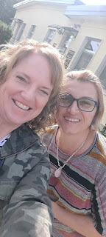

I am hoping to have lunch with her regularly and continue our friendship. :)

The following day, Friday, I met another friend for lunch. Her name is Lasina and she is in my church ward here in Vicenza. We have some shared childhood experiences, and apparently we had much to discuss over the course of our meal, since it lasted for over 3 hours! :)

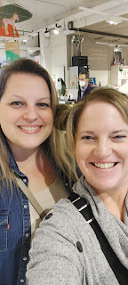

We met at a health food store & cafe near her home in Dueville, just north of Vicenza. She comes here often and I could see why! It was beautiful and spacious, with cafeteria style food that are each made from organic and locally sourced ingredients.

I followed her lead, just as I did the day before with Andrea, which meant we got ourselves a tray and started down the line. I chose to serve myself just one bite of several different things so that I could get a sampling of what they have and to determine what I like the most. My favorite dish was the Zuppa di Orzo soup (almost out of the photo on the lower right). It was SO GOOD!! Next time I'll be getting a lot more of that.

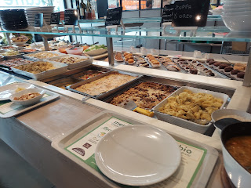

They had a dessert area on the opposite side, with pastries, muffins, brownies, etc. I chose a chocolate brownie with chopped pistachios on top.

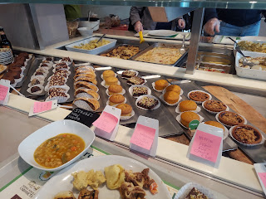

We had to wear gloves through the service line so we don't spread any cooties to the other patrons.

On my plate below, I selected some sauteed mushrooms, sauteed carrots, roasted sweet potatoes, a creamy cauliflower something-or-other, pasta Bolognese, one artichoke stuffed ravioli, a bite of chicken curry, and a grilled squid. My favorites were the soup, the carrots & yams, the pasta Bolognese (lots of meat), and the cauliflower whatchamacallit.

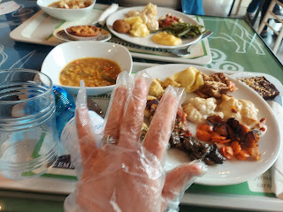

After we talked and talked, and then talked and talked some more, we walked over into the grocery store section where she gave me a tour. I thought it was interesting that these potatoes were labeled as "Patata Americana", but they were very long and skinny like yams. I think they were just basic potatoes, though...

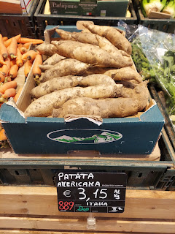

Lasina has some digestive issues going on, so she is very choosy about any grains or flours that she can eat successfully. She showed me some alternative pastas made from lentils (below) - - -

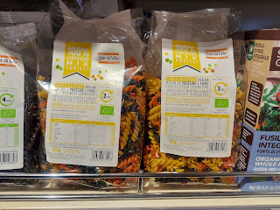

And this interesting GREY rigatoni pasta, made from PEAS - surprisingly!

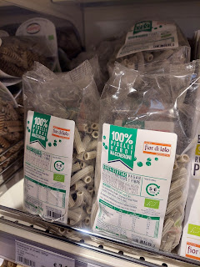

I bought some local honey and a box of pasta made from edamame (soy beans) that only has 3 carbs per serving! I'm eager to try that soon. Maybe with some fresh pesto and parmesan . . .

On Saturday morning, Scott and I got up extra early to begin our adventures for the day. We were outside and across the street in front of the Lidl (our favorite and closest grocery store) by 7:30 a.m. The sun wasn't quite up yet and it was quite cool in temperature.

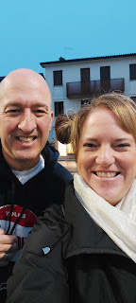

We rode the bus to the Vicenza Train Station, where we bought our tickets to go to Bassano del Grappa.

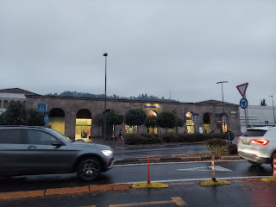

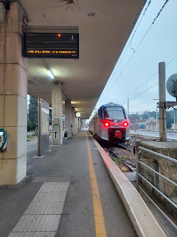

All aboard!!

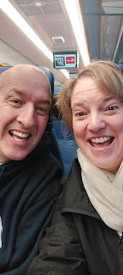

We had to change trains at Cittadella, about halfway to Bassano. It was a quiet and small station, with mostly just the pigeons and ourselves hanging out together.

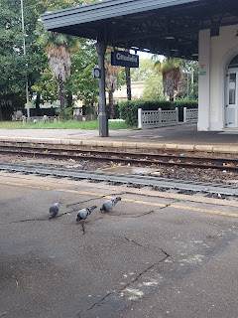

It only took us an hour total to get to Bassano del Grappa (including the 20 minute stop in the middle). The streets were quiet in Bassano that early in the morning, around 9:00 a.m. on a Saturday.

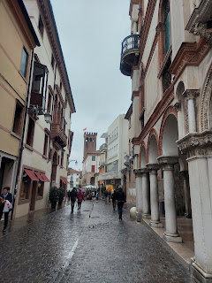

On our way across town to the River Brenta, we walked past this building with a plaque outside that says that Napoleon Bonaparte stayed here from 1796 to 1798. It is now a bookstore.

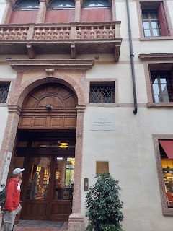

Here is a wonderful website with the history of Bassano del Grappa, including what happened to this charming little mountain town during all the wars, as well as some information about its many artists (including Palladio and Jacopo dal Ponte) and its history in ceramics and other cultural wonders.

https://www.hisour.com/travel-guide-of-bassano-del-grappa-veneto-italy-60376/

As we continued our walk down to the River, we saw all the vendors setting up their farmer's market stands in the streets and piazzas.

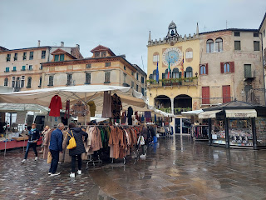

Though not part of the street vendors, this beautiful yellow coat caught my eye in a storefront window. I will forever be a fan of yellow, especially when it's paired with some black and white. I did not buy it, but instead I just took a photo, ha ha.

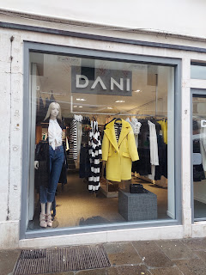

Too bad I had no idea if these would fit me or not, but to have some fleece-lined pants for winter would be nice.

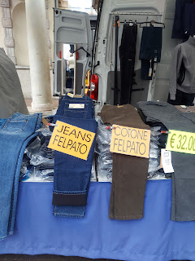

Within 10 minutes we walked from the train station to the River Brenta to see the Ponte Vecchio Bridge.

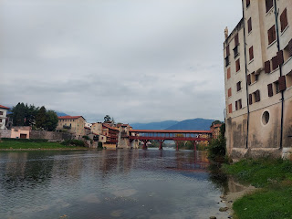

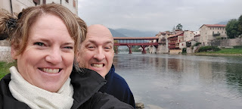

We were fascinated by the ducks and their scavenging efforts. It was hilarious when they would all go "bottoms up" at the same time . . .

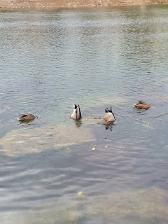

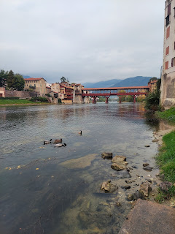

A few ancient cobblestone paths and stairways are sprinkled throughout the narrow streets of Bassano.

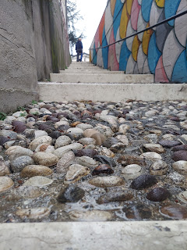

A poignant piece of art adjacent to the river: in the form of a giant rhinoceros.

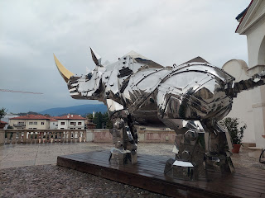

An explanation of the King Kong Rhino:

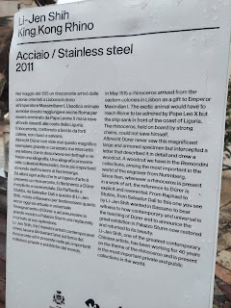

Getting closer to the Bridge . . .

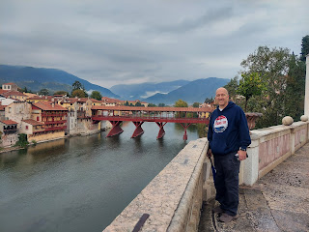

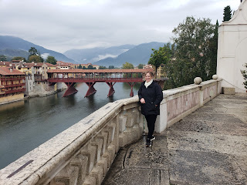

I love how in the history of the Ponte Vecchio Bridge, that even though it was destroyed during multiple wars, it was always rebuilt. The most recent time was after WWII, when local artisans completely rebuilt it to the specifications of Andrea Palladio in just 9 months!! Wow.

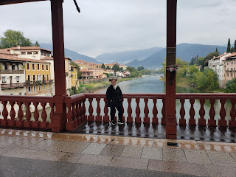

We couldn't resist re-enacting this sort-of-a-farewell-kiss by a soldier in the Alpini Brigade . . .

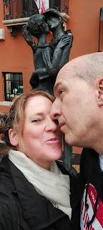

View from the Ponte Vecchio Bridge again.

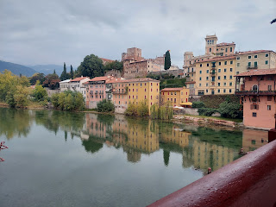

Out of curiosity, I have recently been learning a little bit about the Alpini. They are the Italian Army's specialist mountain infantry. They were extremely helpful and skilled during WWI and WWII, and are the oldest active mountain infantry in the world. In addition to their important military skillset, they are also put to good use by assisting in recovery efforts after an avalanche has occurred in the Italian Alps. They have been deployed on skis during war time, they have used pick-axes to crawl up and over snow and ice, and are just overall an amazing marvel to behold.

I rounded up a few links - mainly for my father-in-law Phil - but also for your viewing pleasure. These are links to some of the famous marching songs of the Italian Alpini.

https://www.youtube.com/watch?v=FWd-077BFuA&ab_channel=ilDavidone

https://www.youtube.com/watch?v=ZA7ClSNGGqI&ab_channel=IlPiave

This next video is particularly entertaining because there was a recent parade of some sort - Alpini soldiers in a marching band as they have just come across the Ponte Vecchio Bridge in Bassano del Grappa:

https://www.youtube.com/watch?v=3NqaBsmjCrQ&list=RD3NqaBsmjCrQ&start_radio=1&ab_channel=IlPiave

I saw several men wearing the famous cap of the Alpini Military when we were in Bassano this weekend. I am not sure if they were having a reunion or why they were gathered and just wearing the cap with the signature feather, instead of wearing a full uniform. But I have huge respect for any military personnel and the sacrifices they have made and continue to make during the course of their service.

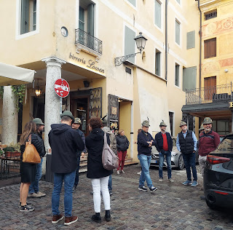

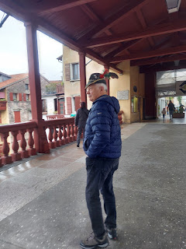

We walked back and forth across the Bridge multiple times that morning, wandering the streets and paths along the river.

On the east side of the River Brenta, the path looks like this: (1 min, 2 sec)
https://photos.app.goo.gl/xaECWt9yp9NvCTxP7

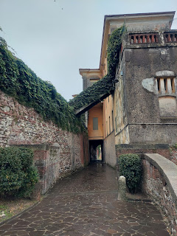

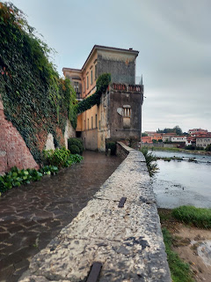

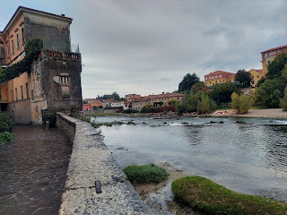

Heading back toward the Bridge along the east side, I tried to get a picture of this cute older couple as they walked along under their shared umbrella. They were fast walkers . . .

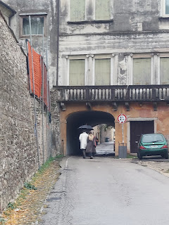

Crossing the Bridge once again, we found a much longer and more scenic walking path on the west side of the River Brenta.

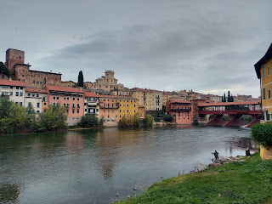

There was a man fly-fishing on the riverbank: (26 seconds)
https://photos.app.goo.gl/f9GpVn8wi68iiPKQ7

I loved the colorful hanging flower baskets in some of the windows as we walked along.

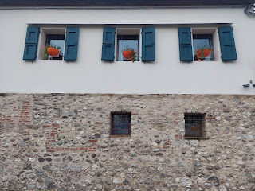

And this house took the cake with all the beautiful ivy and varied colors hugging the exterior walls.

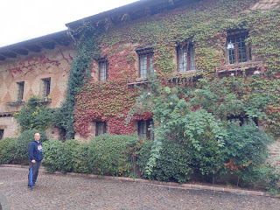

Surely this is an ancient wall of unknown date, but that just gives you an open invitation to stare at it and maybe marvel at how it was constructed . . . (like Scott did)

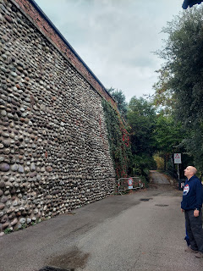

We are thinking of enlarging this next photo to put in a frame and hang it in our living room in Vicenza.

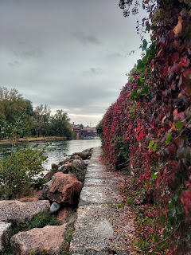

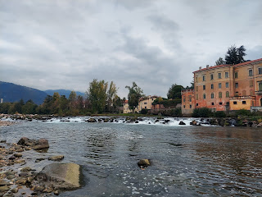

See if you can spot Scott in this next photo.

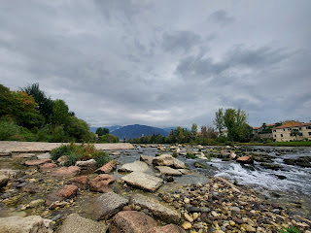

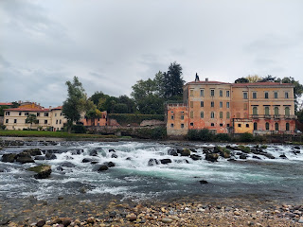

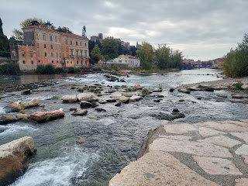

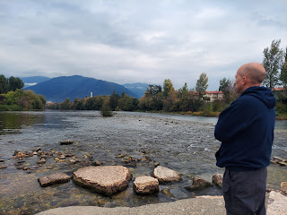

After a youthful jaunt out onto the rocks in the River, we continued walking along for a bit longer, enjoying the toggle between dirt/gravel paths and paved trails.

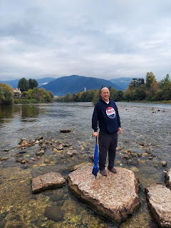

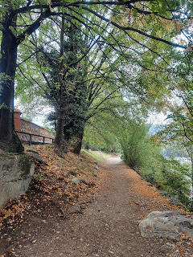

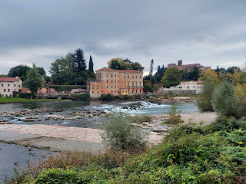

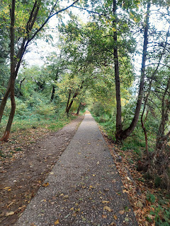

We would have walked for a while longer, except that my tummy was getting rumbly by this point. Nothing feels quite as fun when you're hungry and I didn't bring any snacks with us this time.

We headed back into town, walking past the farmers market stalls once again. This time there were a lot more people hanging around . . .

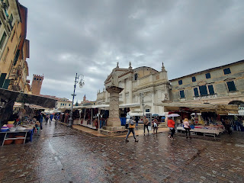

We also popped into an old church briefly. They were having a photographic and artsy display of the history of bicycling in the Bassano area, which we really didn't care so much about. But it was lovely to look up and see the frescoes on the ceiling. It is called Chiesa S. Giovanni Battista. (I believe that translates to Church of St. John the Baptist)

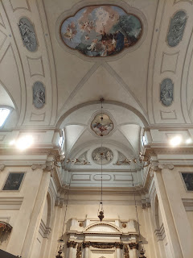

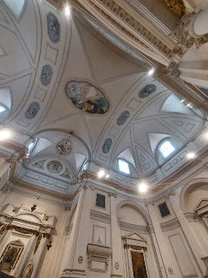

We also happened to walk past this statue honoring Jacopo dal Ponte, also known as Jacopo Bassano. I am still trying to establish the link between him and our Bassano ancestors, also from Bassano del Grappa. I think they are cousins, perhaps 1st or 2nd cousins.

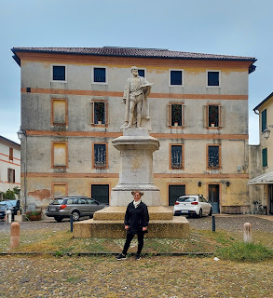

My Bassano ancestors (as I related in another post last October 2021) are on my Grandpa Linton Norman's line. The Normans married Sikes, the Sikes married Laniers, and Nicholas Lanier married Lucretia Bassano back in the early 1600s. The Bassanos were musicians primarily, both players of musical instruments and makers of them. The Bassano Brothers were famous in London in the early 1600s after they left Italy. They made and sold musical instruments internationally at that time.

Others in the Bassano family were artists. They were called Bassano because they came from the village of Bassano. Prior to that they were known as "dal Ponte", among other names. Andrea de Crespano (one of my direct line Bassano ancestors) came from the village of Crespano, a few miles east of Bassano del Grappa.

I found an interesting article online that created a timeline of the Bassano family as it relates to Shakespeare. There are multiple theories about the Bassanos being linked to Shakespeare and him writing them into some of his famous works. In this particular article, it suggests that the Bassanos were originally from MOROCCO, who later moved to SPAIN, who then moved to Bassano del Grappa for safety reasons. I'm not sure of the accuracy of all the details, but it sure is interesting and exciting to consider!

https://shakespearesconspirator.com/jewish-lineage/

That was a lot of information to take in on the way to feeding my hungry tummy, but in real-time it only took me a few minutes to get some of this delicious kebab goodness into my belly. #AlKareem

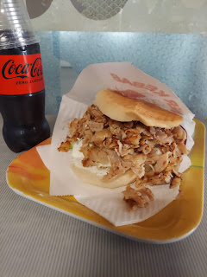

After a very filling lunch, we walked back to the train station to make our way back to Vicenza. Our train was just a little bit slow in getting to our half-way stop in Castelfranco Veneto. Just slow enough to cause us to miss our connection . . . and then we had to wait about 40 minutes for the next train to come through!!

We had brought umbrellas with us to Bassano but didn't really need them at all. While waiting at the train station in Castelfranco Veneto, there were several dramatic downpours . . .

Video of the loud rain hitting the canopy overhead: (16 seconds)
https://photos.app.goo.gl/jJHrwP3E4LfnsCsX9

Eventually we did make it back to Vicenza and back to our house. We then promptly got to work making a pot of chili and a huge pan of cornbread for the cook-off that evening at our church across town. I made the chili while Scott went hunting for a foil baking pan at two different nearby grocery stores. We were only 5 minutes late to the dinner . . . ha ha

There were at least 150 people that came to the dinner. We combined our military ward with the Italian ward for this activity. Marnie Parker and a lady from the Italian ward took turns speaking into the microphone to welcome everyone (in both English and Italian), to bless the food, and to organize the dismissal of tables for everyone to serve up their food.

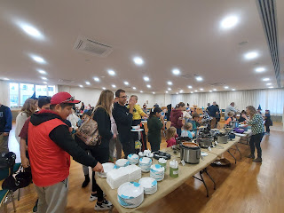

Lots of adults came in Halloween costumes, but Scott and I were in too much of a hurry to give that any thought. Pictured below are Kevin Parker, one of the judges for the chili cook-off, and the three top finishers. Marnie Parker is taking the photo of them all together.

Scott was also one of the judges. He ended up with a VERY full tummy, having sampled a dozen types of chili, along with a plentiful amount of cornbread on the side.

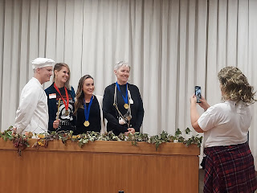

A very cute little Donald Duck across the table from me . . .

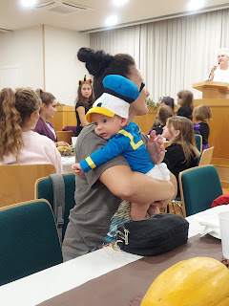

And a stinky, but very cute, skunk named Rosie . . .

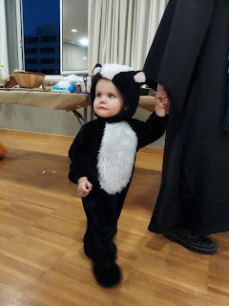

After the dinner was finished, they invited all the children to participate in a parade around the gym while the adults hurried outside to set up their cars for the Trunk or Treat. Kevin Parker played some fun Halloween music and would occasionally pause the music, a cue for the children to stop and freeze until he pushed play again.

Video of the costume parade: (55 seconds) Led by Lauren Parker, a senior at Vicenza HS and also the Student Body President.
https://photos.app.goo.gl/keKrRKaggztRrZpaA

It was a very fun evening and I'm glad we could participate and mingle with so many wonderful people.

I stayed up a little late on Saturday night finishing up preparations for my Primary class lesson the following morning. And then I found out at church that I didn't even need to teach, ha ha, because they would be doing teacher training for all the teachers during that second hour instead! Goodness gracious . . . Oh well, though. At least I was prepared.

I was able to attend Relief Society, a class for all the adult women, and it was so wonderful to be in there again. It's been a while!! The lesson was based on the October General Conference talk, "Beauty for Ashes" by Kristin Yee. We talked about the power of forgiveness and how to navigate that difficult path toward forgiving someone that has wronged you.

And later, while I was resting after church, I got a text from the Primary President asking if I wouldn't mind subbing as the Sunbeams/CTR 4 teacher until they can get a permanent teacher called for that class. This will be a class of 3-4 year olds, instead of 5-6 year olds. I told her I would be happy to help wherever she might need me. So, starting next week I will be in the younger class for a little while. They got another teacher to work in the 5-6 year old class, and those children will be in very good hands.

Now it's Time for Grandbabies . . .

Get ready for a bunch of photos of Jack first - - -

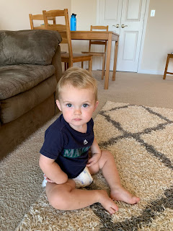

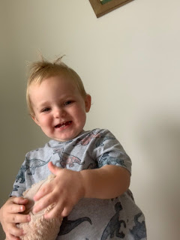

The next two photos are from a couple weeks ago when Hannah ran her half-marathon. Jacob and Jack were out on a support patrol together, and this was a midway point where they could see Hannah run by on the bridge.

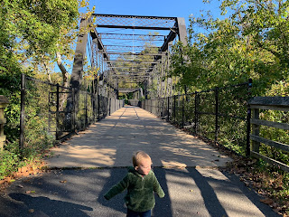

I'm not sure why Jack is sad here, but Hannah looks radiant after her race was done! She did great and as far as I was told, she didn't have any problems to speak of. Hooray Hannah!

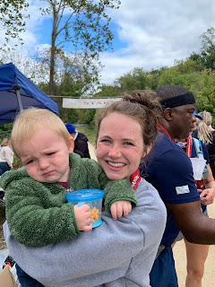

Ready for church . . .

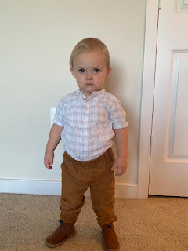

Jacob said that even though it was only 40 degrees, Jack still wanted to go outside one morning and check on the world from their 12th floor balcony. I noticed that he was wearing a puffy warm vest and that he was hugging his friend, Mr. Coyote. :) Super cute.

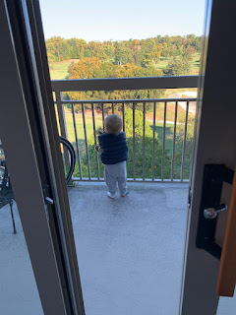

He is also very industrious each day, as seen below.

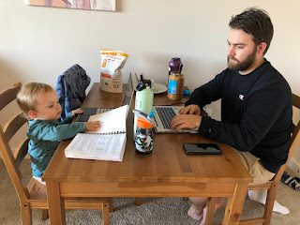

Because you're either working hard or hardly working, as I always say. LOL

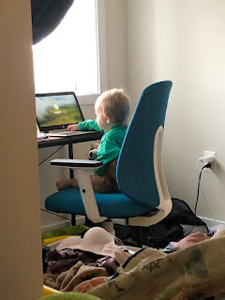

Avery is spunky and silly as usual, and she obviously loves her mac & cheese with peas and carrots! Yum yum!

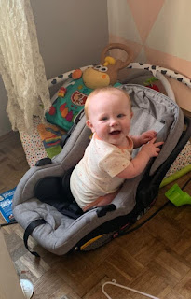

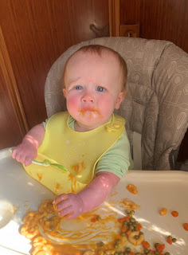

I'm still trying to get together with our kids up in Aviano, but they are busy a lot. I'm hoping to see them maybe this coming weekend.

In Louisiana, the Whitworths participated in a Trunk or Treat at their church as well. Looks like the girls had a great time dressing up!! And I love how Amber and Weston dressed up as Taco Bell hot sauces. LOL

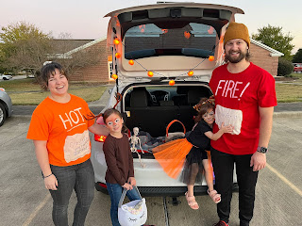

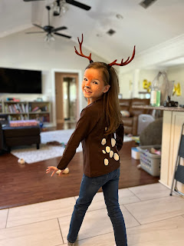

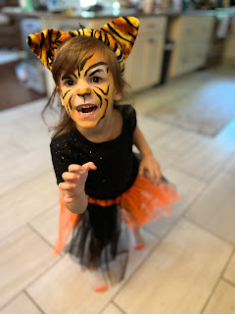

Gwennie also had a birthday this past week! She turned FIVE!! We had to plan ahead of time when to give her a call, since we are 7 hours ahead of them. We found a time early in the morning that worked for all of us. After Amber has had a chance to get the girls fed and dressed on school mornings, they have a few extra minutes before the bus comes, so that was our window. It meant that we had to call at 6:30 a.m. Louisiana time and 1:30 p.m. our time, but we made it work. Scott initiated a group video call on WhatsApp so that he could visit from the base where he was working during the day, I could join in from our house, and we could all wish Gwen a happy birthday. :)

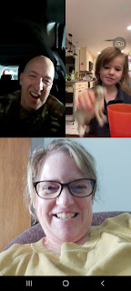

Amber also took Gwen out for a mommy-daughter date. I love this picture of the two of them!

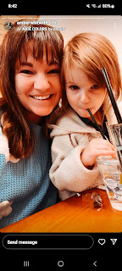

When Amber asked Gwen what kind of birthday cake she wanted, she didn't even hesitate. She wanted a GHOST CAKE, ha ha.

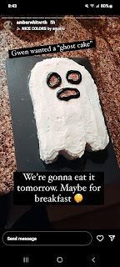

And Amber got a cute haircut with BANGS again this week! She looks super cute!!

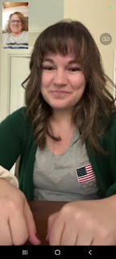

It was a steady week of birthdays, too. Last week it was Chelsea's 33rd birthday, and Kylie's 20th birthday. This week it was Frank's 99th birthday (up in Heaven), my father-in-law Phil's 91st birthday, and Gwen's 5th birthday!

HAPPY BIRTHDAY EVERYONE!! 🙌💕

