Croatia: The Former Yugoslavia
Places mentioned in this post:
Vicenza, Italy
Senj, Croatia
Rijeka, Croatia
Prem, Slovenia

Before I dive into our most recent weekend getaway, I want to share a few other things first. We've had some sickness, a setback (for me), and a major change to consider for our Life Plan.

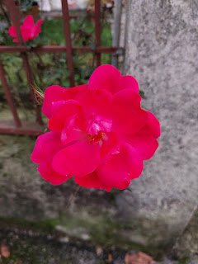

As we've been discussing a potential career shift for Scott for the past couple of weeks, one of the ways we have drawn closer to each other is by going on long walks. This gives us an opportunity to discuss several nooks and crannies of the possibilities together, while we simultaneously get some fresh air and a little bit of exercise at the same time.

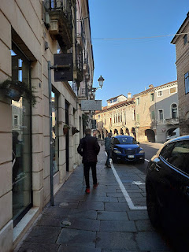

I made a video for my grandson, Jack, recently when I paused to watch a delivery of some building materials to the top floor of this apartment building near the pedestrian-only zone of downtown Vicenza. The crane slowly lifted the wooden beams up to the designated "receiver" through the open window above.

If you're interested, you can watch it here: (2 minutes, 4 seconds)
https://photos.app.goo.gl/PNeYyWMjY7VVQiLBA

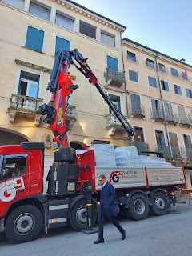

I hope I haven't already mentioned this previously, but this is a fun flavor of chips made here in Italy. The first bite tastes like a salty chip dipped in ketchup, which sounds a little strange, right? But then you want another one. And another one.

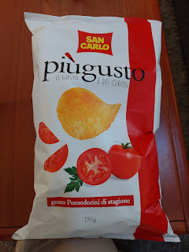

On the advice of several friends, I finally went to see Rebecca Beghetto, a local physical therapist with a holistic approach. They told me she is able to miraculously pinpoint problems that you never even mentioned to her, and that she has cured several issues that needed fixing. She works upstairs in the space above the gym on Ederle (the main base that's also near our house).

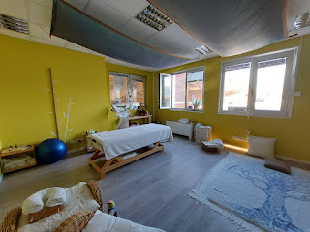

I just took another look at her business card and it says, "Dr. Rebecca Beghetto, PhD". On the back, she lists all of her specialties: Holistic science PhD, osteopathy degree, massage therapy, cranio-sacral therapy, visceral manipulation, biological consecutive kinesiology, naturopathy master, wellness and health counselor.

My experience with her was . . . well . . . let's call it "interesting".

I went there with the main premise of carpal tunnal in my forearms, something I've been dealing with for years. But I was also hoping to discuss some digestion issues that I've been having as well. She is a very passionate Italian, and that's an understatement. As we discussed my health history, all the way back to when I first started getting ovarian cysts 35 years ago, she was clearly disgusted by the Western medicine approach that I've received, and was absolutely irate that nobody put the pieces together sooner (of my "obviously related" symptoms). She even called my US doctors "****ing ***holes"...

At one point, I carefully told her that she didn't need to use those types of words with me, and that I don't ever use them myself. She was a little surprised, but she admitted that she didn't have a full grasp of the English language and would appreciate learning some new alternatives. It's like an epidemic these days, using the same couple of swear words in as many situations and conversations as possible. They don't even work effectively to describe what it is you're trying to say, especially when they're so over-used and watered down, yet they are just plain horrible and offensive and so ugly to hear.

She pushed and prodded several places on my torso, making me wince a few times. Very colorful bruises showed up as early as a few hours later . . . She described her kinesiology process like this:

Imagine that you reach your hand out and place it over a hot flame.
Your brain needs to first register the dangerous heat that the hand is experiencing.
Then your brain needs to send a message to tell the hand to get away from the heat because it's dangerous and will cause damage.
Your hand should respond accordingly and retract from the heat.
This process should take microseconds to evaluate and relay the proper responses.
But what if there is a delay somewhere in the chain of communication? Or worse, no response?

With kinesiology testing, it is much the same. "Let me push really hard on this part of your body and see what the response is". If there is any sort of delay or oddity in the response, then this indicates a problem. She then works to identify
why
there is a delay or problem and offers her best solutions to remedy the issue.

After she finished beating me up (not really, but it felt like she did), she applied some KT Tape in a couple of places to train the muscles to behave differently - relating to my carpal tunnal syndrome in both forearms. KT Tape is often used on athletes and has a very strong adhesive. The tape can last up to 3 days most of the time. In my case, she applied a bright blue tape from each of my pinky fingers up to my elbow. And then she applied a strip of tape from each of my collar bones down toward my underarm areas, too. This is where the catastrophe occurred . . .

By the following morning, the tape on my forearms was already peeling off because it didn't stick very well to my pinky fingers, especially when I needed to wash my hands and later take a shower. So I just peeled those strips off. The other strips under my arms were pretty solidly attached, so I left them on. About 48 hours in, I felt some discomfort at the base of the tape under my armpits, so I decided to remove the strips. When I peeled them off, I also peeled off quite a bit of skin because there were also BLISTERS from a reaction to the adhesive!! Basically, I peeled off the blisters AND the skin that was extremely irritated. OUCH.

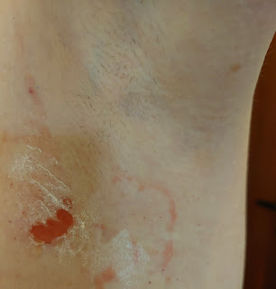

It took an entire week to heal the raw patches on both sides of my body. Scott went to the base to get me some extra strength Desitin cream (usually for babies' bottoms), with 40% zinc oxide. Those raw areas would "weep" constantly, so it was tricky to be able to apply the zinc ointment. And then there was the issue of keeping the areas protected once the ointment was in place. The first couple of days, I put large band-aids on over the ointment so that my clothing wouldn't rub on those very painful spots. But every little bit of adhesive was causing even more upset to my skin, so by the third day of bandages, I needed a new approach.

I got creative and started applying the Desitin first. Then, using cotton pads that I normally use to clean my face, I squeezed out some Neosporin onto each pad so that they wouldn't stick to the Desitin and my skin. Then I would carefully get dressed and try to move as little as I could for the rest of the day. I would repeat this process at bedtime, with fresh dressings before going to sleep. It took another 3 days for significant improvement to be noticed. Eight days after seeing Rebecca, I had healed enough to where I didn't need the Desitin cream anymore, I could shower without cringing, I could move around and not worry about the extent of motion, and I could even begin to exercise again.

There is one important thing that I
will
be going back to see Rebecca for in the future: she advised me to order a Gut Microbiome Kit here in Italy because she wants to see if I have leaky gut syndrome, or a variety of other possibilities including deficiencies, polyps, Celiac's disease, etc. Essentially, I will have to send both a pee and a poop sample off to the lab and they will scrutinize them under the microscope. How fun! It's an expensive test but it should give me some good information. I've been having several digestive issues in the past year or so, plus I am extremely low in iron and my body isn't absorbing the premium iron supplements that I've been using for more than a year now. Some days, I have very little energy, while other days I do alright. I look forward to learning more about my body in the next few months.

I'm just sad that the KT Tape set me back for so many days. One of my friends told me that KT Tape should never be applied to such a delicate skin area . . . so that was an unfortunate misstep that Rebecca made. I will be much more wary of anything else she wants to do to me in the future.

*UPDATE: I will be ordering a similar Microbiome Kit in the U.S. because I'm running out of days to make it all happen in Italy. My doctor in Idaho Falls said we can set it up when I get back. I will share the results with Rebecca in Italy, too, because she has a few more degrees and certifications than my doctor in Idaho Falls, one of which includes being a nutritionist. Based on whatever we learn, she can recommend a good diet for me.

Near the end of the 8 days of recovery, I made a giant crockpot full of chicken chili to feed the missionaries and a couple of soldiers. The crockpot was so full, that the lid barely kept the soup in, ha ha.

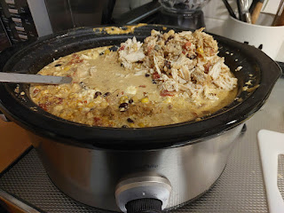

Left to right: Scott, Hector Perez, Elder Edwards and Elder Fairbourne, and me

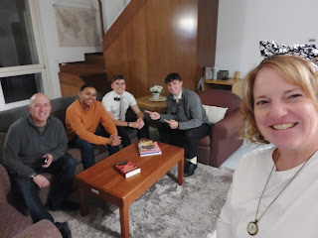

We ended up feeding the missionaries two nights in a row, because our main guest, Hector, wasn't able to join us the first night, so I made another dinner the second night (pork chops, potato casserole, and Brussels sprouts).

The first night, Elder Fairbourne brought a different missionary companion with him because they were on "splits". This is where missionaries will swap companionships for a day so they can learn about a new area and even learn new techniques from a different missionary. Elder Gasser was from Utah and we were curious if he was related to Scott, since he also has the Gasser name on his family tree. When we traveled to Switzerland back in March, our purpose was to find places relating to the Gasser family.

It turned out that I was related to Elder Gasser, too! To find out if you're related, you both need to log in to the Family Tree app and choose "Relatives Near Me". Then it will tell you if there is a relationship or not, and through whom.

For example, here is a screenshot that I took of how I'm related to Elder Gasser . . . (click photo to enlarge)

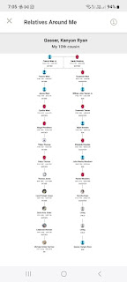

We are 10th cousins through my Grandma Doris' line. It's pretty fun to be able to quickly learn if you are related to someone. I've used this a few other times with success, and it's always a hoot.

Speaking of family history, I recently taught another class at the USO here in Vicenza on November 1st. It was during a two-hour Coffee Connections time slot, and we had 8 ladies show up to learn how to build a family tree on FamilySearch.

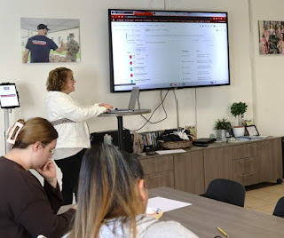

It was such an amazing experience this time, mainly because of the discussions that we had together. The whole first hour was mostly spent learning about each other and our backgrounds, including where our ancestors are from.

From left to right in the photo below:

Kailee
- she shared with us that not only are her ancestors from Poland, Belarus, and Eastern Europe, but her grandmother just recently opened up about being a survivor of the Holocaust. The family has since recorded multiple stories with her and then published them in a book that each of the grandchildren now have.
Maria
- her family is from Dominican Republic and Mexico.
Lorena
- Her family is from Argentina, but with a recent DNA test, she learned that she has ancestry from Spain, Morocco, Italy, and several other countries.
Me
- my ancestors have deep roots in the U.S., but I also have England, Germany, Wales, and several other European countries in my DNA.
Anna
(behind me) - she is mostly Italian, but her mother's ancestors are from Germany.
Elaine
(in the back) - she is Filipino and will be traveling back to the Philippines for a family reunion over the holidays. She is eager to get some help from a local FamilySearch Center when she travels home, because she wants to find some records in the archives over there.
Frieda
- she works at the USO and has come to previous classes that I taught on a weekly basis last year. She started from scratch, typing her own name into FamilySearch a year ago, and now she is back 6 generations on her family tree!
Zandra
- her family is mostly from Mexico, and she has struggled with some psychological roadblocks with several family members not wanting to talk about their ancestry and heritage.

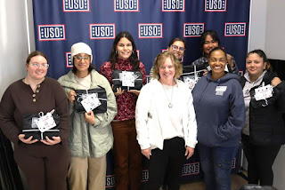

Before I taught everyone how to use the FamilySearch website and build their family tree, I spent some time sharing some recent studies that show promising results when you "do" family history. These can include better mental health, more confidence, more resilience, and a better awareness of how you fit into the world around you.

Kailee, whose grandmother recently shared her story of surviving the Holocaust, has now expanded the minds and hearts of her children and grandchildren. Kailee shared with us how she was incredulous at first when she learned about the things her grandma had to go through. But now, she has a better sense of the power that lies within each of us, the power to survive, the power to get through hard things, and the power to THRIVE. She feels stronger because of what her grandma went through, and she feels like she can get through hard things in her life now, too.

The power lies in having the
knowledge
of what our ancestors have gone through and worked to overcome. We have to have the stories first. And then we can process that information and begin to weave it into our own journey through life. We can begin to recognize that life is bigger than the seemingly singular "trench" that we are currently stuck in (I have depression or anxiety, I just lost my job, I suffer from an addiction, etc.). We are MORE than our struggles. Others in our ancestry have struggled, too . . . and found a way to navigate through those obstacles. And if they could do it, maybe I can, too!

After the class was done, Lorena came over to tell me that during the past hour, she had entered in her own name, her parents' names, her grandparents' names, and then the tree just opened up for her from that point! She saw her great-grandparents and many more family members. She was almost in tears as she tried to put her feelings into words, pointing to her chest and telling me in her very thick Argentinian accent, "I feel . . . happy. I feel . . . something I cannot hardly describe. Thank you for teaching me today!"

On another recent walk into downtown Vicenza with Scott for some Christmas shopping, we saw a small crew hanging up decorations above the narrow streets. I love this time of year . . . it's so magical and beautiful. Christmas is a longer season in Europe, because they do not celebrate Thanksgiving. The long and relaxing holiday season over here begins in early November and lasts through December, something that I really love a lot. Christmas Markets usually open up the first week of December, but sadly I won't be here for that this year.

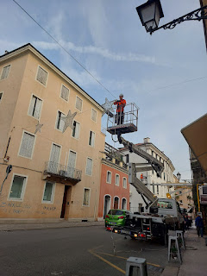

I peeped into the van holding many more stars that needed to be hung up . . .

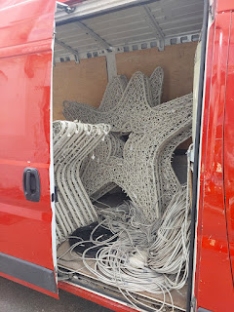

There was also a large ornament ball being set up outside the Olympic Theater . . .

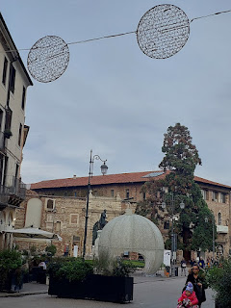

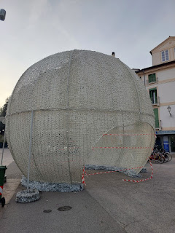

I just love this time of year . . .

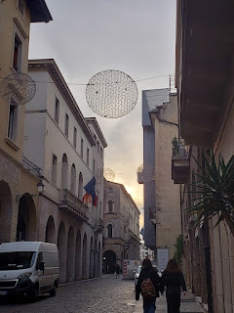

A weekend getaway to Croatia . . .

Scott had been sick all week, and against my very sound advice to stay home each day, he kept pushing himself by going to work. Inevitably, he'd limp home sooner than usual, sometimes as early as 11:00 a.m. to get into his pajamas and go to bed. I'd make him some tea and tuck him in, silently scolding him for going to work in the first place (sharing cooties everywhere!!). He has a mind of his own, and short of hiding the car keys, I don't know that I could have kept him from going out . . .

We postponed our trip to Senj, Croatia by one day so that he could have another day to feel better. I also insisted on driving us all the way there, about 4.5 hours in total. Originally, we wanted to stay as close as we could to the coast, but still make a trip inland one of the days to visit Plitvice National Park - a large nature park with boardwalk trails and waterfalls galore.

But with Scott not feeling 100%, we downgraded our expectations and simplified our plans quite a bit. We couldn't cancel our booking this late, so we decided to just go and have a nice place to relax and sleep. The AirBnB that we found was absolutely gorgeous. It was large and spacious, it was clean and comfortable, and the views were stunning off the balcony where we could look out over the Adriatic Sea.

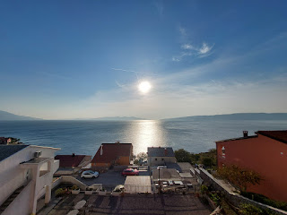

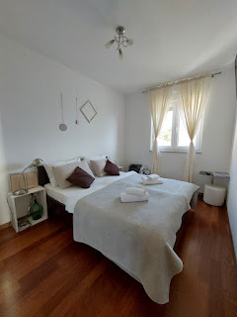

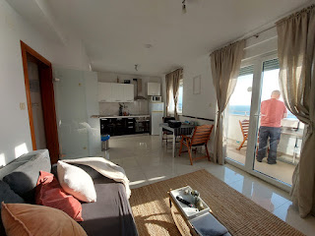

We had a decent sized kitchen, with some basic cooking supplies. There was also a nice dining area and living room. But the balcony called to us, with the warm sun shining overhead and the sound of the sea below.

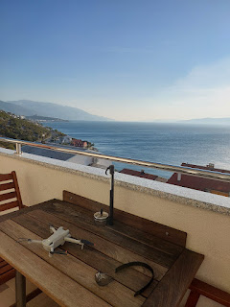

I had done a little reading ahead of our trip, wanting to understand more about the history of Croatia. I learned that Croatia used to be part of Yugoslavia, which existed from 1918 (immediately after WWI) until 2003. Originally, it was known as the Kingdom of Serbs, Croats, and Slovenes. It wasn't until 1946 that they changed the name to Yugoslavia.

From that point on, Yugoslavia was a socialist federation consisting of 6 republics: Croatia, Montenegro, Serbia, Slovenia, Bosnia and Herzegovina, and Macedonia. In the late 1980's and early 1990's, things started to fall apart due to political and economic issues. The country broke up in 1991, with Slovenia and Croatia declaring their independence. The rest was pretty messy and tragic for Serbia, and Bosnia and Herzegovina. I'll share a link in a minute of a video that encapsulates what went down during that decade.

What I wanted to lead up to and point out, is that our host told us that a long line of soldiers were strung across the hillsides behind what is now their home (upstairs) and our AirBnB (downstairs). He was just a little boy at the time, but his uncles and grandfather told him some stories of what had happened. He opened up because I had asked him about the area and how it may have been impacted by the war. It was hard to picture a war that took place behind us on such a beautiful afternoon.

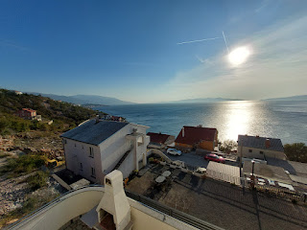

The hills behind our home away from home . . .

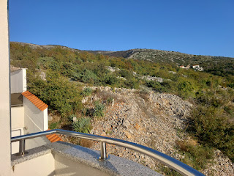

Here is the link to a YouTube video that explains what happened to those 6 republics of the former Yugoslavia, with maps and a brief overview. I had to watch it twice because it goes kinda fast.
(16 min, 25 seconds)
https://www.youtube.com/watch?v=czQrU0OPIR8&t=848s

Even though it's not a "pretty" topic, it's still an important one. If we hide from our past, we will never learn what we need to learn for our future. It's important to know and understand what other countries and cultures have gone through. We can empathize and extend kindness to them, and hopefully never repeat the same mistakes again.

We took advantage of the good weather on Saturday when we first arrived by sending the drone up.
This drone video is in two parts: the first part shows the Adriatic Sea and the hillside where we stayed in Senj; and the second part was in Slovenia, during a brief stop on our way home near a tiny village named Prem. It was just so beautiful on our drive home that I suggested we get some footage.
(4 minutes, 50 seconds)
https://www.youtube.com/watch?v=jq_CHpQqDZI

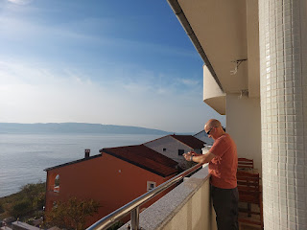

Our host, Domagoj Biondic, is a member of a local Croatian band named "Trio Marinero".

He shared some of his videos from YouTube with me. Here's one of their most popular songs, a traditional Croatian song that is often played at wedding receptions: (3 minutes, 56 seconds)
https://www.youtube.com/watch?v=OJ_5spLR8TQ

And here is a YouTube link for Domagoj playing "I Shot the Sheriff" on his guitar: (46 seconds)
https://www.youtube.com/watch?v=W1TQLBOEOwk

He loves guitars and especially his idol, Eric Clapton. He even had this guitar design installed in the entryway through the gate to the building where they live . . .
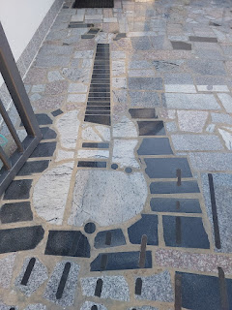

We drove less than 5 minutes to get into the city of Senj (pronounced like "Senn"), where we could walk around the harbor area a little bit. It was pretty chilly, so we didn't stay for too long.

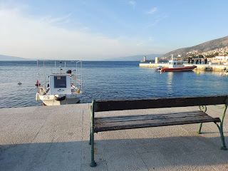

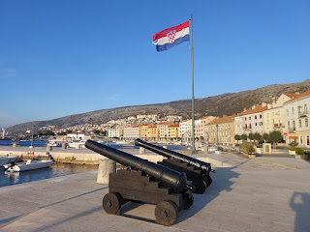

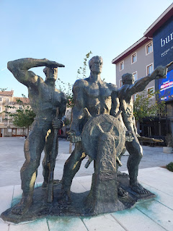

The Spar grocery store is close to the harbor, so we grabbed a few supplies for the weekend there. We also bought a few interesting items for Christmas gifts, such as soup mixes, herbal tea, and jams. The produce was fresh, beautiful, and colorful.

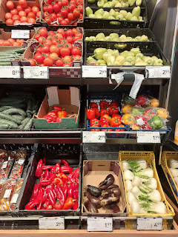

I could not figure out what these vegetables were . . . but with the help of Google Translate, I learned that they are celery root. How would you even use something like this in a meal? Someone please tell me if you know . . .

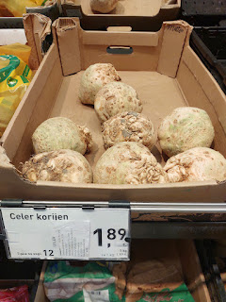

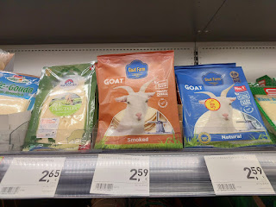

Above and below: Something our host's wife, Andrea, told me is that the goats in Croatia make the most unique cheese.

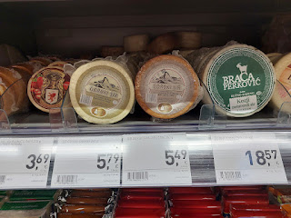

There is a crazy wind in Croatia called the Bura. The Bura winds can be especially strong in the winter months and shoulder seasons, blowing as much as 220 km/hour (136 mph). It blows from the NNE to the ENE into the Adriatic Sea. Senj is said to be the origin of the Bura. One thing that we noted is that between our AirBnB and the city of Senj just south of us, the wind seemed to blow in a more NNE direction. But just 5 minutes up the road to the north, the wind whipped across the sea in more of an ENE direction. The two wind directions definitely seemed to converge right in front of where our lodging was, and we could see it all happening from our vantage point on the hill.

The wind kicked in that first evening, and howled the entire rest of the 2 days we were there. Many times we wondered if the roof might go flying off, ha ha. Thankfully, the building is new and of solid construction.

Back to the goats
- when the wind whips across the sea, it swirls and looks like fast-moving mists flowing across the top of the water. (Videos and photos below) As the wind meets up with the salty water, it kicks up a salty mist onto the herbs, grasses, and vegetation on the hills and islands near Senj. Krk, for example, is a large island just south of Rijeka, but Krk is also directly across from Senj.

Well, guess who loves to eat those salty grasses and herbs on the hillsides? GOATS. So, when they produce their milk, which is then made into cheese, it has a very unique flavor and is enhanced by their salty diet. WOW. How interesting!!

This next product in the grocery store is called Lino Lada. It was highly recommended in a video I watched prior to our trip. The host of the video moved to Croatia over 10 years ago and she shared several of her favorite foods from local grocery stores, this being one of them. It's a combination of a creamy hazelnut butter and a chocolate hazelnut butter (like Nutella), but it's all in ONE JAR. Half light colored and half dark. You can dip your knife in (or a giant spoon if you wish) and get a big swirl to spread on your sandwich. I bought a few jars to share with some family members.

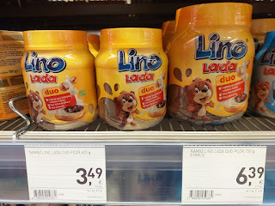

They also had several yummy soup mixes, so I bought a variety to add to some Christmas boxes. They were cheap, but they sounded so good!

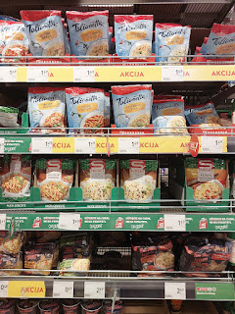

We scurried back to the AirBnB to warm up for a bit before heading out for dinner. I really enjoyed seeing the sea in the different stages of lighting.

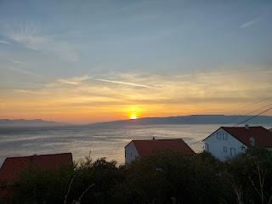

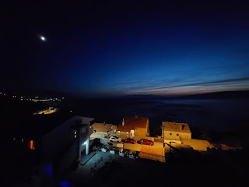

Each of the two nights we were in Senj, we chose a restaurant ahead of time for dinner, and then nothing worked out as planned. Saturday night, we were wandering in the tiny little alleyways of the downtown area, looking for the place we had chosen. It turned out to be closed for the season. But . . . on our way back to the car, walking arm in arm and freezing to death in that crazy cold wind, we turned a corner and a waiter was standing on the front step of this restaurant, just waiting to welcome us in.

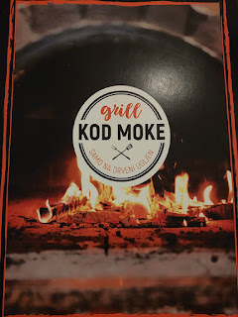

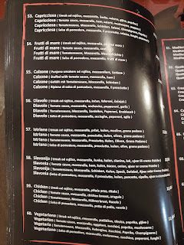

Not the best picture of Scott, ha ha, but he was still working on the tail end of his sickness. Bless his heart. XOXO

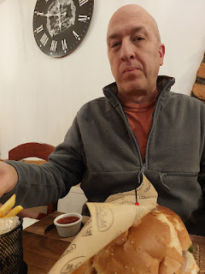

It was nice and cozy in the restaurant upstairs and we quickly defrosted. Our waiter's name was Goran and he was born in Macedonia, but has lived in many places over the years. He had a big smile and a twinkle in his eye, and was comfortably chatty with us at the end of our tasty meal. He was probably in his late 30's or early 40's, I would guess. He wanted to know our thoughts about the new president-elect in the U.S., since it was a few days after the election was over. We briefly discussed the state of the world and how to make the best of it in your own little "corner". We can't solve all the world's problems, but we can be a light within our own little circle of influence.

I ordered a pizza with grilled vegetables on the side, and Scott ordered a burger with fries. They had fancier dishes, like several types of steaks and seafoods - and they all looked amazing, but we just didn't have that big of an appetite.

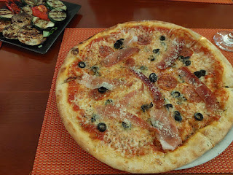

I slept on the couch that night because Scott was still snoring like a freight train, even though he was using his "snore machine". We call it that because it just sounds cute. It's really just a mouth guard that helps his jaw stay properly aligned at night. It helps him to not snore 99.9% of the time, except for when he's been sick - which is hardly ever.

When I got up to use the bathroom in the middle of the night, I was enthralled with the big, bright moon and its reflection on the water.

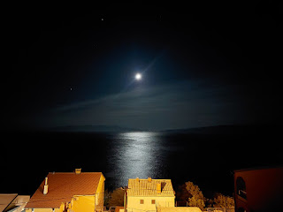

On Sunday morning, the Bura was alive and well, swooshing and swirling across the Sea. (19 seconds)
https://photos.app.goo.gl/zAbco7yh4v8p13sp9

We drove about an hour north to go to church in Rijeka. (pronounced like "Ree-YECK-ah") Rijeka is a very large city, with a population of about 108,000. It used to be under Italian jurisdiction and was called Fiume, but the Italians were heavily persecuted after the end of WWII, which essentially forced them out of the area soon after.

During the years 1943-1960, there was a mass exodus of Italians who left Rijeka - between 230,000 and 350,000 evacuees. When Yugoslavia formed, they persecuted anyone Italian and stripped them of their rights (1954). Yugoslavian authorities unfairly taxed the Italians and made it virtually impossible for them to hold down a job. Many were even
executed
- just for being Italian!!

I tell you what, after reading so much about the recent history of abominations in Croatia, it leaves a yucky feeling in my chest. Even while I was staying there, I felt the oppression and darkness still hanging around somewhat, even though the cities now shine more brightly as a whole.

We studied the map before we left our apartment in Senj, looking for what the parking opportunites might be near the church in Rijeka. It was basically just street parking, if you could find a spot, or else you could park far away in a paid lot and then walk to church. We took our chances by choosing the street parking, and fortunately, we got lucky.

This is the neighborhood where the church was located - in the large building on the left . . .

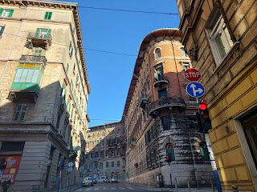

The high rises were quite lovely in this part of town.

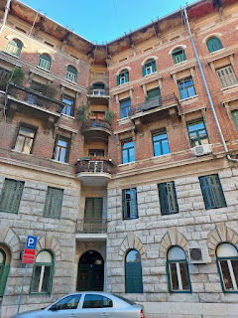

This small sign on the outside of the building was the only indication that we had arrived at the Church of Jesus Christ of Latter-day Saints.

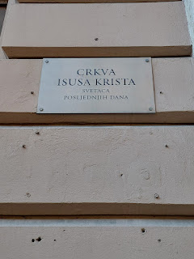

The outer door was locked, and you had to push the buzzer to be allowed inside. It took us a minute to figure out which buzzer to push . . . (click the photo to enlarge and see if you can figure it out, too.)

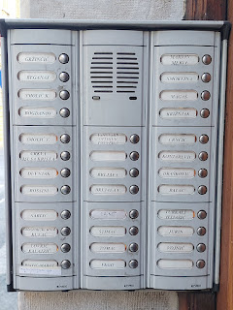

Inside the door, there is a long hallway, and then we followed the stairs up to the next floor.

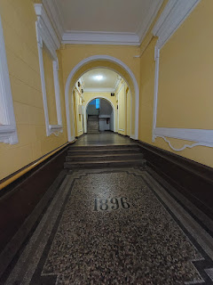

The missionaries immediately came over to visit with us, both the elders (young men) and the sisters (young women). One of them promised that they would come sit by us during the meeting to translate, since their headsets were few and weren't working properly at the moment. One of the sister missionaries played piano for the entire meeting, and one of the elders helped pass the sacrament.

Before the meeting started, I took a look in the hymnbook to see what we were in for . . . lol.

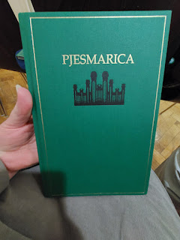

This opening song would be known in English as: "Lord, I Would Follow Thee."

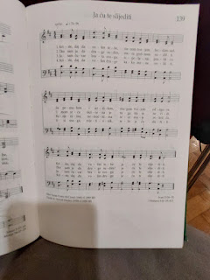

The hymn for the Sacrament would be known in English as: "Behold the Great Redeemer Die."

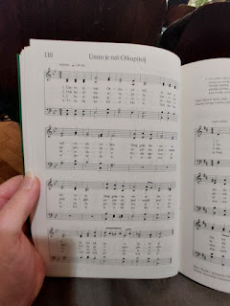

The rest hymn would be known in English as: "Be Still My Soul."

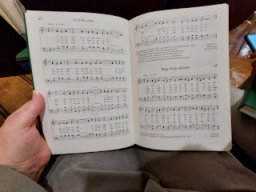

And the closing hymn was: "God, Be With You Till We Meet Again."

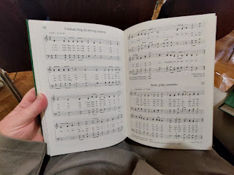

I knew it was going to be beautiful, so I recorded us singing all 3 verses: (2 minutes, 46 seconds)
https://photos.app.goo.gl/yeRRDvpxQNgUSmt96

**I apologize (yet again) for sounding so awful. It is seriously so hard to keep a melody AND sing in a different language. The third verse is the best sounding verse, ha ha because I had gotten a little more comfortable with the words by that point. But still, dang. I sound pretty flat in a few places . . . Sorry.

One of the speakers mentioned how usually there might be as few as 6 people attending church in their little Branch, but on this day, we had close to 25!!

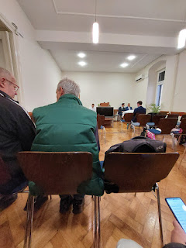

Before we left the meetinghouse, we visited with several people, including the very young Branch President and his beautiful wife. I also had an interesting visit with Elder Richardson, who sat next to me and helped to translate for us. He is from the San Diego area. He had previously served in Bosnia and Serbia before arriving in Rijeka, Croatia.

I asked him how the church was doing in Bosnia and Serbia. He said that things are slow over there, but the people are still struggling as a whole after the big war during the 1990's. The older generation are very solemn and have much they are still processing (mentally). The younger generation seems to be doing quite well, though, he added. They are more optimistic and bright about their future. I was glad to hear that. My heart had been heavy with all the recent knowledge I had learned about this area.

An interesting side note that came up as we were visiting with the Branch President and his wife, is that when the Milan Italy Temple is ready for patrons to come to the House of the Lord, Croatia will be part of that same temple district. Right now, they are assigned to go to Frankfurt, Germany, which is quite a distance to travel. Some even opt to go to the Rome Temple, instead. It will be a few years, though, until the Milan Temple is finished and dedicated.

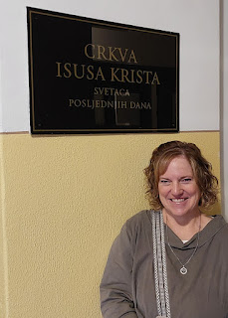

Here are a handful of videos as we drove through Rijeka back toward Senj. There is a mixture of Italian influence and what felt like a Russian influence, as Yugoslavia used to be part of a Communist region.

Video #1: (19 seconds)
https://photos.app.goo.gl/LWsysbyb1yJb1hHv6

Video #2: (44 seconds)
https://photos.app.goo.gl/wi58XyEJxd8ACAbRA

Video #3: (11 seconds) Down by the water
https://photos.app.goo.gl/316PB4qcG8VRFiWo6

Video #4: (10 seconds)
https://photos.app.goo.gl/tQB5k2Xj353Enkkn6

From Rijeka, you can see how the Adriatic Sea takes shape as it pushes southward . . .

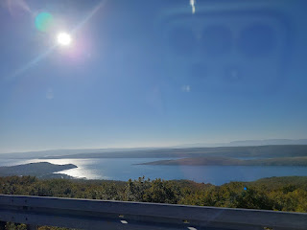

There is a huge bridge that connects travelers over to Krk Island, the largest island in the Adriatic Sea.

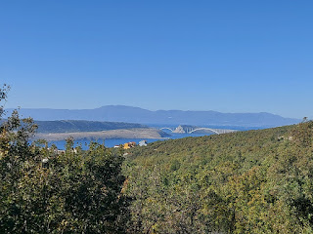

Video as we passed by one of several marinas on our way back to Senj: (13 seconds)
https://photos.app.goo.gl/9DhrKrCZsH1dRvdP7

I played around with one of the photos that I took on the drive, using the eraser tool to get rid of the reflection of my phone on the car's windshield. Just don't look too closely, ha ha. Instead, just enjoy the moodiness and timelessness of the sea . . .

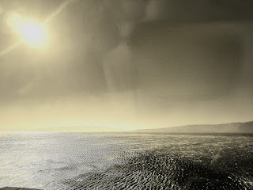

A couple of the
many
cute details at our AirBnB . . .

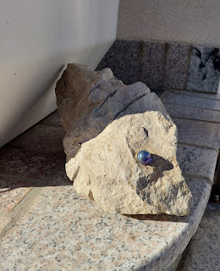

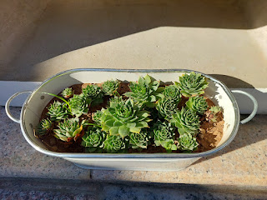

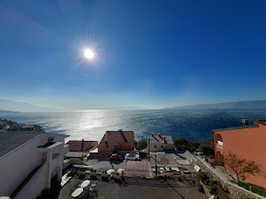

After a snack and a short rest, we decided to be brave and find a trail down to the water . . .

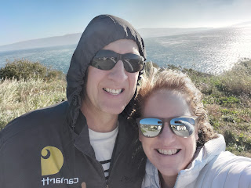

We danced with death in walking along this narrow path next to the highway . . . but we soon found a path on the opposite side that led down to a little cove.

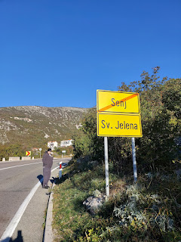

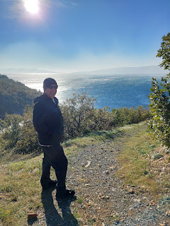

Directly across the road from the Restaurant Adria, is a path that leads down to Plaza Jelena, a small beach and cove with a few boats tied up there.

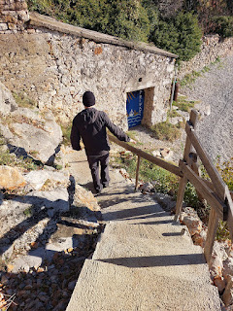

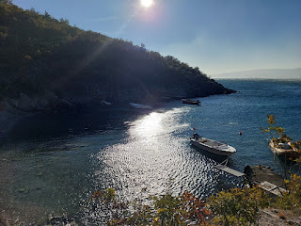

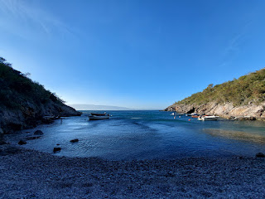

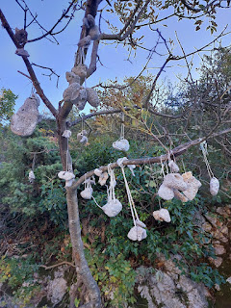

It seems to be the custom that if you find a rock with holes in it, you should string it up in the tree . . .

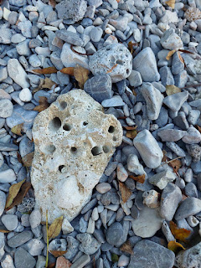

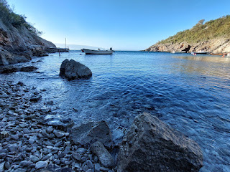

Even though we were sheltered from the worst part of the Bura winds, you can still see the pushy-shovy ripples on the water: (13 seconds)
https://photos.app.goo.gl/KwH6W4zf42BDQWcw8

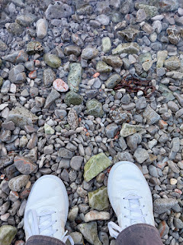

For those of you who love water sounds: (18 seconds)
https://photos.app.goo.gl/47M8u9jqHoFiKJX16

I found several beautiful rocks with a mixture of white, cream, green, and rust colors . . .

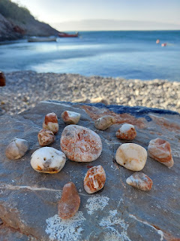

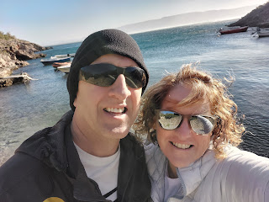

My mind started thinking about anchors and moorings as we clambored over to where a few boats were tied up . . .

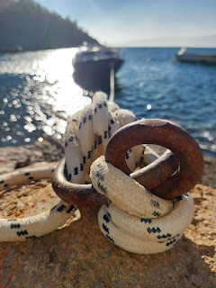

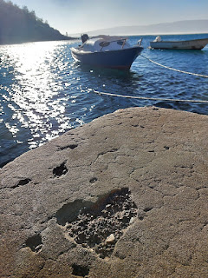

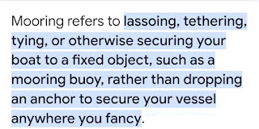

I thought about our Savior, Jesus Christ, and how He is the Perfect Rock to tether ourselves to. He is constant and eternal and He is always available for us, whatever we may need. We have to first mentally acknowledge that He is a safe place to find harbor from the ills and ailments of life. Then we need to yoke ourselves with Him. We will better weather the storms of life if we look to Him in everything. In every matter, big or small.

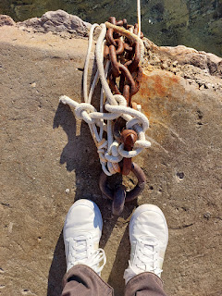

Sometimes we may think we don't need Him, and we untie ourselves from His perfect and loving influence . . . we think we know better on our own.

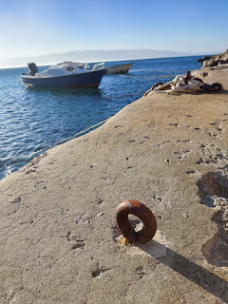

It is always better to link up with Jesus. I like to picture us arm in arm, buddies, and eternal friends.

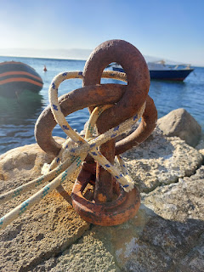

Sometimes we may toss Him aside, because we have been hurt, offended, or misled somehow. But those offenses did not come from Him. Those perceptions may have come from other humans, who are IMperfect and flawed. Or we may have misunderstood the perfect timeline of God and Jesus Christ and are looking for someone to blame.

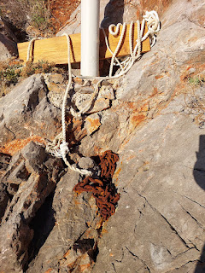

Whatever the storms we face in life, it is always better to moor ourselves to Jesus. (16 seconds)
https://photos.app.goo.gl/yiQnfGTALndgcbuG8

We found a different path to get back up to the road. It was steep and rocky, but it worked.

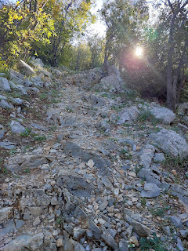

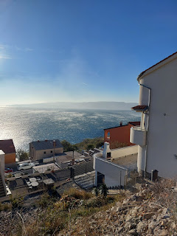

Video looking off to the left, where the city limits of Senj are: (14 seconds)
https://photos.app.goo.gl/ZpVvtPCvyxbLw7te6

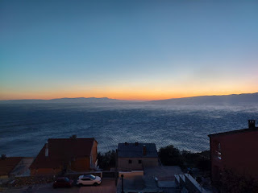

We attempted to go out to dinner again on Sunday. Our host had told us about two really good restaurants: Konoba Ivka and Restaurant Martina. We walked through those dark and narrow alleyways again to get to the first one, but the whole building was dark where the restaurant was supposed to be. So we walked back to our car and drove to Restaurant Martina. We got there at 5:50 p.m. As we walked up to the front door, a young man came out to greet us. He told us the kitchen was closing at 6:00 and that if we wanted to eat, he was very sorry. If we only wanted drinks at the bar, then we could come in out of the cold for that.

How strange that the restaurant was closing so early! We decided to drive back to our flat and rummage through the modge podge of grocery items we still had in the fridge. I ate eggs, lunchmeat, and cheese on two slices of bread for dinner. :)

We took our time getting out of bed Monday morning, which was so nice. We were in no hurry to get somewhere, even though we knew we had a 4.5 hour drive home. One of the last things I wanted to stop and see was the sundial that we kept passing every time we drove into Senj.

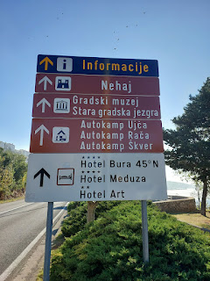

Senj, Croatia is located at the 45th parallel. It is equidistant between the North Pole and the Equator.
There is even a hotel named Hotel Bura 45 North, which is funny because our host had mentioned that the Bura wind is strongest out of Senj than just 5 minutes north or south of town. It's like the Bura really does originate here! She also added that it shows up for a few days every month of the year. In the summer months, it is welcomed because it cools people off. But in the winter months . . . BRRRR.

One last video of the Bura winds whipping across the water: (13 seconds)
https://photos.app.goo.gl/LaqPRM4X4QT5FKeu8

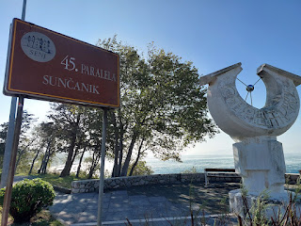

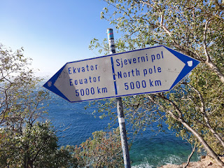

This was a very interesting sundial . . .

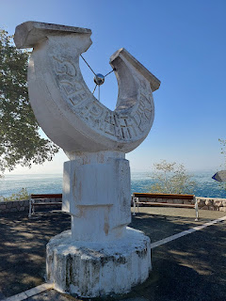

The last place I wanted to stop for a picture was this giant mural on the north end of Senj as you head out of town. The small caption at the top says: "1991-2017. Always on the Front Lines."

The two giant words say "Rije" and "Cani". Together, this translates to: Words Can . . .

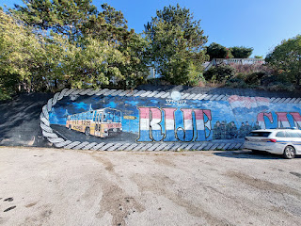

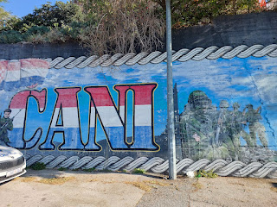

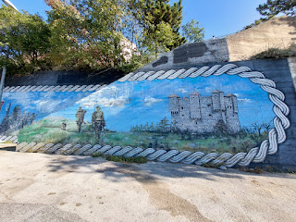

We missed an exit on our way home, which allowed us to take a more scenic route through the hills and tiny villages of Slovenia. I was not sorry about that at all (other than the fact that my bladder was full and I had to hold it until we could get back on the freeway to find a rest stop.) They have a dedicated gas station, restaurant, convenience store, and a bathroom at each rest stop in Italy. And the bathroom we found at this one was like most in Europe, you have to pay to enter. But there was one big difference - it was an upgraded version. It had a TAP PAY! You can use your credit card to pay the 1.50 euros. Gotta love that.

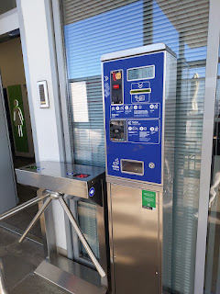

Coming up:
We leave for Iceland on Monday morning and then Minneapolis for Thanksgiving. I'm not sure when I will get the next blog written . . . But I will have some BIG NEWS to report regarding Scott's new job. So stay tuned . . .

