Do You Wanna Build A Snowman?
Mr. McGillicutty has had a rough week. Even though we've gotten several more inches of snow, he's not looking too good . . .
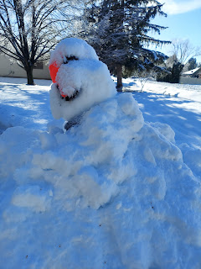
Anyone up for a BBQ? Just let me know . . .
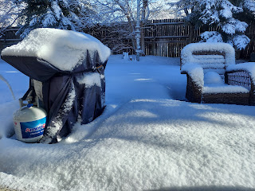
Last Sunday, I began a 5 day dogsitting adventure with Milo Cunningham, a large poodle mix. He was always ecstatic when I came down the street to let him out into the back yard. After he did his business, he ran and romped around in the fresh snow without a care in the world. :)
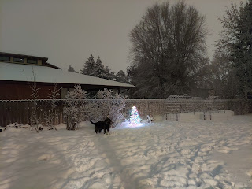

The snow was coming down so hard and fast Sunday night, that as soon as I finished shoveling a section of the driveway, you couldn't even see where I had shoveled . . .

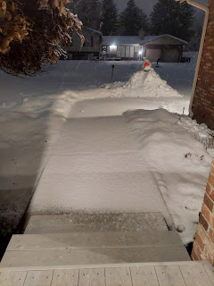

By Monday morning, there was a good 3+ inches of fresh snow on the ground. I knew what I'd be doing for the next few hours . . .
First, I walked over to check on Milo and feed him his breakfast. I didn't want to drive down the street because I was worried my car would get stuck in the snow. Thankfully I have some great winter boots (Columbia brand) that keep my feet toasty and warm and also have good traction.
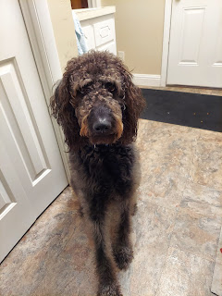

The Cunninghams have taught Milo the cutest phrase when they want him to go potty. They tell him to "Go hurry up!" And he knows exactly what to do . . . ha ha

While he was playing in the back yard, I shoveled the Cunningham's driveway so it wouldn't freeze and turn into a sloped ice skating rink before they returned from Disneyland.

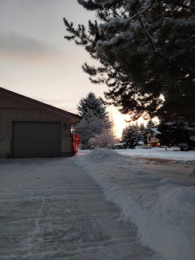

The sun was coming up in a beautiful fashion as I walked back to my house shortly thereafter.

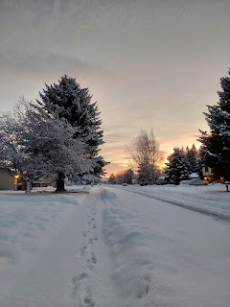





After I fed myself, I headed back outside to clear my driveway and Ellen's driveway next door. I used our snowblower for the most part, and had to resort to a shovel every once in a while.

Video of our snowblower "trying" to launch the snow: (9 seconds)
https://photos.app.goo.gl/6Q6N3diXk77Z191n8

I say "trying" because A) the snowblower is old (about 15 years old), and B) it depends on the type of snow as to how far it can launch. If the snow is light, then it can launch pretty high and far. If it's wet and heavy, then it gets clogged easily. This was a mix of the two . . . wetter/heavier snow from Sunday night that turned light and fluffy sometime during the night. So the top layer was mostly fluff.

It was still faster to plod along behind the snowblower rather than shoveling, so I was grateful for that! I cleared three driveways and all the sidewalks before going inside to relax for a while.

One of the projects I did on Monday was to dig through every possible military storage container in the house in search of Scott's military coins. He's a sneaky one, that guy . . . I found a few coins in the most random places!! He's pretty sure he has more than this, but we just don't know where they are. It's possible he gave some to our kids, but I don't think this would account for how many Scott thinks are still MIA.

Scott's explanation of military coins to me is that basically the coin is like a commander's autograph. Whoever the commander is, (general, colonel, etc.) he has some special coins made that he can hand out. If he likes you, you get one. If you did something noteworthy, you get one. If you finish a deployment or a military school, you get one.

I placed the ones that I did find onto this "Idaho-shaped" plaque that I bought from a local vendor back in Vicenza last April. It's made from olive wood and the vendor's wife engraved Scott's name and an American flag on it for me. Now, finally, it's hanging proudly on the wall down in the family room next to all the other patriotic photos and framed art.

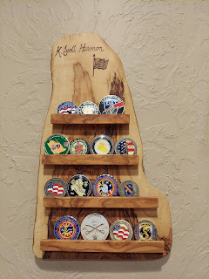

As I was digging through our "Iraq" box, I came across some precious notes and letters from Scott's two deployments when our children were young. Each deployment was roughly 18 months long with the trainings beforehand and the debriefings afterward.

I found a note where I had jotted down a conversation with Jacob when he was 8 years old (2004):

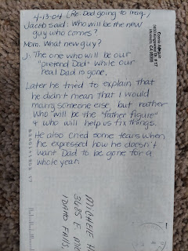

He had the hardest questions that he would ask, but sometimes they were questions that I didn't want to say out loud myself. For example:

"What happens if Dad dies? Will we get a new Dad?"

And then a day or two later:
"So if Dad dies, and we get a new Dad, when do we get the new Dad?"

You see what I mean?

I tried my best to explain to him that if Dad died in Iraq, it would take me a long, long time to work through all of that, and that there is no exact time frame for finding a "new Dad".

When Scott deployed in 2010, the kids were older and less willing to follow my encouragement to try to be as happy as we could in spite of him being gone. For me, I didn't want to spend 18 months wallowing in despair. I needed to be at peace with the whole thing, and I tried hard to convey that to our 3 kids, who were 10, 14, and 16 years old.

With the first deployment, they were 4, 8, and 10, and were more willing to follow my lead. (2004-2005) If I could demonstrate that we could be happy in spite of our circumstances, then they trusted me and figured that all would be well. Not so with teenagers . . . they have their own minds and their own feelings. I can't remember how many times I heard the phrases, "This is dumb!" "I hate this!" "Why did he have to go?" "This is so lame!" (in 2010-2011)

In spite of their protests, I encouraged them to write a weekly email to their father on the other side of the world. I enjoyed reading through all the letters again this week and seeing how each of them acclimated to their father's absence.

Benson: (10 years old)
*CLICK the photos below to enlarge so you can read the words

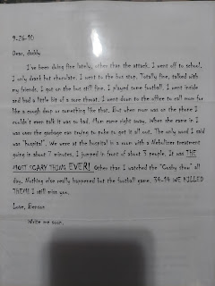

Jacob: (14 years old)

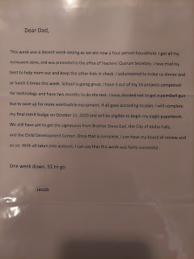

And Amber: (16 years old)

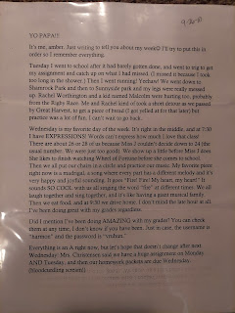

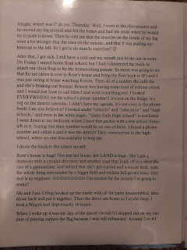

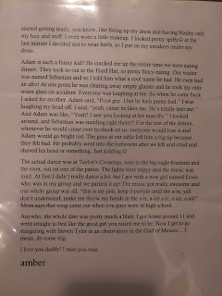

Those deployments were the best of the times and the worst of times. They were great because we learned how to deal with hard things. People came to our aid when we needed help. Our love for Scott grew immensely during those long separations. And we had to dig deep to find ourselves. They were the worst of times because we had to deal with some hard things. We had ask for help more times than I wanted to. Those separations were sooooo looooong. And we had to get over ourselves in order to grow.

Isn't that how life goes, though?

The temperatures in Idaho turned frigid this week, after all that fresh snow settled in. Monday night, as I walked down to check on Milo, I found the icicles hanging from their spruce tree just mesmerizing.

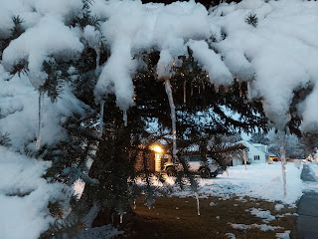

When I drove across town to go to the temple Friday morning, my dash said it was 16 degrees outside. And Sunday morning, the temperature was 8 degrees as I woke up. EIGHT DEGREES. That's not right.

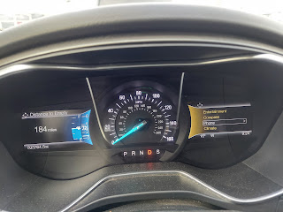



I enjoyed my time in the temple and getting out of the cold.



One of our church leaders, Elder D. Todd Christofferson (an Apostle), shared his thoughts about why temples are so important on Instagram this week and I loved every single thing he said.

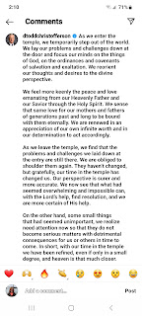

This is exactly why I try to go to the temple as often as I can. :)

The rest of the week was a blur . . . a blur of checking on Milo several times a day, working around the house, talking to Scott/Amber/Jacob/Kylie/etc., then lather, rinse, repeat.

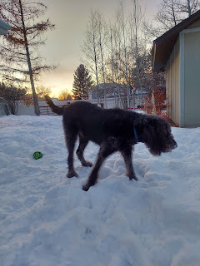

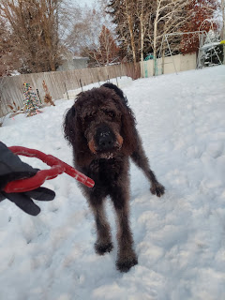

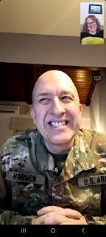

Scott got a pile of Christmas cards mid-week. Whenever I go over to Italy, we forward our mail to his APO address. (It takes an extra couple of weeks for it to arrive in Italy) We arranged for the forwarding to stop when we got home to Idaho on New Year's Eve, but I guess we should have stopped it sooner, ha ha. He showed each card to me and then read them to me over the phone. It's not quite the same . . .

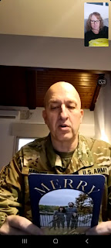

When I talked to Jack during the week, he was a little sleepy, and therefore more stoic than usual. It took a lot of convincing to get him to crack a smile. I tried making all kinds of silly faces until finally something clicked . . .





Amber has been hard at work every single day creating illustrations on her I-Pad for her online class. She showed me some of what she's doing and it looks so professional! She is so talented, which I've always known. But I am so proud of her for taking this time for herself while the girls are in school, and honing her craft. :)



Saturday, Amber and Weston worked on their yard for a while down in Louisiana. Amber referred to it as "bush-whacking." I love what she posted about it: "Used a chainsaw for the first time. Age 28."

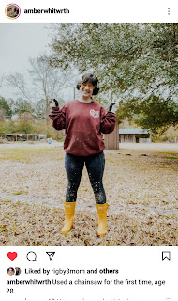

I've been trying to stay motivated this week to do stuff. Any sort of stuff! I know, that doesn't sound like me . . . but with Benson's accident and me being on the other side of the world, it was a struggle every single day. I would go to bed with great intentions for the following day, but shortly after I got up and did one or two things, my motivation was spent.

Tuesday, I was an emotional wreck. I cried too many times to count that day. At the root of it all was my desire to just be a mom to my son on the other side of the world. I wanted to just "pop in" and tuck a casserole or some soup in his fridge, say hello, give him a hug, and just stay briefly so as to not invade his adult space too much. I felt lost because I couldn't do those simple mom things. It was especially difficult because deep in my mind, I knew that everything I wrote for my talk in church last week should be applicable in this situation. But I still had to go through the grieving process all over again, because I couldn't do the things I wanted to do, and Benson is a conversational hermit. Most of the time I don't hear back from him when I reach out, and I have to be okay with that. And most of the time, I am okay with that. But this week, I wasn't.

By the end of the week, I was feeling much better. Stronger, more motivated, less teary, and more reconciled to my limited conversations with my youngest child.

On Saturday, I took myself roller skating again. This will be my weekly exercise date with myself. The girls that came with me last week weren't able to join me this time (they all had babysitting assignments), so I went solo. I had a good time and stayed about 90 minutes before heading home.



Video of me cruising along: (18 seconds)
https://photos.app.goo.gl/PWZ74ahd8UxpfFXS6

Shortly before I decided to pack it in and leave, I noticed a young girl watching me closely every time I came around the rink. I kind of got the feeling that she was trying to mimic my technique or something. At one point, as I skated past her, I hollered out, "You're doing awesome!" And I gave her two enthusiastic thumbs up. She responded by saying that she was trying to figure out how to cross one foot over the other as you go around the corner and she was trying to do what I was doing. I stayed with her for several laps and we worked on the technique. I asked her what grade she was in, and was surprised to hear her say "4th grade". I told her that's when I started roller skating myself, and that I came as often as I could all the way into 6th grade. The more I came, the better I got. She seemed encouraged by that. It felt good to help her and give her a couple tips before I left.

I look forward to going again next weekend! :)

