Girl's Night, A New Puppy & A New Baby!!
Benson has a new puppy!! We didn't start out last weekend with that in mind, but a spur of the moment decision led to some big smiles. We were hanging out in Meridian and having a great time with my sister-in-law Carol and all of her children and grandchildren, and then Benson's world changed forever.

They have a short devotional and a tasty dinner every single Sunday at Carol and Mike's house, and whenever I'm over on that side of the state, Benson and I get invited to join them, too. (When Benson gets his car running, he'll probably go to their house more often.)

While we were all still together after the devotional, I took a group selfie before we ate dinner. I'll try to name everyone.

Front L to R: Benson, Nellie, Me, and Louisa (blond with striped shirt)
Couch potato bunch on the left: Kim and Heather on the couch, with Monroe laying down next to them, Mike Whitten is behind Benson, and Mikey (black hoodie)
Fireplace zone: Cami on the floor by the hearth, Price standing in front of the fireplace with his daughter Anna (you can almost see her eyes), Carol is in the back right corner.
Middle cluster: Robert with his black hoodie up around his face, Ben with the wavy brown hair, Penny (the puppy matchmaker), and Sam is in front of Penny.

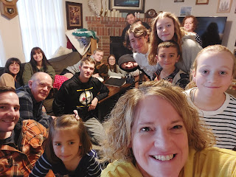

Carol had put together a taco bar and we all enjoyed the food very much. The cousins all sat around the dining table, talking and laughing about everything under the sun.

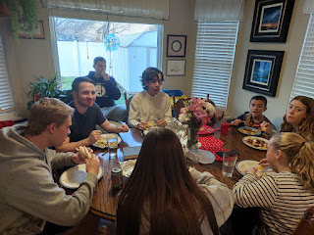

After the kitchen was all cleaned up, I set out the two games I had brought with me: Dead Grandma and Sushi Go. You may recall that Amber illustrated the Dead Grandma game, a light-hearted game of bidding for Grandma's most prized possessions. All the kids loved that game so much that I ended up leaving it there for Carol and all of her grandchildren to play again and again.

While we were playing Sushi Go (another really fun game), Penny mentioned that her manager at IHOP was trying to find homes for her German Shepherd puppies. She still had several to home, and is also raising 4 young boys plus working as the manager at IHOP. She needed help, and fast! Penny started showing photos of the puppies to those seated closest to her, which happened to include Benson. The puppies were identified as Red, Blue, Yellow, Purple, Black, etc. She asked Benson if he'd be interested in a puppy. He said "Possibly" . . . and then next thing we knew, he told her that he wanted Purple. Penny couldn't believe it and wasn't sure if he was serious at first. But he was.

Benson asked me if that would be okay, not because he needed permission to get a dog, but because it would mean driving back to Meridian the following morning to pick Purple up and I was the one with the car.

I made sure that he wasn't just agreeing to take a puppy and that he really truly wanted to take care of one, and then I told him that yes, we could come back to pick her up the following day. We went to Walmart late that night and he got all the necessary supplies, including a kennel. Then he puppy-proofed the house before we went to bed.

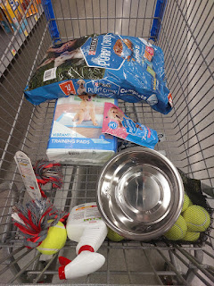

Monday morning found us in Meridian once again, not having to wait too long before "Purple" showed up. Carol's daughter, Heather, had scooped her out of the box from Penny's car and wanted to be the one to hand the puppy to Benson for the first time.

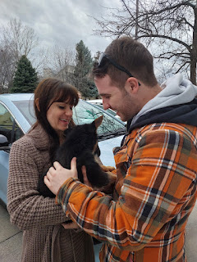

It was love at first sight . . .

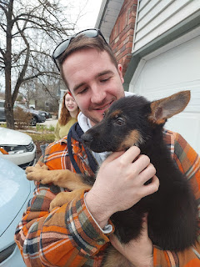

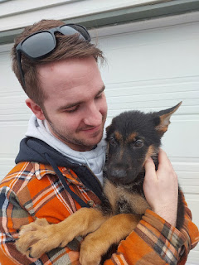

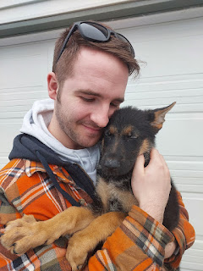

Purple, along with her brother, Blue, had come to Carol and Mike's house, so we took them out to the back yard in case they needed to go potty. Benson had to coax Purple for a while to get her to step out onto the cold, damp lawn.

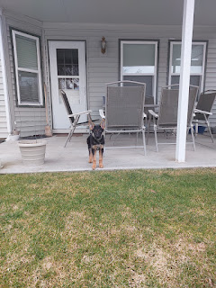

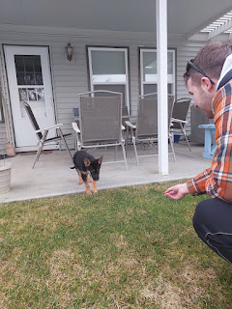

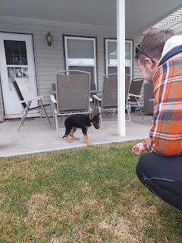

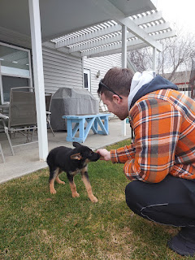

Video #1: Benson coaxing Purple onto the grass for the first time. (17 seconds)
https://photos.app.goo.gl/RivdRmsvtxQhM76b7

Video #2: Benson scratching her back. (8 seconds)
https://photos.app.goo.gl/N2EaVNsiEDD1axVP7

Video #3: Purple sniffing inside my coat sleeve, ha ha. (19 seconds)
https://photos.app.goo.gl/FbtZKPiCV2Zj9QSS7

Video #4: Benson convincing her to come further out onto the lawn. (23 seconds)
https://photos.app.goo.gl/o6gGFgQN1gVbw87R8

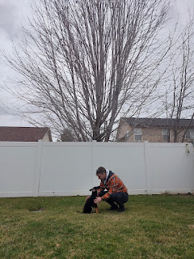

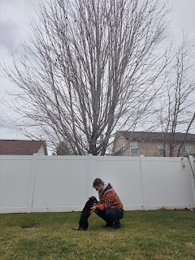

We didn't stay in Meridian for too long, mainly because I still had a long drive ahead of me to get home to Idaho Falls. She slept on Benson's lap in the back seat, and while the two of them quietly dozed, I drove us back to Mountain Home.

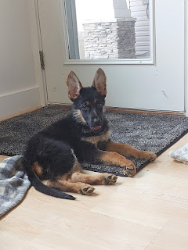

A short time after our arrival, the puppy had an upset tummy. She barfed all over the rug and the floor and the blanket in the photo above. Poor thing . . . Benson sent her outside while we teamed up to get everything clean on the inside. Benson does not currently have a washer and a dryer, which makes things more difficult when something like this happens. But he does have a utility sink in the laundry room. So, while Benson cleaned and sterilized the floor, I washed the rug and the blanket in the utility sink. Man, who knew that a fleece blanket could hold so much water!! Even after I did my best to wring it out, it felt like it weighed about 100 lbs. as I hauled it outside to dry by letting it hang over the fence.

She threw up 2 more times before I left, but thankfully they weren't such big amounts, so the cleanup was much faster. I ran to the Commissary around the corner to get them a few more items before I left Benson alone with a puppy, carless and without a washer/dryer.

I checked back with him later that night, and again the following day. She threw up a few more times, but was doing great by the next morning. Benson had called the Vet on base during the night just to be sure that he was doing the right things. They told him to not give her any food or water for a solid 8 hours to let her tummy settle down. It worked. And she hasn't thrown up since! Hallelujah!

We think it was a mixure of the stress of being taken away from her family and getting to know her new Dad, along with some possible motion sickness from the one hour drive over to Mountain Home. Hopefully, she won't continue to have issues in the car in the future, but if she does, we'll be ready. We've already checked on a few ideas to minimize the trauma next time.

I reluctantly said goodbye and drove myself home. I chatted for about an hour with Jasmine, my former foster daughter, whom I haven't checked on in a while. She is doing great with her little family down in Arizona. They have a dog with motion sickness, too, so she offered a few tips on what they do whenever they have a long drive coming up.

Later, as I was chatting with my sister, Charmaine, the most gorgeous sunset was all around me. Delicate pinks were in front of me, lavenders to my left, and the most stunning oranges were behind me.

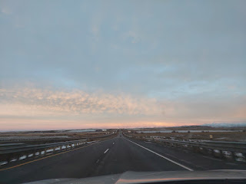

I couldn't take a photo of the fiery skyline behind me, so I did the next best thing: I utilized the view in the side mirror.

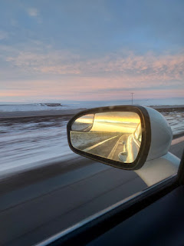

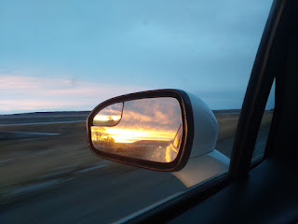

I made it home in good time without any incidents. Once I got settled in, I immediately went across the street to show Kim some photos of the new puppy. Her dog, Cleo (a Great Dane), who is always very motherly, was also extremely interested in the puppy scents that I was wearing. She was visibly concerned when she sniffed out a tiny area on my shirt that had a bit of puppy barf residue. I had to tell Cleo that the puppy was okay and that everything was alright. I think she believed me . . .

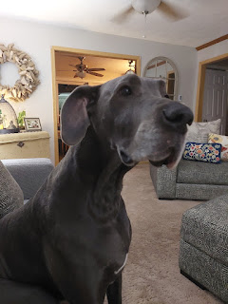

Benson decided to name the puppy, "Daisy". So Daisy is doing pretty well so far in her first week with Benson. Oh! By the way, she was 11 weeks old when she was adopted, so now she's 12 weeks as of this writing. She was extremely sad the first day that Benson had to go to work, crying out in a shrill puppy voice. But as she has begun to see the consistency of him coming back halfway through his shift and then again at the end of his shift, she is less and less traumatized at the separation now. She is always super happy to see him, too, when he gets home.

Video of Daisy hiding under Benson's jacket in the afternoon sunshine: (16 seconds)
https://photos.app.goo.gl/Na98gweyZfuixwiEA

Video of Daisy learning the command, "Sit": (11 seconds)
https://photos.app.goo.gl/hhGTFPNQmhjziirW6

For Benson, Daisy is keeping him company and giving him unconditional love. She is getting him outside more, on lots of walks, and is providing some meaningful companionship and entertainment. I think this will be a good experience for them both. :)

The middle of the week found me bouncing around with multiple appointments: a haircut, a cleaning and checkup at the dentist, and a trip down to Pocatello to get my military ID card renewed. It was going to expire 12 days BEFORE I get back to Scott in Italy . . . but now I'm all set. The Pocatello Temple is just 1.5 miles from the National Guard Armory, so I drove over to visit while I was in the area. I wore a dress to my ID card appointment so I could go into the temple afterwards with a more appropriate attire. My only other visit to this beautiful temple was when they had the Open House a couple years ago. It was sure pretty on the inside. I sat in the Celestial Room for a good long while, just praying and thinking and enjoying the peace and quiet that is so prevalent in the House of the Lord.



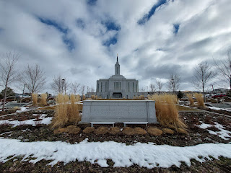

On Friday morning, Scott and I did a shortened version of our weekly Personal Finances Class. I had a lot going on that day in preparation for some friends coming to spend the night. But Scott had lots of fun trying out a few different filters on our "Google Meet" session. My favorite was the cowboy filter. He sure looks handsome, ha ha.

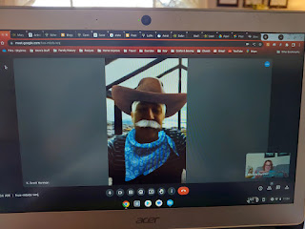

I cleaned the house, made a menu plan and got some groceries, and then I cooked up an Italian soup for dinner, along with garlic bread and veggies with a homemade ranch dip. The girls that came are all attending BYU-Idaho and just wanted a night away from their roommates and the same old "grind" of their daily schedules.

Pictured below: Emily (with the hat), Me, Lauren, and Lauren's cousin, Hannah.

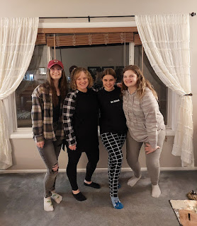

Emily and Lauren are the daughters of two of my closest friends back in Italy. I'm always happy to host these amazing girls in whatever ways that I can. We had a great dinner and then we played the Dead Grandma game for hours while we nibbled on a bite-sized assortment of goodies I had picked up at the Broulim's bakery earlier. (brownies, cannoli, and a giant cream puff that we cut into tiny portions)

Lauren loved the Dead Grandma game so much that she didn't want to stop playing it! I decided to give my second set away to her, which made her very happy! I have one more game in my possession, but it doesn't have the expansion pack that the other two had - the ones that I gave away. I'll buy a couple more sets so that I can keep spreading my daughter's fame and fortune. It's fun telling people that my daughter illustrated the game and that my son's friends created it.

Here is the link to Dead Grandma:
https://www.deadgrandmagame.com/

It's also available on Amazon:
https://www.amazon.com/gp/product/B0CPTD921B

The next morning, I made French toast, eggs, and sausage for everyone. They kept thanking me, saying that both the dinner and the breakfast were the best meals they had had in a while, ha ha.

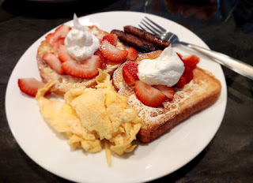

I've also been hard at work on Jack's birthday gift. I'm on the home stretch and I can finally see the light at the end of the tunnel. Sewing several individual items on the race car panel has been tedious, especially working with all of the straight pins that are holding everything in place. I have to roll up (or bunch up) sections at a time to shove it through the "hole" as I turn the whole thing to sew in a new direction.

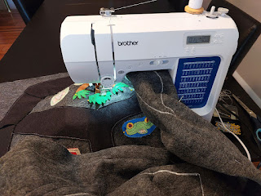

But these pins sometimes poke all the way through and into my finger or into the palm of my hand . . .

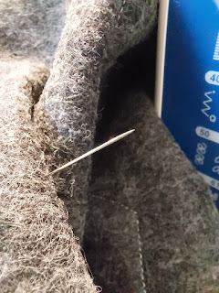

I have gotten this far in the last couple of days (photo below). I have a few last touches to add on, and then I can connect this whole race car panel to the construction panel (shown below) that I worked on a while back. Then it will be a reversible playmat - hopefully bringing hours of fun to Jack for years to come.

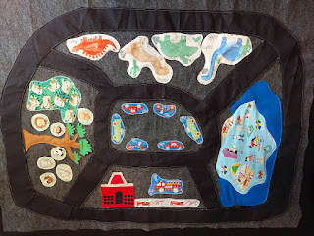

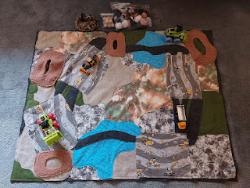

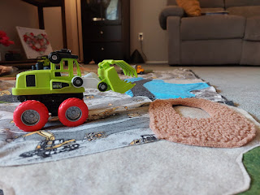

OKAY, I have permission to share the exciting news now: Grandbaby #6 is on its way!!!

Jake and Hannah are expecting a baby this fall!!!
Hannah is a little over 12 weeks along now, and her due date is September 4th. Sometime around 17-20 weeks gestation is when they can find out the gender. I'll keep you posted. I'm so excited!!! Hannah will finish up her Master's Degree in April, and then things should slow down a bit for her over the summer. I think she will just be working part-time and taking care of Jack. What a perfect time for Baby #2. :)

I got to have an entertaining video call with
Avery
this morning (Sunday). She had just had a bath and was a ball of energy as usual, LOL. I tried to read "If you give a mouse a cookie" to her, but it only lasted about 30 seconds or so before she was off and running. (.....Jumping on the bed to be more precise)

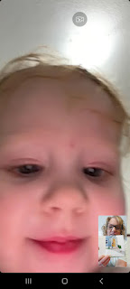

She likes to pretend to eat things, making the cutest little snarfing noises, ha ha.

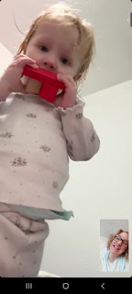

She can identify several colors now, which I got a kick out of when she brought blocks over to her mama, one at a time. Kylie would ask her what color it was, and Avery got them all right! I told Kylie she's doing a good job parenting Avery. Plus, when Kylie sings "Ring Around the Rosies", Avery does all the actions. What a cutie! I hope you enjoy the photos below that I took during our video call. :)

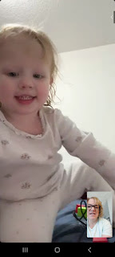

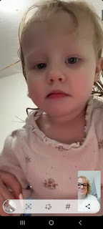

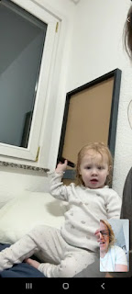

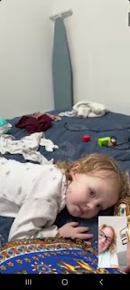

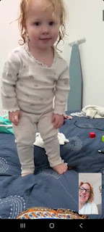

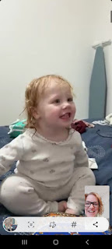

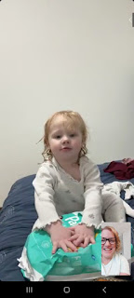

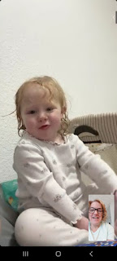

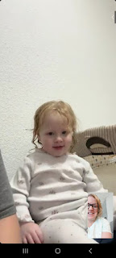





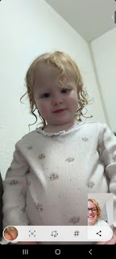



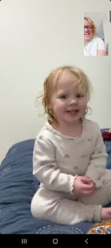

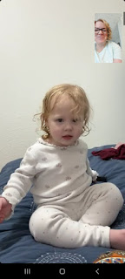

She was a bundle of energy!! I tried to capture different moments, and all of those photos took place within about 8 minutes or so.

Meanwhile,
Scott
is in England for some meetings this week. He's staying in the barracks on a very tiny base. This is what his room looks like . . .

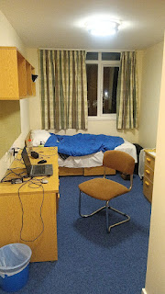

He is close to both Bath, England and Stonehenge. A group of people went Saturday evening to Stonehenge and caught the sun going down. Breathtakingly beautiful!

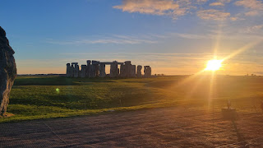

Scott went Sunday morning with another group, and it was cold and rainy. I was glad that he went, though. He almost didn't go because he didn't think it would be worth paying the $25 (in British pounds) to get in, but I talked him into going. Charmaine and I went there in 2018 and we loved it! You feel really small next to those huge stone tablets. It almost feels other-worldly.

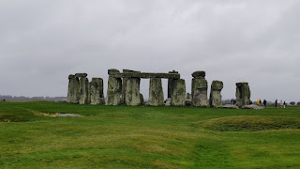

ALSO:
Scott got word that his final promotion came through this week!! It was several months earlier than we had anticipated, but WOW. This is his
FINAL PROMOTION
for his whole military career!! He is now a CW4 (Chief Warrant Officer 4). When he retires next year, his pay will be equivalent to that of a Major.

I am so extremely proud of him!! And because of my huge love and admiration for him and his military career, he asked the powers that be to please wait to have the advancement ceremony until I get there in a few weeks. I was so grateful that he did that. XOXO

Amber
and her family drove up to Minneapolis to spend the weekend with Jake, Hannah and Jack, and to explore the possibility of moving up there in the near future. They had a great time and have fallen in love with the area. Weston has had a couple of job interviews and things are looking promising for them to uproot and move north this year.

While Amber was working on packing for their trip, she put Abby and Gwen on a fun job of excavating a dinosaur egg. See video here: (12 seconds)
https://photos.app.goo.gl/13513ja5Lhn3eUeV6

They all went to the Mall of America on Friday night . . . (Weston is in the photo below)

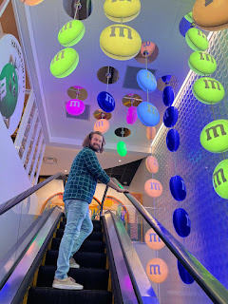

Gwen & Abby . . .

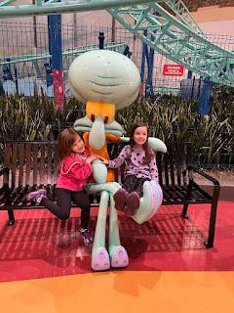

Video of Jack, Abby and Gwen getting ready for Bumper Cars: (39 seconds)
https://photos.app.goo.gl/AvYTrXeMnWMPxdcTA

Video of the kids trying to get unstuck: (25 seconds) **Listen for Gwen's happy squeal as she rams into someone. I chuckled when I caught her doing that . . .
https://photos.app.goo.gl/aBFQ7jKTYYo6F76NA

They also went to the zoo. It would be such an amazing thing for those two families to live closeby to each other. Cousins should grow up with cousins. And siblings should be close, too, and hang out together. We have been so spread out for so many years . . .

Abby, Gwen, and Uncle Jake . . .

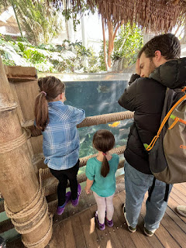

Coming up this week, I hope to finish Jack's playmat AND finish the Rawles Blog. Crossing fingers that I make some serious progress . . .

