Harmon Family Reunion: Part One
We have had a wonderful and very packed couple of weeks with family! It was so busy that I even took a week off from writing my blog . . .

We celebrated Independence Day, took family photos, ate lots of food, and played, played, played.

L to R: Scott, Gwen, Me, Abby, Amber, Benson, Daisy, Jake, Hannah, and Jack

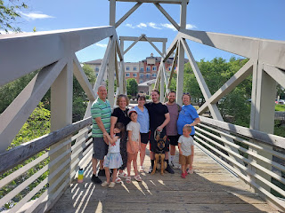

BUT FIRST, we had to get all the way from Italy to Idaho Falls . . . and it ended up taking 40 hours instead of 20-ish. We got up in the middle of the night at 2:00 a.m. to begin our travels on June 25th, and then it turned out that our flight was delayed 2.5 hours so we could have stayed in bed a lot longer, ha ha. We didn't know until we were checking our luggage in at the airport that there was a severe delay in the schedule - it hadn't even shown up yet on the United Airlines App.

Then, when we flew into Chicago O'Hare, we learned that our next flight (Chicago to Denver) was delayed (3 hours!), which meant that we would end up missing our final leg into Idaho Falls that night. We ended up sleeping on one of the couches in the Denver Airport . . .

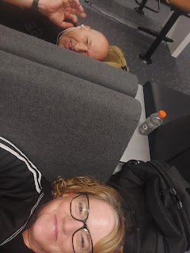

We found a quiet area at the tail end of Terminal B, which was where our gate would be for the next morning's flight. I slept pretty hard from 10 p.m. to 2 a.m. and then I was awake from then on. We played cards. We watched reels on Instagram. We mostly just laid there and tried to rest. At least it was reasonably comfortable. It could have been much worse.

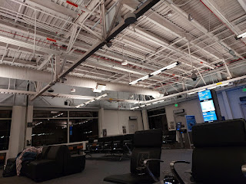

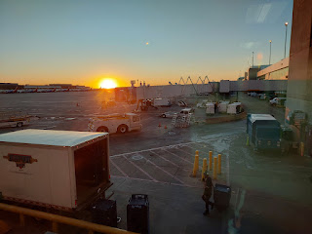

When the sun came up, we went in search of some breakfast - using our meal vouchers. As we sat at our gate eating a pretty tasty airport meal, I felt a prompting to give a $20 bill to a young couple sitting nearby with a baby. I ignored it at first, dismissing it as unusual. But the thought came again, "Give the $20 bill from your purse to them." When it came a third time, I figured I'd better do it.

So I walked over and made some small talk. "Good morning . . . your baby sure is cute . . . did you guys get stuck in the airport last night, too? . . . Oh - you did? So did we! . . . How did you sleep?" And then I explained that I felt like I was supposed to give them this twenty dollar bill, crumpling into tears as I said the words out loud, which then made me feel so embarrassed. How were they supposed to receive that $20 bill when the person giving it started crying?!! Anyway, they thanked me several times and then I retreated and finished eating my breakfast.

I definitely feel like this was an important lesson for me to learn. Not always do we know WHY we receive a prompting to do something. It might not make any sense at all, and we might try to logic our way out of it. This young couple probably did need an extra twenty bucks, but they also looked well put together and didn't appear to be lacking on the outside.

I think what made me cry, is that deep down I knew that God was happy with me. He spoke to me through the Holy Ghost, with a still small voice. He spoke THREE TIMES. I finally listened and then I acted on that prompting. And that made Him happy. He was pleased with me that I obeyed and followed through. And THAT'S what mattered most.

Video of our descent over the green farm fields of Idaho Falls: (18 seconds)
https://photos.app.goo.gl/mmcBVpi7MC9tNx3x7

Once we got home later that morning and plopped our stuff into the bedroom, Scott and I were both itching to tackle something outside. Gwen (and later Abby) helped me to give the umbrella tree a "haircut" in the front yard. Gwen was an especially hard worker! She wanted to take turns using the pruning shears and then she'd pass them back to me while she helped scoop up all the leaves and branches on the ground. The branches had been hanging pretty low before we started the haircut, and were partially blocking the path to the front door. But once we were done, it looked great!

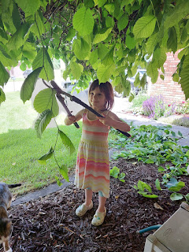

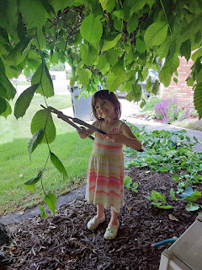

By the time I went to sleep around 10:30 that night, I was absolutely bushed. The previous 3 days caught up and punched me in the face. I did some calculating and discovered that with the 1 hour nap in the Venice Airport before we left, and the 4 hours in the Denver Airport, I had a total of 5 hours of sleep in roughly 76 hours. GROSS! But I slept like a rock that night and woke up feeling much better and like I was ready to play.

Benson arrived the following day, and then Avery came over to see us a day later. Benson hasn't seen his daughter since last summer, because Kylie was with her in Italy for several months. It was so fun to hang out and see her darling and budding personality! She is a hoot.

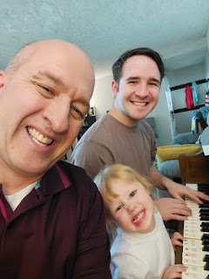

In her cute little croaky voice, she'd say something like, " 'N' go outside?" To which we'd respond, "You wanna go outside?" Her reply was always, "Okay." As if we had come up with the idea . . . ha ha. She loves playing with water, bubbles, or music. Those are her favorites.

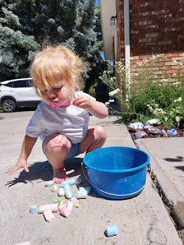

Video #1 of Avery: (23 seconds)
https://photos.app.goo.gl/59DMfTuZoCzaBVZB8

Video #2 of Avery: (16 seconds)
https://photos.app.goo.gl/AMnZdFqN6ZawgERK6

Video #3 of Avery: (22 seconds)
https://photos.app.goo.gl/U7DWtv6edsjW3Wcx9

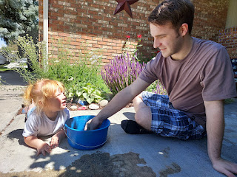

Video #4 of Avery: (9 seconds) She was so cute - we were picking flowers for her to smell and enjoy, but then she heard the helicopter taking off from the hospital just around the corner. She said, "Oh no!" and reached up for Daddy Benson to pick her up. XOXO
https://photos.app.goo.gl/A85sd7PfLHyExCUt9

We weren't sure if Avery was going to be able to be with us when we would be taking a family photo in a few days, so we took a few pictures while we DID have her. :) In this photo, she was wearing Abby's pink tennis shoes, ha ha.

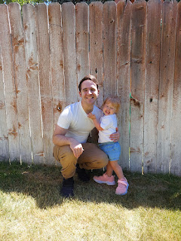

I thought it would be cute to have Avery on Benson's shoulders for a photo, but she did NOT like that.

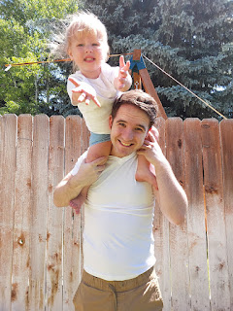

However, she IS very good at saying "Cheese" and smiling big, ha ha.

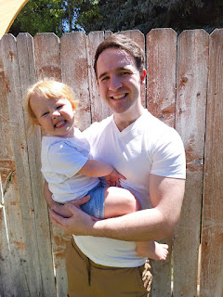

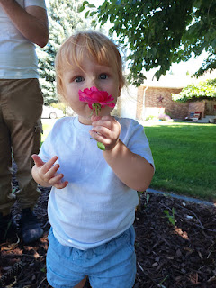

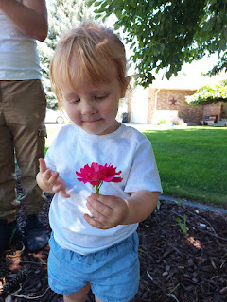

We picked way more flowers than we anticipated, ha ha. She really enjoyed it all, though!

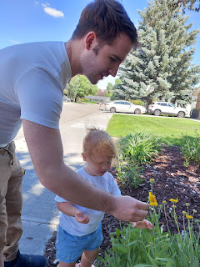

We also took her to the park at the end of our street. It was so sweet to see how much she loves all of us. We have missed her so much over the past several months . . .

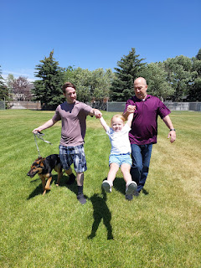

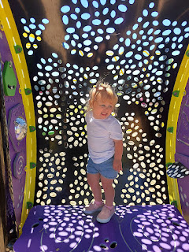

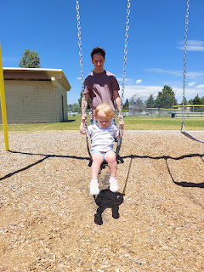

Hilarious photo of Benson trying to get ANY sort of momentum going down the slide with Avery. He said that it was not a slick slide at all, and the tight turns made it virtually impossible to get going.

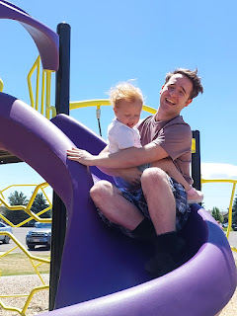

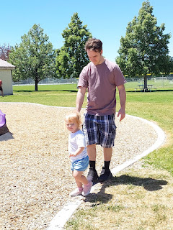

Coloring time . . .

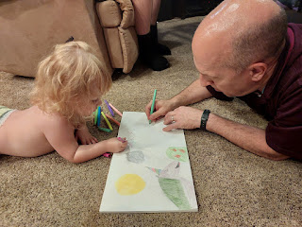

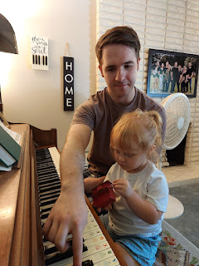

Video #5 of Avery at the piano - she was stressing a little because she wanted BOTH of the foot pedals to be utilized at the same time, ha ha. (14 seconds)
https://photos.app.goo.gl/tR1dcigkpMfeiLuv8

Video #6 of Avery at the piano: (52 seconds) She wanted me to sit next to her at the end of the video.
https://photos.app.goo.gl/mJCjVzAedwsFBigR7

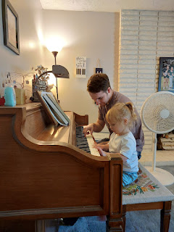

Video #7 of Avery playing marbles with Grandpa: (24 seconds)
https://photos.app.goo.gl/zminYFj9fBFECUtF7

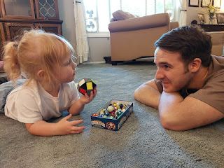

Video #8 of Avery "cooking" and playing downstairs with me: (55 seconds)
https://photos.app.goo.gl/PRkBAtcVURDJLAdBA

Video #9 of Avery playing downstairs with Scott and Benson: (16 seconds)
https://photos.app.goo.gl/v7szT6iLdJsDJ4nd8

Video #10 of Avery playing "Superman": (40 seconds)
https://photos.app.goo.gl/8otiqRfevub8Fs2V6

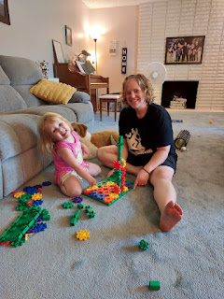

We made a baked version of Chicken Shawarma one night. It was so good! Scott thought he'd died and gone to heaven. We used boneless, skinless chicken thighs with several spices and let all of them marinate for a bit. Then we layered them into two loaf pans and baked them for about an hour. Then we chopped them up and spread them all out onto a large cookie sheet to broil and crisp them up a little before serving with all the toppings.

This is the recipe we used:
https://myfoodstory.com/chicken-shawarma-recipe/#recipe

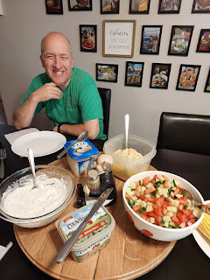

Video of a new game that our boys made up, simply called "Your Turn": (9 seconds)
Benson hits his target (Jake).
https://photos.app.goo.gl/2T9G1uingW4Rdz8SA

The boys took turns shooting a tennis ball at each other, using Daisy's ball-chucking gun. Whether they hit their target or missed, they'd say, "Your Turn" and then switch. I even joined in the rotation and I've gotta say - it was pretty fun!

Video of Jake hitting his target (Benson): (8 seconds)
https://photos.app.goo.gl/ft4JDiA2NrP6gPGZ7

On Sunday after church, we met up with Bev (Scott's sister) and her clan from Arizona over at the Snake River Greenbelt in downtown Idaho Falls. We walked a good long ways with all the little ones before heading back to our cars. There are always plenty of places for the kids to climb and explore on the paths.

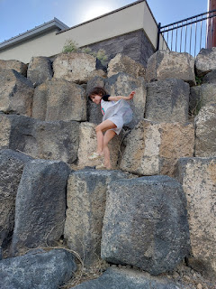

Bethanne and Everett . . . (Bethanne is married to Caleb Jackson, Bev's grandson)

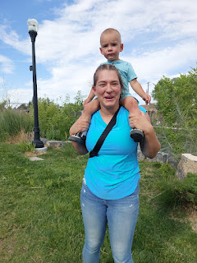

Gwen loved all the climbing opportunities . . .

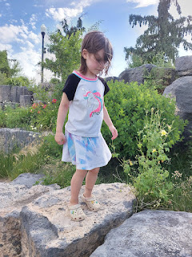

Harrison on his balance bike (Bev's great grandson) . . .

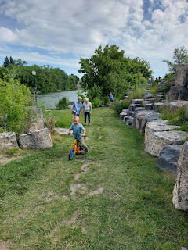

Gwen watching a fat little marmot on the rocks overlooking the Snake River . . .

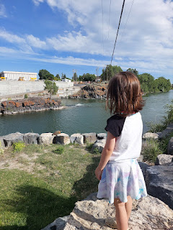

A better photo of Mr. Marmot . . .

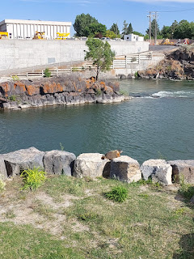

Not everyone, but a large representation of our family group: (L to R)
Ken (Bev's husband), Vanessa (standing by the flag pole), Bethanne and Caleb (sitting, with Harrison), Everett, Scott, Daisy, Benson, Bev (in the white pants), her friend Kay Bishop, and Taylor (Vanessa's youngest daughter).

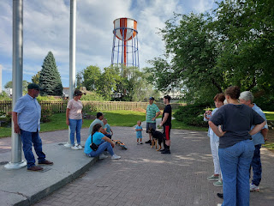

Abby and Gwen, tired but happy . . .

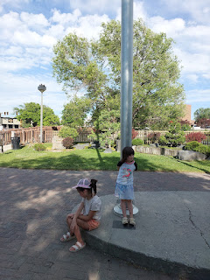

Cute little Mama Amber . . .

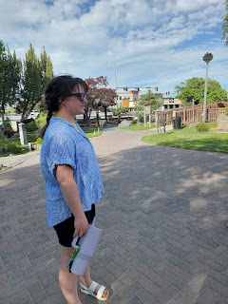

The following day we all met up once again at the local trampoline park in Idaho Falls . . .

The little kids loved jumping into the various foam pits . . . (Jack is in the photo below)

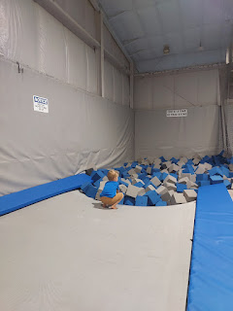

Video #1 at the I-Jump Trampoline Park: (32 seconds)
https://photos.app.goo.gl/HPSTR8XAMT3hR8Qe6

Video #2 at the Trampoline Park: (16 seconds) "Bye-bye Grandma!"
https://photos.app.goo.gl/qBrFyvnN8CijccHc6

Video #3 at the Trampoline Park: (9 seconds) Jake throwing foam blocks at Jack.
https://photos.app.goo.gl/VgkxxfhJaD9V1DPQ6

Video #4 at the Trampoline Park: (40 seconds) Jake & Vanessa were running around with all the kiddos in the dodge ball area. They all had a blast chucking squishy foam balls at each other.
https://photos.app.goo.gl/2K8v5uutB5XtgwoR8

On Tuesday, July 2nd, four of us drove down to the Pocatello Temple together and did a session there. Jake and Hannah came with Scott and me, while Amber and Benson stayed behind with the kids.

Jake and Hannah don't get to go to the temple very often, since it requires getting a babysitter for Jack. This time, we went during his nap time and when we got home, he was happily playing in the pool outside with Abby and Gwen.

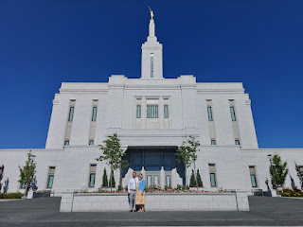

Scott and me . . .

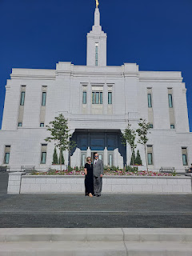

We met Vanessa and her kids and grandkids at the Tautphaus Park Zoo in Idaho Falls. (pronounced like "Toffus") Jack is watching the goats through the fence below . . .

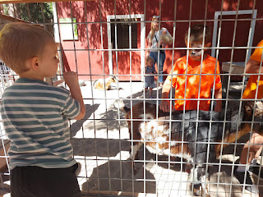

Video of Gwen and Vanessa and Harrison feeding the goats at the zoo: (16 seconds)
https://photos.app.goo.gl/HX88jv35UgBkydd96

Gwen thoroughly enjoyed brushing the goats . . .

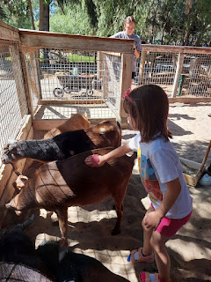

Cousins Harrison (4), Everett (almost 2), and Gwen (6) sitting inside a giant egg . . .

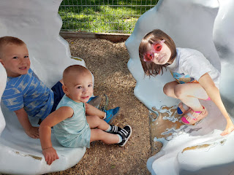

Gwen, Harrison, and Everett inside the hen's nest . . .

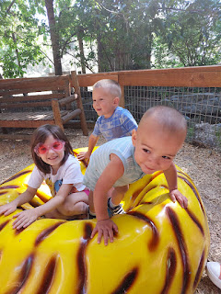

Gwen - the tiger-hugger . . .

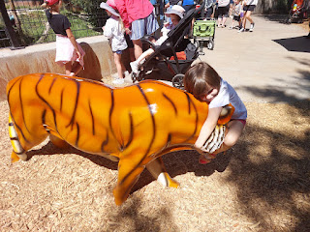

Jack and Gwen riding the bronze lion . . .

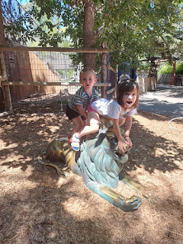

Later that same day, one of the birch trees in the back yard just randomly fell down! Benson saw the whole thing happen while he was in the back yard, and fortunately, Jack was in the swing at the far end of the yard, so miraculously he was safe. It fell onto the sun shades that are strung up over the patio area, and - also a miracle - they didn't get ripped or ruined either.

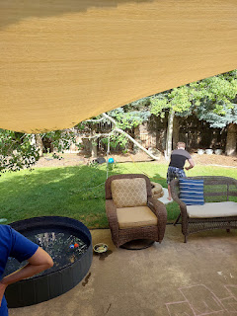

Benson held the weight of the tree to keep it off the sun shades until Scott could quickly decide what to do.

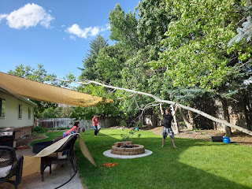

Video of Scott, Jake, and Benson moving the tree: (5 seconds)
https://photos.app.goo.gl/cND5y7km2DH3qKXaA

The next morning (July 3rd), it was a team effort to get everything taken care of. Scott used the new chainsaw to chop all the branches off and then he cut the trunk into chunks for firewood. ("Trunk chunks" lol) Jack really enjoys having a job to do - gotta love that - so he helped me load the firewood into the wheelbarrow and then together we drove the wheelbarrow over to the woodpile and got them all stacked up. Then, we loaded up all the branches and hauled them out to the front sidewalk for the city workers to come pick them up after the holiday weekend.

Video of Jack helping with the tree cleanup: (31 seconds)
https://photos.app.goo.gl/YyxeXCqcQQ8bybS3A

Video of the boys trying to get the base of the tree out: (14 seconds)
https://photos.app.goo.gl/L7DZVKjXDfPZf9VB6

I thought this moment was so sweet . . . Hannah let Abby know that the baby was moving around in her tummy and Abby came
running
. Abby had been super interested in feeling the movements whenever it might happen. Abby kept saying how much she loves babies and toddlers, too. XOXO

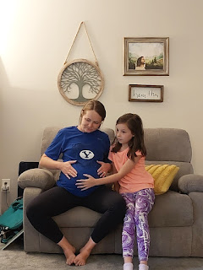

On July 4th, we fulfilled one of Benson's wishes for the week by eating lunch at Big Jud's, about 30 minutes north of Idaho Falls in a township called Archer. Big Jud's has HUGE burgers - the kind that you can cut up into 4 hefty servings. They have a famous challenge that if you can eat the Big Jud Burger in one sitting, you'll get your picture taken and added to the heroes wall and your burger will be free. In this case, Benson and Jake agreed to share the burger instead of taking on the challenge.

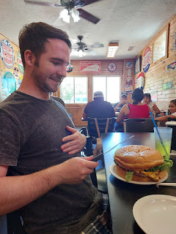

The Big Jud burger is about $25, which is a great deal because most of the lunch menu items were $12-15 each. With the burger being close to 4 servings, that's a bargain!

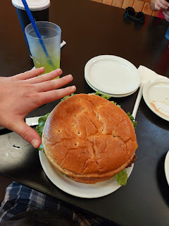

Jack and Gwennie . . .

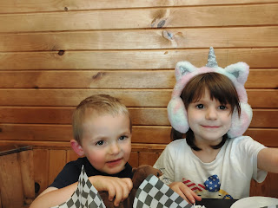

Jack, Gwen, Me, Abby, and Scott

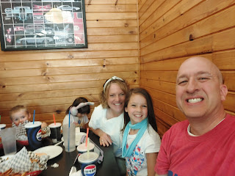

Jack, Jake, Hannah, and Benson

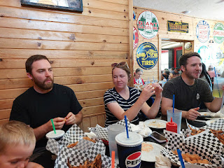

Weston arrived later in the afternoon on a flight from Oregon. The airline had overbooked his flight, so they began asking if anyone would be willing to take the next flight with some handsome compensation. By the time they got 7 people to agree to bump to the next flight, the compensation offer was for $1300!! Weston got into Idaho Falls in plenty of time so we could squeeze in our family photo shoot before they drove up to Rigby to spend some time with his family.

This is the photo we will be making into a large print to hang in the living room. We will add a little "inset" with a photo of Benson and Avery from a few days earlier. Amber is going to help us with this, and she'll also add some green touches to the little dead spot in the lawn . . .

L to R: Amber, Gwen, Abby, Weston, Benson & Daisy, Me, Scott, Jake, Jack, and Hannah

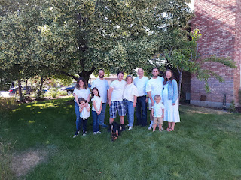

Scott, Benson, Daisy, and I headed to the fireworks a little ahead of everyone else so we could secure a large enough spot for the big group. The Melaleuca Freedom Celebration is the largest fireworks show west of the Mississippi River year after year. Melaleuca is a "Wellness Company", owned by Frank VanderSloot, who hosts and pays for the fireworks show. Shell for shell, the Melaleuca Freedom Celebration puts out more than what they do in the Boston Harbor! It's pretty spectacular and always brings crowds of people - usually more than 200,000.

We have our new favorite spot and our new favorite place to park, too. Benson and I found a place last summer and it was perfect again this summer. The kids weren't too close to the river, which was a relief to all the young moms and dads. But there was plenty of grassy space to run around, play frisbee, and there was even a bathroom nearby.

Gwen carefully lined up all of her "Pop-Its" in a circle so she could walk on them and pop them all. I've never seen anyone do that before, so I was pretty impressed.

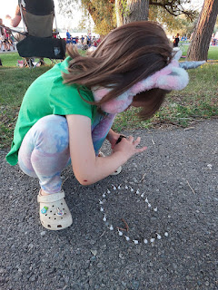

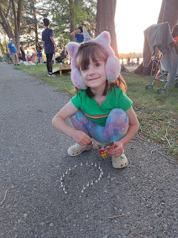

Gwen, Harrison, and Abby throwing their Pop-Its down to explode them . . .

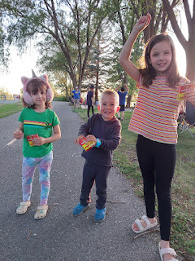

Jack thought it was all pretty cool . . .

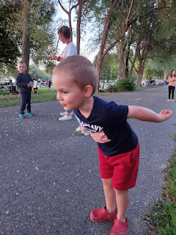

Scott and Vanessa, hanging out with Daisy while the rest of the boys played frisbee . . .

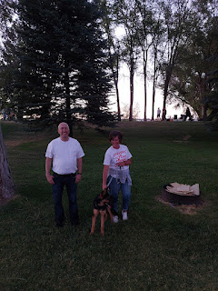

Video of the frisbee "circle" between Benson, Jake, Weston, and (I think) Caleb (Vanessa's son):
(11 seconds)
https://photos.app.goo.gl/F8nvXi64URx1ostb8

I bought the LED frisbee on Amazon and it was so fun!! Many evenings, we played with it in the front or back yard while everyone was together at our house.

As the fireworks show was close to starting, Amber handed out glow necklaces to all the kids. It helped the moms and dads to know where each of their children were, but the necklaces also entertained the little ones, too!

L to R: Benson and Daisy, Amber (behind him), Abby, Gwen, Scott way in the back with a white shirt, Jake and Jack - next to Scott, Hannah and Bethanne on the right. The extra little boy next to Gwen was just a new friend whose family was seated close by.

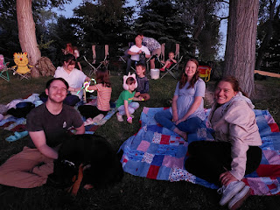

Video of Abby and Gwen dancing to Taylor Swift with their glow necklaces on: (15 seconds)
https://photos.app.goo.gl/HsLPaFHUMzRgGAAX6

Here we go . . .

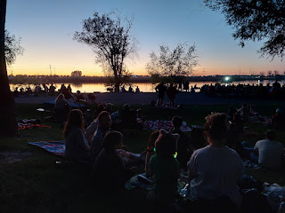



This year's show was breathtaking and spectacular! I was so grateful that Scott was able to be there with me. We sat holding hands through most of the 30 minute show. I always cry on the 4th of July, with or without him. I love this land and I'm so thankful that my ancestors immigrated here and made this their home.

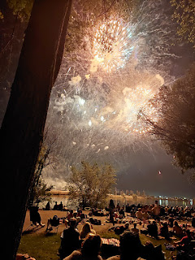

Video of the synchronized fireworks and the song "God Bless the USA": (1 minute, 49 seconds)
https://photos.app.goo.gl/6JVghzZhLXN31EGEA

I cry every time.

The following morning, unfortunately we had to say goodbye to Jack and his parents. We were so sorry to see them go . . . it was so fun to have them here with everyone, and all at the same time. They drove down to Scipio, Utah to spend a week with Hannah's family before flying home to Minneapolis.

Jack and Abby playing catch with the whiffle ball . . .

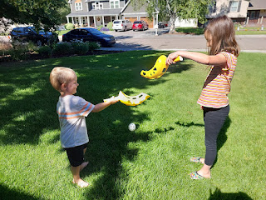

The next day, Avery came over to play with us again. She is such a doll.

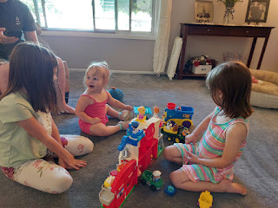

It was a bit of a circus that morning because not only did we have Avery for a couple hours, but Scott's sister Bev and her husband Ken stopped by to visit before Scott flew back to Italy. On top of that, Chelsea and her husband Garret were in town, too. I was trying to visit with so many different groups of people and it was a little stressful because I wanted to spend more time with each of them, but I had to divide my time instead!

35 years ago, I placed a baby girl for adoption when I was just 18 years old. Then, about 7 years ago, she found me through a DNA test!! Because I do a lot of family history work, I had already submitted my DNA to Ancestry.com a few years earlier. Chelsea's adopted mother had given her four adopted children an early Christmas gift in 2017 - a DNA test kit from Ancestry.com.

Chelsea was the only one who had such remarkable results - she found her birth mother: ME!! We have gotten together a few times over the last few years, but mostly we stay in touch by phone and/or video calls. This time, she and her husband, Garret, drove to Idaho Falls from their home in Denver, CO to visit for a couple of days. I'll share more about their visit in the next blog post.

Avery - on our way to meet up with Kylie and Kylie's step-mom, Nicole . . .

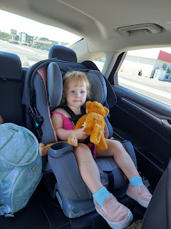

Benson and Avery . . . so cute!!

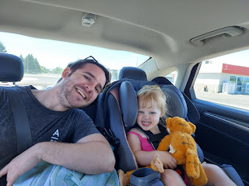

Scott giving goodbye hugs to Avery . . .

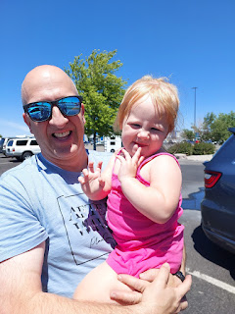

Benson photo-bombing our goodbye photo, ha ha . . .

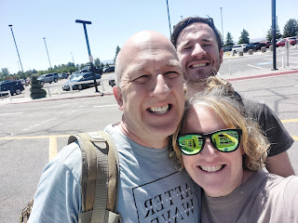

Saying goodbye to my best friend . . . yet again . . .

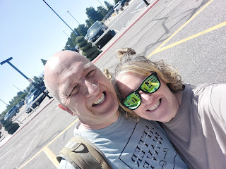

He flew back to the other side of the world without a hitch, until he got home and discovered that the power had blinked off at some point while he was gone - - and everything in the fridge and freezer were completely spoiled, melted, oozed out onto the kitchen floor, and oh-so-stinky. So, instead of getting into bed when he got home around 11 p.m., he stayed up for an extra hour to clean things up. He got into bed well after midnight, poor guy.

There is a lot more to share, but I'll type up the rest for next week. I hope you are having a great week and that you have good things to look forward to. :)

