Legally Blonde . . . With a Snowblower
Happy (Belated) Valentine's Day! I spent most of the day getting myself unburied from all the snow. How romantic . . . ha ha

We got about 7-8 new inches of snow and it was a messy, sloppy Valentine's Day all over town. I got up early to fire up the snowblower and clear some driveways before going to the temple. I hurried over to the Parkinson's driveway as quickly as I could because I knew Kim needed to take her son, Jackson, to his scheduled knee surgery very soon. As I was launching snow from her driveway, she came outside and hugged me. She said, "You don't need to do this!" I shouted back (over the loud snowblower), "But you're my Valentine!" Jackson hobbled out to their car on his crutches, and I quickly cleared the driveway so they could drive away a few minutes later.

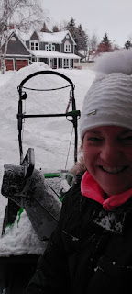

For Round One, I cleared my own driveway, as well as Kim's, Ellen's, and the single mom that lives next door to me. (I don't know her name . . . how awful of me)

Then, I left a little early to give myself plenty of time to drive over to the temple. The roads were messy and slippery, but I made it safely with time to spare.

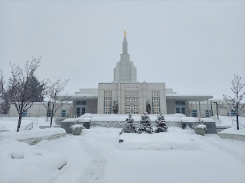

While I was inside the temple, it continued to snow. When I got back out to my car afterwards, there was a layer of about 2 inches of wet, heavy snow covering it. Thank goodness someone invented window scrapers with a bristle brush on one end.

I carefully drove home and then changed my clothes to do some more snowblowing. I filled up the fuel tank and set out to take care of as many driveways as I could before I ran out. I cleared my driveway, Ellen's driveway, Kim's again, the Kloaks (across from me), and 2/3 of the Dixons' driveway - as well as everyone's sidewalks - before I ran out of fuel crossing the street back to my house. That felt pretty good to help so many of my neighbors.

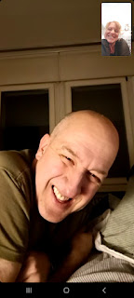

I also got to talk to Scott for a little bit before he went to bed for the night. He was starting to get a sore throat, so he wanted to go to bed a little earlier than usual. Poor honey.

He had sent me a thoughtful gift for Valentine's Day, and it even arrived a day early.



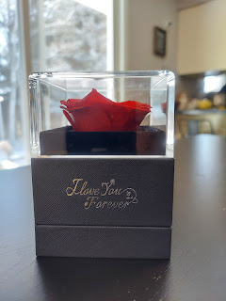

The necklace says: I love you to the moon and back. (How sweet XOXO) I wore it to the temple. :)



For Scott, his Valentine's gift will be the box of clothes that I sent him, along with some spices that will make his meals taste amazing. :) He should receive the shipment in the next 2-3 days.

Here is the view of my back yard after that very snowy day . . .

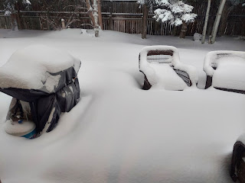

Kim and I had discussed getting dinner together and eating it at her house for Valentine's Day, since her husband, Ben, would be down in Utah for job training. But there were so many people coming over to check on Jackson after his surgery that it was just too crazy to try and coordinate a meal. I was a little sad, but I was so tired from all that snow removal business, that it actually seemed quite appealing to just have a quiet evening alone.

I muscled my car through the deep snow on our street and over to Broulim's to get a few groceries. I found a good looking dinner tray that they make fresh daily there, with salmon, green beans and a few "new" potatoes (baby potatoes). I commandeered my car through the deep snowy mess once again, to get safely back into my garage for the night.

While my dinner was cooking in the oven, Kim came over with a "thank you" gift for helping clear their driveway earlier. She brought me a box of giant cookies from "Crumbl", a popular cookie chain in town.

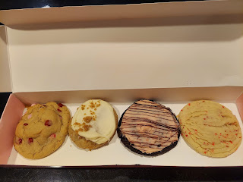

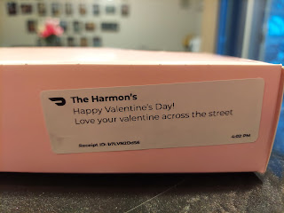

She told me that Jackson picked out all the flavors for me when they were making their order online. What a nice young man!

Besides all the snow, it has been SO COLD up here!!! Every year, I'm always surprised at how cold it is. Do I forget the cold from last year? Is it really colder than what it was last year? I dunno . . . but it is always shocking the older that I get.

I drove across town on Monday for a couple of errands, and decided to hop out and take a few pictures, even though it was only 4 degrees at the time. With wind chill, it said it was about -12 degrees. Yikes.

View of the frozen Snake River, looking from the bridge on Broadway toward the Idaho Falls Temple off in the distance:



I drove a little further and hopped out VERY quickly for a shot of the frozen waterfall.





Fascinating to see all the crunchy crystallized ice on the top layer, while still hearing the roaring of the waterfall underneath . . .



So beautiful . . . and yet SO COLD!!!



The Idaho Falls Temple was across the river from me . . .



Amber and I had a nice long phone call early in the week, because she is diving back into our family history book project, and we had some things to discuss. She asked me a few questions about my great grandmother, Sarah Jane Baugh, so I went and dug up everything I could find about her in a book that I have downstairs.

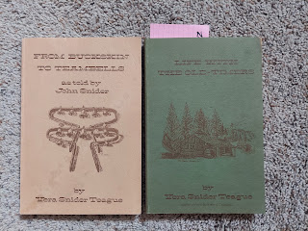

I thought my grandfather, John A. Snider, had written some things about his mother, but he really didn't have much to say about her. Instead, his sister, Vera, is the one who had written several elaborate details about their mother, Sarah, who was born so tiny that they could fit her in a bread loaf pan! (click photos to enlarge and read)

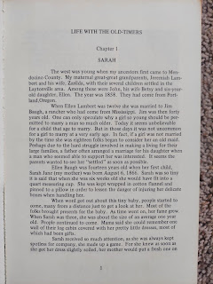

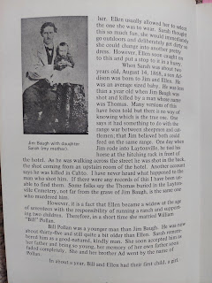

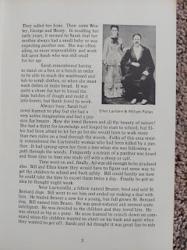

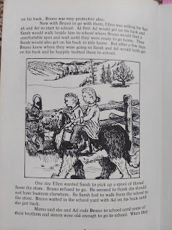

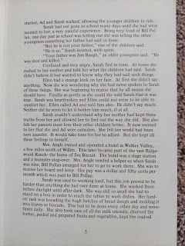

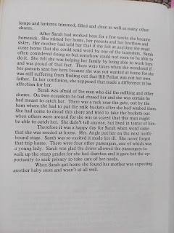

Right away, Amber uploaded these images to Sarah Jane's profile on FamilySearch so that more people could read the wonderful stories about her. What a thoughtful daughter!!

Over in Italy, all of my Wednesday Group friends went to Venice together because it's the week of Carnival there. I still get all their texts and photos since I'm part of the WhatsApp group . . . they had an incredible time and here are some of the photos they shared.

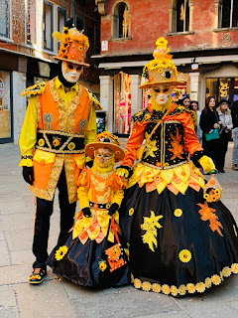

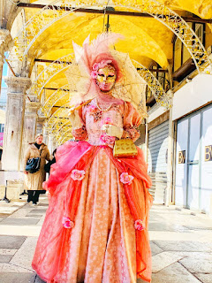



Why do they dress up so fancy? And why does everyone wear a mask? I had to look online for an explanation:

Per the Venice Carnival website: The Venice Carnival began in 1162 in celebration of
the Venice Republic's victory over its enemy: the Patriarch or Aquileia
. The people of Venice gathered in Saint Mark's Square (San Marco) to dance and celebrate their victory. Ever since then, the victory was celebrated in the streets of Venice.

Why the masks: "Wearing masks and costumes
made it possible for people to hide any differences of class or status
, and it was even allowed to make fun of the aristocracy. This time of regulated social outburst was a way for the Most Serene Republic of Venice to maintain order and power throughout the rest of the year." (www.theculturetrip.com)

The Wednesday Group of Ladies: (those who could make it this week) L to R - Melani Jenny and her daughter, crouching in front are Alison Delap and Marnie Parker, Catherine (in back), Lindsay Zita in the white hat (she taught us how to make those beautifully decorated cookies in December), Rachel McGovern, Andrea Miguel, and a new lady (I don't know her name).

Melani, Alison, Marnie, Rachel, and Andrea are all in my military ward in Vicenza. The other ladies are from the base Bible Study Group, which includes a variety of denominations. They are some of the most amazing women I've ever met.

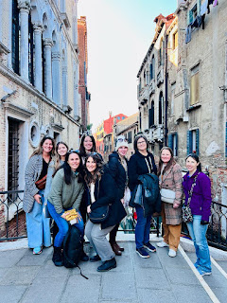



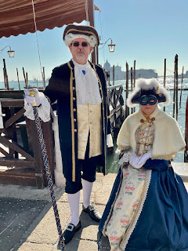

Someone even had a sense of humor in Venice - not sure if this is a tortilla, or pita bread, or what . . . but he's sure taking part in the Carnival tradition of mask-wearing! ha ha

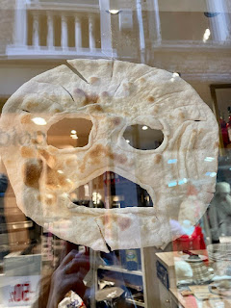

I also want to include one more photo of Venice - this one popped up in my social media feed for Valentine's Day. It's HEART SHAPED!!



I've been re-doing my bedroom color theme for several weeks now, a little at a time. For years, I always wanted a brightly colored bedroom, with my favorite cheerful color of YELLOW. And a couple years ago, I put this quilt together and made my "dream" bedroom.

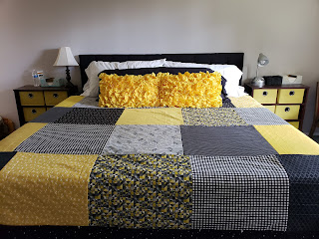

But then, when we started building a home together in Italy, I was gravitating toward the calming and gentle hues of green as I purchased bedding and decor over there. Now, whenever I come home to Idaho Falls and step into my bedroom of BRIGHT YELLOW, it has become too much . . .

So a change was needed. And I made a monumental decision to BUY a duvet and duvet cover instead of putting all the money and hours (and hours) into making one. I found this duvet & cover on Wayfair.com and I love it so much. A simple white with light green stripes.

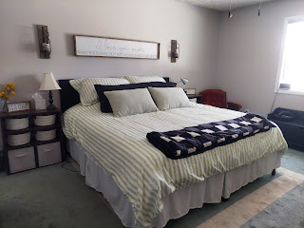

After looking in several stores, I also finally found some accent pillows this week that are the right hue of green.

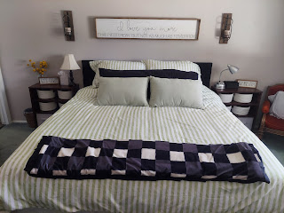

And I had to look for many days to find these baskets to replace all the bright yellow storage bins on either side of our bed. I ended up ordering them from the At Home website. I was having trouble finding a size that would fit my nightstand shelves when I looked in the local stores.



Anyway, my bedroom is much more CALM now. I'm not so surprised (LOL) when I walk into my bedroom anymore. It's very relaxing and peaceful.

Jacob has been hearing back from a few of the schools he applied to last fall. He is supposed to start on his PhD program in August, so a big move is pending for them once again. When I was helping Grandma Lillian through the grocery store up in Salem recently, Jacob had called to tell me about his online interview with Notre Dame. ND was one of the top 5 schools he was most hoping to be accepted into.

Well, this week, we got this photo from Jacob. :)

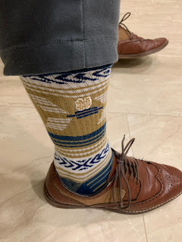

I'm so proud of him!! It's quite an exceptional honor because during his interview he was told that there were about 300 applicants to the Notre Dame PhD program, but they would only be accepting 9 or 10 candidates. Jacob made the cut!!! How exciting - and what an honor!!

Our texting conversation on Friday went something like this:

J: Got accepted to UNC-Chapel Hill today and immediatel declined.
Me: Well it's good to know that you know what to do and where to go. :)
J: It's down to - Minnesota (accepted in), Michigan (waitlisted but likely), Princeton (haven't heard back yet but probably rejection). The other programs I don't need to hear back from now.
Me: So you're thinking Minnesota over ND?
J: Minnesota is a much stronger program even though ND is significantly cheaper with the cost of living. I'd say odds are 60% chance Michigan, 39.9999% Minnesota, and 0.0001% Princeton.
Me: I had you pegged for ND for sure . . . Now I'm scrambling to keep up, ha ha
J: Yeah, the ND problem is that there is one superstar professor I wanted to work with, and if they left to another school while I was there, I'd be stranded. Minnesota has 10 superstars so I'm safe there.
Me: Where is the school in Minnesota? It'll be COLD up there . . .
J: Minneapolis, yes, way cold, so another reason we're hoping for Michigan.
Me: And what city is U of Michigan in?
J: Ann Arbor, 45 min outside of Detroit
Me: Detroit is high in crime. I wonder what the quality of life is like in Ann Arbor?
J: Very very nice. Detroit is run down.

I studied Ann Arbor on Google Maps for a bit and I saw that it is its
own entity,
completely separated from Detroit. It looks nice, with a river that runs through the city, lots of parks, and some green areas. It's also not too far from several major cities: Detroit, Chicago, Indianapolis, Cleveland, and even Niagara Falls and Buffalo, NY. I had no idea that Detroit was so close to Canada . . . they're practically kissing each other!! ha ha

So we'll see where they end up in the very near future. Notre Dame would be a great school, Minnesota, University of Michigan, and maybe a couple others are what they are hoping for. Ann Arbor is also just 2 hours away from Hannah's sister in Grand Rapids, so that is a huge reason for them to consider that school.

This weekend, actually, Jacob, Hannah and Jack are in Grand Rapids visiting Hannah's sister. How fun for them!!

Jack was very entertained by the flight crews at the airport. Not too surprising . . . XOXO



And he had a good nap on the flight. What a good boy.

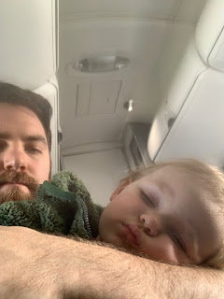

Even though on Wednesday evening I started getting a sore throat, I still went to an Off-Broadway performance of Legally Blonde with my friends, the Andersons. L to R: Megan, Kimber, Jen Anderson, and me. (the ticket wasn't cheap and I didn't want it to get wasted)
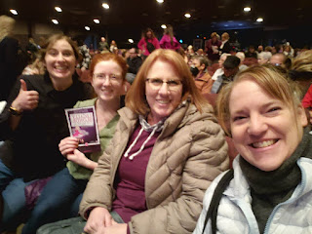



While I was visiting Grandma Lillian in Oregon, Jen had reached out to me to see if I would like to go to the musical with them. Since I love the movie, Legally Blonde, I was excited to get a ticket, especially when it was going to be performed right in Idaho Falls!



The show as a whole was just "okay". The music and the mainly female cast were a bit shrill (maybe my tired little head was more sensitive than usual), some of the scenes were a bit more risque than the movie, and the opening AND closing song were both named, "Oh My God!" To hear them shouting that phrase hundreds of times was not very fun . . . But there were some scenes that were really well done. I liked how there was an emphasis on Elle Woods (the main character) overcoming her self-doubts and eventually feeling empowered, like that she could accomplish anything she set her mind to. That's an uplifting and positive message to send out to the world!

We got home late that night, and I went straight to bed. I didn't do much of anything for the next several days, to be honest. I've been fighting this mediocre sickness that mainly consists of a swollen throat and a pretty big headache every single day. Ibuprofen wasn't doing enough on Friday, so I broke my promise to not drink any more diet sodas so that I could drink a Diet Coke to help with the headache. It did help, so at least I kind of made a good decision there . . . I quit drinking diet sodas about 3 weeks ago now and I've been feeling a bit healthier and my energy has improved. I used to just drink a Diet Coke occasionally (like once a week, or sometimes once every couple of weeks). But then I discovered Fresca, and then I discovered Diet A&W Root Beer . . . wowza. I haven't had a root beer in years, so that was so exciting to me! It really tasted good, too. Pretty soon, I was drinking a diet soda every single day, and eventually I realized it was all just too much. So I quit. But Friday's splurge was worth it. :)

For the last few days, I've been laying verrrrrrry lowwwww. Haven't made my bed in two days (don't tell my parents), and I even skipped a shower on Saturday because I just felt so blahhhh. My brain has been mush for the most part, but here and there I get a burst of being able to concentrate on a project for a little while.

I'm hoping to get better SOON so I can get back to working on some important things. I'm running out of days before I leave this house again, and I need to make every single day count!!!

I'm still really enjoying my favorite Banana Pancakes. Today I added some extra creamy cool whip on top, just because I thought it would feel nice on my sore throat. And it did . . .



And I'll be darned if homemade canned peaches didn't save the day . . . Last night I wanted some COLD FRUIT on my throat. I had eaten all of my strawberries, raspberries, blueberries, and kiwis from the fridge. I had one apple left, but I just wasn't feeling it. So I went downstairs to the cold storage room and saw several jars of canned peaches sitting on a shelf!! Hallelujah!! It was a dream come true. My heart was VERY happy.

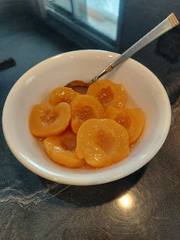

Scott also found me a car this week in Italy. It's a 2010 Ceat Leon (a Spanish car). Therefore I think the Ceat is pronounced like "say-ott". Scott says it's fantastic and very comfy. It's a stick-shift and diesel, which is what we both wanted and needed. (Dad: we needed diesel because of Scott's military fuel card. Everything in Italy has a 22% tax added on, even fuel. So the military gives them one fuel card. You have to declare a primary car and what the fuel type is for that car when you fill out the paperwork for the card. Then the 22% tax is subtracted at the pump when you use that card. If you have a secondary car, you want the fuel type to match the primary car so you can get the discount for both cars with the same type of fuel. If your secondary car needs unleaded, for example, then you only get the 22% discount for the primary car.)

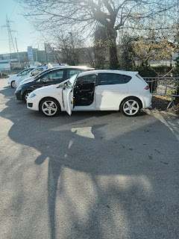

I'm excited to get over to Italy soon to try out my new car. More importantly, I'm most excited to get over to Italy soon to see this guy. He is the love of my life. We're both missing each other a lot right now. It's hard to imagine we've got 2 more years of this . . .



One last photo to share: My mom brought some homemade Valentines and some flowers from her garden on a visit to Grandma Doris on Tuesday. Grandma is 101 years old and is steadily making her way toward turning 102 in June . . . Bless her sweet little heart. XOXO

