Mexican Thanksgiving Feast

Happy Thanksgiving!!
I hope all of your turkeys turned out delicious, with all the trimmings. :) I hope that the people you chose to spend the day with brought happiness into your heart. I hope that you acknowledged some of the blessings in your life, the small ones as well as the bigger ones. And I hope that the gratitude that you felt brought some peace into your soul. :)

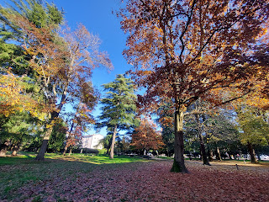

I would like to share some of the things I am most grateful for this year.

Top 10 Things I'm Thankful for in 2022
(in no particular order)

1.
My family.
This year I've been all over the country and all over the world, and have had numerous visits with my ever-growing family. I was able to hug my 101 year old Grandma Doris and receive loving kisses on my cheeks from her in Northern CA. I was able to hold and hug my newest granddaughter, Avery, for the first time in Aviano, Italy. I played with my 1.5 year old grandson, Jack, at a park in Arlington, VA. I took my 2 older granddaughters kayaking and roller-skating in Idaho Falls, ID. I hung out with both of my sisters in a swimming pool in San Diego, CA. I laughed and shared stories with my Dad and Michelle while sanding plaster on the walls in Willits, CA. I attended church and young women activities with my mom in Ukiah, CA. I offered a few days of companionship and conversation to my Grandma Lillian in Salem, OR. I had a walkabout on the Snider family homestead with my nephews, Jaxon and Logan, up in Rathdrum, ID. I danced on a boat that was driven by my brother, Ryan, as we laughed and swam with his family in Napa, CA. Before heading back to Italy, I received a precious priesthood blessing from my father-in-law, Phil, in Rigby, ID. I had a sleepover with my cousin, Loreena, where we shared too many family history stories to count in Petaluma, CA. I met my pen-pal cousin, Valorie, in person for the first time in Portola, CA. I have been able to travel to Italy and spend several months having new adventures together with my sweet husband (and best friend). And because of his military service, we had the means for me to visit all of these family members, along with many more not mentioned.

2. Perfect segway into #2 -
Our military service
. I have always referred to it as "the inconvenient blessing". It's usually never convenient, but the blessings still flow nonetheless. Prior to this current assignment in Italy, I added up all the time we have had to spend apart due to Scott's military service. The total: 6.5 years apart out of 30 years of marriage!! He has served in Iraq twice, Saudi Arabia, Italy, as well as numerous military schools that have ranged from a couple of weeks long to several months each. I have had to raise children without him and fix things that break around the house without him. But in return, it has given us affordable health insurance, money to fix those broken things around the house, and opportunities to make memories with our family. It will provide us with a comfortable retirement in not too many years from now, and will allow us to serve at least a couple of missions somewhere in the world to teach people about our Savior, Jesus Christ.

3.
A roof over my head and a place to lay my head at night
. I love the safety that I feel in my little corner of the world. In Italy, I have learned that it is not about the "stuff" that I fill my house with that makes it a place of love and warmth. It's visiting with the people who stop by, it's the laughter as we play a game, it's the smell of good food being prepared, and it's the feeling of relief when you have a place to kick off your shoes after running errands or working outside and now it's time to take a break and relax. It's a place to gather your family and spend time together. It's a place to study the scriptures and pray and to ponder on the workings of the universe. It is a sanctuary away from all the ugly things the world has to offer. It's a place to love and to be loved.

4.
My testimony
. I love and appreciate the life that I have lived, including the good and the bad. I have found meaning in all of the trials that I have gone through. I love to take glances back at where I used to be and then feel a sense of gratitude and joy for where I am now. I wouldn't even be at a place where I could appreciate where I used to be if it weren't for Jesus Christ. He has been my Constant, my Rock, and my Unfailing Friend my entire life. He has taught me how to forgive some pretty big things. He has accepted me in all my imperfect ways. He has shown me how to minister to each person within my realm of influence, and how to demonstrate true unconditional love. He has helped me to become a better wife, a better mother, a better grandmother, a better sister, a better daughter, a better friend, and a better disciple of Him. Without Him, I am nothing. Even WITH Him I am still next to nothing. But because of Him, I am enough. Because I am everything to Him.

5.
Imperfect people
. I love to see an imperfect person who at least tries hard in life. I learn so much from watching other people fail. In truth, I should enjoy my own failures more than I do, ha ha. As I watch someone try, and fail, and then try some more, I can appreciate the process and can observe some key lessons. We are all imperfect and we will all fail. Some of us will fail miserably. Some of us will fail gracefully. It's what we choose to do with that failure that piques my interest the most. I feel inspired when I watch someone pick themselves up, dust themselves off, and get back up on that horse again. I want to cheer for them. I feel my eyes sting with tears for them. That's when I might be wise enough to realize that I can apply those same principles of grace and tenacity and grit and forgiveness to myself as well. As I'm watching this other person trying so hard to figure life out, and they fail time and time again, but they keep on trying, I am reminded to do the same. I am worthy of being loved even when I fail. I am still destined for greatness even when I'm a flop. I am a divine spirit having a human experience. And I'm doing okay for the most part.

6.
Family History
. When I learn about my past through those who have gone before, it puts my own life into perspective. I can appreciate the present because of the past. I love those moments where it feels like everything is just briefly on "pause", like time just stops. You can quickly take stock of what is around you, WHO is around you, and you feel like you are experiencing a fleeting moment of eternity that can cause your heart to flutter at the same moment that all is quiet and still. I feel like life as a whole is much larger than the moment I am currently having. I am who I am because of THEM. While I might forget a birth date or the name of the town where someone lived, I never forget about them. My ancestors are real, not just a name on a headstone or on a parish record. Someday I will meet them. And I want to know enough about them to have a few conversation starters. Time with them in the eternities will be time well spent.

7.
Socks without seams
, especially around the toes. On a lighter note, ha ha, I really love a good pair of socks that don't have a poky seam near any of my toes. Those seams can get really annoying to me. Seamless socks are seriously the best!! I have one pair of the Bomba brand of socks, and they are just delightful. :)

8.
Essential oils
. My boys call them witchcraft. I call them amazing. I love how wonderful they smell. I appreciate when they take away my aches and pains. I am in awe of how they help me stay healthy (most of the time). I am grateful to have something to help me relax and go to sleep at night. And if my brain is feeling fuzzy or I'm having difficulty concentrating during the day, I have an oil mix that does the trick within moments. I feel like this is more safe and natural than relying on caffeine to perk up my brain!

9.
Hanging my laundry out to dry in Italy.
This is seriously one of my absolute favorite things about living in Italy. When I'm up on the roof, hanging clothes on our drying rack, one piece at a time, I feel grounded and connected to where I am in the world. I feel connected to all the women throughout the centuries, who also hung their clothes up to dry. It's something we all do, no matter where we live or what culture we are part of. We all need clean clothes that are washed and dried. The technique may differ somewhat from place to place, but it's essentially the same throughout the world. It is relaxing and peaceful to hang my clothes out to dry in the sun. It feels immensely satisfying.

10.
The Vicenza Military Ward
that I attend here in Italy. The church members of our ward are unique in that they are all connected to the U.S. Military. Some serve in the military. Some are civilian contractors that serve the members of the military. And some are here with DoDea (doh-DEE-yah) - meaning that they are educators and are contracted to teach the children of military families. I love seeing how confident and strong these military families are as I mix and mingle with them. They don't seem fearful or apprehensive about anything . . . and they are teaching their children to be adaptable, flexible, and resilient, without even realizing it. They just go about their jobs in a quiet and unassuming way, like that it's all perfectly normal that we're living in Italy, getting groceries, going to school, driving the kids to and from soccer/tennis/volleyball/dance/piano practice, etc. By far, my favorite thing that I've seen so far, is when Scott and I went into the Commissary a couple months ago. I had only been back here for a couple of days, and we were grabbing some groceries on base. As we turned the cart to go down the next aisle, there was our Bishop! He was dressed in his everyday military uniform, and was there, just like us, to get a few needed items. He inquired about us, how were we doing, how was it having me back in Italy, etc. But I was just sort of star-struck. He was just an ordinary man, serving in a church calling that he did not ask for. But seeing my Bishop in his army uniform was something I had never seen before. I've never had the privilege of living with Scott when his military service calls him off to distant lands. So I had never even thought about this level of service before. But it truly was something spectacular to see. I am at a loss for words here, trying to describe what it meant to me. It was something so simple and unassuming. But for me, it was life-changing.

As for the Rest of the Week . . .

Monday:
The week started off strong and I spent the day getting organized for Thanksgiving. I went to Emisfero (like an Italian Super-Walmart) to get some groceries . . . only I ended up getting a basket full of Christmas decorations instead!! ha ha

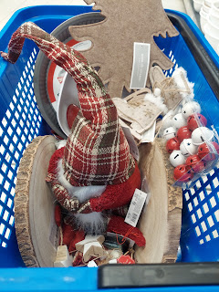

I needed a large portion of pork shoulder or pork butt, but using Google Translate, I couldn't find what I needed. I asked the butcher if he had either of those, and he did not. So I typed into Google Translate that I needed a large piece of pork to make carnitas. He pointed to a huge slab in his display case . . . and I ended up going with his suggestion. It had some good fat content in it, so it seemed like it would work.

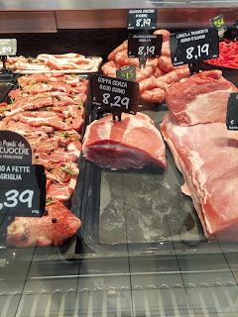

I bought almost all of the slab of pork that he had on display. (The empty area in the photo above - at a cost of $8.29/kg) I told him (in Italian) that I needed 3 kilograms. He weighed the large hunk of meat, cut a piece off, and then indicated to me "you like this amount?" It was 3.44 kilograms . . . Umm, okay I guess. That's a lot of meat!! (7.5 lbs)

Later that evening, Scott and I went to Leroy Merlin to buy a Christmas tree. Ultimately we decided to just buy one from Amazon Italy and have it delivered to our house, since the price was quite a bit better. In the meantime, I found a few more ornaments while Scott was making the purchase on his phone. I enjoyed the whimsical Christmas decor in the store that had lights and motors to make things whir . . .

Video: (38 seconds)
https://photos.app.goo.gl/xtWj6nDUidxUE3LG8

Tuesday:
There was a strong and steady rain the ENTIRE DAY. After driving Scott to work so I could have the car for the day (our Peugot was still getting those bearings fixed in the shop), I managed to get myself to a doctor's appointment off-base. We got a good referral from the Haines in our ward for Dr. Novek, an American doctor practicing in Vicenza. I lucked out with finding a parking spot on a very crowded, one-way street, and then had to find the parking meter to pay for the space. I had to look up a phrase on Google Translate to understand that it wanted my license plate number . . . it was pouring rain, and I was about to be late for my appointment, but somehow I remembered our plate number so I didn't have to run back to the car to look. At least I thought I did . . . turns out I had memorized the plate number for the Peugot, not the little red Suzuki . . . (thankfully I never got in trouble during the hour I was gone for the appointment - maybe due to the rain?)

After some stress about arriving ON TIME instead of early, and getting checked in (a miracle all by itself), I was directed to a different building nearby that looked more like a house.

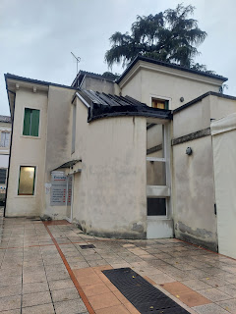

I had a good visit with Dr. Novek and he gave me some good information to take home and do some additional research on my own. I'm at a crossroads regarding my health, with what I used to take for my pre-diabetes (Metformin), what I am currently taking but am almost out of (Rybelsus), and what he recommended for me to consider starting instead. (a daily injection of a cousin to Rybelsus) I have a lot to think about, but I don't think I want to do the daily shots.

I came home, made myself some breakfast, and then prepared 6 Christmas packages to be mailed to family members back in the U.S. I am so excited for these gifts to arrive!! I wish I could say what's inside the boxes, but that would spoil everything . . .

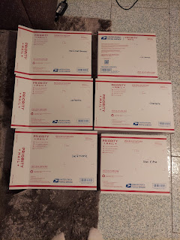

Thankfully, I had 3 large shopping bags to carry the packages into the post office on base. Again, it was still raining non-stop. The bags saved me from having the boxes toppling out of my arms and into the puddles.

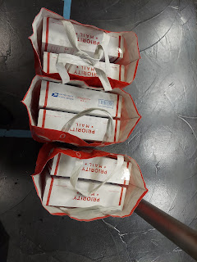

After getting the rest of the groceries for Thanksgiving at 2 more stores, I settled in at home momentarily before it was time to drive across town and pick Scott up from work. It was quite a busy day!!

That evening, I prepared the 3.44 kg of pork to go in our crockpot. Scott had ordered a crockpot recently from the U.S., but he forgot that the voltage was the wrong kind for the Italian outlets. We should have ordered it from Amazon Italy so it would be ready for use, but we didn't.

I still went ahead with the steps to get the meat into the crockpot.

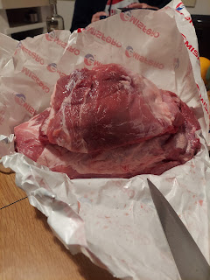

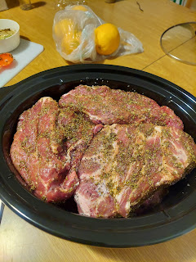

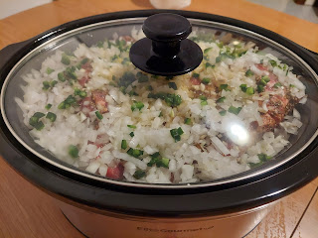

Once we plugged it into our adapter/transformer, we kept a close eye on the crockpot. I noticed that the handles on the side were getting pretty hot. That didn't feel right to me. Scott eventually admitted defeat and recommended that I try to borrow someone's Italian crockpot. I was able to quickly locate one from our friend in the ward, Stacie Preece. Scott hurried over to pick it up at 9:15 p.m. that very night!

We transferred everything over to the new crockpot, set it on Low for the night, and let it do all the work while we slept.

This is the type of plug that we needed in the first place - -

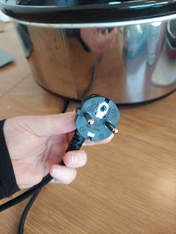

My throat was scratchy during the day and I had a croaky voice whenever I spoke. At bedtime that night, I had a hard time swallowing my own spit because my throat was so swollen. Somehow I managed to get some sleep though . . .

Wednesday:
I didn't rush to get out of bed and I let Scott just take the car to work, since he would be home by lunchtime.

The meat cooked perfectly during those 10 hours and shredded extremely easily.

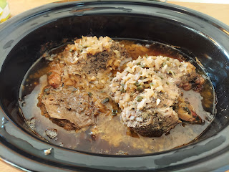

When Scott got home from work, we worked as a team to get 3 pies made. I was worried about making the pie dough without my kitchen tools from Idaho, but was surprised when the dough mixed quite well by just using a fork!

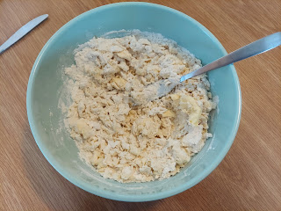

I didn't have my pastry mat from Idaho either, so I just used the kitchen table. (Of course, I cleaned the table first)

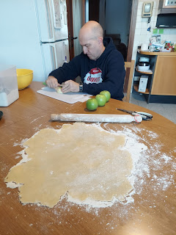

Pumpkin pies: Check!

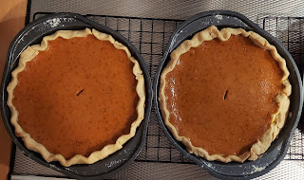

Apple pie: Check! (The top got a little dark in our unpredictable oven, but it didn't affect the taste!)

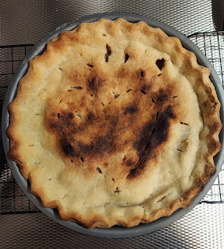

We received our Christmas tree a day early from Amazon Italy (yay!). So, after Scott put it together, I decorated it.

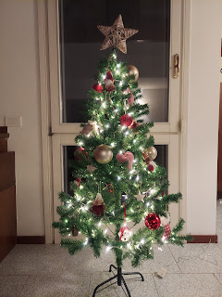

We thought it would be a little taller, ha ha . . . but it will still do the trick.

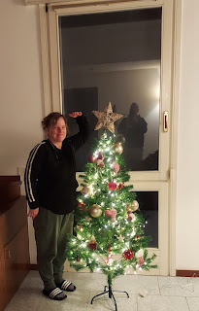

The other Christmas decorations were already set up on the end tables next to our living room couch - from my trip to Emisfero on Monday.

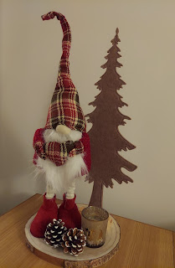

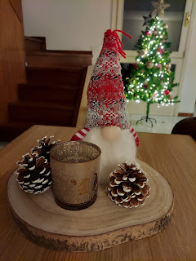

In the middle of the afternoon, I asked Scott to give me a priesthood blessing because I was feeling so lousy. My biggest worry was being too sick to host Thanksgiving. While that sounds a little weird, or shallow perhaps, my underlying fear was being too sick to have our son, Benson, come down from Aviano to join in the festivities. If I canceled the feast, I knew our friends would be okay, but I worried about Benson. I'm sure he could have fenagled some other plans last minute, but I wanted him to be here with US. So yeah, that's why I didn't want to cancel Thanksgiving.

He gave me a sweet blessing and I felt a lot of peace and calm reassurances that everything would be okay. During each hour that day, and each hour the following day (Thanksgiving), I noted that I felt a 5% improvement each of those hours. I felt like I could safely have company over and not get them sick and that we could have a lovely time together.

Thursday:
Turkey Day!! Or in this case, Pork Day!! We decided to have a Mexican Feast because I didn't want a half-burned, half-raw turkey presented to our guests.

The carnitas turned out delicious!
Recipe here:
https://www.recipetineats.com/pork-carnitas-mexican-slow-cooker-pulled-pork/

The refried beans in the crockpot turned out delicious!

Recipe here:
https://www.themagicalslowcooker.com/slow-cooker-refried-beans/

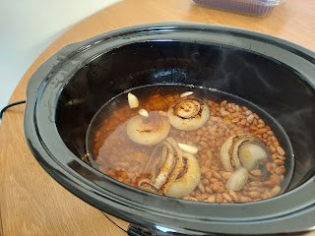

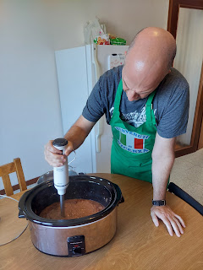

The chicken enchiladas turned out delicious!
Recipe here:
https://www.aheadofthyme.com/salsa-verde-green-chicken-enchiladas
/

For some side dishes, I made pickled red cabbage, creamy cilantro lime cole slaw, and fresh salsa. My friend, Lasina, also made a tasty corn salad (with cilantro and cotija cheese).

Here is my plate:

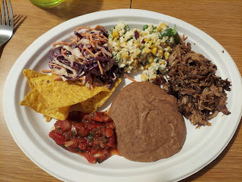

Benson was delayed in coming down to Vicenza because their one car died temporarily. I guess sometimes it just dies. Kylie had the car this time, so Benson had to wait until someone could jump it and then Kylie could bring it over to him. He made it to our house just as we had finished eating. We DID wait to eat some dessert until he came, though . . .

We had a very nice visit with Benson, Lasina and her husband Chris, and a single soldier named Cody. Benson stayed for a little while after everyone else left, which was also nice. Scott put all the leftover food away and tidied up the kitchen so I could rest and visit with Benson.

By the time I got into bed that night, I was BEAT.

Friday:
We drove up to Aviano to pick up Avery around lunchtime and bring her down to our house for a sleepover. Kylie had asked us to watch the baby so she could go to an all-day appointment on Friday. Benson was watching Avery during the morning before we came. I felt pretty good that day, even though I had a headache.

Beautiful snow capped the top of the Dolomites as we drove to Benson's house.

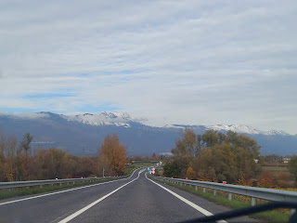

Just around the corner from their house is this beautiful view.

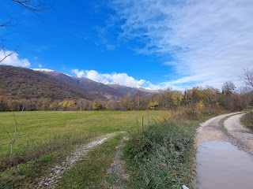

I sat in the back seat with Avery for the drive down to Vicenza. I gave her some Ritz crackers and slices of apple to nibble on, which she enjoyed very much.

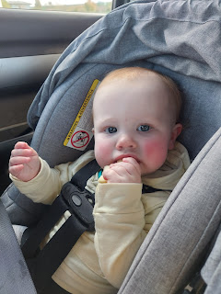

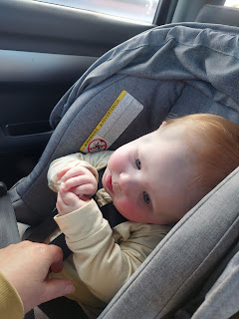

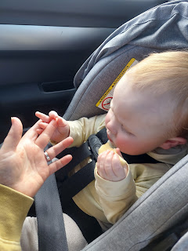

Video of Avery chatting about her apple slice experience: (38 seconds)
https://photos.app.goo.gl/JXqqsiVCN2pEwbCK6

She is always SUPER observant about everything going on around her. NOTHING goes unnoticed. I love how intently she was studying the building where we live as Scott slowly pulled up to our gate.

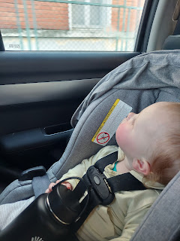

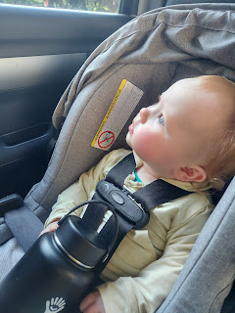

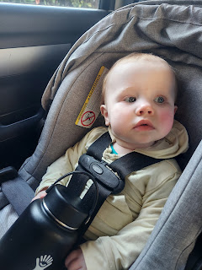

After unloading the car and bringing in all the baby gear, Scott left to take our Peugot to the inspection place (on base) one final time. We had already picked it up from the shop, it passed inspection just fine, and is now all set to be purchased by a young couple on Monday.

Meanwhile, Avery enjoyed inspecting our Christmas tree. :)

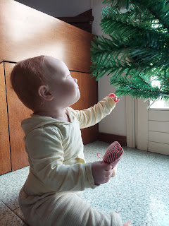

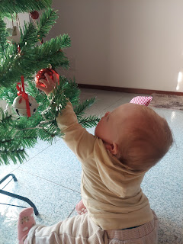

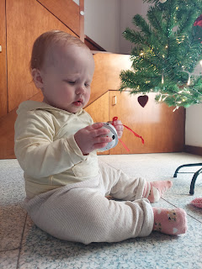

Video of Avery playing with a Christmas bell: (41 seconds)
https://photos.app.goo.gl/4TCKxYdwzo4LxBkn8

She is such a silly girl!! She makes us laugh all the time. :)

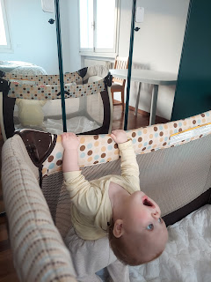

Video of Avery having fun in her newly set-up playpen: (22 seconds)
https://photos.app.goo.gl/Nqw1zBibwkR2fJGD8

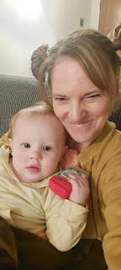

We got out the new blocks that I bought recently and she enjoyed playing with them for a LONG time.

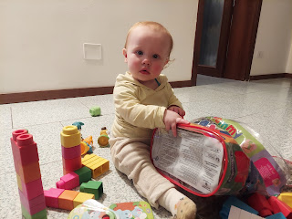

Funny video of me trying to keep up with the demands of feeding her some scrambled eggs. When we found something she liked, she would excitedly yell for more, ha ha. I put some eggs in front of her to grab on her own, but she liked figuring out how to use the fork. My job was to try to catch the fork "mid-fling" before it landed on the floor below, ha ha.
(20 seconds)
https://photos.app.goo.gl/QwHToa6E8uqePGHk7

Saturday:
Good morning everyone. XOXO

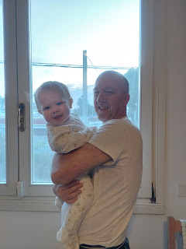

She woke up 3 times in the night, but really it was only the first time that took the longest. Nor sure if she just woke up disoriented and therefore sad, or if she was teething or what. Either way, she was inconsolable for a while. Poor thing. It was just as hard for us to have to walk away and let her cry for a few minutes after we tried everything we could think of . . . especially for Scott. I'm more of a "well, this is what needs to happen for the greater good" kind of person, but for Scott, it literally felt like her cries were ripping his heart out and that he was the worst grandpa on the planet.

She woke up happy though. All was well once again.

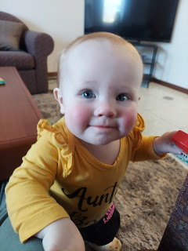



For lunch, I made her some ground beef, pasta noodles, and peas. We tried to be sneaky by stuffing a green pea in some of the macaroni noodles, but she was just as capable in removing them first.

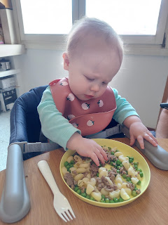

Video of just how peaceful and delightful it is to watch her eat: (46 seconds)
https://photos.app.goo.gl/J5nAJQH4RK3R9jLk7

(*Note: a giant cold carrot is great for a teething baby.)

We borrowed a stroller from a family in the ward and took Avery on a lovely fall walk after lunch.



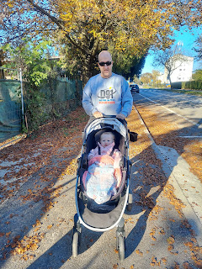

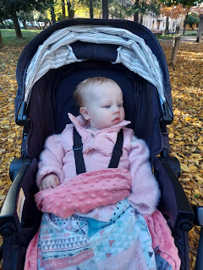

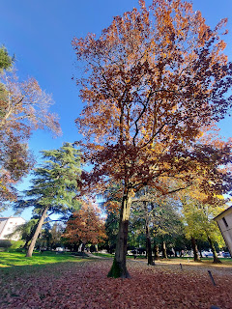

She enjoyed it all very much!

For dinner, Scott tried something new. We had recently bought an immersion blender so we could make the refried beans for Thanksgiving. It came with a small food processor in the box, and he wanted to give it a try. He put that giant carrot into the food processor chamber, and let it chop it all to tiny bits. Then he fried them up in a pan with a little bit of olive oil until they were tender.

As he fed them to her, he literally could not feed her fast enough, HA HA HA. It was hilarious! She was yelling excitedly and wanted all of it to just be IN HER MOUTH as fast as possible. She is so great. :)

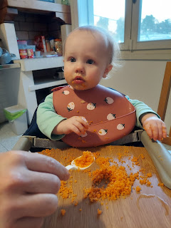

When Benson came to get her later that evening, she was more than ready for bed. She reminded me of Benson when he was little, because they both tend to get wound UP as it's time to wind DOWN. In between bouts of fussy hollers, this next video shows how she chose to channel her depleted energy at bedtime . . .

(13 seconds)
https://photos.app.goo.gl/SKzsotgYYaEfqAQV7

As for me, I got into bed pretty quickly after they left. I had spent most of the day coughing and I was DUN. Croup is an infection of the larynx, or voice box. It causes your throat to swell up in the first couple of days (especially at night) and it makes it hard to breathe. Then, at the tail end of the sickness, you have to cough up all the gunk that caused the swelling in the first place. So that's where I'm at now.

Tea helps, but only temporarily. Cough drops help, but only temporarily. Eucalyptus oil on my throat helps, but only temporarily. Most of the time, I just cough and cough until my head hurts. So I'm at home this morning (Sunday) instead of going to church. I don't think I'm contagious, but NOBODY wants to hear anyone hacking up a lung in public these days . . .

Time for Grandbabies . . .

Jack and Avery share a common interest in being upside down LOL

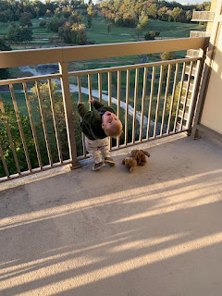

Two very handsome plaid twinnies . . .

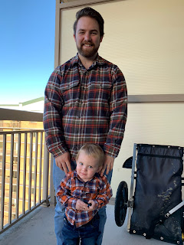

Darling video of Jack being motivated to climb up the ladder at the park: (1 min, 31 sec)
https://photos.app.goo.gl/SKzsotgYYaEfqAQV7

Abby and Gwen have been enjoying their week off from school for Thanksgiving. Abby helped decorate Gwen's face with some makeup . . .

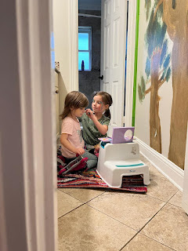

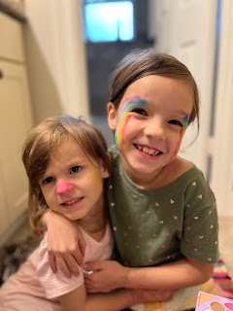

(Gwen is looking ferocious because she is a tiger)

Last but not least
, in case you were wondering about the family genetics and who resembles who . . .

Compare the photo of Jacob in his plaid flannel shirt above to these photos of my brothers.

Ryan on a recent month-long hunting trip with his dog, Cooper. They traveled through Wyoming, Montana, and Northern Idaho before returning home to Napa, CA.

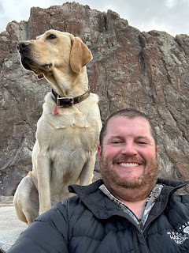

Michael (my baby brother) and his two boys Jaxon (in blue) and Logan up in Northern Idaho

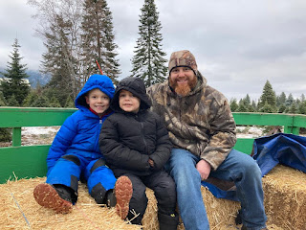

Mike and Steph, with Logan and Jaxon as they picked out their Christmas tree over the weekend

