Southern Donuts with "Mom"
It's been a tremendous week down here in Louisiana with the girls! They have overcome sickness more than once and we have done some really fun things. :)
More on the Donuts with "Mom" thing in a minute . . .
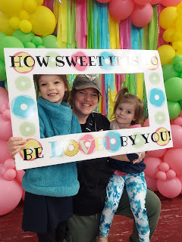

Monday:
After doing some house cleaning and the last of my packing, my friend, Barb Vance, drove me to the Idaho Falls Airport and I began my trek down to Shreveport. My flight was delayed from Denver to Shreveport, and then once in the air, the captain told us that due to a very large storm in eastern Texas, they were routing us down to New Mexico, then over to Houston, and finally up into Shreveport.

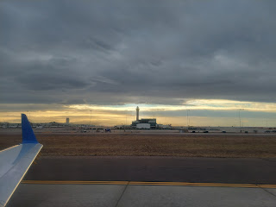



Here is a video that I took as we were getting close to Shreveport - with all the lightning going on around us. (40 seconds)

https://photos.app.goo.gl/okvN8NZEcJs882HLA

Once we landed and taxied over to our gate, we had to sit there (not quite to our gate) for quite a while. After several minutes, the pilot got on the intercom and shared, "Thanks for your patience, folks. We're trying to get someone's attention to help us pull up to the gate . . . we see people walking around and we've been flashing our lights at them, but so far it appears that no one is able to come over and help us park. Please continue to stay seated and hopefully we'll get you on your way soon."

After a good 20-25 minutes in all, we finally "arrived" and could disembark. It took another 30 minutes to get my suitcase from the baggage claim, and then FINALLY I could meet up with Amber who was waiting outside to pick me up. It was a very late night by the time we got back to her house, but it was so good to be there!

Also, here's a super cute picture of Avery:

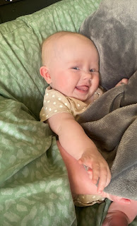

Tuesday:
I learned that during the night, Gwen had fallen ill to the same high fever and flu-like sickness that Abby had had a couple days prior. Her fever reached a scorching 102/103 and in addition to giving her some ibuprofen, Weston gave her a priesthood blessing. Both allowed her to fall back asleep. She woke up feeling slightly better, but then it turned into a roller coaster ride throughout the rest of the day. She felt fine, she felt horrible. Her fever was fine, then her fever was right back up to 102 again. At one point, we even had to overlap Tylenol with the ibuprofen just to get it under control, using a cold washcloth to cool her forehead as well.

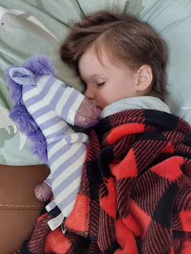

Just before dinner, she felt well enough to set up her stuffed zebra for a ride on their cat, Goose.

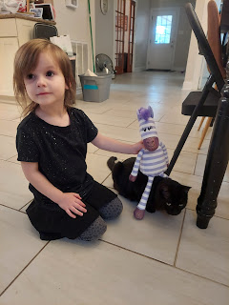

Abby was so happy to be home from school and to come hang out with all of us! I had gotten up at the ridiculous hour of 6:10 a.m. (Central Time) to take part in the morning routine of getting Abby ready and out the door by 6:37 a.m. to catch her bus out front. I needed to see how it was all done, since I would be in charge for the rest of the week.

Video of Abby getting off the bus and us holding hands and walking down the driveway: (46 seconds)
https://photos.app.goo.gl/GiXXnMetMDYg8NN99

While she had recovered for the most part from her sickness, she was still pretty wiped out. Plus, she likes to be wherever the action is and missed seeing me all day. Yes, I am the action. :)

Wednesday:
Amber and Weston headed off on their grand adventure by 7:00 a.m., while I helped get Abby out the door by 6:37 a.m. We let Gwen sleep in, since she wasn't ready to go back to preschool quite yet. Thankfully, as the day went on, she felt better and better. We went to Target to get some supplies, which included balloons, per Gwen.

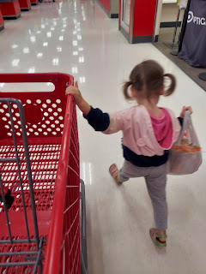

She got a happy meal at McDonald's, and I got honey walnut shrimp from Panda.

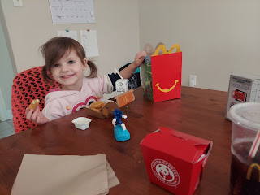

In the afternoon, we went on a 30 minute walk so I could get some exercise in.

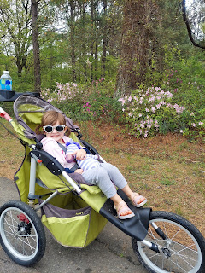

She was a very good sport.

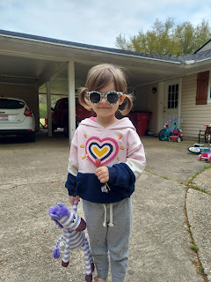

Something I noticed (as we waited at the end of the driveway for Abby's bus) was this streetlamp on their property. It reminded me of something out of the Beauty & the Beast movie, with its branches and tendrils wrapping and curling around the lamp post. Would you agree?

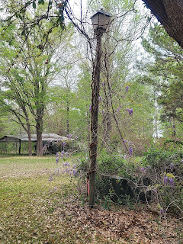

If you looked closely at the dainty wildflowers that Gwen was holding in her hand above, you may have noticed some Indian Paintbrush. They are in bountiful abundance down here right now! Amber found this VERY sweet book recently and I enjoyed reading it with Abby in the evening.



Abby is always in such a good mood. She gets up way before any child should have to on a school morning, is consistently a "Star Student" in her class, and even comes home in a cheery mood. I love how she is so consistent and helpful all the time, too. :)

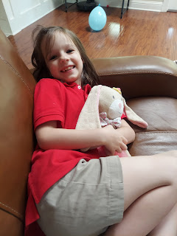

We started a special little project where I've been having the girls draw a picture of something from each day while Mom and Dad are gone. We are a tiny bit behind today (Sunday), but we will catch up before they come home on Monday, ha ha.

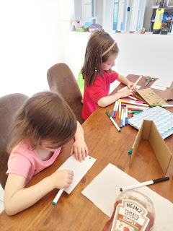

This is one of the sweet photos that I sent to Amber and Weston. Weston has been paying extra to have access to the internet on his phone each day so that we can keep in touch while they're on their cruise. Abby was all tucked into bed and their cat, Goose, was contentedly purring on top of her blue blanket . . . He's so dark that it's hard to see him!

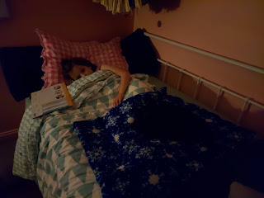



It was also Jack's FIRST BIRTHDAY!! Happy Birthday sweet thing!



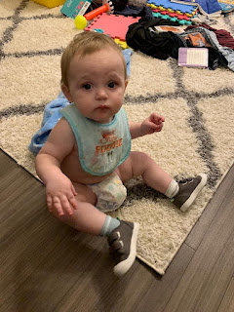

A darling "birthday card" from his cousin, Calvin, in Utah.

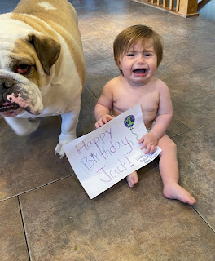

And here he is gnawing on, sucking the life out of, and thoroughly enjoying a piece of broccoli: (24 seconds)
https://photos.app.goo.gl/1nMPyN44vRUW2aF7A

Thursday:
Gwen had done so well the day before that I decided it was okay to send her back to preschool. It was a good thing, too, because they released all the butterflies that they've been caring for as caterpillars in her classroom.

It was a tricky schedule on this particular morning, though, because not only did TWO girls need to get to school on time, but it was also Donuts with Mom at Abby's school and it began at 7:00 a.m.!! I got myself up just after 6:00 and put a little make-up on so I didn't feel so grungy and unbecoming, ha ha. Then I started getting the girls up and ready around 6:20. Somehow we were out the door by 6:50 a.m. and on our way to the school. Wow.

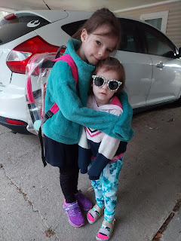

They had a welcoming sign out front so I had the girls pose for a quick picture and then we went into the gym for our donuts.

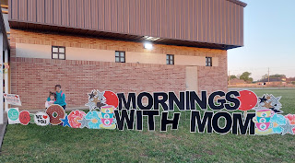

The staff there are so caring and fun and you can genuinely feel how much they love all the kids. One of the things they offered was to get a photo together, so of course we did that!

When it was time for me to leave, Abby burst into tears, saying that she didn't want to be apart from me. She asked if she could come home with me so we could spend more time together. As I was in the middle of some very gentle negotiations, her friend Jocelyn came all the way up to the top of the bleachers where we were sitting and cheerfully said good morning to Abby. Jocelyn ended up saving the day because she didn't want Abby to go home. Soon, they trotted off to class together and that was that. :) Jocelyn's method was much easier than me trying to convince Abby that she only needed to go to school this day plus one more - and then it would be her spring break!

Soon after, I got Gwen off to preschool and then I came home to exercise and shower. I hadn't gotten to my shower yet when Scott called. He's been doing a night shift for about 8 days while he helps with a training mission as the targeting officer. We have a small window to chat each day between about 10:00 - 11:00 a.m. (Louisiana time) before he has to leave for work. In his hotel room he has a little cook-top stove and he likes to heat up a frozen pasta/veggie/chicken mix for his "breakfast" at dinner time. (His work schedule is from 7 pm - 7 am)



We chatted about lots of stuff, including some important dates coming up. It looks like we'll be getting the keys to our new house on April 27th, which is during his training in Germany. So now I'm the next best thing for getting everything taken care of in his absence. He'll get the paperwork signed, and then I get to receive the keys and start getting us settled in.



I started making a list of all the things we will need in the new house, and we've been discussing what to do and where to find the items. There is a community of other US Military families over there, including all their stuff that they can't take along when they move to a new duty station. We anticipate finding some things that we can purchase from them, some things we can buy locally or on the base, and then there is an IKEA store nearby or Amazon.com for all the rest.

After preschool and a leisurely lunch, Gwen wanted to go on another walk around the neighborhood. Only this time she wanted to be barefoot.

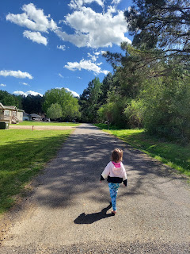

I got a couple videos of her trotting along in her bare feet. When she got to a spot in the road where it was gravelly, she'd wait for me to catch up with the stroller, then she'd climb in for a moment until we cleared the "poky parts". Then it was back to barefoot nature girl again!

Videos of Gwen barefoot and cruising along:
(11 seconds)
https://photos.app.goo.gl/GkPJ1Z6ztXC4kyA89
(12 seconds)
https://photos.app.goo.gl/d7CYhwgEcxCgXKXF9

Video of Gwen finding some souvenirs: (7 seconds)
https://photos.app.goo.gl/YCSrkzCN6Q5RuYfH6

After Abby got home, we went on another walk around the neighborhood. She (Abby) noted this beautiful flower bed at the end of the street, with some bright pink flowers, some of which were two-toned and magnificent! She said, "Mimi, can we go knock on their door and tell them how pretty their flowers are?" You bet!! So we did! People in the South are so friendly that this wasn't weird at all. They just love it.

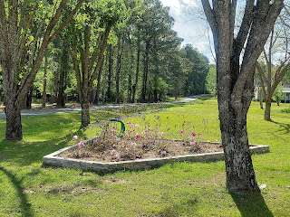

They wanted their picture taken in front of the flowers, but not wanting to traipse across the lawn to get up close, I had them pose on the edge of the road. It was a windy day, as you can see from Abby's hair . . .

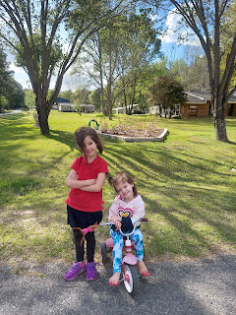

Jacob and Hannah moved into their new apartment this same day, too. Well, technically they just brought enough with them to sleep for the night, and then the rest of the big move was made on Saturday.

This is the view from their new digs on the 12th floor: (9 seconds)
https://photos.app.goo.gl/yDt3SKSjVidUxCjc9

This time, they found an apartment on the top floor where hopefully they won't be bothered from loud upstairs neighbors during the night. They've had a rough go for several months now and have been very sleep deprived.

Also - Jack finally got his Quiet Book!! You may recall that I had to suck it up and not throw a fit that it would be arriving the day AFTER his birthday . . . well Jack loved it and didn't mind one little bit that it came late.

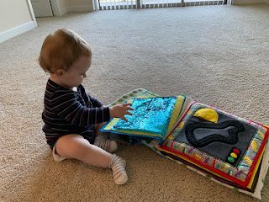

Jacob reported that Jack was trying to bite these . . . which I had already anticipated and tried to really secure each button well so it wouldn't become a choking hazard.

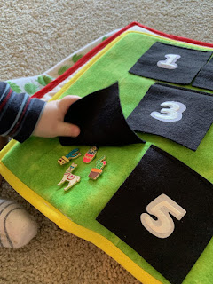

I'm super relieved that it arrived safely. When you put so much of your heart and soul into something, it would be devastating if it got lost or ruined!

Friday:
Scott woke up with lots on his mind, but he was also quite sleepy at the same time. Poor thing. He's the one who called me, but then he still needed a minute to get his brain working, too.



He blessed his "breakfast", made up of the same pasta/veggies/chicken mixture that he had the day before.



And then we talked about everything on his mind and all the things coming up really fast!! All too soon, it was time to say goodbye so he could head off to work.



For preschool on Friday, Gwen got to plant a beautiful flower and then bring it home! She was so happy!

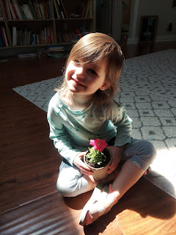

But unfortunately, as the afternoon progressed, I could tell she wasn't feeling well again. She fell asleep while I folded laundry next to her, bless her heart.

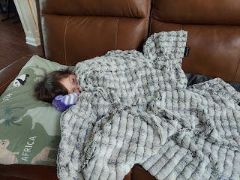

The day was quite beautiful. It was around 70 degrees and sunny, which is quite a bit nicer than when I left Idaho Falls.

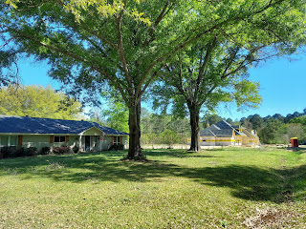

Abby came home in another great mood and wanted to practice her cartwheels. What a cutie!

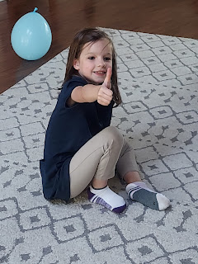

Right about the time I was ready to put the pizza in the oven to bake, and we were going to watch Tale of Despereaux for a Friday Night Movie Night, Gwen was just not doing well. I stopped the dinner preparations to go check on her and noticed that she was quite warm. Sure enough, her temperature had jumped back up to 101. I sent off a quick text to Amber and Weston, but didn't think I would hear back from them for a while. And then the thought occurred to me to just stop and say a prayer. Abby and I gathered around where Gwen was laying on the beanbag, and as soon as I opened the prayer with "Dear Heavenly Father . . ." I couldn't speak. I was too choked up and overcome to say anything further. I felt the spirit so strongly and I felt the words come into my mind, "Thank you. Thank you for turning to Me for help." And I felt the love of our Heavenly Parents and Jesus Christ so profoundly for these two sweet little girls. I had to fight really hard to pull myself together enough to finish the prayer, and then explain what happened to Abby and Gwen. I could tell they were touched as well.

Amber somehow was able to respond immediately, too, which was reassuring. She advised me to take Gwen to the nearby Urgent Care and let them diagnose what's going on. So we turned off the oven and loaded up into the car to go to the doctor. They took a Covid/Flu combination test, which both came back negative. Her ears were fine, her throat was fine, her lungs and heart were fine. She just felt like garbage, even though the ibuprofen I gave her right before we left was helping somewhat. The doctor was a little puzzled, but said she thought Gwen was just having a "bounce back" or a relapse of whatever had been ailing her earlier in the week. She prescribed a prescription strength cough medicine and an antibiotic just in case the fever came back again, and then off we went.

To get to the nearest Walmart, it meant another 10-12 minutes away from the clinic. Unfortunately, though, we arrived at 7:03 p.m. and the pharmacy had just closed at 7:00 p.m. Rubbish! We had no choice but to just head home and try to salvage what we could for the evening. A 30 minute drive home is what we faced at this point, and by the time we arrived, we had been gone for 2 hours!! I got the girls set up to watch a little bit of the movie while I baked the pizza and all was well. I kept Amber and Weston posted on everything that whole time, too.

At bedtime, I didn't have the prescription strength cough medicine, which would have been nice, because Gwen was already maxed out on Delsym and her allergy medicine (Zyrtec). I was running a diffuser with essential oils near her bed, too. But at 10:30 p.m., when I could hear her just coughing and coughing and coughing, I went in to apply some Vick's vapo rub to her throat and neck. Poor thing, she was about to barf from coughing so hard! Soon she fell back asleep and did fine during the rest of the night.

Saturday:
Gwen woke up feeling quite well, all things considered. "Hallelujah!" is all I could think in my head!

She announced that she was a sneaky snake, slithering across the floor . . .

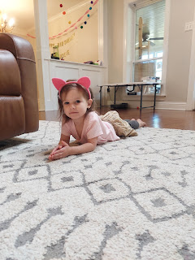



The girls worked hard to clean their rooms while I vacuumed, swept and cleaned the bathroom.

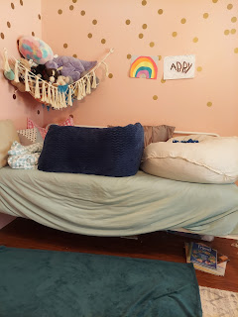

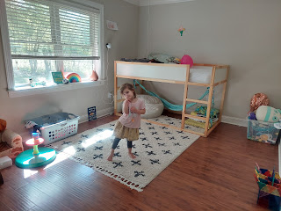

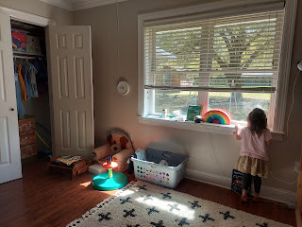

Then if was off to the Jubilee Petting Zoo in North Shreveport. This place was huge! They have baby emus to feed right in front of the gift shop where you buy your tickets. They gave us each a cone filled with seeds and animal feed, which they said was fine to feed to any animal on the farm, including the cone itself!

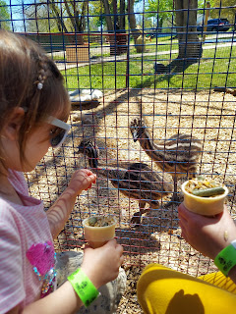

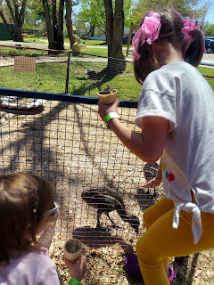

The bunny rabbits were almost as big as Gwen!

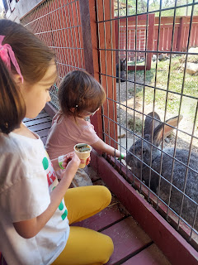

Gwen's favorite thing of all was this ginormous Bounce House. If it weren't for her coughing fits that popped up every time she started jumping, she could have stayed in here all day.

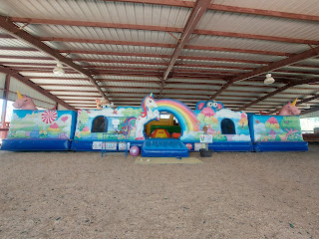

Here's Abby in front of the entrance.

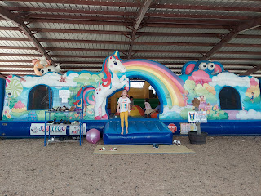

They had a huge covered pavilion with an airplane seesaw, birthday party tables, and plenty of fun toys to climb into or onto.

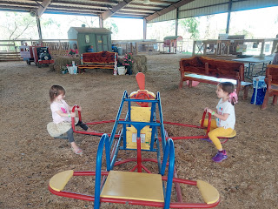

We fed the little kangaroos . . .

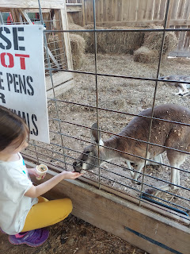

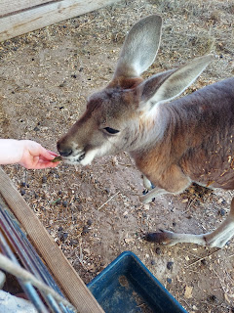

This little guy was all tuckered out. (He looks dead . . . but he's really not)

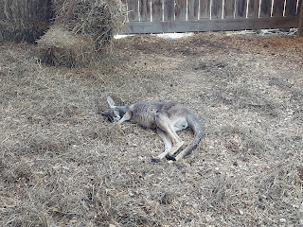

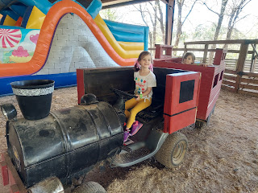

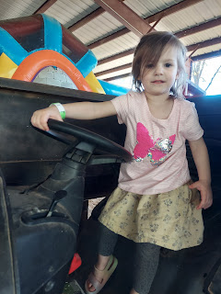

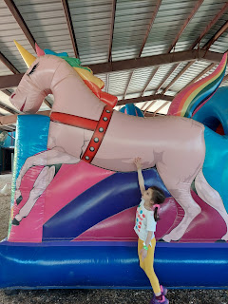

In back of the pavilion with the bounce house, was a decent sized splash pad area with a playground.



We found some sort of chickens with pom-pom hairdos. They were a little more aggressive in getting some food from our ice cream cone supplies. They pecked so strongly that it made Gwen's cone tip over and empty out most of its contents, which they then pecked at furiously to get it into their mouths through the fencing. Gwen was a little shocked, ha ha.

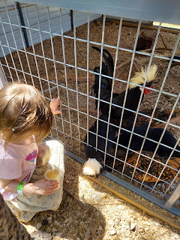

Inside the baby goat pen, I thought it would be super fun! But one of the baby goats nipped at the food in Gwen's hand, causing her to scream and start crying. Then another one jumped up with its front legs on Gwen's tummy, which caused even more distress. Then Abby started picking up on Gwen's fear and was trying not to cry, too. I worked hard to help them stay calm and to teach them a technique to defend themselves, similar to if a puppy jumps up on you. You just stick your knee out in front of you. If the animal tries to jump on you and you put your knee up, they just bounce off and can't get to you. I showed them how to do it a few times, which did help to calm them down, but ultimately they just asked if we could get out of there.

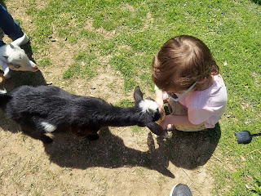

Next, we hopped on the train to ride out to the coolest playground I've ever seen! It was perhaps a 10-15 minute walk from the main play areas and petting areas if you wanted to skip the train ride.



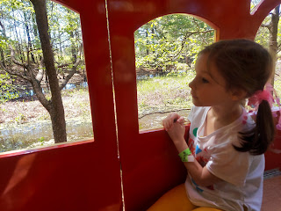

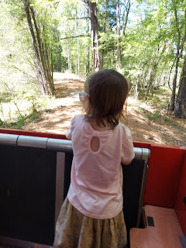

This brings a whole new meaning to those who read the Magic Treehouse books . . .

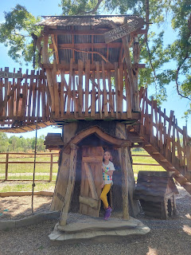

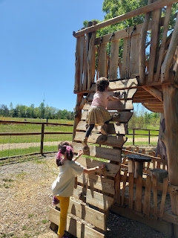

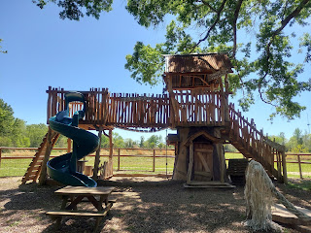

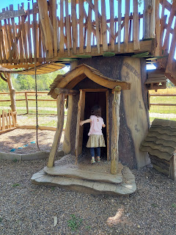

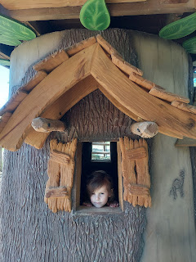

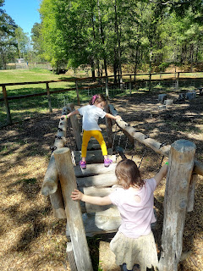

Video of the girls getting across the log run: (11 seconds)

https://photos.app.goo.gl/JyP9SBWtuCKsNis69

So many obstacles to explore and climb across . . .

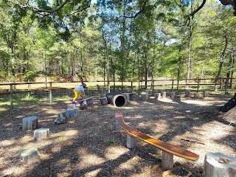

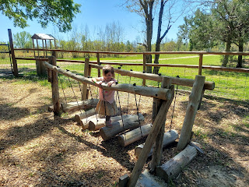

After another train ride back to "civilization", the girls cashed in their tickets for a pony ride. Buttercup was dressed up as a unicorn for the day, since it was National Unicorn Day! Who knew!?!

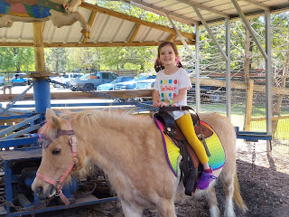

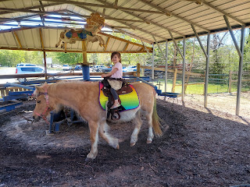

Our last big adventure was to go on a hayride and participate in feeding some of the larger animals from the safety of the trailer bed.

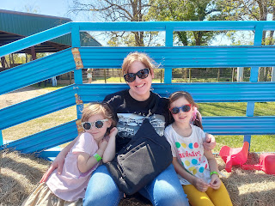

As soon as we got into the feeding pen, Douglas the Camel came trotting over to see what we had brought him to eat. :)

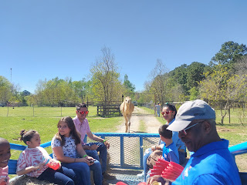

There was a horse, a zebra, a camel, and a couple of cows that all lived amicably together in the pasture.

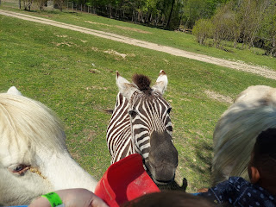

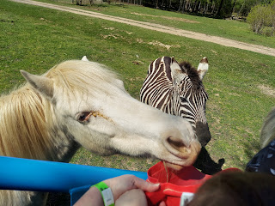

Douglas was SUPER friendly . . .

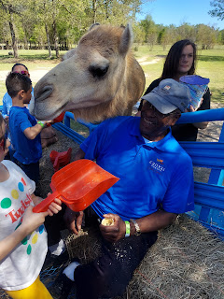

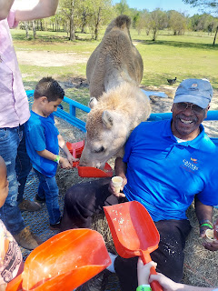

Video of Douglas nibbling - or should I say gobbling up the food in the red scoop: (13 seconds)
https://photos.app.goo.gl/YCx731mLBf2MwrCe9

Another video of Douglas and his overly friendly nature: (9 seconds)
https://photos.app.goo.gl/SDYz2tGUQ1KrHvecA

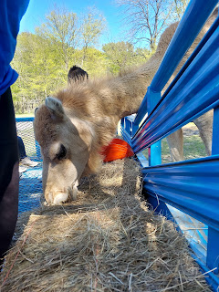

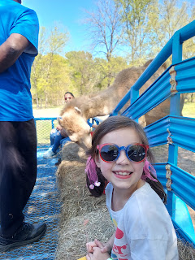

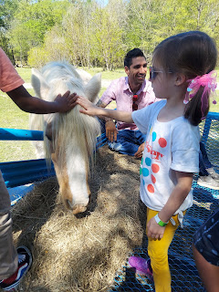

Just as I was taking this photo, Gwen screamed because Douglas got a little too close for comfort. It looks like they're both screaming at each other, ha ha.

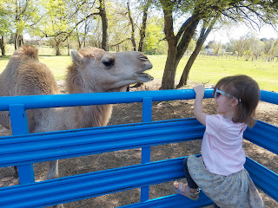

We played one final round in the Bounce House before admitting our exhaustion and leaving. We had been there for about 3.5 hours. We were thirsty and tired, which meant easy tears for the girls. I decided to stop at the nearby Sonic and get some cold drinks to help perk us up on the 30 minute drive home.

Everything was going swimmingly until a couple miles short of our exit, when Gwen poked her straw through her styrofoam cup and then the lemonade started spilling out the bottom and all over her lap while in her carseat. You may not know this, but Gwen detests being wet unless she consciously chooses to be, such as in a bath or a swimming pool. If it's unexpected, like this lemonade fiasco, then it's all over but the crying. I was trying to do several things at once: help to calm Gwen down and reassure her that we were just moments from being home where we could get her out of those wet clothes, figure out what to do while it was still leaking, got the idea to have her pass the cup over to Abby to park it in her cup-holder and try to catch the last 1/2 cup or so of liquid, continue to reassure Gwen that it wasn't the end of the world, and ALSO keep the car going straight and not running off the road!!

Thankfully, we made it home about 2 minutes later and successfully got Gwen into the tub while I cleaned out the car from all the mess.

After both girls got all squeaky clean from playing at the petting zoo & farm, I put on a movie for them to watch while I made crepes for dinner. That cheered everyone up! When I placed their plates in front of them at the kitchen table, it went drastically quiet. Nothing, not even the tiniest peep was heard for several minutes while they happily downed their crepes. It was bliss. I made a mental note for myself: If you want a quiet minute, just make some crepes and then feed them to the girls.

The evening ended with this happy little crepe on my plate, which went into my tummy soon after I took this photo.

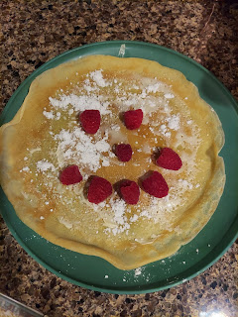

Sunday:
We got up and got ready for church in good time, eating leftover crepes for breakfast before heading out. I swear, crepes are so magical! When I went in to wake up each of the girls, all I had to was mention that after they got up and went potty, they could have crepes for breakfast. They went from a dead sleep to an energetic "Hooray!" in about 0.5 seconds. I might as well have told them we were going to Disneyland after they got up and went potty! It would have had the same reaction, ha ha.

They did great at church and were very reverent and cooperative. They enjoyed their primary classes and were happy to see friends and teachers that they love. I enjoyed a few minutes of grownup class time of my own by attending Relief Society. I tell you what, being a grandma is THE BEST. But being a parent, or even a substitute parent, is hard. It's hard work - with blood, sweat, and plenty of tears. It's all worth it though. I wouldn't trade these past 6 days for anything else. I'm just tired tonight is all.

After church, the rest of the afternoon and evening seemed to take longer than usual. The girls were easily offended, whining and tears were the staple emotion, and my patience was wearing thin. After hours of attempts to lead them along with arts & crafts, decorating cupcakes, board games (including Twister), many conversations, and even a couple of TV hours, they were still on edge with each other and couldn't get into a groove that lasted more than 30 seconds before someone imploded. In the middle of making dinner, I couldn't take it any longer. I summoned the last ounce of my patience + nice voice and announced, "All-right . . . we're done. I need you girls to go have some quiet time in your rooms while I finish making dinner. I'll let you know when it's ready." Their response was weeping, wailing and gnashing of teeth, but they dutifully marched off to their respective rooms and closed their doors. I took several deep breaths and got the rest of dinner ready in silence.

When they came to the dinner table a short time later, they were much more calm. I'm not exactly sure what the cause of all the contention was. It could be that they just miss their parents and the routine that is normal for their family. It could be all the wind that was wreaking havoc outside today, making it uninviting for any outdoor play. It could be that Abby is just starting her spring break and is trying to find a groove. It could be that Gwen still isn't her normal self after all the ups and downs of being sick this week. It could be a combination of all of these things. I really have tried to find a good mix of quiet and relaxing activities, fun and invigorating activities, snuggle time, individual time with each of them, work time, veg out time, etc. So I'm not sure what I'm doing wrong . . . but it will be wonderful when Amber and Weston get home tomorrow afternoon! I'm so glad they had this lovely vacation time together. They needed it. And I have enjoyed all the fun that I've had with Abby and Gwen. I really, truly have. And I will miss them when I leave on Tuesday morning to go home.

A few final photos:
Gwen "helping me" with the cupcake batter. (It's Weston's 30th birthday today)

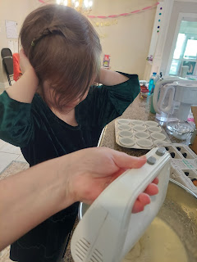

Playing a fun game of Orangu-Twang with the girls this afternoon. You roll the dice to see what item you have to hang on the orangutan. When he gets too heavily laden with stuff, then the whole thing goes "TWANG" and things go flying. It's pretty funny!

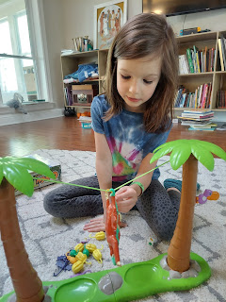

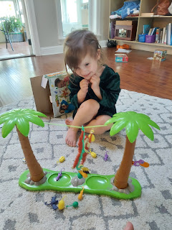

Quiet time this evening after dinner, watching the movie, "Spirit Untamed". Abby is snuggling with Goose, the cat.

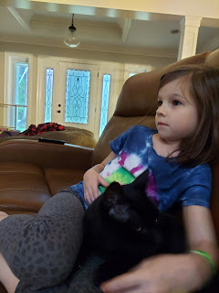

A photo I took during one of our evening video calls with the vacationers down in Mexico. They called every night to say prayers with the girls and talk to them for a bit.

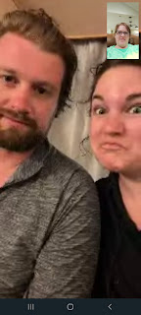



By the time I publish my next post, I'll be in Italy . . .

