Spring Flowers & Cotton Candy Skies
What a beautiful week!! The flowers, the skies, and the weather overall has just been spectacular! I've been on walks all over the place, and we even bought some flowers and plants to call our own this weekend. :)
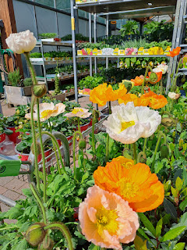

We enjoyed one last day with Avery on Monday. She is a little pumpkin and is so easy to please.

She enjoyed the grilled cheese sandwich that we made for her lunch that day. She did better with it once we cut it up into little bite sized pieces, rather than a long strip. She kept trying to shove way too much in her mouth, ha ha . . .

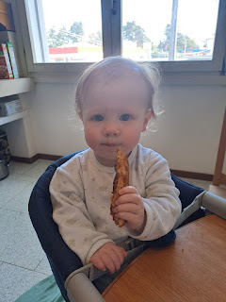

We discovered her passion: BALLS. She loves to squeeze them, throw them, fetch them, and then chuck them again.

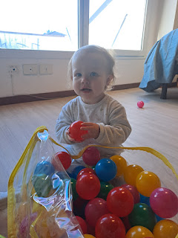

And she definitely loves bath time . . .



We took her to the PX on base during the afternoon to grab a couple things. She did great in the cart.

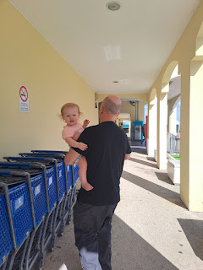

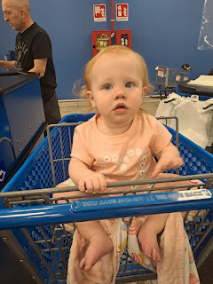

I LOVE her little curly locks in the back . . .

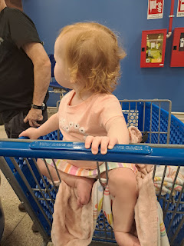

On the drive from the PX to the Mall, I hung up her blanket to keep the sun out of her eyes. That made her very happy. :)





We didn't have a stroller this time (we borrowed one during previous visits), so we took turns carrying her chubby little cuteness around the mall. I find it amusing that Avery DETESTS a lot of textures, both with foods and with things that her hands might come into contact with. (Such as Poppa's fuzzy head with that short haircut that he has . . .)

Gwen, on the other hand, has specifically ASKED if she could ride on Poppa's shoulders so she could rub his fuzzy head, but Avery was very disturbed that his short haircut was prickly and fuzzy. Scott might as well have had the plague, the way she kept her hands FAR AWAY from his head . . . LOL

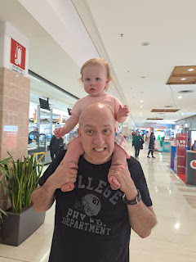

We found a cute children's area in the mall where Avery could play a little. Two young girls made a beeline for Avery, and basically fell in love with her.

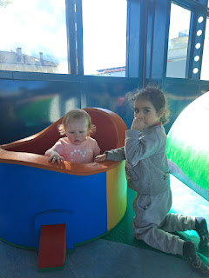

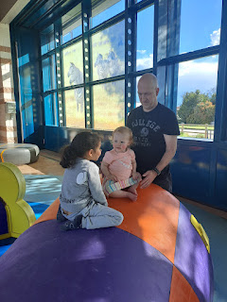

I think the two little girls were sisters, and they spoke only a few words in English. I tried my best to communicate in my limited Italian. I learned that the older sister is 7 and her younger sister is 5. They played peek-a-boo with Avery and made her smile a few times. :)

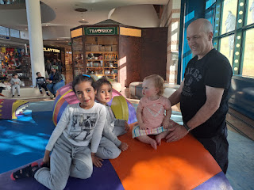

Where Avery lives up north is very rural, and mostly consists of small towns and villages. I'm not sure if she's ever ridden on an escalator before, but we gave her a little taste of the BIG CITY, ha ha.

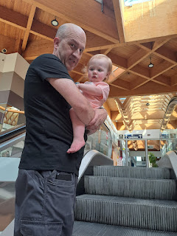

After dinner, we started our drive to the Venice Airport to meet up with Kylie, who was flying back in from Cyprus. I mistakenly reported last week that she had spent the weekend with friends in Greece, because I thought Cyprus was part of Greece. IT'S NOT. It's a large island off the western coast of Lebanon, Syria, Israel, and Turkey. Boy was I wrong . . .

Here are a few pictures she shared with me.

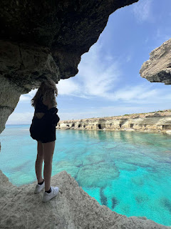



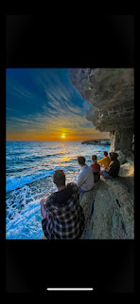

Avery had a little bit of a hard time adjusting to the whole "spring forward" thing, losing an hour of sleep, and throwing off the already delicate schedule of a toddler. During the short 45 minute drive to Venice, she started falling asleep in the last 10 minutes or so. What a sweetheart.

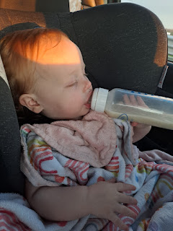

Funny story that I shared with our kids during the drive with Avery: (1 min, 23 seconds)
https://photos.app.goo.gl/M9AonVvFQSB7FwkeA

The skies over Venice were absolutely stunning. This was the view out the back window where I sat . . .

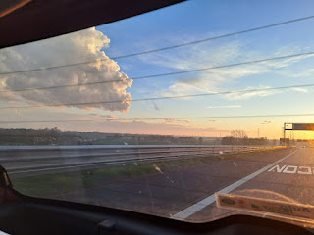

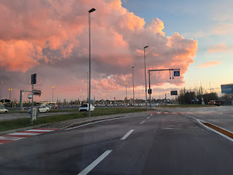

And once we found a place to pull over and wait for Kylie, I got out and took a couple more photos.



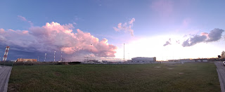

She was with a couple of friends, so we helped transfer all of Avery's luggage from our car to theirs. Scott did most of the work again, while I visited with Kylie and handed Avery off. We all got home to our respective cities in under an hour and then we went to bed.

Tuesday:
I walked to the base and mailed a couple packages off, along with some postcards. Our friend and neighbor back in Idaho Falls, Peter Vance, LOVES honey. He loves honey from all over the world, so whenever we get a chance to share some with him, we do it. This time, we sent him 3 little honey jars from Bled Castle in Slovenia. He will be so happily surprised when that package arrives . . .

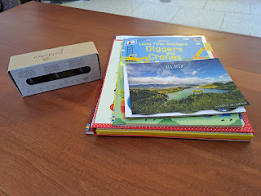

This poster was helpful at the post office on base. There has been a change recently to how you can list items on a customs form. They are more fussy than before, and you have to be SO SPECIFIC when you write down what is in the box on the form. Otherwise they will send the package BACK TO YOU and you will have to fix the item description and then PAY AGAIN to ship the package a second time.

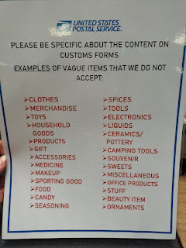

How do I know this? Because it happened to me back in February. I got a package all prepared to send to Kylie and Avery for Valentine's Day. I listed all the contents, making the fatal mistake of writing "toy" as one of the items in the box. I mailed it out at the end of January so it would get there in plenty of time before Valentine's Day. Only 10 days later, it came back with some notes on it saying it was rejected in customs. I had to fill out a new form, take it to the post office, and pay a SECOND TIME to ship it out. As per the clerk's suggestion, I wrote "floating bath toy" as the description this time. It finally did make it to Aviano, Italy, but a little past Valentine's Day . . . LESSON LEARNED.

I had a short visit with Amber and Gwennie during the middle of the day. Gwen was home because she wasn't feeling well, but she was still chatty enough with me on the phone and gave me a few darling smiles.



For dinner that night, I made shrimp fajitas. They were SO GOOD!! Earlier, I had walked to the post office on base, then I walked over to the Commissary to get a few items that I can't get in an Italian grocery store (such as cheddar cheese, sour cream, and tortillas).

We worked on the dinner prep together and then we watched some America's Got Talent: All Stars while we ate. Yum!!

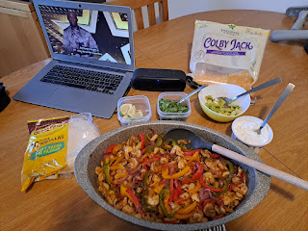

When I went up on the roof to switch some laundry on the drying rack, I saw another magnificent sky.

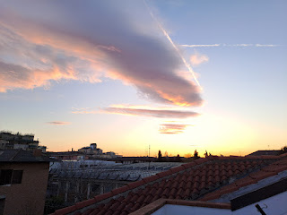

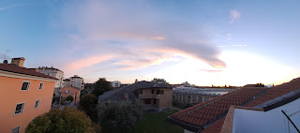

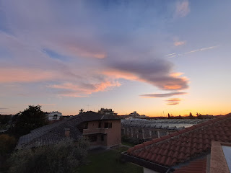

Wednesday:
I went on a nice long walk up to Monte Berico and back. It's about 30 minutes each way.

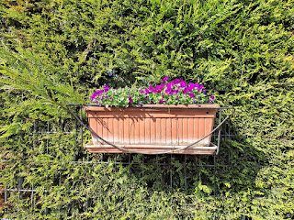

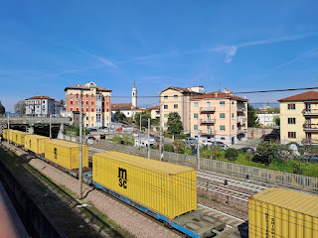

This is where the steps begin. I found out later that there are 192 steps up to the top. I had to take a couple of breaks to catch my breath on the way up, of course.

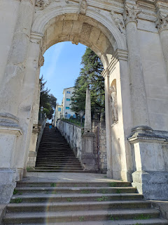

But wow, once it levels out onto a nice wide pathway at the top of the stairs, this is the view that you get, overlooking a big portion of Vicenza.

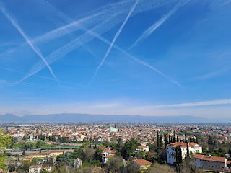

Then there is another incline to steadily walk up . . .

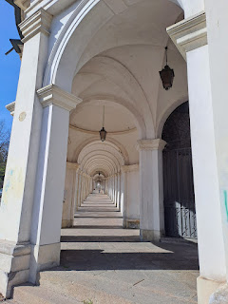

And then finally you get to the Basilica of Monte Berico at the top.

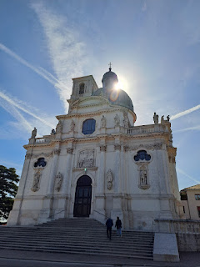

I actually tried counting the steps as I went back down, but I only came up with 180 +/-. I got distracted a couple times, ha ha.

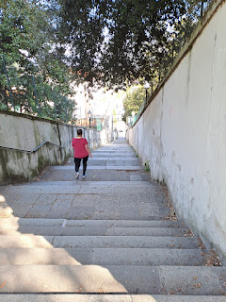

Just in case anyone is wondering, dandelions are alive and well here in Italy, too. Speaking of wondering: Did someone purposely transport dandelion seeds on some ancient ship on their way over to America? What a cruel April Fool's joke . . .

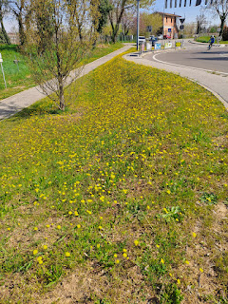

I've been thinking a lot about what sort of theme I could incorporate into my photo adventures this year. Last year, I did a fun collection of "Flowers of Italy". You can see that album here:
https://photos.app.goo.gl/i4RGiVYYiVicd4Ln6

I considered doing a theme of doors, architecture, gardens, etc. But ultimately I have decided to build a collection of photos called, "People of Italy". I wanted to call it "Faces of Italy", but quickly realized that logistically that won't always turn out. Sometimes people don't want you to photograph them, and sometimes I will have to be sneaky. Other times I might just get a side view, or a view from behind. It won't always be an actual face that I get a photo of, so that's why I will call it, "People of Italy." This will be a collection that hopefully provides a warm and encompassing view of the people here - their lifestyles, their work ethic, their hardiness, how similar we all are around the world, etc.

I'll start with this photo. As I walked behind this older lady, I first noted her steady and quick pace. Then I noticed her white hair and hunched neck and shoulders. From behind, I couldn't tell what her age was, but I could gather that she was definitely "older" if her hair was white. She had a solid pair of hiking pants on, the kind that 30-somethings would wear while hiking up and over the Alps. She also had a solid pair of shoes on, ones that provide comfort but that also mean business at the same time. It wasn't until we rounded the corner, with both of us heading into the same neighborhood, that I got a better look at her face from the side as we parted ways, me going down the first street, while she continued on. I was shocked to see that she looked as if she were in her 80's, maybe even as old as 85. I was very impressed that she could hold her own to the extent that she did!

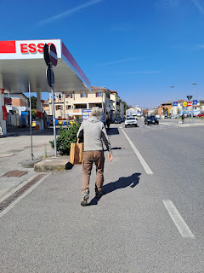

I've said this before, but I'll say it again. The elderly people of Italy are just amazing!! They are always out and about, on foot, on bikes, on public transportation (bus, train, etc.) and they don't let their age slow them down much. Their pace may slow somewhat, but they still do all their shopping and walking and living life to the fullest.

Stay tuned for this collection of photos to grow, but here is the beginning of the album, "People of Italy":
https://photos.app.goo.gl/bZuCQbYys1vjJfnW7

Later in the afternoon, I walked over to the base again to visit the Thrift Store. My goal was to find some children's books to beef up my meager collection in Italy.

I found several good ones, and ended up buying close to 50 new books!! Because they are priced at 3 for $1, I was able to get all of them for about $16. Fantastic!

My bookshelf upstairs went from this . . .

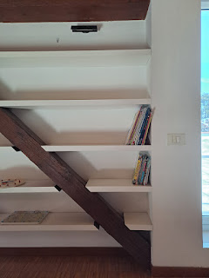

To this . . .

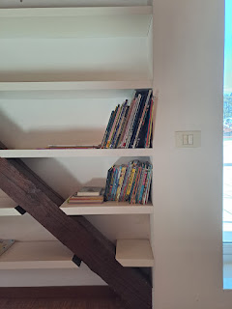

It's small and simple, but my little collection of books, puzzles, and games for grandchildren is now a comfortable amount that will occupy them during quiet times when we're all together later this year.

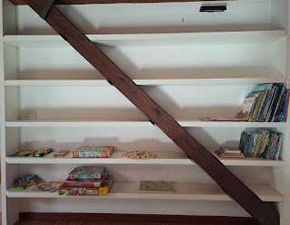

While I was browsing and choosing books to put into my basket at the Thrift Store, there was another lady that was just as serious as I was, kneeling on the floor to really go through each book and taking her time in the process. Eventually, I asked her, "Are you finding anything good?" She laughed and said that yes, she was. We got to talking and I learned a great deal about her. Plus, she is now my new friend.

Her name is Anya. She is married and has 2 little boys, ages 4 and 6. She is from Ukraine and her husband is from the U.S. I asked how they met, and she told me that she went to Orlando, Florida as an exchange student and that's when she met him. They just moved here from Germany, and her husband is some sort of director over youth activities, not as a military servicemember, but as a contracted civilian. They've been stuck in the hotel (Ederle Inn) for a long time now (since mid-February) as they have hunted and hunted for a home that suits their needs. They will finally move into their new place in 2 weeks.

I asked how her family is doing in Ukraine. She told me that her mother and her grandmother are in Kyiv and they are okay. Her grandmother is 86 years old and adamantly refused to leave when the war broke out. At the same time, she is frustrated and disgusted with the war. They are frequently woken up in the middle of the night because of some bomb going off somewhere in the city . . . Anya says that she checks the news before she goes to bed and again first thing when she wakes up. If she wakes up during the night, she checks it then, too. Her uncle lives in Russia (her father is Russian) and they keep in regular contact with him. He has been consistently oblivious to what is really going on with the war in Ukraine. He always wants to share some video with the family that he just watched on the news in Russia, but it's just propaganda that the Russian government is feeding to its citizens, and basically just pulling the wool over their eyes. Anya said she gets so tired of her uncle not listening to them trying to explain what's really going on. He is too trusting of what he sees on the carefully selected news stories . . .

Anya also shared with me that she was about to go pick up their beloved dog, Molly's, ashes from the vet on base before she went back to the hotel. She said her boys have really struggled with her passing and they regularly ask when she will be coming back. The decision to save her ashes seemed like a good one so that they could have some additional conversations about what happened to Molly and where she is now. They plan to spread some of the ashes in Germany this spring, whenever they go back for a visit, because that's where Molly spent most of her life and was so happy there.

Anya and I exchanged phone numbers on WhatsApp and we've been in contact over the past few days. I'm working with my other friend Andrea (from Germany) to set up a lunch date for the three of us this week. I'm so excited! I love making new friends and getting to know women from other countries and cultures.

When Scott got home from work, we walked over to a new grocery store that I found. It's called InterSpar, and it's a huge store that I see whenever I walk over to Monte Berico and back.

Partway there, we saw a random rooster next to the sidewalk. I think he is someone's pet, because there was a bowl of water next to him.

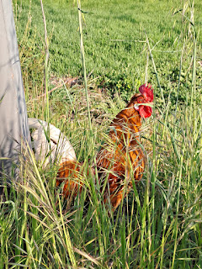

I'm always in awe of (and a little intimidated by) the fresh fish and seafood options in Italy.

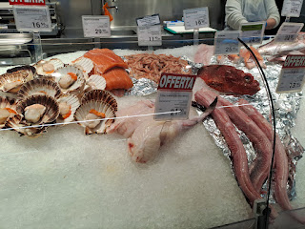

I would love to try many of them, but I need to do some SERIOUS research first on how to prepare and work with such exotic foods . . .

They even sell shelf-stable QUAIL EGGS in the grocery store!

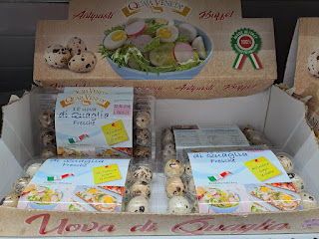

Thursday:
This was an at-home day. The fixer guy was scheduled to come mid-morning to fix one of our bedroom blinds. All the blinds in our house are motorized, and this particular one would only go down a little bit and then it would stop. We don't have any curtains, so there is no privacy to be had when the blinds don't go down . . . Thankfully we only had to wait 24 hours until help could come.

He installed a new motor and got everything fixed in about an hour and a half. I kept myself busy by sweeping, mopping, washing dishes, and other nesting chores.

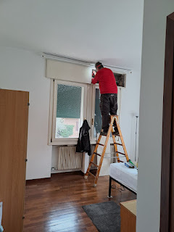

I washed all of our bedding that day, and fixed up our duvet to be more functional. When we bought the duvet and duvet cover at IKEA last spring, we quickly ran into a problem. We had chosen a lightweight duvet, but it has a little bit of a "slickery" outer fabric. This meant that it would slide all around inside the duvet cover and get bunched up on one side (usually Scott's side) and be virtually non-existent on my side. We took it out of the cover several months ago and have just lived with it as two separate layers of bedding ever since.

But when I recently bought a new duvet and duvet cover for our bedroom back in Idaho Falls, I noticed that they had some clever ties in each corner inside the cover to hold the duvet in place. Ingenius!! So this is what I set about to create for our bedding here as well.

I used an old t-shirt to create some loops in each corner of the duvet cover on the inside. And then, genius of all genius, I found some random fabric straps in my special jar of "Random Items to tie up, clamp, or otherwise shut something up". They worked perfectly!!

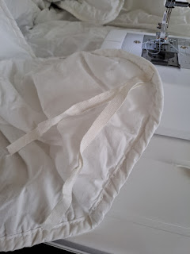

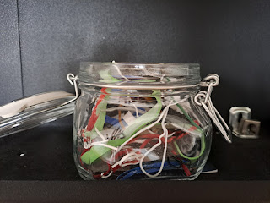

Now our bedding stays where it needs to stay and we have a good night of sleep.

We made creamy garlic and mushrooms pork chops for dinner, along with some steamed cauliflower.

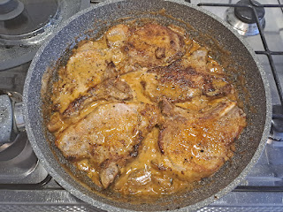

Friday:
I walked up to Monte Berico again, this time shaving off a couple minutes on my overall time. I thoroughly enjoyed seeing all the flowers, shrubs and trees beginning to bloom. I have to pinch myself all the time because I still can't believe how advanced spring is over here versus back home in Idaho . . .

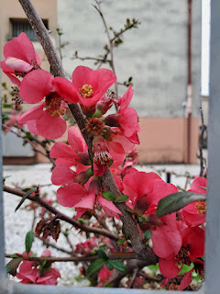

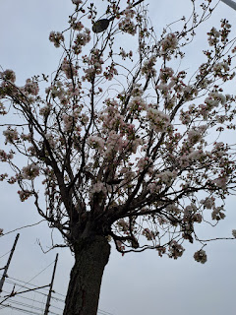

Another elderly hero in Italy, pushing his bike up the hill before hopping onto it, once he crested the hill.

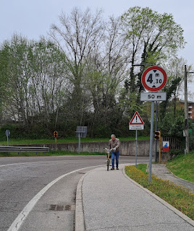

The morning was quite a bit more hazy than when I came up here two days earlier.

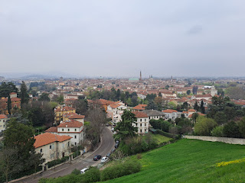

Italy is always hard at work. Everywhere you go, people are sweeping, cleaning, building, delivering, etc.

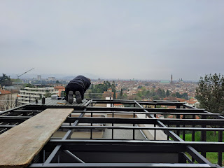

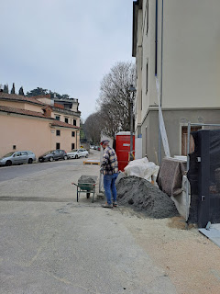

The postal workers typically use a scooter to deliver the mail. It's pretty convenient for all those tight spaces and narrow streets in Italy.

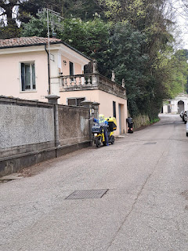

Right after he delivered this lady's mail, she came right down to grab it. She was very intently reading this letter while smoking her cigarette, which allowed me to be sneaky and snap her picture . . .

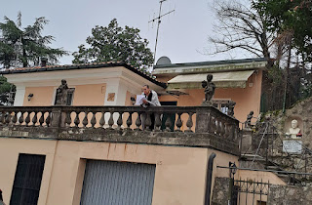

This young lady is dressed in very typical European fashion. Torn up jeans, some black leather, and a good pair of walking shoes.

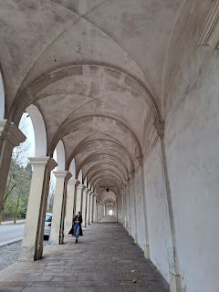

There are rare evidences of homelessness in Vicenza. I'm not sure what the policies are in Italy for aid and organizations, but I hardly see anyone that is homeless or asking for money.

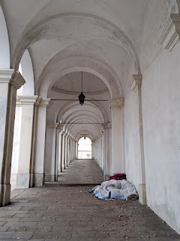

A lady walking to her car with her husband, threw some money down onto this person's blanket for when he (or she) woke up.

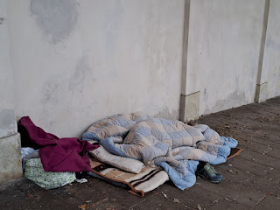

On my way back down from Monte Berico, I came up behind this woman who was getting ready to mount her bike while wearing a very long leather jacket. I was worried . . . but I didn't need to be. Her jacket was very flexible and forgiving, and she hopped on with ease and rode down the hill.

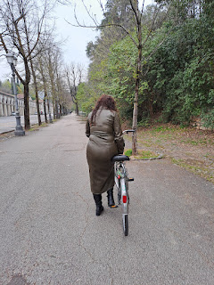

Let's talk about jackets for a minute. (Maybe I already mentioned this last week?) But everywhere you go, no matter how warm the day might be, Italians will ALWAYS be in a coat, or sometimes even in a coat + scarf + hat. Meanwhile, I'm all sweaty from my walk, so I've got my light jacket tied around my waist and I'm just cruising along in a short sleeve shirt and jogger pants . . . ha ha

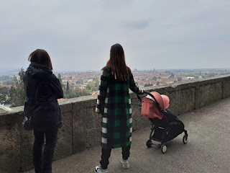

I passed several elderly folks out walking on their way to somewhere . . .

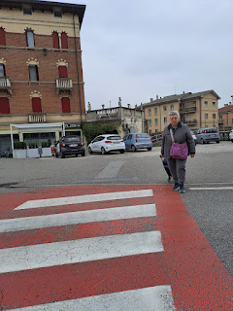

A grandma walking her grandchild . . .

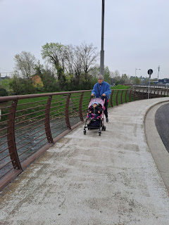

I said "Ciao" to Mr. Rooster on my way back through . . .

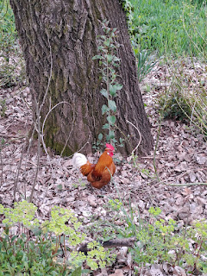

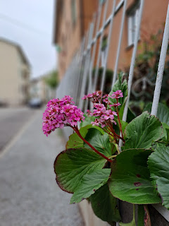

And caught up to this handsome man out for his morning stroll . . .

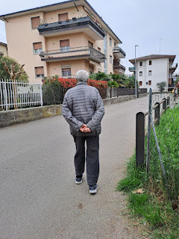

As soon as I got home, I freshened up and changed my clothes so I could meet Lasina for lunch up in Dueville at our favorite spot, NaturaSi, a cafeteria and health food store.

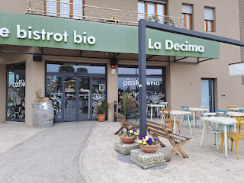

I had genuinely missed this fabulous buffet during the past few months . . .

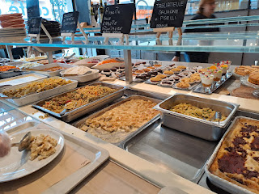

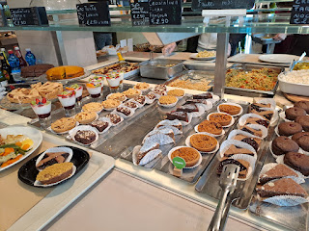

For my lunch, I got: (clockwise from the bottom) pasticcio - which is messy lasagna, gnocchi in a creamy sauce with butter and parmesan, a tiny bit of polenta - a cornmeal sort of mush, lots of assorted vegetables, fresh mozzarella, and a slice of chickpea pie - sort of like a quiche, but cold. The gnocchi definitely stole the show!! Oh my goodness they were delicious.

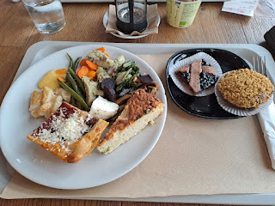

I grabbed two desserts to try, a pastry w/ jam square, and a sort-of-brownie with chopped pistachios on top. I definitely enjoyed the brownie and ended up leaving most of my jammy pastry behind.

We spent about 2 hours talking and talking about all sorts of things, as we usually do. It was really nice to hear some of the wisdom and deep thoughts that Lasina always has. After we ate, we grabbed a couple of desserts from the buffet line ("to go") and then took them over to another friend, Mita, who had a birthday that day. We visited with Mita for about 30 minutes or so before we left. Lasina dropped me back off at NaturaSi where my car was parked, and we hugged goodbye.

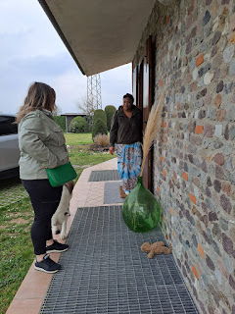

I drove myself back down to Vicenza (about 20 minutes from Dueville) and went to the mall so I could look for a couple of things in Emisfero (similar to a snazzy Super Walmart - if there was such a thing). I was on the hunt for something I could bring to Abby and Gwen since I will be at their house for Easter.

In addition to finding something cute and sweet for the girls, I saw that there were also some olive trees for sale . . . for just 17.90 euros. I wish I could bring one home to the States with me . . .

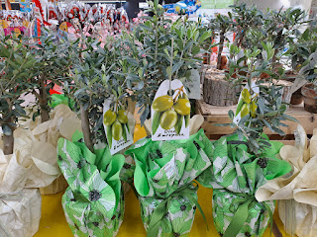

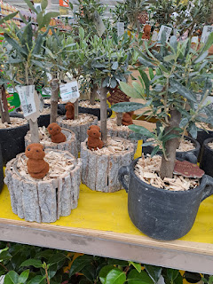

Also, albino asparagus is in season once again . . . It's quite a popular thing over here.

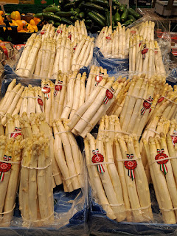

I got to see Gwennie again during a brief phone call with Amber. Gwen was home early because they had a field day at school and it finished earlier than on a normal school day. She was happily playing with a new digital camera (for kids) that had just arrived. Both Abby and Gwen will each have one for when they come to Italy this fall. How fun!

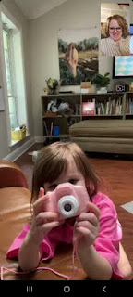

Saturday:
Scott and I ran several errands together, and I got to drive the new white car for the first time. It's pretty great! I will be very comfortable driving it when we have several rounds of company this spring. One of our first stops was at Leroy Merlin's (like a Home Depot or Lowe's). We were on the hunt for a reclining patio chair, a potted plant or two, and storage buckets to build up an emergency 72-hour kit.

We found some of the items on our list, but had to make one additional stop at the Veridia (a massive greenhouse and nursery store) because we couldn't find a good watering can with a skinny spout. It's a good thing we stopped at Veridia because Scott found his dream plant: a kumquat tree.

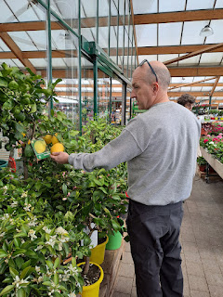

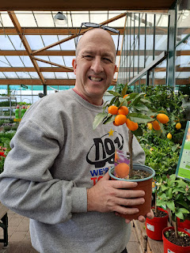

It's interesting to see the names in Italian for flowers that are familiar back in the States . . .

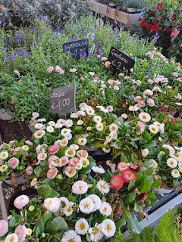

By the time we finished, we had a full trunk and a full backseat as well!

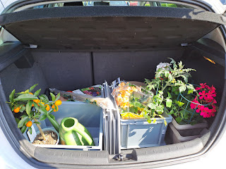

Our new baby is happily at home on our bedroom windowsill in the sunshine. His name is Kevin. Kevin the Kumquat Tree.

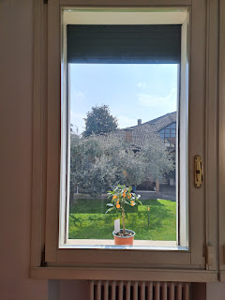

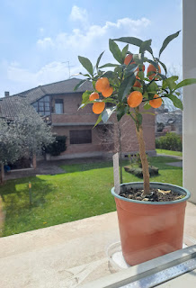

I got a cherry tomato plant and some flowering plants: mostly geraniums. Monday I will transplant them and give them a nice place to thrive up on the roof.

We went on a walk together to pick up a package that was a little distance away. There are several Amazon Hub locations where you can have a package dropped off and then you can come pick it up at your convenience. It's nice to have that as an option because if you choose to have it delivered directly to your house, and if you're not home when they happen to stop by, they will not leave it because everything is ultra-locked in Italy. If you don't open the door to the building for them to set it inside, then they'll just drive away . . . So unless I'm planning to just be home for the entire day when I know the package is due for delivery, it's nice to use the Hub dropoffs as a convenient alternative.

Lots of flowers are springing up everywhere . . . do you see what I did there? SPRING-ing . . . ha ha

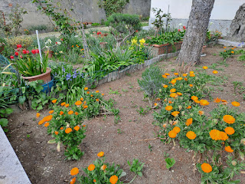

I called Abby to wish her a Happy Birthday when we got back from picking up our package. I ended up chatting with her, Amber and also Gwen for about an HOUR!! The girls wanted me to read them a story, which ended up being 3 stories, ha ha. (Which I was more than happy to do)

Abby showed me some of the gifts she had just opened, which included some jewelry from Grandma Linda and a gift card to Barnes & Noble from her daddy. She was not only excited to find a new book or two, but she raved about how B & N has the BEST chocolate, LOL.

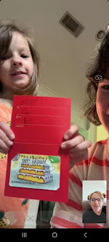



What a beautiful young lady she is becoming! I am really looking forward to seeing Abby & Gwen (and their parents) in a few days. I'll be in Louisiana for Easter, but more importantly - for Abby's baptism on Monday, the day after Easter.

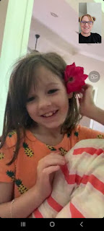

After all the stories had been read over the video chat, we had to say goodbye at 6:00 p.m. Italy time because General Conference was beginning!!! Scott and I went up to the roof to listen to the wonderful conference talks during the last hour (once we had finished eating dinner and listening to the first few talks in our kitchen).

We found these comfy reclining chairs at Emisfero for just $29 each. Leroy Merlin wanted $65 each . . .

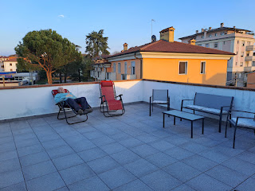

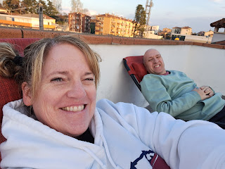

While we listened to all the thoughtful and amazing messages of conference, we watched the sunset in its entirety. How beautiful!!

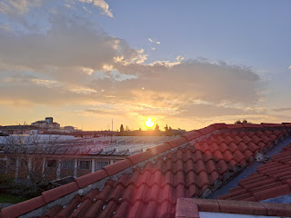

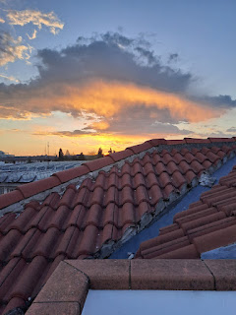

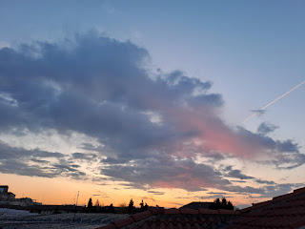

At one point, Scott went back downstairs to fetch us each a blanket to snuggle up in. It was getting chilly up there!

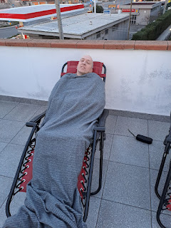

Video #1 of the sunset during conference: (17 seconds)
https://photos.app.goo.gl/dy8QFBK5yH6rbnoW7

Video #2 near the end of the sunset: (22 seconds)
https://photos.app.goo.gl/rhpoNn244UUWn95i7

My favorite nuggets from the Saturday conference so far:
(we have yet to listen to the other 2 Saturday sessions, since they took place in the wee hours of the night for us in Italy)
Focus on celebrating the real meaning of Easter and the Resurrection of our Savior in a more purposeful way
Never give up an opportunity to testify of Christ. He is everywhere.
Don't worry about being 110% prepared for every little thing. Learn to listen more to the Holy Ghost, who will help you in all things.
Be a beacon of light in sharing the Gospel. Don't hide under a camouflage.
Regarding finding personal peace: 1) The gift of peace is given AFTER we have the faith to be obedient. 2) Keeping the commandments requires more than just being obedient. We must LOVE the Lord with all our hearts.
Sunday:
Around lunchtime, we went on a one hour drive over to Jesolo, a suburb of Venice. I had seen online a few weeks ago that Jesolo would be celebrating their 2nd Annual Kite Festival on the beach there and it looked and sounded like so much fun!

We were lucky to find a place to park that wasn't too far away, and then we made our way over to the beach where all the festivities were well under way. There are several little alleyways that lead from the downtown streets to the sandy beach, as seen in the photo below. You can see the kites in between the buildings . . .

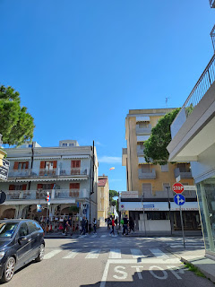

Happily for the kite fliers, the wind was quite cooperative early in the afternoon. Later, not so much.

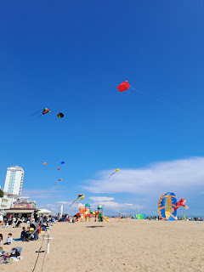

We saw the Easter Bunny and his friend flying above Lido Beach.

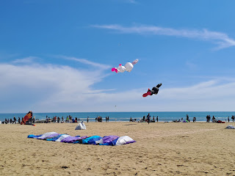

Video of all the kites when we first arrived: (25 seconds)
https://photos.app.goo.gl/Ukr1fcuGjc1xP4WT7

Video of a HUGE circular kite trying so hard to get up in the air: (13 seconds)
https://photos.app.goo.gl/NRTPLtygY5pevhv67

And a guy was preparing his kite to fly right in front of us.

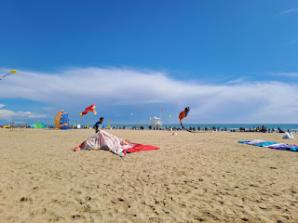

Video of his large kite as it begins to take flight: (44 seconds)
https://photos.app.goo.gl/qi7NtruMeN7tigJG9

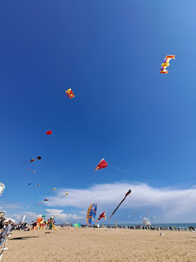

We walked down the beach a ways to see more kites and to enjoy the warm sand on our feet.

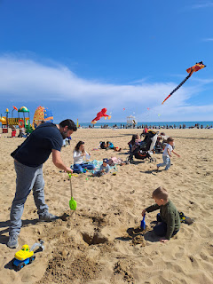

I loved seeing all the families everywhere, and especially all the dads playing with their kids.

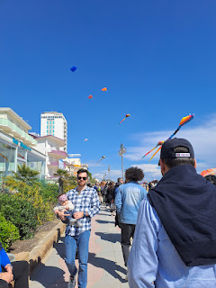

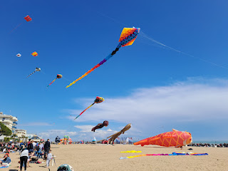

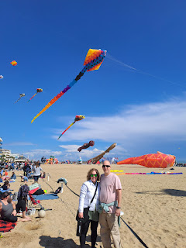

As I stood in line to use a horrible public toilet, a few feet away this handsome doggy's caring owner was giving him a drink of water from her water bottle. She poured it as slowly and as best as she could, while the dog lapped and slurped as much as he could get into his mouth. She also poured some water on his head to help him cool off a bit.

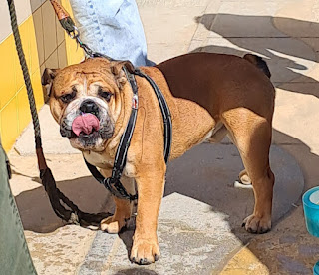

I think these giant figures were just inflatables, and not actual kites. The kids sure loved them!

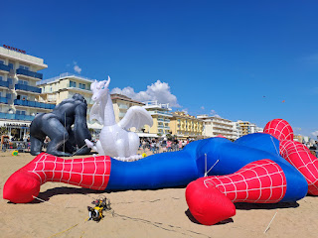

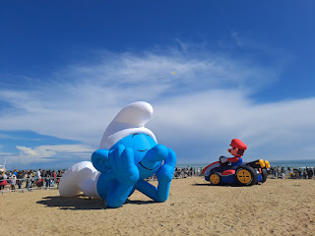

Want to play a little game of "Find Scott" again? Amber found him pretty easily this time. (Click on the photo to enlarge it.)

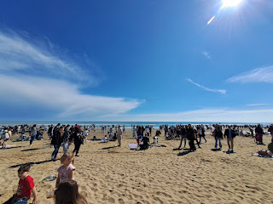

The organizers of the event set up a huge open arena on the sand where teams of people could compete in a sort of synchronized kite flying competition. We watched for a little bit. They were really good!!

Video of the team we saw: (51 seconds)
https://photos.app.goo.gl/fxy7tZjFU3K73nRaA

I put my feet in the Mediterranean Sea for the first time . . .

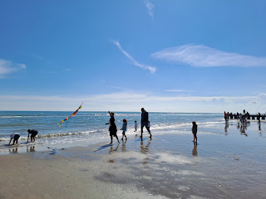

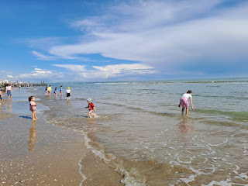

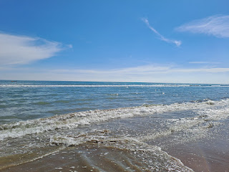

The water was colder than I expected, but I could see how it would feel refreshing on a hotter day.

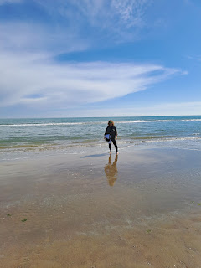

A young family was manning this beautiful rainbow arch a little further down the beach.

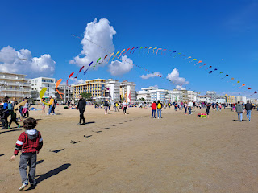

Video of the family trying to get the arch to have more "arc": (17 seconds)
https://photos.app.goo.gl/kP4UYUegUFW5KLwG7

Scott noticed that a couple of the wooden rods had fallen out of their respective kites, so he helped put them back in. What a nice guy.

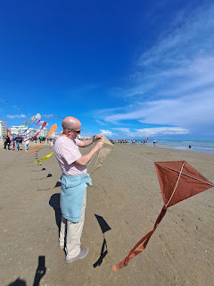

This was the final thing that I wanted to see. We had seen it from waaaaay down the beach but we couldn't tell what it was until we got much closer. How magical!!

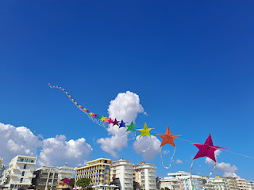

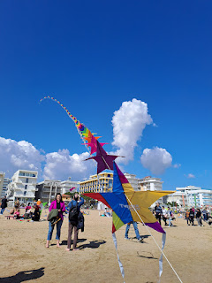

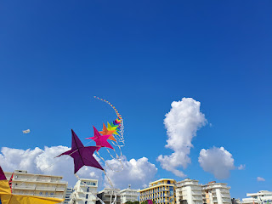

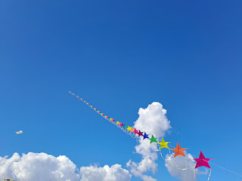

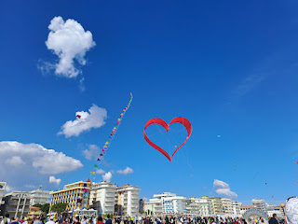

No, I didn't draw that heart on the photo . . . it's another kite!

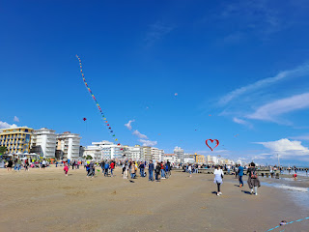

We eventually headed back down the beach and back to our car. We spent about 2 hours in Jesolo and it was perfect for a short afternoon jaunt. If it wasn't a Sunday, and if we wanted to spend more time there, we could choose to ride this GIANT ferris wheel that could be seen from miles away. Jesolo is a beachy town and is very touristy, but in a cute, vibe-y sort of way. I could definitely enjoy going back there again. Especially with grandchildren.

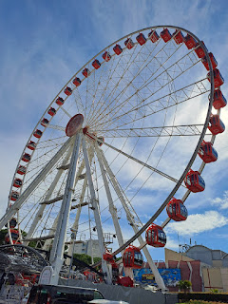

I was really digging the huge clouds in the sky on the way home, and the bright yellow fields. Canola possibly?

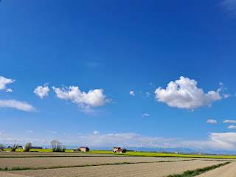

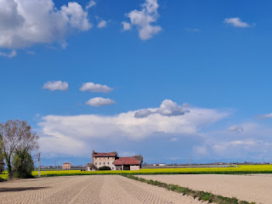

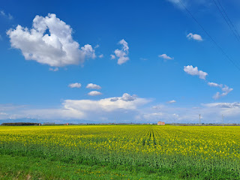

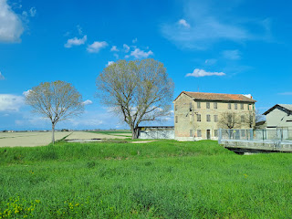

Scott and I worked together making a shrimp fried rice dinner, which took longer than usual because we have to do everything from scratch here, and with minimal kitchen tools. To have riced cauliflower (tiny rice sized bits of cauliflower, but without all the carbs of actual rice) you have to use a cheese grater to make it tiny when you don't have a food processor. Then it needs to be sauteed in a large pan. In Idaho, I can just buy a bag of frozen riced cauliflower in the frozen section of a grocery store and heat it up in the microwave . . .

Anyway, everything turned out great and we finished up just in time to hear our beloved prophet, Russell M. Nelson, speak to us. Wow, what a powerful message he gave!! I love how he encouraged us to be peacemakers in the world, to stop allowing contention to have a place in our hearts, and to be filled with charity - the pure love of Christ and the antidote to a prideful world that aims to tear each other down.

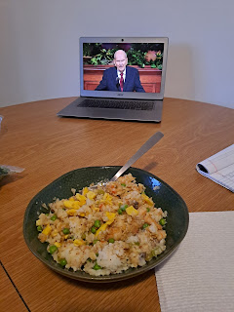

Time for Some Grandchildren . . .

Jack got to hold an onion that is just about the size of his own head. LOL

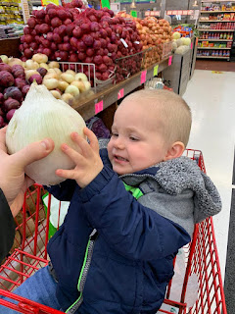

And isn't he just the cutest garbage man you've ever seen?!!

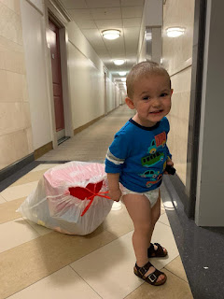

Video of Jack playing soccer with Jake and Hannah: (33 seconds) SUPER CUTE!!
https://photos.app.goo.gl/miuuLqTr1SehfiHj9

And here are a few more pictures of Abby, the Birthday Girl!







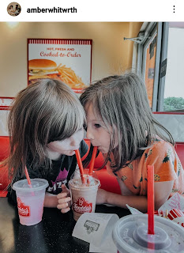

Amber shared the above photo on Saturday, along with their traditional birthday Q & A session (below).

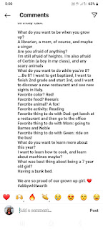
I love Abby's answers!! She is definitely growing up and maturing. I love her so much! I'm really looking forward to being with her when she gets baptized next Monday. I fly back to Louisiana on Thursday and I'll be there for one week before I fly back to Italy. Yes, it will be a whirlwind, but it will be the best kind of whirlwind!! XOXO

