The Netherlands: 100% Dutch Charm (Part 1)
Places mentioned in this blog post:
Amsterdam, Netherlands
Zaandam, Netherlands
Keukenhof Gardens, Netherlands
I got to fulfill a bucket-list dream of mine this past week! I was able to see all the bloomin' tulips at Keukenhof Gardens near Amsterdam. I spent 3.5 glorious days in the Netherlands and I cannot wait to return someday! The people are friendly and they smile easily, whether the sun is shining or the rain is pouring with a stiff wind. The architectural charm is SO CUTE, and it reminds me of Mr. Rogers' Neighborhood, ha ha.
Note the leaning buildings, as seen from a canal cruise in Amsterdam on our last night . . .

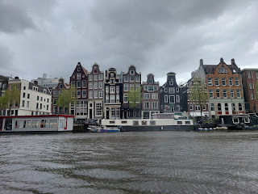

My young friend, Emily McGovern, and I rode to the Venice Airport at 3:00 in the morning last Sunday night to catch a 6:00 a.m. flight to Amsterdam. Scott was kind enough to drive us in the middle of the night, bless his heart.

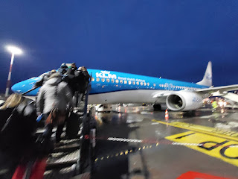

The Netherlands were fascinating from the air . . . green fields mixed with colorful rows of tulips . . .

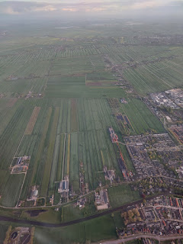

And many, many canals and waterways . . .



Video over the Netherlands and its water: (15 seconds)
https://photos.app.goo.gl/UVx1bByEd5PenYi79

Video over the farmlands of the Netherlands: (11 seconds)
https://photos.app.goo.gl/9T7qjqSDNaMfaQ8WA

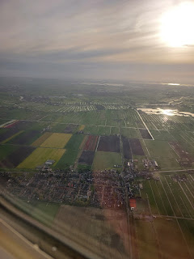

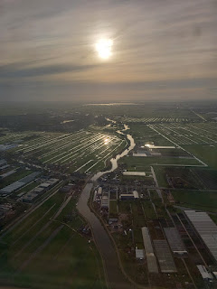

We landed around 8:00 a.m. and made our way by train to our hotel in Zaandam, just north of Amsterdam. The train ride was swift and efficient, just 17 minutes from point to point.

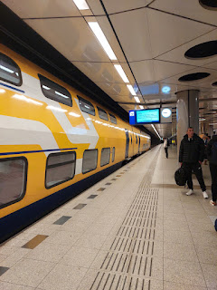

We learned a LOT about the transportation system during our short stay. There are many good options for getting around, both in and around Amsterdam. We used a kiosk at the train station to load up a plastic travel card that the vending machine offers (versus a paper card), and then we would tap the card to enter the train platform area and tap again as we exited at whatever destination. We could see what our remaining balance was each time we "tapped out" of a station. We also used the Omio app a few times to book a ticket from Zaandam to the Schiphol Airport and back (for various connections). Omio always does a great job and is very straightforward and user-friendly.

When you come up out of the Zaandam train station, this is what you see . . .

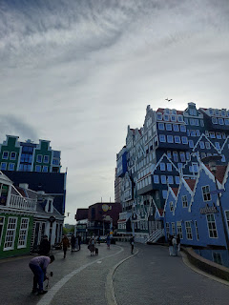

Emily and me . . .

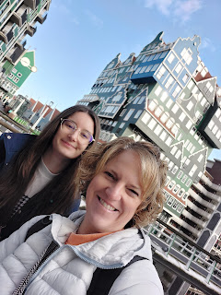

This is a famous hotel in Zaandam, called the Inntel Hotel. Everyone - and I do mean everyone - likes to stop and pose for a photo in front of it. Some tourists would spend sevvveral minutes trying to get the most "perfect" pose . . .

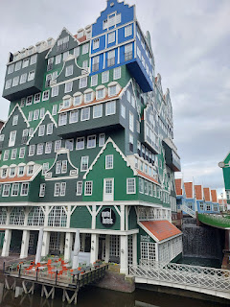

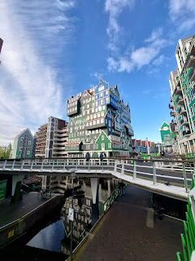

We stayed at the nearby EasyHotel, kind of diagonally across from the Inntel. It was a good price and they gave us the option for 2 twin beds. Zaandam is cheaper, as a whole, compared to Amsterdam, and it's also conveniently located to everywhere we wanted to go: 20 minutes to the Airport, 25 minutes into Amsterdam, 20 minutes up to Zaanse Schans, etc. And it was a quiet and cute place to come home to at the end of each day.

I got a kick out of the hotel rules when we checked in . . . "No hoods" and "No Laughing Gas"??!!

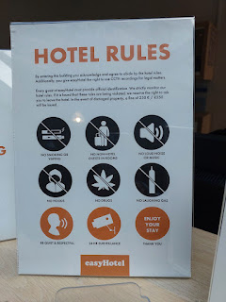

View from our room on the 10th floor, overlooking Zaandam . . .

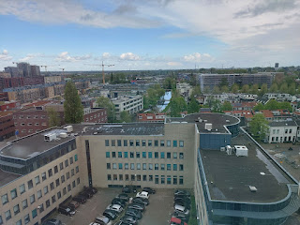

We paid an extra 20 euros to be able to check in early, which was so helpful. We dropped off our luggage and went in search of a late breakfast nearby. This place was really yummy and was only a 1 minute walk from our hotel. It's called Lagom Cafe.

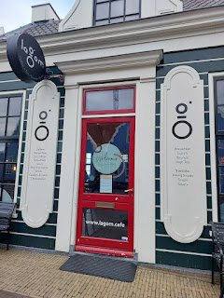

We ate here two separate times - our first day and our last day.

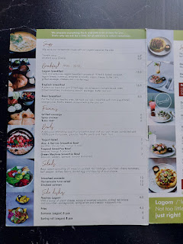

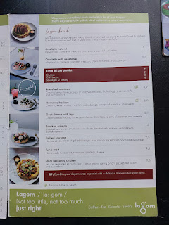

The first time we visited, I ordered the Omelette with vegetables. The omelette came on top of their specialty Viking bread, a flatbread with Swedish origins. It was really good, with one exception: mayonnaise. This was my first introduction to how much the Dutch love their locally made mayonnaise. I was brave for the first few bites. And then I decided that I don't like to eat mayonnaise for BREAKFAST, so I scraped it off (it was in between the omelet and the flatbread). I also just ate half of the flatbread, on account of the carbs.

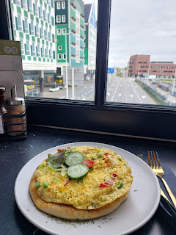

We went back to our hotel room and had a nice little nap, which helped us to reset and prepare for the back half of the day.

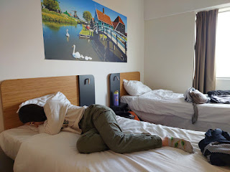

We made our way to the Jewish Museum in Amsterdam, to meet up with our tour guide at 3:00 p.m. Renauld took us on an English walking tour of the Jewish Quarter and it was very enlightening. A German artist has taken the time to make these "stumbling stones" in front of what used to be the homes of Jewish families before they were hauled away during WWII. Each stone has the name of a family member, their birthdate, the date they were arrested or taken, the date they were deported and from where, and the artist purposely used the word "murdered", along with the date and the location.

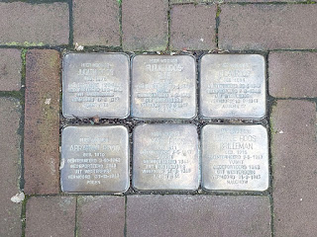

The Roos family above was memorialized as follows:

Judith Roos (b. 1876) Interned/Arrested: 12 Sep 1942. Deported: 14 Sep 1942 from Westerbork. Murdered 17 Sept 1942 at Auschwitz.

Fijtje Roos-Elte (b. 1880) Interned: 30 Apr 1943. Deported: 7 Sep 1943 from Westerbork. Murdered 10 Sep 1943 at Auschwitz.

Juda Roos (b. 1881) Interned: 30 Apr 1943. Deported: 7 Sep 1943 from Westerbork. Murdered 10 Sep 1943 at Auschwitz.

Abraham Roos (b. 1910) Interned: 3 Oct 1942. Deported: 1943 from Westerbork. Murdered 31 Dec 1943 in Poland.

Jacob Roos (b. 1911) Interned: 7 May 1943. Deported 1943 from Westerbork. Murdered 14 Feb 1944 at Auschwitz.

Duifje Roos-Brilleman (b. 1915) Interned: 7 May 1943. Deported 1943 from Westerbork. Murdered 31 Mar 1945 in Malchow.

Our guide, Renauld, explained that the stones were painstakingly made one at a time, the names and information were made by hand, and then laid into the sidewalk in front of the family's previous home. The stones were purposely left sticking up just a little bit, so that you might trip or notice them more fully, because they weren't completely flush with the brick walking path. It was poignant that the artist was German and that he really felt a need to do this to try to make things right.

To read more about his memorial project, click here:
https://www.historynet.com/stumbling-stones-how-a-german-artist-is-memorializing-holocaust-victims-one-brick-at-a-time/

We spent a few minutes in the square across from the Jewish Museum. It was an important place on 25 February 1941. There was a strike and an uprising because of how the Jews were being treated in Amsterdam. It lasted for two days, which doesn't seem like a long time, but it was significant because nowhere else did anyone rise up and "fight back" against the atrocities that were being inflicted on the Jewish population. In no other country, according to our guide, did something like this take place. And THAT is what made this strike so significant.

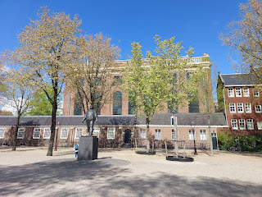

However, there were some serious repercussions because of the strike. The Germans responded with brute force, shooting at the strikers and killing several of them. Many were arrested, and the mayors were even replaced in both Amsterdam and Zaandam! (German-minded replacements were put into office, of course.)

Every year since the end of WWII, citizens and city workers gather in this same public square, around this statue of a passionate dock-worker, to commemorate the acts of bravery from that fateful day in history. It was an initial gathering of 300,000+ people who didn't like what was happening to their good friends and neighbors, who also happened to be Jewish.
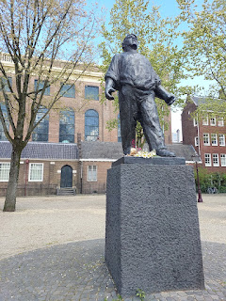

This was a really good reference article about the revolt:
https://www.nationalww2museum.org/war/articles/amsterdam-general-strike-february-1941

Next, we walked a short distance from the square to the National Holocaust Name Monument of Amsterdam. It was designed by an American architect, Daniel Libeskind, and built by locals in Amsterdam. The exhibit just opened in 2021 and has 102,000 bricks to represent each of the 102,000 Jews from Amsterdam that were rounded up and mostly killed. Each brick has the name of a person and they are all in alphabetical order.

Here is our guide, Renauld, explaining the four Jewish characters that mean, "In Memorium".

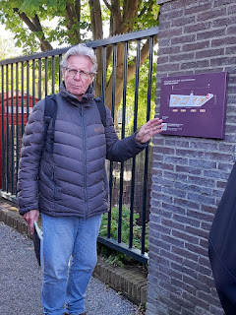

The upper portions have a mirrored exterior, to draw the eyes upward and to reflect the environment around you.

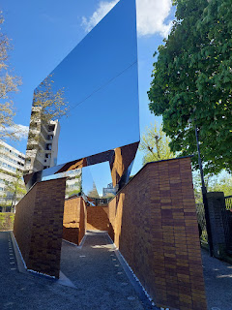

Video of the names on the bricks and the white stones: (25 seconds)
https://photos.app.goo.gl/vRmt4tiSmxWpSJnb6

Renauld helped us find Anne Frank's name (Annelies Frank). Her memorial brick lists her birthdate as 12 June 1929 and shows that she was 15 years old when she died.

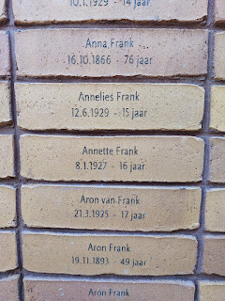

Anne Frank's older sister, Margot, was born 16 February 1926. She died at the age of 19.

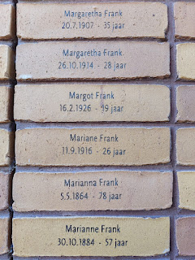

Their mother was Edith Frank-Hollander. She was born 16 January 1900 and was 44 years old when she died. When I asked about the hyphenated last names for the females, our guide verified that the women were listed with their married name first and then their maiden name second.

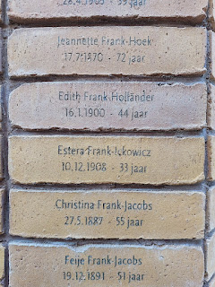

It was humbling to think of all of these people one by one. All 102,000 of them.

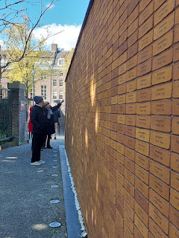

The National Holocaust Name Monument sign . . .

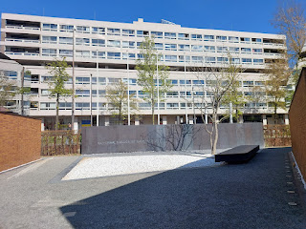

White stones have been imported from Jerusalem and placed at the base of each wall of names.

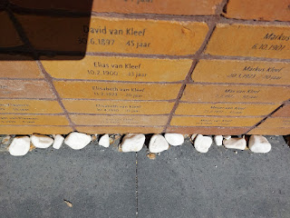

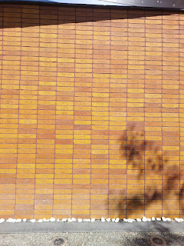

Our guide then led us on a lively walk through many older Jewish neighborhoods as we made our way toward the Anne Frank House.

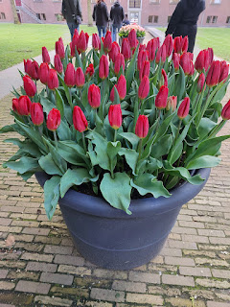

Our first sampling of Dutch tulips . . .

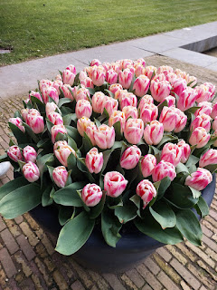

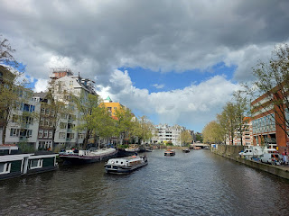

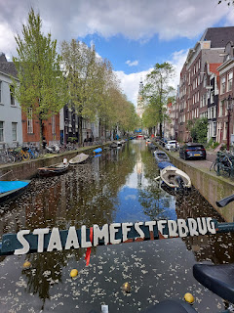

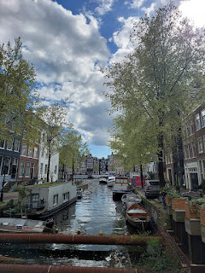

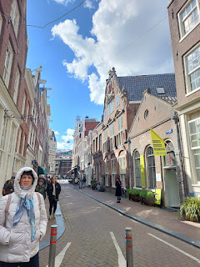

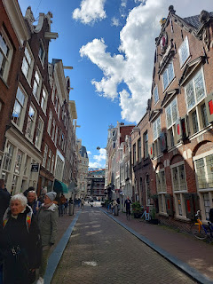

Not sure what this was, but it appeared to be some inner workings of a bridge over one of the many canals.

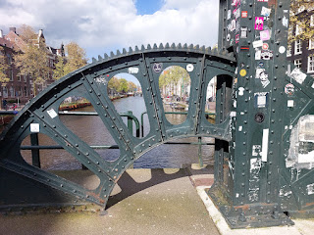

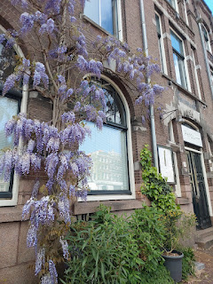



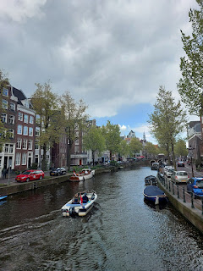

On the small central gate below: De Brakke Grond. Anno 1624.
Translation: The Brackish Ground. Year 1624.

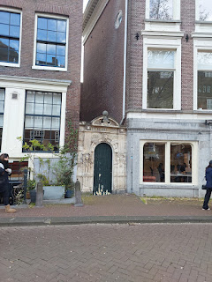

Per Wikipedia: "The name "de Brakke Grond" refers to the swampy area that was originally located at this location. The mixture of the fresh water from the Amstel River and the seawater from the IJ (?) made the groundwater here brackish. In the Middle Ages, this area was dominated by a number of monasteries."

Dam Square (below): Built in the 13th century to prevent flooding from the nearby Amstel River, which connects to the sea, it is now a consistent gathering place for locals, tourists, entertainers, and pigeons.

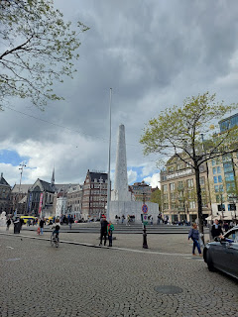

This National Monument in Dam Square, completed in 1956, was built to honor those who fought in the Resistance during WWII. Inside the monument, there are several urns with soil collected from execution grounds and war cemeteries from WWII, one from each Dutch province.

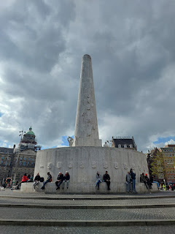

View of the National Monument from the opposite side . . .

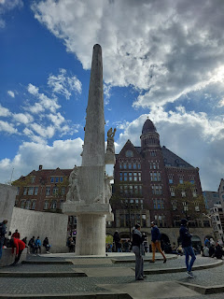

As we walked through the far end of Dam Square, we passed by the old Royal Palace that was built in the 17th century, but is no longer where the Royal Family resides. Once in a while, they will come stay for a day or two for a special occasion and to host a royal reception. I can't imagine all the work that goes into cleaning and preparing for just a 1-2 day stay . . .

Video as we passed the Royal Palace on foot: (6 seconds)
https://photos.app.goo.gl/38inwYxd7ncdweWCA

Side note:
We were told multiple times to watch out for bicycles everywhere we went. If you're going to step off the obvious sidewalk onto any other surface, you must yield to the bikes. There are approximately 1.5 MILLION bicycles in Amsterdam, which is more than the number of actual residents!! They have devoted bike lanes on the roads, including their own bicycle roundabouts!! Scooters and mopeds can share the bicycle lanes, as well. E-bikes are especially dangerous because of the speeds they are capable of. So, just be careful, be aware, and be vigilant in looking left and right everywhere you go! Sometimes there may not be an actual sidewalk that is elevated and separate. Clues to find your correct "footing" could include noting the different colors of cobblestones under your feet. For example, a tan brick pedestrian path is sometimes more narrow than the red brick bike path next to it. Stay on your path and be aware of your surroundings at all times.

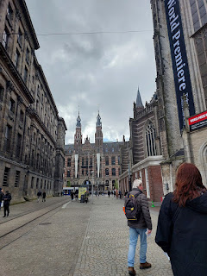

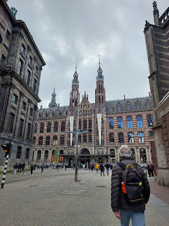

We passed by the old Main Post Office of Amsterdam (built in 1899). It is now a luxurious shopping mall on the inside.

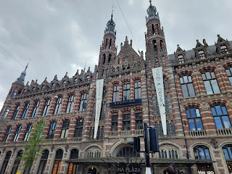

Signs pointed the way to the Anne Frank House . . .

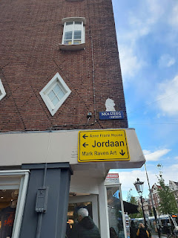

We paused for a minute for one of the guests in our group to purchase a gift box of the famed Dutch stroopwafels. The warm smells of carmelized syrup and freshly baked waffles emanated through the open door.

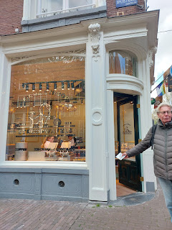

Note the lines on the ground in the photo below. Narrow sidewalks are on the right and left, while a wide bike lane dominates the center. It may not seem like it's very far to get from a shop on the one side to a shop on the other side, but you must be very careful before you just start wandering across . . .

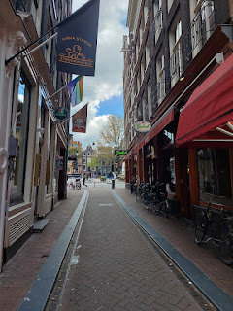

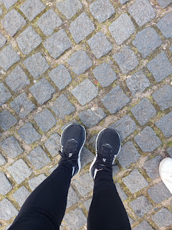

The little red "house" in the center (below) is the skinniest house in Amsterdam. Our guide told us that a man and his 2 dogs live inside.

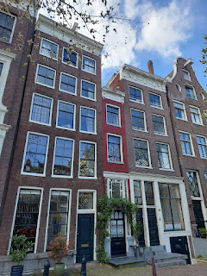

I just love the architecture throughout Amsterdam! While I don't profess to know my genres of design, it reminds me of the craftsman style, which I am consistently drawn to. Organized details, careful embellishments, and clean lines. That's what I like.

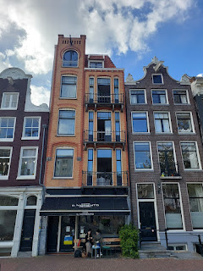

Once in a while, I would see a collection of street art, which might be in the form of spray-painted murals or layers of stickers on a doorway, ha ha.

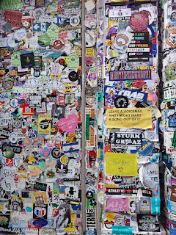

The Dutch have a strange fascination with rubber duckies. We passed by several touristy duck shops over the course of 3 days . . .

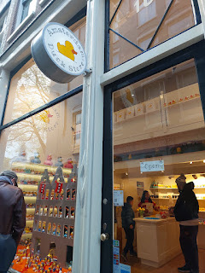

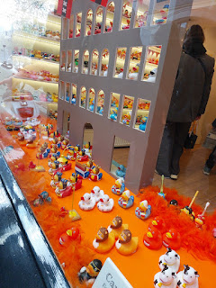

Video of a different rubber-ducky storefront window on a different day: (22 seconds)
https://photos.app.goo.gl/HK7r5716aKVUYa8E7

But oh, the beautiful canals . . .

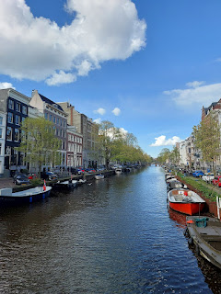

There were many styles of bikes, too, with varying ways to carry your goods (groceries, children, etc.).

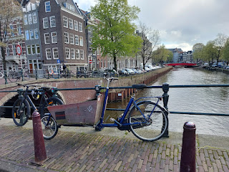

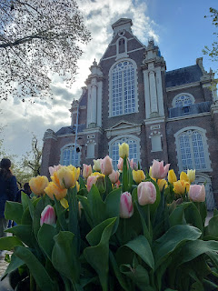

Finally, we were getting close to the Anne Frank House. There is a beautiful statue of her just around the corner, depicting hope and youth and innocence.

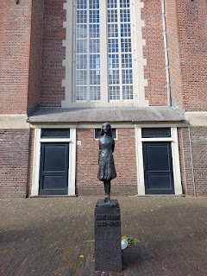

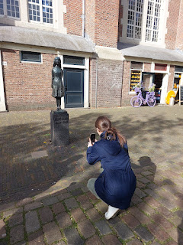

This is the side view of the building where Otto Frank had his Opekta pectin business. There was an addition upstairs which he secretly had renovated for months, as he contemplated and prepared to take his family into hiding.

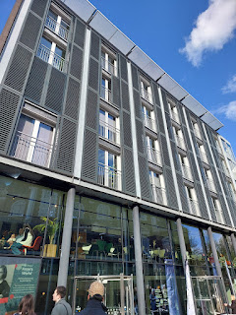

If I haven't mentioned this before, there is an EXCELLENT series on Disney+ regarding the Frank family. It's called, "A Small Light". The viewpoint is mainly through Miep, Otto Frank's secretary, and Miep's husband, Jan. It was an incredible show to further understand what was going on in Amsterdam during WWII, but the perspective of Miep and Jan was pretty eye-opening. They were young newlyweds, but they had to get really good at lying to everyone, including their own families, in order to protect everyone hiding up in the attic.

The Anne Frank House is extremely difficult to get tickets into . . . The whole reason I booked this walking tour was because we couldn't get into the Anne Frank House. In one of the reviews for the walking tour, someone mentioned how this was a great alternative, so that convinced me to book this instead. They release tickets for the A.F. House 6 weeks in advance, but many people have said that it's like trying to get tickets for a Taylor Swift concert, ha ha. Everything is sold out in just a few minutes. Our guide said that the months of November - January are better for trying to get in, so maybe I could try again sometime in the future.

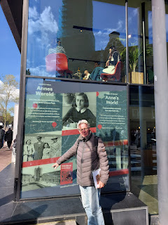

Here, Renauld is showing us a cross-section of the pectin offices downstairs and the secret annex upstairs. On the lower left, you can see the dark green exterior door in the drawing.

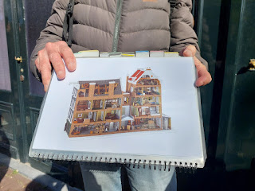

And here is that same door from the outside . . .

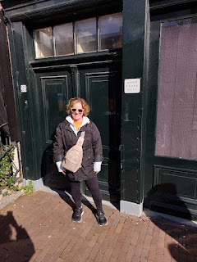

Video of the outside of the building where Otto Frank and his family hid during WWII: (11 seconds)
https://photos.app.goo.gl/WAU9GJ929UrtNj7R8

This was where our walking tour ended. Emily and I were quite hungry by this point, so we began walking to our chosen restaurant for dinner, about 12 minutes away.

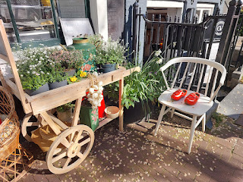

Video of some boats passing by on the canal: (9 seconds)
https://photos.app.goo.gl/uQw1NA8sGaXYTTDTA

The restaurant we chose is called Blue Amsterdam. It is located in an addition that sits on top of a shopping mall and has a 360 degree view of the city through all of its windows.

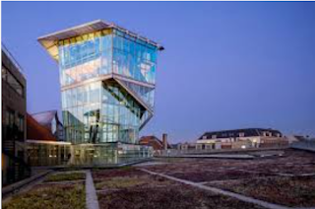

We had some nice views from our table, overlooking Amsterdam.

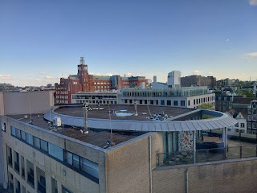

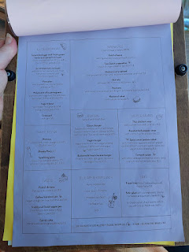

I ordered the Thai Chicken Soup, French Fries, and a slice of their famous Dutch apple pie.

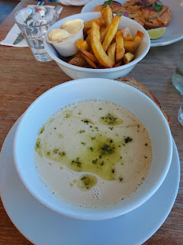



I also got a little crazy and decided to order a glass of their homemade ginger ale, with ginger, lemon juice, syrup and mint. I only drank about an inch of it - not because it tasted bad, but because I knew it had some lurking carbs. It was really good and I wished I could have had a little more.

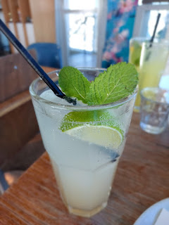

Everything was delicious. The apple pie was also delicious, but it just looked different from what I was expecting. It had chopped bits of apple, slivered almonds, and other miscellaneous items. The restaurant was close to closing, so they had already shut down their whipped cream station. I was sad, but I decided not to throw a tantrum in public, ha ha.

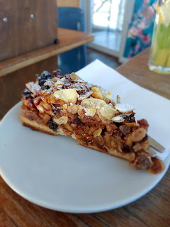

That reminds me of another interesting observation from Amsterdam: their shops tend to close EARLY in the evenings, like 6:30 p.m. The whole MALL under the Blue Amsterdam restaurant was emptied out and closed by 7 p.m. Wow. How would that even be in the U.S.? We are so used to stores being open late and then opening up early again the next morning. Most places in the U.S. are open 7 days a week, too. Maybe this is part of the problem of everyone being so overworked.

In most of the places I've visited in Europe, stores close by early evening and there is typically at least one day a week where they close as well. This allows for family time in the evenings and on the weekends, which is so important! In Italy, they also have riposo on weekday afternoons, too, allowing for quiet time or family time for a couple hours every day.

But in America, we work, work, work, and we push ourselves all the time to go, go, go and do, do, do. On this side of the world, the mentality seems to be "work just enough to provide for your family, no more, no less." With less business hours for shopping each day, those hours are really maximized well, as far as paying the employees to be there, utilities being used during those hours, etc. I wish the U.S. could figure out something that is more efficient.

On our way to the train station to put ourselves to bed for the night, we stopped inside a cute little stroopwafel store to get something to share with our families. They had several cute little tins to protect the stroopwafels for transport, which was so helpful.

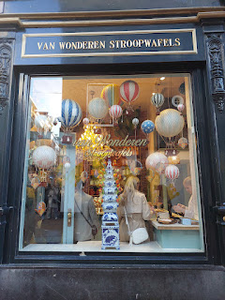

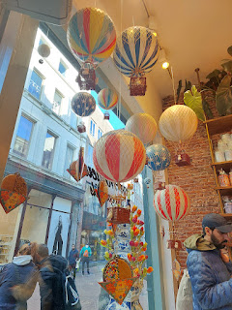

A beautiful sunset over Zaandam as we got ready for bed . . .

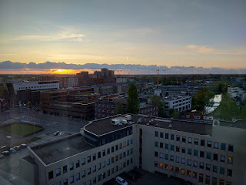

KUEKENHOF:
After a blissful night of sleep in my little twin bed, I got up early enough to see the sunrise.

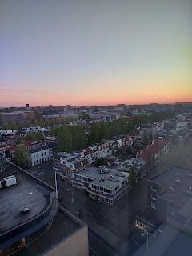

We took a train from Zaandam to the Schiphol Airport to the west of Amsterdam. There, we connected with the Keukenhof transport bus, which took us directly to the tulip gardens near Lisse. (SW of Amsterdam) We passed farmlands and tranquil morning scenes during the 30 minute bus ride.

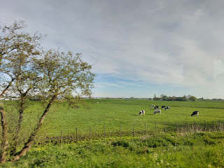

It was cost effective and efficient to do the "Combi-Ticket" through the Keukenhof website, which allowed us to choose where to meet up with the bus. The combi-ticket provided round-trip transportation as well as the entry ticket to get into the gardens. It was roughly 33 euros per person.

https://keukenhof.nl/en/plan-your-visit/

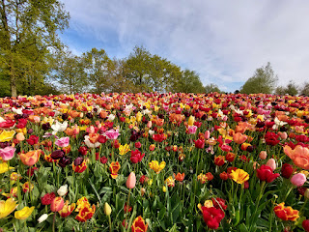

The smartest thing we did was to get there EARLY in the day. We could have booked tickets for up to an hour earlier, but I was worried we would still be tired from our first day and that middle-of-the-night drive to Venice. So, instead, we booked a 9:00 a.m. bus from the Schiphol Airport out to Keukenhof, arriving around 9:30 a.m. There were already several busloads of people, but we didn't realize how "spoiled" we were just yet . . .



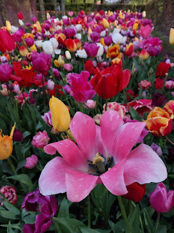

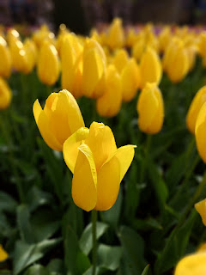

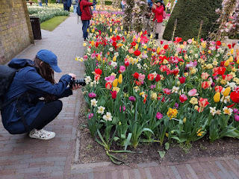

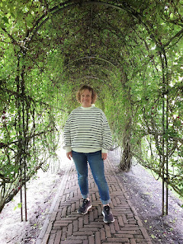

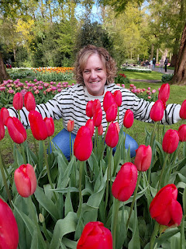

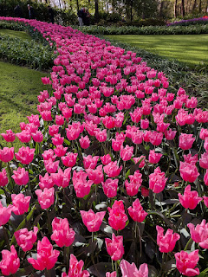

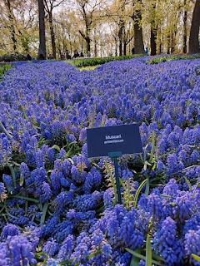

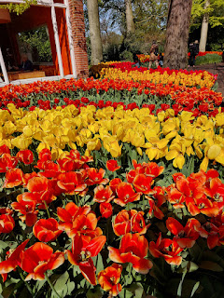

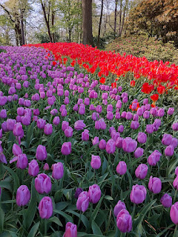

By the time we covered about 75% of the 80 acres and stopped for lunch, the crowds were RIDICULOUS. All of the morning people were still there, but now there were busloads upon busloads of people that had arrived in the hours since 9:30 a.m. It was nearly impossible to get any photos of the flowers at that point, because you could hardly move in any direction through the human swarm - people of all ages, many languages and cultures, in one giant mass. That's when we decided to call it a day.

We squeezed our way back to the entrance, where this delightful mechanism could be heard from quite a ways away. It's an old Belgian dancehall organ that's been converted and now plays whatever song you want for 10 euros. What a happy way to end the day!!

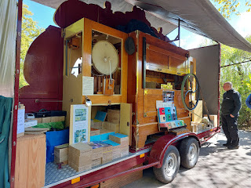

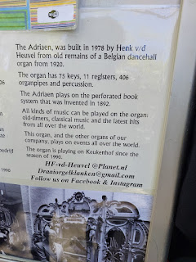

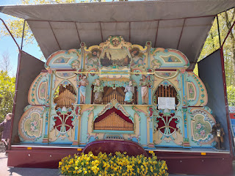

Video #1 of the Adriaen organ: (22 seconds)
https://photos.app.goo.gl/iTF3BMd9wWMFJC9R8

Video #2 of the Adriaen organ: (23 seconds)
https://photos.app.goo.gl/4rs4REPaDjJHjYGW6

Video #3 of the Adriaen organ: (29 seconds)
https://photos.app.goo.gl/3VgncRD9NJQ24tJG6

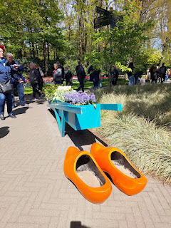

Click here to view all the photos and videos from Keukenhof:

https://photos.app.goo.gl/Lsd2MyAEn5fWV9wp7

Please don't think that because of the thick crowds later in the day that this somehow ruined my dream. It most certainly did not. It was an amazing experience and I would gladly do it all over again!! I'll just be sure to go as early in the day as possible . . .

Something that we hadn't planned to do on the same day as Keukenhof was to visit Zaanse Schans. But the weather was just
too beautiful
on that Tuesday (April 23rd), and we knew that the next 2 days would be rainy and cold. We decided to return to the Schiphol Airport as quickly as we could, and then catch a train up to Zaanse Schans immediately before the winds brought in the weather changes later that afternoon.

We were on the "right" side of the bus to see some of the tulip fields of Lisse as we drove back to the airport.

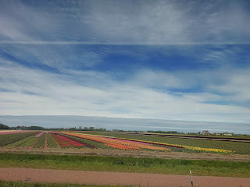

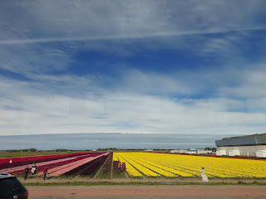

I will write about Zaanse Schans in the next blog post. I fell in love pretty hard with this darling little town, with its windmills, canals, clog shops, and SO MUCH CHARM. The whole town smelled like chocolate, too, which was HEAVENLY. I'll explain more next week . . . XOXO

