Valentine's & Mountain Home
Even though I had several appointments and other obligations throughout the week, as a whole it felt like a slower week. I've had a few more quiet moments than usual, which has been really nice. Maybe I'm appreciating the quiet spaces to think and ponder a little more now that I'm getting older, but I think it also has to do with this Personal Finances Class that I've been taking with Scott. I never would have imagined that by breaking down our finances step-by-step and discovering why we do what we do - that it would have trickled over into other areas of my life to encourage some beautiful changes. (more on that in a minute)
Vases of pink and white blooms that I made for my neighbors, Kim and Fikker (from Ethiopia) . . .

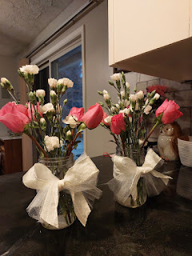

Valentine's Day was a great day! It began the day before when Scott and I wrote love letters to each other and then emailed them. Here is a portion of what Scott wrote to me:

"
As I write this, I can't help but smile, thinking of your kind and caring nature. It extends to everyone around you, family and strangers alike. It's a quality I've always admired and cherished, even more so after 31 wonderful years of marriage. We've faced separations and deployments, reminding us how precious our time together truly is. Each moment by your side feels like a gift, and now, enjoying this Italian adventure, even if it's only half the time, brings me immense joy."

And here is a portion of what I wrote to him:

"
One of my favorite things about you is how you don’t get rattled when I’m rattled. You don’t get defensive and upset when I’m feeling rotten or moody. I appreciate how you somehow recognize that I’m not upset at YOU, I’m just upset in general. You are thoughtful in how you listen to me as I offload whatever is bothering me, and you are quick to want to help me to fix it. One of your signature phrases (besides “don’t ever underestimate my power to forget things”) has been: “Water off a duck’s back.” What a great way to go through life, letting the things go that could drag us down, anger us more than they should, or make us feel “less than”. You have taught me to create my own little protective barrier and to carry on with confidence, joy, and positivity. Thank you."

We were each buoyed up by what the other person wrote and the words felt really special and uplifting.
On Valentine's Day, I had an appointment for my annual mammogram. While it's not the greatest experience, I know it's for a good reason and that it helps me to take good care of myself. "Self-love" . . .

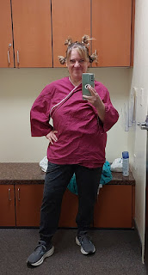

I also had a visit from the cutest little backyard bunny, who was probably really happy that the snow has mostly melted - because now he has more options for nibbling.

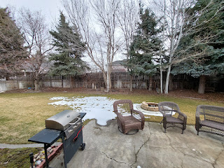

You can see him sitting on the curbing next to my apple tree. Sorry it's a little murky-looking, I had to take the photo through my need-to-be-cleaned-window, plus the screen . . .

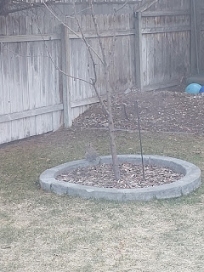

I volunteered to make a dessert to bring to the Valentine's evening dinner in Rigby, but I ended up making two desserts. The first one is always a crowd favorite: Sugar-Free Layered Dessert, with both vanilla and butterscotch puddings, cream cheese, and a thin shortbread-like crust on the bottom.

Here is the recipe:
https://photos.app.goo.gl/Ero96uE6h4Vx1bGN8

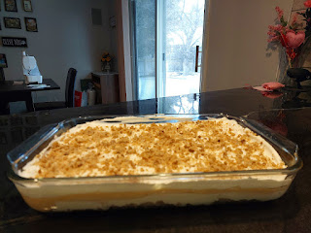

The second dessert I made was Chocolate Truffles. It was the first time I made this recipe and I thought the process was pretty easy. Here is the link:
https://sallysbakingaddiction.com/homemade-chocolate-truffles/

I chopped up the chocolate, poured the heated heavy cream over the top, and let it sit for a few minutes. Then I stirred it until everything was melted and poured it into an 8x8 pan to let it cool in the fridge for a couple hours. I used a cookie scoop to make some sorta-kinda balls and then I let them sit in the fridge for a little bit. This allowed them to dry out a little bit per the recipe's instructions, otherwise they would have been too sticky to work with.

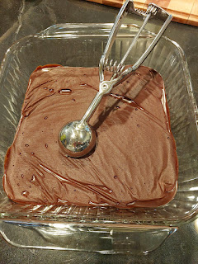

Finally, I was able to take each scoop and roll it in my hands to make little truffle balls, and then roll each one into whatever coating that I wanted: sprinkles, chopped walnuts, coconut, etc. The only thing I would do differently the next time is to find a few more brightly colored sprinkles so the color stands out a little more. The coconut ones were fantastic, and the gold-flecked sprinkles worked really well. But the red, pink, and lavender ones were a bit bland in the "dazzle" category.

Still, overall, they turned out to be quite impressive. Everyone thought that I spent a lot of effort on these, when in fact, I only spent maybe 30 minutes total (not including refrigeration time).

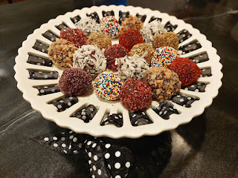

Vernetta has had a longstanding tradition of making Pink Mashed Potatoes for her family each year on Valentine's. She makes the mashed potatoes and then uses some cake decorating tools and tips to create the delicately dolloped heart shapes. She uses a spatula to lift them off the cookie sheets after they have baked in the oven briefly to firm them up.

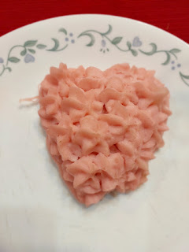

Clockwise from me down at the bottom: Pam & Jacob Cline - the newlyweds (as of Feb 16th), Vernetta (in red), Phil Harmon, Joshua Cline, and Eddie & Marie Cline. Eddie and Scott grew up close in age, and they are good buddies. I really love Eddie & Marie a lot, they are just wonderful people. They are funny, they are kind, and they are amazing parents.

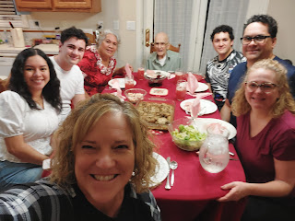

After dinner was over, Dad (Phil) went off to putter around for a little bit. He came back into the kitchen at one point, and was just kind of leaning onto the kitchen island, holding his head in his hands. Vernetta noticed him first and asked if he was okay. He said, "I think I'm about to pass out . . ." We quickly jumped up to assist him: Vernetta holding him up and me coaching him to do some deep breathing - "in through your nose (try to count to 4), and then out through your mouth (try to count to 4)". Eddie and his son, Jacob, helped him across the room to the couch where he could lay down. He then asked Eddie to give him a priesthood blessing, which he did, along with his son, Jacob. Immediately, the pale white coloring of Phil's skin began to "pink up" and he declared that he felt much better.

He began sharing story after story with all of us: stories of his service during the Korean War, and stories of his early adulthood and his wife, Coy. He laughed and joked and it was all just pretty amazing. We were so glad that he was feeling better. His heart just struggles sometimes and his blood pressure dips dramatically. He kept thanking Eddie and Jacob over and over for giving him a blessing. :)

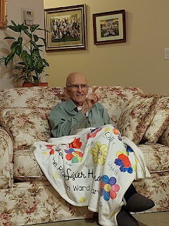

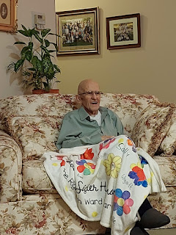

Vernetta recorded many of his stories while the rest of us just sat back and listened.

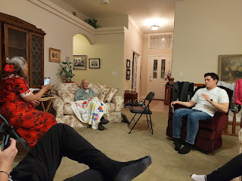

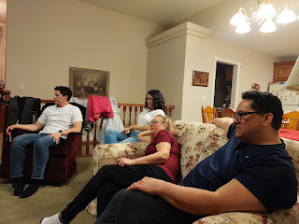

Sometimes Phil retreats into his elderly and frail age, but when he emerges and perks up like he did on the evening of Valentine's, it is always a joy to be a part of it all.

One of the changes I have begun to implement has to do with my habit of spending money on my grandchildren. Now, it's not a crime to spend money on your grandchildren, and I will continue to do so until my life is finished on this earth. But the Personal Finances class that I've been immersed in, along with my husband, has brought something to light recently.

As we reviewed the past week of purchases together, I realized how much I had been spending on the giving of gifts since the previous week: offering to pay for some activities in San Diego, giving that man a gift card at the grocery store (see my last blog post), selecting a few more misc. items at Smith & Edwards on my way home from SLC to stuff into the Valentine's boxes for my grandchildren, etc.

I noticed that I usually feel pretty strongly about doing these things for other people, and I began to question WHY I felt so strongly about these gifts.

I think it's because I live far away from family and friends and therefore I want to connect to them somehow. I buy gifts, or make/sew/bake gifts, to then send off so that the recipient(s) will know how much I love them. I associate the giving of gifts with my love for them. If these people lived closer, I would probably just spend a lot more quality time with them, instead of buying them things. But since most everyone lives far away, I want to send them my love in a "package".

But then my introspection turned to an even deeper level. I began to question whether the stuff I send to my grandchildren actually connects them to ME or not. While I purchase the items to somehow represent my love for them, do they actually think of me when they eat it/play with it/build it/etc.??? Does it even create a deeper bond between them and me if it's just "stuff"?? After all, it could get broken, or lost, and they will likely grow out of it eventually, too.

That's when I began to explore the idea of "what if there is something better than sending them *stuff* to help them connect to me". The idea came to me that perhaps I could write them a note or a letter regularly (like 2x/month), with a story and/or an inspirational and spiritual thought. Each note would be age appropriate (for a 2, 3, 6, or 9 year old currently). I had the distinct impression that the things that I say to each of my grandchildren could be beneficial to them, especially as life will get messier, darker, and more difficult as we get closer to Jesus' Second Coming. If I have something to say to them that could be uplifting and encouraging, then those things have a greater potential to help them connect to me. They will feel my love for them through my words, stories, and pictures.

What an amazing train of thought, and to have it all come about because of a personal finances class!! That is the power of an inspired class, where the Spirit of God is invited into each meeting through prayer and study together. I have already sent off the first notes to my grandchildren, with the exception of Avery. I don't have an address for them in Italy, and they were supposed to be back in the U.S. last November but we're still waiting for them to come home. Hopefully, Avery and Kylie will be back in Idaho soon and then I can re-establish a regular communication with sweet little Avery again.

A recent photo of Kylie and Avery - using a butterfly filter on Kylie's i-Phone . . .

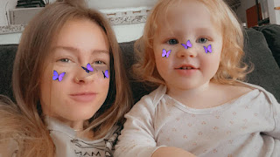

Thursday was a busy day. I met with Scott in the morning for our weekly Personal Finances class, since I would be driving to Mountain Home the following day during our usual meeting time. We spent about 2 hours reading, discussing, and then starting to build an official budget together as part of Chapter 4.

After lunch, I drove to my friend Trudy's house to help her with some family history. She "inherited" stacks of old family group sheets from her older relatives and was feeling really bogged down as to what she should do with them. She didn't want to throw them all away, but she didn't know how to work through the massive piles either. We discussed a few options and tried a few techniques for her to choose from, as far as double checking some of the information to make sure it was already on FamilySearch.org before throwing things away.

We did a lot of visiting, too, as evidenced by my being there for about 3.5 hours! I used to be Trudy's secretary several years ago, back when she was serving as the Relief Society President. I loved going on visits with her and I learned a great deal from her. She always had a knack for getting to know people and asking them a lot of questions without making them feel awkward or that we were prying too much. She truly has a genuine interest in people and wants to know their story and understand them better. She instilled a greater confidence in me to just
ask the questions
when I'm with someone new. If they don't want to answer, then they won't. But, when asked with love and genuine interest, and conveying a sense of trust and kindness as we're on the Savior's errand, generally the response is very positive.

I had just enough time to run a quick errand before meeting my friend, Lasina Jensen, for dinner at Dixie's Diner. This restaurant has consistently been one of the top restaurants in Idaho Falls for many years, and it did not disappoint us either. We ordered two kinds of burgers and then we split them in half to share, since they both sounded really good. The one was a Gyro Burger with kebab meat, feta cheese, and tzatziki sauce. The other had bacon, cole slaw and Swiss cheese. The Gyro was definitely our favorite.

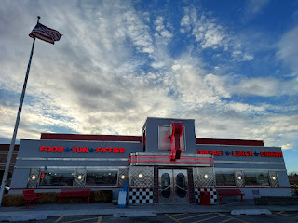

I hadn't seen Lasina since December, when she helped me get home from my hair appointment so I didn't have to walk home. I was waiting for Benson to arrive a couple days later with my car, and I had already walked to the appointment without asking anyone for help. She happened to text me and then she found out where I was and that I didn't have a car to get home. Lasina and I used to get together more often when we were both in Italy, and I'm not sure exactly why that is. I do know that life has been very busy for her as she adjusts to a new country, a new town, working full-time, and everything else that competes for our time. I've been very busy, too. But it was nice to connect again over dinner.

I squeezed in some cleaning and packing throughout the day, so that I could be more prepared for my trip the next morning. On Friday (Feb. 16th), I checked the weather and the road reports to make sure there wouldn't be any surprises or big concerns as I drove across the state to see Benson. The weather looked fine and the road reports all said "dry, moist, or wet pavement" in the different sections of interstate that I would be on. I was grateful that everything looked pretty good.

But when I got on the road mid-morning, it was a completely different story. About 30 minutes south of Idaho Falls, it was clear that something was amiss. Between Blackfoot and then clear out to American Falls and beyond, it was pretty dicey. There were stretches of road with deep slush on it, which bogged down the tires and made the car fishtail around at times. In that same 45 minute stretch, I counted FOUR vehicles that had slid off the road, with two of them in bad condition. I passed a semi-trailer that had jacknifed off the side of the road into the snowfilled ditchbank near the exit for the Pocatello Airport. I passed a car going the opposite direction - or TRYING to, anyway. He had spun around and then got stuck with his back tires spinning in the deepish snow next to the two lanes of traffic. What made it especially worrisome, is that it appeared that the nose of his car was sticking out slightly into one of the lanes of traffic . . . YIKES. Maybe he was off the road enough that he wouldn't get hit, but I couldn't tell from the other side of the freeway as I drove along.

One time, I wanted to pass a big semi-truck that I had been following for some time in the slow lane. The amount of precipitation that he was flinging out at me was ridiculous, and I decided to pass him because the passing lane looked good at that point to do so. But half-way into the maneuver, all of a sudden there was deep slush in my lane and I was swerving a bit and trying to maintain control of my car. It made me have to slow down, which also made me match the same speed as the truck I was trying to pass. I didn't want to slink back and be stuck behind him again with my wipers on high and trying to see through the unintended hurricane that his truck produced. I wanted to get in front of him! But I had to decide if that was too reckless or not. I made the decision to just go for it, and I slowly increased my speed while making sure that I still had control over my car. Soon enough, I finally was able to get just far enough in front of him that I could get out of that slushy lane and back into the right lane. With most cars sticking to the right lane, this was the preferred driving lane for a long time. The right lane just had a really wet surface, while the left lane was loaded with thick slush because nobody was brave enough to navigate through it.

I passed another car off the road, but this time I couldn't get a good look at it because there were so many emergency vehicles surrounding it.

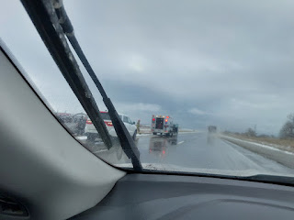

And right after that one, there was a fourth car in the median, all beat up, with a police car nearby sitting there with its lights flashing. I didn't know if it was a fresh accident or not, but clearly the car was in bad shape. I made sure to exercise caution, though, and I eventually made it to drier roads and better weather. By the time I stopped to use the bathroom in Burley, the roads were completely dry and it was just really windy, but there were no more storms or snow or crazy shenanigans.

When I got to Mountain Home and Benson's house, there were beautiful blue skies and warmer temperatures. It was about 10-12 degrees warmer than it was in Eastern Idaho!

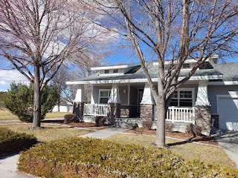

I was grateful to have made it through those scary and yucky areas and that I didn't end up as one of those several cars that spun off the road . . .

Benson was in full swing cleaning his house. He had just received the new vacuum I sent him through Amazon, and he was happily vacuuming and sweeping and mopping when I arrived. I jumped in to help him, not only because I enjoy cleaning things, but also because it felt so good to be out of the car after almost 4 hours, ha ha.

We got him loaded up on groceries from the nearby Commissary and then he cooked me a nice Chicken Masala with rice and veggies dinner. We went for a really long walk, too, for about an hour. The stiff wind was a little chilly, but we just walked and talked and talked and walked all around the base. It was really lovely.

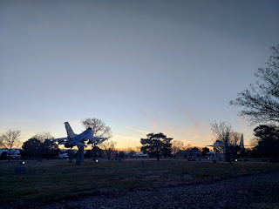

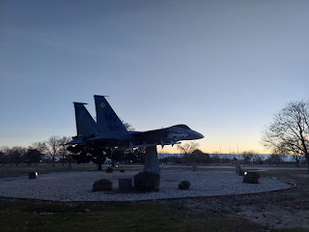

On Saturday, we drove over to Boise (about an hour west). Both on Friday and Saturday, there were a MULTITUDE of dead, dried-up sagebrush rolling across the roadways. Better known as tumbleweeds, they were hilarious to watch as they rolled pell-mell across the road to then get obliterated by an oncoming car. I tried to catch one of the bigger ones on video, but it was harder than I anticipated since most of them just jumped out all of a sudden. But I did get one mediocre video of a bigger one a little ways ahead of us.

Tumbleweed video: (3 seconds)
https://photos.app.goo.gl/LNmg4afC2744geQLA

Benson got a haircut in Boise and then we did some shopping where there more options than what Mountain Home offers. He needed some items for the house: mixing bowls, a laundry hamper, some barstools, etc. I needed new windshield wiper blades, ha ha. We found everything we needed except for the barstools, which he is just going to order from Amazon.

We also met up with Mike and Carol (Scott's older sister) for a meal in the mid-afternoon. They offered to treat us at Black Bear Diner, always a favorite. The meal portions are always huge, which allows you to take home the leftovers for another 1-2 meals, ha ha.

L to R: Mike & Carol Whitten, Me, and Benson

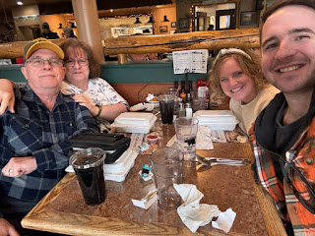

Next, we stopped at Costco to get a couple more items before driving back to Mountain Home. Originally, we were going to go to the theater to watch, "The Boys in the Boat", but Mike mentioned that you can rent it on Amazon Prime for $20. Normally, I'd prefer the big screen with some popcorn and a Diet Coke, but after a big meal and lots of errands, it was more appealing to watch it from home and skip the snacks . . . It was my second time seeing the movie and I loved it just as much the second time. Benson loved it, too. We even researched a bit more about the boys in the movie, to see what happened to them afterwards. None of them ended up going off to war, thankfully. One possibility online mentioned that they were slightly older than the draft age, so maybe that turned out to be in their favor. They all went on to live full and long lives.

I forgot to mention my blustery morning walk. The blue skies were somewhat deceiving because that wind outside was FRIGID!! I chatted with Scott through my earbuds during the 30 minute walk, and hallelujah for quality technology because he didn't hear the overwhelming sounds of the wind whipping along, but he could somehow hear the robins cheerfully chirping in the nearby trees!

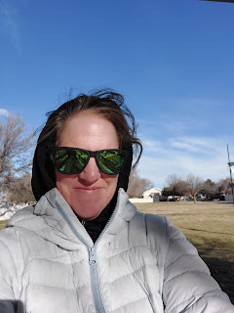



Amber sent me a couple photos this week of the girls. One of them was when they went to the library recently. The girls are loving their at-home schooling endeavors and they are excelling rapidly. Abby has even been taking a typing course, which she has begun to use as a platform to write some stories as she practices on the keyboard.

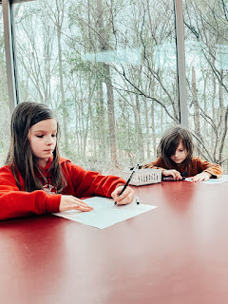

Abby came down with some sort of bug during the week, though, and had a pretty bad earache one night at bedtime. Weston, with his doctor skills and supplies, checked her ears to see if there were any signs of infection. Thankfully, they looked okay, and the pain was attributed to her swollen throat and other symptoms. I looked in my book of essential oils to make a suggestion, which ended up being tea tree oil and lavender. You can put a couple drops onto a cotton ball and then tuck it into the outer ear area. I tried this myself a couple years ago and it really did help. The pain went from almost unbearable down to zero overnight. Abby had the same results, too, thank goodness.

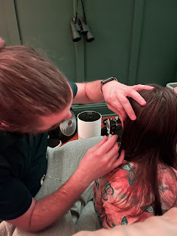

Jack has a new fish tank at his house now.

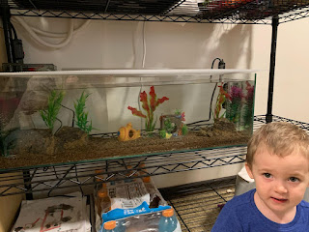

Jacob wrote us in our Whatsapp family chat: "At 11 a.m. earlier today, Jack and I were outside in the cloudless, windless, 40 degree spring sunshine. And then . . ."

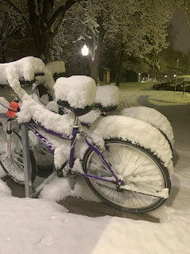

The next day Jacob shared this cute photo of Jack with the caption: "When you snitch off Mom's plate, not knowing it was spicy . . ." (his eyes are all watery and a bit concerned, ha ha)

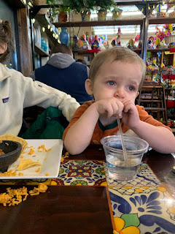

Saturday, Jake and Hannah took Jack to a MONSTER TRUCK JAM in Minneapolis!! Jack has been a big, big fan of monster trucks lately. He always hauls his "Gravedigger" monster truck everywhere they go. Jake was pleasantly surprised to find out that a show was coming to town, so he bought tickets for the whole family to go.

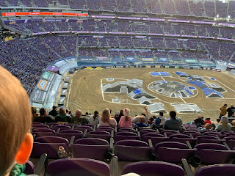

Video of Jack getting ready to watch the action, holding his cucumber and "Gravedigger": (7 seconds)

https://photos.app.goo.gl/DnzqGzDPZVGW4eR99

Video of Jack's beloved Gravedigger, one of the monster trucks, putting on a show: (39 seconds)
https://photos.app.goo.gl/GgU6vWGd1PFrzYfW9

