What?!! Moving to Italy???
I have 2 very exciting announcements!
We are moving to Italy! (By we, I mean mostly Scott)
We both have finally succumbed to Covid-19
I will explain . . .
Scott has been very interested for some time now in finding one more deployment before he completes his lengthy military service and retires for good. There are multiple benefits in doing this, ones that he is very much privy to. He wanted a Tour of Duty that wouldn't be in a dangerous area, and one that would allow me to come and visit him. Well, Voila!
At his army drill weekend in December, he was talking to a buddy of his who had applied for and been accepted to do a tour of duty in Italy. Scott came home very excited and wanted to apply to be the 2nd targeting officer for that same duty station in Italy (they needed 2). First, though, he wanted to wait for his buddy to get over there and tell him all the details. The buddy was scheduled to report in Italy at the end of January.
Well, plans changed very quickly this past week. Monday, Scott received an email from his buddy stating that he would be declining the position due to work and personal reasons, and that he had also recommended Scott to take his place! The buddy had just received an important promotion in his civilian job, and he didn't want to be away from his little children so much, since he had just recently returned from a deployment to Syria (where his family could not - obviously - visit him). He had originally gotten excited about it because it's just such an awesome opportunity. But then reality sunk in, and he ended up changing his mind.
Scott sent a follow-up email to Italy that same day, stating his interest in taking over the position. By the next day, Tuesday, he heard back from Italy, asking him to submit some documents and forms for them to review. We didn't hear anything for a couple of days, but on Friday morning, they had offered him the job!

In a helpful bullet-point manner, here are some of the details that we have learned:
The job is located in Vicenza, Italy (photo above), located about 45 minutes west of Venice
The job is for 2 years - with the option of extending for another 2 years. (In a late-night conversation with the Sgt. Major in Vicenza, he said that he is finishing up 4 years in Italy and is hoping to extend another year. He added that it's so wonderful that no one wants to ever leave. EVER.)
Scott will have his own house to live in. We are currently shopping for a home on a website they provided for us, with military-approved housing. This means that I can come and stay with him for long periods of time.
He will make crazy good money the whole time he's there.
For every year that he's over there on active duty, he gets to retire that many years earlier. Currently he can retire at 58, due to previous deployments since this rule was put into place. If he only serves for 2 years in Italy, he can retire at 56. He will be 53 this year, so that's not too far away!
He will earn points toward a heftier retirement allotment with each period of active duty service.
He will not be penalized for stepping out of teaching for whatever length of time. It's the law. "It's as if they never left". In other words, it will be like he's in the classroom teaching, without actually being in the classroom teaching. He will rack up any promotions, sick days, raises, etc. "It's as if they never left". This means he will be able to finish up his teaching career sooner as well.
He has 60 days to arrive in Italy from the time they offered him the job. If he's ready sooner, then great. If he needs more time, that's fine too. He is aiming to report on March 1st. This will give the high school some time to find a long term math teacher to replace him.
We plan to keep our house, and I will just go back and forth to stay with him part of the time, and be home in our house for part of the time.
Legally, I can stay up to 90 days in a 6-month period. So most likely, I will go over to Italy for 3 months, then come home for 3 months, and then repeat.
He will be able to accumulate one month of "leave" per year of active duty. This will allow him to come home for a visit maybe once a year, and also give us some time to do a little traveling together.
We hope that friends and family can come over to visit us as well!
He has spoken to more than one person in Vicenza and they have all verified how wonderful this job is over there, that it's like a dream, only it's a reality!!
We will also be about 90 minutes (south) from our son Benson and his little family in Aviano. We hope to be able to visit them and see our beautiful new granddaughter from time to time.
I found this interesting article about the military base just outside Vicenza, where he'll be working.
https://www.liveabout.com/u-s-army-garrison-usag-vicenza-caserma-ederle-italy-3344641
And here is a lovely article suggesting a few things to do in Vicenza.
https://twomonkeystravelgroup.com/7-awesome-things-vicenza-italy/
So how do we feel about this whole thing?? Wonderful! Fantastic! Happy! Joyful! Grateful! Excited!
In the Book of Mormon, there is a scripture that says, "There must needs be opposition in all things". Where there is evil, there must also be good. And where there is joy, there must also be the inevitable sadness or pain. If not, then we might become complacent and ungrateful for all of the blessings we enjoy, and forget to recognize where those blessings truly come from.
Along that same line is a poignant section of this past week's Come Follow Me lesson (centered on the Old Testament this year). Here is the quote:
"One thing the Creation story teaches us is that God can make something magnificent out of something unorganized. That’s helpful to remember when life seems chaotic. Heavenly Father and Jesus Christ are Creators, and Their creative work with us is not finished. They can make light shine in dark moments in our lives. They can form solid ground in the midst of life’s stormy seas. They can command the elements, and if we obey Their word like the elements did, They can transform us into the beautiful creations we were meant to be."

Along with all the joy and excitement and eagerness of this opportunity, and amid the ensuing "chaos" and commotion and planning, Coronavirus has decided to pay us an uninvited and unexpected visit. While I certainly don't feel very beautiful at the moment, I still trust that my loving Heavenly Parents are molding me into something better.
On Monday evening, Assan drove down from Rexburg to bring his daughter, Azure, to stay the night with us. His wife, Marissa, (our niece) was due to have her gall bladder removed early the next morning. I had heard through the grapevine that their family had been sick in the days leading up to the surgery, and that they had referred to it as a "bad cold".
Azure slept in until almost 11:00 the next morning (Tuesday). Assan told me that she usually wakes up around 8:30 a.m., so that was a bit surprising. I fed her brunch, and then we played for about 2 hours before she got sleepy again, and faded into dreamland in my arms. I laid her down on the living room couch, where she slept again for another hour.
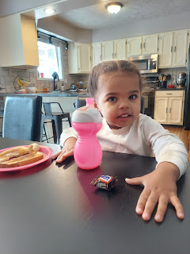

While she slept, I used my new sewing machine and sewed on a little loop to several hand towels for the bathrooms. They are ready to be hung on the bathroom hooks now. :)

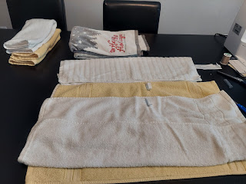

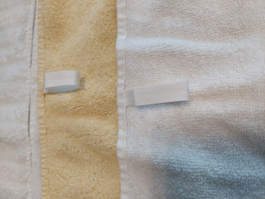

We built a playground with Legos and had some fun before she got sleepy again.

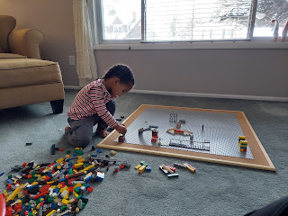

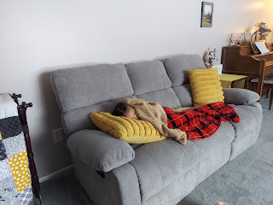

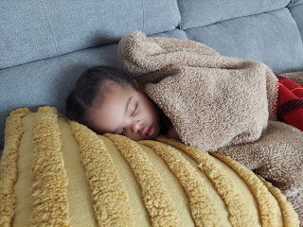
She didn't have a ton of energy when she woke up, which was HIGHLY unusual, so I thought she might like to watch a movie downstairs. She wasn't interested in watching anything, and was even moaning a little while she laid down on the couch next to me. I got worried that she might throw up, so I went upstairs to gather some supplies, including a bowl, a roll of paper towels, and a plastic bag to use as a garbage.
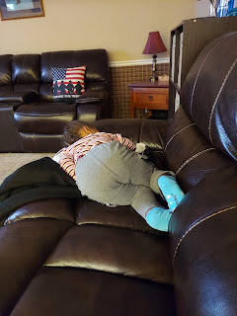

Thank goodness she never needed the bowl, but fell asleep instead. Poor baby.

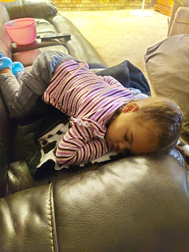

Eventually it was time to take her back up to Rexburg Tuesday evening, so I woke her up, cut an apple into slices so she had a snack during the 40 minute drive, and off we went. She seemed happy to be home.

Wednesday, I drove up around 10:30 a.m. to pick her up again, this time for another overnight so that Marissa could rest and recover at the same time that Assan needed to work on his studies.

On the way to our house, she fell asleep again on the drive. I swear, it was like I was able to cast some sort of sleep-inducing spell on her!

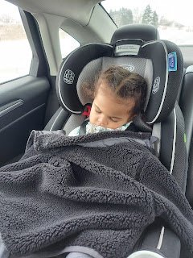

She had more energy throughout the day though, which was nice. She noticed Scott's mom on the family tree, and gleefully exclaimed, "Gramma!!"

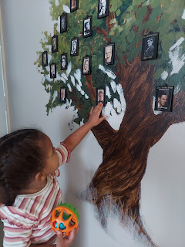

We played downstairs in the room where Abby and Gwen stayed for over a year. It's a room that I refer to as the Grandchildren Guest Room - it's pretty much baby-proof and has plenty to occupy young kids for hours.

Azure wanted me to do the Jack-in-the-box for her, but it's her spectrum of expressions that cracked me up!

Click to watch: (18 seconds)
https://photos.app.goo.gl/PNDT59rATipE5J1V7

To break up the day, I took her to the grocery store where I stocked up on some things for a few dinner plans. Thank goodness I went on that day, because soon I wouldn't be feeling very well . . .



She had fun learning how to slice up her own banana before bedtime.

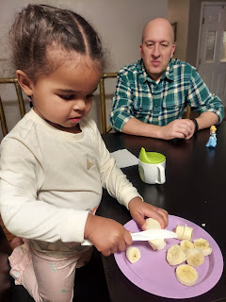

She slept well, and didn't wake up until around 9:30 or 10. I had plenty of time to go out and shovel the snow that had fallen overnight. She loved eating some of Grandma Harmon's canned pears in a bowl that also has a built-in straw to slurp up all the juice.

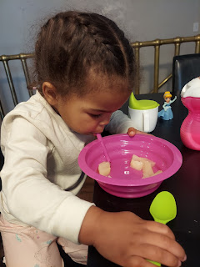

By this day, Thursday, I had a scratchy throat and I felt really tired. Somehow I still kept up with her energy, mostly by trying to entertain her with things that worked her brain. We built with Legos, we built with bristle blocks and Lincoln logs, and we even played pretend with Barbies.

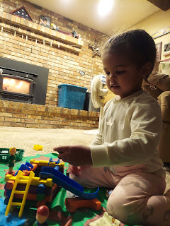

She didn't ever want to slow down to watch something on TV. Verrry disappointing . . .

Mid-afternoon I had the brilliant idea to put her in the bath tub for a while, to let the warm and soothing water entertain her for a bit. But a few minutes in, she had diarrhea in the tub!! She freaked out because it was messy, so I had to calm her down first and reassure her that everything was okay. Then I drained the tub and cleaned everything up with a good sanitizer spray. Soon I was able to fill the tub back up again, she happily played with some toys, and we got her all squeaky clean.

Around 3:30 p.m. we loaded all her earthly possessions into the car and drove across town to pick up her Grampa Gordon (Scott's brother), who flew in to help care for the little ones while Marissa recovers from her surgery. Azure enjoyed seeing a giant school bus next to us at a red light.



After we picked Gordon up, we drove over to the nearby high school and picked Scott up as well. Then we all drove together up to Rexburg to deliver Azure back to her family. We stayed with them for almost an hour, visiting and hanging out, and then Scott and I drove back to Idaho Falls.

When I woke up on Friday, it was almost 9:00 a.m.!! I ended up canceling my haircut and physical therapy appointments for the day because I didn't feel well at all, and I was coughing by then, too. I stayed in bed pretty much the whole day. I had a bad headache, a runny nose, a cough, and a general feeling of misery.

Scott came home from school with a dry cough, the kind that feels like you have a tickle in your throat and makes you cough pretty often. He said he felt just fine though, but I was worried . . . Somehow I was able to get out of bed long enough to make meatloaf for dinner, with cooked sweet potatoes on the side. We spent some time that evening chatting about all the Italy plans and figuring out what we could. We also browsed through all the housing listings and got excited about the possibilities going forward.

I went to bed early, well we both did. I couldn't get warm all night though, shivering much of the time. Scott told me the next evening that he would be sleeping in another bed because I was tossing and turning so much the night before . . . probably because I had a fever and thus the feeling of not getting warm enough.

Saturday, it was another day of feeling like garbage. Scott was awake for most of the night (for a variety of reasons), but was able to talk to the Sgt. Major in Italy in the wee hours of the morning, since they are 8 hours ahead. He got a lot of questions answered, and was very happy. Too happy to sleep, as he put it. He even woke me up around 2:30 a.m. to tell me about his awesome phone call.

He thinks he got about 3 hours of sleep total on Friday night, ha ha. Too excited to sleep - - for sure. He had plenty of energy throughout the day on Saturday and took good care of me. His cough was only occasional, but he felt fine. He took a nap in the afternoon finally.

Meanwhile, (still on Saturday) I heard from Amber in Louisiana that Weston had a fever of 102 and had tested positive for Covid. She was trying to take care of the girls and the household, even though she felt herself also starting to get symptoms (swollen lymph nodes, scratchy throat, super tired, etc). She encouraged me to go get tested, since I was on Day 3 at that point.

Scott drove me down the street to Community Care and waited in the parking lot for me. He figured if I tested positive, then he probably had it too. This was me . . . feeling like crap, and waiting for the dreaded results.



Sure enough, the results were positive. I was shocked! I thought I'd hear them say, as has happened a few times before, "Your results are negative, just take it easy and get lots of rest . . ."

Instead, they said, "Your results are positive. You'll need to isolate for 5 days starting today. Just use whatever over-the-counter things you can to be more comfortable - like ibuprofen, Tylenol, cold or flu medicines, etc." The doctor said Scott needed to isolate with me as well, since he was also having some symptoms. Once our symptoms are all done, we need to wait another 2-3 weeks, and then we can get a booster shot. She also informed me that there were 400 positive cases of Covid in Bonneville County just the day before!! Wow.

Some thoughts on all of this: I don't regret getting immunized. I'm grateful for it because I am confident that my symptoms would have been much, much worse if I hadn't been. (Given my history with asthma) Getting immunized doesn't necessarily prevent me from getting Covid, but it helps to minimize my symptoms. I think that Covid-19 is more "watered down" lately (not as potent), but it is also spreading much faster. The incubation period used to be a few days up to 2 weeks. The Delta variant has an incubation period of about 4 days. And omicron is more like only 3 days. It's more like a really bad cold at this point, and it's jumping to new victims much faster and easier it seems.

Now I'm no doctor, but I still think that getting immunized is better than not getting immunized. I'm grateful to be feeling 5% better today (Sunday) and I'm hopeful for my future. Amber is a little worse today (Day 3 for her I believe), but Weston is better thankfully. He said that 3 patients tested positive last week from his practice, so he may have gotten it from them. Hopefully they can get through it all quickly and get feeling much better soon.

I think we probably got sick from Azure and her family. When I was texting with Assan earlier this morning, he said they had a fever and coughing for about 3 days. This was right before and leading up to Marissa's surgery. They just thought it was a bad cold, nothing more. It's likely that Azure went through her own version of the sickness early in the week while staying at our house. I was caring for her and holding her plenty. I even kissed her cheek and forehead a few times, bless her little heart. And Scott - who is not a germaphobe like I am - had no problem sharing the food that was left on Azure's plate or eating off the same fork as her. We both got sick within a day of each other, so we were likely exposed by the same source.

Oh well, it doesn't matter where we got it. We're in the thick of it now. We are working our way through it and we'll be fine soon enough. At least we get to be home in quarantine together. There's nobody else I'd like to be this sick with! :)

These have been my go-to's so far: homemade applesauce (not pictured because I ate up the last few jars that we had), canned peaches, and plenty of Lipton soup mixes. I love eating super cold peaches when the jar has been in the fridge. It feels really nice on my throat.

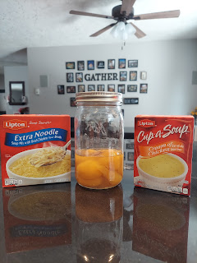

Our friend and neighbor, Melissa Hafen Anderson, called this afternoon to ask if she could bring some dinner over and leave it on the porch. She said she's thankful we got sick so that she can finally do something for us! She said we do a lot for other people but we're never really in need of much ourselves, so now this gives others a chance to serve us. What a sweetheart.

Here are a few pics and videos of the grandbabies from the week to finish up this post.

Gwen started preschool this week! She woke up early and proceeded to gobble down her breakfast so she could be ready to go. Her school will be on M-W-F from 8-12 each morning.



Her new teacher took this photo of Gwen mid-morning, sharing that she (Gwen) was super happy and having a great time. :) I'm glad she's enjoying it so much!



Jacob and Hannah made it back to Washington DC late Tuesday night, finding about a foot of snow on their car that sat in the parking lot while they were gone. They will be moving soon to another apartment, not too far away from their current one. They haven't had a good experience with their upstairs neighbors for some time, and I don't know exactly what all the racket is that has been going on above them in the middle of the night for months. But they decided it wasn't worth it to stay and continue to lose so much sleep. The landlord released them from their contract, and now they're gearing up for yet another move.

Here's Jack with his little cousins back in Utah before they left. Calvin, Jack, and Boone.

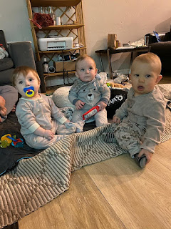

And here's Jack being hugged by a giant sloth LOL

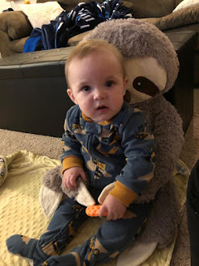

Video of Jack getting a face scrub: (30 seconds)
https://photos.app.goo.gl/Ba7J3L6rKQkYZAWK7

Video of Jack giving the most adorable facial expressions: (6 seconds)
https://photos.app.goo.gl/D3Fmb6f7YmMuhXwLA

And little Miss Avery Mae . . . she's trying to roll from her tummy to her back now! She's getting so big!! Here she is, learning how to eventually put together one of her mommy's favorite puzzles . . .

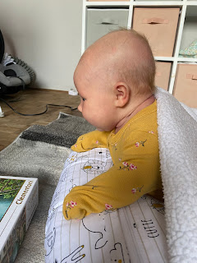

Video of her wide awake and feeling chatty: (29 seconds)
https://photos.app.goo.gl/vofB48V7PDM6YYKy7

Video of her smiling and pretending to cough: (47 seconds)
https://photos.app.goo.gl/PDcfaXNXFQ8qHQWa9

We sure love seeing them as they are growing up. Our grandchildren are the best! And I will fight you if you say otherwise.

