So Apparently We Are the Energizer Bunnies
Yep. I'm pretty sure that we are the Energizer Bunnies. At least based on this past week, with all its flurry of activity! We did, however, balance all of our work with some fun and relaxation as well.
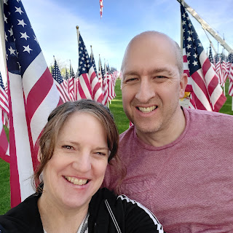

More on what that photo above is all about in a minute . . .

We sure squeezed a LOT into our week, working on things like yard work, kitchen demolition, another new ceiling fan, housework, 2 new cords of wood, cupcake deliveries, and so much more. But the thing we always say to each other is how good all of that feels. We are two people who love to be productive, who love to work hard and gain the satisfaction of seeing the fruits of our labors. We are always excited to jump into a project, and we enjoy working together through it all. I guess that's a big part of why we are so happy in our marriage and why we are best buddies.

Monday:
We got this scrumptious photo of Jack. Need I say more?

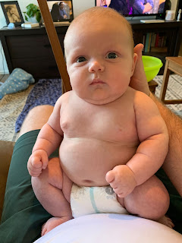

And a darling video of Jack "trying" to wake up. It's just so hard when life is so comfy and cozy.

Click here to watch: (50 seconds)
https://photos.app.goo.gl/eCVTEG4cB4CgWE1x9

Amber also shared a picture of Gwen being adventurous out in the Louisiana rain.

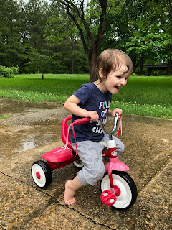

As for me, I did some cleaning inside the house, and went to receive my monthly massage. :)

Tuesday:
I headed out in the morning to get a couple of items for making my monthly cupcakes. The plan was to deliver them to my young women's class later that evening. I saw this awesome sign in Hobby Lobby and immediately shared it with my kids. Amber quickly responded that she could relate!

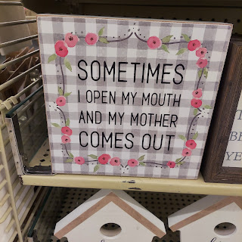

I am here to tell you that you CAN still use a cake mix that expired in 2015 and it WILL still taste amazing! You just have to add a couple of extra ingredients to help ensure that they will be a success. This box mix required eggs, water and oil. I also added a small (1/2 cup or so) of unsweetened applesauce. I like to keep the pre-portioned ones handy, the ones in the individual cups, and then I just use one in whatever recipe needs it.

Using the applesauce helped to make sure that the cake mix wouldn't be crumbly after baking. I used an old cake mix a few months ago, thinking that it would be fine, and it turned out very dry and crumbly. So this time I hoped that by adding the applesauce it would correct the issue. (It did)

I also added a little sprinkle of dark chocolate chips inside the batter, which made for a nice little chocolatey surprise later. I placed about half of the needed batter into each cupcake liner, dropped in the chocolate chips, then added the rest of the batter to cover it all up. I guess you could put just about anything in the center, as long as it's completely covered up for baking so it doesn't sneak out and ruin the surprise.

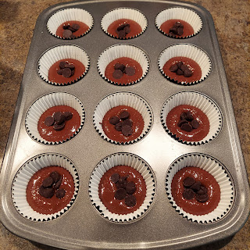

After the cupcakes came out of the oven and started their cooling process, I went outside to start pulling weeds. Shortly after I got situated in my front flower bed, it started sprinkling on me. No matter. I'm not afraid of the rain.

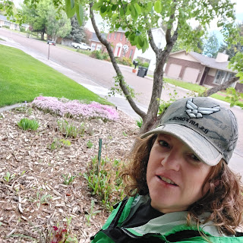

Two hours later, I had that entire flower bed free of weeds and all trimmed up from the long winter. The sun had come out and things got so warm that I had to shed my jacket while I finished up. No sooner than 10 minutes after I put my things away and came back in the house, a thunderstorm came out of nowhere and literally doused the entire land with a slew of torrential rain! Lightning, thunder, and heavy rain came down to water all of my little plants and flowers. I was just grateful that I had finished when I did - because the sun was shining when I was packing up and there was no indication of a storm any time soon! Surprise . . .

That's okay though, because I was ready to get to work indoors by decorating all those cupcakes. :)

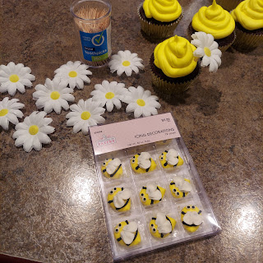

I wanted to do something with a spring theme, so I found these cute fondant bees at Hobby Lobby, along with the cute little daisies. The flowers had a little opening underneath where a toothpick fit into the hole perfectly to act as a prop.

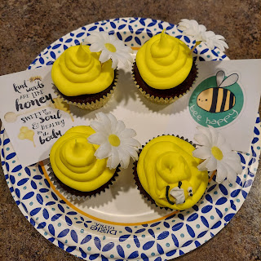

Little did I know that our young women's class president, Mercedes, has an obsession with bees! She loves them so much and was absolutely ECSTATIC that I brought her a bee-themed cupcake! She was almost jumping up and down because she was so excited! ha ha

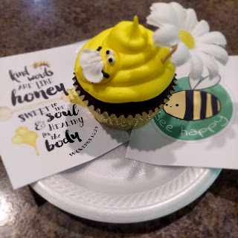

We also got this adorable picture of Jack, snuggling with his super soft little stuffed elephant. :)

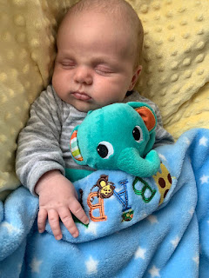

Weston shared a link with our family to a commercial that he is in, as part of their eye care practice in Shreveport. He appears at the end of the commercial - second from the left. We are so happy that he found a great place to work!

Click here to watch: (30 seconds)
https://photos.app.goo.gl/y3keErSAaZa9s3pW8

Wednesday:
I got up a little earlier than usual so that I could take my friend's daughter to school (the mom was out of town and the grandma staying with them doesn't have a car). I hurried home just in time to welcome in the carpet cleaning crew. I had scheduled for them to come clean a few rooms in our house. They did the living room, family room, downstairs bedroom, downstairs hallway, and the stairs all in about an hour!

My favorite thing is always seeing all the carpet lines. Is that weird?

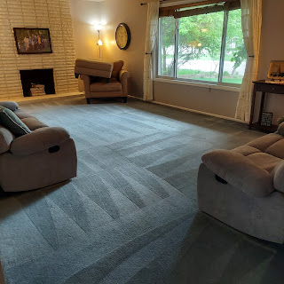

As soon as the carpets were done, I got all gussied up and went over to do some job shadowing for about 5 hours at the Miracle Ear. I learned a LOT and was getting more comfortable in some areas, but boy, my brain was pretty packed with information by the time I got home. I collapsed onto the bed and watched a couple shows until Scott got home.

Jacob asks us regularly in our family group text what we're eating for dinner. When he reached out in curiosity this particular night, I was ready with something good for once! Usually when he asks, we're just having something lame like leftovers, or grilled cheese sandwiches or something . . . But not this night!

I made "Spicy Citrus Salmon". It was NOT spicy, but it was quite possibly the most amazing salmon we have ever had!! And it was ready to eat in about 45 minutes, including all the prep and baking time. We had some steamed vegetables on the side, along with some VERY happy tummies.

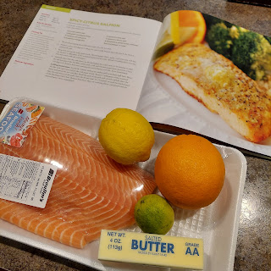

Thursday:
After some discussion with Scott the previous evening, I realized that I was having some serious second thoughts about starting this new job. First of all, I was not
looking
for a job. Jobs always seem to show up on my doorstep at the craziest times in my life . . . My goal right now is to put my house in order - I'm
still
trying to get caught up from when I was gone for all those months while Scott was in Saudi Arabia. I have a ton of projects that I didn't get to while Amber and the girls were here . . . I guess we were having too much fun in other ways.

And my brain is SO FULL of details for SO MANY things right now. I've got details for all these trips coming up swirling around in my head, details for my responsibilities in young women's at church, trying to get back into my family history research, trying to get my yard work done (although it's never really done), and trying to collaborate with Scott with all of our home improvement projects. I didn't feel like I had any more room in my brain for what it would require by starting this new job. PLUS - we didn't even know how much it would pay yet. I hadn't been given that information yet.

After reaching out to my boss' wife, Holly on Wednesday night, asking what they anticipated paying me and her subsequently telling me that she would get back to me after talking with her husband, Jim, I decided to also make it a matter of prayer.

I told my Heavenly Father that I have a lot going on in my life right now and that I didn't feel up to the task of adding another HUGE thing to my already full plate. I am the type of person that likes to be able to dabble in multiple things - which means being available enough to do so, and having enough energy and the "wherewithall" to participate in those multiple things. If I get too caught up in
one thing
to where I don't have the energy or motivation to do much else, then over time, I feel cramped and unhappy. Like that I am bursting at the seams for some wiggle room to branch out, instead of being confined to one major responsibility.

After praying that night, I felt at peace. I realized that I had never really taken the time to consider my overall time to spare and what I might be capable of doing. I am a people pleaser and once again, I said yes to someone without really taking everything into consideration first. And now it was catching up to me!

So, Thursday morning, I prayed again, asking for the confirmation and support that I needed in making this decision (to not take the job). I felt at peace and I felt comforted. I felt like Heavenly Father was telling me that if I wanted to start this job, He would support me. And if I didn't want to take on this job, He would support me in that as well. He just wanted me to be happy, whatever that looked like. I marveled at that concept all day long. :)

I finally heard back from Holly near lunchtime, and I shared all of my concerns with her. She told me repeatedly, "I totally understand. I get it!" And she sincerely meant it. She said the reason she isn't working more hours/days in the office herself is because she likes to dabble in multiple things as well, and she doesn't want to be locked into one huge time-absorbing sponge. She wished me well and encouraged me to let them know if I ever change my mind. Even way down the road. I'm not sure that I will, though, because the pay wasn't as much as I would have liked. Scott emphatically stated that my time is worth much more than that amount. :)

I felt like a huge burden was lifted from my shoulders by turning down this job. And I am using my time wisely, working on all those many other details, many projects, and many responsibilities. :)

One of the projects I decided to dive into right away was to start pulling down the kitchen backsplash. Scott wanted me to at least try it out, seeing what I could learn in the process while he was at school.

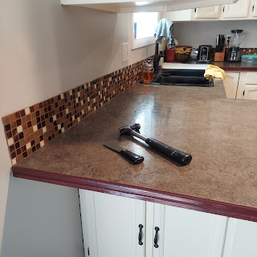

The first block of mosaic tile did not come down very easily. I think my putty knife was at too much of an angle and ended up going too deep into the drywall. I fine tuned my technique and was able to do much better in preserving the wall from that point on. :)

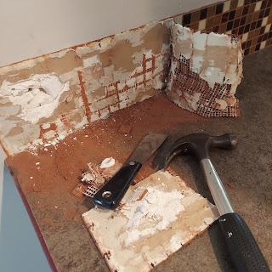

I used the hammer to tap my putty knife as I went along. I didn't get much further than this, though, because I couldn't reach, ha ha. But also, my right forearm was getting cranky (with my carpal tunnel issues), so I decided to take a break.

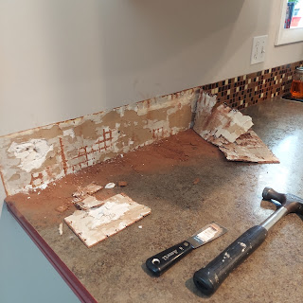

I had a great conversation with Kylie in Italy, while I sanded all the edges of the countertop trim. I lightly sanded it all first, then I'll putty in the indented line around all the edges this coming week by using a strong wood fill putty. This is an important step so that when we use the epoxy to make our new countertops, the edging will be more prepped to "accept" the epoxy that goops over the edge. It will cling to a prepped and primed surface much more nicely than if we did nothing. And we want it to look GOOD!!

Anyway, I chatted with Kylie while I worked for a bit. She had just rescued 2 baby kittens who had been abandoned and were only about 2 weeks old. She had just returned from the vet, who wanted her to make an extra effort to keep them warm for the next couple of days. She filled up a couple of rubber gloves with warm water and the kitties nestled right up to them.



She also bottle fed them while we talked, and they seemed to respond well to her loving care.

We discussed many things, including how to work on getting her a Visa. It's hard for her to do much from the other side of the world, especially in making phone calls. I made a couple of calls for her that afternoon, attempting to get more information on what she needs to do to get one. We're hoping to continue on that path this next week, getting some things lined up for her for when she comes home later this summer.

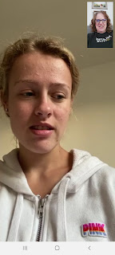



As far as her pregnancy, she is doing well. She has a super high metabolism and needs to eat almost constantly, otherwise she ends up throwing up. She told me how when she and Benson go out to dinner, they get nice and full, drive home and get comfy on the couch to watch a movie or something, and then Kylie will tell him, "I'm hungry." ha ha

He'll protest that they just ate, to which she replies, "I know. But I'm hungry. And if I don't get something in the next 5 minutes I'm gonna barf!" She is in good spirits, even though it's a constant battle to stay one step ahead of throwing up. I think she is about 14 weeks into her pregnancy now. :)

I took a friend, Amanda, to lunch to celebrate her birthday. I became friends with her because her daughter, Aari, is in my young women's class. Amanda has been feeling down and depressed lately with all that is going on in her life, so a birthday lunch invitation was cheerfully accepted.

I ordered the seafood chimichanga at Jalisco's, trying to compare it with the other Mexican restaurant that I love (Yessi Puerto Vallarta). This one was not near as good. :( Good to know.



After dinner that night, Scott and I went for a bike ride along the Snake River Greenbelt downtown. The day was warm and absolutely beautiful! The breeze kept the little bugs and gnats out of my way and prevented them from being swallowed as I was riding along and breathing heavily.





On our way back to where we parked, we saw a little family of geese on the river, enjoying the evening as well.



And the best part of our day was getting this darling video of Jack, who really enjoys watching his little animal mobile above his swing.

Watch it here: (35 seconds)
https://photos.app.goo.gl/bgPeS7h1h5qVDSB18

Friday:
I started off my day at an old lady's pace. No offense of course. But as soon as I got up out of bed, I was so tired and dizzy that I knew I would be getting back in bed very soon again. I showered and blew dry my hair, then crawled back into bed until maybe 1:00 or so.

I think I was super tired because I have started a whole new level of exercising this past week, using resistance bands. I found a great 30 minute workout on YouTube and it's pretty intense! I had done my workout Thursday morning, and then went on that long bike ride with Scott later that evening. My legs were like jelly when I got home, and I woke up feeling so trashed and tired. I guess my body just needed a little more time to recover.

I think it's good to listen to your body and take care of yourself. I learned that from my mom and from her mom. I can do hard things, and I like to do hard things. But I also like to take a break every now and then, as time and circumstances allow.

By mid-afternoon, I was back in the saddle again. My body felt more refreshed and recuperated. I decided to clean some bathrooms and dust and sweep while waiting for Scott to get home from school.

Soon after he got home, we received our large order of wood, delivered right to our driveway. We had all but run out of firewood a few months ago, and knew that early summer would give it plenty of time to dry out before the next winter, as well as net us some better pricing by planning ahead.

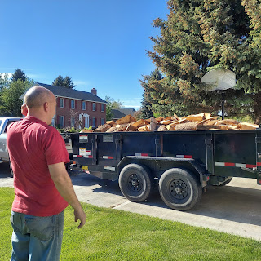

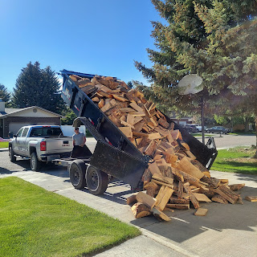

Date night - here we come!

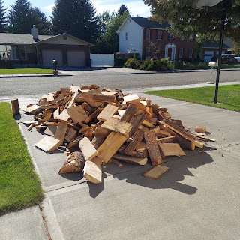

He is so cute! We got two cords all stacked up and the driveway swept up in no time at all!

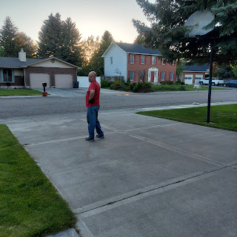

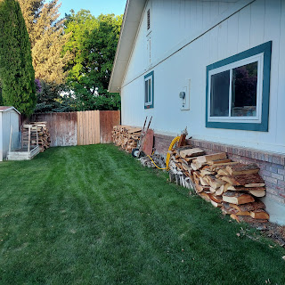

To finish up the day, we got another cute video of Jack, talking to his little animal mobile.

Click here to watch: (20 seconds)
https://photos.app.goo.gl/tEFzVKVx9XTrZEHE7

And this sweet picture of him sleeping on his momma.

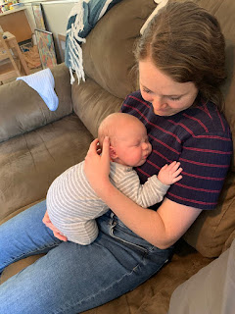

I also spent a little time enhancing this video of my great grandmother, Eliza Gertrude Flowers, my paternal grandfather's mother. (My mom - to her father, Linton Norman - to his mother, "Gertie")

Scott found a way to take an old photo and make it into a live video by using the My Heritage website. You can try it yourself by going here:

https://www.myheritage.com/deep-nostalgia

Here is the video of my Great Grandma: (14 seconds)

https://photos.app.goo.gl/LgTkFjUHsdutvb837

What a way to make someone come alive!! 💓

Saturday:
I still cannot believe how many things we accomplished yesterday!
Scott finished removing the rest of the kitchen backsplash and used our shop-vac to slurp up most of the mess
I finished up the cleaning and got the kitchen all sparkly and shiny once again
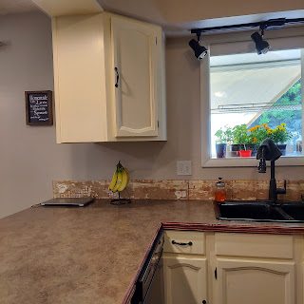

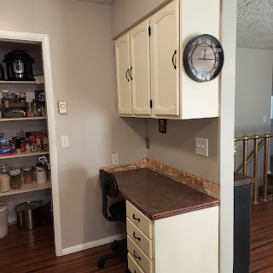

Then we moved outside to hang up our beloved sun shades for the summer season. We bought these originally for Jacob and Hannah's wedding reception in our back yard 2 years ago, but found that they really help keep our kitchen and dining room nice and cool, as well as providing an enjoyable back patio area.

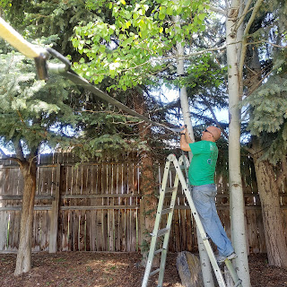

We hung both of them up, overlapping them slightly, to shade most of the patio

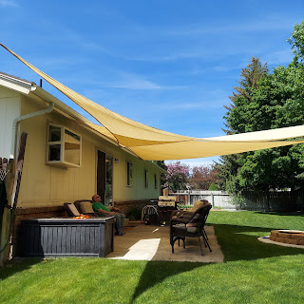
We went to Home Depot and Lowe's to find a new ceiling fan for the dining room. We had success at Lowe's, and then came home and got to work. I knew how to prep the fan blades, so I got those ready for Scott, then while he did the rest of the installation, I went outside to pick some of our abundant rhubarb.

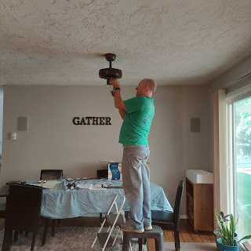

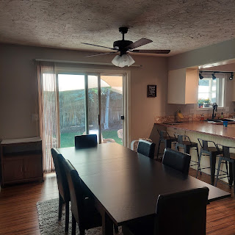

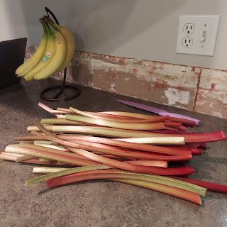
We did one more small chore for the day, by mounting a TV screen in the guest room downstairs, and putting up a couple of decorative shelves. (Jacob and Hannah and Jack are coming up today, and plan to stay downstairs)

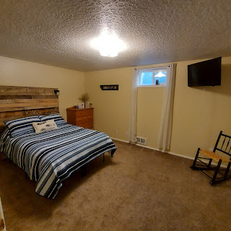

To wrap up the busy day, we decided to do something fun. We picked up some dinner (a burrito and a taco salad) and drove over to Freeman Park. Little did we know, there was something special in store for us!!

The Field of Honor was all set up for Memorial Day weekend, hosting 1,000 flags, complete with sponsored tags to honor veterans and loved ones.

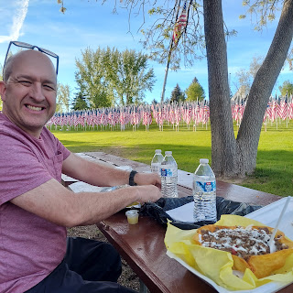

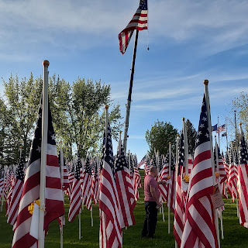

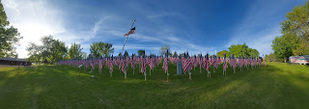

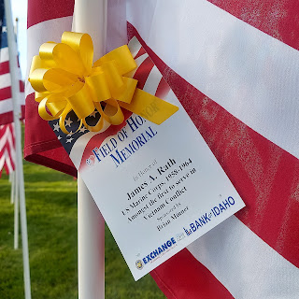

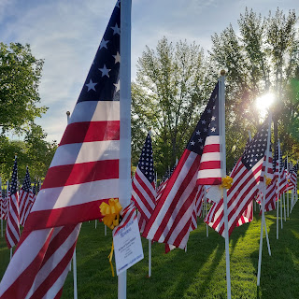

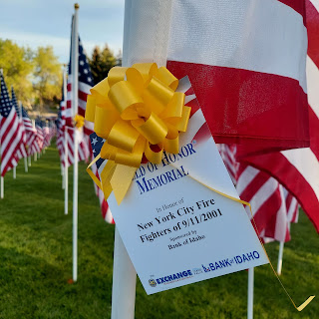

It was sure stunning to see such a patriotic display. I was moved to tears when the nearby music started playing Lee Greenwood's "God Bless the USA". And I got instantly choked up when I saw this US Navy veteran walking slowly along with the help of his cane. I gathered up the courage to walk over to him and thank him for his service, praying that I wouldn't start bawling in the process.

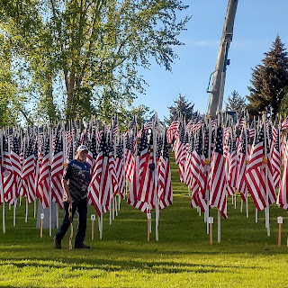

I also snuck in a short video of Scott wandering around amongst the many, many flags. :)

Watch it here: (27 seconds)
https://photos.app.goo.gl/UbWSuJYqhdKbP2im8

I'm so glad we were able to stumble upon such a magnificent tribute to our military and other heroes on our date. We meandered along the river for a little bit afterwards before heading home.

What a wonderful week it has been!

Some last minute photos . . .

Abby and Gwen "wearing their pajamas" at bedtime. I swear, the look on Gwen's face reminds me of some of the mischievous photos I've seen of ME when I was her age . . . Mom, Dad, would you agree?

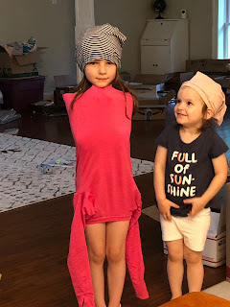

And here is Kylie's new kitten, Lyla. Their other cat, Maybelle ran away a month ago and hasn't been seen since! The new kitten LOVES Kylie's hair. Way too much, according to Kylie, ha ha.

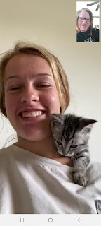

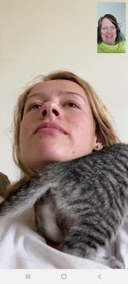

That face though . . . 💓

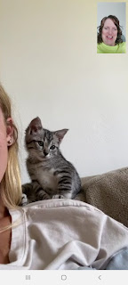

And one last photo - a tribute to our military heroes from something my friend shared on social media this weekend. Makes you think, doesn't it?



