Baby Jack, Animal Shelter, and Holy Rhubarb!!
We had a very relaxing visit with Jacob, Hannah and little Jack from Sunday through Tuesday.
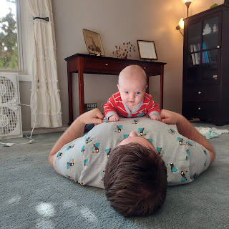

Jack is getting really strong during his "tummy time" practice sessions. The goal is to help him get a strong neck, and he's doing great for being just barely 2 months old today!

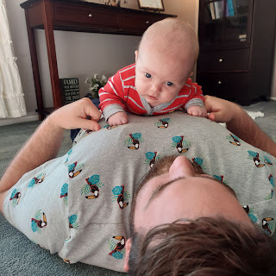

We set up the playpen outside for him to snooze while we played a fun backyard game called "Kubb". (pronounced Koob)

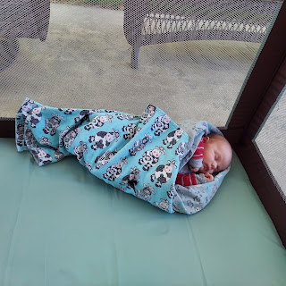

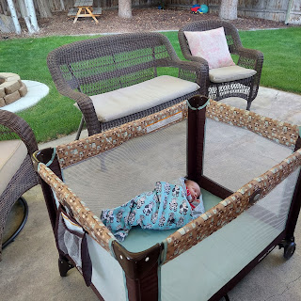

Essentially you're throwing a stick across the lawn to try to knock down your opponent's pieces. And then once you've done that, you can go for the king in the middle. It was really fun!!

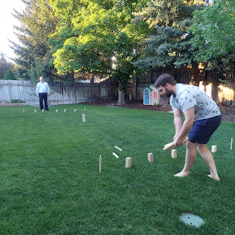

Monday:
After breakfast and a quick dance session with Jack, we went for a long walk along the Snake River.

Click here to see Jack dancing: (10 seconds) **We had some fun music playing, but as soon as I started recording, the music stopped for the camera to record. Dang it!
https://photos.app.goo.gl/DwrC7dtbaDCNbnVY7

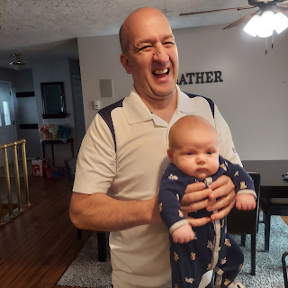

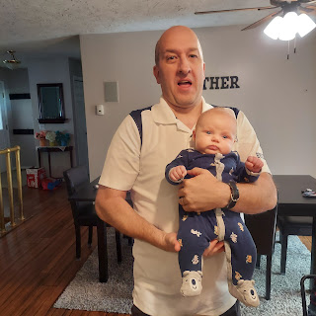

Jacob, Hannah, and Jack

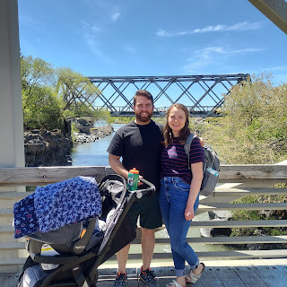

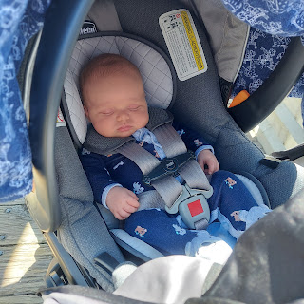

Jack was left in our trusting care while his parents went on a little explore in the Japanese Friendship Garden, with all of its brooklets, pathways, cascades and waterfalls.

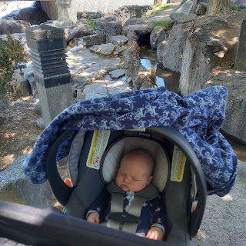

We walked and walked and walked in the
very
warm mid-day sunshine. We probably put in about 2 miles or so.

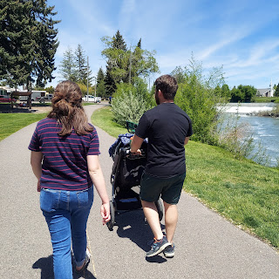

Jack - dreaming about the temple I'm sure . . .

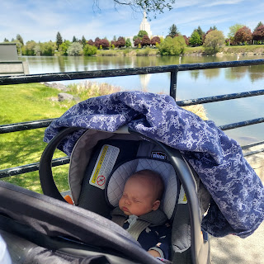

The rest of the day was a mixture of hanging out, resting, visiting, and eating, ha ha.

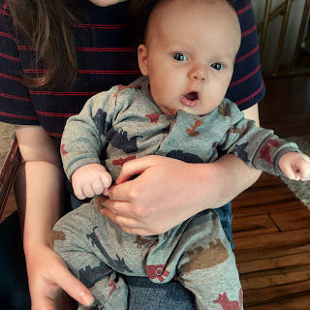

Jack and his beautiful momma, Hannah

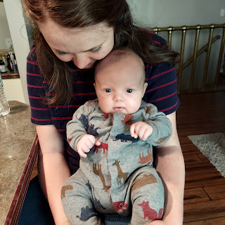

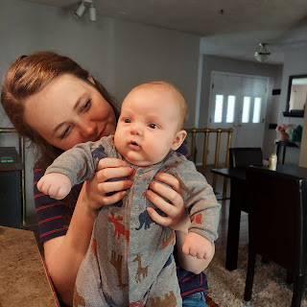

I decided to introduce him to some of his other family members on our family tree wall. He enjoyed it very much. :)

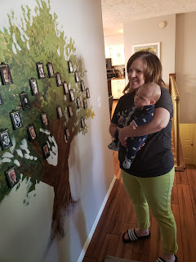

And then it was naptime again. This time we went outside to rest in the quiet of the back yard.

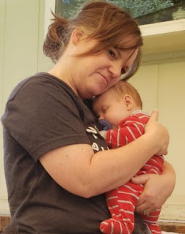

I gotta say, there's something about a baby sleeping on my chest. It seems to make me very sleepy as well . . .

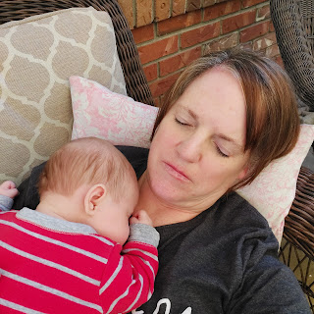

We had a very informal French Ancestor Night - just focusing on the French cuisine this time, by making a whole lot of crepes. I got the idea from a recent dinner at my mother-in-law's house when she made a crepe bar.

The main staple is of course, the crepes. Then the toppings can be either sweet or savory.
Our savory toppings: shredded chicken, sautéed mushrooms, caramelized onions, parmesan cheese, wilted spinach, artichoke hearts, sausage links, and goat cheese.
For the sweet toppings: Nutella, cool whip, blueberries, strawberries, sliced bananas, and toasted coconut.

It was AMAZING!!!

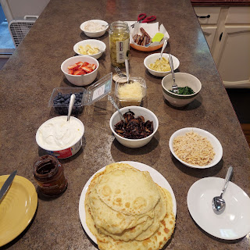

After dinner, we went out back again to play some Kubb (Koob). Jack happily let us know he was doing just fine!

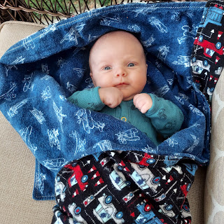

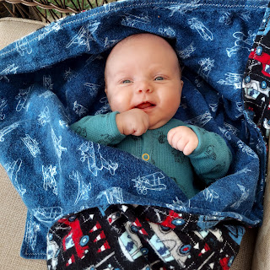

While I played on a team with my BFF Scott, I happened to notice that my apple tree has a lot of little apples forming! Hooray! Last year, we only had ONE apple and then the wind blew it off mid-summer. This year, we should have a couple dozen apples. I'm really looking forward to seeing how they taste!

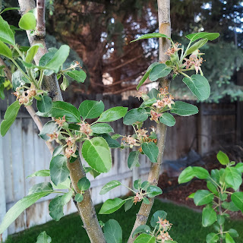

Scott and I crushed our competition this time. We do make a great team. :)

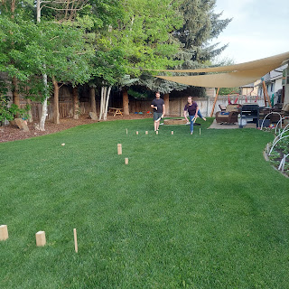

Cute snuggle time as a family at the end of the day. :)

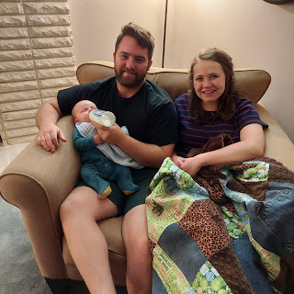

Tuesday:
Coy and Phil were able to come down to Idaho Falls to meet their great-grandson for the first time. They were unable to come to our French dinner the night before because Mom's heart was being rebellious and non-cooperative. She has a pacemaker, but sometimes her heart still goes rogue and it makes her very, very tired. She was feeling better by Tuesday morning, thank goodness.

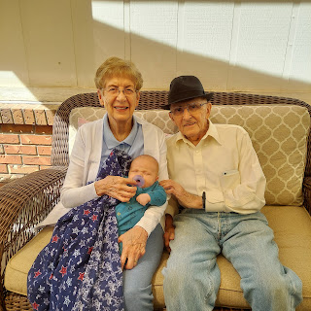

She got to feed Jack his bottle. He happily ate it all up and fell into a deep coma.

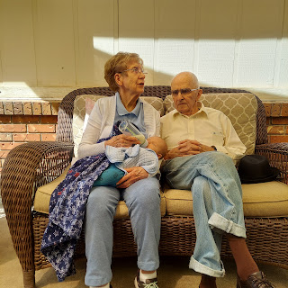

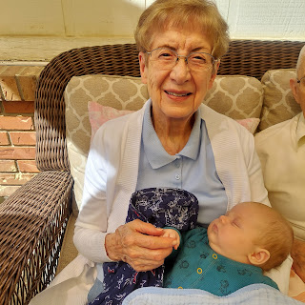

Just before they left, we were able to capture this darling picture of Jack, dreaming about something wonderful obviously. Maybe another bottle of milk?

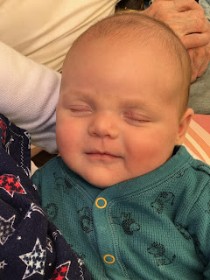

Later that afternoon, I took the young women in my class over to the animal shelter for some eagerly anticipated service.

From the left: Claire, Allie, Brielle, Linnea, Mercedes, and Aari

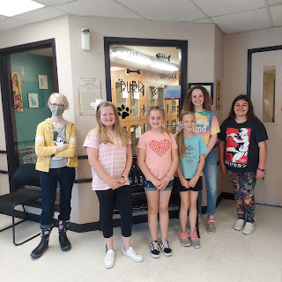

Mya, who works at the shelter, gave us a tour of the entire facility and taught the girls all about what they do there. Once the tour was done, the girls were just starting to wander around looking at all the doggies to see which one they would like to play with, when we got our first important assignment.

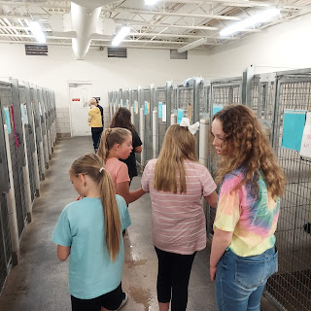

Assignment #1: Fill up the Kong toys with treats for the dogs. First, they had to get a count of how many big dogs there were (for a big Kong treat), and how many little dogs there were (for a small Kong treat). They received a demonstration on what types of things to put inside the Kong toy, and then they got right to work. Types of food and treats to choose from included: chunky wet dog food, crunchy biscuits, peanut butter, and some squeeze cans of processed cheese, ha ha. They had fun doing a mixture of treats inside each Kong toy.

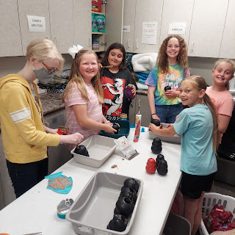

This little puppy was so sweet! Her name is Panda. While all the other dogs were barking and being quite loud, she just sat there all quiet and calm. If you put your hand up to the cage, she would gently lick your hand. What a precious. She is only about 4-5 months old.

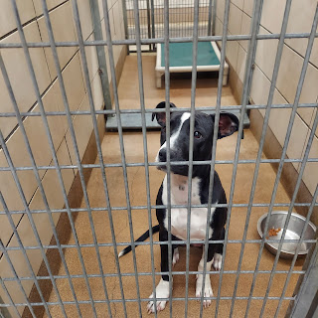

Next, the girls were invited to come help with some vaccinations. The shelter had just received a 4-pack of kittens who needed to be vaccinated. Mya demonstrated how to load up their syringes with the right amount of deworming medicine, and then she let the girls administer the medicine to the kittens.

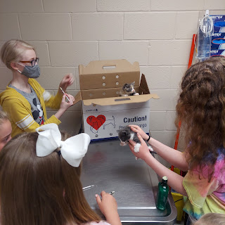

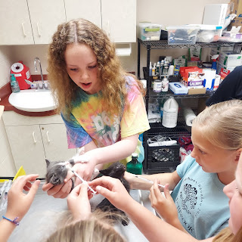

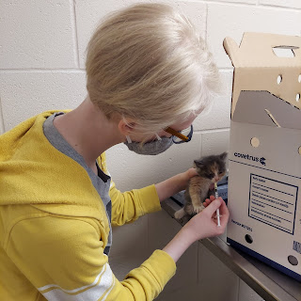

Mya took care of the other shots herself, not wanting the girls to accidentally poke themselves and get hurt. They really enjoyed doing something so hands on. Once the vaccinations were all finished, the girls were able to get the kittens set up in their new kennel, complete with blankets to snuggle, food and water, and their choice of little toys for the kittens to play with.

Next, we took one of the dogs outside to play in the enclosed yard. Unfortunately, the dog wasn't very interactive or playful, so we didn't spend much more than 5 minutes outside with her.

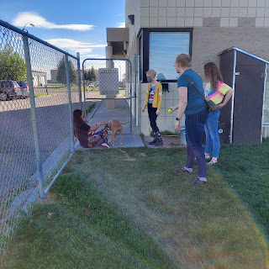

Lastly, the girls were able to play and interact with all the cats and kittens before the shelter closed for the day. They were instructed to sanitize their hands in between handling cats from separate kennels. By the time we left a few minutes later, the girls were seriously on Cloud Nine! They said things like, "I'm going to come back here tomorrow!!" or "I'm going to come here and help every single day this whole summer!!" I'd say that was a very successful activity . . . one that we will probably do again in the near future.

Wednesday:
In between shopping and errands throughout the day, I was able to talk to Kylie in Italy, as well as my dear friend, Jennifer, in Ukiah, CA.

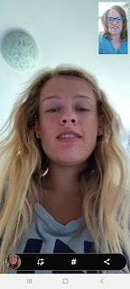

Unfortunately, the kittens that Kylie rescued last week didn't make it. They both passed away by the next day. They were just in too bad of shape by the time she received them and got them to the vet. One of them even passed away in her arms. I told her that someday when she gets to heaven, those kittens will be so happy to see her again and they will be so grateful for the loving care that she did her best to provide.

I talked for 2 hours with my friend, Jenn. We got ALL caught up, ha ha. She is so amazing. She is a wonderful mom to her children, 12 year old twins, and tries so hard to teach them the most important things in life that will help them grow up to be contributing members of society. She has a natural curiosity about everything, and asks the best questions all the time. I always enjoy her company, whether in person or over the phone, and I hope she and her family can come up here to visit me in Idaho someday. :)

I also did some shopping and errands for a chunk of the afternoon. I found Jack a cute little swim suit that I can bring down to Utah in a few days.

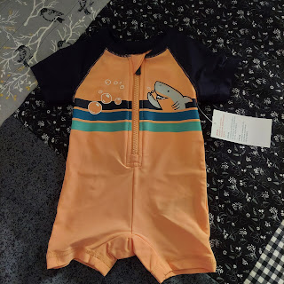

And, among other things, I went to get some ideas for our kitchen backsplash. We will be working on it later this summer, but we wanted some ideas for what we can expect ahead of time. These are some of the patterns that we like. We're trying to coordinate with our cream cabinets and our eventual black "marble" countertops. (using epoxy)

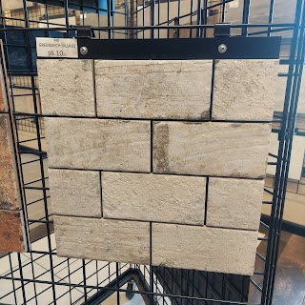

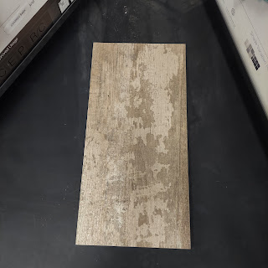

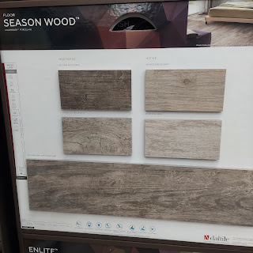

Jacob and Hannah, meanwhile, were sending us several pictures of their adventures down in Utah. They went with Hannah's mom and other family member to visit Thanksgiving Point in Lehi, Utah with all its gardens and statues and many other things to see.

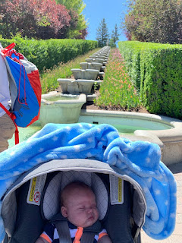

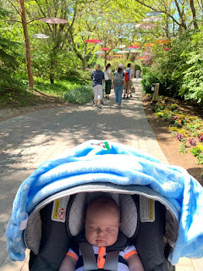

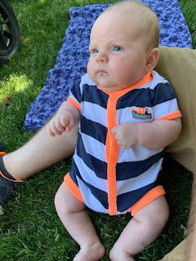

Jack and the koi fish

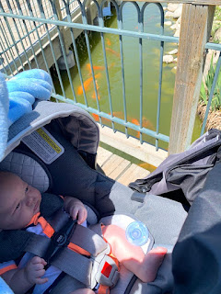

Look at these things! They're kinda scary!!
Video of koi fish: (24 seconds)
https://photos.app.goo.gl/DdZvUeGfGsijf6wZA

Here is just one of the photos they sent of some of the amazing statues at Thanksgiving Point. The time it must have taken to create all of those details is just mind boggling.

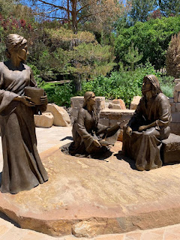

Thursday:
I puttied around the edges of the countertops in the kitchen. It didn't take too long, which was nice. Maybe about an hour. It's a high quality wood fill that, once dried, you can drill into because it's so solid. That stuff is STAANNNKY though! It smells like a really strong nail polish remover. I had to open some windows because it was starting to give me a headache. :)

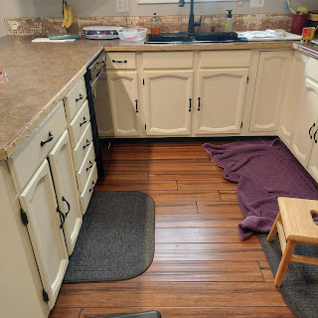

I got to talk to Kylie for a bit again. We talked about upcoming plans for her baby shower later this summer, as well as a "gender reveal" party they are planning for August 21.

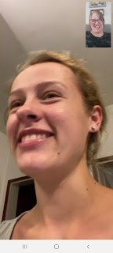

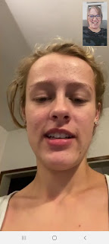

Meanwhile, down in the Louisiana bayou, Weston bought a tractor lawnmower! Amber captured the wonder and joy on Gwen's face as she rode with her daddy for the first time.

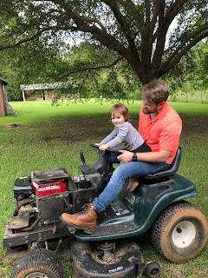

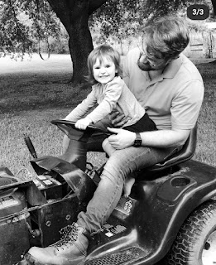

They also went to a local park in Stonewall, where the fire department and sheriff's department played a game of kickball against all the kids. They provided snow cones and hot dogs as well. What a fun little community! Amber shared that the officers were great at letting the little kids get easy points while being tougher on the big kids.

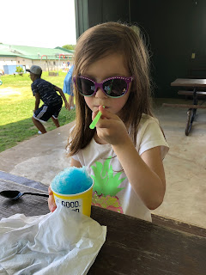

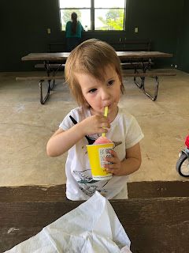

Amber later messaged us, saying the following:

"I still haven't seen my first snake or my first wild hog. And we heard our neighbors firing gunshots last night. It's nice to hear that and think 'oh, they're probably shooting a wild hog' and not 'oh jeez, I hope it's not a homicide!' " She added that Weston was sure it was a .22.

Amber also shared this photo of the girls in the grocery store - adding that she got several approving looks and comments at how well-behaved her girls were while shopping. Abby had chosen a book in the store and was reading it to Gwen while Amber took care of business.

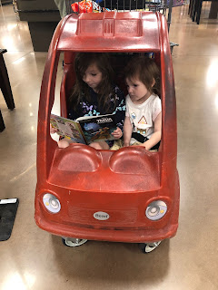

I also drove over to our local U-haul store in Idaho Falls to check out the cab. I wanted to know what it looks like before we drive across the country in a few days.

It is painfully basic and minimal as far as capabilities for listening to music and charging our cell phones. But we can do basic. We can do hard things.

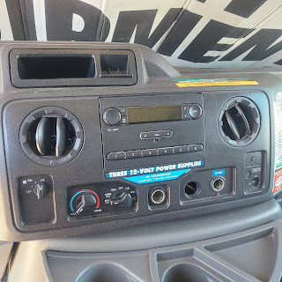

I also measured the seats so that I could get fabric to make some cushions for our bottoms and backs for the long drive.

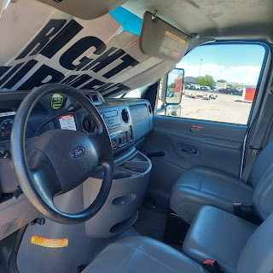

At the fabric store (JoAnn's), I ran into Weston's sister-in-law Crystal! So we took a selfie to share with Amber and Weston.

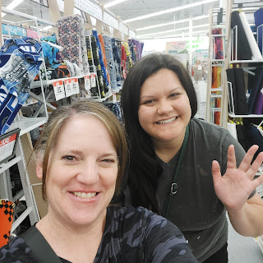

Sewing project #1: Repair our outdoor flag that was getting some really frayed edges.

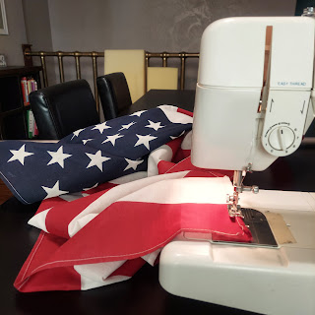

And our daily photo of Jack:

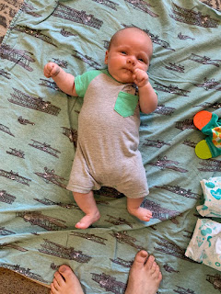

Friday:
Our friends, Peter and Barb Vance, sent us a couple of great photos of our kids down in Provo.

Left to right: Zach and Maddie Buell, Nathan Vance, Jacob, Jack and Hannah

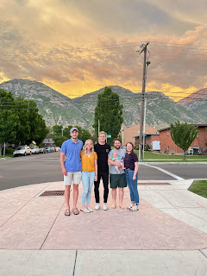

These 3 boys grew up together here in our neighborhood. They did everything together. Zach was the sportiest of the bunch, playing basketball mostly, and has a hilarious sense of humor. To this day, I laughed more at his weekly emails while he served on his mission in Columbia than anyone else's mission emails!! Nathan was always the sweetest and kindest young man, but always enthusiastic for anything in the great outdoors (hiking, snowboarding, rock climbing, running, you name it, he's down for it). And Jacob was right there in the thick of their wonderful friendship. They even worked hard and earned their Eagle Scout awards all at the same time, when they were just barely 14 years old!!

Jacob called this photo their "Last Supper". Everyone is parting ways very soon. They've all been down in Provo going to school, but now they're all heading out into the big world. Zach is a finance guy and will be moving with his wife down to Houston, Texas for a new job. Nathan works for Apple and will be moving down to Austin, Texas. And then Jacob and Hannah are moving to Washington DC this coming week. What a great group of boys - all grown up now and making the world a better place.

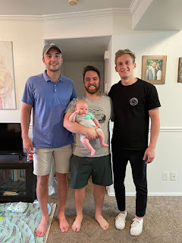

Back home, I was busy trying to kill myself while plucking white dandelion flowers off my neighbor's patch of side lawn. Seriously, I was in a really big hurry to save my lawn before the gusty winds arrived Saturday!!

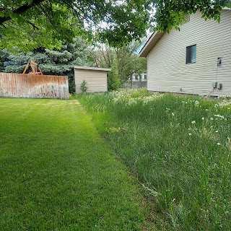

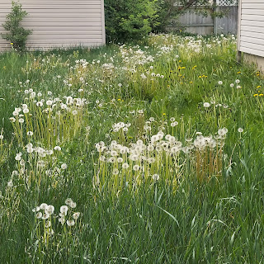

I filled up a huge trash bag full of just the dandelion fluffs!! It took me just over an hour and man, was I a sweaty mess by the time I got back inside.

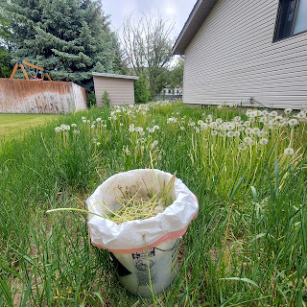

My neighbor, bless her heart, is not a gardener. She doesn't hire anyone to cut her lawn, either. And she is a very serious hoarder. We have helped her for years, but about 3 summers ago, our other neighbor asked us to please stop helping her. That sounds strange, but it was for a good reason. We want to be Christ-like, but that doesn't necessarily mean doing
all
the work for someone. She has some problems that we want to see her get some help for, and the rationale is that if we keep fixing up the outside, then the City of Idaho Falls and the Dept. of Health and Welfare won't think there's anything to worry about
inside
her home. But it's all piled up with garbage and rotting items on the inside. And that is a very BIG problem! So I had to do some soul-searching and find a way to reconcile what being Christlike really means.

Jesus is always there to help us, but that doesn't mean He will do ALL of our work. He needs us to be responsible and accountable on some level. Sometimes that means tough love. And that is what we are painfully allowing to happen next door. But it comes at a cost though: dandelions.

I told Scott we should build a fence along that side of the house to try to keep our yard a little more protected from all the fluff. And you know exactly what fluff I'm talking about.

Whenever I think of dandelions, besides wanting to murder ALL OF THEM, I often think of this short film that came out a few years ago. It's a hilarious portrayal of a dandelion and its desire to reach better ground.

Click here to watch: (2 1/2 minutes)
https://www.youtube.com/watch?v=0piknq77P_k&ab_channel=Ashrapperr

After I got some lunch and cooled off for a short rest, I started making some outdoor pillows for our patio.

Before: The larger ones used to be a nice bright coral pattern from Jake & Hannah's wedding reception. The smaller one got attacked by the backyard squirrels a while ago, so they could steal the stuffing for their nest. It has definitely seen better days.

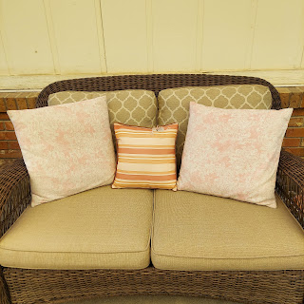

And After:

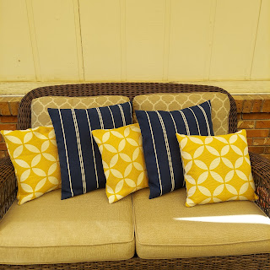

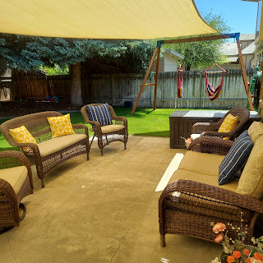

I love to make what is called an Envelope Pillow Case. It's super easy!!

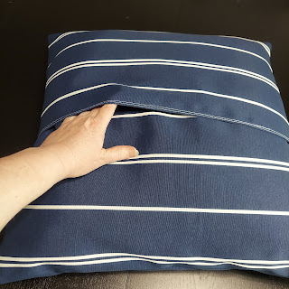

Here is the link to the YouTube video that I use pretty regularly to make all kinds of pillow coverings.
Video Tutorial: (3 minutes, 12 seconds)
https://www.youtube.com/watch?v=wc3ZaokODrs&ab_channel=MyGirlfriend%27sQuiltShoppeMyGirlfriend%27sQuiltShoppe

We also got this darling video of Jack for the day: (31 seconds)
https://photos.app.goo.gl/GJE7FLRTQJuMsm7R6

Saturday:
Very first thing, I got a call from Benson and Kylie, who wanted to discuss some plans for later this summer and fall. Specifically, they are trying to get everything lined up so that Kylie can just stay here in the States and have her baby HERE!! Benson will have a TON of leave accumulated by then, and anticipates being able to have 40 days saved up by then. Details are still being worked out, but it looks like they will all be here through Thanksgiving and Christmas!!!!!! Hooray!!!!

Also there's this: Need I say more?

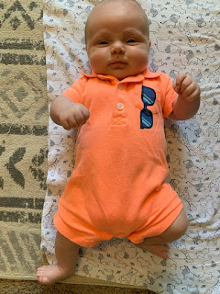

I rolled up my sleeves and got to work on two big projects:
Cushions for the Uhaul Truck
RHUBARB. And oh my GOSH. So much rhubarb!!

First - the cushions. Here they are in all their glory. I found some pieces of foam rubber at a local upholstery store and then I made covers for them.

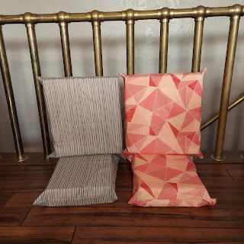

And then I spent the entire afternoon and into the evening working on that rhubarb!

Over this past week, I tried an internet suggestion on how to store rhubarb so it stays crisp and fresh in the fridge. It worked!! The article said to rinse them (and I cut the ends off), wrap them up in damp paper towels, then place them in a grocery sack and put them in the vegetable drawer of your fridge.

When I took them out Saturday, they were still in mint condition! Some of the tips curled slightly, but I just cut those off.

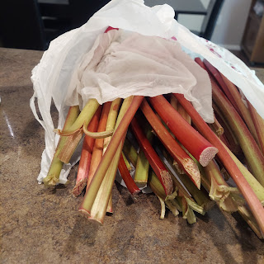

I used a mandolin slicer to thinly slice each stalk. You have to be SO CAREFUL so you don't slice your fingers (which has happened before - but not this time!).

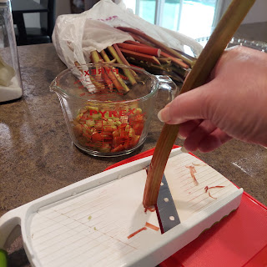

That grocery sack of rhubarb made 15 1/2 cups of thinly sliced pieces - ready to be baked!

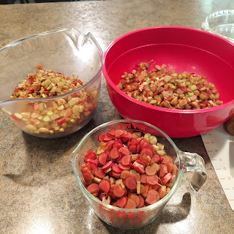

First: Strawberry Rhubarb Pie - my Grandma Zoe's favorite.

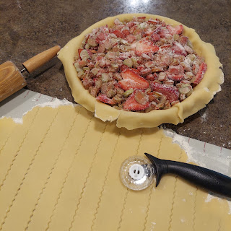

I always have to make a "Z" in some form to honor her memory. :)

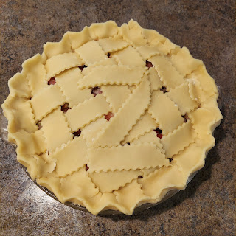

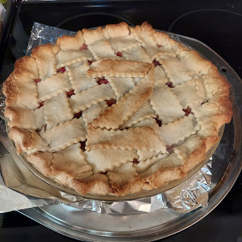

Next: Rhubarb Crisp (a double batch!)

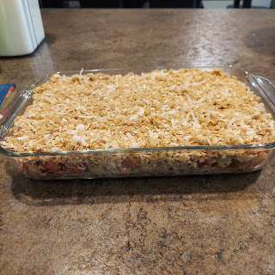

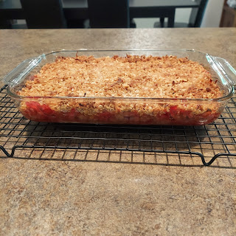

And lastly: Rhubarb Cookie Bars (a double batch)

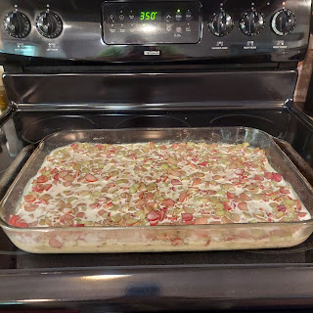

This was my first time making these bar cookies, and they are scrumptious! It has several eggs in the recipe, so it suggests that you keep it refrigerated.

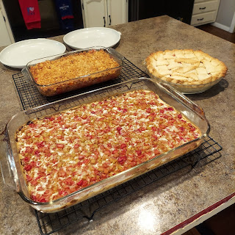

Here are the recipes:

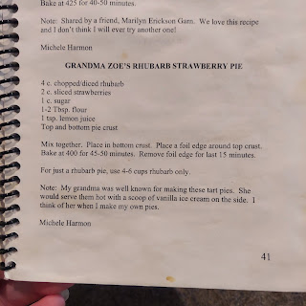

Betty Crocker Cookbook

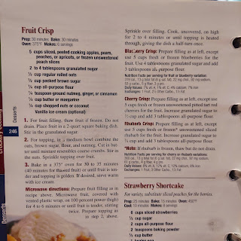

And the Rhubarb Cookie Bars:
https://www.tasteofhome.com/recipes/go-anywhere-rhubarb-squares/

After a million hours in the kitchen, and once Scott got home from his Army Drill down in Pocatello, we made a simple dinner (BLATS = bacon, lettuce, avocado, tomato inside a tortilla) and watched the movie, The Tourist, with Angelina Jolie and Johnny Depp. It was really good! (Warning: it does use a really bad word near the beginning of the movie, but then never again)

Finally, some last photos and videos of Jack. He is THE BEST!! And I love him. He's so squishy! :)

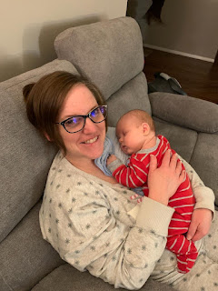

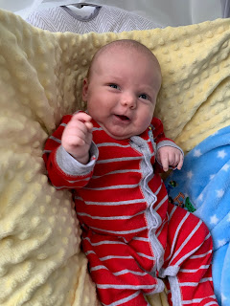

And a video of Jack trying to talk: (20 seconds)
https://photos.app.goo.gl/TktoGC4s6GBShQEq8

