Farmer's Market & A Two Hour Walk
Since my last blog post was late in being published, I can relish in having fewer days to write about this time. In between rounds of family coming to visit us in Italy, it's been quiet and relaxing here, with a chance to just slow down and recuperate. Don't get me wrong, I'm not complaining about family coming to visit! We loved having them here, and we are excited for the next group to arrive. It's just nice to slow down in between . . .

After a leisurely morning on Thursday, I boarded the bus across the street to go downtown for the Vicenza Farmer's Market. For $1.30 and a ride that was less than 10 minutes, I didn't have to worry about finding a place to park if I had driven my own car. Using two apps together on my phone, travel is easier than ever. I use Google maps to indicate where I want to go (i.e. the Palladio Basilica downtown), and it tells me where the nearest bus stop is, what time the bus is expected to arrive, how many stops to ride along the way, and where to get off, as well as how far to walk once you've gotten off the bus.

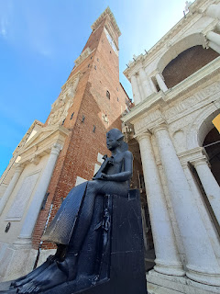

The second app that I use is now called Mooney-Go, and I use it to buy my bus ticket for $1.30. (The app used to be called My Cicero but was recently changed.) When the bus is about to pull up, I activate my ticket and that starts my 90 minute countdown. I can hop on and off any buses in town for free within that 90 minutes, otherwise I would need to buy another ticket for $1.30 if my 90 minutes runs out. I can see at a glance how many minutes I've got left to go, if I'm worried about having to pay another $1.30, which I'm usually not . . . ha ha

The Basilica can be seen below as the large white building with the green copper roof. The large piazza (or courtyard / public square) in front of it is where vendors come every week to set up their booths.

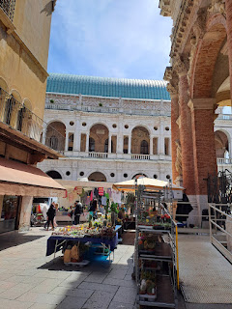

Speaking of the Basilica, I learned something new about it this week. Apparently there is another use of the word "Basilica", a Roman use of the word that does not have a religious connotation. The Palladian Basilica was never used as a church or a religious gathering place. It was built to serve as a Town Hall, and did just that for many years. Now it houses several shops and a Jewelry Museum, since Vicenza is world famous for their jewelry making techniques, especially in gold. Pretty cool fun fact!

I learned a LOT from this website as I researched some ideas for when Jacob and his family are here.

https://rossiwrites.com/italy/veneto/things-to-do-in-vicenza-italy/

I spent about one hour wandering around the Farmer's Market, just enjoying the sunshine and a nice walk.

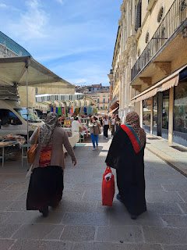

I found a couple of scarves in one of the booths, for about $10 each. They are thin and light and airy, which will be so nice for the upcoming summer season.

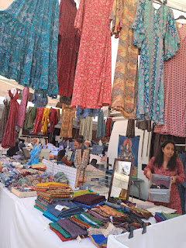

I got a kick out of this dog, who was tugging on his leash with his teeth, trying to prompt his master to move along and get back to walking and exploring and sniffing and all the fun stuff that dogs love.

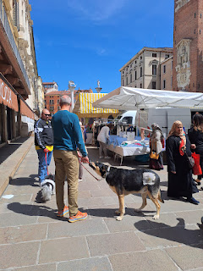

What a beautiful afternoon. It was really rejuvenating to be out and about with absolutely no agenda whatsoever.

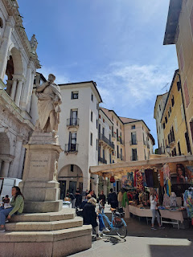

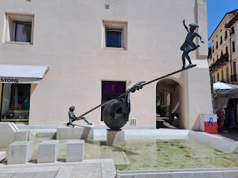

This booth had several varieties of olives for sale . . .

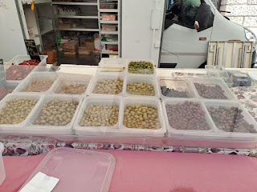

As well as several types of nuts for sale . . .

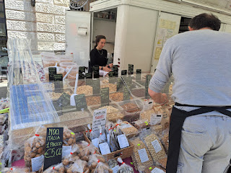

I chuckled out loud when I turned a corner and heard this little dog barking excitedly as his owner stood talking to the vendors in this SALAMI truck . . . Obviously he wanted some samples . . . ha ha

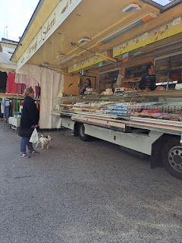

Finally, I found some flower vendors, which is what I was hoping for.

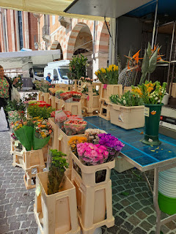

I got this huge bundle of gorgeous blooms for just $12.

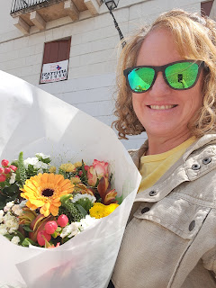

These two sweet older men were trying to pack up their wares, and needed to work together to push a large (and tall) stack of wooden chairs further back by an inch or so. They counted it off (uno, due, tre) and pushed with all their might, grunting and exerting themselves briefly until they had success. Then I overheard them congratulating each other. How precious.

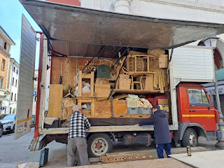

I have been steadily updating my "People of Italy" photo album. You are welcome to peruse it here:

https://photos.app.goo.gl/bZuCQbYys1vjJfnW7

Once I got home, I hung out the next load of laundry to dry up on the roof. This is still one of my favorite things that I get to do in Italy. It just makes me so happy and is so satisfying on many levels. :)

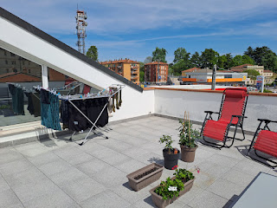

Once the clothes were taken care of, I got to work putting those beautiful flowers into the one vase that I have. I had to trim the stems extra short so they would fit better in the shorter vase.

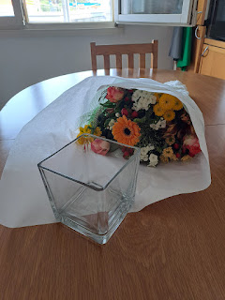

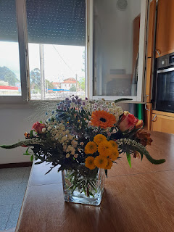

Video of my happy little flower display: (19 seconds)
https://photos.app.goo.gl/HcSWjEjFasmEu3KN7

I had a great visit with Amber that same afternnoon. Abby was home not feeling well, so I got to see her as well.

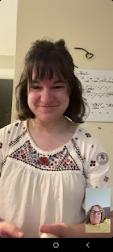

My relationship wiht Amber is a beautiful one, and we are able to talk about sad things as well as happy things and work through everything. She has an unconquerable spirit and I will forever picture her with a smile on her face, even if there are tears in her eyes at the same time. Life is mostly good in a consistent, upward sort of way. Sometimes things happen that trip us up, but it helps to keep a solid focus on our Savior, who will guide us through everything.

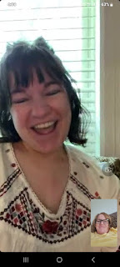

She and Weston have been designing and working hard to build a strong cubby bench near their entry door. This will be such a great place to park muddy shoes and have a place to sit to take them off. Weston has some really good handyman skills, and what a blessing that is!

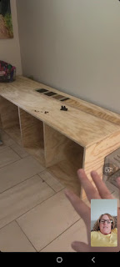

Abby made a silly face as she was showing me a new tooth coming in (on the upper left side of the photo below).

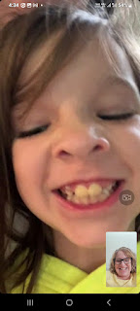

On Friday, Scott had a bonus day off work (Vicenza kids were out of school, so the Army took a day off so that families could be together). We went for a REALLY long walk that morning. It was originally going to be about an hour, but we had such a good time, we just kept going and going. By the time we got home, TWO hours had passed!!

We walked to a new place, about 30 minutes south of our house, called Oasi della Valletta del Silenzio. It means "Oasis of the Valley of Silence". We enjoyed all the beautiful flowers, bonsai trees, old gates and other architecture along the way.

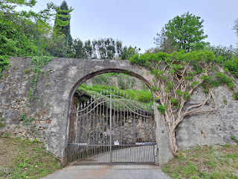

We took a little detour to see what this sign was all about . . . "Villa Valmarana". And of course, it had plenty of stairs to go UP, ha ha.

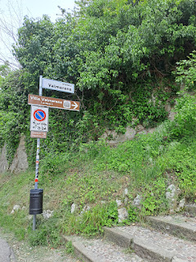

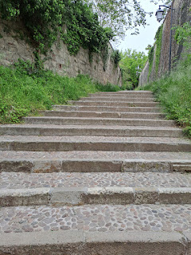

It was a fancy Villa that you could pay to tour if you wanted to. We just took a couple photos real quick, and then we went back down the trail to where we were headed originally.

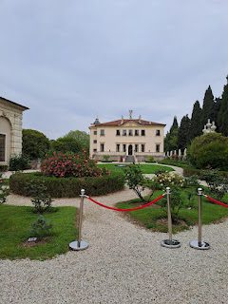

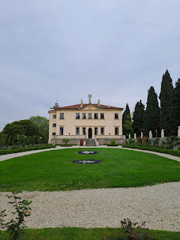

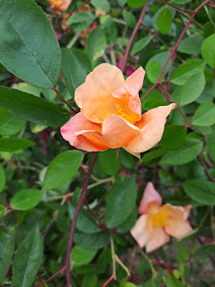

We had a startling discovery when we noticed Monte Berico up on the hill across the vineyard from where we stood. On other walks, we have peered down over the walls that line the walkway up to Monte Berico and could see this valley, but didn't know where it was exactly . . . well, now we know!

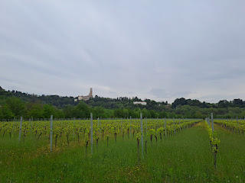

In attempting to get to the Oasi, we accidentally passed the street that would have led us to the entrance. But we got to see some beautiful shrubs and plants growing in the local Italian yards . . .

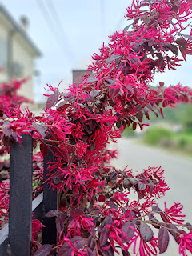

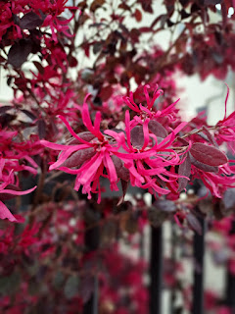

Once we realized we had missed our turn, we back-tracked and found the right road.

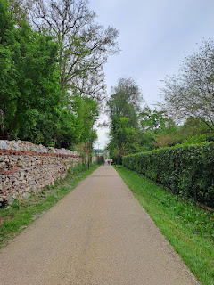

Here was the entrance . . .

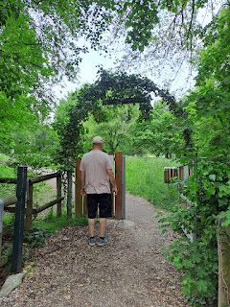

It truly was a beautiful and peaceful place, one that I later compared to the Sacred Grove in upstate New York. The park had a large community garden, and plenty of benches and picnic tables here and there amongst the trees and trails. It was definitely a place to think and ponder, to refresh and rejuvenate, and perhaps even to pray.

We kept hearing a bird saying, "Cuckoo! Cuckoo!" See if you can hear him, too - - -

(15 seconds)
https://photos.app.goo.gl/PWEigkjJgH7Cd7Bs6

You can take a silent and peaceful tour of your own through these photos.

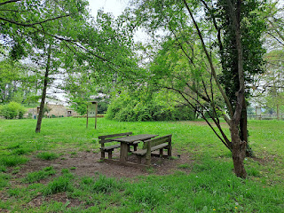

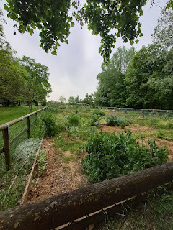

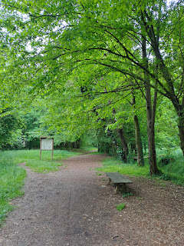

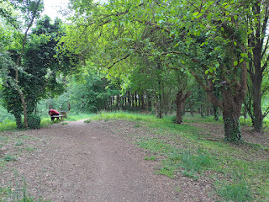

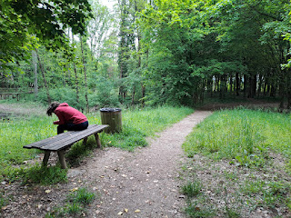

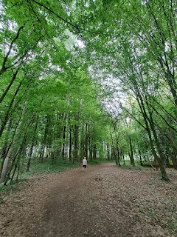

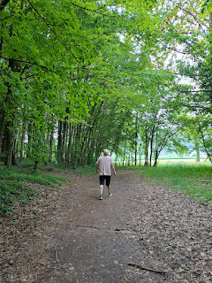

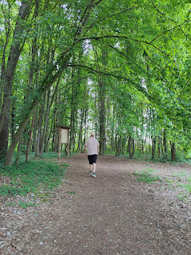

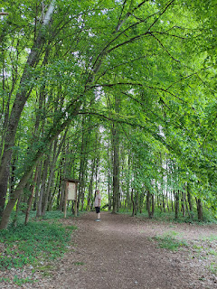

(a chart of all the species of plants . . .)

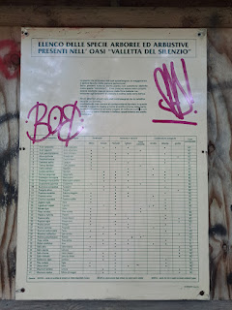

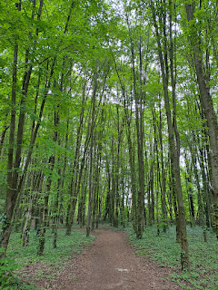

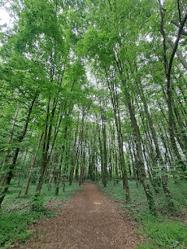

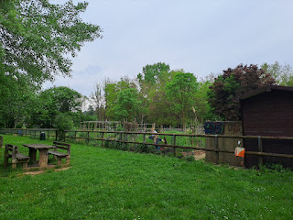

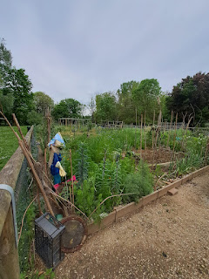

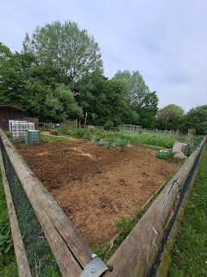

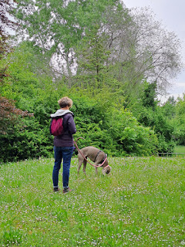

As we came out from the Oasi, and headed back through a suburb of Vicenza, we passed a large group of schoolchildren walking to the Oasi. They were very joyful and chatted excitedly with their friends as they walked hand in hand. :)

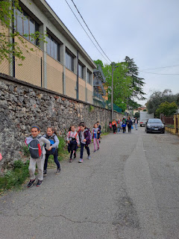

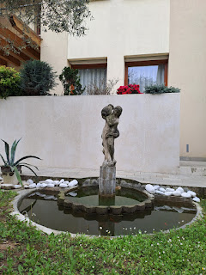

A nonna hanging up her laundry on the balcony . . .

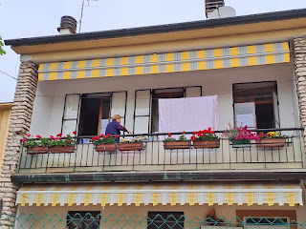

La Rotunda, still vibrant with meadows of canola in bloom.

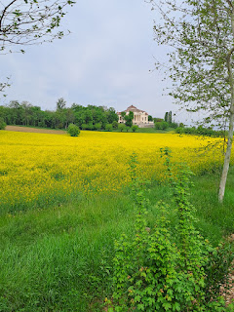

Another nonna watering her plants mid-morning . . .

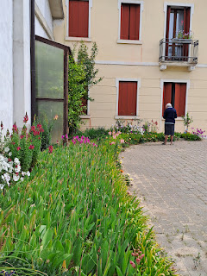

Getting closer to our home as we crossed over the canal bridge . . .

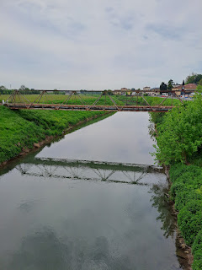

Not sure what kind of bird this was, but he was very poised and still and peaceful . . .

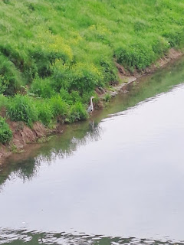

Video of a super cute (and very fluffy) dog in front of us: (26 seconds)
https://photos.app.goo.gl/zqSmez4pRz5vb8rZ7

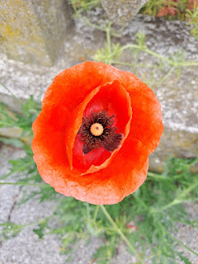

Once we got home, we took care of some getting-the-house-ready-for-more-company chores during the afternoon. It was nice to work as a team and for Scott to have an extra day off!!

The guys that Scott works with had set up a dinner date for everyone, including all the spouses, on Friday night. Just prior to the dinner, and on the way there, Scott wanted to send his drone up again because the canola at La Rotunda was just so profoundly beautiful.

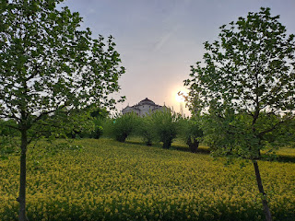

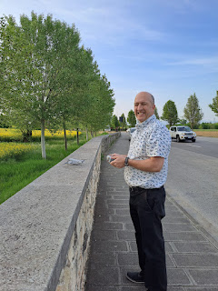

Video of the handsome drone operator: (25 seconds)
https://photos.app.goo.gl/x1uvnvPFZBHo586v9

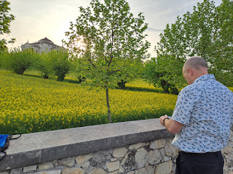

We were the first ones to arrive at the designated restaurant, so while Scott sent his drone up again to take a peek at the nearby cliffs, I took photos of the gorgeous roses in the parking lot.

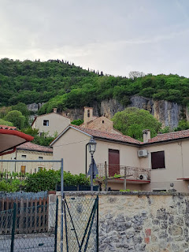

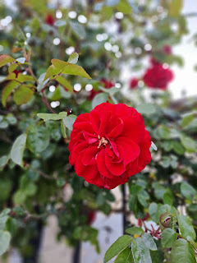

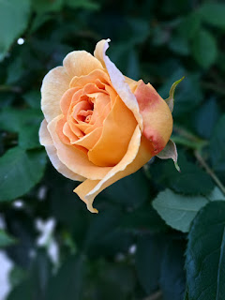

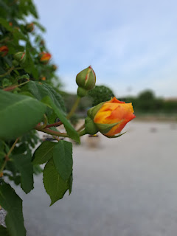

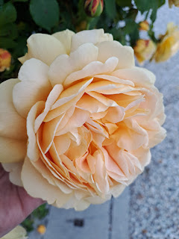

Soon, others started arriving, and eventually a photo session was in order for all the guys before we went in to eat.

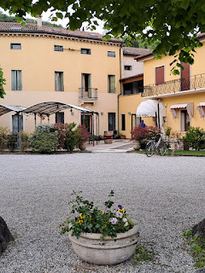

My friend Andrea's husband, Bogdan, is next to Scott on the right. He is a very smiley guy and is very friendly. The only other time I've ever seen him, is when I met him down in Morocco last June where all the soldiers had a lengthy military training.

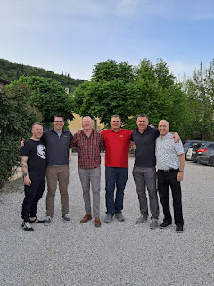

I met some new ladies, too, which was nice. From L to R: Me, Valeria (from Italy), Nicki, Andrea, and Claudia (from Germany).

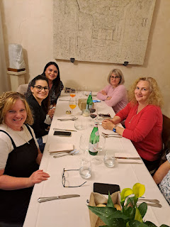

From the menu: Appetizers (we didn't order any of these)

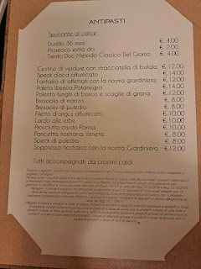

First Course: I ordered the Tagliolini Ragu, with Pioppini Mushrooms. It was really good! I don't normally order pasta, but Scott and I shared it, so everything worked out just fine.

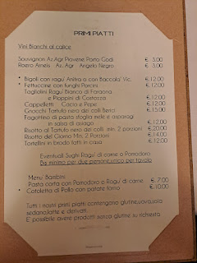

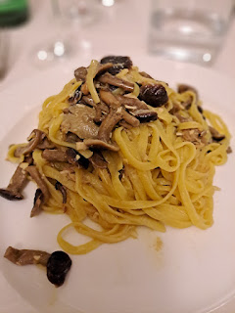

These are the Second Course options: I ordered the Tris Baccala' Vicentina near the bottom, below "Altri Secondi" (which means "other options"). It was basically 3 different types of local codfish specialties, in small portions, but all on one plate.

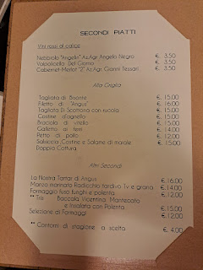

Thanks, Google Translate, for helping us understand the menu much better!! XOXO

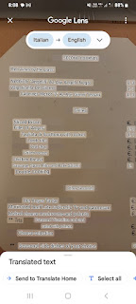

Here's what it looked like. My favorite was the cod served over polenta on the right. The story of how this dish came to be can be found on the webpage link above for the 25 Best Things to Do in Vicenza, but I'll share it again here: (look for point #10)

https://rossiwrites.com/italy/veneto/things-to-do-in-vicenza-italy/

The cod at the top of the plate was pretty plain, and could have used something to go with it, like a sauce. It did, however, have a green olive perched on top . . . The bottom left dish reminded me of a crab salad. It was very mild and delicate, and I enjoyed it with the marinated cherry tomato and the pickled red onions. Definitely 2nd place to the cod with polenta though.

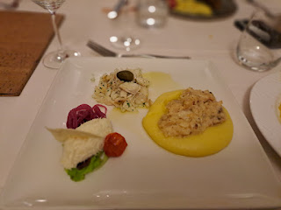

There was much drinking of vino and much merriment at the table (we didn't drink any wine, but mostly everyone else did). I enjoyed hearing stories from Claudia and Valeria, who were seated closest to me. I wish I could have sat closer to Andrea too, though . . .

Claudia ("Klow-dee-ah") is from Germany and was very entertaining. She has a German Shepherd dog who loves gelato. She (the dog) will systematically and very slowly walk past each flavor of gelato in the shop, sniffing each one, until she gets to the Vanilla gelato. Then she stops and won't budge until she gets some. HAHAHA

Thankfully, the gelato is always behind protective glass windows . . .

Valeria, who sat right next to me, is 27 weeks pregnant with a little boy. She spoke excellent English and was our advocate with the waiters if we needed it. She wanted to hear some labor and delivery stories, but then quickly regretted it when a couple of the ladies had some real humdingers to share. I had to reassure her more than once that most mothers have a normal and safe delivery, and not to worry . . . Poor thing.

After dinner was finally over at 10:30 p.m., we gathered the guys for one more picture outside, since another comrade was late to dinner and wasn't in the first photo.

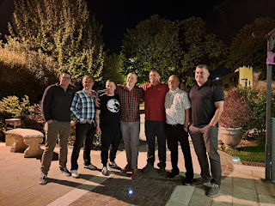

Saturday was another team-working day for Scott and me. While I planned out a menu and a grocery list, he started working on the curtains for the upstairs bedroom, in case Jack would be sleeping up there. We bought some blackout curtains a while ago because it gets so hot up there in the summer months.

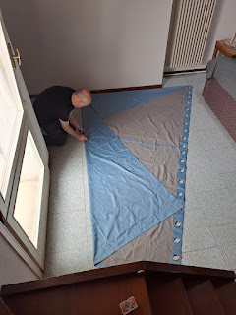

But, (nervous heh-heh . . .) the window has an odd shape as you can see.

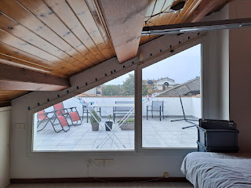

Thankfully, we have a mathematician in the house. He knows some geometry skills.

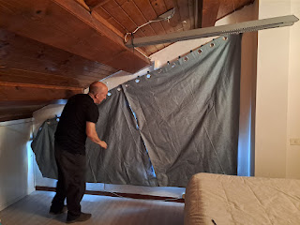

The curtains are hanging like this temporarily, until we can do a little sewing after our company leaves.

I also got a haircut, and this time they did a good job!! I didn't like my last haircut in Italy, but I sent Antonella this picture after I got home to style it. I asked her to please tell Maria how much I love it and to thank her again for me.

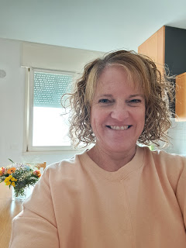

We did some cleaning and then we were off to get all the groceries together. Today (Sunday) I'm cooking a large pork roast in the slow cooker. It will be pulled pork in about an hour . . .

I got 2.25 kilograms (about 5 lbs) of the pork that is 2nd from the bottom right in this next photo.

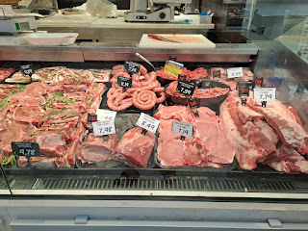

While shopping at Emisfero, I saw some of the same little mushrooms that were in my pasta from the night before. They are super cute!

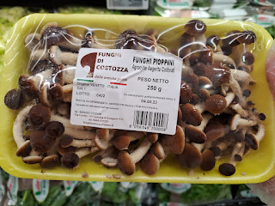

And Scott thought these looked like "Zucchini Grenades" . . . LOL

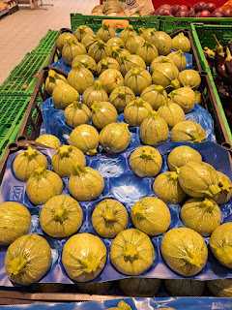

And finally . . . the best news of the whole week: Jack is now in Italy!!!!!

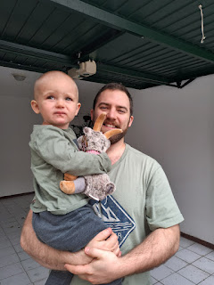

He's holding the new little mountain goat I bought for him last weekend up in the Dolomites. :)

They did great in their travels, especially Jack. On the 7 hour flight from DC to Dublin, he watched a movie and then slept for 3 hours. His parents didn't feel as sleepy, since when they landed in Dublin, it only felt like midnight to them (DC time). They wanted to sleep on the next (3 hour) flight, but couldn't. Jack slept part of the way back to our house, though, once he ate his fill of the strawberries and blueberries I brought for him.

As soon as he walked in the door of our home, he was just SO HAPPY. He went from room to room, exploring, and relishing in the wide open space (as opposed to being confined to a seat on the plane). Once he found the playroom upstairs, he was GIDDY, ha ha.

After about an hour of play, his mom and dad tucked him in for an afternoon nap, both for him and for themselves. When Scott got home from work (he had an extra shift on Sunday), he wanted to see everyone but they were all still asleep . . .

So, what does any good grandpa do? He tiptoes into the baby's room to rub their back, hoping that the baby will gently wake up . . .

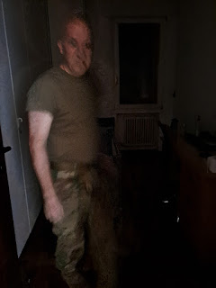

However, in Jack's case, it didn't even phase him! It was past 4:00 p.m. and Scott was worried he wouldn't go back to sleep later in the evening, so he left the door open to let other sounds naturally filter in. Soon enough, Jake and Hannah woke up on their own, and they went in to wake Jack up as well.

While I worked on the finishing touches for our pulled pork dinner, Jack needed a job. I set him up at the table with a bowl, a whisk, some scoops, and some macaroni noodles. He loved how loud the noodles were as they moved around in the melamine bowl, and even snitched a couple of the crunchy noodles to snack on . . .

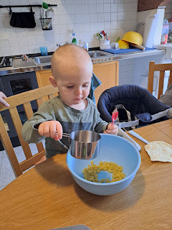

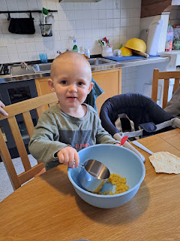

He was pickier than usual during dinner, probably from being in a different time zone. But he found solace in eating some shredded cheese, continuously asking for more "rice".

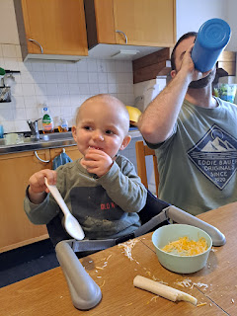

After dinner was all cleaned up, we went upstairs to the terrace and played with the drone for a bit. Jack was absolutely mesmerized by the drone. At one point, he pointed up to the sky (where it had disappeard from view) and called it a "bee". Very clever, considering that it buzzes loudly like a bee.

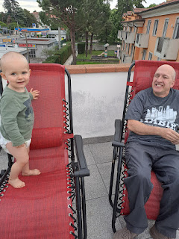

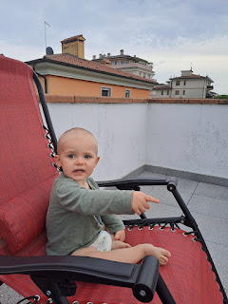

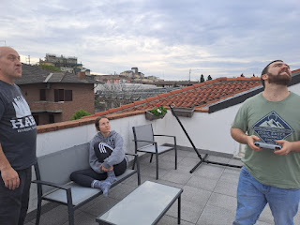

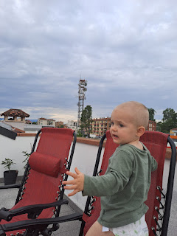

When we put him in the "sensory swing", he had a BLAST!! He was sooooo silly, ha ha. A sensory swing has many capabilities: you can sit in it like a swing, you can lay down in it like a hammock, and you can even completely envelop yourself inside like you're in a cocoon.

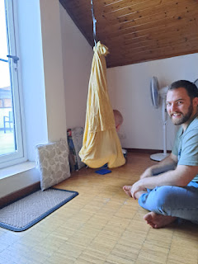

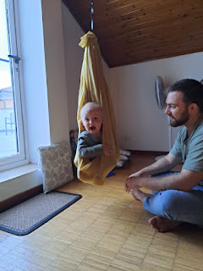

Video #1 of Jack in the swing: (50 seconds)
https://photos.app.goo.gl/MceatghFk2U525kY9

Video #2 of Jack in the swing: (37 seconds)
https://photos.app.goo.gl/CdLrnHP7kJpXuCpQ9

Today (Monday), we plan to visit some local parks so that Jack can run free and wild for a while. It should be a great week ahead!! XOXO

