Farewell to CA Forests, Family, and Friends
It was a SAD DAY when I had to leave so much fun behind in California when I left on Monday. I truly wished that I could have stayed for another week or two . . . I loved the smell of the forest, seeing the stars above at night, laughing and working together with family, etc. I saw deer, rabbits, I heard foxes barking every night, and an OWL even landed on my windowsill one night as I lay reading my scriptures in bed!! When I told my friend, Jen, about it, she said it must have been an invitation for me to go to Hogwarts!! LOL
During the one-mile drive from the highway back to my Dad's house, which I drove every day, there are some beautiful scenes along the way. (I had to be quick in taking a photo so the mosquitoes didn't eat me.)
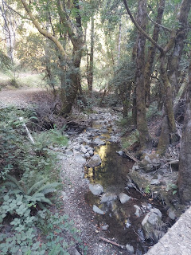

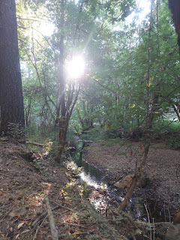

Last Sunday, I packed a lot into my last full day. I left early to get down to Ukiah in time for church with my Mom. (10:00 a.m.) Several members of the ward shared a sweet testimony of how the gospel of Jesus Christ has blessed their lives. It was the first Sunday of the month, which is a Sabbath Day set aside for sharing testimonies, combined with many of us fasting (going without food and drink for 24 hours, or as long as we can) to pray for and focus on something more meaningful than food. (i.e. a friend/family member in need, or a desire to overcome a bad habit, etc.)

One of the testimonies was from a young man who said he recently read in a church magazine that our Prophet Russell M. Nelson encouraged us to use proper language in our prayers. I had noticed in recent months that many people have been using words like: Thank you for . . .; We ask your help with . . .; We love you . . .; etc. Now, it's not a terrible thing that we use phrases like this, but our Prophet reminded us that there is a more divine way to address God, our Father and our Creator. We should use phrases like: "We thank thee for . . .; We ask for thy help with . . .; We love thee . . .; etc. It's a greater sign of respect and reverence, but it needs to be recognized as important and as a way to honor our Father in Heaven. Once understood, then you can try to put it into practice. If you stumble or get all tongue-tied in your prayer, then by all means, maybe you could default to using "you, your, etc." A loving God will not be offended if we pray sincerely and humbly, however the words end up coming out. I am trying to get back in the habit of using "thee, thy, thine, etc." and it feels like it's the right thing for me to do. I have been saying a mix of you/your and also thee/thy/thine lately, but I'm working on making the shift . . .

I was able to see my friends Grace Johnston and Jill Millward at church, and as we went to Sunday School class, we all sat together, along with my Mom. After church, I hopped into Mom's car and we went to visit Grandma Doris again.

Grandma was mostly sleeping the whole time and had a hard time waking up enough to acknowledge us.

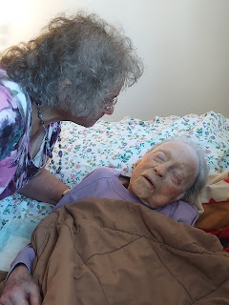

I'm so grateful that Mom thought to take a few pictures of me as I stroked Grandma's face and warmed her cold hand.

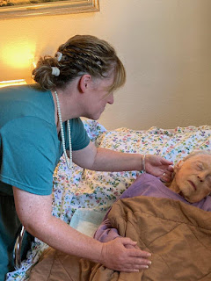

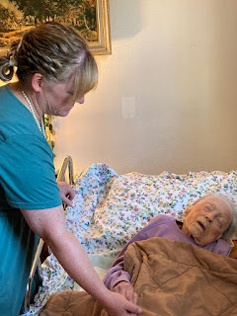

She did open her peepers a couple of times . . . most of her words were jumbled and difficult to distinguish, though. We had to concentrate really hard to figure out what she was trying to say.

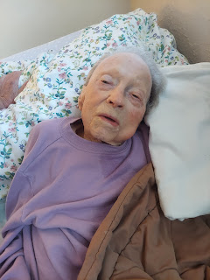

She did ask for water a couple times, so the nurse brought in a drink for her and helped her get it down. What a tender service that caregivers perform . . . it reminds me of the words that our Savior spoke, when he said: "Inasmuch as ye have done it unto the least of these..., ye have done it unto me." (Matthew 25:35-45)

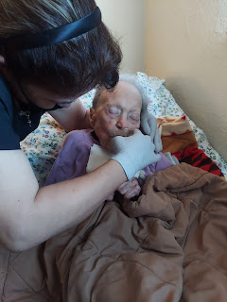

Someone painted this beautiful rock and placed it on a table in Grandma's room. Very thoughtful.

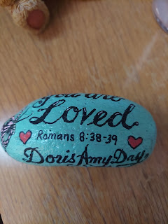

We didn't stay too long, since Grandma wasn't very responsive. Mom and I sang her a few songs, including one of Grandma's favorites, "Jesus Loves Me, This I Know". We gently kissed her cold cheek as we left. This was most likely the last time I would see her in this life.

Later in the afternoon, as Mom and I broke our fast and ate a late lunch, we collaborated for a bit on some family history. I had brought a few papers and letters to CA with me that Grandma Doris had given me years ago, and Mom has been dissecting them and adding family names to our tree in FamilySearch. It's so wonderful to see that my Mom has been "bitten" by the "family history bug", ha ha. She is really enjoying all the new things she's learning during her training sessions each week. She even shared with me that sometimes she might inadvertently neglect some household chores because she's so into whatever she's researching for our family tree. I love it! I always tell people that Family History is like the greatest suspense novel you've ever read, with no ending . . . ha ha

Speaking of family history, I was able to see my friend Jen one more time before I left CA. She had some questions and needed a few tips as she tried to add some names and information to her family tree. Her teenage son was also very interested in what we were doing, which was great. Because of my profound love for family history and research, I will always make time to help people with their own family history, and that's a promise!
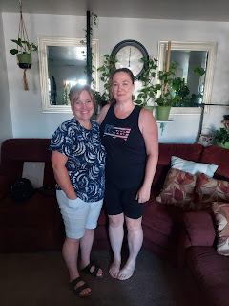

Once I left Jen's house, I scurried up to Willits one last time. Michelle fed us a scrumptious dinner of taco salad fixings and then we all piled into my car to drive a little ways north to visit the Laytonville Cemetery.

Between the dirt road that goes from their house out to Highway 101, we saw a little family of young deer. As our car slowly approached them, they scurried up the steep hillside and out of sight.

Video of the deer: (21 seconds)
https://photos.app.goo.gl/b6EK2b6APxWDJqg36

I had been to this cemetery once before with my Dad, maybe a year or two ago, and we both had a pretty good memory of the area where my 2nd great grandfather, James Baugh, is buried. The problem is that there is no marker of any kind for his final resting place.

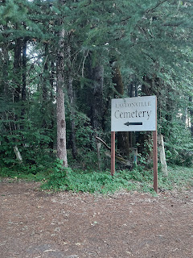

So how do we know where he is buried? Michelle's son, Jeremy, used to be the caretaker for the Laytonville Cemetery a couple years ago, so he shared a copy of the cemetery plot map and any notes associated with it when we went up there the last time. With what Dad and I both recalled from two years ago, we felt confident that he is buried somewhere close to these giant trees.

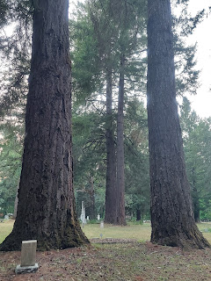

There were a few other random headstones in the same area, but no marker for James Baugh. I would like to change this. I want to coordinate with the current sexton of the cemetery to see if we can narrow down the spot so that I can have a headstone made for James in the near future.

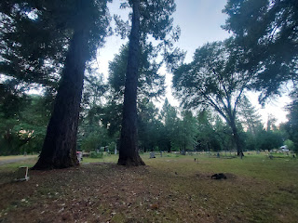

James Baugh was a bit of a character. He was born in 1839, but I don't know where. In his short life, there are 3 separate records with 3 different states listed for his birthplace: Mississippi, Virginia, and Alabama. That sure makes it hard to research more about where he came from when I don't even know where to start. He didn't live very long either, so he didn't generate very many records that could be helpful.

He married Ellen Lambert (whose gravesite I visited a couple weeks ago in Goldendale, WA on my way to see my Grandma Lillian in Oregon) in Cahto, Mendocino County, CA on August 10, 1865. One year later, my great grandmother, Sarah Jane Baugh, was born. I don't recall if I have already mentioned this before in a previous post, but Sarah Jane was something of a celebrity when she was born. She was so tiny, she fit into a bread loaf pan, and her parents would place her in the loaf pan to keep her warm on the open oven door. They would also lay her on a pillow and pin her nightgown to the pillow to carry her around. I don't know if she was a preemie, but she was certainly a miracle baby and they didn't want to injure her. People came from miles around just to see her, according to Sarah's daughter, Vera Snider Teague, who wrote a book with several beloved family stories. (I have a copy of this little treasure).

Back to James Baugh: He and his wife, Ellen, also had a son named Addison on 14 August 1868, when Sarah Jane was two years old. Just three months later, James Baugh was murdered, leaving Ellen Lambert Baugh a widow (with 2 babies) at 16 years old!! Ellen married James when she was only 12 years old, 2 months before her 13th birthday. She gave birth to Sarah Jane when she was 13 (almost 14) years old, and had Addison when she was 15 (almost 16).

I have the newspaper account of what happened leading up to James Baugh's murder, and from what I can tell, it sounds like he was a little hot-headed and may have incited the situation that brought about his own demise!

Here is the typed version of the testimonies that were given in court, regarding the murder in November 1868: (you can click on each photo to enlarge it)

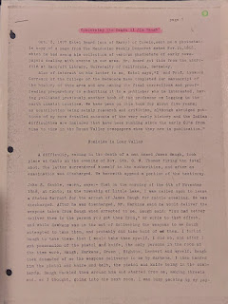

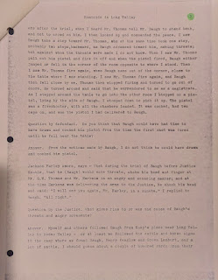

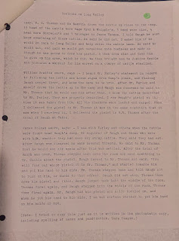

Whatever the case may be, and whatever type of personality James Baugh was, he is mostly a mystery to me. I don't know where he came from, or who his parents were. I don't know if he was hiding his past and therefore he changed his story frequently as to where his origins were. Maybe he was a good guy and I'm judging him incorrectly. I am still eager to discover more about him, and I would still like to place a marker at the cemetery to mark where his body lies.

Before I left the cemetery that evening, I went back to stand near where his body is buried so that I could have a "chat" with him. I told him that I wanted to know more about him and his family and that I would love it if he could point me in a good direction. I figured that he's had time to cool his jets (if his jets needed cooling) and that maybe since he's in heaven somewhere, he might have access to some helpful info. I just hope he heard me and that he's willing to share something that could be beneficial for my quest.

I wandered carefully around nearby sections of the cemetery because I knew that other family members were buried here, but I couldn't remember who or where exactly. I was super excited when I made this next discovery . . .

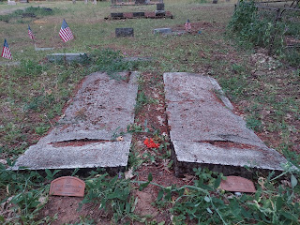

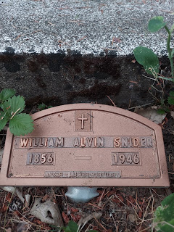

It was my GREAT GRANDPARENTS - William Alvin Snider and Sarah Jane Baugh Snider!!

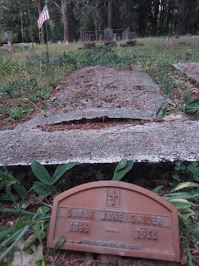

I took a wider photo of the area where they are buried so that next time I go, it will be easier to find if I just look back at these photos. I wished that I had some flowers to put on their headstones, something I will be sure to do next summer when I return.

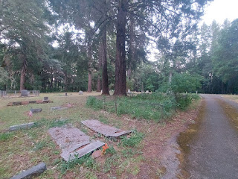

I'm so glad I could share this experience with my Dad and Michelle. It was a great way to wrap up the end of my time visiting everyone in California. This was the one thing I wanted to be sure to do before I left, so we squeezed it in at the end of the day on my last night . . . ha ha.

As I packed up the last of my things, I smiled when I saw my worn out work gloves. Ripped seams, holes, dirt, etc. They sure gave their all for two weeks. I'm grateful they hung in there until the very end . . .

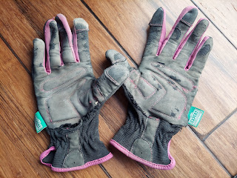

Monday morning, I headed out at 7:30 a.m. because I had a long day ahead of me. From Hwy 101, I took Hwy 20 East through Lake County all the way to Yuba City so that I could see the new Feather River Temple on my way. My timing was just a bit too early to go inside the temple for their special Open House (open to the public from Aug 19 - Sept 9), but I could still walk around the outside and take some photos in person.

This is the view from the south end where the parking lot is.

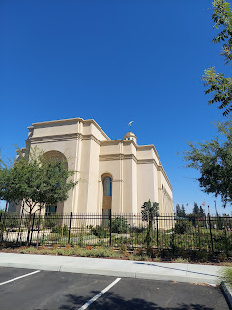

I was surprised that the temple is located right in the center of town! The police department was just south of the parking lot, and down the street was a Burger King! To the southeast, and across the busy intersection is the Sutter County Courthouse. To the north was another busy road with shops and restaurants (i.e. Ross, Target, Starbucks, etc.).

But as you walk around the temple grounds, there is a definite feeling of it being an oasis from the busyness of life. In each corner (N/S/E/W), there is a little olive tree grove with benches to sit on and just be quiet.

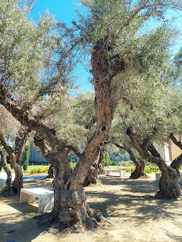

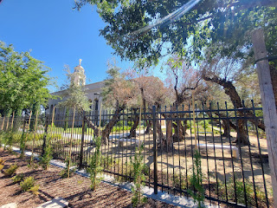

The landscaping was so pretty all the way around! And I saw several missionaries in their work clothes, tidying the grounds in preparation for the upcoming Open House. They were cleaning the iron fence, planting flowers, delivering mulch in wheelbarrows, etc. And they were all so happy! Even though it was very hot outside, they still looked up, smiled, and greeted me as I walked past.

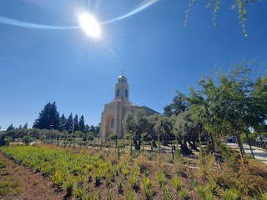

One of the missionaries even offered to take my photo in front of the main entrance on the north side.

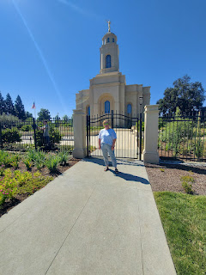

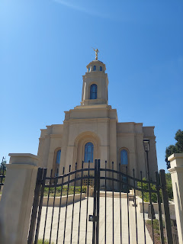

I called my Mom on a video call as I walked back to my car, so I could show her the temple and share my thoughts about what I was seeing in person. I also called my Dad right after that to share some of my experience with him, too. I think they will enjoy the scenic drives back and forth to this new temple, instead of muscling their way through gnarly traffic each time they've gone to the Oakland Temple in times past.

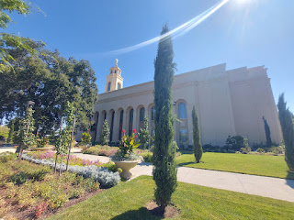

I made really good time to my next destination: Portola, CA. I thoroughly enjoyed the GORGEOUS drive on Hwy 20 over to Hwy 49, and then up and over what is called Gold Lake Hwy. Wow. Some of my favorite places I passed through were: Bullards Bar Reservoir (I crossed over a massive dam), several campgrounds along Hwy 49 that were adjacent to the Yuba River with huge boulders and cascades and waterfalls galore, Downieville - super cute and historic along the Yuba River, several resorts along the river - including one where you park next to Hwy 49 in a parking lot and then you cross over the river on a suspension bridge to get to your lodging (!), and Sierra City - which is right next to a section of the Pacific Crest Trail.

Just on the other side of Sierra City, I turned onto the Gold Lake Hwy, which took me UP into the mountains. I pulled over briefly to check out this scenic view . . .

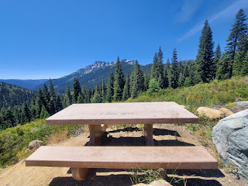

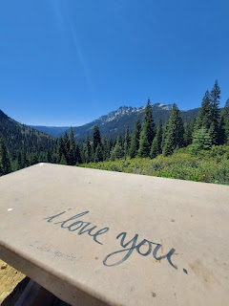

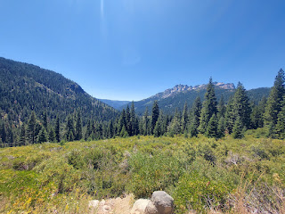

I didn't know this at the time, but as I looked at Google maps afterwards, off in the distance (in the photo above) was the Pacific Crest Trail. Che Bello!! (How beautiful!)

Even though there was an abundance of construction zones on my drive, including several one-lane roads where I had to stop and wait my turn with a long line of other cars, I still got to Portola within 10 minutes of when I told Valorie I would arrive. I was eager to see my 81 year old cousin, Valorie Sappingfield. Her mother, Mary Rawles Sappingfield, was the youngest sister to my Grandma Zola Rawles Snider (my Dad's mother). I like to stop by and see Valorie on my way home because it gives me a chance to share photos, news, and stories of other family members that I've visited with. She doesn't have any internet because she's hiding from the IRS . . . SHHHH . . .

Valorie and I went out to lunch and visited at her home for the whole afternoon. It was lovely. I'm always grateful for any time I get to spend with her, and I now realize that she won't be around for too much longer. Her breast cancer is back, but this time she doesn't want to do chemotherapy or anything that lowers her quality of life. She just wants to hang in there until "the Good Lord takes her home". She is such an amazing lady and I love her dearly. She told me on the phone after I got home that she thinks of me as her daughter. This is quite an honor, especially since she never had any children.

Valorie and me - at the same Mexican restaurant that we ate in last summer . . .

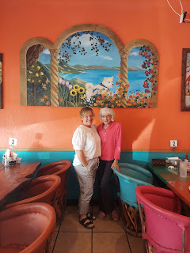

The rest of my drive to Winnemucca went smoothly. I listened to a variety of music and podcasts and watched the sun set on my left.

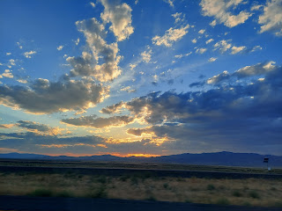

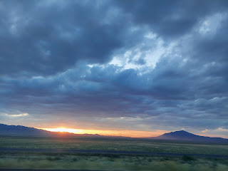

On Tuesday morning, I went for a nice long walk before getting some breakfast across the street from my hotel and hitting the road. As I walked down the main street of Winnemucca, I saw this giant cross-section of a Redwood tree from Crescent City. At first, I thought, "Yeah right . . . Winnemucca - the gateway to the Pacific Northwest?? That's a stretch!"

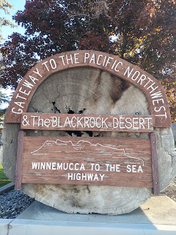

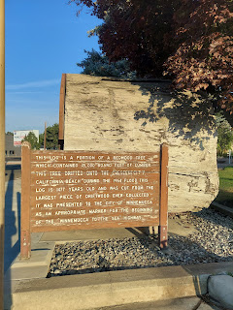

But then the sign on the side had an interesting tale to tell: "This log is a portion of a Redwood tree which contained 45,000 board feet of lumber. This tree drifted onto the Crescent City, CA beach during the 1964 flood. This log is 1477 years old and was cut from the largest piece of driftwood ever collected. It was presented to the City of Winnemucca as an appropriate marker for the beginning of the 'Winnemucca To The Sea' Highway."

I still don't fully connect the whole idea of 'Winnemucca to the Sea' . . . but since I drive through here regularly on my way to Mendocino County, CA - which includes the ocean, I
guess
I can sort of connect the dots . . .

A couple hours into my 7 hour drive, I stopped at the California Trail Interpretive Center near Elko, Nevada. I stopped there last summer and enjoyed it so much that I decided I needed to pop in there again. They also have some nice restrooms and some cute items to purchase for my grandchildren . . .

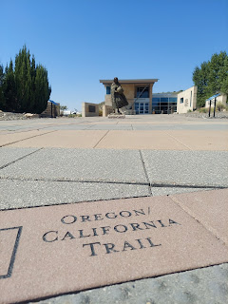

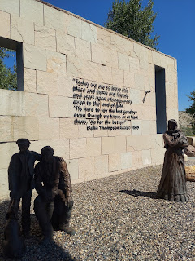

A couple hours later, I noticed a significant event that was about to happen to my car . . .

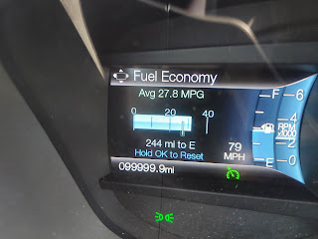

It turned 100,000 miles!! Wow. This car has been so good to me since 2019. :)

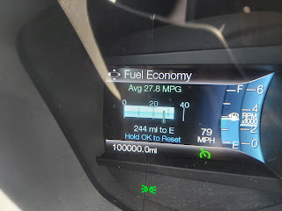

I made it home around 5:00 p.m. and spent an entire hour talking and laughing with Benson. It was so nice to be home, and I'm pretty sure he missed me, too.

On Wednesday and Thursday, I unpacked and cleaned some parts of the house. Benson and I went to the grocery store together and found some items to stock up on. He miraculously lasted 3 weeks without a car, and did a good job finding portions of food in the freezer and pantry to feed himself. But boy was he glad to come to the store with me, ha ha. I also sat down and made a long list of big things to take care of around the house, and I've been slowly crossing things off over the past several days.

When the pest control technician came to check the bait stations again, he found a little bit of activity in my food storage room and the utility room . . . I had taken a lap around the house before he arrived, to see if I could find any other entry points besides the chimney area on the south side (the one I plugged up a few weeks ago). I found a questionable spot on the north side, near the wood pile, and I had the technician look at it with me. We investigated the hole from the opposite side, which was in the garage, and found a definite entry point.

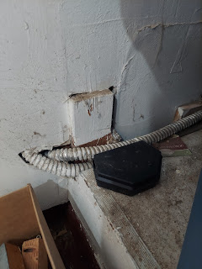

We knew it was "definite" because of the mice poops on the ground near the hole, and we had the pleasure/horror of finding a very dead mouse behind the box underneath the hole . . . GROSS. Thankfully he disposed of it for me.

I called my backyard neighbor (a retired master electrician), Don Blatter, to make sure it was okay to stuff some steel wool and SOS pads into the hole when there are electrical conduits coming out of the same hole. He said it would be just fine, and that the conduits are pretty robust. He said you could whack them with a hammer and probably nothing would happen . . .

So that night, I stuffed that hole "good and plenty" and sealed it up. I was surprised that I could fit EIGHT (8) SOS pads in that huge hole and then 2 additional steel wool scrubbies on the outside. The mice have been able to get into the whole house because they got into the inner wall in this very spot . . . man, if I had just known sooner . . . but at least now I have more confidence in leaving to go to Italy again soon, knowing that my house will be significantly more protected.

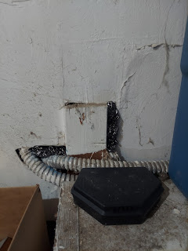

Benson has been working full-time on his car for what feels like forever, as I'm sure he will agree. My garage looks more like a war zone lately, but I know he is doing some great things and this is so good for him, too, to have a project to keep him busy.

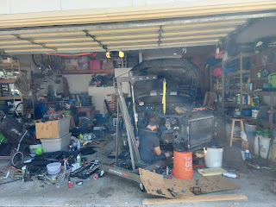

He is such a patient and diligent worker. I am genuinely so proud of him!! XOXO

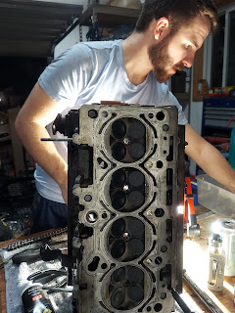

This is what he found to be the problem with cylinder #2. This is why it wasn't holding compression, and this is why the code kept saying "misfire in cylinder 2".

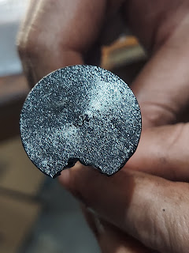

He looked like a skilled surgeon Friday night, carefully placing "keepers" in remote and tiny spaces . . .

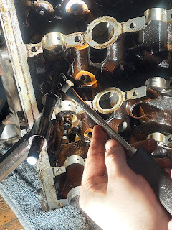

This is a "keeper", a tiny half-circle shape that he found a way to attach more precisely by putting a bit of goo on it first . . .

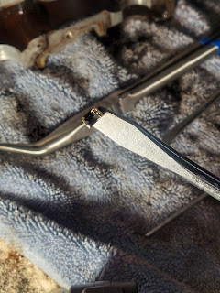

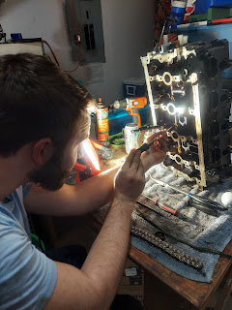

As of this writing (Sunday night), he has placed some large components back into the front end of the car, and he is hoping to be done putting everything back together by Tuesday . . . (God willing) . . . I hope so, too! I keep praying for him every single day.

Friday morning allowed me to have a wonderful phone date with Chelsea, my daughter that was placed for adoption almost 34 years ago. She is doing great! We chatted for about 90 minutes, with both of us multi-tasking most of the time. We were both cleaning around the house, which made us laugh, because we recognized that we are alike in so many ways.

Later that evening, Benson and I drove up to Rigby to see Grandpa Phil and Bev for a bit. Phil is doing alright still, even though he gets confused easily and prefers shorter conversations. He had a bandage on his neck because he just had a squamous cell spot removed and he has one more to be treated in a week or so.

Me, with Phil shortly before we left . . .

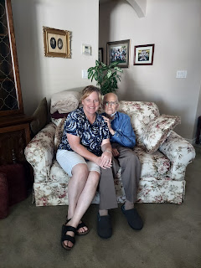

Next, we drove a little bit further north to see my niece, Natalie, and her husband Chance at the cute restaurant where they both work. It's called "Crush" and is primarily a boba drink shop, but they also sell crepes. Benson and Natalie were born the same year, as well as my niece, Ana. They haven't seen each other in a LONG time . . . We hung out for a while and had a great time. We are planning to get together again on Tuesday here in Idaho Falls.

L to R: Benson, Natalie, and Chance

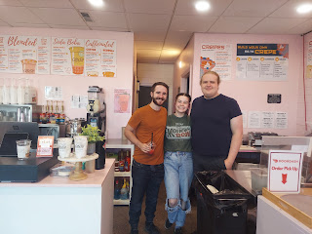

Natalie made me her specialty crepe with fresh peaches, lots of fresh cream, and cinnamon. It was AMAZING!! I kind of ate the whole thing once I got home, even though it made me VERY full, ha ha. It was that good.



I spent several days in a row helping friends in one capacity or another. By Saturday afternoon, I was exhausted and even a little grumpy. As I spent some time trying to figure out why I was so grumpy, I realized that because I am a naturally inclined "people pleaser", I had gotten a little out of balance. I needed a little time for myself, time to reset, and time to check a few more things off my own To-Do list. So, even though this coming week is a mixture of appointments for me and appointments to help a friend here and there, I will be more mindful of my need to have some occasional quiet space. I will take good care of myeslf so that I can continue to help others, something I really do enjoy doing. :)

