Happy Birthday to Me!!
I am 52 years old today. It's interesting, joyful, and a little unnerving to look back over half a century of memories . . . but I am truly grateful for every single experience I've had in life because each one has shaped me and made me into who I am now. I am so grateful for all of the loving influences that have made such a difference in my life as to how I see myself and feel about myself. I have had loving parents and grandparents who have told me they love me and who also showed it in their actions. I have been sufficiently nurtured, supported, and encouraged to become someone who leaves a positive influence on the world. I am so, so grateful.

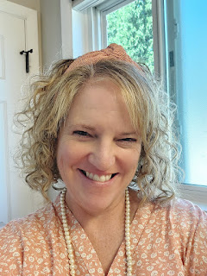

A gorgeous bundt cake that my neighbor, Kim, brought over - -

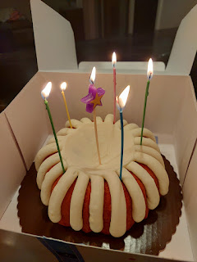

This photo kind of encapsulates my personality . . .

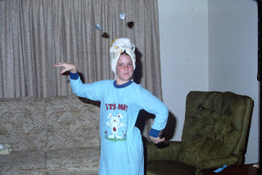

I like to smile and laugh and be happy. (Me, about a year old in Adak, Alaska with my beautiful Momma)

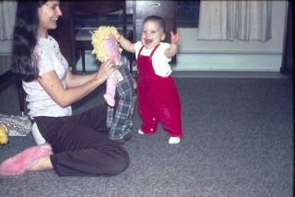

Perhaps 4 or 5 years old, with what looks like a Barbie package . . .

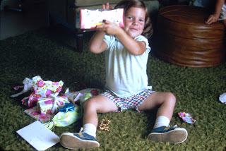

Rockin' those piggy tails in Yosemite National Park . . .

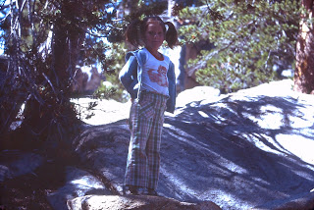

My 10th birthday - notice that it's half a cake . . .

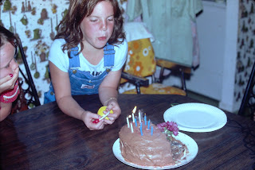

. . . because sometimes my sister, Charmaine, and I would share a birthday celebration, since our birthdays were only 10 days apart. In the photo below, she is blowing out her assigned candles, while I waited for my turn to follow.

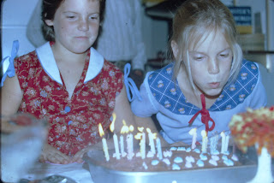

Life is so good and I am so grateful for it. Even with all of its ups and down, I am just so grateful for it all.

It has been a busy week, but a productive week.
There will also be a big surprise near the end of the blog . . . it has to do with jingly bells . . .

Monday, August 21:
I wasn't sure if I was coming down with something or not, so I slept in a little and didn't work TOO hard that day . . . I trimmed down the perennials out front and cleaned up all the mess. That's about it for the rest of the day, ha ha. I rested and watched a few episodes of Little House on the Prairie and just took it easy for the remainder of the day. :)

Even though my son, Benson, had tested negative for Covid, I still think he probably had it. The longer you go before getting tested, the weaker the possibility that you'll get a positive test result. He was about 7 days in before I got him a test, so it's possible that we waited a little too long.

I took several rounds of essential oils to beef up my immune system and thankfully I never got anything. (knock on wood)

Tuesday, August 22:
Benson was finally feeling better, so we went out to dinner to celebrate all the hard work he had put into his car for almost 2 months. He loves Indian food, so I treated him to Tandoori Oven, a place I have been to numerous times. He was in Indian Food Heaven.

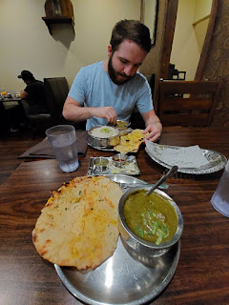

I ordered Shrimp Saag with Paneer Naan bread (cheese curds and mild spices on the inside). Benson ordered Lamb Saag with Garlic Naan bread. It was all very delicious!!

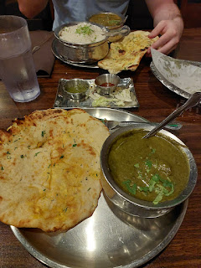

With my new phone, there are some silly filters to choose from in the camera app . . . I said, "Hey Benson, c'mere." And then, SNAP. Ha ha . . .



To bring closure to his weeks and weeks of working under the hood of his car, we took all the giant oil-and-other-fluid-laden pieces of cardboard out to the backyard firepit and made a bonfire.

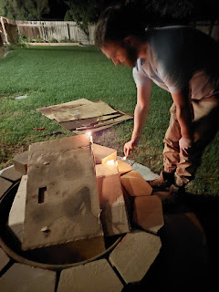

We might have been laying some extremely large pieces onto the flames . . .

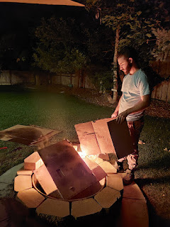

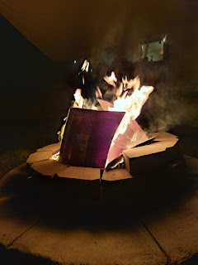

It got REALLY exciting at one point, because apparently cardboard makes big pieces of ash that like to float up above the fire and then land on things that they shouldn't be landing on . . .

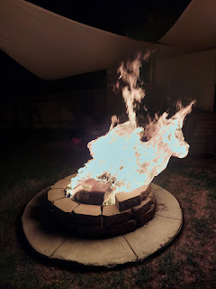

At one point, there was a piece of LIVE ash (it was definitely aglow) that floated up and landed on the nearby sun shade that is strung up between the trees and the house. We purposely have a large gap in the two shades over the firepit, and it's never been a problem before. But yikes - when it landed on the sun shade, I thought it might light up and then burn our entire house down!!

I grabbed the fireplace poker stick that we had with us and ran over to try to dislodge it somehow by poking it from underneath. I only succeeded in making a few holes in the shade itself . . .

It wasn't catching on fire, thankfully, but I was still in panic mode, so I ran over to grab the hose next to the patio. Wouldn't you know it, though, it had to be tangled up this ONE TIME. I fought until I got it untangled and the water was turned on, then I ran over and started spraying the entire back yard it seemed, ha ha. Moments later, Benson closed the sliding glass door to the dining room so I didn't spray into the house again . . . LOL

Thankfully, nothing caught on fire and all was well. We started cutting the giant pieces into smaller ones so that the flames didn't get so high, causing live ash to go everywhere. If a piece did rise up into the atmosphere, I quickly aimed my hose and shot it down.

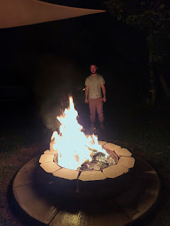

Eventually, after an hour or so, we burned up the last piece of cardboard. Benson hosed down the firepit really well and then we went to bed.

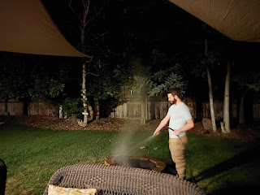

Wednesday, August 23:
I spent the morning pulling all the weeds along the back fence, and I ended up going a little nuts with trimming some tree branches at the same time. I usually trim the branches in the early summer, but I didn't do it all season long until now, so they were hanging pretty low.

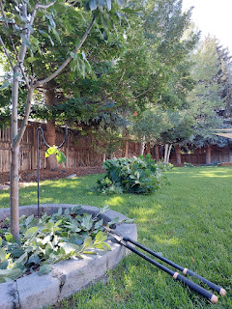

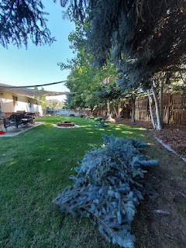

I ended up with six or seven large piles of branches across the back yard. Thankfully, the city will come pick up all our branches as long as they're bundled up and cut down to 4 feet or less in length. Benson helped me with that part. I wheelbarrowed the piles out to the front, and then he trimmed them down and tied them into bundles.

I also investigated the fire incident from the night before, and saw the holes that I had accidentally created. The dark stuff is the ashy mess just sitting on top of the sun shade. It's not ruined, as a whole, but it doesn't look that great either. Oh well. It will still function nicely next summer.

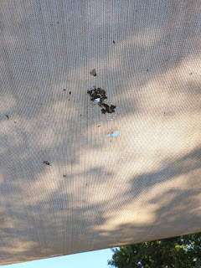

I got an early birthday gift from my son, Jacob that same day. It was a GINORMOUS bottle of Fish Sauce. On the note it said: "You were my cooking 101 teacher, and I would be nowhere in the kitchen without you. It's such an important part of me, and I have you to thank for that. I love you. Hope you have a happy birthday with no chores!!" (He has always tried to convince me to not work so hard all the time.)

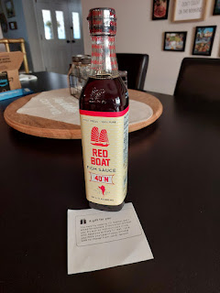

I have only used fish sauce a couple of times in my life, but he wants me to be brave and try it more often. He said when I get back, he will share some of his favorite recipes with me that call for fish sauce. My sister, Charmaine, also sent me a recent success that she made for dinner using fish sauce. She made Vietnamese-style meatballs with chili sauce and coconut-cauliflower rice as a side dish. It looked really tasty and I'd like to try it soon.

Thursday, August 24:
I drove up to Rigby to see Scott's dad and also to get some sewing advice from my sister-in-law Carol. I was able to visit with Dad for a few minutes before he headed off for a surgical procedure to remove some cancerous skin cells on top of his head. His surgery was a success, but it took 3 hours to get everything taken care of. He is now healing and in the caring and capable hands of his younger daughter, Bev.

Incidentally, my mom had the same procedure two days prior. Her surgery was more simple and didn't take very long, compared to my father-in-law's experience. She has been healing up nicely in California.

I didn't stay for long, because both Carol and Bev were "on the clock," working remotely for their respective employers.

Bev at her desk at one end of the family room . . .

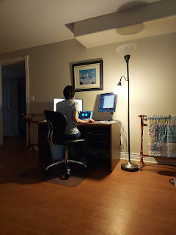

And Carol at the other end of the family room . . .

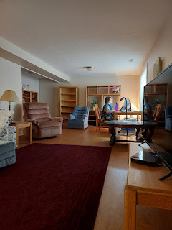

They are wonderful sisters to me and I love them both so much. Carol helped me figure out what I need to do to shorten a couple pairs of jogger pants with an elastic cuff, something I haven't done before. If I weren't about to leave the country, she said she'd take them back home to Boise and do them for me!

Later that afternoon, as I was organizing a few things downstairs, I rediscovered something important. I had looked for these photos in my cloud accounts recently, after Grandma Doris passed away, but couldn't find them. So I opted to take a photo of these precious framed pictures instead.

The photos were taken in 2015 when Amber and Weston came out to Ukiah, CA for a short visit when Abby was a few months old. We wanted to take some photos with 5 generations of mothers and daughters.

Top: Amber, Weston, and Abby
Middle: Amber and Abby
Bottom: My mom Linda, Grandma Doris holding Abby, Amber, and Me

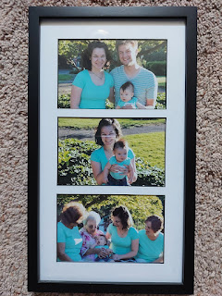

Top: Amber and Me
Middle: My mom and Me
Bottom: Grandma Doris and my mom Linda

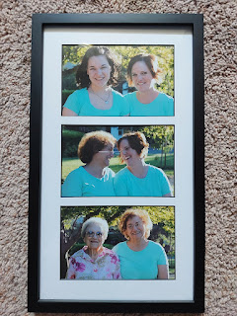

This one is such a treasure: Grandma Doris holding Abby. I think this is the only GREAT-GREAT grandchild she ever got to hold. Gwen never went out to Ukiah to visit and neither did Jack or Avery.

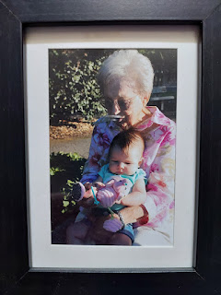

Sweet Benson . . . sometimes you just gotta close your eyes for 15 minutes and snooze deeply.

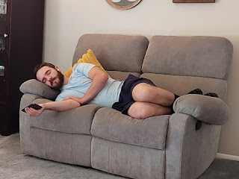

Friday, August 25:
I did a lot, I'm sure, but I can't remember much of anything, ha ha. That evening, though, I had the pleasure of taking some dinner to the sister missionaries. They were originally going to come to our house and eat dinner with us here, but I got a text that morning saying that they were needed at the Temple Visitor Center during their scheduled dinner hour, and could I please bring something to them instead. I told them I could be their "Door Dash" service and asked them what they were craving. They instantly responded, "CHICK-FIL-A!!" They texted exactly what they wanted (which was super helpful) and I ran to get it for them at 4:30 p.m. I only had to show the text to the kid working at the drive-thru and then wing-bam-boom, the order was done.

When I delivered the food, I asked the sisters if I could take their photo for my blog. A senior missionary offered to take a photo of all of us together - - even better!! They are two of the loveliest missionaries I've ever met. I wish I weren't leaving so soon, because it would be so nice to hang out with them some more. (By the time I get back, they will probably have transferred to another area.) They are cheerful, down-to-earth, friendly, kind, inquisitive, and confident in who they are and in sharing the light of Jesus Christ.

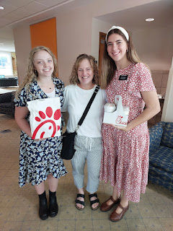

That evening, oh my goodness, a crazy storm came rolling in. It dumped who-knows-how-much rain in about an hour.

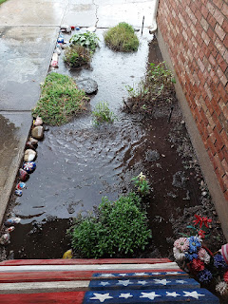

Video of the storm, looking out back: (17 seconds)
https://photos.app.goo.gl/hnCaz5d3NEvB7yXq8

Video of the storm, looking out front: (33 seconds) *Sorry I didn't get my flag down in time...
https://photos.app.goo.gl/AGr5EBW2r8w6QgyK6

With my new camera on my phone, I also took a slow-mo video just for fun: (14 seconds)
https://photos.app.goo.gl/oMhjGkZiRv32iz879

My friend, Amanda, posted a cute video of her kids after the storm, KAYAKING in our neighborhood!!



What a crazy and fun world we live in, ha ha.

Saturday, August 26:
I spent the bulk of the day decorating for CHRISTMAS!!! What in the world, you ask? Well, I just think about how nice it will be when I come home in December and the house will be so festive and ready to relax in, so I can simply enjoy the spirit of Christmas. Two of my three kids will be here for the holiday, so I decided to put in some effort ahead of time. :)

Benson helped me by getting all of the boxes down from the garage and setting both trees up.

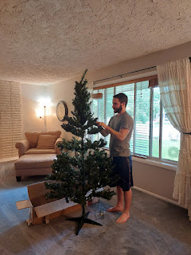

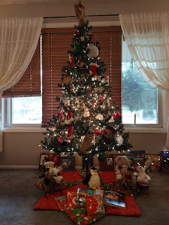

Notice that I have my front blinds closed to block the tree from view. I don't want passersby to know that I've decorated for Christmas inside . . . but I did tell my neighbor, Kim, that she could start plugging in the Christmas tree lights as soon as December hits. Maybe then it will look like someone IS home, and that's a good thing.

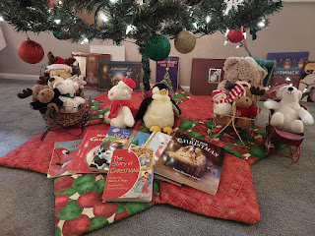

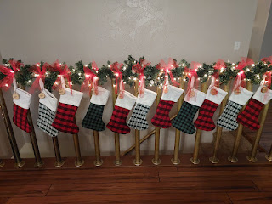

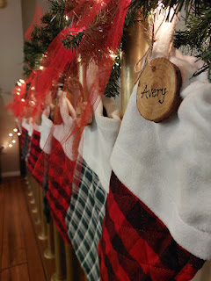

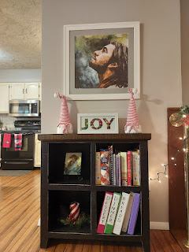

My sister, Melanie, crocheted me this beautiful Nativity set a few years ago and I love it so much!! I wanted something that my grandchildren could hold and play with. This is definitely one of my most treasured items that I take out of storage for Christmas each year.

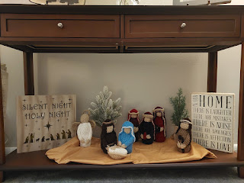

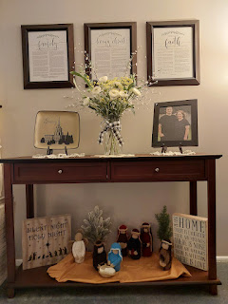

Meanwhile, Benson started prepping at noon for 3 racks of ribs for dinner. We had invited the Parkinsons over for dinner, as a way of saying thanks for all they do for us. They are seriously the best neighbors across the street and we are in debt to them for all their many kindnesses.
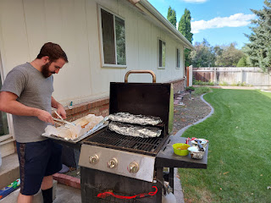

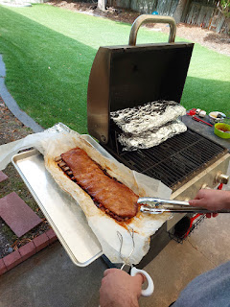

Benson prepped two of the rib racks with a dry rub, and one with a sticky rub.

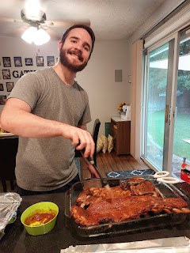

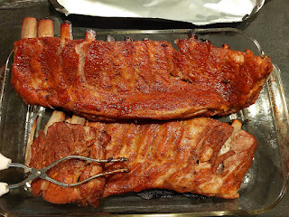

I may have mentioned this a couple weeks ago, but now I have pictures to go with it. I learned from my step-mom, Michelle, how to cook corn on the cob in the easiest way possible.

Step 1: No peeling or removing of strings needed. Just place the whole corn cob in the microwave as is. I cooked 3 at a time, a total of 12 minutes for each group of 3.

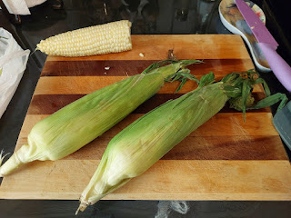

Step 2: Using oven mitts (or silicone gloves), carefully slice off the fattest end of the corn cob. (It will be hot!) The objective here is to disconnect the leaves from the end, without sacrificing too much of the corn.

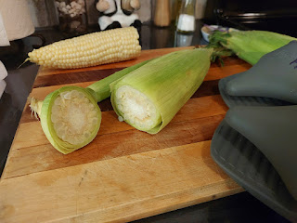

Step 3: Squeeze from the smaller, pointed end (with the tuft of silk hair). Squeeze firmly and you will begin to see the corn cob emerge as it slowly slides out of the opposite end. Think of it like you're birthing a corn cob. :)

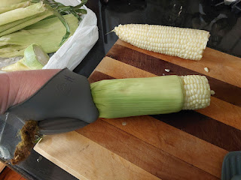

Step 4: Voila! A perfect corn cob, perfectly cooked, and 99.9% string-free!! The bundle of leaves just looks like a hollow sleeve. If the corn does not want to slide out when you squeeze from the other end, it may not have been cooked long enough. Try a little more time in the microwave, maybe 1-2 minutes. You may have to wrap the corn in something though, like a paper towel, perhaps.

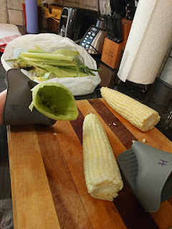

I love this method because it saves so much time!! I don't have to peel and shuck, and deal with all the mess and the impossible strings that you can never fully remove. I hope you have success when you try it as well! :)

I turned the corn into a lovely corn salad, using this recipe:
https://www.cookingclassy.com/corn-salad/#jump-to-recipe

*Note: I used the beautiful lead crystal bowl that used to belong to my Great Aunt Mary Sappingfield. Her daughter, my 81 year old cousin, Valorie, gave it to me on my way home from CA a couple weeks ago. It felt so great to put it to good use in my home now.

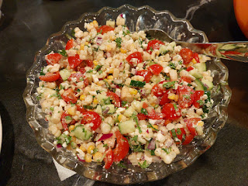

Thanks to the nearby grocery store, Broulims, I didn't have to bake anything for dessert. I just bought an assortment of goodies from the bakery and had Benson cut them up into bite-sized portions and arrange them on a platter. He did a great job! (Brownies, eclairs, cake pops, and cannolis)

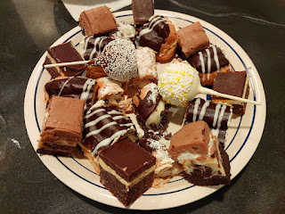

Oh - and we sliced up some French bread and set out several options for dipping. (I set out a little glass bowl for each person.) You simply add a little olive oil and some type of balsamic or flavored vinegar as the base. Then add salt & pepper, Italian seasoning, etc. You can pull off a little portion of the bread and dip it into your sauce to mop it up. It's so good!!!

I love the Lazy Susan that my brother, Ryan, made us for Christmas a few years ago. He turned a wine barrel lid from Napa, CA into a useful tool that we can use on the dinner table. It's so handy!

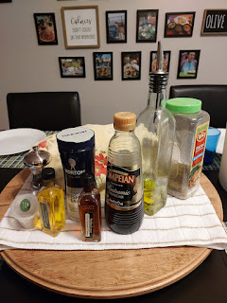

The dinner was delicious and we had a great time visiting and eating with our friends, Ben, Kim, and their kids, Mady and William. Their other son, Jackson, was at work for the evening.

After dinner, Benson and Ben set up a game of cornhole in the back yard. They played until it got dark, and until Benson eventually won. :)

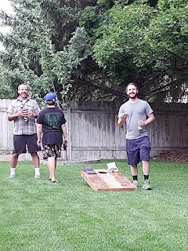

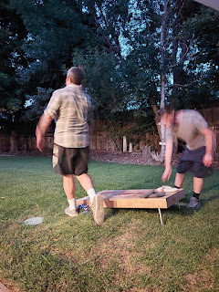

Sunday, August 27:
The anniversary of the day I was born. How delightful! I received numerous calls and texts from family and friends, including a couple of in-person visits. I felt very loved and remembered.

I even got a video call from my 2 year old grandson, Jack. With a little bit of coaching, he was able to say, "Appy dooday, Mammaw!" (Happy Birthday, Grandma!)

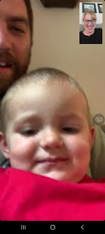



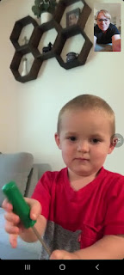

And then he proceeded to fix some stuff with his handy-dandy screwdriver.

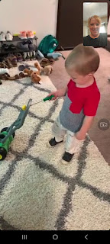

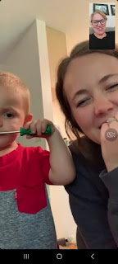

In one weeks' time, I will be hiking high up in the Dolomites of Italy with my sweetheart, and I look forward to being reunited after several long months apart. Don't be too worried if next week's blog post is a couple days late . . .

