A Quick Trip to CA & Then Off to Italy
This post is out of order, but that's okay. I figured I would get caught up at some point! I am at the Dallas/Fort Worth Airport, waiting to fly off to Italy again. I am comfortably set up inside the USO in Terminal B, where they have good Wi-fi, snacks, and relative quiet.

I recently made a very quick trip to CA and back, probably the shortest visit I've ever made! I intended to stay longer, maybe up to 8 or 9 days, but my medical situation called me back up to Idaho sooner than I wanted to go. I spent two days driving out, three days there, and then two days driving home.

I brought my niece, Mari, along for the ride, since she hadn't seen her family in a long time. We stopped in Winnemucca, Nevada for the first night. We had a hearty dinner at Sid's Restaurant, about a quarter mile from our hotel - AND the same place where Scott and I met my Dad for dinner back in April. We ordered a sandwich to share and a salad to share, and it was just the right amount. :)

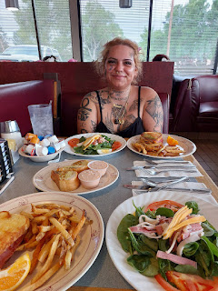

Once I dropped Mari off at her dad's house in Ukiah, CA the following day, I drove to the north end of town to stay with my friend, Jill Henrie Millward. We've had so many wonderful visits in the past few summers when I've come out to Ukiah, and she invited me to stay with her this time, which I happily accepted. It turned out to be a good thing, too, because with all the work happening at my mom's house, it wouldn't have worked out for me to stay there anyway.

Jill is one of my earliest childhood friends. We met when I started attending Primary classes at the Church of Jesus Christ of Latter-day Saints. I was only 6 years old. She is a very accomplished artist with multiple mediums: wood, ceramic, canvas, etc. Her entryway proudly displays a couple of collections that she made in recent years, which were also housed in the Corner Gallery on State Street in Ukiah at one point or another.

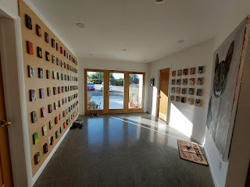

Her living room is simple and artsy, with concrete floors that are complimented by furry pillows and soft blankets on the couch.

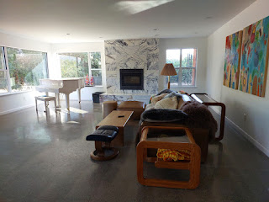

She often gets on a random kick of making multiples of something specific - like cats . . . or dinosaurs. This cute little grouping sits on her dining room table, and one of the dinosaurs serves as a flower vase. How fun!

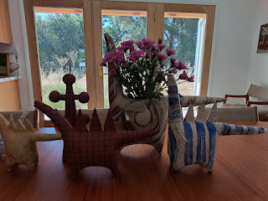

She made all of the dishes that she and her guests use for meals. Each one has a stamped, or embossed, design to claim it as her own.

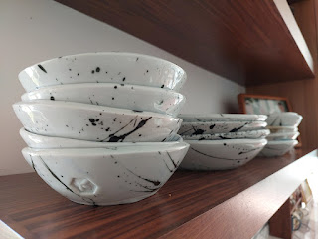

She invited me to go on a walk the next morning - after a very good night's rest. I was surprised to learn that the Lake Mendocino Dam was only a 5 minute drive from her house! And even more surprising, I guess, was realizing that even though I grew up in Ukiah, I had never ever walked across the dam.

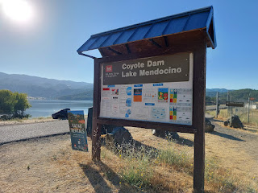

The morning was perfectly cool, a welcome relief when summer days in CA can be roasting and even brutal at times. I love that Ukiah can experience a high of 95-100, but then it will cool off to 55 degrees overnight.

Part of Lake Mendocino, as seen from the Dam . . .

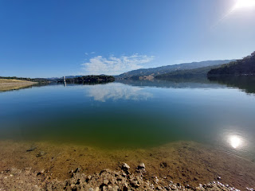

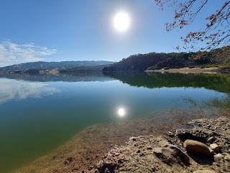

A single paddleboarder quietly cut through the calm water close to where we walked . . .

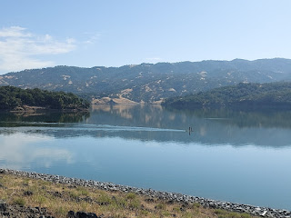

I saw the bright red of the dreaded poison oak from a mile away . . . well, maybe not a MILE away, but certainly my Spidey senses started tingling to warn me well in advance. In the past, if I even LOOKED at poison oak, it somehow appeared all over my body very soon after.

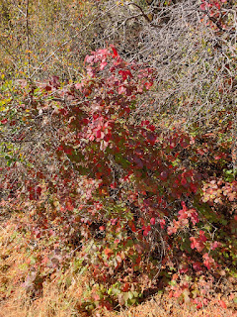

With as much talking as we were doing, I had to stop a few times just to get enough air to breathe. This was before my surgery, and I wasn't able to both walk AND talk very well. I could do one or the other, but not both.

When we got back to Jill's house, we saw a herd of goats nibbling in the vineyard that sits adjacent to her quiet cul-de-sac. She told me the cutest story as we parked the car and walked over to see them. Recently, she and her sister Sarah (who lives next door to Jill and also next to the vineyard) were outside when they noticed a baby goat who had somehow gotten outside the electric fence. The two sisters worked together to shepherd the goat and help her get back into the enclosure. Ever since that day, #86 (each goat has an ear tag with a number assigned to them) comes A-RUNNING whenever she hears one of their voices. She trots over like an excited little puppy whose master has just returned home for the day. It's the cutest thing you've ever seen!

Short clip of #86 getting some love from Jill: (3 seconds)
https://photos.app.goo.gl/sf4Ebb982XAemXdn9

Video of Jill and all the goats: (15 seconds)
https://photos.app.goo.gl/2C4ojYHRyiqS5Zwy8

Apparently, Parducci Winery hires a herd of goats and sheep to help eat certain areas of the vineyard that they want to change or swap out. There is a large dog that stays with the herd the whole day. Even though he is very friendly, he also knows that he's on duty and he is still very focused.
One more video of the goats (because they're so cute): (11 seconds)
https://photos.app.goo.gl/YavFD1NByX5kjjJw9

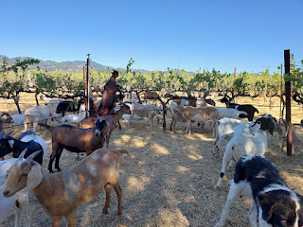

One of the goats didn't mind standing on top of a sheep in order to reach the grapes: (5 seconds)
https://photos.app.goo.gl/5Bqt5MVQjD3b46Lf7

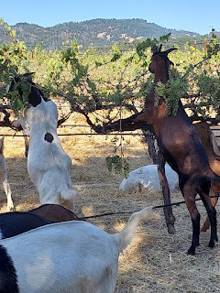

By mid-morning I was on my way into town to pick up a couple of respirators at the local hardware store and then I headed over to my mom's house. My doctor back in Idaho Falls had been extremely concerned when she discovered that I had an elevated level of D-dimer in some recent bloodwork. D-dimer shows a protein that is in the blood that CAN be linked to a blood clot or a recent blood clot that is being broken down. (There are other possibilities for the elevated level, too.) She did not want me anywhere near the mold remediation work that was going on at my mom's house, especially when we didn't have all the answers relating to my difficulty breathing yet, and she worried that maybe I had a blood clot in my lungs!

I was told that I should not participate in the mold removal and that if I intended to be in the house, I should wear a respirator mask. I was so bummed that I was "sidelined" and couldn't help at all. I love a good project - and especially one that would be helping my mom to have better health. But, dang it all, I had to be okay with just watching others do all the work.

My younger brother, Ryan, was such a champ! I guess my mom did a bunch of work already by spraying, scraping and/or treating the mold ahead of time (and yes, she did wear a mask). Ryan then started tackling the long list of tasks, and ended up completing roughly 75% of them before anyone else even showed up to help.

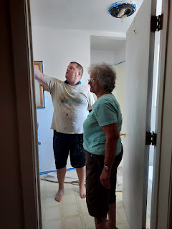

Unfortunately, Ryan also got hurt pretty bad the night before I arrived. He was stepping down off a small ladder onto the plastic dropcloth below . . . but the dropcloth moved as soon as his foot touched it (on account of the slick hardwood flooring). As he fell down, his ribs made a horrific contact with the paint can sitting on the floor . . . yikes. He's pretty sure he cracked at least one rib, but there's not a lot to be done when it comes to your ribs. My mom wrapped him up nice and snug and he kept on going for the next 3 days, just like an Energizer Bunny.

My Dad stopped by to drop off some games that I had ordered for the Rawles Reunion. We had fun setting them all up together in the living room. It has always been so nice to see my parents get along and be so kind to each other, even though they divorced many years ago. They have set such a good example of how to be not just civil - but to go one step further and to actually be caring. The world could sure use a whole lot more of this . . .

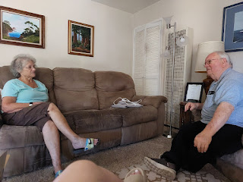

Something I COULD do to help out was to make dinner. My mom had all the supplies, so I got to work putting everything together. After we ate some shrimp salad, I had to dash off to find some camp chairs for the reunion in the morning - and before the stores closed that night.

In the morning before the reunion, Jill asked me how I wanted to paint the platter that I had made the summer before. I told her I loved the splatter pattern that was on her dishes in the kitchen, so she taught me how to do that in her studio.

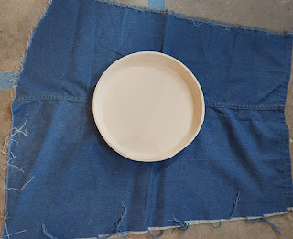

I wanted a "before" photo, but then Jill plopped down onto the garage floor next to the platter because she said it needed "context". Ha ha

So, here is the context . . .

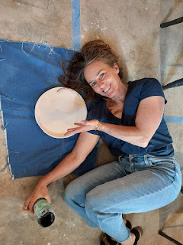

Video of Jill explaining how to do the splatter technique: (19 seconds)
https://photos.app.goo.gl/v8Q661w2nHFB658W7

This is how it turned out after I gave it a "go" . . . Jill would add the glaze and then fire it later that day for me.

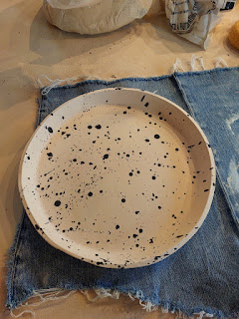

Another one of Jill's collections . . . this one is an assortment of fried eggs . . .

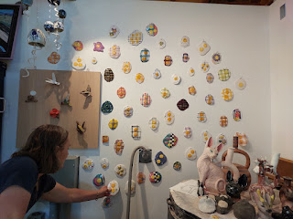

The Rawles Reunion was held at the Rawles Ranch just north of Ukiah - home of my cousins, Tom and Kathy Rawles.

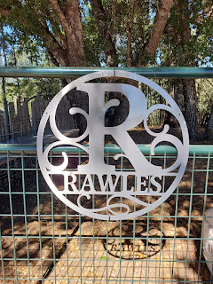

They, too, have a large herd of goats! But their bunch are much stockier than the ones next to Jill's place.

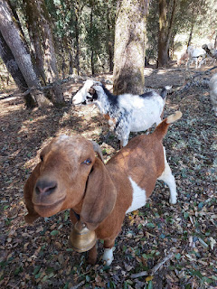

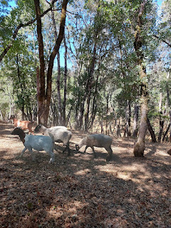

I hardly took any photos at the reunion because - and prepare yourself for a shock - I was visiting with everyone the whole time! I know . . . it's so unlike me to be such a chatterbox . . .

The event was short and sweet, with only 2 scheduled hours. It felt like it went so fast! Family members brought their lunches and chairs, and I made sure to make my way around the whole circle within the two hours.

Before everyone left, we took a group photo. The hilarious thing, though, is that when Ryan set up his phone on a feed bucket and turned the timer on, he ran over to stand next to me . . . only actually the timer didn't work and his phone snapped a photo before he even had a chance to get in the frame! So he's missing entirely from the group photo, darn it. We didn't even notice until after the reunion was over and everyone was gone.

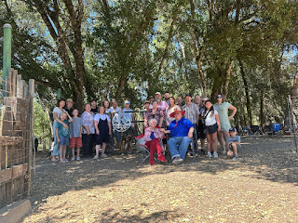

It felt like the reunion was a little bit underwhelming this year for some reason. Maybe because it was so short? Maybe because I forgot to bring anything to share from my large treasure trove of Rawles history and heirlooms? Or maybe it's because deep down, I do actually miss some of those favorite activities from the past but I just didn't want to be the one in charge of them . . .

I'll be chatting with some cousins in the coming months to figure things out for next year and how we can make some improvements without making it "too" elaborate. The most important thing, in my opinion, is to just be together. Everything else is the fluff. Some fluff can be great. If there's too much fluff, then nobody wants to be in charge for the next one . . .

After the reunion, I hopped into my Dad's car and we went on a little gallavant. We drove into Calpella to try to see the area where my Aunt Naynee used to live. I have fond memories of visiting her and Uncle Bill when I was a little girl. We got as close as we could to where their old house used to be, but the private road was gated off near a storage facility. We stood where the railroad tracks used to be, and I took a photo from across the field. Now, there appears to be just a house next to a large greenhouse facility where pot is being grown. How sad.

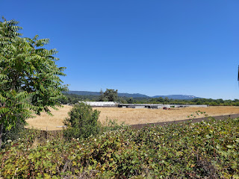

From there, we drove into Ukiah and treated ourselves to some ice cream at the Mexican ice cream shop next to Raley's. It hit the spot. We visited for a while and enjoyed our little table for two.

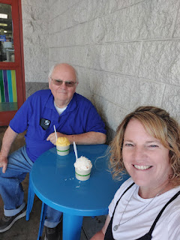

Back at Mom's house, she and Ryan were hard at work. They had been painting and doing trimwork in her upstairs bathroom as well as the dining room downstairs. I did help just a tiny bit by taping along the window and floor so that Ryan could paint. I felt so pathetic by not doing very much, so I convinced Ryan to let me do some caulking, too. That felt better. Then I wasn't just sitting there watching my brother work so hard with his broken ribs while I just sat there and cheered him on.

My sister, Melanie, was a hero from the sidelines as well. She wanted to contribute in some sort of way since she couldn't come up from Arizona to help, so she provided a tasty dinner that we didn't have to cook. XOXO All I had to do was go pick it up and voila . . .

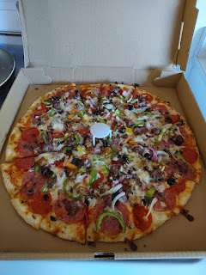

This is such a cute photo of my mama . . .

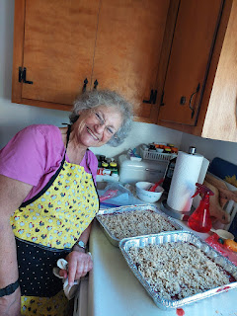

She has some fertile plum trees in the back yard, and one of the most delicious things she makes is plum crisp. She made two large pans of the plum crisp, in between all the other work she was doing with Ryan. We all helped to devour one of the pans, and then she sent the second pan with Ryan when he left to go home on Sunday afternoon. I'm not 100% sure about this, but I think that plums might be his favorite fruit.

Meanwhile, my older sister Charmaine and her husband Scott were making their way up from San Diego to come lend a hand as well. They started the day in Scott's plane while we were at the Rawles Reunion and it took about 7-8 hours to fly up to Ukiah. They had to navigate around some wildfire smoke down in Southern CA and it was a little dicey for a while, but they figured out a new flight path while circling up in the air.

I was able to watch them land at the Ukiah Airport and pick them up after they secured the plane and gathered their belongings.

Video of them landing: (55 seconds)
https://photos.app.goo.gl/X6xgACHo1mCEjRjE9

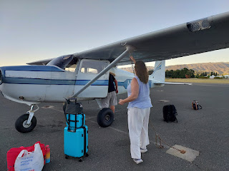

This guy, with his cracked rib(s) . . . nobody could tell him to stop or to rest. He is one determined man.

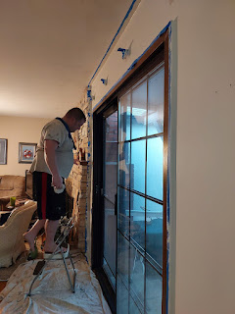

On Sunday morning, I rode to church with Jill so that Charmaine and Scott could have my car for the day. Charmaine had plans to get together with her two daughters, even though half of that plan fell through. Ana was not able to come up from San Francisco, so Charmaine spent the bulk of the day with Mari instead. Scott was dropped off at the Ukiah airport again so he could fly down to Santa Rosa and spend some time with his dad.

Church was wonderful, as it always is. I sat with my mom, and it always feels like I'm coming home when I attend the Ukiah Ward. This is the ward that took me under their wing when I was a teenager, like a hen gathers and protects her chicks. They consistently showed me through their kind words, their kind actions, and their generous prayers in my behalf, that when we fail in life, it's not the end, and that everything will be okay. I love them all so much!

Several of my old friends sought me out after Sacrament meeting and we visited for several minutes. I think I convinced a couple of them to come stay with us in Italy! (Grace Johnston and Nathan Clark, along with their spouses of course)

My mom teaches her cute little ones in Primary, so she went off to be with them while I eventually made my way to Sunday School. After church, I rode home with my mom so I could hang out with her and Ryan again. :) Ryan was still hard at work when we arrived, but we weren't surprised. I changed out of my dress and offered to help a little.

We did pause long enough to take some photos at one point, ha ha.

Me and Ryan . . . my younger, but much taller brother.

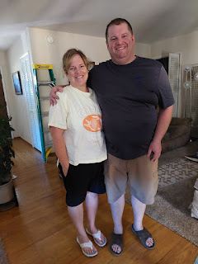

Mom and Ryan . . .

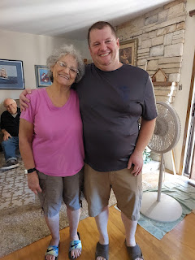

Dad and Ryan . . .

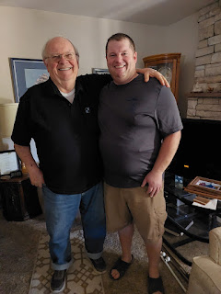

My father gave me a priesthood blessing that afternoon, as well. I was grateful because it seemed likely that I would end up having surgery back in Idaho, even though I hadn't met with the second ENT yet. I always feel so full of peace after a priesthood blessing. It's just one of the ways that Heavenly Father is able to let me know that He is aware of me and wants to bless me in some of the ways that I need.

Since Charmaine and Scott borrowed Mom's old truck (it used to belong to Frank), I had my car back and could drive myself back over to Jill's to get ready to leave the following morning. When I got there, my platter was all done. Formed, painted, glazed, and fired. It turned out so pretty!

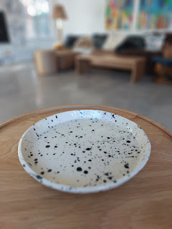

For context, ha ha . . . (even though Jill wasn't there to lay down next to it!)

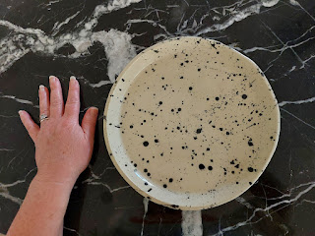

Jill was in town having dinner with her parents and sister, so I had the whole house to myself for a bit. I decided to open up her gorgeous piano and tinker for a little bit.

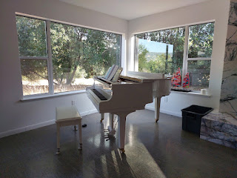

I played one song after another in the new and updated hymnbook for our church. It felt so good to just play and make music and enjoy the quiet for an hour or so.

Video of me playing one of the songs: (1 minute, 42 seconds)
https://photos.app.goo.gl/bc8y5ghm3q3kfVKq8

These photos are out of order, but I got them a little later from Charmaine. I was caulking along the baseboard area in the dining room.

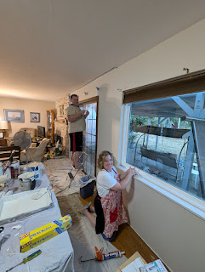

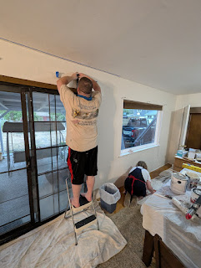

When Charmaine got back over to Jill's house (we were all staying there together), we decided to go on a walk and spend a little sister time before I had to leave early the next morning.

There were some ripe blackberries to pick first, just outside the front door . . .

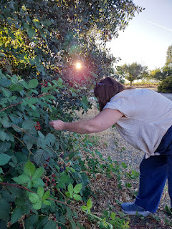

An interesting mailbox that we passed by on our walk . . .

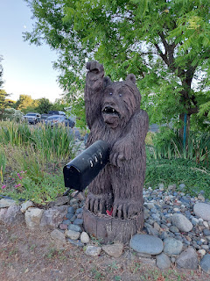

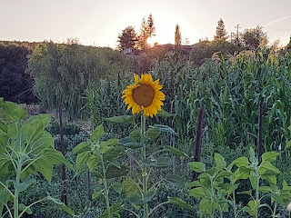

We walked down Tollini Lane and all the way to the opposite end of the vineyards that belong to Parducci Winery. The sun was almost setting . . . the "Golden Hour" . . .

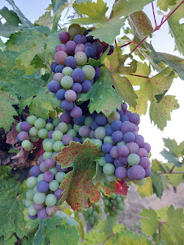

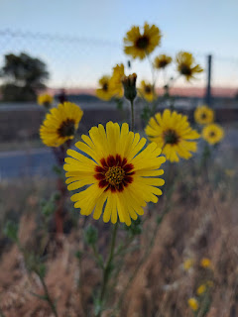

My Irish twin sister and me . . .

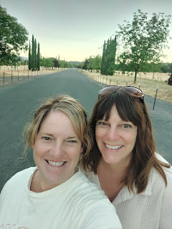

Jill now has TWO hairless cats. Ken is older and more reserved. Fred, short for Winifred, is very precocious and curious. She started licking Charmaine's hand, which made her laugh. She said, "Oh my gosh! I've never touched a hairless cat before . . ."

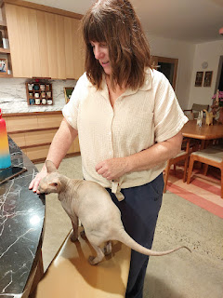

Jill wanted to go on one more walk with me early Monday morning before I left town. She led me through the vineyard, even helping me to climb over the electric fence at one point. We had to cut through one of the rows to get to another section where there was a much wider path to walk on.

As we walked in the coolness of 6:30 a.m., before much of the world is even awake, all of a sudden we heard the bleating of a little goat off in the distance. Jill hollered out, "Number 86?? Is that you??" And sure enough, it was!! She heard us talking from afar and recognized Jill's voice. What a precious.

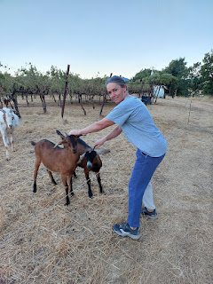

We followed the path for a few more minutes before turning back so that I could finish getting ready to go.

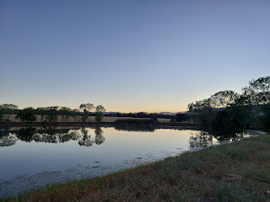

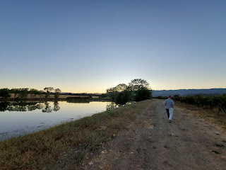

My time in Ukiah was way too short, but it was still special in so many ways. I got to see both my parents (and my step-mom), my brother Ryan, my sister Charmaine, my friend Jill, friends at church, and lots of cousins at the Rawles Reunion. I have a finished platter that I helped to make. I received a priesthood blessing. I had a lot of wonderful conversations in those three days. My heart was full.

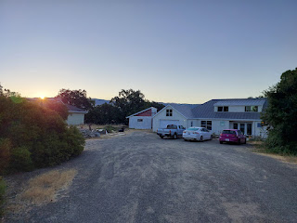

We took a little selfie before I hit the road . . . Me, Jill, and Charmaine. XOXO

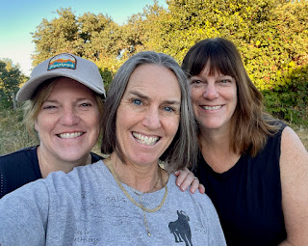

Mari ended up bringing a little puppy home to Idaho with us. With the recent loss of her 15 year old dog, Ducky Momo, she and her father Bernardo arranged for her to get a "replacement". She was going to bring home an older dog that needed to be re-homed, but he turned out to have a few too many ailments and problems. So Bernardo got her an 8-week old toy poodle puppy instead! She was really sweet on the drive, sleeping 98% of the time.

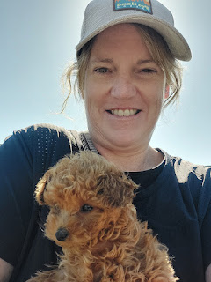

We stopped by to visit my cousin, Valorie, as I have made it a tradition to do so in the past few years. She is 83 years old now and lives in Portola, CA. She is slowly declining due to a return of her breast cancer, but she still has a strong mind and determination in life. She has decided to just let nature take its course and she is not pursuing any chemotherapy or radiation. I don't want her to get to the point of suffering, but I don't want her to go anytime soon, either.

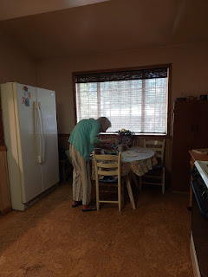

She insisted on making us something for lunch, which I thought was especially sweet since I know she gets tired easily. She made us a simple Chinese chicken salad with reheated cornbread on the side. It was delicious and heartwarming all at the same time.

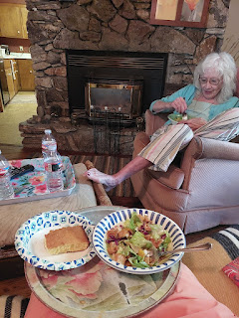

I don't usually stay longer than 90 minutes or so, since the drive is already quite long to get to Portola and then on to whatever hotel I've set up in Nevada. We had about 8 driving hours on Day One - from Ukiah to Portola to Winnemucca, Nevada. And this didn't include any stops for gas or potty relief . . .

Every time I visit Valorie, I always ask if we can take a photo together. Last summer she was not in a good frame of mind to be in a photo, thinking that she looked too skinny, or too this or that. But this summer, she was happy to participate. We had Mari take a picture of the two of us. :)

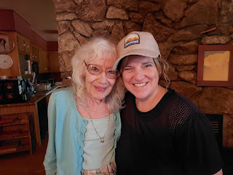

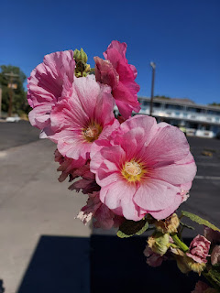

In Winnemucca, we ordered food from a BBQ place down the street and then we brought it back to the hotel to enjoy. Because the puppy was too young and hasn't received all of her shots yet, we couldn't take her for a walk or anything. So Mari had fun playing with her on the bed in their room instead.

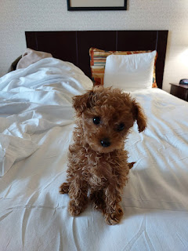

The next day, we had roughly 6.5 hours of driving to get through, but it turned out to be a dramatic drive, through some epic obstacles. You wouldn't know it from this next photo, though . . .

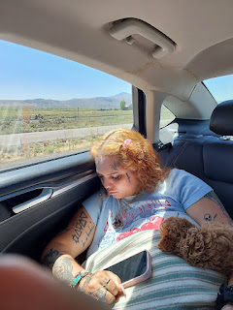

Literally, those two slept in the back seat for 98% of the drive from California to Idaho . . .

Incident #1:
Shortly after we turned north from I-80 at Wells, Nevada, we noticed some dark smoke in the hills ahead. This is a curvy and mountainous stretch that goes from tiny Wells, Nevada to even tinier Jackpot, Nevada with about one hour between the two.

Maybe 15 minutes into the hills, we reached the origin of the smoke . . . it was a wildfire that had started next to the highway!!

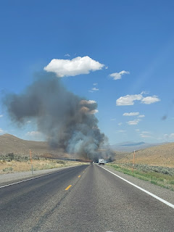

We could see the angry orange and red flames up ahead, and we stopped in the middle of the road to assess what to do next. A semi had pulled over in front of us, so we waited for a minute to see what he decided to do. Vehicles slowly began to share the left lane, alternating whose turn it was to carefully pass by the fire and navigate through the billowing plumes of smoke.

I took a short video as we approached: (4 seconds)
https://photos.app.goo.gl/89KpkF7n17VewegE9

And Mari took a longer video as I drove through that section: (34 seconds)
https://photos.app.goo.gl/S1F9jaFJZmMATX769

She said she could FEEL the heat from the bigger flames on her side of the road. But I was too busy concentrating behind the wheel to notice . . .

That was one of the scariest things I've ever had to navigate through! Obviously the fire was fresh, since it was completely unattended out in the sagebrush-filled wilderness. My hope was that people would report the fire as they pulled into Wells, since that was the closest town, even though it was now behind us. However, for my peace of mind, as soon as I came into Jackpot 45 minutes later, I made sure to pull into a truck stop to dash in and report it as well. There was no cell service anywhere in between the two towns, which is so frustrating every time I drive through there. This is 'Merica!! It's so important to be able to make phone calls if something goes wrong up in the mountains.

I learned later that Highway 93 between Wells and Jackpot was shut down for a period of time (in both directions) while the fire was brought under control. So we just barely squeaked through before we couldn't get through at all . . .

Incident #2:
Maybe 5 minutes north of the wildfire, I came around a corner and had to hit my brakes pretty hard and do a little swoopedy on the road to avoid some huge chunks of tire that were cluttered all over my lane. I found a smaller piece to straddle and then I kept on going. My pulse was still a little high because of the fire behind me, but now I felt like I needed to be on high alert for the rest of the day!

Later that afternoon, when we were only about 35-40 minutes from home, the next thing happened.

Incident #3:
Traffic came to a complete stop next to Blackfoot, Idaho. Construction work had been happening frequently on the drive, but this section had something more significant going on. We just didn't know it at first.

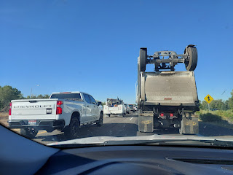

Signs had already been posted to indicate that we were merging into one lane ahead, but as we sat there for several minutes and didn't move, we began to get a little frustrated. 15 minutes. 20 minutes. 30 minutes went by and we didn't move - AT ALL. People started flipping around on the interstate by crossing the median to then head the other direction. Others used the onramp next to us (on our right) as an offramp instead! Mari needed to go to the bathroom and was getting very dancy in the back seat. I suggested that maybe she could open both the car doors on the right and use them as a shield to go potty on the road, but she didn't want to. And I can't blame her!

So what did I do? I called 911.

When I was asked my location and the nature of my emergency, I said that we were on I-15 north and next to Jensen's Grove (the main lake on the outskirts of Blackfoot). The emergency was that we had been stuck for almost 40 minutes now and I had someone in the car who needed a bathroom badly, but we had no idea of what was going on and why we weren't moving at all.

She put me on hold for a minute and then came back on to tell me that there had been an accident about one mile north of us. A semi truck - who was hauling either one or multiple bulldozers - had hit the side of a bridge going up and over I-15, had punched through the wall and overturned onto the median of the interstate below. WOW.

I asked how long it might take to get traffic moving again. Her answer: it could be a good long while to clean everything up. My next question was: Is it possible to cross the median and take the exit directly across from us into Blackfoot? Her answer: Well, ma'am, that would be illegal. But I'm not going to tell you what to do or what not to do. (What I heard in the fine print was that I could do whatever I needed to do.)

Traffic was stopped in both directions, so it was much safer to attempt to get across this one time. So I did! The median was pretty steep and full of very dry grass. I had been running the car that whole time with the A/C on because it was in the 90's outside, and the last thing I wanted to do was to start a fire because my undercarriage might connect with the weeds. But I made it across safely, we took that exit that was right across from us, we found a McDonald's within 2 minutes, and Mari made it to the bathroom. I also took the puppy out to go potty while Mari was inside, so all was well in the world.

Thankfully, I knew of an alternate route that could get us home. I drove further into Blackfoot so I could connect with Hwy 91, even though Google Maps kept wanting me to get back on I-15. I was not about to fall for that trick, though.

What should have taken us 30 minutes to get home, took us closer to 1.5 hours instead. And I did see on the news the following day that I-15 was shut down until almost 11 p.m. the night before!! That means that the interstate was shut down for about 5 hours!! Holy cow. I wonder how they got everyone else moving . . . Did they open up a detour of some kind? I guess I'll never know. I'm just glad we found a way out of that mess.

The following morning, I met with the ENT (Dr. Hall) who recommended surgery to fix my breathing issue in my throat. We began lining up a date for the surgery and getting approval from insurance.

I attended the neighborhood/ward party and brought a large corn salad to share. Meats were provided, including fried chicken, pulled pork, and brisket. Everyone else brought the side dishes and desserts, depending on what letter your last name started with. I had a good time visiting with several friends that I've known for years, including these two beautiful ladies: Amanda Whipple (left) and ReNae Cunningham (center).

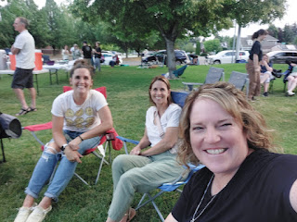

As I walked home from the party, I got a phone call from Amber. She basically said, "So....I know this is gonna sound crazy, but we are ready to leave in about 40 minutes and we're gonna drive all through the night and we'll see you around 8:00 tomorrow morning."

Whaaaat???

Weston (who now prefers to be called West) wanted to attend his high school reunion in Rigby, Idaho. I think he really wanted Amber to come with him, so they decided to drive all Thursday night and spend a little more time with family on Friday and Saturday before driving home again on Sunday.

Amber drove the first 6 hours and then West drove the last 4. Everyone arrived safely, although exhausted. I made Abby some hot chocolate and then when I tried to take a photo of her, she made this face, ha ha.

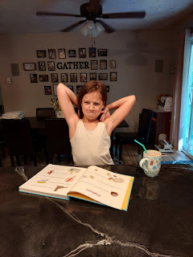

It was a nice and slow Friday, especially for Amber and West, who took a loooooong nap for several hours. I hung out with the girls and we had a good time.

On Saturday, I suggested we do a Spa Day. I washed Abby's hair over the sink while she relaxed and felt like royalty.

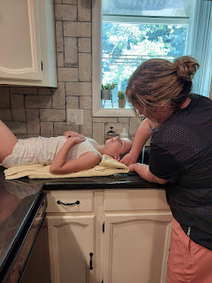

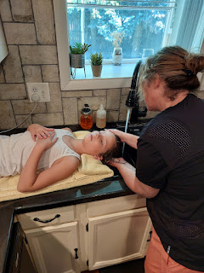

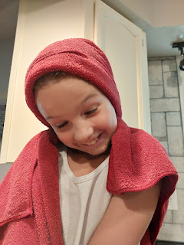

Gwen worked on pulling out another loose tooth until she finally had success . . .

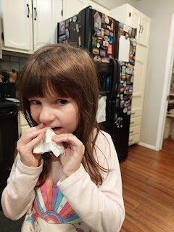

I painted the girls' fingernails and toenails in whatever colors they chose . . . (Abby's hands here)

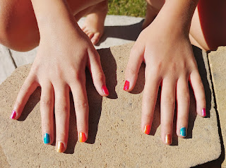

First, Gwen smiled as cute as Matilda (a darling movie on Prime) . . .

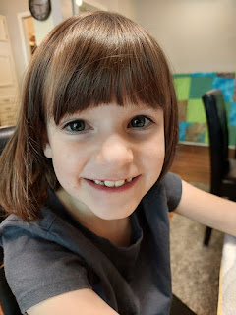

And then she wanted me to take a picture of her with this face . . . LOL

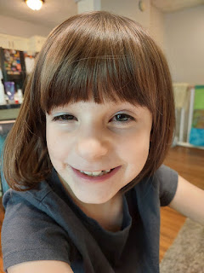

Gwen wanted her fingernails to be painted in the color scheme of Wicked - Glinda is all about pink, and Elphaba is typically decked out in vibrant emerald green.

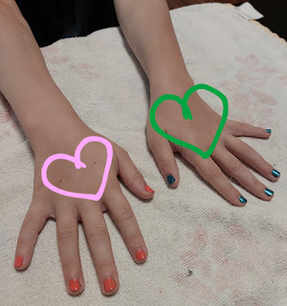

Everyone helped me to harvest all the remaining rhubarb still in the garden - and it was a LOT!! Abby wanted to help trim off the ends, so I let her do 90% of the work. She tried a few of our suggested techniques for using the giant knife, but the one she liked the best was to lay the rhubarb stalk down on the cutting board and then WHACK each end off (with her hands waaaaay out of the way, of course).

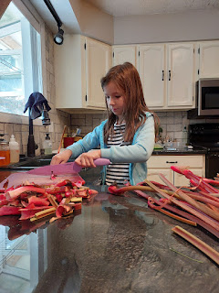

Video of her technique here: (5 seconds)
https://photos.app.goo.gl/TzjFMFA7SH8bVgsF8

I stayed next to her the entire time to supervise and cheer her on. She stuck with it clear until the very end! I was quite impressed with her diligence.

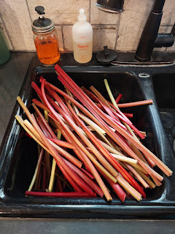

After they were all cut, she even wanted to stay and help wash the hundreds of stalks and stack them on the towel to dry.

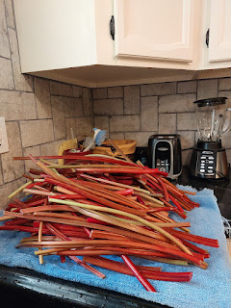

By the time we were all done, we had filled 6 gallon-sized bags full of rhubarb. Amber took one bag home with her and made some rhubarb cream cheese danishes for breakfast. Wowza! I gave all the other bags away to friends at church. In the grocery store closest to our home in Idaho Falls, rhubarb sells for a hefty $5.99/lb.

In the middle of the afternoon, we all drove across town to attend the Annual Ukiah Reunion, hosted by Steve and Lisa Morales. This is a reunion for people who grew up in Ukiah, CA, but who now live in places like Idaho and Utah. Lisa (whose maiden name is VanderStoep) was one of those special people who encouraged me and motivated me to want to stay close to Jesus Christ when I was going through hard times in high school. She was 2 years older than me, I think, but she was (and still is) such a dynamic person. They went all out with everything they provided at the reunion!

They have a beautiful and spacious property west of the Idaho Falls Airport, with chickens, a train car that they want to convert into an AirBnB, a playground, lots of shade, and a beautiful home. They made oodles of pulled pork that was to die for - seriously the best I've ever had in my entire life, along with cole slaw, beans, and a variety of other side dishes. Some people brought desserts to share - including some incredible lemon bars that were made by Jamie McKell. First of all, I had no idea he was a baker, even though he comes from the womb of his very talented mother, Marie McKell. For many years, she always brought homemade bread for the young priesthood boys to break and bless as part of the Sacrament portion of our Sunday meetings. Her bread was so good that I always wished I could eat the entire tray . . . I learned at the Reunion that Jamie is so talented that his friends wish he would open up a bakery in Idaho Falls or Rigby.

This is the group photo that was taken at the Reunion just before we had the privilege of eating some of the incredible food that was provided . . .

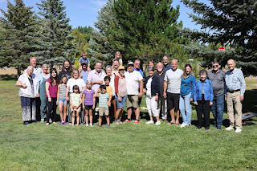

I'm standing a few people in from the left, surrounded by Amber, West, Abby and Gwen (in front of me). Lisa is barely visible in the back row - sort of in the center. She is wearing an olive green shirt, next to Scott Butler (who is wearing a royal blue shirt). Lisa's husband Steve is to the right - tall, silver hair, and wearing a dark blue shirt.
Amber and her family left after the photo was taken so that they could go up to Rigby and visit with Weston's family a little bit more prior to his high school reunion. After I spent some time at the Ukiah Reunion, I drove to Rigby to pick up Abby and Gwen from their cousin's house. We stopped at the Sonic once we got back into Idaho Falls so that the girls could get something protein-packed into their depleted tummies. They were having too much fun playing with cousins and could not bring themselves to eat anything earlier. While we waited in the drive-through line, I told the girls they could unbuckle in the backseat. They wanted me to open the sunroof so they could pop up and see the views from "way up there", and then they would laugh and giggle together in the back seat. :) What cuties.

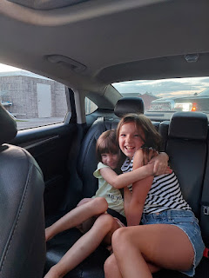

After Gwen ate her footlong hot dog and Abby finished her cheeseburger, I took them over to Orange Leaf for some frozen yogurt. I'm pretty sure they've been here before, but it must have been a long time because to them it felt like a brand-new experience. We happily ate our treasure-filled bowls and then I took them home to get ready for bed.

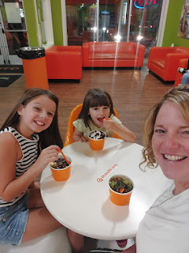

Amber and West had a great time at the high school reunion. They came home later that night with lots of fun stories.

And then, all too soon, the weekend was winding down and it was time for the Whitworths to drive back up to Portland . . . darn. We were having so much fun! They left on Sunday morning, within moments of me needing to walk over to church around 8:50 a.m. They left a big hole behind . . . in my heart, that is.

I'm so grateful that they could squeeze in one more trip down to Idaho so I could see their faces again.

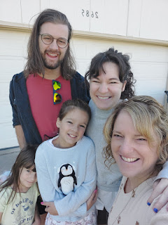

And off they went . . . with girly hands waving from the back seat . . .

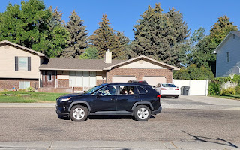

Something that I saw on Instagram recently has meant a great deal to me. This is a snippet of quotes from a recent general conference talk given by our beloved prophet, President Russell M. Nelson. He is always so encouraging and uplifting, but these words have brought me so much peace and confidence in recent weeks.

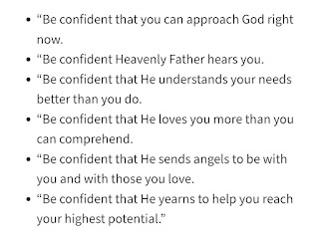
I was only able to attend the temple ONE TIME during the entire month that I was in the U.S. I had one additional appointment set up to go, but then I was having some tummy issues that day, so I canceled and just stayed home instead. I look forward to going to the temple this fall - whether it's in Italy or another country, it makes no difference.

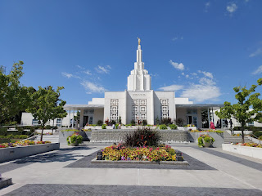

In the final days before I left Idaho, my dishwasher stopped working. Thankfully, I have some really good friends who are also very capable and handy in a situation like this. Between Ben Parkinson (standing) and Scott Anderson (looking underneath the dishwasher on the floor), they were pretty sure it was a connection issue with the GFCI outlet, and not a failed dishwasher. Either way, we got the standing water to drain out (yay) and then I left the door cracked open for a couple days to air it out completely.

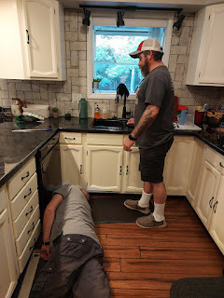

I also helped my sweet neighbor, Sherry Hanks, to be able to log into FamilySearch so she could begin some projects on her family tree. It took some time and effort, and we ended up having to call for help down in Salt Lake City, but they were so kind and instructive on the other end of the phone. We got her all logged in now, and she is eager to start adding memories and stories to her section of the worldwide tree. If I weren't leaving town, I would have taken her over to the FamilySearch Center across town and helped her to scan all her boxes of documents, photos, and stories that she's so excited to work with. I ended up having to "hand her off" to another very capable friend, Steve Meyers and his wife Julia. They will do a great job!

Sherry is such a spunky gal at 80 years old . . . she always looks on the bright side and figures that every experience in life - good or bad - has something valuable to teach us.

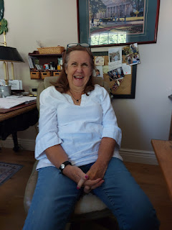

She always heads down to Tucson, Arizona each winter to live in a little trailer with her sisters. They go 4-wheeling in the desert, they read books for hours a day, they laugh and giggle together, and they even go rock hunting regularly. She showed me her impressive collection of agates and other gems that she's found down there. There are so many large and beautiful rocks that are on display in her home . . .

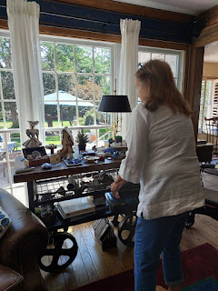

On another occasion, I took my niece, Mari, out for a picnic dinner. We decided on some Indian food, and then we hauled our "loot" and some camp chairs in my little blue wagon until we found a nice little shaded spot next to the Snake River. The massive waterfalls were on the other side of the river across from us. It was so peaceful and tranquil and very therapeutic to sit there, eating our delicious food, and listening to the sounds of the river and the birds up in the trees.

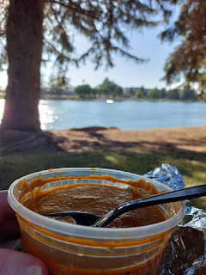

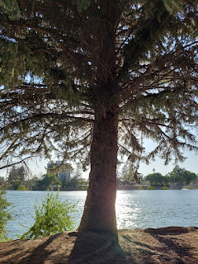

This was also the night before my throat surgery . . . (see the previous post for more details)

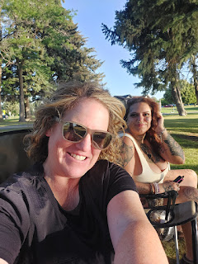

I came home after the picnic to find a thoughtful gift box from my Mom sitting on the porch . . .

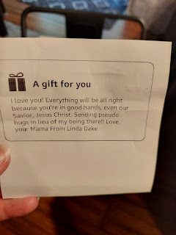

It was full of all kinds of goodies: a cute insulated mug, a candle, a bath bomb, a handsome smelling bar of soap, a face massage set, an eye mask, some fuzzy socks, and a little blanket. She found it on Amazon - and what a great find! I felt her love across the miles, and I basked in her thoughtfulness as I prepared for surgery early the next morning. XOXO

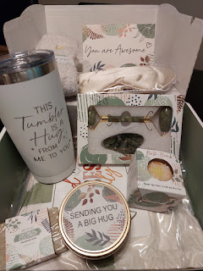

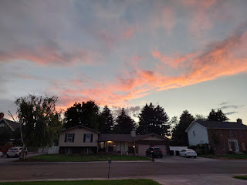

As I shared in last week's post, surgery went well. I can breathe better now and I am healing muy rapido. :)

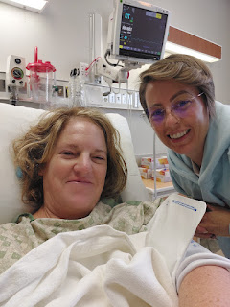

Two days after surgery, I was invited to a surprise party to celebrate the recent 60th birthday for our dear family friend, Peter Vance. He shares the same birthday as our son, Jake (July 30th), but the party was a couple weeks later on Sunday, August 17th. I estimated about 80 people who came to be part of the surprise. He is such a good man and a good husband to my friend, Barb. He has stepped in numerous times to help our kids in the last 20 years, especially whenever Scott was gone with the military. He is also the person who bluntly told me I needed to get my throat checked because "that's not normal". He was totally surprised when he came into the back yard after a nice long walk with his oldest kids, and there we all were, whooping and hollering. :)

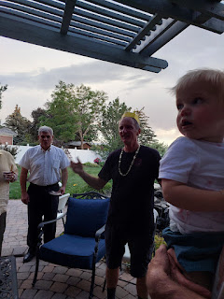

In the final days before I flew off to Italy, I took some family history items across town to get them scanned onto a thumb drive. I spent 3 hours scanning photos and documents relating to Scott's second deployment to Iraq in 2010-2011.

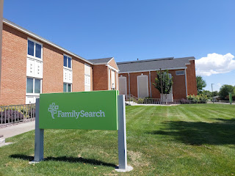

I couldn't find our family's most cherished treasure - a green binder with all of our printed chat conversations and emails from his first deployment to Iraq in 2004-2005. I looked all over the house multiple times, and I even prayed for help to find it . . . but no luck yet. I had the thought that maybe I sent it in our shipment of household goods to Italy. I'll let you know if I find it as I begin to unpack all the totes of stuff that we shipped back in April. I hope and pray that I'll find it . . . because I don't know where else to look.

I had my post-op appointment with Dr. Hall, which included another camera shoved up my nose and down my throat. It was smaller than this little doo-dad (below), but I struggled way more this time than the other 3 times I've had the "privilege" of having this done. I think it was harder this time because I still had some swelling after the surgery, and my gag reflex was more poignant. I'm just thankful that I didn't throw up on him by the end . . .

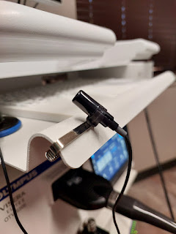

Lastly . . . I drove down to Salt Lake City to pick up Benson from the Airport on Wednesday. He had first driven West's car back up to Portland for them on Tuesday, after borrowing it for the past year or so. He spent the evening with Amber and the Fam, and even slept on the couch with both cats curled up on top of him or nestled in somewhere next to him, ha ha.

I sent a text to Amber asking for proof of Benson on the day he drove 7 hours to get up there. This is what I got in response . . . XOXO

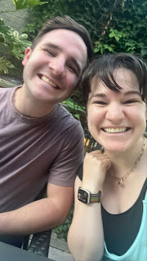

The next day, Amber drove him to the Portland Airport so he could fly to SLC and spend the night with me. But first, lots of hugs from the girlies . . .

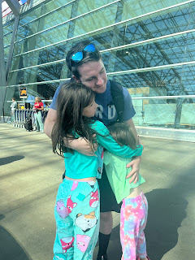

Benson, Amber, Gwen, and Abby XOXO

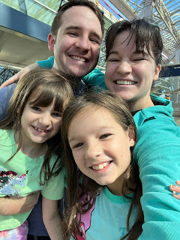

While Benson's flight was in the air, I was driving down to SLC. About halfway there, I got a warning on my dash saying that there was low tire pressure. I thought it a bit odd, since I had driven to CA and back with no problems, and I had been driving it around town since then with no problems either. It was concerning to me that the warning popped up as I was flying down the interstate at 87 mph. I was also in between cities and it would be about 25 minutes or so until I got to the next one (Malad).

I had just started to listen to a general conference talk, but as my mind began racing with all the possibilities, I couldn't concentrate on the person speaking so I turned everything off. I said a prayer asking for help to get safely to a place where I could take a look and/or get the problem fixed. I continued to drive with laser focus, both hands on the wheel, and a listening ear for any guidance that might be whispered to my mind from the Holy Ghost (i.e. slow down, be careful here, prepare for ___ ).

I didn't ever feel the need to slow down, so I didn't.

The
very moment
that I took the exit heading into Malad, I heard the tire going WHOOMP WHOOMP WHOOMP WHOOMP, and that's when I knew it was very, very flat.

First, I parked at the Maverik gas station next to the exit so I could take a look. Wow.

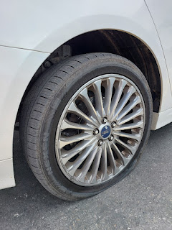

Then I went inside to ask the clerk where I could get a flat tire fixed in town. He showed me on his phone where Ron Keller Tire was, and thankfully it was just a little ways down the same street. After I limped the flew blocks with my hazard lights on, I parked outside the shop. As soon as I walked inside, there was a kind man who greeted me and asked what I needed. He directed me to pull into the shop right away and told me that they'd take good care of me.

I used their bathroom and then settled into the waiting room where Mr. Lynx was very welcoming, ha ha. I sent out some texts, including this photo to my husband and children. Amber's reply was: "Does Mr. Lynx like sports?" I answered, "He does! And he says to tell you that he likes badminton." Amber quickly quipped: "He gives off that vibe for sure."

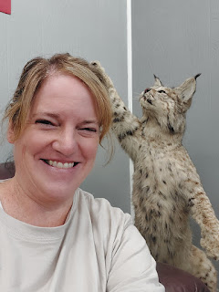

I barely had enough time to send off those couple of texts, play one round of some game on my phone, and then they were all done! They had already let me know that the tire was completely shredded and not salvageable, and I had given them permission to put a new tire on. After paying $268 for the new tire, I was back ON THE ROAD in less than 20 minutes!!

I gave them a 5-star review later because that's the maximum amount of stars that I could give. I was in awe of how fast they took care of the problem, and I was also very grateful for their kindness and the respect that they showed to me.

As I began my second half of the drive down to the airport, I said a prayer out loud to thank my Heavenly Father for blessing me so abundantly and keeping me safe. I mused for a while on all the possibilities that could have happened instead . . .

~ The tire could have blown in an instant instead of the moderate pace of deflation.
~ I could have ended up with a flat tire in the middle of nowhere.
~ I could have gotten the flat tire south of Malad in the crazy busy and very densely populated cities in Utah, where the construction mess was insane and it would have been a lot more dangerous for me to pull over or get to a tire shop.
~ The flat could have happened to Benson the next day as he drove my car back to his home in Mountain Home. Mostly just farmland and nothing much but fields and windmills on that drive. He could have been stuck out in the middle of nowhere.

However . . .

~ Heavenly Father loves us a great deal. He is in the details of our lives.
~ He knew that if He gave me a warning, I would listen.
~ He knew that the warning needed to precede a good place to get the problem fixed.
~ He knew that I was trying to hurry to pick up my son.
~ He knew that Ron Keller Tire would be a great place to get the help I needed.
~ He knew how to conduct that symphony of events so that I could have the best possible outcome.

Not all scenarios turn out as well as this one did. But that doesn't mean that Heavenly Father isn't in THOSE details of our lives. There is always something to be learned through whatever we are working through. We need to be humble enough to listen, and then be committed enough to do whatever it takes to accomplish the end goal. He will help us during each step of the way. This is what pure, divine, and enduring love looks like.

As it turned out, Benson's flight was about 15 minutes late, so when I pulled up at the curb to pick him up, I had to wait about 10 minutes for him to catch up to ME!!

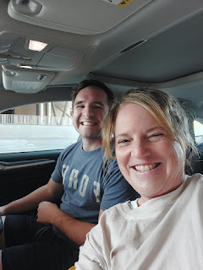

I happily switched places with him so he could drive us back up to Idaho Falls. He is such a good driver and I always feel very safe with him. It was nice to just kick back in the passenger seat and watch the world go by.

We stopped to visit the Smith & Edwards store just north of Ogden, Utah - one of my favorite stores ever. They have so much to offer inside their huge warehouse, and I usually end up spending a good hour as a pit stop. I love their kitchen gadgets and tools, their wide assortment of spices, and all the toys/puzzles for the grandkids. They also have some unique snacks and chocolate bars. For example, I bought Scott a chocolate bar with peanut butter & jelly in it. He hasn't opened it yet, but he laughed when I gave it to him. He's a huge PB&J fan.

Benson told me I should send a picture of this sour warhead blue raspberry flavored PICKLE to Amber, since she doesn't like pickles. He thought this might entice her . . . would you eat it? I remember bringing home all kinds of fun flavors of pickles for Benson when he was a teenager. He loves pickles so much. I like pickles, but I wouldn't say that I love them nearly as much as he does.

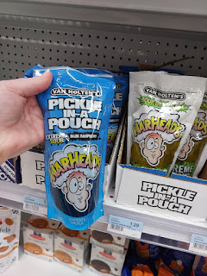

Benson marveled at everything the store had to offer, including their camping equipment, BBQ grill and smoker accessories, etc. He ended up buying a couple of spice bottles for some smoked meat and came out of there with a huge smile on his face.

We drove a little further north to Tremonton, Utah to get some dinner. I chose this Mexican place because it was rated 4.8 out of 5 stars, but I didn't know it would turn out to be a BUS, ha ha. How cute.

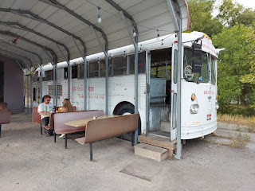

They had so many tasty options to choose from . . .

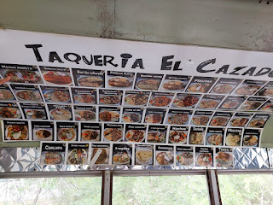

Benson chose the smothered burrito with pulled pork . . .

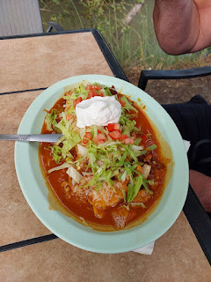

And I chose the chicken fajita platter . . .

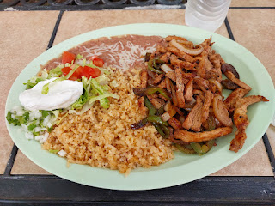

Both were absolutely delicious. We sat at a table behind the bus and next to a canal with water cascading over a small dam. There was a huge fairgounds across the street, and we learned from the owners of the bus that the Box Elder County Fair is celebrating their 100th anniversary and that this was the opening night of the Fair. We saw dozens of horses from our little table, and I wished that we had time to go over and visit with them. I love vibrant Smalltown America communities such as this one. And I really miss a good rodeo. I haven't been to a rodeo in a few years now - I'm always here, there, and everywhere instead of just parking myself up in the stands.

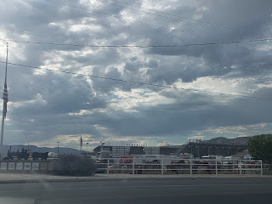

Benson and I talked almost nonstop on the 3-hour drive home. We had a great time. I'm so glad I had the opportunity to be with him again before I flew over to Italy. He is such a good man.

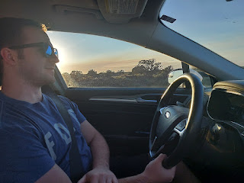

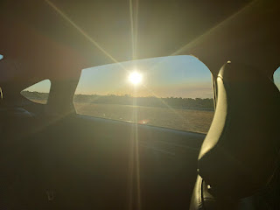

I made it safely to Italy three days later on Saturday morning. Scott picked me up and brought me home to Vicenza. I didn't get one single minute of sleep on the 10-hour overnight flight, so I took a little nap after lunch. What really did the trick, though, was that I slept for 10 hours that night. It felt absolutely amazing.

Now, I'm not only digging into getting this house cleaned over here, but I'm also starting to unpack and organize all the totes that we sent in our shipment of household goods. It finally arrived after 13 weeks (instead of the 7-9 weeks that they told us). It's kind of like an early Christmas right now, ha ha. I'm having fun pulling out all the stuff we sent to Italy so long ago: family history stuff, kitchen stuff, fabric and crafting stuff, and some cute wall art from Hobby Lobby.

Scott had his first day of teaching seminary this morning. The 20 or so students meet at the military high school on the smallest base in Vicenza, "Villagio". It's about a 15 minute drive from our house, and they meet at 6:45 a.m. - 7:45 a.m. From there, he drives straight to work.

We will be figuring out a good evening routine in the coming days . . . I want to make sure to have a nice dinner for him each night, and we also want to go to the gym together a few days a week. I'll have to be efficient with my time in order to make those two things happen between 4:30 - 6:30 p.m.

Buuut . . . it feels nice to settle in again. This will be the longest stretch ever of being in Italy. And I don't hate the idea one little bit. :)

