Catching Up On Life Again
This post will be a little bit of this and that . . . stuff that's been happening in between and amongst the bigger events in recent weeks. :)

Right before I flew to the U.S. for a month, Scott and I shared an evening with some of our friends from the Vicenza Ward. Tevin and Kelly Campbell hosted the dinner at their home, which is part of an Italian Villa near Monte Berico. Kelly has the cutest hobby: she collects glass "rocks" that have been smoothed by the ocean and she incorporates them into the most darling greeting cards.

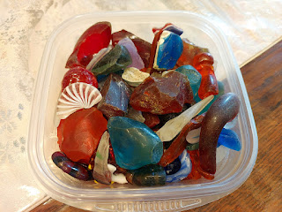

She's spent hours on several beaches in Italy, Ireland, England, etc. - digging around and collecting these glass "rocks". She makes sure to label them as to where they were found, and she makes a tiny note on the back of each greeting card to acknowledge where the rocks originated from. Each of her cards sells for roughly $10. I didn't include any photos of her work, because, well, I'm respecting her artistry. But I'll share a couple of ideas that she's used:
Depending on the shape of the rock, she might make it into a Santa Claus gnome, drawing a long beard and legs to further enhance the folksy image on the front of the card.
Or she might place 3 similar sized rocks, all small and a beautiful shade of light green, forming them into 3 birdie friends sitting on a telephone wire together. She adds beaks, legs, and a few minimal extras to the scene with a high-quality pen.
After Kelly showed us her latest cards, Rachel (to my left) cut up the cake that she brought while we all continued visiting. Below: Rachel McGovern (pink shirt), Kelly Campbell (dark blue shirt), and Marnie Parker.

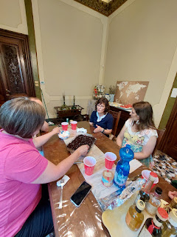

Rachel's son, Jacob, spent a few minutes looking through Kelly's glass rock collection in the living room after our meal. She has tupperwares and ziploc bags of glass rocks in addition to this beautiful - and very full - tray. Kelly can tell you where every single rock came from . . .

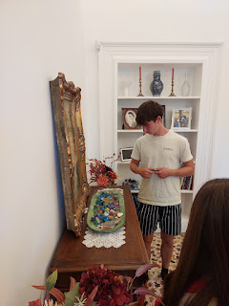

This was our dinner group that night, which was to celebrate one last meal with the Parkers before they moved up to Germany.

L to R: Kevin Parker, Ava Parker, Olivia Parker, Scott, Me, Marnie Parker, Rachel McGovern, Kelly Campbell, Jacob McGovern, and Tevin Campbell.

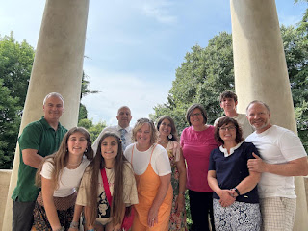

Also, I finally got a photo from Sister Terry Sim (one of the Military Relations Senior Missionaries in our ward here) with all the quilt squares that she assembled together for the USO a few months ago. The two squares that I made are near the bottom - the USA heart and the Italy heart.

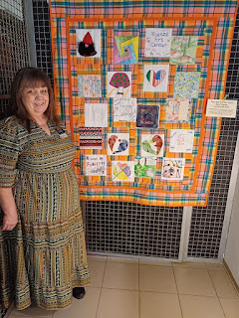

Scott and me, as he dropped me off at the Venice Airport to fly to the U.S. for a month (July 22 - August 23).

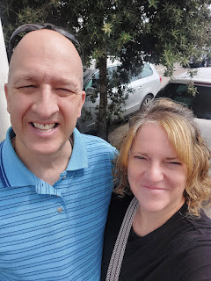

Shortly after my return to Italy from the U.S., I began taking note of the gorgeous sunsets behind our house again. If there's ever an evening WITHOUT a spectacular display in the Western sky, it is a rare occasion, indeed.

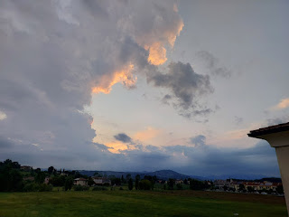

I don't know what kind of flower this is, but holy cannoli . . . look at the size of those blooms!!

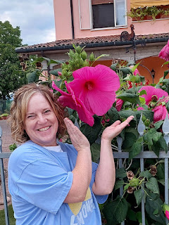

On one of our evening walks, I enjoyed taking a few pictures of the freshly tilled fields near our house.

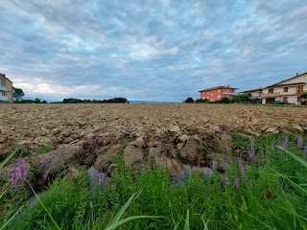

And those heavenly, colorful skies once again . . .

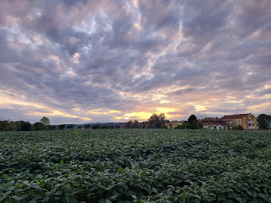

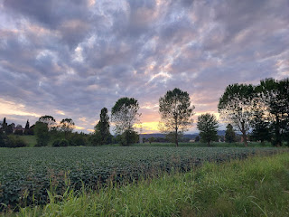

One night when we returned home from a walk, I saw the largest snail I've ever seen . . .

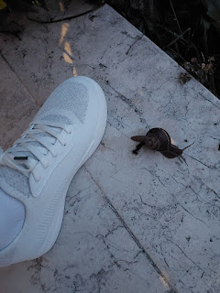

And now, it's time for the stars of the show . . . My Grandchildren!!

Maisie is such a doll. She has so much personality!! From a distance, Scott and I were under the impression that she is super chill and sweet and demure. But Jacob corrected us one day, ha ha. Maisie likes to be right in the thick of whatever action is taking place, and she gets frustrated if she's too far away from whatever "it" is. It could be Jack reading a book, or playing with his stuffies, or eating a snack. It could be Mom and Dad laughing about something. She wants to be RIGHT THERE. :)

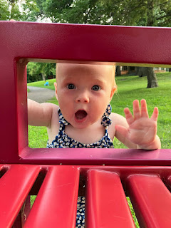

There are several parks and nature outings close to where Jake and Hannah live now. He sent us these two photos and challenged us to figure out where they were, based on distinctive features in the photos. Our only clue was that it was within one mile of their house. It took me a couple of wrong guesses to finally land on Lake Como in St. Paul, MN.

Maisie offers a joyful thumbs up . . .

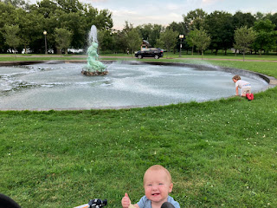

Jack and Maisie together . . . XOXO

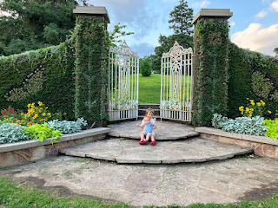

Maisie - in quite a contraption as Jake and Hannah were shopping for a new couch recently . . .

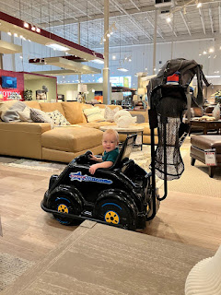

Jake made the kids some Mickey Mouse shaped pancakes one morning . . .

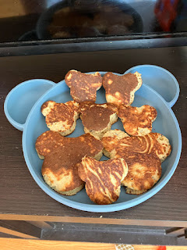

Jack got the Mickey Mouse heads, and Maisie happily gobbled down the scraps. She didn't care.

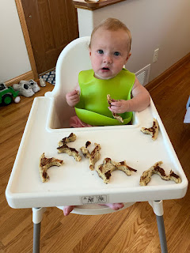

Before church one Sunday morning . . .

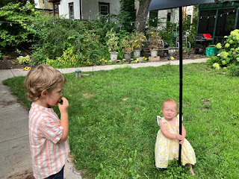

Eating a giant carrot in the bathtub . . . because why not?!

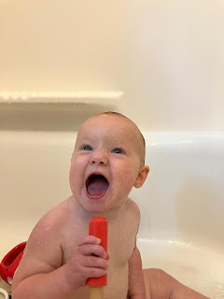

Out on one of the many lakes in Minnesota for Labor Day weekend . . . (and by the way, this is my new screensaver on my phone.)

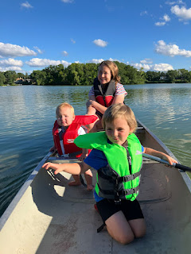

Jack had fun swimming in the shallow end of the lake . . . (with a life jacket on, of course!)

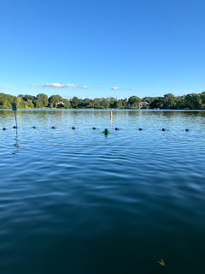

While Maisie played it a little safer in the less-than-6-inches area . . .

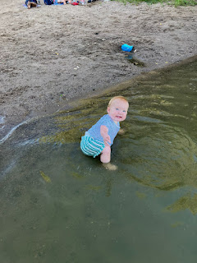

On another family outing, Jake sent us this photo with the caption, "Can we just dip our toes in?" This is a famous quote in our family. It connects back to when Scott and I took our 3 young kids to Freeman Park in Idaho Falls, where there is a creek that runs through the large park. They asked, "Can we just dip our toes in?" We agreed, and then the next thing we knew, they were all soaking wet and asking if we had any towels in the trunk . . . NO, WE DO NOT. WE DIDN'T THINK WE NEEDED TO BRING SOME!! Ha ha ha.

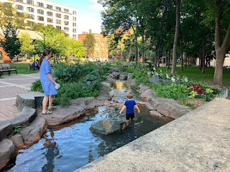

Jack and Maisie have been to a few Minnesota Twins baseball games now . . . what a fun core memory!

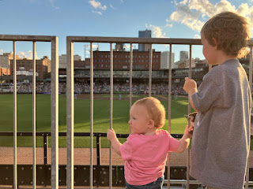

Jake recently sent us this string of photos with the caption: "We stumbled upon the fact that our kids are Japanese." (Meaning that Jack and Maisie absolutely loved the simplicity of these ingredients, which are considered staples in Japan.)

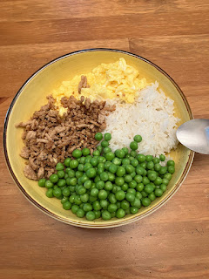

No complaints here . . .

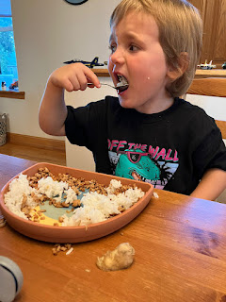

Or here . . .

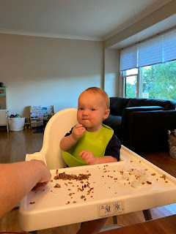

Maisie's first word = Zeess/Zeesh.

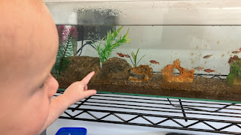

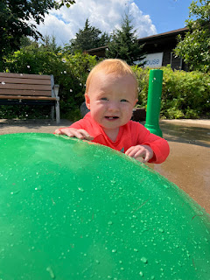

Hannah recently asked Jack, "What do you want to be when you grow up?"
Jack (in all earnestness): A grandma.
Love that.

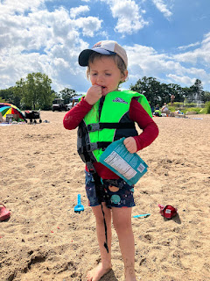

Local splashpark on one of the last warm summer days . . .

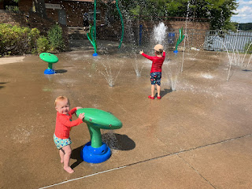

That face . . . so expressive.

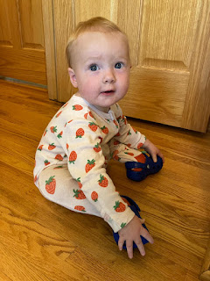

Maisie - first thing out of bed on the morning of her first birthday. What a sweetie.

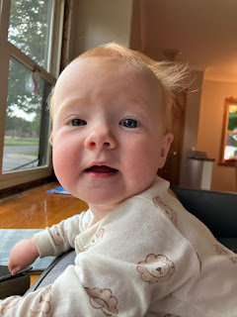

Since she loves fish so much, they took her to the local Aquarium for her birthday.

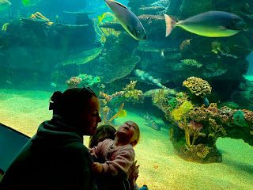

Video of Maisie enjoying her birthday cupcake: (even nodding when they asked if she liked it!)
(37 seconds)
https://photos.app.goo.gl/SubUfKu3Kf8mDr9t8

Meanwhile, up in Portland, Oregon
. . . Amber took the girls blackberry picking late in the summer.
Amber has often said that this was one of her favorite childhood memories - when we would drive out to Ukiah, CA to visit grandparents and inevitably we'd pick some blackberries on Sanford Ranch Road. Often, homemade vanilla ice cream would be made for the occasion, and fresh blackberries would be served on top. Sometimes my mom would also make a blackberry cobbler, too. Yummm.

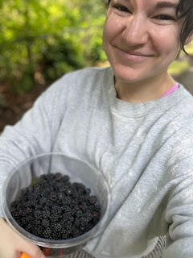

Gwennie . . . I think she picked more than what she ate . . .

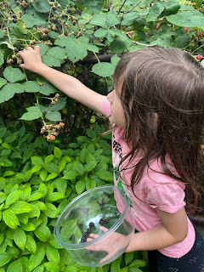

When the family went to one of the area parks, they came across this fun little game in the playground. It seems very fitting for the Pacific Northwest, lol.

Video here: (50 seconds)
https://photos.app.goo.gl/owRXUo2DqEAGMP8G7

Abby participated in an Aerial Silks Camp for one week in July. This photo was taken just prior to her performance recital at the end of the camp. She looks so grown up!

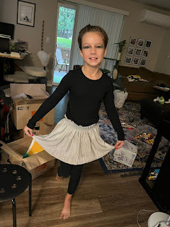

Video #1 of Abby's performance, which was simultaneous with two other kids. Abby is on the far right.
(1 minute, 34 seconds)
https://photos.app.goo.gl/MhqQJ7vypXhjmGKC6

Video #2 of Abby's performance, where they switched from the giant ring over to the hanging silks. This time, she's front and center: (3 minutes, 6 seconds)
https://photos.app.goo.gl/oTjmcu1yUzmhjrm76

She really is quite a natural and always has been. She is both graceful and focused.

Abby and Gwen watching something on the laptop together . . . such sweet sister bonds . . .

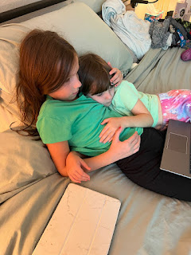

Amber and I have been coordinating finding a white dress for Gwen's upcoming baptism. I intend to embroider something special for Gwen's dress, similar to what I did for Abby a couple of years ago. This was a cute video that Amber sent me so I could see what they chose - Gwen likes SIMPLE and SOFT, so this was a perfect choice for her. I'll be adding side-seam pockets and then I'll embroider something inside one of the pockets.

Video of Gwennie here: (43 seconds) "I'm a lower case T!"
https://photos.app.goo.gl/UHHHqDvmtd2p5wiu9

I know these are out of order, but I have a few more photos of the little ones to share. We got to talk to Jack and Maisie a few days ago on a video call, and they were just finishing up their morning milk session, ha ha. Even though Jack is 4 1/2 years old, I think he still likes to lay down and drink a giant bottle of milk to start and end each day. Maisie is old enough to hold her own bottle now, so they laid down next to each other and slurped all their milk down. So precious.

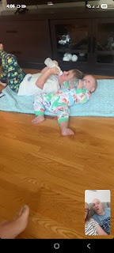

Maisie snatched up Jack's bottle when he left his behind . . .

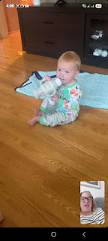

As we were chatting with Jack, Maisie - wanting to be right in the thick of the action, started poking Jack's face as he was talking, grabbing at his lips, ha ha. Jack was a good sport and didn't get rattled. But Maisie was promptly moved a few more inches away so Jack could finish what he was trying to say.

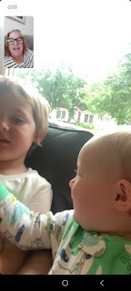

Jack wanted us to take him on a video tour of our house. So we did. He had lots of questions about this or that. And he's such a good listener. I'm always impressed with his attention span for someone his age.

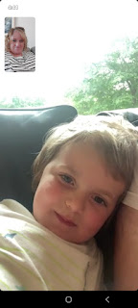

Gwen and Abby started a new school year - Gwen is now in 2nd grade and Abby is in 5th grade. So far, they are LOVING it.

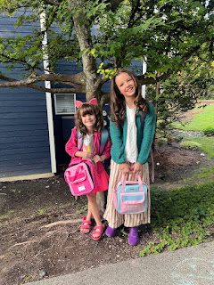

As for Avery, I'm so excited because I just booked a ticket to fly up to Germany in a few weeks and I'll get to see her then. I'll take lots of pictures to share. :)

I've been trying out some new meals this past week, and this one was SO GOOD. It consisted of roasted veggies (and a can of garbanzo beans) with feta cheese crumbled on top, plus whatever protein you want on the side. We pan-sauteed some chicken while the veggies were in the oven.

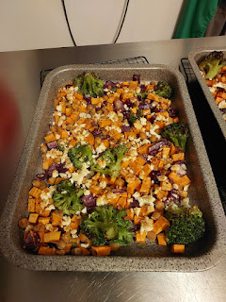

Everything was topped with a creamy Greek yogurt and tahini dressing.

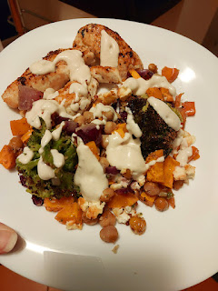

The recipe was on Instagram - I follow the profile "mediterranean.diet.plan". They have multiple contributors who regularly share healthy and fun recipes, along with a video on how they made their particular meal. Sometimes they'll provide a link to a webpage with the recipe, but this one didn't have a link. The recipe is called "High-Protein Baked Feta Chicken and Sweet Potato Meal Prep". Essentially, the contributor was able to divide this up into 4 servings for lunch or dinner that week.

I highly recommend this!! There are so many flavors and textures to enjoy in every bite. Scott commented numerous times on how much he was enjoying it. :)

I screenshotted the recipe in two pics, so here they are:

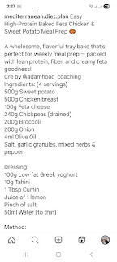

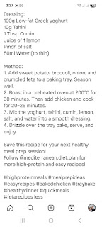

It's amazing how sometimes you're just super in sync with someone . . . most often for me, it's either Chelsea or Abdel. Last week, I woke up thinking about Abdel and I knew that I hadn't talked to him in several weeks. He has been settling into his new job in Qatar, and I've been wondering how that's all going so far. As I made my To-Do list that morning, I put his name on the list - intending to reach out before the end of the day.

Well, the day marched on, and yes - I was crossing several things off my list by dinner time. But I had not reached out to Abdel yet. All of a sudden, my phone started ringing with a WhatsApp video call - and it was HIM!! Wow. He said he had been thinking about me and wanted to know how I was doing. He always wants to make sure I'm okay. He said his whole family thinks so highly of me and they always ask him if he's checked in with me lately.

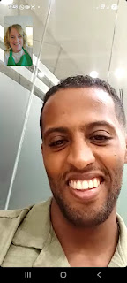

So far, he's absolutely loving his new job in Qatar. He works with the staff of servers that take care of the Prince whenever he's in the country. Apparently, he (the Prince) travels a lot to other countries, like Algeria, Italy, Morocco, etc. But when he's in Qatar, Abdel and his crew prepare the meals, serve the meals, and clean up afterward for the Prince and whoever was with him at the time.

Abdel also has several days off during the month, such as the day when he called me. He was wandering through one of the shiny clean - and huge - malls in Doha. We talked about lots of stuff, including the possibility of Scott and me going to see him sometime after Christmas. He told me that the months of July and August, and even into September, are just way too hot. He thinks that January - March would be a very nice time to come for a visit.

I'm so glad he's doing so well. He's making good money and he's been able to send some money home to his family in Agadir, too, which I'm sure they're very grateful for.



I've also been unpacking and going through all the stuff we sent over in our shipment of household goods from Idaho Falls to Vicenza. As time has allowed, I've enlisted Scott's help in hanging up a whole slew of artwork and picture frames on the walls. While I COULD do it myself, it's nice to have a buddy so one person can hold it up on the wall while the other person says, "move it up a little, a little to the right, etc." It's hard to get perspective when you're the only one to there to hold something up.

Here's a little taste of what I've been doing . . . making our house into a home. XOXO

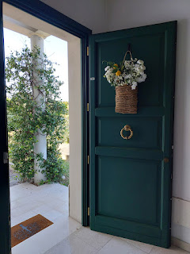

In the very near future, I'll make a video that takes you on a tour of our new home for the next long while.

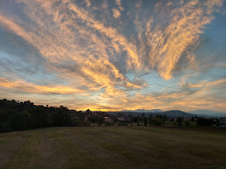

Lastly, a few days ago we got the news that our sister-in-law Pam (Gordon's wife) has brain cancer. We only have very minimal information so far, because Gordon (Scott's older brother) has been very busy dealing with everything that's been going on.

We don't know how they discovered there was a problem, but we can assume that Pam had some symptoms that were concerning and eventually led to some CT scans with contrast. That's when they found this very large tumor in the right rear section of her brain, the occipital lobe.



Within just a couple of days, she underwent surgery to remove as much of the tumor as they could safely remove. Later that day, they received confirmation that yes, it was cancer and dang it all, it's a really bad one, too. Glioblastoma is a very aggressive form of brain cancer and her life expectancy is possibly only 15 months. That's BEFORE they've met with the oncologist to figure out a plan for moving ahead with whatever is recommended after surgery. The amount of time could increase, but more likely it will decrease, after they've had a chance to review all the medical information. We will see.

One of the biggest problems with Glioblastoma, is that typically the tumor is in such a tricky place in the brain and surgeons are not able to fully remove 100% of it. Because some of it gets left behind, it will continue to grow and spread at a very aggressive pace. Even with chemo and radiation, life expectancy is usually between 12-18 months. We're not sure yet if Pam will choose to go through the hell of chemotherapy and radiation or not. Bless her heart. What a hard decision to have to make!

Gordon is planning to take as much time off from work as the law will allow at this point, and then he will retire, he told us. He wants to spend every single day with Pam and that's all there is to it.

We are heartbroken with the news, and it has rocked us to the very core these past few days. Scott and I have cried together several times, talking about what we would do if we were in a similar situation, and we are trying to send up as many prayers as we can in their behalf.

The day after her surgery, Gordon sent us this photo. On first glance, it looks like she's grimacing with pain. But his comment was this: "Pam is speaking much better today and her personality is coming through. She keeps thanking the nurses and apologizing to everyone for being sick." That's when I could see that in the photo, she was probably chuckling a little bit, at the same time as maybe being embarrassed for being the center of attention. She likes to be the one taking care of everyone else.

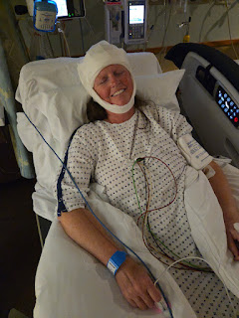

Cancer is the worst. I hope she will be blessed with a balanced amount of time where she can be with her family - her husband, children, and grandchildren - but also not have to suffer for a long time either.

If you're the praying type, her name is Pam Harmon and I'm sure she would be grateful for any prayers you could offer in her behalf.

