30 Italian Gingerbread Men
The first half of this week was spent recovering from being sick, but it was nice to have the quiet space and the time to just lounge around and cough. The second half of the week more than made up for the restfulness of the first half, ha ha.
Monday:
I spent a chunk of the day working on Avery's ABC photo book (her Christmas gift) and putting together rhyming pentameters. "A is for Avery . . . B is for bathtime . . ." I have made a photo book for each of my grandchildren generally around their one year old Christmas. I gather photos of the baby (with help from their parents) and make it into a book about them, with rhymes and somewhat clever lines. It's been a fun tradition to keep up with. It just so happens that this year I ended up making both a Quiet Book and now an ABC Book for Avery, all within a short period of time, since her birthday is so close to Christmas . . .

I chose to use this darling photo of Avery for the front cover of her book.



*Also - I always use Shutterfly to make the 8x8 books. They save my projects online indefinitely, which is nice, especially if one of the books gets lost or damaged. I can just order another one.

I also had a video call with Amber as she was out running errands. She's always fun to chat with. Just looking at these screenshots of her makes me smile. :)





Tuesday:
We got a package from Amber in the mail with some peanut butter, among other things. We had asked her recently to please send us some PB because there was none to be had over here! The Commissary was completely out for weeks!! And Italians don't generally use PB, so it's hard to find anything in their stores. They DO, however, have a constant supply of Nutella over here . . .

Also included in the package from Louisiana: this beautiful artwork and thoughtful note from Abby.

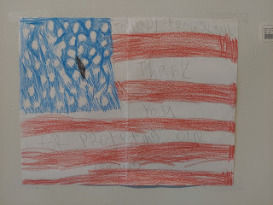

"To Papi, From Abigail. Thank you for protecting our community."

Wednesday:
FINALLY . . . I got out of the house and felt well enough to do something with some friends. The Wednesday Group was headed up to Nove, about 30 minutes north of Vicenza, to visit the ceramic shops and a pewter shop as well. Nove is famous for its pottery, so that's pretty cool.

I rode with my friend, Marnie Parker, and the other ladies who lived closer to Nove just met us there. Our first stop was at the VBC Shop. They have one of the nicer ceramic shops in town, I'm told.

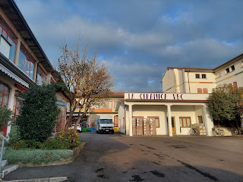

Beautifully detailed decorative plates, right as you walk into the shop.

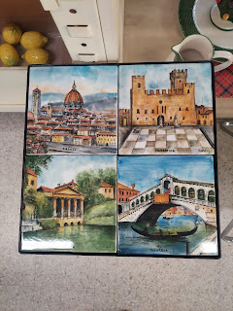

Downstairs is where all the orders are being filled. Upstairs is the "shop". There are several very long rows of ceramic plates, bowls, chargers, pitchers, soup rests, etc. It was a bit overwhelming at first, so I just let everyone else take the lead while I followed along slowly, mostly just taking photos.

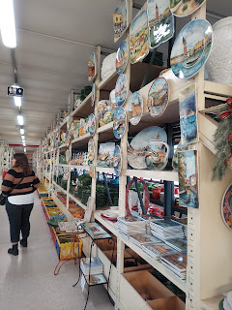

Marnie showed me this cute little legendary chicken pitcher and the story behind it. Apparently, in 1478, a feuding brother wanted to take out his other brother. An assassination plan was put into place that during a small village festival, he would sneak in during the night and kill his brother and all those that worked for him. But as they snuck in to where the brother lay sleeping, a large yard full of chickens started clucking loudly and woke everyone up. The plot was foiled and the chickens surprisingly became the heroes! Chicken-shaped pitchers were soon created to serve wine out of, and thus the legend of the good luck chicken pitcher began.

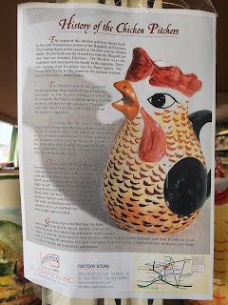

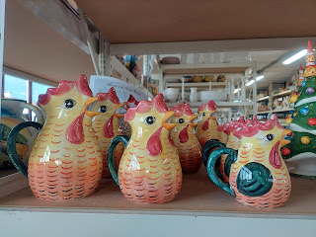

There are several other cute and clever water pitchers in the shop as well.

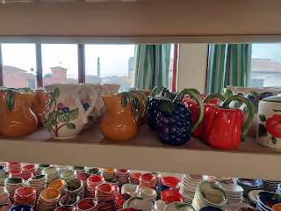

Video of some of the shop: (14 seconds)
https://photos.app.goo.gl/9WnmGipFufN7WjUZA

I liked the "story" depicted on these plates . . .

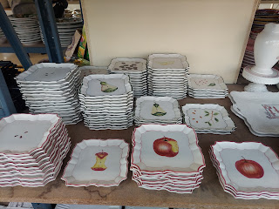

Decor with deep and rich green colors always seem to grab my attention here in Italy. I thought these were absolutely beautiful!

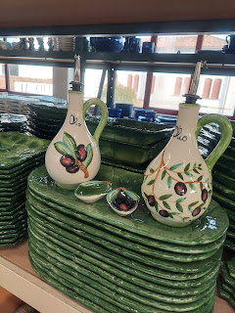

The ladies come here pretty regularly, I gathered. Several of them have been slowly building up their dinner sets. One lady bought 4 full sets of dinnerware while we were there: dinner plates, salad plates, soup bowls, tea cups and saucers, etc. A few others chose to focus on just getting all the bowls for 12 guests, or something like that.

I don't need any of that while I'm here. We are keeping our purchases to a minimum in Italy because we most likely won't get any help in shipping anything back to the U.S. when Scott's service is done. So whatever we buy, we will probably have to pay to ship home ourselves. Or get rid of . . . or sell . . .

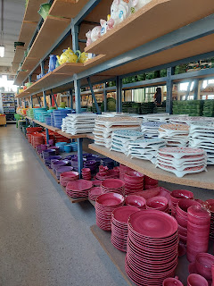

I did, however, settle on two purchases. When I saw these beautiful divided serving trays, I instantly knew I should buy 2 of them for my neighbor, Kim Parkinson. They had her name written all over them! They are definitely her style and I knew she would really appreciate having them. I just appreciate HER so much. They have been doing a very good job taking care of our house and yard while we're gone.

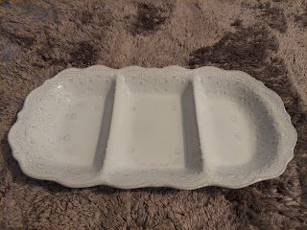

And I ended up buying this pitcher for myself.

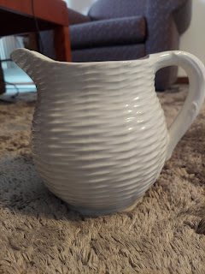

A few of the ladies were quick to point out to me that this pitcher was made specifically for Tiffany & Co., a well-known and trendy company based out of Manhattan, NY. It even says Tiffany & Co. on the bottom. But I didn't care about that. I'm not into designer labels and trendy items. I just liked how it looked and it was only $15. And I needed a water pitcher. :) The only pitcher I currently have for serving guests, is a plastic one with a blue lid on top. I got it for $1.00 at the thrift store on base back in May. I was very happy with my new pitcher purchase.

Our next stop was another ceramic shop nearby, but none of us bought anything there. Not only was it more expensive than where we just were, but it was filled with specialty collection items, not so much an every-day selection.

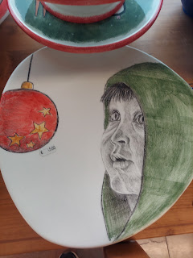

This dinner set was beautiful, but pricy.

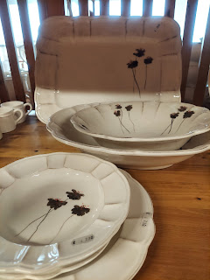

Our last stop was at a pewter shop in Nove. The couple that owns the shop live upstairs and have operated this store for 50 years! They work down in the basement and then sell all the items that they've made on the main floor of the building.

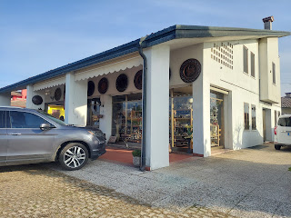

As soon as I walked in, I noticed some GORGEOUS chess sets!! But my goodness, the price was way too much. (They wanted $280 for this set)

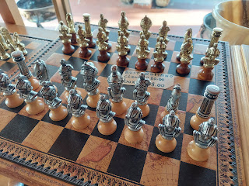

I bought a cute little pewter Nativity set for $38, handmade in their shop downstairs.

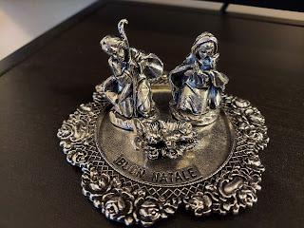

I also bought a couple of pewter ornaments to hang on our tree. She lovingly gift wraps everything for you, too.

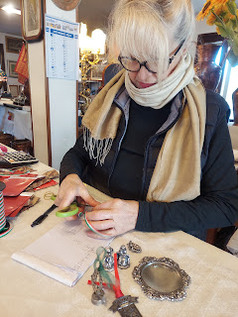

Thursday:
I drove over to the Soave area (about 40 minutes west of Vicenza) to visit Bonamini (the olive oil manufacturer) again. I decided to get a few more items to give as Christmas gifts. I only spent about 10-15 minutes there before I was on my way again, since this time I knew exactly what I wanted.

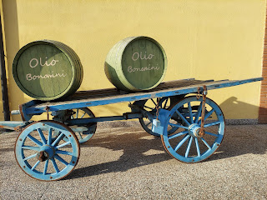

Because it was such a beautiful day, I decided to stop at the Castello di Soave (Soave Castle), since it was just a few minutes away from Bonamini, and is also on my way back home. I've been very curious about it each time we drive past it on the freeway - but we're always on our way to somewhere else.

The castle itself (up on the hill behind this front entry wall) was closed until later in the afternoon, so I didn't attempt to go on a tour. Instead, I just found a place to park and then wandered around taking some pictures while enjoying the warmth of the sunshine.

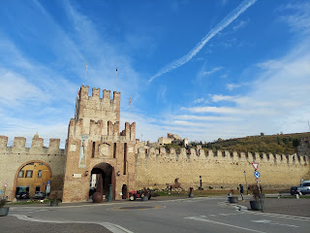

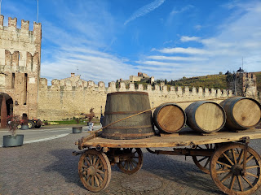

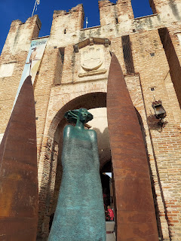

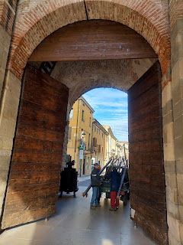

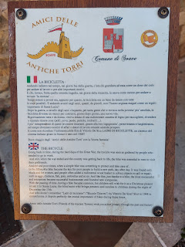

Above and below: A tribute to the bicycle and all that it provides for the rider, especially during WWI.

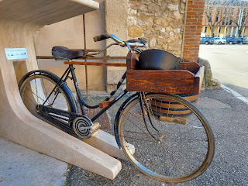

Through each castle wall arch, you can either walk or drive through. There is a charming little village inside, with shops and restaurants to explore. I didn't go very far inside the wall, at least not on this day. Next time I will.

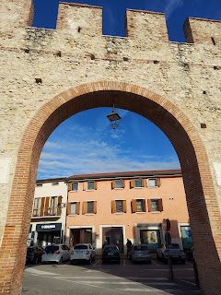

Alongside the castle wall, there is a large children's park. I sent a couple of pictures to our kids because this is exactly the kind of place they would want to bring their children. Who wouldn't want to play on a playground next to a castle??

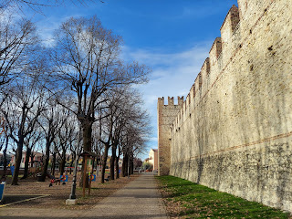

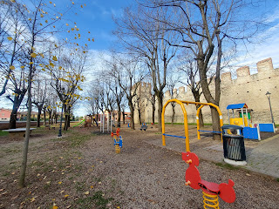

On my way back to the car, I tried a couple different settings on my camera to take some pictures of the white pansies and the canal.

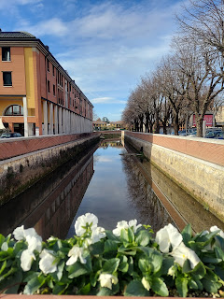

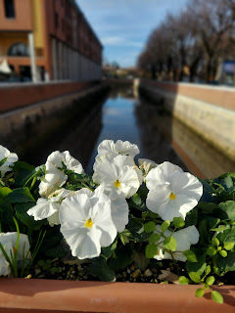

When I stopped at the Commissary back in Vicenza, I did a double take as I stood in line to check out. They had a display of CLAXTON FRUIT CAKES for sale!!!

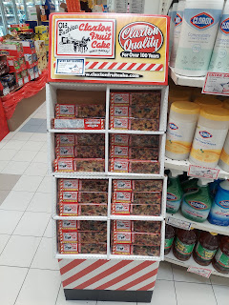

Claxton, Georgia is a tiny little town where my Norman family lived at one point during the late 1800s and early 1900s. Records that show that they lived in Glennville, Tattnall County, GA, but nothing specific about them living in Claxton. But here's the thing. I stopped in Claxton back in 2007 when I was doing some family history research.

I had a photo of a house that my great grandfather, Linton Hendry Norman, had built and also possibly lived in. There was a note on the photo that said Claxton. I wanted to find the house in person. I didn't know where in town the house was, but I could tell how tiny the town was, so I had the idea to stop and ask someone if they might recognize the house. I stopped in a shop (literally one or two stores down from the Claxton Fruit Cake bakery) and asked the lady that worked there if she had ever seen this house. She said yes, and immediately recognized where it was. She immediately put someone else in charge of the shop and led the way in her car (I followed behind her) just a block or two down the street.

Sure enough, there was the house. A few aesthetic changes had taken place over the years, but structurally, it was all the same. And the kicker was when I saw the exact same clothesline over on the right side of the house, still standing in the same place as where it was also pictured in the black and white photo I held in my hand.

(I wish I had the photos here in Italy . . . and I couldn't find them on my Google Drive either . . . hmmm)

**Update: I was able to find the photo of when I visited the house in 2007. I still don't have access to the old black & white photo right now...I'll have to look for it when I get back to Idaho Falls.

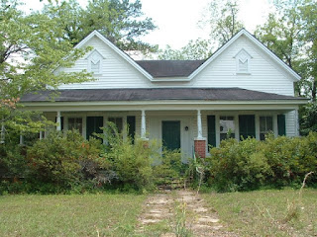

Another funny thing about Claxton, is that on their giant water tower that you can see for miles and miles, it says, "Claxton: Fruitcake Capital of the World". HA HA HA HA HA You can take that more than one way, LOL. So funny!!

While I was there in Claxton back in 2007, I actually stopped in the bakery and bought several fruitcakes - the exact same ones that I saw here in the Commissary!! I shared them with my mom and my Grandma Doris, and a couple other family members as well. They bake all year long to prepare to sell these fruitcakes during the bustling Christmas season. Amazing. What a small world.

Friday:
BAKING DAY. The Primary leaders in our ward were in charge of the Christmas Party, and one of the activities they wanted to have was a gingerbread man for each of the children to decorate. They needed help . . . I volunteered to help in whatever way was needed . . . and that's how I landed the job of baking all the gingerbread men. :)

Stacie Preece, the Primary President, had a very streamlined plan to get the job done. She mixed all the dry ingredients herself, then passed everything off to Joy Simons to mix with the molasses and the rest of the ingredients. I thought that Joy had a stand mixer (like a KitchenAid), but I found out at the party that in fact, she didn't. She and her strong US Army Airborne husband used their HANDS to mix each batch of gingerbread!!! They got a pretty good upper body workout from what she described . . .

Next, Joy delivered all the supplies to me on Friday morning. Several bags of gingerbread dough, a food scale, and ONE mold pan.

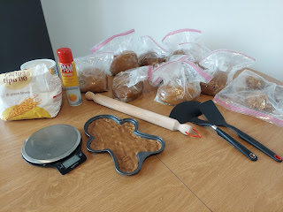

I was told to measure out the dough to be approximately 300-350 grams each. The food scale really came in handy!!

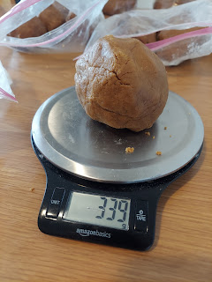

My oven is tiny and has a hot spot in the back left corner. If I leave something close to that corner for too long, it gets burned. So my process was to bake that ONE mold pan very carefully: 10 minutes in the right half of the oven, then it needed 2 additional minutes in that warmer back left corner.

As long as I sprayed the mold pan each time, then the gingerbread man would come out of the pan perfectly and onto the cooling rack after baking. I could then hurry and press the next ball of dough into the same pan and repeat.

When Scott came home later in the day, he wanted to streamline our process even more. By this time, Stacie had just dropped off a SECOND mold pan for me. It was a little nervewracking to have 2 pans in there at the same time because I didn't want the one on the left to burn . . . but we found a good system.

Bake one on the right for 10 minutes. When I move it over to the left for the final 2 minutes, then I could add the second pan to bake on the right half of the oven for 10 minutes. As that 2nd one moves over to the left, then the next pan goes in on the right . . . and so on. We had two cellphone timers going the whole time. But the overall process definitely gained some speed by having a second mold pan!

In total, I baked 30 of those huge gingerbread men. It took me about 8 hours of constant tending, pressing, rotating, emptying, and repeating. I was exhausted by the end of the night, but it felt wonderful to be able to help in such a big way.

The primary leaders were focused on getting all the food, decorating the church, and organizing the talent show. They were infinitely grateful that I was willing to do this monumental task for them!

The sister missionaries texted me during the day because Sister McCullough was very sick and needed a priesthood blessing. Scott left me for a portion of the evening to go give Sister M. a blessing across town. Here he is, helping me switch the pans in the oven just before he left . . .

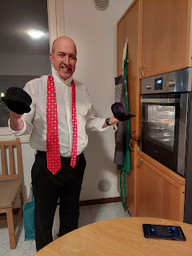

Each gingerbread man fit almost perfectly into a gallon ziploc bag, and then I stacked them all into a giant box lined with a bath towel to nestle down for the night.

We somehow managed to feed ourselves a very late dinner and then we went to bed.

Saturday:
Ward Christmas Party!! Look at this strong and handsome guy carrying all the gingerbread men into the building and up 2 flights of stairs for me . . .

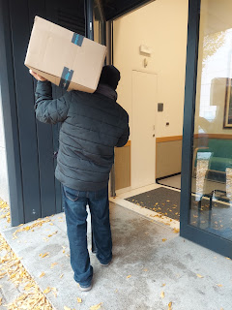

The chapel upstairs had been renovated to a Christmas wonderland.

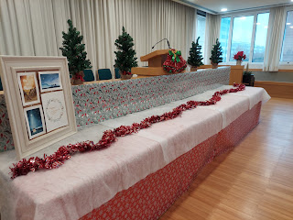

Those who didn't want to perform live in the talent show, were encouraged to bring a table display to share. One of the young women, Ellie Delap, painted these beautiful Nativity scenes. She is only about 15 years old!

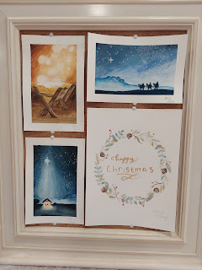

Once all the rest of the display items were in place, I took a short video of the full table: (23 seconds)
https://photos.app.goo.gl/EKHjLkVHbCvGzrwx5

One of the food areas had croissants and rolls, meats and cheeses, and fruits and vegetables. Another station had biscuits and gravy, or biscuits and whipped cream with frozen fruit to top it with. And there was also a hot chocolate station in another area.

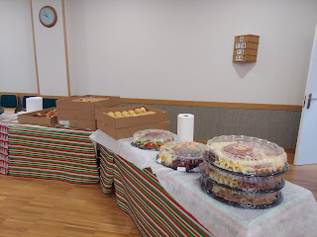

The tables were simply decorated with wrapping paper and sprinkled with candy. :)

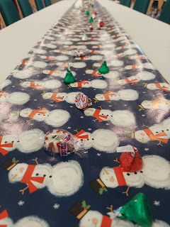

After the meal had begun, and people were mostly done eating, then the talent show began. There was a nice variety of musical numbers and alternative talents.

Video #1: Two young men playing saxophones. "Oh Christmas Tree". (20 seconds)
https://photos.app.goo.gl/KD4SivuuGrGURGZ3A

Video #2: A young man solving a Rubiks Cube in 30.9 seconds. 3 separate people mixed it up before he began solving it. Amazing!! (38 seconds)
https://photos.app.goo.gl/CbPSwQ6ZCKhNY22R6

Video #3: Part One - Sister Morrison (one of the missionaries) did a humorous Bob Ross tutorial on how to paint a local Vicenza scene. (1 min, 14 sec)
https://photos.app.goo.gl/TtrRAz8inyptGkyW8

Video #4: Part Two - Sister Morrison (1 min, 1 sec)
https://photos.app.goo.gl/mW1c9bJ4Sro234798

Video #5: Stacie Preece and Ellie Delap doing a flute duet, "The First Noel" (2 min, 15 sec)

https://photos.app.goo.gl/AhNXyaQsFYY1JzD29

Video #6: Kevin Parker (in the Bishopric) doing a fantastic yo-yo routine to a Star Wars medley. He's amazing!! (3 min, 12 sec)
https://photos.app.goo.gl/VjJUiWttpVEHknQR8

Video #7: Sister McCullough (feeling MUCH better on Saturday) playing a violin solo, "Bring a Torch, Jeanette Isabella", accompanied by Dedra Tolman on the piano. (2 min, 26 sec)
https://photos.app.goo.gl/c9kFUmjF7Wtz2Kxz8

*Sister McCullough is a music major at Utah State University and man, is she talented!! She has played her violin in our ward numerous times and every time it feels like we're hearing a masterpiece. Her mission comes to an end next week as she heads home for Christmas and then back to school at USU. We will sure miss her!!

Little Rosie Simons - she is such a cutie with her reindeer ponytail holders. She is the same age as Jack.

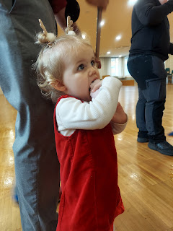

During the lengthy talent show, the children were able to receive a gingerbread man and a plate of supplies to decorate him/her with. They really enjoyed this activity!!

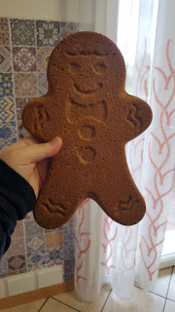

I heard later that the younger kids got really excited and started grabbing their own gingerbread man out of the box, but in the process, some of the legs were breaking off because of their exuberant energy, ha ha. Once an adult took charge and started handing each one out, the gingerbread men remained intact. Meanwhile, some of the older children took that as an opportunity. They said things like, "Oh, I'd love to do surgery on my gingerbread man and fix him!" or "I want to make mine a pirate!"

Here is one example of how they doctored up a broken leg and now she's good as new!

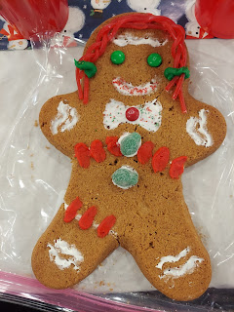

Time for Grandbabies . . .

In Louisiana, Abby and Gwen were able to participate in a very special Bethlehem experience at the stake center. Amber shared some photos and details with me on a phone call Saturday night.

When the girls first arrived, they were welcomed at this booth. They were given 3 pennies each. One penny was to pay their taxes, and the rest was intended for food and lodging.

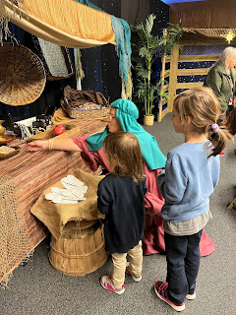

They were taken to another area where they could select some ancient Bethlehem attire to wear.

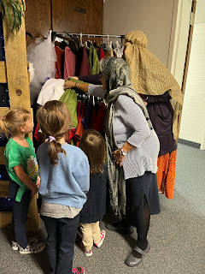

They could participate in the scene of the Nativity.

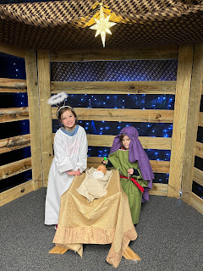

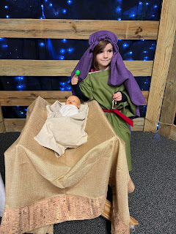

And at the end of the activity, they were able to decorate a star to bring home and put on their Christmas tree.

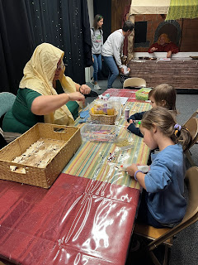

There were also hundreds of Nativity sets from around the world on display and Amber really enjoyed seeing all the different ones.

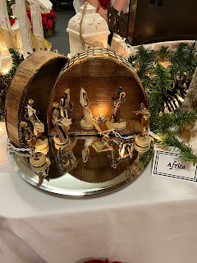

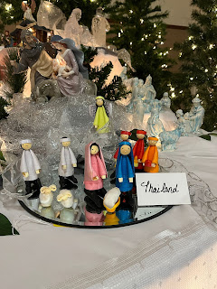

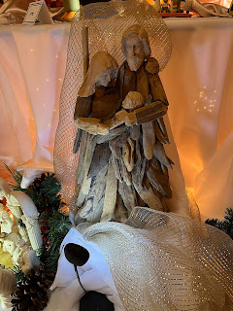

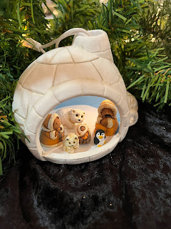

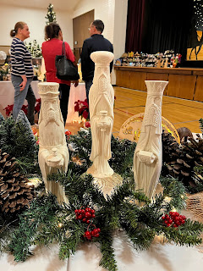

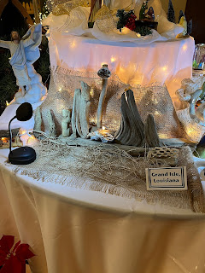

I thoroughly enjoyed my Saturday night video chat with Abby and Gwen!

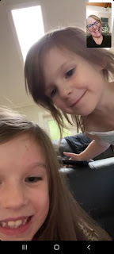

Abby just finished reading the ENTIRE first Harry Potter book in LESS THAN A WEEK!! Holy smokes!
She's only 7 years old . . .

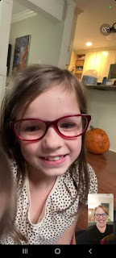

We took turns showing each other some of the ornaments on our Christmas trees. :)

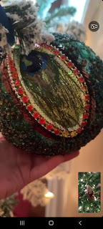

And I loved this photo of Gwen that Amber shared on Instagram.

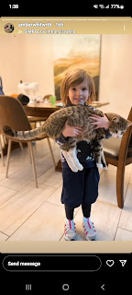

Gwen also got to ditch school for part of a day so she could get her latest immunization shots and then enjoy some ice cream at Baskin Robbins. What a cutie!

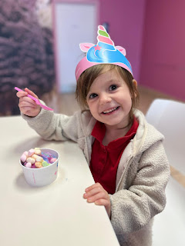

In Washington DC, Jacob, Hannah and Jack have all been sick with Covid the entire week. They've gone through the fevers, the body aches, the congestion, the coughing, and all of the yuck that Covid brings. I'm so sorry that they've been so miserable and I sure hope they are feeling better soon!

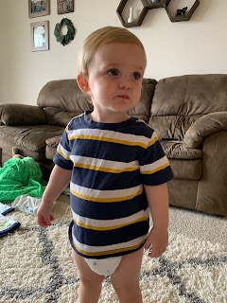

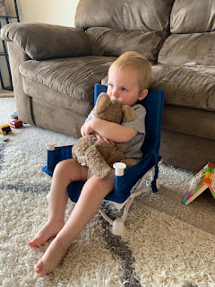

Near the end of the week, Jacob sent this video of Jack hanging out in the bouncy chair that he used to play in when he was much younger. When we saw that he had quite a runny nose, we inquired about it and that's when we learned that they've all been so sick.

Video of Jack: (13 seconds)
https://photos.app.goo.gl/qSLqhTWZRh8No6ge9

Jack's Saturday morning vibe . . .

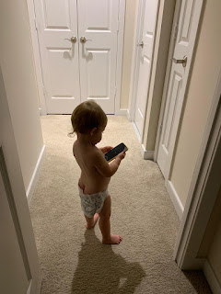

Kylie sent me this cute video of Avery: (44 seconds) I love how she tilts her head so sweetly. :)
https://photos.app.goo.gl/1focpw5CYCfWE2G47

Sunday:
I am still helping out in Primary, and today was their program practice for the actual program that will take place next Sunday. We couldn't practice in the chapel because the Italian ward begins their Sacrament meeting at the same time. So we had to practice in the primary room instead. So many families are dealing with sickness here, and that meant that we were also short on adults to sit with the kids during the practice.

I was in charge of just two children today, Luna and Noah. I wore my 3 silver bracelets to church so I could give them something to hold and play with quietly during primary, and it helped. But Noah was having a very energetic day so I had to constantly come up with new ideas to keep him occupied and somewhat quiet. I had him draw the entire alphabet, one letter at a time, in the air with his invisible "pen". Then I had him draw a snowman with all the accessories. Near the end of the program practice, I could see he was starting to lose it. How did I know? Because he had licked his arm to the point of leaving a decent layer of slobber across approximately 6 inches of skin. I was hoping he wouldn't rub it on me . . . and thankfully I had a tissue in my purse, which I handed to him so he could clean his arm off. I had originally suggested that he wipe it off onto his pant leg. But he told me he didn't want to get his pants dirty. (!)

Here he is, coming back from throwing the tissue away in the garbage can. He really is a sweetheart and is very snuggly. But today his wild side was front and center! LOL

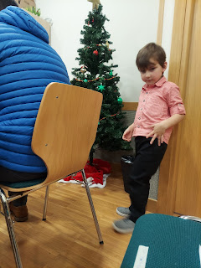

I'm going to look for something this week that I can give to these young 'uns to keep their hands quietly occupied during the program in Sacrament meeting next week.

As for MY hands . . . as soon as I leave the primary room I always pull out my hand sanitizer spray and hope that I get all the potential cooties that young children consistently bring along . . . You know what I'm talking about - - when you see them picking their nose, and then 2 minutes later they want to hold your hand and snuggle . . . aren't children just the best?!! XOXO

