A Girl and a Horse
One of my favorite things in the whole world is a horse.
Any
horse. I love to be near a horse, but I especially love to ride a horse. A few days ago, I was able to at least be near a horse.
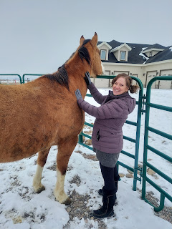

"Jacks" (or possibly Jax) is this horse's name. He was very curious about my hair at one point, and it made me laugh.

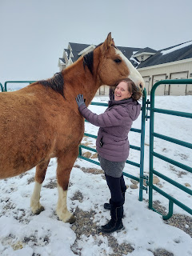

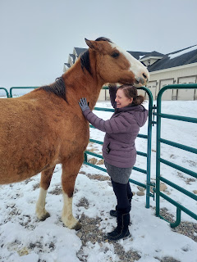

I went over to visit my friend, Sharina Beutler, who used to live in our neighborhood for several years until they built their dream home a few miles south of us. She asked me if I could come and collect all the eggs from their 20 chickens this next week while they are out of town. Excited at the prospect of being able to round up that many eggs, I came over to get a tour of the farm.



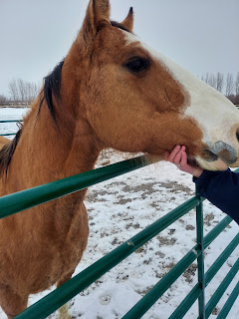

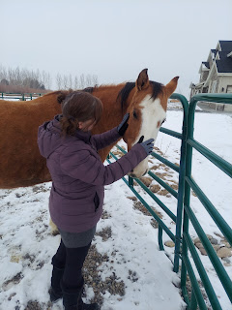

I'll check on this guy every day that I go over there for eggs this week. For moral support. (Someone else has been assigned to feed and care for the 2 horses)

As for the rest of the week . . .

Monday:
Abby learned how to "Floss" (a cute dance move). Apparently her dad taught her how. :)

Click here to watch: (10 seconds)
https://photos.app.goo.gl/ioWKsbeQ2dKCU2Jy6

I also forgot to post this cute picture of Abby from last week. She tried on the new pajamas I sent her and loved them!

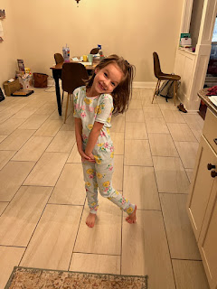

I was also VERY motivated to do a couple things that I've been putting off for way too long . . . including painting over all the putty spots upstairs that I made several weeks ago.

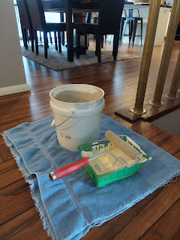

Much better looking now . . .

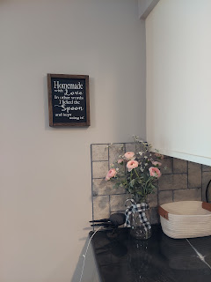

Tuesday:
I have been wanting to visit the local Trackside Mall for a few weeks, somehow feeling an urge to go over and peruse the antiques emporium for whatever struck my fancy. I finally decided to go.

I came across this gorgeous Civil War era photo album down in the basement. How sad that there are all of these old and beautiful photos, and yet they aren't in the possession of their own living family members!! Some were just photos, but some were even tin types!!

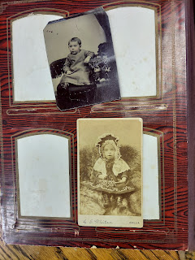

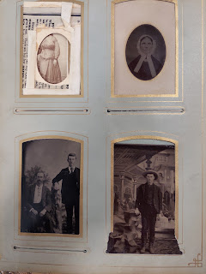

There were even newspaper clippings that had to do with the family members that were contained in the album. If I had more time right now, and $100 to throw around, I would seriously snatch this photo album up and put in some hours of research to find some living family members to send this to. I bet they would be so appreciative . . .

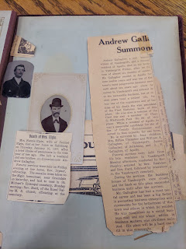

Instead, I found this squishy (and bouncy) donkey for $11 to bring home for the grandchildren whenever they come for a visit. I cleaned him up a bit and then put him down in the Grandchildren Guest Room. :)

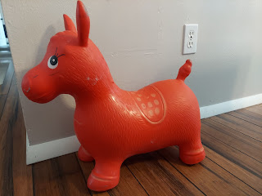

That afternoon, I made a batch of pumpkin chocolate chip cookies for our YW activity that night.

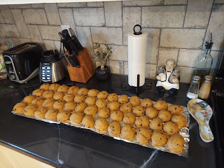

We had originally planned to go ice skating at the Tautphaus Park Hockey Rink here in town (pronounced Toffus). We showed up with quite a large group of young women, only to learn that the rink had just sold out of tickets and nobody else could get in. Talk about disappointment!

We quickly had a pow-wow outside and decided to go bowling instead. (Half of the group went to Orange Leaf to get frozen yogurt, but our half wanted to go bowling) As we walked into the bowling alley, it became apparent immediately that we probably wouldn't be bowling either. It was packed and every single lane was in use. I talked to the clerk at the counter and he said it was league night . . .

Hmmm, so now what? We put our heads together to figure out ANOTHER plan - I had all my younger girls (ages 11-13) and a few older girls (16-17). We decided to go over to Walmart (because at least it would be indoors on a very cold night) and play Scavenger Hunt and Sardines.

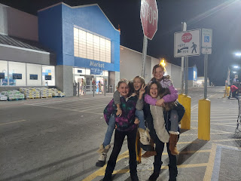

With the scavenger hunt, the older girls went and hid somewhere in the store and took a photo to give us a hint of something that was close to their hiding spot. They texted the photo to Megan and me (we were the adult leaders) so we could show the girls. Then we had to go find them in the store. (Notice that we had on way too many layers of coats and jackets, ha ha, because we had originally needed them for ice skating!)

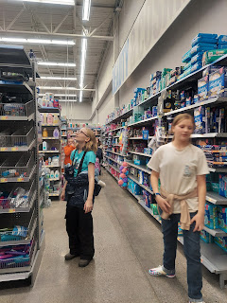

After one round of that, the girls wanted to play Sardines instead. It's similar to hide-and-seek, but everyone ends up silently hiding with the "IT" and whoever shows up last is the new "IT". It's really a lot of fun! After 3 rounds of that, we finally left the store and grabbed cookies from my car before taking all the girls home. I told them while they were happily munching on several cookies that this was very much an analogy of Life. Especially in the past two years . . . Yeah, just when you have something figured out and you get a plan in place, then Nope. It's not possible to do that thing anymore. So you have to have a Plan B. And in some cases, like this particular night, you'll need a Plan C and even a Plan D!! They ended up having so much fun though - which is a lesson in itself. Try to have a good attitude even if things don't go the way you planned it! :)

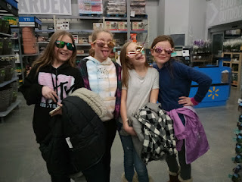

Wednesday:
We fed the Sister Missionaries for dinner. It was a lot of fun to hang out with them - they're so wonderful! We decided to "gourmet up" some breakfast items for dinner, and it went over really well. I made a puffed oven pancake with bits of Granny Smith apples chopped up in it - served with spray-can Cool Whip. And I tried my hand at making some egg muffins, with sausage and cheese in them.

This is the recipe that I used:
https://www.tasteofhome.com/recipes/scrambled-egg-muffins/

I omitted the green bell peppers, and I used red onion instead of yellow onion. They were yummy!

The rest of the day I was mostly working on Jack's quiet book. I also had a fun visit from my mother-in-law, Coy. Phil had an appointment nearby, so she came over to hang out with me while I worked on dinner. We talked and talked and talked . . . :)

I forgot to take pictures of any of this. Whoops.

Thursday:
I went over to my friend Sharina's that morning to tour the chicken house. I'm really looking forward to collecting all the eggs this week!

As I left her house, I drove straight to Black Bear Diner, a restaurant near my neighborhood. I met my friend, Amanda, there for lunch. Her daughter is in my YW class. She was having a hard time with all the things she's juggling right now, so I did my best to lift her spirits and help her feel like she matters and that she's wonderful.



Later that evening, Scott helped me hang up some photo frames in the living room, since the ugly pock-marked wall (from the putty spots) is covered up with paint now. :)

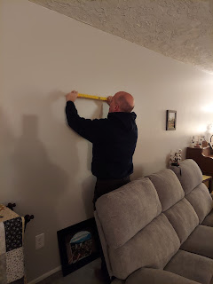

Here's what it looks like now.

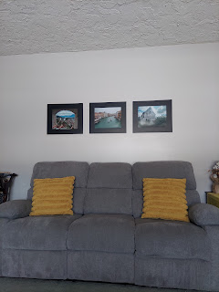

The three photos are ones that I took when I went to Europe last fall.
Left: Looking out from Thun Castle toward the city of Thun, Switzerland
Middle: Venice, Italy
Right: Ibersheim, Germany (where my Mennonite ancestors fled from the persecution in Thun during the 1500s)

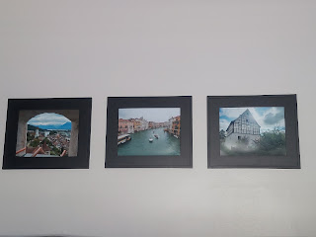

Friday:
While I baked cupcakes, I had a wonderful video chat with my sister, Charmaine, who just recently moved down to San Diego, CA. She gave me a tour of the gated community where she and (her) Scott live, which includes 3 or 4 outdoor pools, plus a few hot tubs, a gym, and a little market store.







I'm hoping to be able to go visit them down there sometime soon!

Later, after my Scott got home from school, we met our friends, Ben and Liz Lemons, at McKenzie River Restaurant across town. It was our first time eating there, and we really enjoyed it! Weston and Amber had given us a gift certificate for Christmas, so we figured it was a good time to use it.

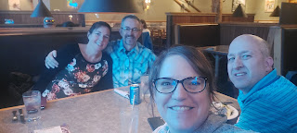

I ordered the Rangoon Flatbread (topped with crabmeat, scallions and Thai chili sauce), which was tasty but I just wish it had more substance. It didn't have as many toppings on it that I would have liked, and the flatbread was more like thin crackers. I was expecting more of a thick bread, like maybe a pizza crust. Next time I will be ordering some pizza!

(Ben is always such a goofball! I was trying to take a photo of my food . . .)

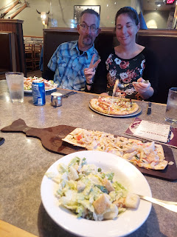

Ben and Scott go back a LONG time together. They first taught next door to each other at Bonneville High School. This is where Scott very first started teaching when Amber was a new baby. Ben was the favorite teacher at the high school and worked with the student body officers. He taught a business class, while Scott taught math next door. They hit it off immediately and have been buddies ever since!

Ben is currently the principal of an elementary school in Shelley, Idaho with 3rd and 4th graders only. He is always a lot of fun and makes it a point to learn every single student's name and to keep tabs on everyone and know what's going on in their lives. He's amazing.

When Benson was little, we would call Ben Lemons, "Big Ben", to distinguish between their names. He has always had a profound love for our kids and just has a lot of love in his heart to give to everyone he meets. What a great guy. :)

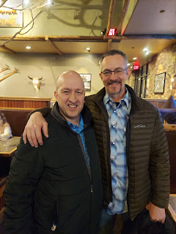

Saturday:
I knew I wasn't going to be able to accomplish as many things as I wanted to, but even after I slimmed down my expectations, I still came up a little short. I wanted to work on finishing up the cupcakes so I could deliver them, work on the Rawles Newsletter and Blog, and perhaps do some cleaning and work on Jack's quiet book. All before 4:00 - because Scott and I had an appointment at the temple.

While I started on my own stuff, Scott set out to install some video surveillance equipment, which needed a "smart" switch installed near the front door. He began the project, but quickly had questions regarding the electrical wiring he was working with, so he reached out to our back yard neighbor and friend, Don Blatter. Don used to work as an electrician at the INL (Idaho National Laboratory) but recently retired. He's our "go-to" guy when it comes to electrical work in our house.

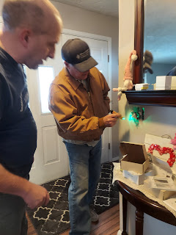

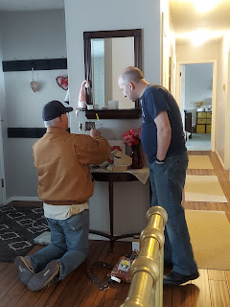

Even though the photos make it look like Don did most of the work, he didn't. He just showed and taught Scott a lot at first and then he supervised the rest while Scott did the work.

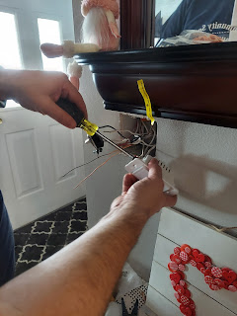

Voila. Now we're sooooo smart!!



As for me, it took a lot more time than I anticipated to make the cream cheese frosting and get everything ready for delivery. I did our laundry all morning, but still haven't folded anything or put it away yet. I worked on the Rawles stuff, printing out the mailing list so I could clean it up a bit. I even made some phone calls to get clarification on addresses and spent some time updating the information on the spreadsheet, such as who had died since this list was made in 2019 . . .

Finally, the cupcakes were ready to head out.

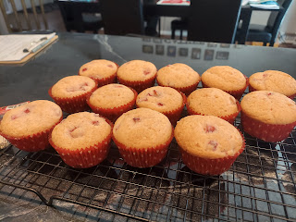

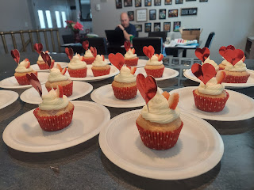

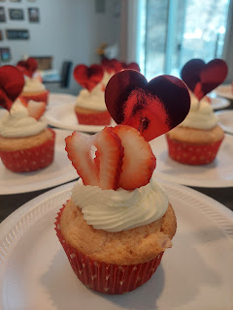

I made these strawberry cupcakes on Friday afternoon, and just barely ate one today. OH. MY. GOODNESS. They might be the tastiest cupcakes I've ever made!

I used this recipe for the cupcakes:

https://preppykitchen.com/strawberry-cupcakes/

And this separate recipe for the cream cheese frosting:

https://www.lifeloveandsugar.com/strawberry-cupcakes-cream-cheese-frosting/#tasty-recipes-32793

A very powerful combination!!

When I went out to deliver all the cupcakes, I figured I would be back home in under an hour, which is usually what it takes. Not so this time, ha ha. Everywhere I went, people were super chatty and had lots of questions about our plans for Italy. After 1 hour and 15 minutes, I had to come home even though I hadn't delivered to 2 of the girls yet. I was out of time!

I hurried home, changed my clothes as fast as lightning, and then we hurried across town to the temple. It seems like I usually walk into the temple all out of breath and in a bit of a rush, and then while I'm inside the temple, I somehow calm down pretty quickly to where I can feel the reverence and sweet spirit of being in the Lord's holy house. I enjoyed that very much yesterday. :)

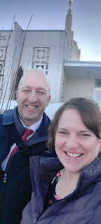

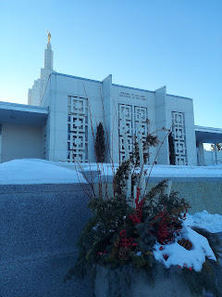

Having said that, as soon as we left the temple, unfortunately, it was hurry hurry hurry all over again. This time our friends, the Garners, had plans to meet us at our house around 6:30 so we could hang out and visit and have dinner. They had been down in Idaho Falls (from Rexburg) to run some errands in preparation for their daughter Hannah's upcoming wedding in April.

While my house was less than perfect and messier than usual (I hadn't cleaned up from decorating cupcakes or even washed the dishes), we had a lovely evening just hanging out and talking about this, that, and everything until after 10:00 p.m. Scott and I picked up two pizzas from WinCo (grocery store) on our way home from the temple, along with some fresh mushrooms, sliced olives, and a green bell pepper to add on top, and then we baked them in our own kitchen. Very tasty! Especially when the pizzas only cost $5.99 each!!

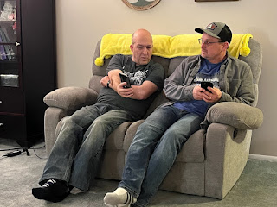

While Scott and Rich talked about all the latest and greatest sports stuff, Andrea and I talked about our kids, our church callings, and the ups and downs of life. They have been such good friends all these years. Scott and Rich went to elementary school together and have been friends ever since. :)

I went to bed very tired, but happy, around 11 p.m.

Sunday:
When we arrived at church this morning, there was a shocking announcement that one of our very dear friends passed away yesterday. Patricia Meyers ("Trish") died after things didn't go so well with her recent open-heart surgery. She was supposed to have a valve repaired or replaced, one that had already been operated on when she was 17 years old but has since deteriorated. She didn't improve in the way that everyone hoped for, and ended up on life support for about 9 days before her husband had to make the very difficult decision to let her go. She just wasn't making any improvements, but was regressing instead. She wasn't even that old! I think she was only in her 60's, maybe her late 60's.

Trish has always been perhaps my biggest fan when I make plans to go on family history trips. She has followed my blog for the past year and a half, even though I've been home most of that time. She is my hero when it comes to family history and I hope to someday have the knowledge and expertise that she had. She taught me so much over the years, and she was also the one to originally tell me about Roots Tech (a world-wide family history conference with classes and seminars for FREE now), which I have enjoyed for 3 out of the last 4 years. She and her husband used to run the Idaho Falls Family History Center together, and have contributed so much to our ward and many others who were learning how to do their own research. I will REALLY miss her a lot. Her funeral is this Thursday and Scott is hoping to slip away from the classroom to join me. I hope he can come with me. We have both worked very closely with Trish and her husband, Steve, for the past several years.

I had to search meticulously in my Google photos to find this
one
photo that I knew had Trish in it. It was taken last March as we were leaving the church building. There were several of us talking, and we decided to have our picture taken together. We've all known each other for many years.

From the left: Trish Meyers, Chris Bennett, Amy Schmutz, me, Barb Vance, and Meigin Larsen - (pronounced MY-gin).

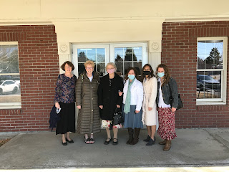

Gosh I am going to miss her.

In our YW lesson this morning, Megan taught the girls about Abraham and how he went through hard things, just like we do now, and what he did (or rather where he turned) to overcome those trials. Brielle helped her teach the lesson, asking the girls to come up and either write or draw some of the things that Abraham faced in his day and some of the trials we face in our day. I thought they all did a good job!

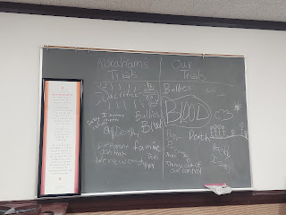

Here are some of the BEST baby pictures from the week:

Little Miss Avery Mae - such a little ray of sunshine! :)

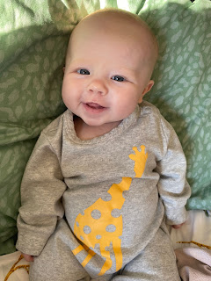



And Jack-Jack (notice they are on a bike ride in DC - in February!) Jacob said it was about 60 degrees!



And a cute video of Jack and his slobber: (20 seconds)
https://photos.app.goo.gl/H9h6wftxgf8pkc4K9

One last photo -

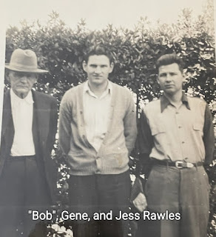

This was sent to me yesterday from my cousin Loreena Hester. She's been going through her mom's old scrapbooks and she found this gem to share with me. Eugene Carlton Rawles, a.k.a. "Bob" Rawles is my great-grandfather and was my Grandma Zoe's father. This photo was taken just before Gene Rawles (Loreena's father) left to serve in WWII. "Bob" was really ill when this photo was taken, according to the note on the back. I looked up his death date to see when he died, but it wasn't until 1948. Maybe he was just sick with something temporary, but maybe he died slowly over the course of a few years. His obituary simply states that he died after a "lingering illness."

And a couple last minute screenshots from our video chat with Jacob and Hannah - well, mostly Jack. :)

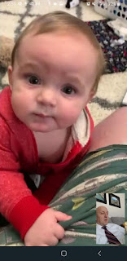

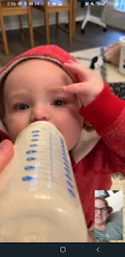

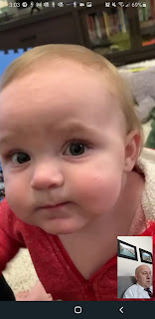

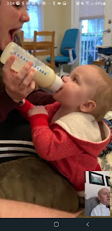



He cruised all around the room, crawling, standing up, cruising along the edge of the couch, sitting down, crawling somewhere else, etc. I love this next one with his little chubby feet crossed. He's thinking about chewing on his momma's shoe . . .

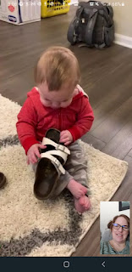



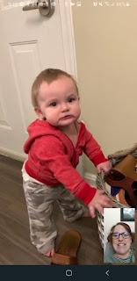

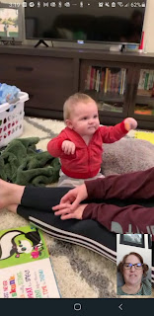

Sweet boy and his momma

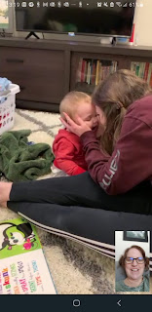

This kid loves to eat a good zipper



Goodbye sweet boy! Talk to you again soon! :)



After we hung up, Hannah shared this photo of Jack. He looks like he's a little stunned . . .ha ha

