A Moroccan Mother's Day & Other Family Adventures
Places mentioned in this post:
Agadir, Morocco
Casablanca, Morocco
Vicenza, Italy

On my last full day in Agadir, Morocco, I wasn't sure what the day would shape up to be. I was so tired from the day before, when Abdel and I had walked for several hours in the heat of the afternoon to visit the Kasbah. We had talked about using one of the kayaks (available for free through my hotel) and carrying it across the Promenade to the beach . . . but I just wasn't feeling up to it. Well, Abdel had a great alternative idea, but I didn't know where we were going or what we were doing until we got there.

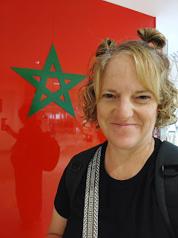

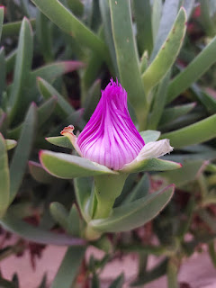

The flowers at the hotel never ceased to make me happy . . . I was sad to leave them behind.

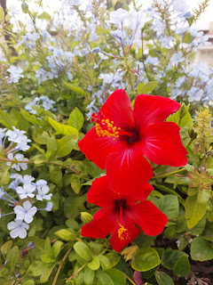

I was also sorry to say goodbye to the fabulous pool at The Dunes. The rooms may have been old and outdated, but the pool area was so lovely and well-kept. I wish I had access to a swimming pool all year round.

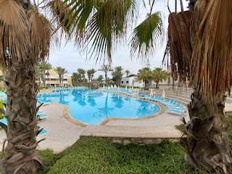

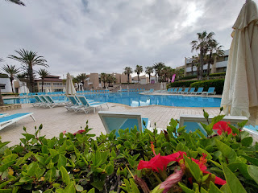

Abdel suggested that we go to a place called Agadir Bay. I thought it was going to be a beach area, so I dressed like I was heading to the sand and the water. Instead, we walked from the hotel entrance to a busier intersection nearby where we could catch a taxi, and then off we went to somewhere . . . Abdel insisted on paying for our taxi, telling me that I had done so much for him and now he wanted to do something in return.

The driver dropped us off near the downtown shopping district - called Agadir Bay - and we began walking toward the stores. I still didn't understand where he was taking me. A few minutes later, he asked if I would prefer this restaurant or another one a few shops down. I told him, "This one looks very nice", so we went in and found a table.

We ordered some fancy gelato desserts and then we sat back to visit while we waited for the server to bring our treats out. Abdel told me that it was Mother's Day in Morocco and he wanted to do something to honor me, since he feels like I am an "extra" mom to him. I had to look it up, but yes, Mother's Day there is celebrated about 2 weeks after most of the world has already celebrated it. Several times, as we sat there, talking and eating and watching the world go by, I had to fight back the tears.

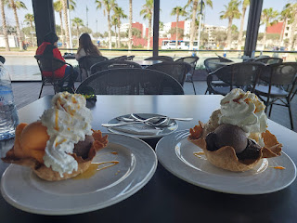

It had been such an amazing week and I was extremely sad to see it all come to an end. I have really come to love Abdel so much over the past 2 years, and having met some of his family on this trip, it was going to be even harder to say goodbye.

I asked him what his plans were for his mother, Majida, on this special day. He told me that she was working all day, cooking 25+ chickens and several other dishes, for a wedding reception. He said he was going to do something nice for her when she finally got home that evening. He might have had to wait until the next day, if he intended to take her out for a nice dessert, too. She was probably going to be exhausted after all that cooking.

We noticed a steady stream of buses going by on the main road in front of the restaurant, filled with soldiers that had finished their "war" for the day and were now being transported back to their respective hotels. I wondered if Scott was on one of those buses . . .

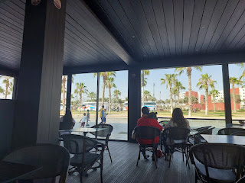

Something I had mentioned to Abdel a couple days before was the idea of him coming to visit us in America. We talked about the possibility of him securing a Visa to allow him to stay for a while in order to work, and that he could live with us during that time frame. He is really excited about this idea. Our homework will involve learning what the steps are, who to talk to, and then get the process started. The thought of this NOT being a final goodbye was helpful to both of us.

A word that Abdel used often, especially when we were in Marrakech, was "yalla". It's pronounced with a heavier emphasis on the the front end (YA-lah). He told me it means either "come on" or "let's go". The times he used it the most often were when we were trying to dodge scooters and other traffic in Marrakech. He was trying to guide me and keep me safe the entire day.

This is what it looks like in Arabic . . .



I tried not to cry as we walked back to an intersection where we would be more likely to find a taxi. I tried not to cry as we drove back to my hotel. But when we got out of the taxi, as I hugged him goodbye, I couldn't keep those tears in any longer. When he saw that I was crying, he said gently, "Don't cry. You're going to make ME cry!"

With promises to stay in touch, as we have diligently done already for the past two years, we hugged one last time and then I walked into the hotel and cried some more. Thank goodness for sunglasses to hide my eyes.

The next morning, I woke up a little before 5:00 a.m., even though my alarm was set for 5:15. (*upside down emoji*) After gathering all my stuff, Scott and I had an early breakfast together at 6:00 a.m. and then I rode in a pre-arranged taxi to the Agadir Airport.

The resort was quiet and dark at 6:00 a.m. . . .

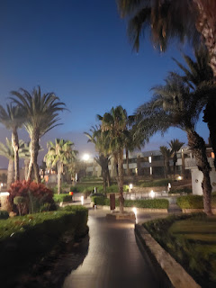

I had no problems getting to Casablanca . . .

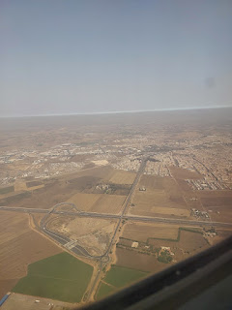

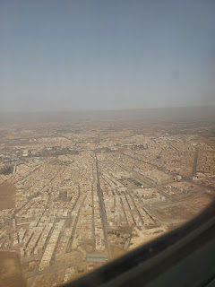

But it did take much longer than expected to get out of Casablanca. They had arranged for a different plane to come in, and it was late. Every step took 5x as long as it normally should from that point on (going through the gate, getting on a bus, getting off the bus, getting ON to the plane, etc.). I think we left Casablanca about 3 hours later than what we were supposed to.



From Bologna, everything picked up speed again, and I got my luggage, my car, and arrived home in a timely fashion, even though it was around 10:00 p.m. instead of 7:30 p.m.

The following day, Abdel sent me this precious photo of his family preparing a breakfast meal together. From L to R: His twin sister Latifa, his mother's sister came to visit, his father (I can't remember his name but I saw it written down one time), and his mother Majida. She was baking some sort of bread, kind of like flatbread or tortillas.

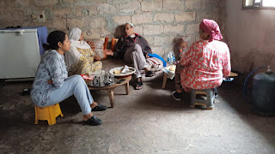

Below: I saw this on Instagram recently, and I knew instantly that I wanted Amber to paint me something similar at some point. She gave me a couple of coupons for Christmas - good for any painting, of any size, of any subject matter. I shared this with her and she loves it, too. Her paints are all boxed up and sitting in a storage unit up in Beaverton, Oregon for now, but someday she will be all settled in up there, and THAT'S when she will have time to make me something beautiful like this.

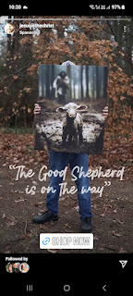

I found a new salon to get my hair done in Italy. I didn't actually "find" them, but a couple of my good friends highly recommended this place. I walked over to scout it out and set up an appointment. They had an opening for the very next day! And several people spoke English there, too, which was a bonus. It's always so hard to explain what you need when there's a language barrier . . .

The salon is called Nico & Co. and is located in downtown Vicenza.

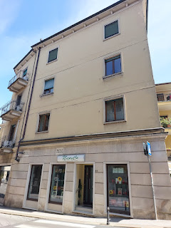

The salon is situated on one of the canals running through the city, but this one had some beautiful cascades that I had not seen anywhere else in town before.

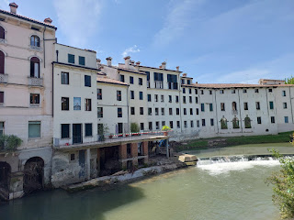

Nico's son, Robby, is who cut my hair. He did a great job and communicated very well with me. The difference between Antonella's salon and Nico's salon is COMMUNICATION. At Antonella's salon, I would bear the burden of trying to communicate what I WANTED to have happen, and relied on them to understand and then implement. But sometimes they had ideas of their own, or felt that the best way to accomplish my requests was to do "this" or "that" - without checking in with me as we went along. Often, I was shocked about something by the end . . . whether it was the price (because they added in some extra steps without asking me first) or cutting my hair way too short, etc.

Robby, on the other hand, took my requests and then explained how he would go about making all of them happen, and then asked me if this was okay. It was a symbiotic form of communication and I appreciated it very much!!

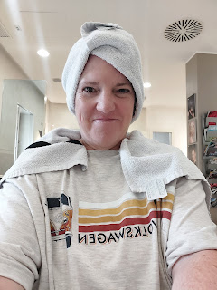

This is the view from within the salon . . .

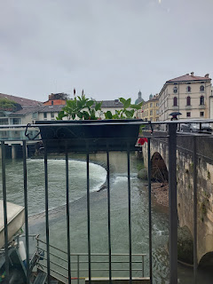

Below: Photos of a few more delightful flowers in a random spot of Vicenza. These gorgeous hydrangeas were poking through the fence along the edge of the parking lot of EuroSpin, a nearby grocery store.

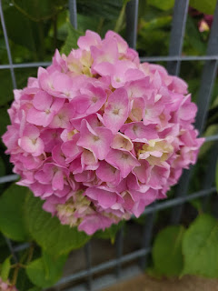

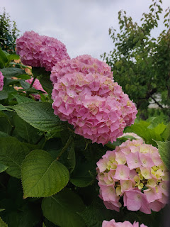

I had the pleasure of picking up and hosting an amazing lady named Brittney Espersen for a couple of days. She was flying over to see her daughter, Isabella, graduate from the military high school over here. What an incredible person Brittney is! She has been very public about her life on Facebook, where she posts daily deliciousness and photos of what they're serving up at The Food Mill in Columbus, GA where she is the General Manager.

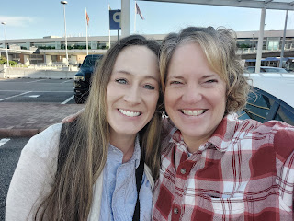

She was interviewed recently by a journalist about her past drug addictions, homelessness, and rehab that led to her current job. Several years ago, she was offered a couple of options for learning a career path while in rehab, and she chose to become a culinary chef. She's been clean and sober for over 10 years now, and she currently helps men and women coming out of rehab themselves, by training them in her kitchen at The Food Mill.

At The Food Mill, they coordinate with local farmers to purchase fresh produce for the restaurant. They also feed up to 300 meals to hungry children for breakfast during the weekdays. She told me that when she gets new recruits, she explains to them that in her kitchen they will not use profane language, and they are not allowed to yell or raise their voices at each other. They also have to remove any body piercings and cannot come to work with long acrylic fingernails either (for health and safety reasons).

I told her this was one of the most incredible things I've ever heard! I am always shocked and many times I'm just plain frustrated at the lack of language filters that people have in public these days. Both young and old, male and female are dropping F-bombs left and right, with no awareness of young children/ladies/or elderly people nearby. But Brittney is helping her culinary students to be more self-aware and to use a filter in certain settings. She is teaching them to find better language to use when communicating, and to do so in an orderly manner, instead of angrily or with a higher volume.

I gushed with my gratitude and appreciation for all that Brittney is doing in her life. She still carries a fair amount of guilt and remorse for her past mistakes, but she is sure trying.
Every. Single. Day.
And that matters a great deal. We talked a lot about our personal lives, our pasts, which allowed us to became deep friends in just 48 hours.

We didn't have much time for exploring the area because she wasn't in Italy for very long at all. She got in on a Thursday evening, we had all day Friday together, and then I drove her back to the Venice Airport early Saturday morning. We had to go on base to get her a special pass for attending graduation on Friday night, and there was a lot of rain in the forecast. After learning that she had already visited Venice on a previous trip to Italy (her husband has custody of their two teenage kids), I decided to take her to an Italian grocery store. It would be something to do indoors and out of the rain, and it would also give her an opportunity to see some exciting things like full-bodied octopi, a million types of Italian cheeses, tons of pasta, and don't forget the long aisles of olive oils! She was in heaven, ha ha. She took lots of pictures and enjoyed the whole experience.

As we exited the huge grocery store (Rosetto), I noticed that the skies were clearing up and a little bit of blue was peeking out. We hurried over to Monte Berico so she could see all of Vicenza while the sun was still shining and the views were spectacular.

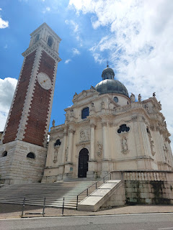

That evening, we arrived at the smallest base in Vicenza (Villagio) where the brand new high school was just opened last September. Her ex-husband had the tickets for us to get in. Brittney was very nervous and even a little anxious because she knew that her ex-in-laws were also there for Isabella's graduation. She hadn't seen them in a long, long time, and their relationship was strained to say the least.

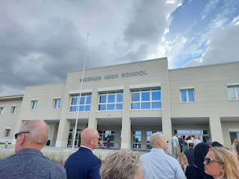

She was hoping for an opportunity to apologize to them and to let them know she has worked hard to pull herself up out of the gutter and that she wishes them all the best. We said a prayer together before we drove over to the high school, and we just hoped for a miracle.

The ceremony and proceedings were very nicely done. The marching band did a great job of playing the Italian national anthem first, and then the U.S. national anthem. There were Italian dignitaries in attendance, so this was the respectful thing to do, since we're on THEIR soil.

At the end, the senior class president had them do what I had also directed 35 years ago at my own high school graduation: change the tassel from the right side to the left, signifying that you are now officially graduated!

Watch it here: (45 seconds)
https://photos.app.goo.gl/F6rrY7B5bPCPvRRV7

Brittney hugging her daughter afterwards . . .

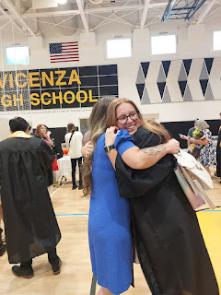

Brittney with her daughter Isabella and her son Ben . . .

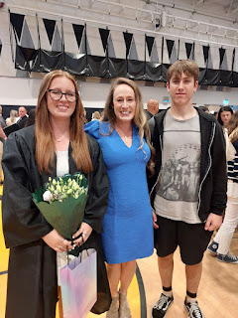

I was happy to see my good friend, Christine Swanson, who was working there with the USO, helping to serve the refreshments. She is wearing the dark blue hat in the photo below. I was able to visit with her briefly once the cake was all gone, ha ha. I was surprised to see her there, but then I shouldn't have been surprised since she is always doing so much with the USO, even after her normal working hours are over.

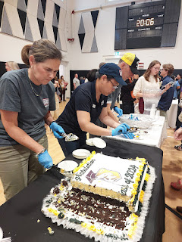

Here is the miracle. I had stepped away from visiting with Brittney and some of the other family members, in order to visit with my friends (the McGoverns), who had a twin son and daughter that graduated that night. As I made my way back across the gym toward Brittney, I saw her in the middle of a long hug with her ex-mother-in-law. I hurried to grab my phone and take a picture while I walked, because I wanted to capture this moment for her. I wanted her to be able to remember this miracle for the rest of her life.
It's a little blurry because I was in such a hurry to take the photo before they stopped hugging. But I needn't have worried. They stood in that precious and kind and loving embrace for SEVERAL minutes. It was a beautiful thing to watch from a respectful distance.

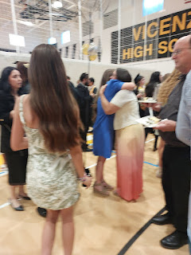

Brittney told me later that her ex-mother-in-law told her she freely forgave her a long time ago, and that she was sorry she hadn't told Brittney sooner. Wow. They bonded deeply through that hug and stood close together, visiting for a long, long time.

As we walked outside to the car afterwards, Brittney's tears began to freely fall, as she recounted what had just taken place. She was shaking, perhaps with shock, so I linked arms with her and we slowly made our way over to my car. She shared how this had been such a heavy burden for so many years, all the pain and turmoil she had put the family through, and now - TEN years later - that burden had just been lifted. She felt lighter - both in her outward step but also deep down in her soul.

When she woke up the next morning, bright and early, she was still feeling tender about what had happened the night before. She felt almost like a whole new person. THIS is the power of forgiveness! Especially when you associate forgiveness with the power of Jesus Christ's Atonement. Because of Him, we can forgive. Because of Him, miracles can happen. Because of Him, people can change for the better.

I am so humbled that I could be a witness to such a weighty miracle in Brittney's life. It was even a small miracle as to how I ended up inviting her into my home in the first place! She had sent an email to our Vicenza Ward bishop, asking if there was someone who could pick her up at the airport and allow her to stay with them for those couple of days. Bishop Horner relayed the message to my husband, Scott, and we felt like this was definitely something that we could do.

We all go through hard things in this life, of varying degrees and at varying stages of our maturation process. The single most important thing that should come out of those hard things is that we learn something positive, motivating, and soul-changing. I have had several of these life-changing experiences in my own life, some of which I've shared through my blog previously.

I am just so proud of Brittney and all of her consistent hard work that has gotten her to this point. I hope she can continue to give herself a little bit of grace and self-love, too, and that she can feel the love of our Savior every single day going forward. She deserves those things. We all do.

**Note: I asked for her permission to share her story in my blog. She gave her wholehearted consent. XO

Recently, my mother shared a few things that she has discovered as she's been sorting through some of Grandma Doris' things after she passed away last August. One of those magical discoveries was this HANDWRITTEN list of scriptures that can help you in various situations, compiled by my Great Grandfather, Leon P. Jones. (click photo to enlarge)

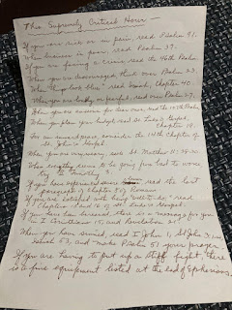

When I go out to CA for my next visit this summer, I am really looking forward to helping my mom sort through some of these precious heirlooms.

Speaking of family history, did you know what your DNA results can do for you? On Ancestry.com, they now have enough data and knowledge to be able to differentiate what genetics you have inherited from your mother's side vs your father's side. Holy Moly!! Take a look below at what Ancestry.com recently updated in my DNA results. (click photos to enlarge)

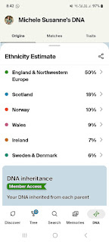

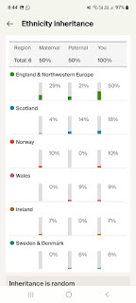



I was most surprised to see that my percentage of DNA from Norway has gone up to 10%. I don't even know who came from Norway yet . . . that's because there's no shortage of research that needs to be done on my family tree . . .

My friend, Marnie Parker, has a dear friend named Megan Rieker who is an incredible artist for The Church of Jesus Christ of Latter-day Saints. Marnie was able to set it up so that Megan could come to Vicenza and speak to our Relief Society ladies last Sunday. She did a special presentation of some of her paintings and how they came to be, while at the same time she taught us some powerful principles of the gospel. Her main focus in her artwork is to depict women in the gospel, through all generations of time.

This is her website:
https://www.meganrieker.com/

She had several copies of her art on display at the back of the room, and she gave us permission to take pictures of anything that we wanted.

"Angel Mother": (Megan's words) "This was inspired by multiple things in my life, like talks where leaders described their mothers as 'angels' on earth. This mother is depicted as flying above the negativity and temptations of the world (shown as thorns). With a child carefully swaddled in her arm, she also carries a compass, so she may steer her family in the right direction. A Mother is the first Christ-like interaction a child experiences in life, and just like Him, she is always reaching out to her child(ren), no matter how wayward, to welcome them home."

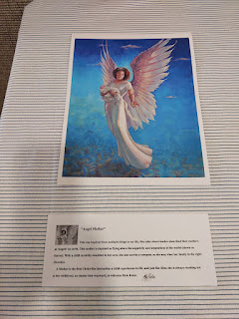

"Eve's First Harvest": (Megan's words) "Eve said, 'Were it not for our transgression, we never should have had seed, and never should have known good and evil, and the joy of our redemption, and the eternal life which God giveth unto all the obedient.' (Moses 5:11)

"Eve was given as a 'help meet' for Adam.
Help
means to surround, protect, and aid, and
Meet
means equal to, suitable for, worthy or necessary, and of course the name
Eve
itself means 'mother of all living'.

"I set out to paint Eve in an unusual period - after the departure of Eden, and in the dreary world. I chose to have her paused after toiling in the first harvest and awaiting the birth of her firstborn. Here Eve is at peace with her role as a mother and helpmeet for Adam. Eve has always symbolized finding joy amidst pain in motherhood."

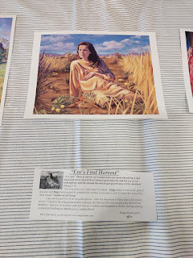

Megan's story is similar to the story of how my daughter evolved into the amazing artist that she is today. There were always "growing pains" but also clear evidences of the sheer talent that lay within. Megan showed us some of her art assignments from when she was roughly 13 years old, even including the blunt comments from her art teacher to make the subject bigger (for the drawing on the left). Megan wanted us to recognize that none of us is perfect, and that there is always room for growth. We need to be humble enough to accept the advice that is being given in order to become better.

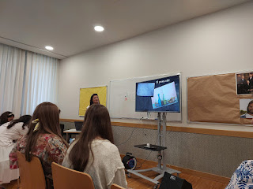

Megan has completed roughly one painting per year for the Church, over the course of 24 years.

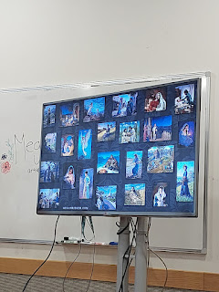

Out of those 24 paintings, she prayerfully narrowed down her focus to 6 that she wanted to share with us. She often does presentations for the women of the church and at girls camp. While she didn't choose these specific 6 to discuss with our group, I still appreciated having a close-up of some of her artwork.

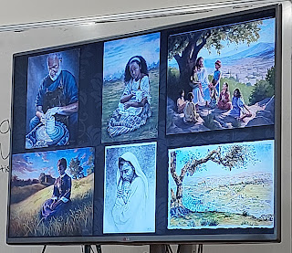

One of her earliest paintings helped to solidify an important gospel principle: to
pray always
. She prays before she begins every painting session, sometimes multiple times throughout.

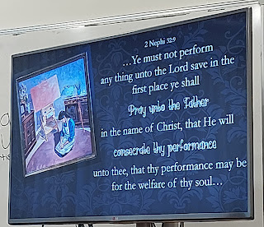

"Forsake All and Seek Ye the Kingdom of God": I have forgotten the reference for this scripture in the Bible, but there is a story of the people burying things that were considered "idols", things that stood in the way of their sacred worship of God Himself. Here, Megan chose to represent women, because that is her commission with the Church. She was quick to acknowledge that there is nothing wrong with having jewelry (see 3 photos down).

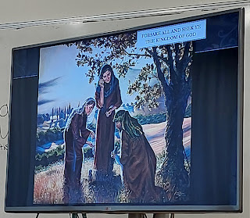

A close-up showing the symbolism of "things" that become like an "idol". We are commanded to have no other Gods before God Himself.

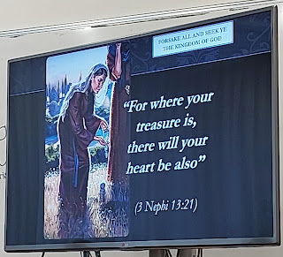

Look more closely at this one . . . (click to enlarge)

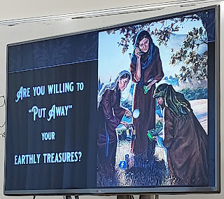

Megan told a funny parable about her art studio when she used to live in Italy many years ago. She had all of her art supplies arranged and available, ready for her to get to work. But she would often let herself get distracted by her "side gig" of making jewelry - shown in the lower right corner below. It was easier to sit and mindlessly make jewelry that would sell easily and immediately, versus having to put a lot more thought and effort into whatever painting she was currently in the middle of. One day, she felt a prompting from God to make note of this as a temptation, and to choose more wisely how to spend her time.

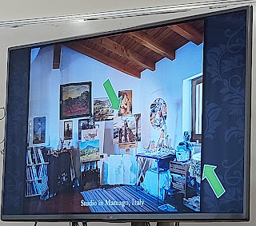

"Mother, a Precious and Chosen Vessel": Megan pointed out to us that the model for the mother on the right was none other than MARNIE PARKER!! They have been friends for about 21 years and have kept in touch as the military has moved each of their families to many places and bases around the world. Megan also pointed out to us that she wanted motherhood to appear fluid and continuous through the many dispensations of time, thus a similar scene is depicted both on the left and the right. She also made it a point to include our Savior in both time periods, as each mother is lovingly teaching her children.

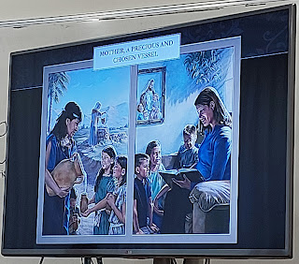

She talked to us a little longer about this next concept, even showing us a time-lapsed video of her process for painting the Five Wise Virgins.

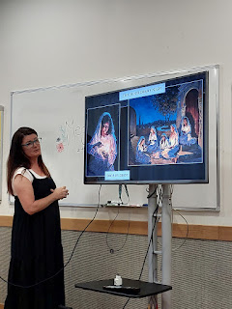

So often, we heap mighty expectations on ourselves (especially as women) to be perfect in all things, when in fact, we are all just a work in progress. We need to give ourselves grace and self-love (just like my friend Brittney) as we try to BECOME. We are all a masterpiece in the making. The early stages of her paintings include rough sketches, then weird colors that serve as a background, along with blobby figures and hideous shadows. Nothing about it seems very noteworthy or beautiful. But in fact, each brush stroke and each intentional shadow are meant to accentuate the light and the beauty of the subject: US.

She quotes a former prophet, Spencer W. Kimball, as she ties together the process of US with the process of adding oil to our lamps:

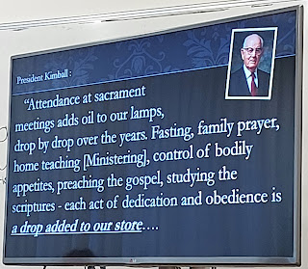

You are a masterpiece in the making . . .

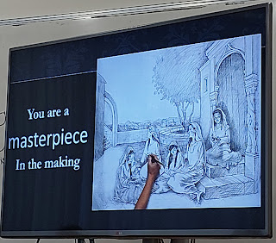

"The Widow of Zaraphath" as told in 1 Kings 17: 10-16 . . . Trusting in the unknown, but full of faith anyway.

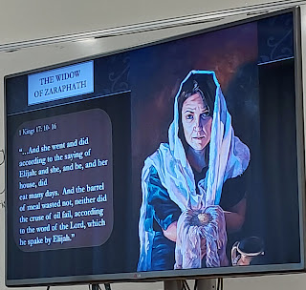

Megan shared with us how her adult son had been diagnosed with diabetes as a youth, and how careful they and he had been in his care for many years. But one day, after the long days of Covid-19 had eased up and they spent a glorious week together as a family, her son tragically died. While he slept, one of his machines stopped working. Usually an alarm would go off if it stopped, but this
one
time, the back-up device was charging in another room, and effectively did not perform its sole intended job. His body went into insulin shock and he died in his sleep. This was just two years ago.

She spoke of her grief and how she had to continue trusting in God, even though many days and weeks and months felt dark, shallow, and empty. Just like the widow of Zarapheth, she gave her last bit of meal and oil to the Lord, trusting that He could heal her heart and help her to rise from the ashes of this great loss.

She named this painting: "Some Kinds of Faith Only Grow in the Dark"

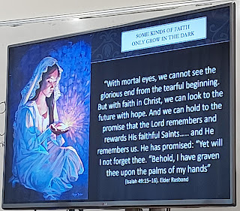

Next, she played this beautiful song for us, by Sally DeFord, called "The Painter's Hand":
https://defordmusic.com/song-list/the-painters-hand/

The last painting she shared with us was a representation of the Iron Rod in Lehi's vision of the Tree of Life (1 Nephi, chapters 8 and 11, in the book of Mormon).

In a nutshell: Lehi, an ancient prophet, who fled Jerusalem with his family shortly before its destruction, had a dream. In his dream, there was an iron rod that led to a beautiful tree, filled with delicious fruit. There were many distractions to navigate in order to get safely to the tree, such as people mocking from a tall and spacious building, mists of darkness, filthy rivers, etc. When Lehi made it to the tree by holding steadfastly to the iron rod, the fruit was so delicious that he immediately wanted his family to come and partake of it, too. He called out to them, directing them to the path that led to the iron rod and eventually to the tree. Some of them heeded his counsel, but some chose to disregard his invitations and counsel, causing them to flounder in the mists of darkness and lose their way.

There is a lot of symbolism in Lehi's vision, which can be explained in chapter 11 of 1 Nephi. For example, the Tree of Life represents the Love of God and all things connected to that sacred, unconditional, and neverending love. The iron rod represents the Word of God (i.e. scriptures, counsel from our prophets and leaders) that help us to stay on the path that brings us the most happiness as we obey God's commandments.

Megan shared with us that she doesn't like the all-too-often representation of the Iron Rod that leads to the Tree of Life. She has seen many depictions that show the path as being linear and altogether too straight and/or flat. She made a good point by stating that life isn't that simple.

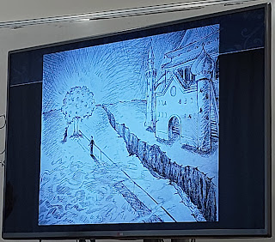

Even as we follow God's commandments, we encounter difficulties, tragedies, temptations, pain and sorrow. Just because we're on the path that leads back to God doesn't mean it will be flat and scenic and perfectly beautiful. Life is messy and hard. So she chose to design her own version of the path next to the Iron Rod . . . one that is rocky, dangerous, craggy, chunky, and difficult.

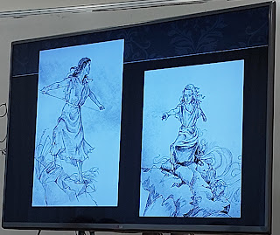

She drew our attention to the woman holding firmly to the rod: her knees and shins are bruised and bloodied from all the times she knelt down on those sharp rocks to pray and ask for guidance and motivation and help. As she is making upward progress, however slowly, she is able to turn around and notice others who are in need of help and ministering. BUT - notice that she does not let go of the iron rod as she extends her hand out to someone in need. She is reaching as far as she is safely able, and is encouraging the other woman to reach out in return, and to keep making her way one step at a time and to not give up.

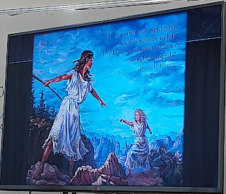

She also added in a quote by one of our apostles, Henry B. Eyring:
"If you are on the right path, it will always be uphill. The Lord is anxious to lead us to higher ground."
Wow. Those are powerful words to consider.

After much deliberation and prayer, she finally settled on a name for this recent painting.

"Lead, Kindly Light". It is based on one of our hymns for Sacrament meeting. (click the photo below to read the verses she connected to the most)

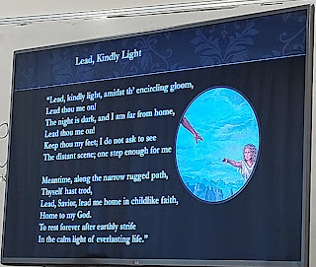

I had the opportunity to visit with her afterwards, and I was especially touched as she took a genuine interest in my daughter Amber's art on social media and also her website. (
www.amberwhitworth.com
) She gave me some good tips to pass along, and she also offered her services if Amber ever needs anything.

Megan told us early on in her presentation that she had suddenly contracted Bell's Palsy back in 2002-ish. This causes the nerves in your face, usually half of your face, to not work. This is why - in the photo below - her face seems a little different. Half of her face is trying to smile, and other half isn't cooperating. I'm sure it hasn't been easy for her to deal with this condition, and for so many years.

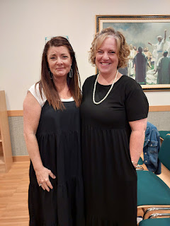

I'm so glad I went to this presentation. It had been a long day already, because Scott got home from Morocco pretty late the night before, and I had to go pick him up. We went to bed close to midnight on Saturday. Then, on Sunday morning, the bishopric was released at church, and a new bishop and two counselors were put in. Scott still had his regular early morning meetings before they were released, and I worked on my lesson for my little Primary class. Then, after church, Scott stayed another several hours for some additional meetings and to help train the new bishopric. He got home around 4:00 and then I left at 4:40 to attend the Relief Society fireside with Megan Rieker that started at 5:00.

I didn't stay too long afterwards. I chatted with Megan for a bit, I ate a peanut-butter/chocolate bar from the refreshment table, grabbed one for Scott, visited with a few people briefly, and then I drove home. I had been filled spiritually, though. Filled to the brim.

I think this is yarrow . . . we saw lots of them in the fields on a recent evening stroll . . .

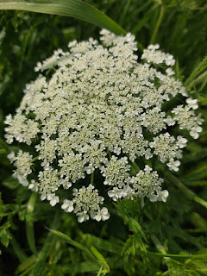

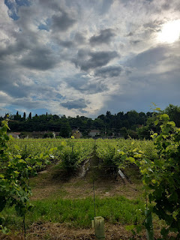

As we walked along a path next to a nearby vineyard, there was a special skinny truck of sorts that could fit in between the rows of grapes. The driver was installing heavy-duty string to secure the new growth on the plants. The rows essentially went from being messy and unkempt looking, to neat and tidy and organized. Very cool.

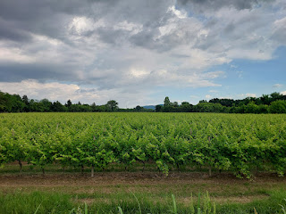



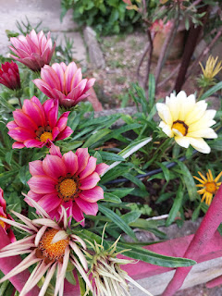

The last bit of a remarkable sunset, as seen from our roof . . .

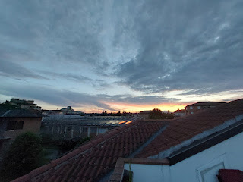

Two days after the fireside with Megan Rieker, I met Marnie Parker for breakfast at the Commissary. I never knew they even served breakfast, ha ha. I ordered the exact same thing as Marnie - an egg/bacon/cheese croissant and a hot chocolate. We have been so busy doing opposite things this spring that we've hardly seen each other. We caught up on all the happenings, and I enjoyed hearing about her upcoming trip to Ireland (she's there with her family right now). I'll need more details after she gets back, for sure.



Time to Get Caught Up On the Grandbabies . . .

Avery:
I had a brief video call with Kylie and Avery a few days ago. They are down in the Tucson, AZ area and it has been swelteringly hot. The day we spoke, she said it was 90 degrees at 8:00 in the morning. Yuck! They do have a swimming pool at Kylie's friend Rylie's house, but it didn't look like it had a gate or any protection around it. Kylie is good at keeping track of Avery, though, so hopefully nothing bad will happen.

Avery was super happy to jump on the little trampoline for a while, even though it was so hot outside.

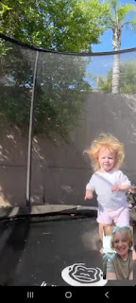

Fishy kissing lips . . .

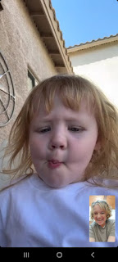

A brief sassy moment, LOL . . .

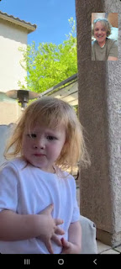

When I mentioned I could hear a bird singing oh-so-pretty in their back yard, she put on her "binoculars" to find him . . . XOXO

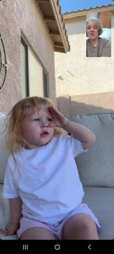

Kylie

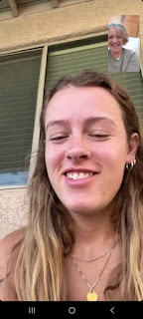

Kylie's friend, Rylie, has a little boy, so he and Avery hang out together a lot. He's just 1 1/2 years old.

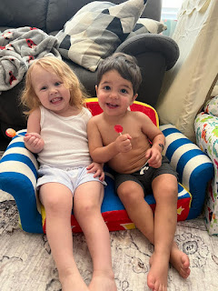

Jack:
He has been having some fun outdoor adventures lately.

Like letting a caterpillar crawl onto his hand . . .

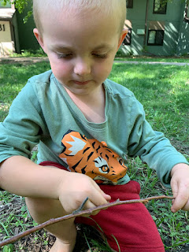

Canoeing on a nearby river . . . Hannah is holding onto Jack in the boat.

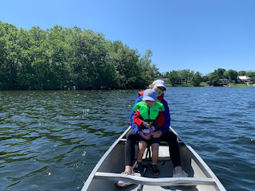

Jake and Jack . . . two strong paddlers together.

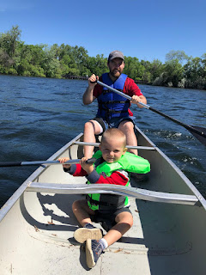

They are currently in Florida - hanging out with Hannah's sister Kaitlin and her family. Kaitlin has two little ones: Calvin (3) and his younger sister, Elliott (1).

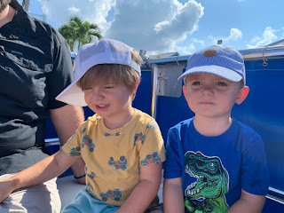

L to R: Jack, Elliott, and Calvin

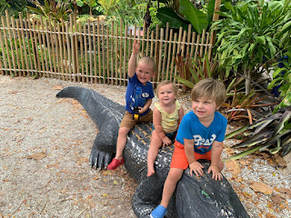

The cutest video of Jack hugging and kissing his cousin, Calvin, while they're on a boat ride: (22 seconds)
https://photos.app.goo.gl/uUaEwb2NPsJiRSN9A

Hannah also finally received her Master's Degree in the mail . . . Yay!!

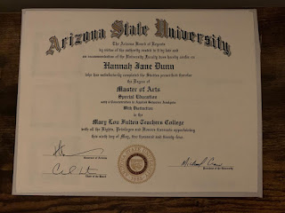

And they have had some great success with their first little family garden . . .

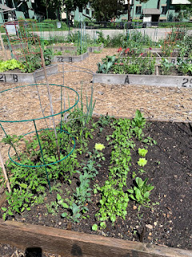

Abby and Gwen:
In the final days before they left Louisiana for good, the girls had an aerial silks recital. They've been going to classes for the past several months and they absolutely love the artistry and challenge of the "sport". I think it's more of a dance form, but it definitely requires a lot of strength in addition to the grace.

Amber and Weston gave each of the girls a flower bouquet after their performances . . . XOXO

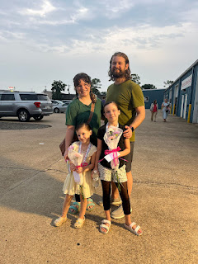

Gwen, with her "bravery pose" . . . she had been a bundle of nerves earlier that day when I talked to her on the phone. She even threw up once, but then she pulled it together and did a fantastic job!

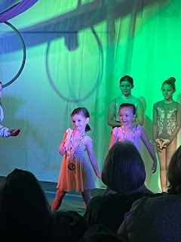

Watch Abby's performance here: (2 minutes, 7 seconds) She did all of her own choreography.
https://photos.app.goo.gl/UaPquWBZoewo6dgE7

Watch Gwen's performance here: (1 minute, 35 seconds) She and another girl are doing the same choreographed routine at the same time.
https://photos.app.goo.gl/mjLBxtTGsoyhkBR89

Group photo: Abby is on the far left in blue; Gwen is in the front row.

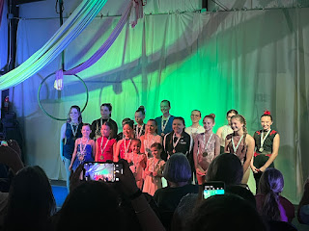

Abby has gotten really good at making stop-motion videos. Watch her latest creation here: (11 seconds)
https://photos.app.goo.gl/cLQQQTeJRjAyBMHv5

They also successfully loaded up a 25-foot U-Haul truck, even though they ended up giving a few things away at the end that didn't quite fit . . .

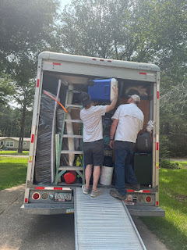

Amber's now-empty art studio . . .

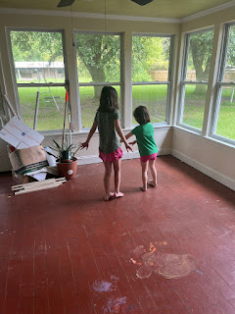

Gwen - using the empty pantry shelves to practice for American Ninja Warrior . . .

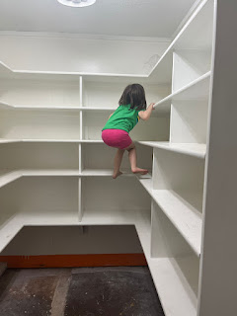

Here is a sweet video that Amber shared. Weston had a surprise going-away party in his honor, and one of their office staff started singing to him, but then broke down in tears. (23 seconds)
https://photos.app.goo.gl/F16m8sRQuX4VuY7Q8

Gwen - holding a giant bunny in my back yard in Idaho Falls. His name is Arden and he belongs to Amber's friend Lyndsey.

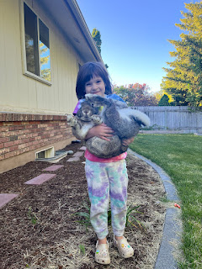

So yes, they made it safely across the country to Idaho - for now. Once their house sells in Louisiana, they can put an offer down on a house in Beaverton, Oregon. Weston just arrived up in Portland yesterday (Sunday, June 9th), and will begin his new job up there right away. He has a company car now, which will be a huge blessing until he gets his Hyundai Elantra fixed back in Idaho.

I can't wait to get back home and spend some time with Amber and the girls at our house . . .

A couple of final things:

Scott received a distinguished award for all of his hard work in making the African Lion exercise in Morocco such a huge success. He didn't feel that he earned it all on his own, since his buddy Jason had contributed at least 50% of the effort, too. Unfortunately, Jason is a civilian contractor, so he doesn't get to earn a military medal. Jason made the front end of the computer programs for the mission, while Scott implemented the back end and made sure everyone knew how to use the programs. I'm proud of them both. At the first opportunity, Scott made sure to publicly acknowledge Jason's efforts, which was a really nice thing to do.

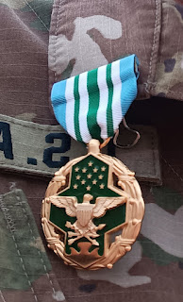

Me - in my traditional Moroccan dress . . . it is so soft and comfy, even on a hot day.

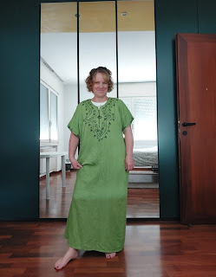

One morning a few days ago, my phone started ringing. It was a video call from Abdel and Jhad down in Agadir!! Jhad wanted to talk to "Tata Michele" - which he dubbed me all on his own. It means Auntie Michele. How cute is that!!



Abdel will be such a good father some day. Hopefully in the near future. He is so kind and loving with children, as seen below where he's giving Jhad a kiss.

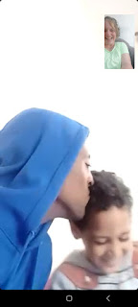



Jhad really wanted to talk to Jack, whom he had seen on a few videos on my phone when I had lunch with them recently. Abdel had to explain to him that Jack was in America and I was in Italy. I told Jhad that when I get to America soon, I will call him on video so he can say hi to Jack. He made me PROMISE that I would do this, ha ha ha ha.



Next weekend, Scott and I will be in France, visiting the beaches of Normandy. Please be patient as I work on the corresponding blog post . . .

