A Visit to Aviano & Sampling a Persimmon
Another relaxing week has gone by. 'Twas a week of small adventures, small tasks, small errands, and some of my favorite small people.
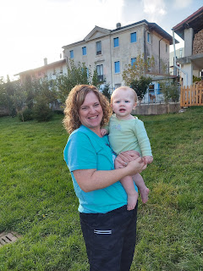

Tuesday:
I went on several errands getting a variety of groceries for the week, as well as some specialty ingredients for a youth activity that evening. I spent a good portion of the morning mapping out a menu plan and compiling a grocery list, dividing the list between the Iper Rosetto (a LARGE Italian grocery store) and the Commissary.

The youth activity was a Fireside at the Spiritual Life Center on Camp Ederle (the base nearest to our house). The Bishop spoke with all the teens first, sharing an uplifting and spiritual message, and then they all got to roast marshmallows and make s'mores over a borrowed firepit that someone brought in. (They got permission first to make a fire on the base.)

Scott said it turned out really well. There were several youth that came, all between the ages of 11-18. And they ate 95% of the s'mores supplies that I had purchased, so they did a good job!! I didn't go with him because I needed to clean up our kitchen from the dinner I had made.

Garlic Pork Chops in Creamy Mushroom Sauce
https://www.eatwell101.com/garlic-pork-chops-in-creamy-mushroom-sauce

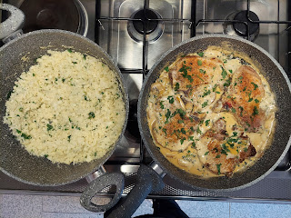

It turned out really delicious! I made riced cauliflower as well, using an unusual - but decent - technique. I don't have a food processor over here, and my blender was pitiful at chopping up the raw cauliflower into rice-sized bits. So I grabbed my box cheese grater and grated the entire head of cauliflower in small sections at a time.

There are several recipes out there for riced cauliflower. I chose one that had a little bit of fresh lemon juice and some fresh minced parsley. I sauteed it in a pan with a little bit of olive oil and butter, salt and pepper for about 8 minutes. Delicious!



Scott oohed and aahed over the pork for the next 2 days, ha ha.

Wednesday:
I prepared a box of baby clothes to send to Jack. The fun is definitely in the finding: going to local stores where I have been steadily finding a little here and a little there over the past week or so.

I met with my friend Andrea on base again and we had lunch at the Italian Mensa. This time I chose a vegetable soup that looked a lot like a split pea soup or a green lentil soup, along with some meatballs and pasta. Again, it was way more than what I could eat, but I did a decent job this time by not getting any additional items (like a salad).

We enjoyed learning about each other's backgrounds a bit more, this time we shared more about our individual personality styles and the personalities of our husbands. After our lunch was over, I walked her back to her office where she gave me a tour. She works for one of 4 colleges that are represented on the base here for all the military personnel. She even sent me some information on a class I could potentially enroll in, since I am considering how and where to take a language course when I am back and forth so much for the next few years.

I also brought her a plate of chocolate chip cookies that I made earlier that morning. She and her girls enjoyed eating them together that evening. :) Andrea even asked for the recipe. That's always a good sign, ha ha.

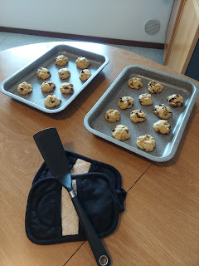

I'm glad to have a friend that I can chat with and do things with in Italy, and she is so nice and friendly and thoughtful. I am very blessed to know her!

Thursday:
I got up extraordinarily early to help out with a morning seminary class (at 7:00 a.m.), also held on base at the Spiritual Life Center. High school students attend seminary for 4 years, learning through books of scripture many wonderful doctrines and principles of the gospel of Jesus Christ. In some areas, there are enough members of the church in the community that there is a seminary building adjacent to each high school, such as what we have back home in Idaho Falls. But in other areas, like Vicenza, or where I grew up in Ukiah, CA, there are fewer teenaged members of the church, so they have to find other places to meet (like in the actual church building or in someone's home). Here in Vicenza, they meet in the Spiritual Life Center.

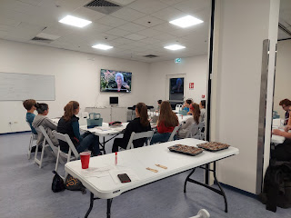

The seminary teacher, Rachel McGovern, needed to leave class a little bit early on Thursday, so she asked if I could help fill in as a second adult. Our church strongly advocates having 2 adults with any group of children or youth, as a safety precaution. Rachel's daughter, Emily, had a fun activity all planned out and she was able to execute it marvelously while I just sat back and enjoyed the whole thing, ha ha. They ended up playing a version of Family Feud as the youth practiced some scripture mastery and memorization.

She would ask a question, such as: "What is the scriptural reference that refers to a prophet being a watchman on the tower?"

The class had already been divided into 2 teams, so one person from each team would come up to the front table to answer the question. Whoever grabbed the dry erase marker first (instead of pushing a buzzer, which we didn't have) could attempt to answer the question. If they got it wrong, they could "Phone a Friend" - meaning they could get some help from the rest of their teammates. If they still got it wrong, it would defer to the other team to try to answer correctly. Points were given based on how quickly they could get the answer right.

One of the questions proved to be a bit tricky. I don't remember the exact wording, but it had something to do with WHO asked the watchman on the tower to preach some specific principles unto the people. The kids were sure it was "the Lord", since in the Old Testament (which is the book of scripture that we've all been studying this year), reference is made often to the LORD. But the correct answer was God. They were debating back and forth over this, and finally they asked me to intervene.

I commended them on asking such good questions with an in-depth attempt to understand the principle correctly. Since Rachel had already prepared the questions and the answer key in advance, I suggested that we defer to what she wrote down for now, but that they could ask her for more clarification the following day when she would be back. I added that even though God, Jesus Christ, and the Holy Ghost are considered one in purpose and unified in all things, ultimately God is in charge as the Father, and maybe that's why He was listed as the correct answer to that question.

After class, I walked across the street to go to the Gym on base. Having worn casual clothes for the seminary class, I brought some gym clothes to change into afterwords, and it all worked out nicely. After a satisfying 30 minute workout, I mailed the package for Jack before leaving the base. Oddly, it was only about 9:30 a.m. when I got home. I still had the whole day ahead of me!!

I worked on Avery's Quiet Book throughout the day and I even closed my eyes for a little bit in the late afternoon.

Scott calls me on video every day as he leaves the base to drive home. He works at the other base across town, so it takes him roughly 15 minutes to get home if the traffic isn't too bad. I always enjoy trying to guess where he is based on what I can see out the windows as he's driving . . .

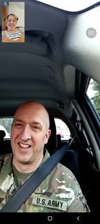

Friday:
Scott had the day off, which was wonderful! We slept in a little, went for a walk, and even went on a date to empty our recycling bins down the street. How romantic!

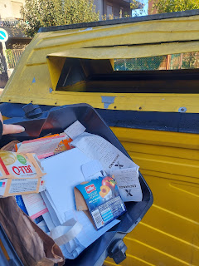

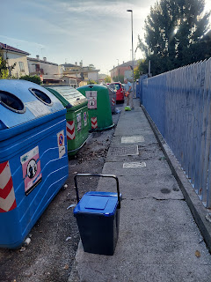

We went for a walk past the dumpsters, heading further back into our neighborhood which we had not done before. I had no idea there were so many apartment buildings tucked behind our street! It was sort of a maze of several short streets that zigged and zagged and eventually led to an underground tunnel that goes under the train tracks. We can always hear the train as it passes by several times a day, but thankfully it's not loud or obnoxious. It's probably the quietest train you could possibly hear, just a quick, smooth passing through our neighborhood and then it's gone.

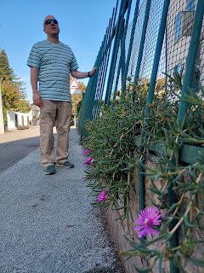

I saw a cute little pomegranate tree on our walk back to the house. It was more like a tall shrub, actually. There were a few little baby pomegranates growing down low and I thought they were SO CUTE!!

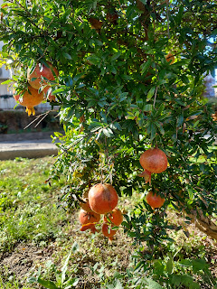

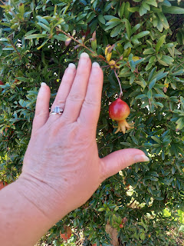

Scott drove me over to the hospital/clinic on base so that I could get another Covid booster shot. He got his booster shot a week ago, and I had scheduled my own appointment to get one. While my paperwork was being prepared at the desk, I found a helpful page in a magazine that was sitting in the waiting area.

At the bottom of the page, it listed some American medications and their Italian equivalents . . . very cool.

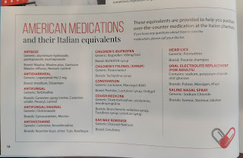

I also found this helpful page in the same magazine - - if you are ever injured, sick or homebound, what could you do to get groceries or other services in the Vicenza area???

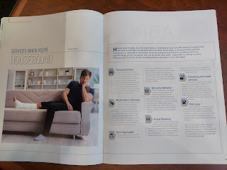

After I got my booster shot, Scott drove me to the Kiabi store (my favorite for finding clothes for little ones). I had learned from Kylie that Avery was outgrowing her 12 month clothes and needed some winter items. Say no more!! I'm always happy to go pick out some things for my grandchildren!!



I made creamy garlic shrimp over zoodles for lunch (using our vegetable spiralizer to cut some curlicues out of zucchini). It was delicious! We also packed up some leftovers to bring to Aviano for Benson.

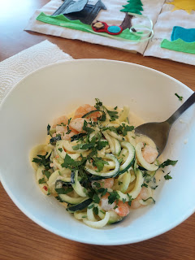

Just before 3:00, we left to drive up north to see Avery (and her parents). A few minutes from their house, we always pass through this area called Castello di Aviano. The roads are EXTREMELY narrow, with brick walls on either side. It's on a steady incline that winds past the castle ruins. It's spectacular to look at, and to see the valley below, IF you are lucky enough to have those few split seconds to catch a look . . . usually it's pretty hair-raising if you are the driver. It's always such a tight squeeze if there are any cars going the opposite direction.

Video as we were passing the castle ruins: (33 seconds)
https://photos.app.goo.gl/PD7kmP9cZwrXMpwU8

Even though their cat doesn't look too happy to see us in the photo below, she was pretty chill and certainly enjoyed her perch in the open front window.

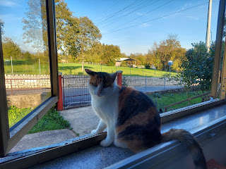

Avery was also happy to see us again. And we were so happy to see her! I miss that squishy little belly and her cute personality.

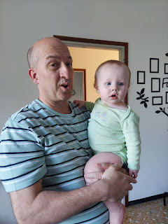

I was trying to get some photos of Scott holding her outside, but he kept making crazy faces! ha ha

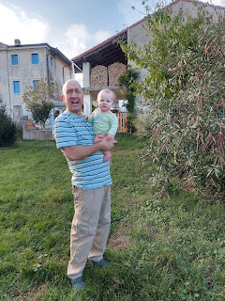

When I asked him why he was doing that, he said he was just trying to imitate the faces that Avery was making as she squinted in the sunshine. But I never saw her making any crazy faces . . . LOL

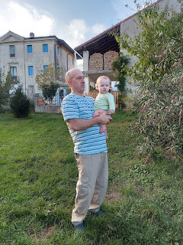

Scott took her around the yard to let her feel some of the trees and bushes. He would demonstrate first.

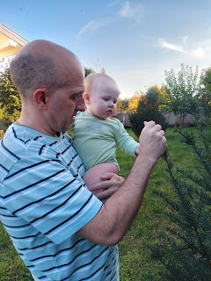

I love this photo because you can see her reaching out to touch the pine needles, but she's thinking about it first . . .

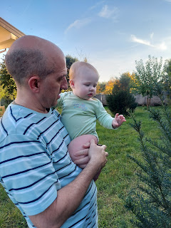

And then she does it.

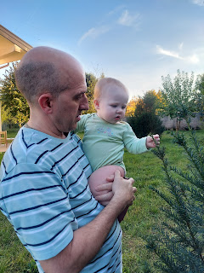

Benson took this picture of me with Avery and got her to smile. Yay!

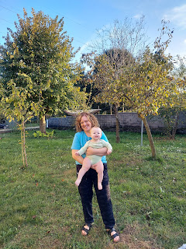

She reeeeally loves to look all around at the big, big sky, any birds that are flying overhead, and any cars/tractors/bicyclists going by in front of their house. She is very observant and interested in the world around her. So precious.

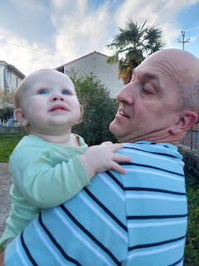

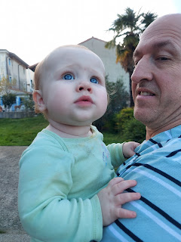

Benson, Mocha, Avery, and me. XOXO

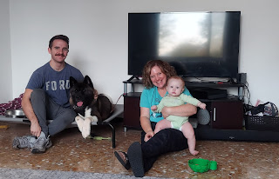

While Benson was on a video chat with Amber, Scott was playing with Mocha. At one point, Mocha slid off the couch somewhat . . . and she just stayed there for a long time, ha ha.

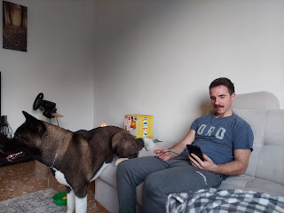

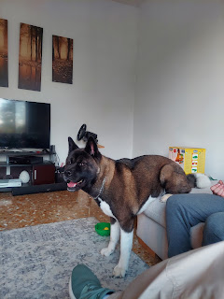

After Benson had a nice visit with his sister, he was able to chat with his brother, Jacob for a bit.

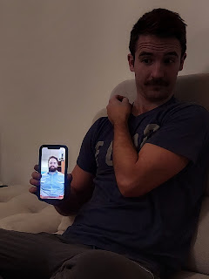

We were lucky to catch Jacob at a time that he could talk, since he was at work and was deep in a project back in Washington, DC.

And Benson was such a good sport for being willing to wake up halfway through his sleep cycle to visit with all of us. He works the night shift and had only gotten a few hours of sleep before we arrived. He got up and hung out with us for about 3 hours. What a good guy.



Eventually it was time to say goodbye so that he could go back to bed. It felt like a really lovely visit and I'm so glad we were able to go up to see them. We saw Kylie briefly at the beginning before she had to leave to help a friend. We kept Avery and gave her lots of love before it was her own bedtime.

Within 5 minutes of starting our drive back down to Vicenza, the car began acting up again. I said a couple of prayers in my head as Scott was driving, but they didn't seem to help. We pulled over two separate times to shut off the motor for a minute or two, in hopes of resetting the computer and getting it to snap out of it. (The problem shows up in the form of lots of herky-jerkies, some unnecessary revving, and occasionally it just dies if we slow down significantly - like when we need to go around a round-about.) But each time we started up the motor again, and began driving, the problem was not resolved.

Around this same time, I was also texting with my Mom in California. She had just received a postcard that I had sent a couple weeks before, and then she sent me a thank you text. I let her know that we were on our way home from Benson's house and that we were having car troubles. I mentioned that any prayers would be much appreciated.

She texted me a minute or two later to let me know she had just finished praying for our safety and that the car would be okay. At the SAME TIME, Scott said out loud to me, "I think the car is fixed now . . ." It did, indeed, feel more normal. No more revving or jerking like it was gonna choke and die. Wow.

That's when I told him that my Mom had just finished praying for us and that it must have been her prayer that worked! He didn't even know what we had been texting about, or that I had asked her to pray for us. But we both instantly recognized that her prayer is what did the trick. Thanks Mom!! We didn't have any more problems the whole way home and got home about 90 minutes later, safe and sound. :)

*As soon as I can find a place to vacuum out the car this week so I can get some pictures of the inside and outside, we will list the car for sale and try to find a more reliable replacement.

Saturday:
At the Lidl grocery store, we decided to buy a persimmon and figure out a way to eat it. Neither of us have ever had one before. We brought it home and looked on the internet for some ways to prepare and eat it. Most websites said you can just eat it like an apple (if it's a Fuyu persimmon). So that's what we did. We just cut it up into slices and ate it.

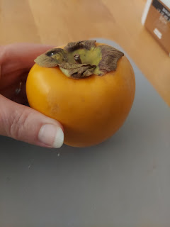

One website said that it tastes like a hint of cantaloupe or honeydew melon, but that it's crunchier like an apple. They were right! It was a very delicate and interesting flavor. It also has a ton of potassium and magnesium, along with a good dose of fiber. I think I'll be getting more persimmons in the near future!



Shortly after lunch, we drove Scott over to the base so he could catch a bus to the Venice Airport.

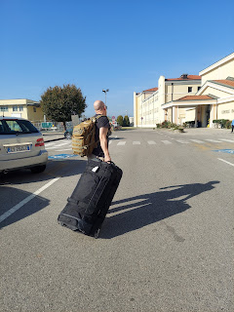

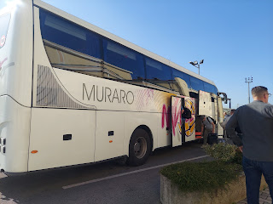

He is in Agadir, Morocco again, but only for one week this time. I didn't go with him because his own plane ticket details were so sketchy and sporadic at best. It didn't feel like a good idea to try to fly me down when we didn't even have his ticket fully arranged until the day before he flew out . . .

In his absence, I'm planning to just hunker down and see how far I can get on Avery's Quiet Book. I really need to get it done, since November begins in a couple days!! Her birthday is November 19th . . .

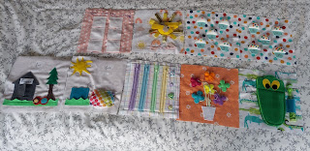

I'm hard at work right now on the 2 lower left pages - they will be a two-page spread of doggy fun. Then I have one final page to make before I can start putting it all together. The last page shouldn't be too time-consuming though, so that's nice.

Sunday:
I taught the Sunbeams Class in Primary this morning. These are the super cute 3-4 year olds. Today we had 3 children: Hunter, Luna and Mabel.

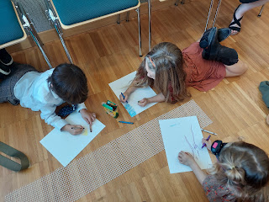

To demonstrate the concept that the Prophet is like a watchman on the tower, capable of seeing dangers or things that we cannot see, I organized an obstacle course in our tiny little classroom.

The kids helped me set it up as they came into class, which was great. I had a bright turquoise bath towel that I laid out to be a "river". I had some big fluffy pom-poms that were grey, black and tan that they placed near the river as "rocks". I used one of Scott's army belts to be a "snake". I grabbed a few wooden spoons from my kitchen to pose as "branches". And I had a long strip of the stuff you use to hold a rug in place on a hardwood floor, so we used that as a "path". I even brought my Air Force ball cap, turned upside down, to act as a "hole in the ground".

I brought one of our headlamps that the kids could take turns using, as they pretended to be like a prophet. With the extra light, a prophet can see things that lie ahead in our path and can help guide the rest of us to safety. They really enjoyed trying different ways to get around the obstacles and lead the other children to safety on the far side of the "river".

After we talked about how President Russell M. Nelson, our current prophet, has been encouraging us to go more often to the temple, the House of the Lord, we talked about blessings that come from the temple. We sang the song, "Families Can Be Together Forever" and then I let them color a picture for the last few minutes. Hunter quickly drew a very handsome and detailed temple, while Luna took her time coloring the sky and some green grass - setting the stage to draw her family once those other things were in place first. Unfortunately, we ran out of time, but she and her younger sister, Mabel, will finish their pictures at home.

They were so cute and so attentive! At that age, though, they have a million questions, so I'll have to be on my toes for any upcoming lessons. My teaching partner, Emily McGovern, will lead the lesson next week, and then I will teach the following week.

Time for Grandbabies . . .

I love this cute photo that Kylie shared of Avery this week . . . that cute tuft of hair sticking up on top . . .



And this chubby little angelic face of Jack . . . doesn't he look like a little cherub?



He got to go see the Washington DC Temple at night recently. What a beautiful thing to share with your 18 month old child!

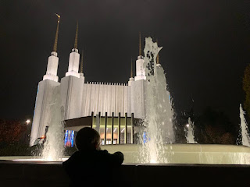

And here he is, admiring the last bits of Fall from his perch on the 12th floor balcony.

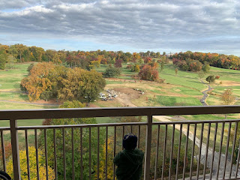

Gwen had the cutest (and mostly mischievous) look on her face in this photo. LOL
Amber reported that Gwen got to make some Spooky Underpants at school. Hilarious!!

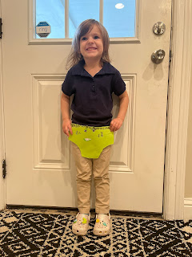

Abby got an upgrade to her roller skates, scoring a better fit that someone in their ward donated to her. Now she can keep working on her skating moves for the next time we can go to a skating rink together. I can't wait!

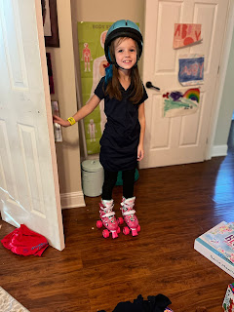

Final thing - -

I've been listening for the past 5 hours to a steady stream of banter and chatter, laughter and joking coming from the Italian neighbors that live below us. They set up a beautiful outdoor dining table in the courtyard and have been socializing all afternoon. I go to the window in my bedroom from time to time to see what they are laughing at, or what their next course of the meal is. The group of guests all appear to be of retirement age, but they sure know how to have fun! I try to be oh so careful so they don't see me stalking them, ha ha.

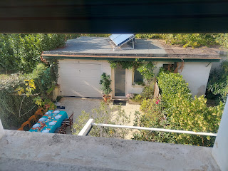

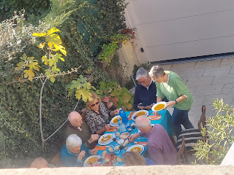

I even caught a few seconds of their lively banter on a video: (15 seconds)
"Bravo! Bravo!"
https://photos.app.goo.gl/k2Ngz8eEngrecSTQ6

