An Italian Car Accident . . .
Just two days after Scott made it back to Italy on Tuesday, Benson was in a terrible car accident on Thursday. He fell asleep at the wheel while driving home from work and drifted into the oncoming lanes of traffic, hitting two other cars in the process. He is okay, but has been pretty sore in the days since. The other two drivers were hospitalized, one went to the local hospital, and the other was helicoptered to another area hospital with a better ICU. They are both doing alright, but I don't know the extent of their injuries.
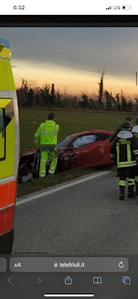

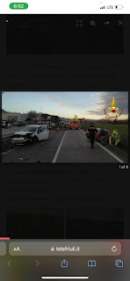

After Benson slept for two days, Scott was able to make contact and then drive up to Aviano on Saturday to check on our son. I tell you what, there is a lot that goes through a parent's mind when something like this happens. I wondered if he was okay, and if he'll be okay in the weeks and months to come. I wondered how it all happened, and what all the details were. A million other thoughts and memories came and went in an instant, recent memories along with memories from long ago. Suddenly, nothing else mattered.
When I saw the photo of his car all mangled, my mind flashed back to the last time I saw Benson getting into that very car as he left our house on Christmas Eve. We had had such a lovely evening together. And how just a few weeks ago, Scott helped Benson install the new car seat for Avery in the back seat while Avery and I waited inside the McDonald's restaurant together. The car was also Kylie's car . . . Benson had his own car and she had hers. But when Benson's car had some issues last year and they've been stuck waiting for parts for months, they had to start sharing the BRZ. Sadly, now they're both without a car.
Yes, lots of thoughts jumbled together and overlapped all at the same time. I had to address what I could sort through and then let the rest go. I am just infinitely grateful that Benson survived the crash and that he's okay!! It could have been much, much worse.
Scott told me that when he got up to Aviano, he hugged Benson 100 times (more or less). I asked if he hugged him carefully, since Benson had been in so much pain. He said no, and that he had hugged him hard. They had a wonderful visit and Scott was able to give Benson a father's blessing. He blessed Benson to know how much he is loved by our kind Father in Heaven, His Son Jesus Christ, and by all of our family. He also blessed him to be able to be calm with all the legal stuff yet to come, and that he can be able to process all of the details and work through them. I am praying several times a day that Benson will recognize the strength that he has within, and that we are here to support him because we love him. There is a long road ahead to recover from the legalities of the accident, but he can do it and it will all be okay eventually.
I asked Scott to please send me a picture of my son's face, since I could not be there in person. I needed to see for myself that he was okay. He sent me this.
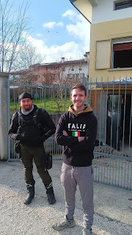

When I first saw the photo, I panicked because I thought it meant that Benson was under guard at his house or something. But then Scott clarified that no, that's just one of Benson's friends who stopped by after work to check on him. Whew! ha ha
Scott is hoping to see Benson again tomorrow (Monday) since it's the last day of their 4 day weekend off. While I'm still a little sad that Scott had to leave me behind in Idaho, I am forever grateful that he is close enough to visit Benson and to hug him 100 times, and to give him the love and support that he needs. What a blessing!!
As for the rest of the week, everything just pales in comparison. Nothing else seems to matter right now. When a horrific accident happens, your focus goes from wide (with all the stuff you're trying to do every day) to very small and laser-focused. The things that matter are FAMILY and RELATIONSHIPS. Everything else is secondary.
I did a lot of shoveling of snow this week. Repeatedly. I even started up the snowblower on Wednesday, after we got 3 inches of wet, heavy snow overnight. In some areas it works better to use a shovel, though. I noticed that my shovel-flinging efforts were beginning to form a mini-mountain in one spot . . . so I got an idea . . . (more on that in a moment) . . .
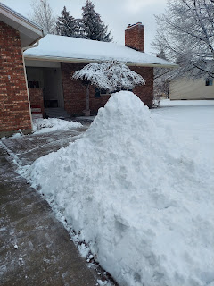

View of the back yard in its wintry white glory . . .

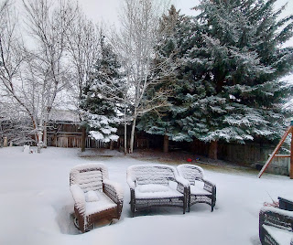

Our next door neighbor, Ellen, bought this snowblower several years ago and basically gave it to us. All she asked in return was that we help keep her driveway cleared when we take care of our own driveway. We have kept up that tradition for about 15 years now.

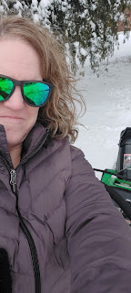

Sadly, this is what is happening next door at Ellen's . . . I took a photo as I shoveled near her front door.

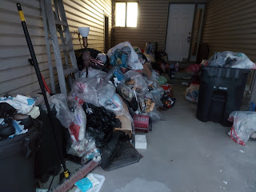

Back to that pile of snow . . . as soon as I finished shoveling and snowblowing my place and Ellen's, I got to work on something a little more fun.

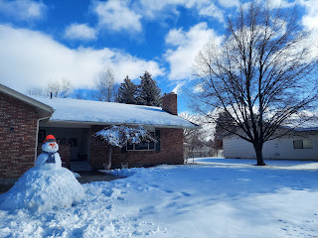

I decided to name him Mr. McGillicutty. He's a really chill guy, too.

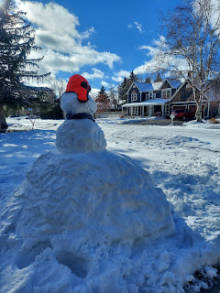

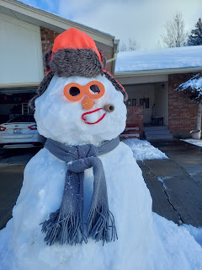

I scrounged around for this and that to build him a friendly looking face. Down in my basement, I have several empty spice bottles that I've been collecting over the years. I grabbed two of the pop-top lids and those are now Mr. McGillicutty's eyes. I have several pairs of plastic toy sunglasses on hand for a rainy day with grandkids, so I grabbed the orange pair to match the orange hunting hat. I made a snowy mound on top of his head so that the hat could mold to the shaped snow and hopefully stay in place for a while. His nose is a small orange votive candle. And his mouth is a red pipe cleaner, with a little cardboard tube to look like a pipe.

Several neighbors have called and commented on how cute and fun he is!! He's quite large in girth, but hopefully that will just help him to last a little longer before he melts . . .

I had a short, but sweet, video chat with Kylie and Avery on Wednesday as well. It was Avery's bedtime, so she was just a blur of energy and it took several attempts to get some screenshots that weren't all blurry, ha ha. She was all over that bed, crawling, standing, flopping, laughing, etc. What a cutie!

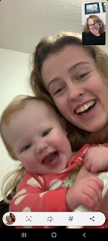

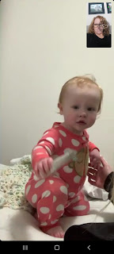

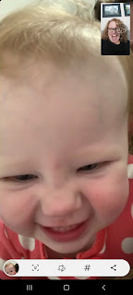

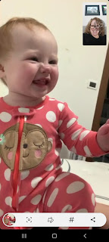

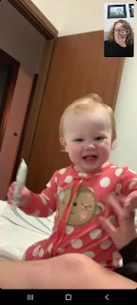

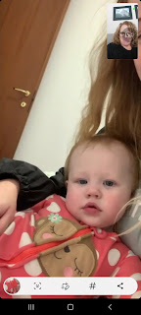

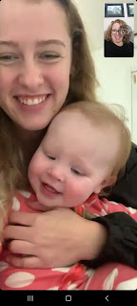

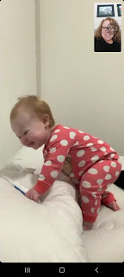

I might as well add in a few more pictures of grandchildren while I'm on the topic.

Amber posted this photo of her and Gwen, with the caption below:

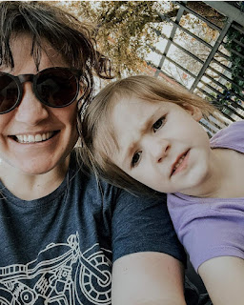

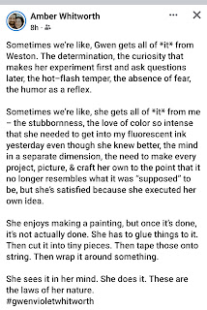

I chatted with Amber a few times this week, which is always a beautiful thing. She is taking an online class on illustration techniques and is really enjoying the projects she's working on for that. She's also working as an illustrator for a fun family card game that will be available for purchase in the near future. The creators of the card game are some of Jacob's friends that he grew up with in our neighborhood. They chose Amber to be their illustrator because not only is she talented, but she also has a fun and quirky sense of humor which they needed for this particular game. :)

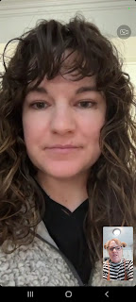

Gwen is still roller skating every chance she gets . . .

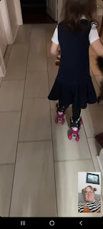

And Abby is still reading every chance she gets. Here she is showing me how the angel I brought her from Italy lights up. So fun!

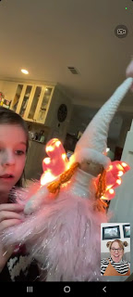

I got this photo of Jack with no explanation. LOL

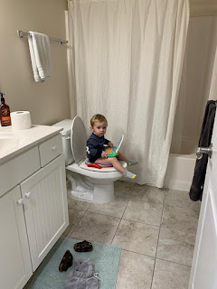

This week we also bought plane tickets for Jacob, Hannah, and Jack to come to Italy at the end of April for a visit. It's going to be so much fun to take them around and show them some of our favorite places!! I can't wait!!

I've been organizing things around the house, shoveling snow, baking things, and getting caught up with friends and family this week. Thursday involved a lot of networking regarding Benson's accident. Phone calls, texts, prayers, etc. I felt a little weak and very emotional, so I texted my friend Barb Vance and asked for a hug and some company if she was available. She came right over and stayed with me for 5 hours!! She provided me with the calm presence that I needed. When I deal with something traumatic, I get the shakes. I'm not sure if it's adrenaline or what, but my whole body just shakes and shivers. Blankets piled on don't really help much either. I was shaking quite profoundly when she first came over, but an hour later, I was calm and felt much better. We just talked and talked for the rest of the afternoon. I am so grateful for her friendship and for her being willing to come and sit with me for those many hours.

Phil and Coy were worried about me when they heard about Benson's accident. They offered to drive down to Idaho Falls to visit me and give me some hugs. But I had a counter-offer instead: I'd come up to see them in Rigby on Friday at their house and they could give me some hugs there. So that's what I did.

They had just gotten home from working at the FamilySearch Library, as they always do on Fridays. But Mom's heart has been acting up again in recent days, which meant she was more tired than usual. When I arrived at their house, I found a note taped to the front door that said, "Come on in Michele. We are taking a little nap."

Indeed they were. And how precious.

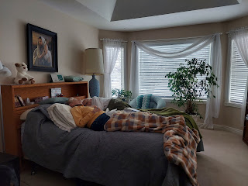

I read quietly in the living room for about an hour before Dad came out. We visited for a long time before Mom woke up and came out to join us. We had a nice visit and exchanged hugs before I drove back to Idaho Falls.

That evening I baked some much-needed brownies. They turned out perfect. I'll be enjoying those for several days . . .

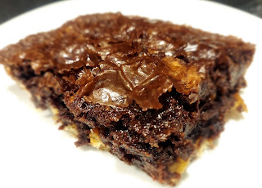

I made plans early in the week to go roller skating on Saturday afternoon with some of the girls from my Young Women's class that I used to work with. This will be a creative form of exercise for me each week, in addition to my regular routine. I read online that you can burn 250-300 calories PER HOUR with just moderate roller skating. (much more if you are hardcore) Well, we skated for over 2 hours on Saturday and it was a blast!!

From the left: Sedona, Me, Brielle, and Linnea

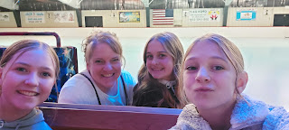

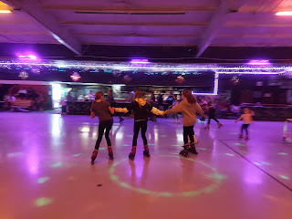

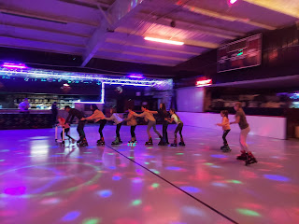

My plan is to go every Saturday and whoever else can come, great! And if nobody comes, I'm still going by myself. I love roller skating that much. :)

Lastly, I worked hard during the week on a talk that I gave in church today. I was asked to speak on the topic of Charity. I have learned a lot of important lessons on what charity is, and I tried to gather my thoughts carefully in spite of all the hype and worry surrounding Benson's accident just 3 days ago. It went very well this morning, and several people came up to me afterwards and told me how much they enjoyed my talk. I'm glad that they received it so well, and I'm glad that it's all over now, too. I get more nervous nowadays for some reason (sweaty armpits and sweaty palms, ha ha).

Here is the link to my talk:
https://docs.google.com/document/d/1--2MVFyFl7VE1bTehiGy4xxi9lKSiP37/edit?usp=sharing&ouid=109847307616181621361&rtpof=true&sd=true

Don't mind the different colors of text within the document. I wrote most of the talk on Saturday (black text) and then shared it with Scott to get some feedback. He added a few things (red text) while I slept Saturday night. When I woke up, we discussed a few ideas, and then I made some final changes (green text). I appreciate that he added some important points and that he cares enough to help me formulate what I'm trying to say. I love him and miss him so much.

