Ancient Padova & Vicenza Tours
Before I dive into some fascinating ancient Italian history, Avery just MADE HISTORY!! She is now ONE YEAR OLD!! What a precious little girl she is!!

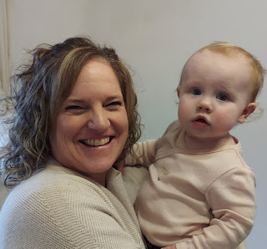

Now, for the rest of the week . . .

Monday:
I finished Avery's Quiet Book!! Hooray!! It felt so amazing to accomplish something so huge - and on the other side of the world! I don't have access to the same materials that I'm used to back in Idaho Falls, so I had to improvise a few times. But it all worked out in the end. Is it perfect? NO. Is it sufficient for a 1-2 year old to enjoy? Absolutely. :)

Here is the video that I made after it was completed. (3 min, 42 sec)
https://photos.app.goo.gl/suo52j61Njk8ZkiFA

That night we had some new friends over to our house, Elder and Sister Jeff & Sherry Haines. They are a senior missionary couple that are assigned to the Vicenza area as part of the Milan Mission. They are super fun and we really enjoyed talking with them for a couple hours and just hanging out. I didn't get a picture, but maybe next time . . .

Tuesday:
I had a slower day for once, which was so needed (and so nice). I only left the house once, and that was for walking over to the base for my eye exam. It was rainy, but not too bad. I enjoyed the fresh air and the 1 mile walk each way.

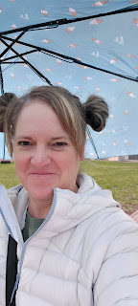

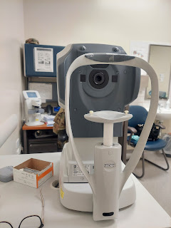

I got a new prescription for eyeglasses, and now I just need to find a place to have them made. I have a list of some places here in Vicenza that were recommended by the optometrist on base, and thankfully they also speak English at each of these places. I am trying to coordinate with Weston (my son-in-law) at the same time, to make the most cost-effective purchase when I'm on the other side of the world. He can give me some discounts since he is a practicing optometrist, but he lives pretty far away . . .

Fall is still looking really good over here . . .

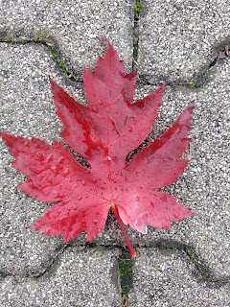

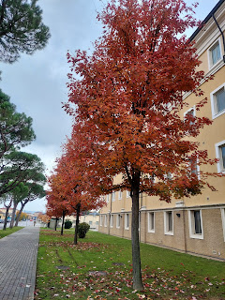

When I got home, I called Amber to chat with her for a bit. She was running some errands at the time, but we still squeezed in a short video call. She is such a good friend to me and is always so cheerful and kind-hearted. I am really grateful to have her as my daughter and my friend.

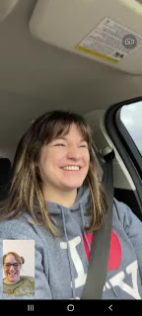

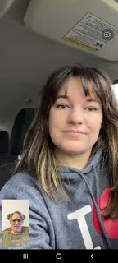

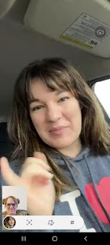

Wednesday:
I began a class on the base called Benvenuti (which means welcome). It's a three-day class intended to help teach you basic information, language, culture and skills to integrate into Italy as your new home. Our instructor was Keti (pronounced sort of like Katie and sort of like Ketty). She lives here in Vicenza and was animated and fun as she taught us all sorts of things.

I felt like I was starting back to school or something, like I should have a sign around my neck that said, "6th grade". ha ha

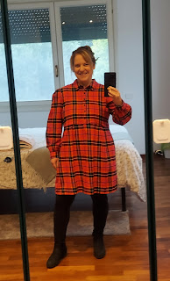

We were supposed to have 14 in the group, but only 8 showed up. Most of the ladies had only been in Italy for about 3-4 weeks at this point. I felt like I had a bit of a leg up in some areas, but I still had a lot to learn!!

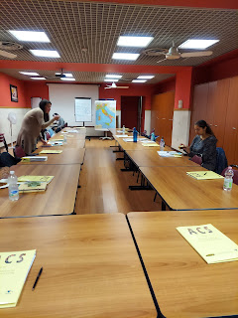

Half-way through the day of learning, we had a traditional Italian lunch served to us. Salad dressing is non-existent in Italy, which I am used to by now. Instead, they use a combination of olive oil, balsamic vinegar, salt and pepper, and occasionally some oregano.

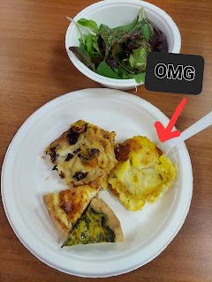

The cute little wedges on my plate were two types of quiche. They were very good. But my favorite thing was the Pasticcio. (pronounced pah-STEECH-ee-yo) In Italian, it means "messy", ha ha. It's like a lasagna actually. The one on the left had sausage and a few vegetables. But the one on the right was my favorite!! It had pumpkin (basically butternut squash - they call it pumpkin) and a buttery creamy sauce called Bechemel. Super rich and probably loaded with calories, but omigosh. It was SO DELICIOUS!!

After lunch, it is customary in Italy to have some form of coffee. I don't drink coffee at all, but I learned a lot about all the types of coffees you can order. This is a Moka Pot. Keti showed us the whole process to make your coffee in the moka pot . . .

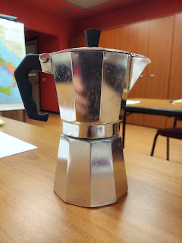

Then she taught us all the types of coffee in the cafes - what size they are, if you want hot or cold milk with it, what to order in the afternoon vs other times of the day, etc.

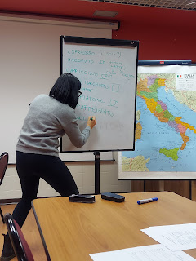

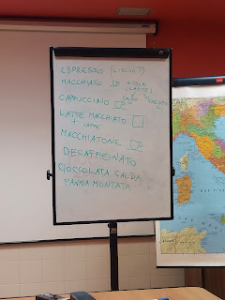

The only thing I like about coffee is how it smells. Not so much here in Italy, though, because it's a different sort of smell and is difficult to describe. But back in the States, the smell of fresh coffee beans reminds me of my Grandma Zoe (my dad's mom). I'm sure all 3 of my grandmas drank coffee, but I think I spent the most time around Grandma Zoe and therefore I associate the smell with her. She even had coffee flavored ice cream from time to time. I miss her when I smell the coffee beans in the grocery store back home.

We learned some basic Italian phrases after the lengthy coffee lesson. I learned how to say:

Buon giorno! (bohn JHORNO) Good morning!
Ciao (chow) which means "hey"
(You're not supposed to say it to a stranger or else you'll get a look in return, like why are you saying "hey" to me??)
Salve (sahl-vay) a formal hello to a stranger as you pass by
Piacere! (pee-ya CHER-eh) It's a pleasure/so nice to meet you
Mi chiamo Michele (mee key-AH-moh) My name is Michele
Vengo da Idaho (just like it looks like it sounds) I come from Idaho
Abito a Vicenza (AH-bee-toh ah Vee-chen-zah) I live in Vicenza
Ci vediamo = see you (chee ved-dee-AH-mo)
Ci vediamo dopo = see you later (chee ved-dee-AH-mo doppoh)
Ci vediamo domani = see you tomorrow (chee ved-dee-AH-mo doh-MAHN-ee)

My brain was very tired by the time I came home from class around 5:00 p.m. We must have scrounged up something for dinner, but I sure don't remember much about the rest of the evening.

Around 8:00 p.m., Scott went without me to set up the font at the church for a baptism on Saturday. I was really curious about how it would happen exactly, but I ended up being too tired to go with him.

He sent me a few photos of the process though. Back in the United States, if someone is going to be baptized, we have a dedicated font in our church buildings for that very purpose. But in other areas of the world, creativity is key. A pond, a lake, a river, etc.

Here in Vicenza, the setup looks something like this.

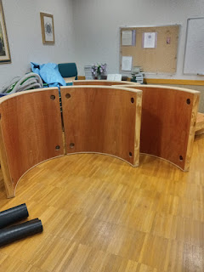

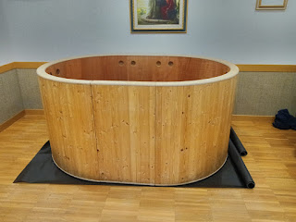

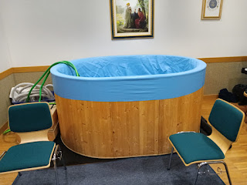

It took 2 strong sets of arms to get the rubber lining over the edges of the wooden frame. Scott assisted the ward mission leader, Chance Wilson, to set it all up. It didn't take very long, and Scott was home much sooner than either of us expected, so that was nice. He was happy to get his pajamas on and we both went to sleep early.

Thursday:
My Benvenuti group met at the bus stop outside the base, and we hopped on a bus headed for downtown Vicenza. Keti wanted to teach us all how to navigate the city on public transportation. Thankfully, Scott and I have been here a little longer, and had already practiced doing this, so I was able to help some of the other ladies to purchase their bus tickets using the MyCicero app.

Our first stop was the Teatro Olimpico in downtown Vicenza. I had only seen it from outside the gate, but hadn't gone on a tour yet, so I was excited for the opportunity to do so. This was Andrea Palladio's LAST great work. He actually died before it was completed. How sad.

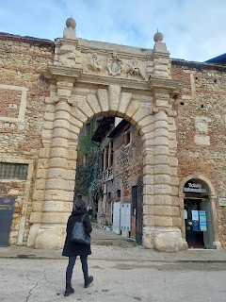

Just inside the gate is a beautiful garden and courtyard.

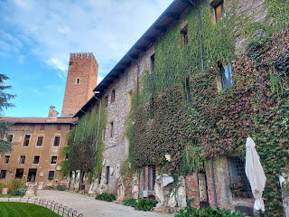

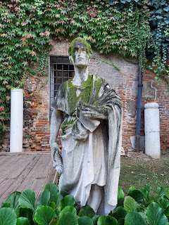

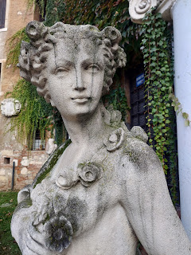

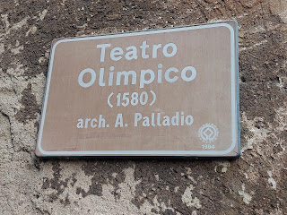

We passed through a grand room full of frescoes on the walls and decorative floor tiles. The fresco panels were all dedicated to various Greek Gods like Apollo, among others.

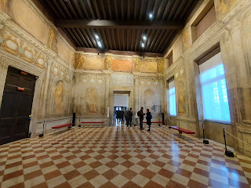

Just before we went downstairs to see the theater, these glass cases caught my eye. They house remnants of how the theater used to be lit up before electricity was invented.

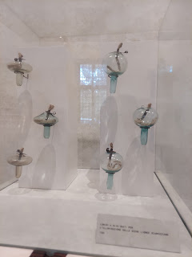

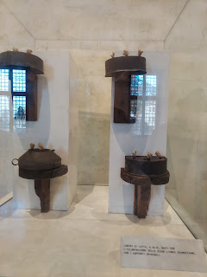

Then we went downstairs . . .

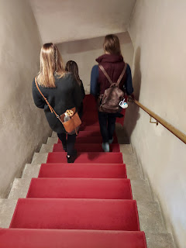

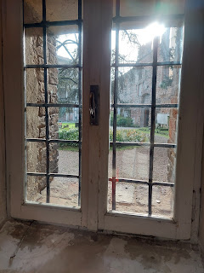

I was NOT expecting such a MASSIVE stage and theater area!! It really took my breath away.

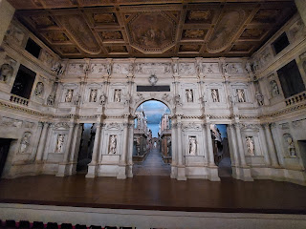

The hallways on the set were staged to look like city streets, and the perspective was just amazing. They really draw your eyes in, as if you are looking a long way down the road . . .

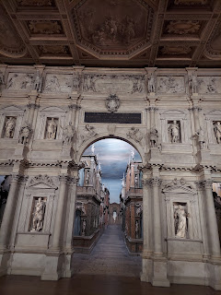

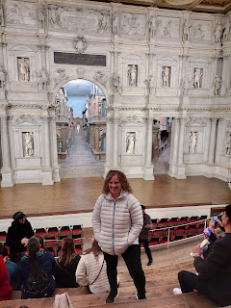

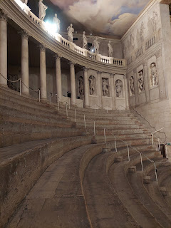

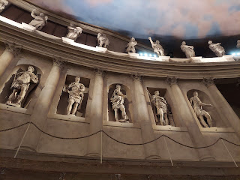

Everything in the theater is ORIGINAL. Including the wooden benches. Let me just remind you that the theater was built in 1580 . . .

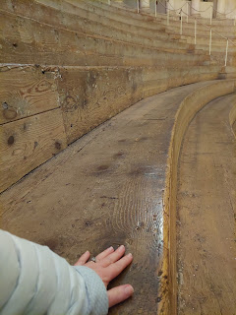

Our instructor, Keti, explained that typically there aren't many shows offered here in the winter months because it is just too cold inside. They can't heat the theater because it will ruin the ancient plaster and other materials that were used to contruct this masterpiece. In the center "street" below, if you zoom in, you can see some humidity damage at the back - up on the ceiling. They were able to stop the process of bubbling in the ceiling, but have not redone the surface at all. They also had termites trying to eat the wooden seating at one point, but they fixed that problem, too.

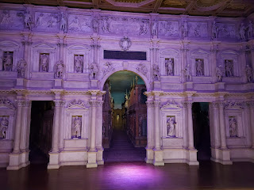

We were able to participate in a light show that is only shown occasionally, when it's not too busy with visitors. They did a 10 minute demonstration on all the capabilities they have with lighting on the set and throughout the theater. It was really beautiful to imagine a play, or a concert of some sort taking place on such an ancient stage.

Video #1: (33 seconds) of the Olympic Theater
https://photos.app.goo.gl/pwqQp9UCJX8TPr567

Video #2: (34 seconds) Just a small portion of the lighting presentation.
https://photos.app.goo.gl/MJHPCeUu5uUkbppZ7

They could easily make it appear as if it were sunrise, or sunset, or anything in between. Absolutely stunning.

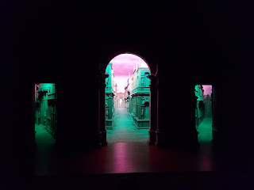

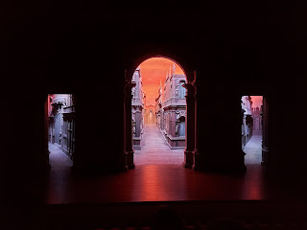

They could even isolate the statues placed all throughout the theater, as well. Directly behind me, they illuminated the statue of Andrea Palladio at one point.

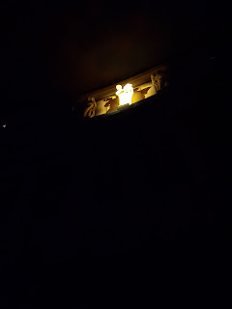

And one more fun fact. Remarkably, the Olympic Theater did not sustain any damage during WWI and WWII, even though other buildings in downtown Vicenza received significant damage. The only damage that occurred during the last 500 years, was when Napoleon Bonaparte visited the theater during the French Revolution. He was curious what materials were used to create all the statues, and how strong it all was. So he reached up and bent some statue fingers . . . and he ended up breaking those fingers OFF!!! If you zoom in on the photo below, you can see a couple of missing fingers on the middle statue. HILARIOUS!! (and yes, I know . . . tragic at the same time . . .)

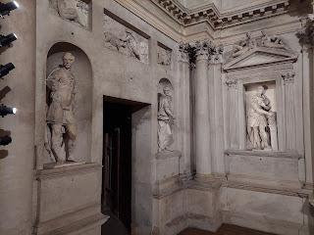

Next, we walked a short distance away to see the Chiesa di Santa Corona. (Church of the Saint Crown)

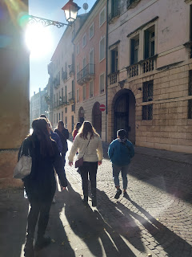

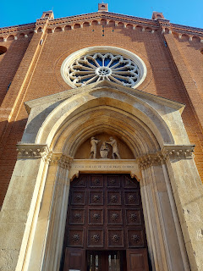

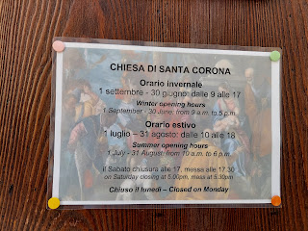

It was - yet again - a beautiful and very ornate church. Construction began in 1261, and additions were made at various later periods. One of the chapels was designed by Andrea Palladio in 1576, and when he died in 1580, he was buried initially in this very church. Later his body was moved to a nearby chapel, built exclusively to honor him.

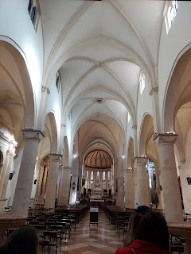

I loved the lighting that presented itself in this next photo, streaming in through stained glass windows and illuminating the altar area.

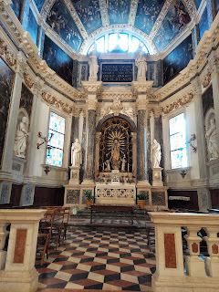

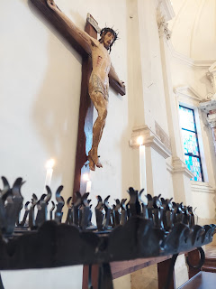

Sometimes there are interesting stories and/or myths that are passed down through the generations of time. Sometimes there is some actual truth in those stories. As Keti explained this next story to us, I paid attention to how I felt in my heart, to determine if there could be any truth to it.

When this church was being designed and built, the Catholic Bishop at that time wanted a place to "house" a very special thorn. This thorn had been carefully preserved and kept by King Louis IX of France, along with many others before him, but was given as a gift to his good friend, Bishop Bartolomeo di Briganze (in Vicenza). The origin of the thorn? Supposedly it was part of the crown that was placed around Jesus Christ's head as part of his Crucifixion.

Below: The King of France (left), Jesus Christ (center), and the Bishop of Vicenza (right)

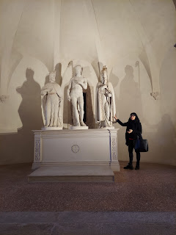

Again, it seemed pretty far-fetched that a THORN had been kept all these centuries, and that it had, indeed, been placed on Jesus' head. For me personally, I didn't feel anything deep in my heart that it was true. It might be true - and I might have just been disconnected. But I simply didn't feel anything about it either way . . .

When I told Scott about it later that evening, he said, "Why does something like that even matter?" I told him that people often like to connect to
something
that was connected to
something even bigger
- like a loved one. For example, I have a wallet at home in Idaho that used to belong to my Grandpa Linton Norman. It has his ID card, some old business cards, and even his social security card inside. Why does that matter? None of the cards are any good anymore . . .

It's because it was HIS wallet. It belonged to him. He used it, he carried it, and he cared about it. Some people like to keep clothes that belonged to their deceased loved one because they used to WEAR that shirt. It may even still carry a lingering scent of their loved one . . . The object connects us to the PERSON that we ultimately care about the most. We might not care so much about the shirt or the wallet by themselves, but we care about who was connected to that shirt or wallet.

The same idea applies to the thorn. The thorn doesn't really matter. The crown doesn't even really matter. But who they CONNECT to matters. So people like to hold on to those tokens or "souvenirs" that connect them to what they care about the most. In this case, Jesus Christ.

But I still didn't feel anything about the thorn. I don't know if it's a "true" thorn or not, but I guess what matters more here is that people are trying in various ways to connect themselves back to Jesus Himself. If they can see the thorn, maybe they will somehow connect more deeply to Jesus Christ.

The thorn was displayed in the Chiesa di Santa Corona for a long, long time. But it has been moved to the Diocesan Museum in Vicenza, and all that remains today in the church is this photo. The thorn was covered in gold and made into something quite fancy. Keti said that approximately 7.5 kilos of gold were used in the creation of this ornate candelabra of sorts. The thorn is placed in the very center - where it looks like an eye.

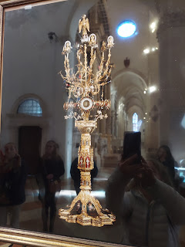

This chapel, one of several, had some beautiful mosaic panels that I spent a bit of time studying.

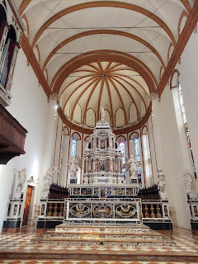

A representation of the Last Supper - with Jesus and His disciples.

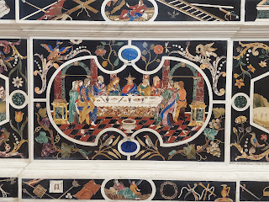

And a representation of when the Virgin Mary appeared to two peasants in 1426 and 1428 on top of Monte Berico (Vicenza). She promised to help end the devastating plague that was going on at that time, and she kept her promise.

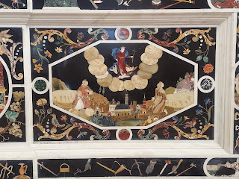

This next painting caused some mixed feelings for me. The painting is huge, and is very beautiful. The artist is Bellini (as seen in the next photo). I was surprised at how riled up I became as I noticed the details in the portrayal of Jesus Christ's baptism. Usually, I can remain neutral and calm as I see religious ideas throughout the world that differ from mine. I can appreciate the beauty of the creation and I can appreciate the care that the artist took to create something meaningful for all to see.

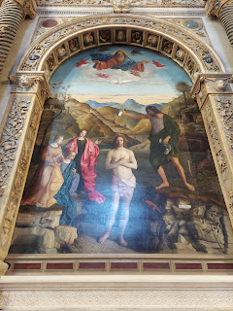

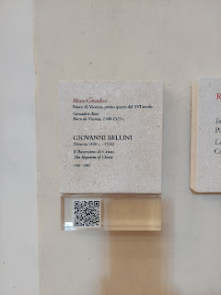

But to see Jesus being "sprinkled" with water right in FRONT OF the River Jordan, got me rattled. I was especially frustrated because in the Bible it very clearly states that He "went up straightway
out of
the water". His baptism was a representation of a death and burial (going under the water) - a death of the natural man, the unclean man. As He came up OUT of the water, it was a representation of newness, cleanness, and purity, as well as being symbolic of the Resurrection. (*Note: Jesus was not unclean, nor was He in need of being made pure. He chose to be baptized to set an example for us all to follow, as He, too, followed the will of the Father.)

Even in 1501 (when Bellini made this painting), there was the mistaken idea that Christ was somehow baptized by being "sprinkled." Maybe Bellini was commissioned to make this specific painting, even if it differed from his own personal beliefs. Who knows. I'm sorry for speaking so strongly about this, and if I have offended any of you, I sincerely apologize. Again, normally I can take a piece of art for what it is trying to convey and I can keep my feelings in check, even if I disagree about the doctrinal differences. But this time, I just couldn't let it go.

Luigi Da Porto is also buried here in the Chiesa di Santa Corona. You might remember his name from previous posts that I have shared. He originally wrote the story of Romeo & Juliet, and Shakespeare was inspired by this same story at a later time. Scott and I have visited the castles of Romeo & Juliet in nearby Montecchio Maggiore, the same castles that Luigi Da Porto based his novel on.

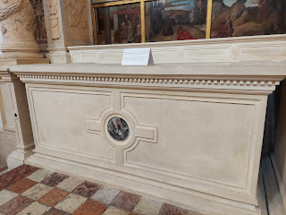

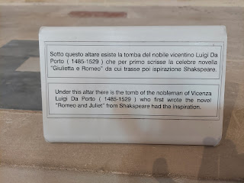

After leaving the church, we meandered through the streets of Vicenza to find our restaurant for lunch, passing through the Thursday Market booths on our way. Christmas decorations are being strung up in anticipation of the holiday season just around the corner. I can't wait to walk around in downtown at night here in December!

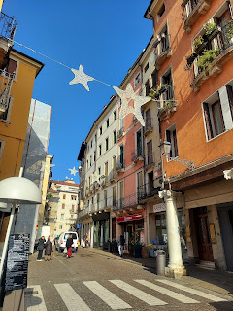

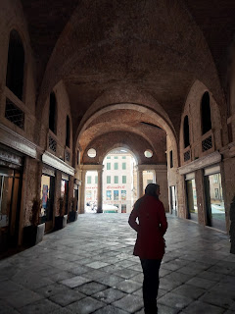

Adjacent to the farmer's market booths, with every kind of colorful fruits and vegetables, stands an ancient tower. This tower, in medieval times, was where people were tortured for their alleged crimes, such as blasphemy. The public were invited to watch, perhaps to potentially influence them to not commit those same crimes. I'm so glad we live in a more civilized world now. (Even though I know there are far too many pockets of evil and inhumane acts still today.)

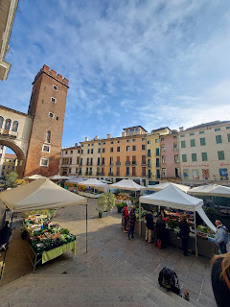

I had a hard time keeping up with my group! There were so many beautiful things to look at as we walked through the booths of clothes, gifts, flowers, etc.

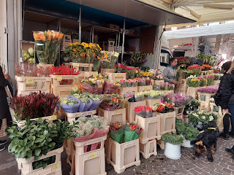

Video of some casual street performers in the midst of all the shoppers: (13 seconds)
https://photos.app.goo.gl/Ptx8esYbGaphonKC9

I loved this tranquil side street, with a few of the locals casually walking to or from their daily errands.

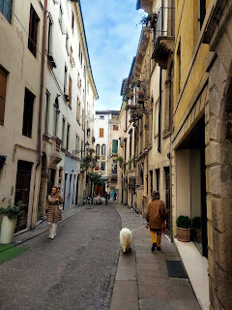

This is the restaurant that Keti had chosen for us ahead of time. The staff were so friendly and attentive, and the food was really delicious and beautifully crafted.

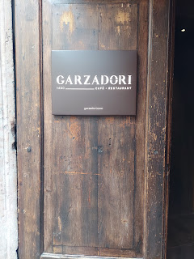

I chose the grilled swordfish and vegetables. (*Yes, it was 20 euros. But it was a special occasion.)

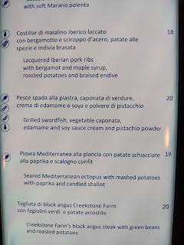

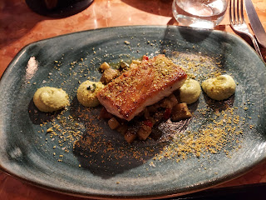

For dessert, several of us chose the "Pump-Queen". A cute little pumpkin shaped custard, with caramel sauce. Super cute!

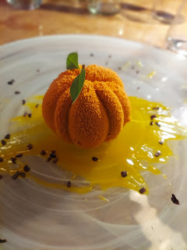

What a great day! I really enjoyed getting out of the classroom and into the city itself. I'm always a fan of getting up out of my chair and using my feet to go on an explore.

That night, after another very simple dinner for the two of us, we played our favorite (and very competitive) game of Sequence. We only have a couple of games here in Italy, this being one of them. I ordered it from Amazon because we needed SOMETHING fun to do as a filler.

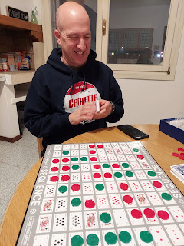

Friday:
I got up extra early to get out the door for our third and final day with my Benvenuti class. Scott and I first had to drop off the car to the mechanic again, this time to fix something so it will pass the military inspection needed in order to sell it. The task: it needs a couple of bearings replaced. We have some buyers lined up for the car - a young military couple that just moved here and are getting settled in.

Once the car was situated, Scott drove me over to the train station to meet up with the rest of my group there. We rode the train from Vicenza to Padova (slightly SE), which only takes about 17 minutes. My only experience in Padova so far has been going to IKEA twice. I had NO IDEA how amazing the city of Padova actually is!! IKEA is right next to the freeway, so we never went any further into town besides that.

Once we arrived in Padova, Keti showed us how to take the tram (similar to a trolley car with flat tracks along the roadways) across town to the Prato della Valle, one of the largest public squares in Europe. It used to be a Roman Arena, with celebrations, competitions, and even executions. (how cheery)

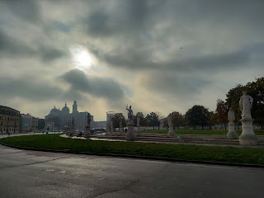

In 1775 it was converted to a large green island, with grass and picnic areas, surrounded by a HUGE oval-shaped "boulevard". There are four Venetian bridges over a continuous canal, and several statues that line all the way around.

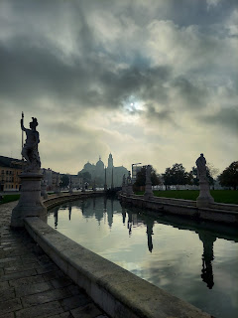

Behind me you can see the Basilica of St. Justine. We will visit that in a minute.

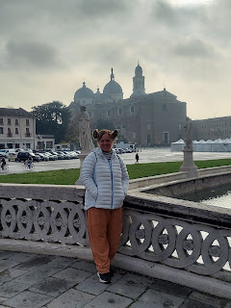

Yay - the sun came out!

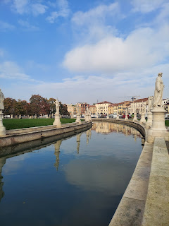

This is Galileo Galilei. It's really fun to say his name, which is something Keti did often, since he was a prominent figure in Padova. More on that in a minute as well.

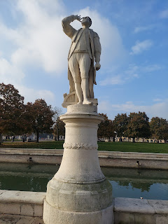

On our way to the Basilica of St. Justine, we passed by the OLDEST Botanical Garden in the WORLD!!

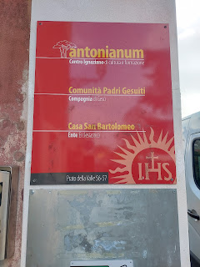

It was founded in 1545 by the Franciscan Monks. They combined efforts with students from the Padova University to study plants and their medicinal properties and were able to come up with some important medicines that are still in use today. One of their famous creations is known as the Oil of St. Justine, created in the 15th century: a combination of over 62 ingredients mixed with olive oil that work primarily as an anti-inflammatory.

We couldn't see much of the garden itself, but got a tiny peek at some of the distant greenhouses when one of the gates opened to let a van out. I really want to take my sister, Charmaine, here when she comes to visit. She will love it!!

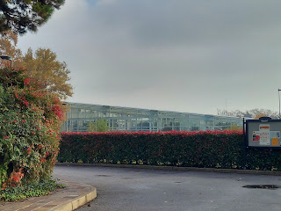

The Basilica of St. Justine has an incredible story.

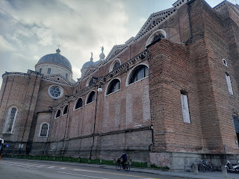

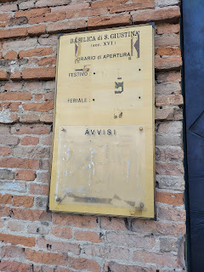

Per Wikipedia: Justina of Padua (Padua is the same as Padova - I see it listed both ways)

"
She was devoted to religion from her earliest years and ultimately she took the vow of perpetual virginity. At this time arose the persecutions of the Christians by
Nero
, and
Maximian
the prefect who had succeeded Vitalian, proved himself particularly brutal. As Justina would visit the prisons to comfort and encourage the Christians there, Maximian ordered her arrest. While she was passing by the Pont Marin near Padua she was seized by the soldiers. When she was brought before Maximian he was struck by her beauty and endeavoured by every means to shake her constancy. However, she remained firm against all attacks and the prefect caused her to be slain with the sword."

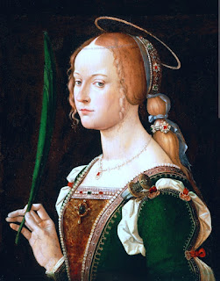

Justina died in AD 304 and was buried where the Basilica now stands in her honor. She is remembered as being a devoted Christian who would not change her beliefs because of any persecution. She was brave and strong and was such a good example. Some say that she was only in her teens when she was killed.

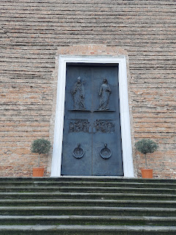

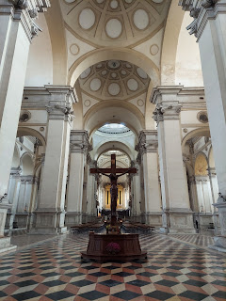

The mosaic floor tiles were mesmerizing as we walked throughout the Basilica.

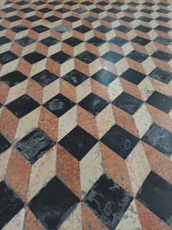

Here is another example of how legend meets up with potential truth.

The Basilica of St. Justine claims to have the remains of the Apostle Luke, one of the original Disciples of Jesus Christ in New Testament times. In the Basilica, Keti found us a brochure (in English) that discusses this very question. I'll share some of what it says.

"According to an old tradition, Luke the Evangelist, was born in Antioch (Syria), died at a very advanced age (84 years) and was buried in the city of Thebes, capital of the Greek region of Boeotia. From here - as is confirmed by St. Jerome - his remains were removed to Constantinople, and conserved in the Basilica of the Twelve Apostles, in the second half of the IVth century.

"[The] manuscript mentions that the remains of St. Luke, together with the relics of St. Matthias, were removed from Constantinople [to Padova] in the times of the Emperor Julian the Apostate (361-363 AD).

"In 1354, Emperor Charles IV of Luxemburg, king of Bohemia, acquired the skull, which ended up in the cathedral of St. Vitus in Prague, then capital city of the Empire. It has been conserved there till the present day."

Hmmm. So somebody wanted Luke's skull??

Continuing on:

In 1992, "at the request of the Bishop of Padua and following the consent of the Benedictine monks, a detailed interdisciplinary inquiry was set up. The skull was brought over from Prague for a couple of days, and the marble sepulchre was opened on the 17th September 1998.

"Within [was a] sealed lead case, [and] a human skeleton was discovered that had been quite well preserved.

(photo from the brochure)

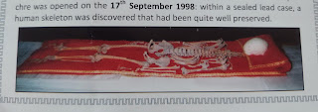

"The Scientific Research Committee, led by prof. Vito Terribile Wiel Marin, established that:

1. The skeleton, almost entirely preserved, lacked the skull, the right ulna and a few of the smaller bones. Subsequently, it was further established that the skull brought over from Prague fits in with the top cervical vertebra of the Paduan skeleton, demonstrating that the parts belong to the same individual.

2. The anthropometric data suggest that the skeleton belonged to a male human being, deceased in old age (between 70 and 85 years), height c. 163 cm.

3. Paleopathological examination revealed the presence of: a well spread osteoporosis, a very serious arthrosis of the spine (especially in the lumbar region), a pulmonary emphysema (evidence for which comes from the curvature of the ribs). Such lesions are typical of a man who died in old age.

4. The careful preservation of the bones through several centuries indicates that already in the past, the remains were considered important relics, worthy of being treated with all the care possible to ensure long lasting preservation.

There is more in the brochure, but here is the conclusion:

"The final results of the research were presented in an International Congress, held in Padua in October 2000. The scientific data . . . do not contradict the traditional claim that the remains are those of the Evangelist St. Luke. Rather, they stand as precise data. Of major historical interest, of course, is the issue regarding how, when, and why the transfer of the body from Constantinople to Padua occurred."

Alright. Now that we have some historical insights and professional and scientific reviews of the skeletal remains, it comes down to this. What did I FEEL when I stood in front of the tomb professing to hold Luke inside??

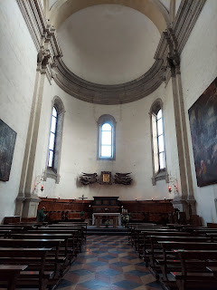

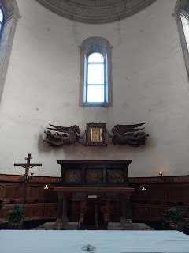

Fortunately, I was able to slip away from the group for a few minutes where I could quietly pray in my mind and listen to what the Holy Ghost conveyed back to me.

I did feel something. I felt my heart burn quietly within me and I felt the Spirit of God whisper to me that this was, indeed, Luke. I marveled at that for a moment. Because why did this even matter? Whether it's his bones or not should not matter. We can read Luke's testimony of the Savior in the Bible and that should be enough.

For me, though, the reason why I marveled is because of the process by which I came to this knowledge for myself. I read and studied the information that was provided in the brochure. I didn't just take it at face value. I wanted to know for myself if it was true. So I prayed and asked my Father in Heaven if it was true. He provided the answer through the Holy Ghost and it all spoke peace to my heart. This taught me that if something matters to ME, then it also matters to my Heavenly Father. If I go to the right source (Him), then He will let me know the truth of all things through the Holy Ghost. I am so grateful for that little lesson that I learned on Friday, in a magnificent Basilica tucked into a little corner of Padova, Italy.

Moving along, we passed the tomb where St. Justine's remains are preserved. She is "Saint" Justine because that is how the Italian people chose to remember her.

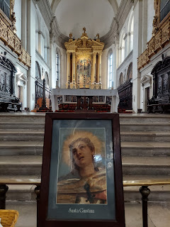

In front of these clergy men, is an ancient well that was built in 1565.

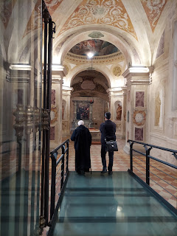

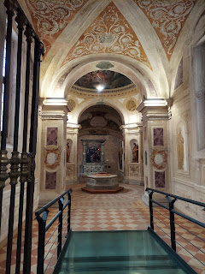

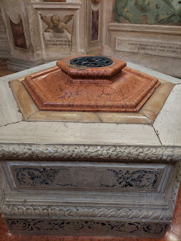

Known as the Well of the Martyrs, it got its name because of the bones of several Christian martyrs whose bones were discovered here in 1269. You can still see those bones today through the grid opening at the top of the well.

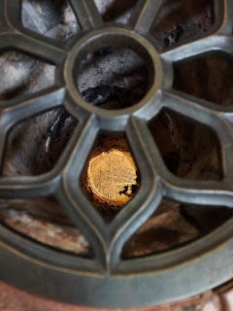

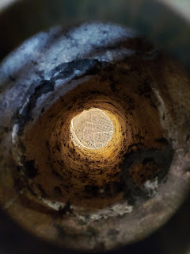

Just around the corner from the Well of the Martyrs sits the transport cage that was used in the middle ages to transport St. Luke's body from Constantinople to Padova.

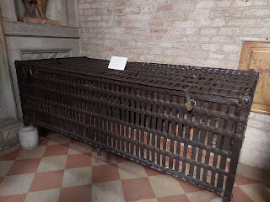

On our way out, we passed by a little shop that usually sells some of the "Olio di St. Justina" products, but it was closed. I did see a little sign on the window in English with an explanation of the oil and what it is used for.

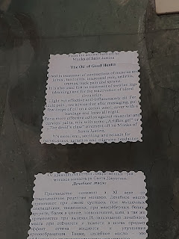

More beautiful views on the way out . . .

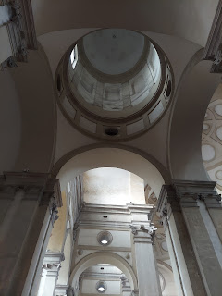

Some additional views as we walked across downtown to our next destination . . .

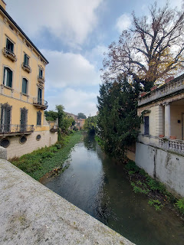

Keti explained to us that every Italian city has a patron saint. Scott and I have talked about this before, and we think that patron saints are thought of as a sort of mediator between us and God. Some people might imagine that God is very busy all the time, tending to all the needs from each of us, His billions of beloved children. Scott and I think that some religions are praying to patron saints as though they are an intercessary. For example, if I have a problem with "X", then I would pray to the patron saint of "X" to help me with that thing, so that I don't have to bother God since He's already so busy.

If you look on the internet, there are patron saints for EVERYTHING. (healing, health issues, traveling, things that are lost, dogs, art, etc.) In the doctrines of my church, the Church of Jesus Christ of Latter-day Saints, there is no need to have a patron saint. We can pray directly to God for whatever we are in need of and He will hear and answer our prayers. The answer might not always be what we had hoped for, but it will be answered nonetheless. :) He is never too busy to help us.

I find it cute, though, that each town has a patron saint and they honor that person all year long, especially on the patron saint holiday that comes one day each year. As we got closer to the Basilica of St. Antonio (St. Anthony), the shops proudly display products in their windows that pay tribute to St. Antonio. Every little item for sale has some reference to "Santo" or "Sant Antonio".

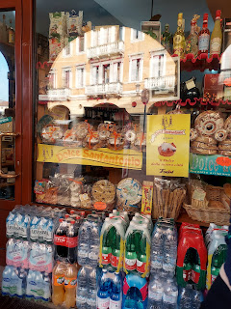

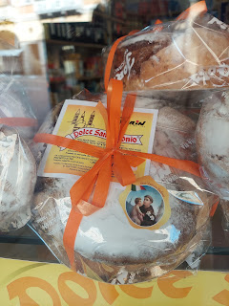

I have the utmost respect for all the patron saints. I just want to be clear about that. They were good people. Amazing people. They led a good life, they set a good example, and some died a horrible death as they clung to their values and their testimony of Jesus Christ and their religious belief system. If more of us had those same attributes, then this world would most certainly be a better place.

Next stop: the Basilica of St. Antonio

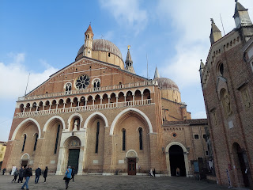

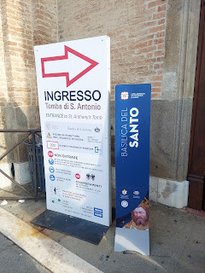

The patron saint of Padova, St. Antonio (Anthony), was a Franciscan monk. He died at the age of 35 in the year 1231. He was known for his powerful preaching, his expert knowledge of scripture, and his undying love and devotion to the poor and the sick. He sounds like a wonderful man to me.

Here is an artist's rendering of St. Anthony rising up to heaven and leaving his earthly body behind.

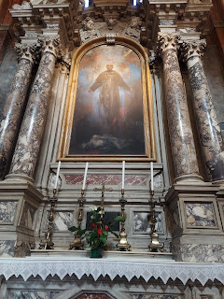

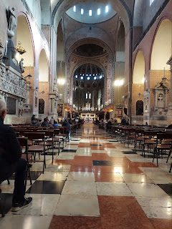

St. Anthony is buried in a tomb here. Visitors can slowly walk through this room, placing a photo of a loved one on the half-wall next to the tomb and request prayers for that person. As we filed through and around the area behind the tomb, we could touch the tomb if desired. I chose not to, but everyone else did. I felt like if I touched it, I would somehow indicate that I was worshiping Anthony. But I was reverent and grateful for his goodness as I walked past his remains.

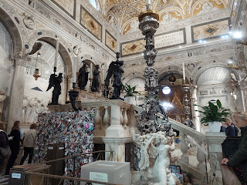

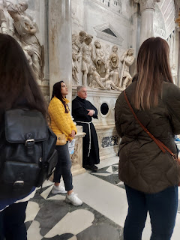

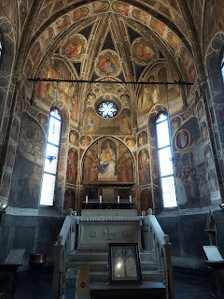

Short video of some singing in the main chapel around the corner from where we were: (20 seconds)
https://photos.app.goo.gl/W5wDbFSLWu2ednFS8

First time seeing some confessional booths in real life . . . the middle "cubicle" has a wooden "curtain"that can be pulled down for privacy. I assume that's where the priest sits? I saw a mesh screen on either side of the middle cubicle where he can talk to someone through it.

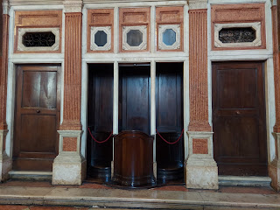

I liked this alcove, even though I don't know what the significance of it was. I liked that the main theme was of various women through the ages. And Jesus was at the center of all of them.

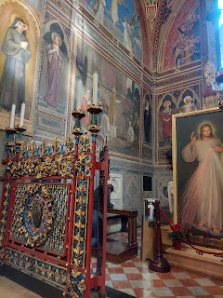

A strange tradition that they have in Italy is to take the body parts of a patron saint and to memorialize them in some way. Specifically, they take the body parts that are most closely linked to what that saint was known for. St. Anthony, for example, was known for his eloquence of speech and for bringing people to Christ through his spoken words. Can you guess the body parts that they kept to honor him?

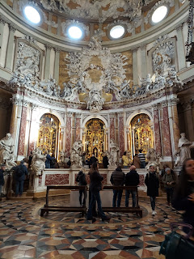

If you guessed his teeth and jaw (look closely in the photos below), and his tongue and vocal chords, then you were RIGHT!!

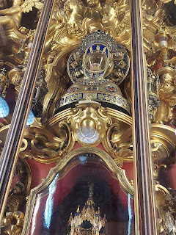

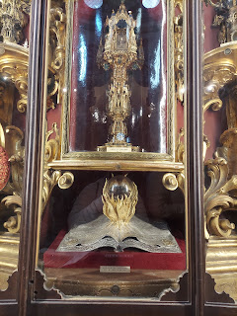

We received a brochure (in English) that showed several exhibits in each glass case and labeled each important item with a number and a description of what it was. Then we could look up and find them in the case. How fun. (??)

Next, we went to the adjacent alcove where Keti arranged for a Franciscan monk to give us a blessing as a group. He was so cute! He spoke a little bit of English and wanted to know where we were all from, even joking a little with us. Then he thumbed through his book of prayers to find something in English for us.

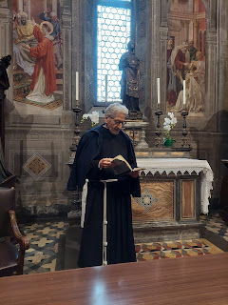

He would say a line of the prayer and then he would have us say a line back to him. When he demonstrated crossing himself (in the name of the Father, the Son, and the Holy Ghost), I quietly abstained. I abstained from crossing myself because that's more of a Catholic thing to do, and I'm not Catholic. But it was still pretty cool that we received a blessing from a monk!!

The courtyard outside . . .

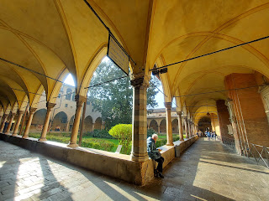

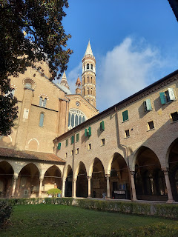

A small scale version of the Basilica and all the structures. The monks all live in the smaller buildings at the back.

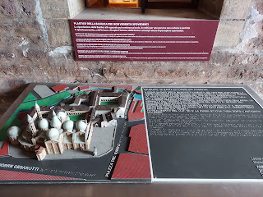

Both Vicenza and Padova are setting up some festive Christmas decorations right now . . .

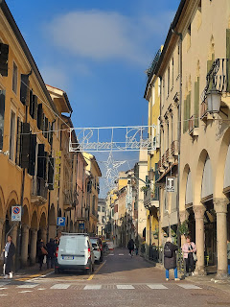

When we were almost to our restaurant, I saw this cute bicycle and HAD TO take a picture of it. When I sent it to my kids, they said it reminded them of the pocket folders they had in junior high. LOL

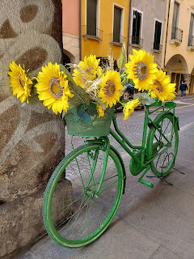

This is where we had our lunch: Ristorante Vecchia Padova.

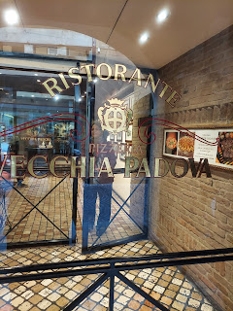

It was cafeteria style, but the staff served us from behind the glass windows. We just moved our tray along and told them what we wanted.

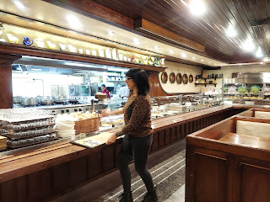

I chose some Pasticcio (the "messy" lasagna) and a piece of salmon, along with a bowl of fresh fruit on the side. Even though it doesn't look like much in the photo, I could only eat about half of the pasticcio and the salmon. I ate all of my fruit, though. :)

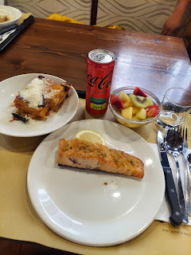

Then it was on to the University of Padova. What an amazing history this school has!

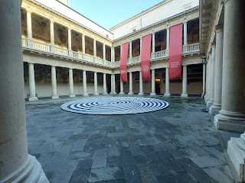

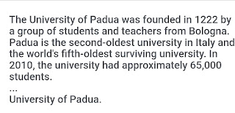

They are celebrating their 800th year this year!!! Holy cow!!!

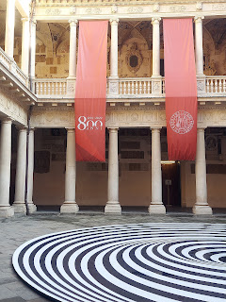

As for Galileo Galilei, he was not only a student here, but he was also a professor!! If you pay to take the tour, you can even see the chair that he used to sit in! We only spent a few minutes at the university, so we did not take the tour. Maybe next time . . .

The last thing Keti wanted to show us was the famous Caffe Pedrocchi. Built in 1839, it is famous because not only did students and intellectuals meet here regularly, but several revolutionary ideas were born here. Those ideas drew the attention of the Austrian Army who were occupied there during the Italian Risorgimento. It was only a few years later (1861) that all the surrounding areas became unified and the Republic of Italy was finally born. The Austrian Army did not like the resistance of the students who gathered at the Caffe. They attacked one day in 1848, and some of the bullet holes are still visible in the walls of the Caffe today. The Caffe is a symbol of ideas and eventual unification. It is said that if you come to Italy, you must go to the Caffe Pedrocchi. So we did.

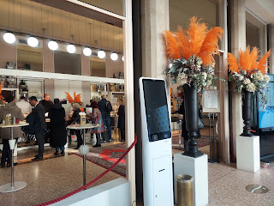

While they are famous for their mint and cream based cappuccinos, I just opted to get a little serving of dessert for $1.30.

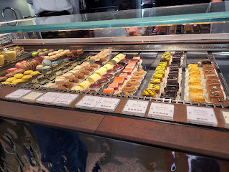

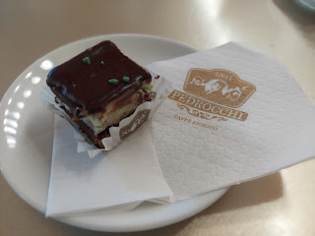

We walked back to the train station and made our way back to Vicenza around 3:00 p.m.

We took a group selfie before we disbanded.

L to R: Jamie, McKenzie, Joselyn (taking the selfie), me, Rachel #1, Keti down in front, Vrinda above her, Kerry in the back, and Rachel #2. They were a super fun group of ladies and I'm so glad I got to meet them.

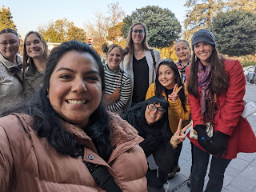

On the bus ride home to my house, a cute little Italian nona (grandma) was standing next to me. It took me a good long minute to be smart enough to stand up and offer my seat to her . . . I just love getting sneaky pictures of the elderly people of Italy. I love their energy, their strength, and their resilience.

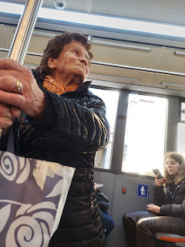

Saturday:
While I worked on our laundry at home, Scott drove over to the church to start filling up the font for the baptism. He wasn't sure how long it would take, so he started early. It only took about 90 minutes, which was much shorter than he anticipated. The water was good and hot, though, so he felt confident that it would be comfortably cooled off when the time came to use it.

Someone at the church also asked them to move the font over by the window (before they filled it with water). Apparently the flooring is strongest over there and the inspector has said to please use that space for something that heavy. What a nice view of the Dolomites out the window! (This is our Relief Society classroom)
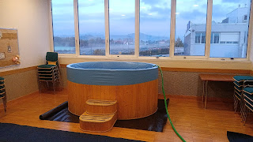

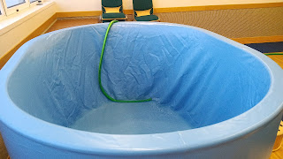

The baptism was at 11:00 a.m. for an 8 year old boy in our church ward. It was so simple and beautiful, and yet it moved me to tears!! Especially when we sang the opening and closing songs. The closing song is called, "He Sent His Son". I love the lyrics:

How could the Father tell the world of love and tenderness?
He sent his Son, a newborn babe, with peace and holiness.
How could the Father show the world the pathway we should go?
He sent his Son to walk with men on earth, that we may know.
How could the Father tell the world of sacrifice, of death?
He sent his Son to die for us and rise with living breath.
What does the Father ask of us? What do the scriptures say?
Have faith, have hope, live like his Son, help others on their way.
What does he ask?
Live like his Son.

Here is the program for the baptism because I thought it was so special yesterday. :)

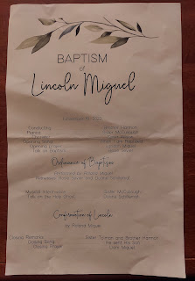

As soon as we got home from the baptism, we changed our clothes and drove up to Aviano to go see the BIRTHDAY GIRL. Hooray!!

The drive was beautiful during the 90 minutes it took to get there.

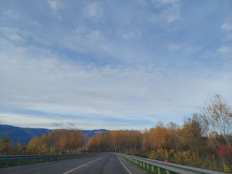

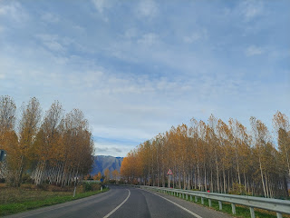

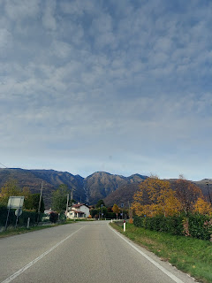

Avery was so happy to see us both. It was so cute because she wanted me to hold her, and then 4 seconds later she reached out to Scott. After about 5 seconds, she reached out for me to hold her again. And so it went. Back and forth. :)

And then I finally got to sit down with her to show her the Quiet Book that I've been working on for the past several months. The only other time I've been able to be there in person when a grandchild sees the book for the first time, was when Abby turned one. That was almost 7 years ago!!

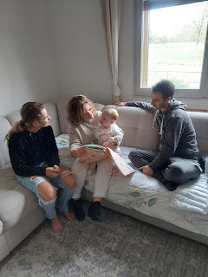

Scott was such a good husband in taking lots of photos and videos for me.

Video of me reading the inside label to Avery: (18 seconds)
https://photos.app.goo.gl/bsYLECYnChcfERvc8

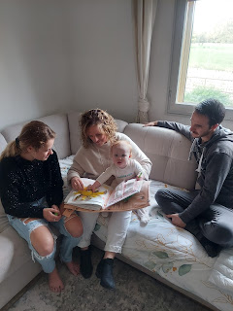

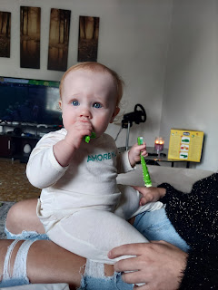

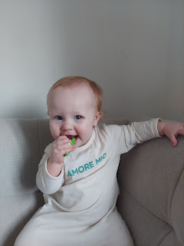

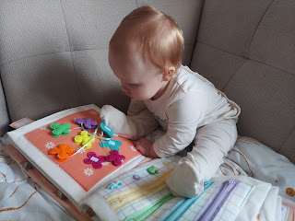

I'm so glad we got to see her for her birthday. It was great to see her parents too. Kylie took Avery over to her friend's house, where she had baked a little cake. She is still trying to send me the video of Avery eating her cake. I'll share it as soon as I have it. In the meantime, we took Benson out to eat. We had a nice visit with him.

I'll end with a couple final pictures of grandbabies. (It's 11:00 p.m. Sunday night)

JACK

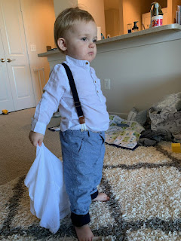

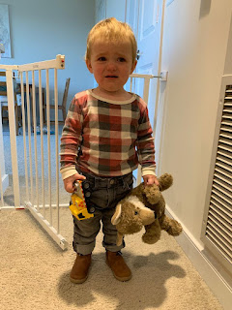

Gwen, Abby, and Amber

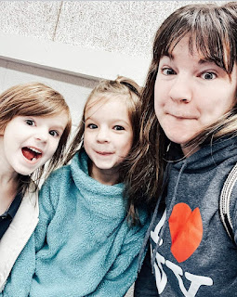

Gwen

