Babies and Parties and Visits
Scott is home!!! Hooray!!! Something I realized recently is that this will be the LAST TIME we have a "forced" separation. The military life has caused us to be separated during much of our marriage. In fact, we have been apart for 8 out of 33 years . . . That is ONE-FOURTH of our marriage!! And now, it's all coming to a grateful end. From here on out, we will be together all the time, except for the times when I will travel solo to go see our grandchildren or take a short family history trip. The difference, of course, is that these will be our choosing, and not because we HAVE TO.

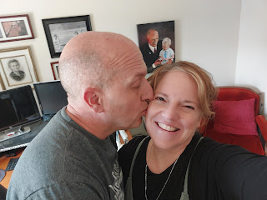

Amidst a windy and chilly week that brought occasional snow showers, I set up a very small Easter display near my front door. Now that I'm thinking about it, though, I don't really have any reference to the Person that we actually celebrate on Easter . . . hmmm. I'll have to give that some thought. Maybe I'll just call this my "Springtime Decor".

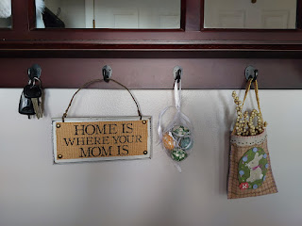

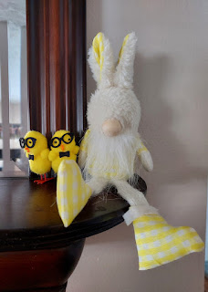

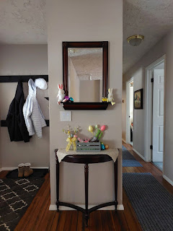

I went to the Idaho Falls Temple on Tuesday morning. There was a light snow on the ground that had fallen overnight. Everything looked especially pretty because of it. This was the first time in a while that I didn't write my Grandma Lillian's name on the prayer roll inside the temple . . . that kind of caught me off guard. But then, she won't really need those extra prayers anymore either, so that's a happier thought.





I talked with my daughter, Amber, for TWO HOURS one morning. It was fantastic. We talked about everything from our upcoming trip next week, to various strength training exercises (which she demonstrated for me), and lots of other stuff.



I went in for my annual checkup at my doctor's office, but while I was sitting in the waiting area, I just kept admiring this beautiful hutch that someone built for her front office. Laura Mason (my doctor) has recently started selling her own herbal tea mixes for various health issues, including gut health. I have two of her specialty tea mixes: Immuni-Tea and Gut Health. They are in the cutest little bags and they taste so good!

But I would really love to have a hutch like this . . . it would be so useful in so many ways.

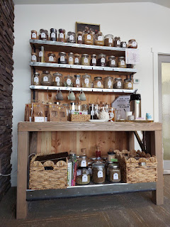

I signed up a few weeks ago to make a cake for our annual Relief Society Birthday Dinner, a celebration of when the Relief Society organization was formed on March 17, 1842. My choices were to sign up to make a soup or bake a cake. Usually I would sign up to make a main dish instead of a dessert, but this time I wanted to be creative, so I chose the cake.

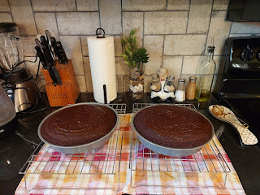

My kitchen smelled like deep, rich chocolate for two entire days, which was a very happy smell. Unfortunately, when it came time to bake the cake and prepare the frosting, it was in the middle of two harried days where my to-do list was exceptionally long and stressful. So it wasn't as "fun" as I had hoped it would be . . .

I made raspberry butter cream frosting from scratch, where you cook the raspberries in a little bit of lemon juice until they are somewhat mushy and soupy, then strain the pulpy liquid through a mesh strainer and just use the "juice". It adds a beautiful color and a lovely tangy flavor to the typically sweet butter cream frosting . . .

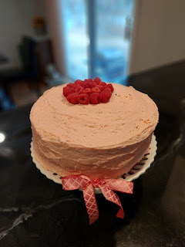

As I began the morning of "Frosting Day", I received a series of texts from my niece, Mari, regarding the tremendous ear pain that she was having. I ended up taking her to an urgent care where she was diagnosed with an ear infection, bless her heart. By the time we got her a smoothie and a couple of prescriptions, two hours had slipped by.

I hurried to get the raspberry sauce done so it could be cooling in the fridge for the recommended 2 hours, and then I raced over to Target to get some gift bags (for the RS activity that night and for a baby shower the following morning). While I was in the aisle that I needed, I ran into someone that I haven't seen for YEARS . . . she and her family are planning a trip to Italy later this year, so she had a ton of questions for me. In the front of my brain, I was thinking, "I haven't seen her in forever, so I should probably take the time to visit with her and be friendly." But in the back of my brain, I was thinking, "Holy shnikies, I am in crunch time to get that frosting finished and ON the cake and I only have about 90 minutes left . . ." So, after answering as many questions as I felt I comfortably could, I told her to text me with any other questions that might pop up in the coming months, and I excused myself to then dash out of the store.

While I was frantically prepping the frosting in my KitchenAid mixer, my neighbor Kim called because she needed to borrow some chicken bouillon . . . it was just one of those days, ha ha. Everything kept inserting itself into an already cram-packed day, and it was almost comical if it weren't so stressful . . .

The RS Birthday celebration turned out to be absolutely lovely, though. There was a really good turnout, with maybe 50+ ladies that came and it was so nice to visit with everyone at my table.

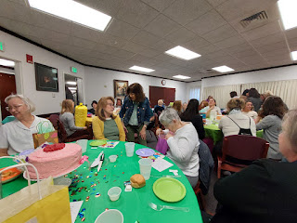

We did a gift exchange where we were supposed to bring something that represented a favorite thing of ours, and to keep it under $10. I brought a cute little off-white picture frame, a circular shape with roses around the edges. When it came to my turn to explain my gift, I shared that one of my favorite things is family history, and that one part of family history is to stay connected to our family members, both the living and those that have passed on. And what better way than through a simple photo frame?

The gift that I ended up being the recipient of was a package of SourPatch Kids (a sour gummy treat) and a package of microwave popcorn. It was from a young mother of several little ones, including a Downs Syndrome toddler. Her life right now is just trying to stay alive and have fun with her kids every day, which is really sweet. Other ladies received gifts of chocolate, candles, handmade (crocheted/knitted) items, books, and one person even made an exquisite stained-glass heart.

The following day, I finished the baby blanket for Jasmine. Yay!! It turned out so cute! I love this new pattern because it really is super easy to put together, but it looks like it took hours and hours to make.

I used this website:
https://www.brightgreendoor.com/3-hour-rag-quilt-tutorial/

Technically, it took more than 3 hours, but the point of it was that it really was pretty quick overall.

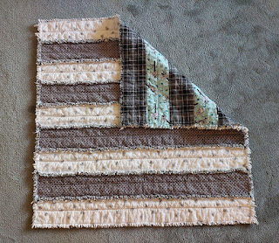

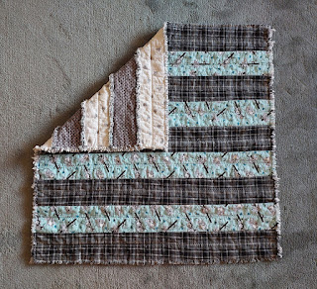

Friday morning, I had the pleasure of attending the baby shower for our niece, Bethanne Jackson, who is having a little girl in the next month or so. I drove up to Rigby with her baby blanket in tow, eager to see Bethanne - along with her sister-in-law Taylor and her mother-in-law Vanessa (the cheeriest person on the planet).

They had prepared a light brunch, with fruit, hash browns, bacon, sausage, potato cakes, and sweet cakes.

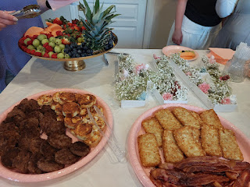

Bethanne was 100% in love with the blanket that I made for her baby, who will be named Andee . . . (short for Andalin - not sure of the spelling)

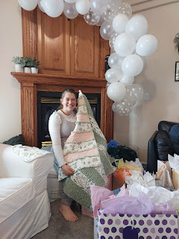

In between all the frenzied days up here, Scott had an abundance of time on his hands down in El Paso. On most days, the wind was blowing the dust everywhere and the sky was a mixed palette of orange and brown haze constantly. But on one or two days, the sky was surprisingly clear and blue and he wanted me to see it!



The day before Scott arrived home, I took Mari to get her laundry done at the laundromat, instead of at my house. I figured it was a good way to save on time, since at the laundromat you can do multiple loads simultaneously. While her clothes were in the wash, we walked to the end of the building, past Planet Fitness (my gym), and next door to the Ashley Furniture Store. The purpose: to sit on a bunch of couches.

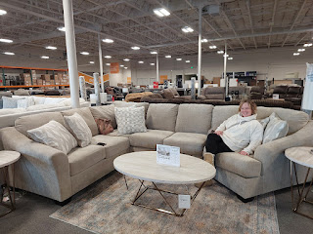

Scott and I need a good sized couch for Italy, and his new employer will provide a shipment of household goods from Idaho to Italy. The couches in Italy, at least from what we've seen, are too firm for our liking. The European couches tend to say, "We like you, but not quite enough to make you want to spend too many hours here."

Ashley Furniture has a connection with the U.S. Military and other personnel who are serving overseas -- through the website "Shop My Exchange". They offer several couches online that they can ship directly to the nearest military base. We (Mari and I) sat on some Ashley couches in a local store that are also listed on this "Exchange" website. So far, I didn't like any of those couches, but I
did
really like the one shown above. They offer a military discount in the local store, so it's possible we will just buy it here and have it shipped over with our household goods sometime in April. We'll see how it all plays out in the coming days. I need Scott's opinion on this couch, but ultimately he promised that I could be in charge of choosing one. :)

My younger sister, Melanie, flew up to Idaho Falls for the weekend so she could visit her son, Caleb, who is almost done with his first semester of college. She made the most amazing broccoli and cheese soup with bread bowls for dinner on Friday. I gobbled mine up super fast and I wished that I could have eaten 3x the amount . . .

We played a version of Monopoly called Ukiah-opoly, based on Ukiah, CA where we grew up. I bought it back in 2019 when I was staying out there for a few months. It was in the local Walmart, but we've never played it yet! I struggled to pass "Go" more than 3 times the whole game, but Caleb and Melanie were rolling in the dough the entire time. About 45 minutes into the game, I dropped out because I ran out of money. I started getting ready for bed while they continued to duke it out for another hour or so. Caleb ended up winning and he absolutely reveled in the whole thing, ha ha.

We watched an F-1 speed race while we played, which was pretty fun, too. You can't quite see it, but just slightly out of the picture below is Caleb's laptop screen where we watched the exciting race.

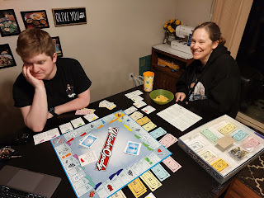

Melanie was so sweet to help me work on Maisie's Quiet Book when we had a little bit of down time Saturday afternoon. I was hoping to get a few things done to the point where I could do some embroidery during our upcoming 2-week road trip, and now I feel like I'm in a good place to be able to do that.

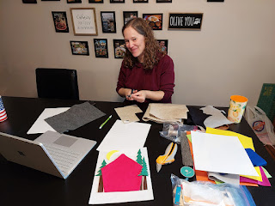

She said she CANNOT focus and do intricate handwork without sticking her tongue out to the side . . .

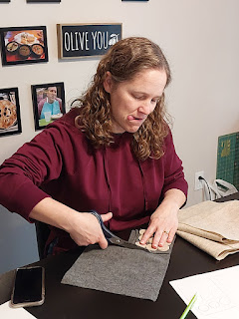

Scott arrived on his flight into Idaho Falls around 1:30 p.m. on Saturday, and he immediately went into "do everything all at once" mode.

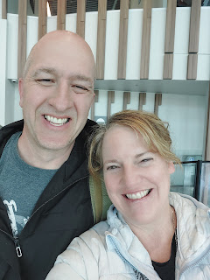

He unpacked, fixed the computer and printer in the office, measured and assessed the needs for a bottom latch to secure our front door, sorted through his military file, tinkered in the office, and a whole bunch of other things that I have no idea what they were, lol. He was a blur for the most part.

While I was working on dinner, he marched out into the back yard to "push on" the tree that was recently identified as needing to be cut down. Scott pushed on it once, twice, and on the third push, the whole thing came crashing down!! Had I known he was going to do that, I would have taken a video! But Melanie and I watched it happen with wide eyes and gaping jaws. I thought he just wanted to gage how weak it was, not to push the whole thing over!

When Caleb heard him mention the word chainsaw, his ears perked right up and he was practically begging to help. He said something like, "I've never actually used one before, but I've seen it done and I've read about it, so I should be okay."

Scott was happy to have an assistant and I love that they worked on all the cleanup together.

Video of Caleb using a chainsaw for the first time: (7 seconds)
https://photos.app.goo.gl/oZpeSod9f1qkEWEy7

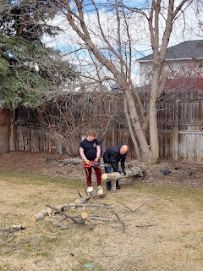

Caleb's roommate, Daniel, drove down from Rexburg to join us for dinner and Melanie picked up Mari, too. We had a total of 6 of us for the meal, which consisted of: Parmesan-encrusted salmon, garlicky mashed potatoes, steamed broccoli, green salad, and a fruit platter. The salmon turned out exceptionally well!

Here's the recipe I used:
https://www.delish.com/cooking/recipe-ideas/recipes/a49884/parmesan-crusted-salmon-recipe/

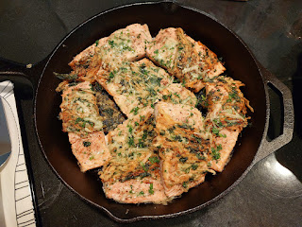

Two Aunties and a Niece . . . Mari, Melanie, and Me

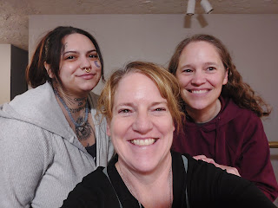

Maisie and Hannah ended up with whatever crud Jack and Jake had in the last couple of weeks, but the girls' version was more short-lived, thankfully. Maisie found a new talent of blowing snot-bubbles with her nose . . .

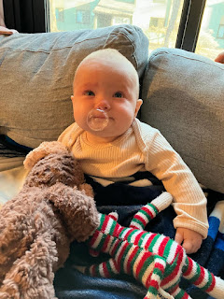

And here she is jibber-jabbering away as she's covered in whatever she just ate: (34 seconds)
https://photos.app.goo.gl/C9UWHFF8b5in2kaa9

Jake sent me this sweet video last night of Jack playing with HIS quiet book that I made him 2 years ago. I'm so glad he loves that Blockus page, where you have to fit all the shapes into the grid! Maisie is such a sweetie, just watching everything that Jack does.

(2 minutes)
https://photos.app.goo.gl/gJACYeHMArjdoyne8

We will hit the road on Tuesday for a jam-packed epic adventure to see as many family members as possible in 14 days. I'm not sure when the next blog post will happen, but I'll do my best!

Also - two last things. I forgot to include this last weekend: our youth sang the most beautiful song in church last Sunday, based on this year's theme: "Look Unto Christ". It's based on the scripture from Doctrine and Covenants 6:36, which reads: "Look unto me in every thought; doubt not, fear not."

Watch the video here: (3 minutes, 55 seconds)
https://photos.app.goo.gl/gpRnmBvcxDaq7YPT7

And the LAST THING: I recently finished a big project for our Rawles family (on my dad's side). If you want to see what I did and read about our Rawles Roots, then you can visit the website here.

RawlesRoots7.blogspot.com

