Carnival, Caroling, and Crazy Cold!!
The bitter cold of an Idaho winter arrived this weekend, just in time for our 1st annual OUTDOOR Neighborhood Christmas Carnival. Approximately 50+ people showed up to brave the bitter temps in order to have some fun and spread some Christmas cheer.
Me, Jen Anderson, Cindy Benson, and Christine Bennett
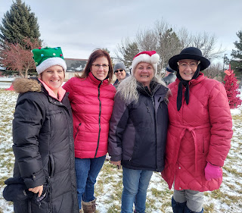

Hailie Reisner helping her dad, Mike, start the fire

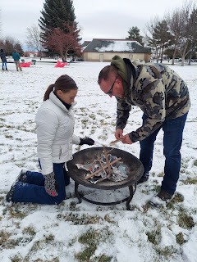

Marshmallows were roasted over an open fire for a variety of S'mores fixings, along with a hot chocolate bar to keep your innards warm. The adults mostly gathered around the fire, while the kids ran around and played all the games.

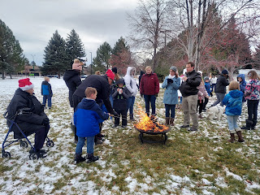

The bishopric put together a gorgeous red flocked Christmas tree with tags of service opportunities for us to choose from. Bishop McCracken owns Sunnyside Gardens here in town, so he knew just how to make a beautiful Christmas Giving Tree! (Bishop is on the left, and Nolan Anderson is on the right)

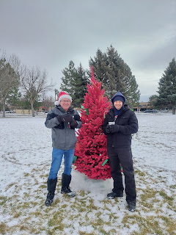

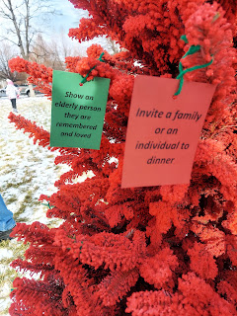

Pin the Nose on Rudolph game

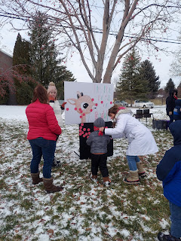

Our young women group put together "Holiday Hoops" and "Candy Cane Ring Toss"
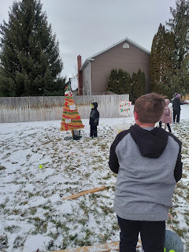

The Candy Cane Ring Toss was set up by tapping rebar into the ground and then sliding old rolls of wrapping paper over them. Paper plates were rigged to be flying discs. :) The prize was a candy cane.

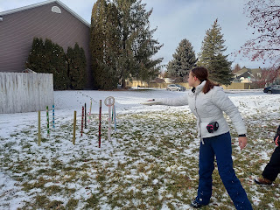

After coming up with the idea for the Christmas tree basketball game, I couldn't find a good name for it. Kylie helped me out by suggesting "Holiday Hoops." Even though Benson and I tried to come up with a name, nothing else even came close to being that good, so that's how Holiday Hoops was born.

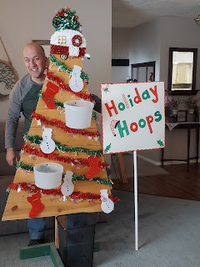

Here is a short video of me practicing some shots to test out the game before we took it over to the Carnival. (17 seconds)

https://photos.app.goo.gl/VsncysyBeVMVCGD57

A couple hours before the Carnival began, the temperature was 28 degrees, but the fine print said, "Feels like 16". Thankfully, it warmed up just a tad by the time the festivities began at 1:00 p.m. Otherwise I might not be here writing this right now, ha ha.

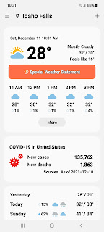

Before and after the Carnival, Scott and I finished grouting the kitchen backsplash tiles and cleaned up our big mess. :) Next up: caulk the bottom edges and seal the grout. Then it will be all done!

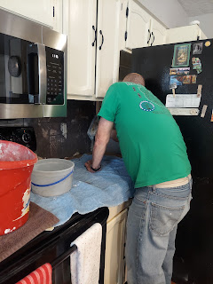

Jack pretty much owned this grocery cart in Washington DC yesterday (Saturday).



Monday:
I went to physical therapy for the first time, to try to fix my foot. After doing a variety of stretches, the PT finished up by doing a deep tissue massage on the arch of my foot with a metal torture tool. It was pretty painful and we had to take a break half way through. The heat wrap at the end felt nice though.

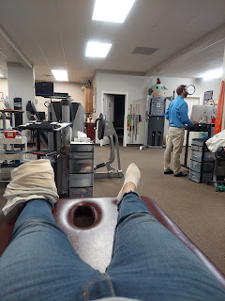

The rest of the day I ran around working on misc. tasks for my young women's calling, and misc. tasks around the house.

Tuesday:
In preparation for the huge Christmas caroling activity that night, I baked 2 apple pies. Another YW leader baked 2 apple pies as well, and then our YW president brought over 4 pumpkin pies from Costco.

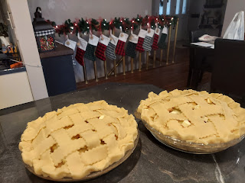

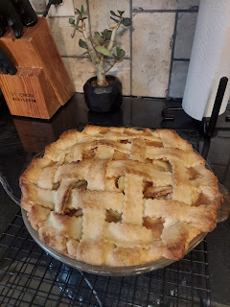

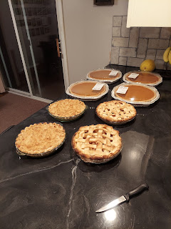

The Bishop provided bales of straw for us to ride on, which was divided onto two flatbed trailers. We had about 50 people in all, which resulted in a pretty fantastic choir as we rode along.

(I'm on the left in this photo)

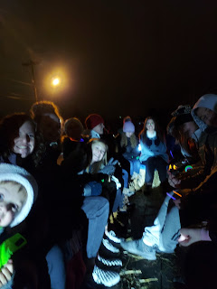

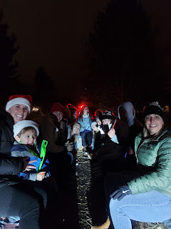

We would rotate which trailer-full of carolers would jump off to go sing at each house. For most of the houses we had a plate of cookies to offer as well.

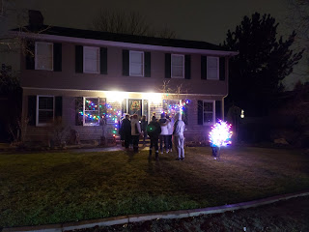

It was so sweet when we sang "Silent Night" for Christine Peterson. Her husband passed away almost 2 years ago while they were on vacation in Mexico. He had a sudden heart attack down there and didn't make it. They are both the sweetest people and our hearts are full of love for her as she tries to build a life without her amazing husband. We were lucky to catch her - she had just gotten home from an evening walk when we showed up. Our beautiful singing made her cry at one point, so I jumped off our trailer to go give her a big hug. She was so appreciative of us thinking of her. That's what this activity was all about - letting people know that we are thinking of them and that we care. :)

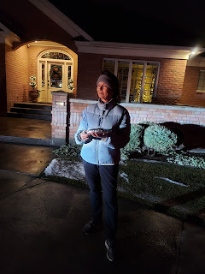

After all the caroling was done (we went to 21 houses in all), everyone ended up at my house for pie. I don't think I've ever seen this many people in my dining room before!! It was a super fun activity and I'm glad I could be a part of it. They came. They sang. They ate. And then it was all over.

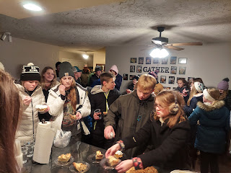

Except for the clean-up . . . that lasted for the next 2 days.

Okay: here's an idea. If you're gonna have straw bales to sit on, don't bring fleece blankets to lay over the top. Initially I loaded up all my extra quilts for the trailer rides because I figured it would help to keep everyone warm. I thought people would place it over their laps. But instead everyone just spread the blankets out on top of the straw and SAT on them!! So by the time I got them all back, they were just covered in straw. Not to mention all the straw that got tracked into my house . . . :)

Scott said next time we should lay tarps over the straw bales because at least they won't stick to the straw.

I didn't know straw would be so difficult to get off. Boy, was I naïve. It's very poky if you don't get it all out of those blankets. I tried a few things to remove the straw. A lint roller? Nope. A vacuum? Maybe . . . it worked a little bit. The straw just didn't want to come out! In order to get ALL the pieces unstuck, I had to crawl around on my hands and knees and pick all the pieces off by hand. I kept my vacuum going the entire time so as I picked pieces off, the vacuum would just slurp it up.

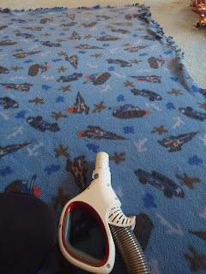

It took 2 days to get all the straw off that many blankets so that I could throw each one into the washer. A labor of love, I'd say.

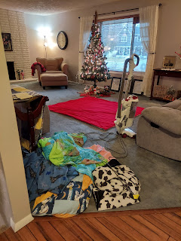

Wednesday:
Back to the physical therapy again. This time, when he did that deep tissue massage on my foot I almost started crying!! He finally gave me a break in the middle, and I asked him why it would be so much worse this time. He said it was probably still inflamed from what he had done on Monday. Well, then maybe you should wait a little longer before attacking my foot again???

Thursday:
In between cleaning up still, I went over to help my friend, Katie, again. This time she asked if I could help her clean up the living room at her old apartment.

Before:

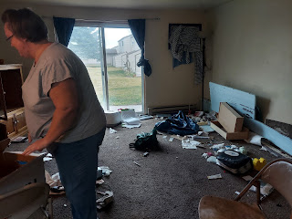

After:
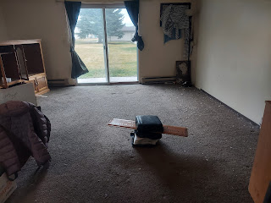

Later that evening, after Scott got home, we hauled another truck load of stuff to the dump for her. Before you say, "But that chair looks good still! It could be donated!" - it was all broken underneath and wasn't safe for anyone to sit on.

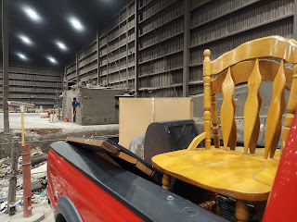

Friday:
I got a surprise phone call from Benson in Italy and I got to hang out with them on a video chat for about 45 minutes. It was pretty great. :)

Benson was feeding Avery for a bit.





Then he burped her. Awwww.

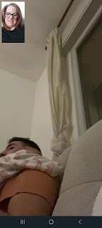

More feeding.

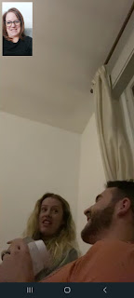



I think he looks so handsome with all that facial hair. :)





He goes back to work on Monday, but he'll have more time off again for Christmas. A nice long break for the holidays he says, so that's nice.



Here are a couple videos of Avery. She is such a cutie pie!

(42 seconds)
https://photos.app.goo.gl/xbty8gBrLWivXQt78

(12 seconds)
https://photos.app.goo.gl/hHejn8A1MXUcrF4a9

We also got some snow on Friday! About an inch, or maybe a little more than that. I think this is when the Arctic Canadian Cold arrived in Idaho Falls.



I shoveled the snow off our driveway and front walk, then did the same for my next door neighbor.

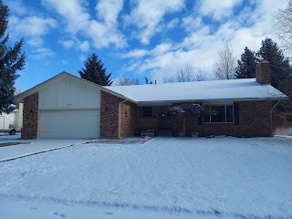

Later that evening, we drove up to Rexburg to meet our friends, Rich and Andrea Garner, for dinner. We ate at a tasty restaurant called The Hickory. They are famous for their smoked brisket and pulled pork. It was fun to catch up with them and be silly together.

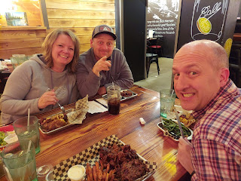

Lastly, here are a few of my favorite Tik Tok videos from the week.

A day in the life of a Mom: (29 seconds)
https://photos.app.goo.gl/PUxPNPwNQiLiGdoXA

I laughed and laughed at this one - a spoof on what happens when your teen slams a door: (13 seconds)
https://photos.app.goo.gl/B7XQXYb6ZteK1utU8

I seriously watched that one over and over and giggled hysterically every time. Scott didn't find it as funny. But Amber did. She got me.

A mom teaching her little boy about music and rhythm: (34 seconds)
https://photos.app.goo.gl/skVzdwPiPLofG8RTA

A guy teaching his dog not to jump up on you: (45 seconds)
https://photos.app.goo.gl/SbikRF3GPC3c67nd9

And here's a sweet photo of Jack with his sleepy face. XOXO



