Chickens: The Pet That Poops Breakfast
Oh chickens . . . !!
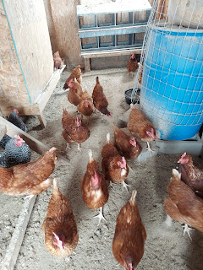
Here are a few henny jokes and sayings:
A hen is only an egg's way of making another egg . . .
What's a chicken's favorite subject? Egg-onomics . . .
You have to break eggs to make an omelet . . . (Sometimes you need to make a mess to get something done)
We had a lot of fun taking care of 20 chickens this week for our friends, the Beutlers. Every time I walked across the snowy path and entered the hen house, they LOVED pecking at the fresh snow on my boots. And they loved to nibble on my shoelaces, too.

Video: (15 seconds)
https://photos.app.goo.gl/Eq8mvkgFWKXiVcCE6

I enjoyed collecting the eggs every day, twice a day. I went over each morning around 10 a.m. (to give them time to do their thing), and then Scott and I would go back over around 5:00 to round up any remaining eggs that weren't there earlier.

Video of me collecting eggs on the first day: (27 seconds)
https://photos.app.goo.gl/kAJsqWPcEZESGPQz8

I used an ice cream bucket to collect the eggs, and we'd get about 20 eggs per day, give or take.

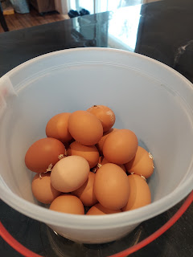

It snowed twice this week, too. No matter what the temperature was in town or in our neighborhood, it was always quite a bit colder out on the Farm. As soon as I opened the car door to get out in the driveway, that nasty frigid wind would just punch me in the face!

We had a good system for the week as far as shoes went. I had an older pair of winter boots that I kept in the trunk of the car on a large piece of cardboard. I'd walk back to the trunk, swap whatever shoes I was wearing for the "poop boots", and walk down the long path out to the hen house.

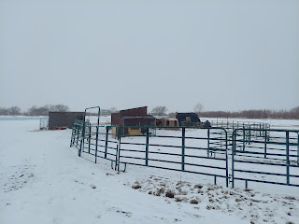

When I was done filling up their water bowl and collecting eggs, I'd return to the trunk of my car and swap my "poop boots" for my clean pair, and set the yucky ones on the cardboard until the next time. Scott chose to dub his gardening muck shoes as his "poop shoes". So we had "poop boots" and "poop shoes". I can't wait to clean them all up very soon! They got a serious (and thick) layer of mud, sand, chicken feed, and chicken poop over the last 6 days.

Some days when the temperatures got up into the 30's during the day and the sun was beaming down, the snow would melt and make some really nice, gooey mud - the kind where each step you took felt like you were walking through some really thick chocolate pudding and your feet would sink down several inches . . . ewwwww!!!

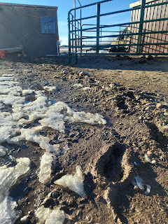

The horses did great, even though they weren't our responsibility for the week. It was usually too darn cold to spend much time with them, or else it was the sloppiest and muckiest horse pen you've ever seen and we didn't even want to slop across the swamp to go pet them. If I had a different pair of boots that were made for just such an occasion, then maybe I'd have trudged out there more often.

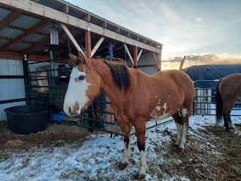

We gave away several dozen eggs, but we still have a TON! Sharina told me that the best way to wash them is to let them soak in lukewarm water for about an hour (to loosen up any poop or gunk stuck on the outside), then use a little dishwater to rub them and gently clean them before laying them out to air-dry for a few minutes. For the past couple of years, I have always saved my egg cartons to donate to the Beutlers, but this time I gratefully dipped into our own supply to be able to refrigerate everything after they were all clean and sparkly.

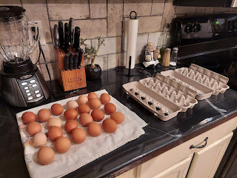

There was an area on top of the feed bin that we named the "naughty spot". Sharina told me that at least one hen would hop up there regulary to nest and to be sure to check up there daily for her "deposits". Sharina had tried to cordon it off by hanging feed bags to block the way, but at least one of the "ladies" still found a way to get in there and lay an egg. I found this determined young lady up there one morning and sent a picture to Sharina, ha ha. Scott came up with a few ideas on how to deter the ladies from laying in the "naughty spot".

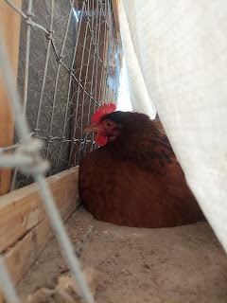

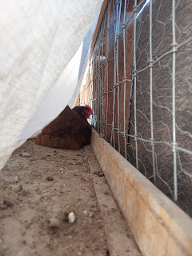

First, he added some twine to the ends of the open area. But this henny got all sorts of tweaked while he was working to attach the twine. We are not exactly sure how she got in there again after he left this morning, but there was an egg in the "naughty spot" when we came back this afternoon. He added even more twine the second time, so we'll see how it goes in the coming days. We'll share our other ideas with Sharina when they get home tomorrow.

As for the rest of the week . . .

Monday:
I had worked tirelessly for several days to get the Rawles Roots Blog and Newsletter ready to send out to all the family. I shared a life sketch of my great-grandfather, Eugene Carlton Rawles, known as "Bob" (LOL). I don't know the story yet of why he chose to go by Bob, but I'm hoping that someone will step forward and share what they know with me! I also put together a spotlight for my great-uncle Gene Rawles along with a crazy, yet miraculous, story of when he was in Germany during WWII. If any of you are interested in seeing the blog, you are welcome to message me and I can give you the link.

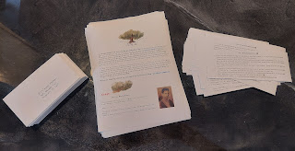

I had to update the family mailing list - which was REALLY out of date, and then prepare all the envelopes to head out by snail mail. In all, I ended up sending about 60 letters and about 45 emails to family members all over the country, including one in London, England. It was a labor of love, so it seemed only fitting to get them sent out on Valentine's Day. :)

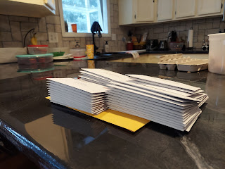

And speaking of Valentine's Day . . . I was pretty drained by the time I got all the letters done mid-afternoon-ish, so I decided to simplify our dinner plans. I set the table all pretty and romantic, with candles and nice dinnerware.

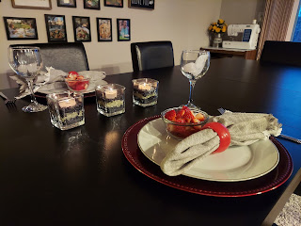

As for our meal - well, it consisted simply of leftover pizza from when our friends, the Garners, came over last Saturday night, and some sliced strawberries on the side. Voila! Super romantic, eh? Well, I knew that my husband is very simple and easy to please, so there was no concern in my mind about how he would feel about the food. As for me, it made me happy to just stay home and relax and not exhaust myself further by cooking for hours and hours. So it was a win-win. :)

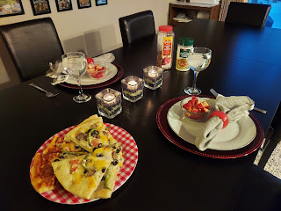

Tuesday:
I went in for a check-up with my dermatologist to see if my scalp is all good now. I have had a few rounds of treating some pre-cancerous lesions over the past 2 years, but I especially wanted to make sure I was okay to go over to Italy soon, knowing that the sun is much more intense there. Unfortunately, he found yet another spot that needs some attention, and he added that this will probably just be an ongoing thing. I received some sun damage in my youth (shocker) and now I will need to be vigilant and diligent about caring for the pre-cancerous spots on my head from all those years of throwing caution to the wind. It takes about 2.5 weeks of applying a solution to the targeted area 2x/day in order to kill it. The area gets all nice and red, and in the final few days it just burns so bad to apply the solution each time. I have to really psych myself up to get brave and just do it! After the 2-3 weeks of application, then I can stop putting on the solution and let it scab over. A few weeks after that is when the dermatologist can inspect my scalp and give his stamp of approval that we got it all taken care of.

We had a fun YW activity that night. We created a menu plan of sorts, made a grocery list, then went to the store to purchase what we needed within our designated budget of $20, and lastly to bring everything home and make the chosen menu item.

The girls looked over the 4 choices of what they could make: Muffin tin lasagna (using wonton wrappers to layer lasagna ingredients in the muffin tins); one pot macaroni and cheese; pretzel bites; and no-bake cookies (a recipe brought by one of the girls in our class). They chose to make pretzel bites.

We made a list of what we needed (we only needed to buy some pre-made pizza dough because I already had eggs, salt, baking soda and water), but I had them locate all the other ingredients in the grocery store and write down the cost for each. It was very enlightening for the girls because at least one of them had never been to a grocery store before!! I bet she
has
been at some point in her life, but maybe she just hasn't gone in recent years and had therefore forgotten what it was like. She also suffers from moderately severe anxiety, so that may have been a factor in why she doesn't go to the store very often. Surprisingly, she did great this time! Hopefully she saw that it's not a big deal to go get a few things in a grocery store . . .

We spent a total of $3.77 for the pizza dough and came home to get to work.

A couple of the girls took the pizza dough and cut it into several small pieces.

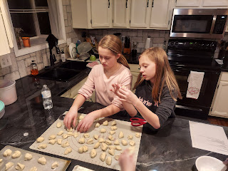

Then another girl dipped the pieces of dough into a baking soda "bath" (4 cups of water + 1 1/3 cups of baking soda). *Way too much water and way too much baking soda we discovered. The baking soda kept settling at the bottom and turning into a thick sludge, so we had to stir it OFTEN.

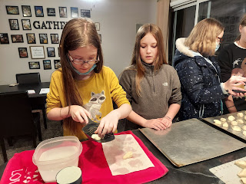

Another girl helped to lay them on the cookie sheets. The final step was to brush on an egg wash and then sprinkle lightly with kosher salt.

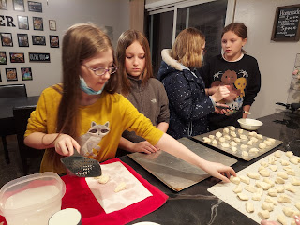

Something the recipe did NOT specify was to spray the cookie sheet with cooking spray FIRST!! It didn't even mention greasing the pan at all!! The first batch that came out of the oven was a beast to work with.

But the girls LOVED the pretzel bites! They ate them plain or dipped them in Nutella, while Scott made a honey-mustard dip for his. The last batch was sprinkled with cinnamon-sugar and they turned out very nicely. All in all, the girls learned a lot that night and had fun playing Sardines in the basement while the food was cooking. All accomplished within 90 minutes. :)

Wednesday:
Amber has been working on another beautiful piece of art for an upcoming exhibit through J. Kirk Richards. I'll let her describe the inspiration she received during the process. (see below)

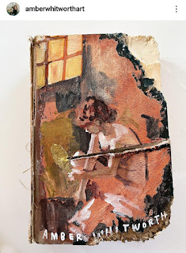



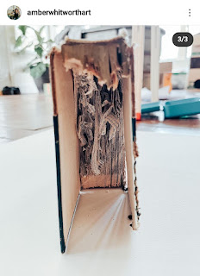

She thinks the deepest thoughts and has the best interpretations that come out into her artwork! Wow. I just cannot say enough how grateful I am for who she is, for her amazing personality, and for how she uplifts and inspires the world. :)

I also went over to my friend Aubrey's house at noon, where she helped me begin a study of the Italian language. How fun! I can read it pretty well, but she was good to correct me several times and patiently explain why each time. It is similar to Spanish, which is my first love as far as foreign language goes, and will help me to more easily learn Italian because of my familiarity with Spanish already. We practiced some very basic conversations and went over the numbers 1-20 and all the letters of the Italian alphabet. I've been practicing with Scott a little, too. Aubrey has an interior design business of her own, but she also minored in Italian during college, and spent 3 months living in Tuscany as part of an internship several years ago. She said it makes her happy to help me prepare for living in Italy because it helps her practice her own Italian at the same time. :)

Thursday:
We got this grown-up picture of Avery, feeding herself over in Italy. She looks very focused and intent and seems to be growing in all the best ways!

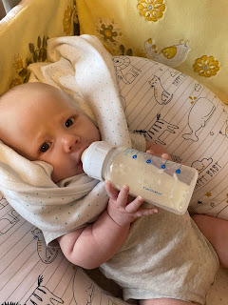

I made a HUGE batch of homemade macaroni and cheese casserole (my all-time favorite recipe when I was growing up) which was my service assignment for my friend's funeral the next day. I decided to make it ahead of time because Scott and I would be getting some vaccines that evening, and I didn't know how well I would be feeling the next morning to prepare things.

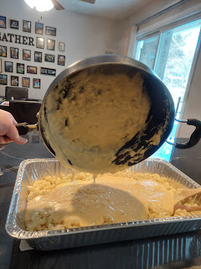

We had set our appointment a week earlier with Walgreens, scheduling a booster of the Covid vaccine (Pfizer) along with the shingles vaccine, which neither of us has ever had before. It's recommended for those 50 and older.

Scott went first. Two pokes: Shingles on top, then Pfizer below.

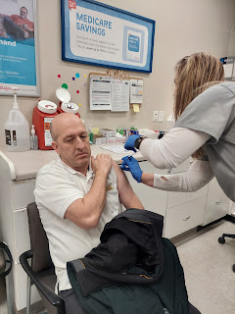

My turn next. Same thing. Two pokes.

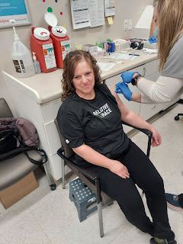

My arm is still sore 3 days later from the shingles vaccine. It's been a little red and splotchy in the area of the injection, and if you bump me or put your arm around me . . . I will wince and jump away because it still hurts that much.

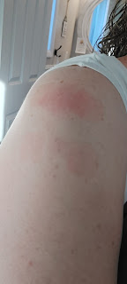

Friday:
After checking on the chickens, showering and getting all gussied up, I went to the funeral for my friend Trish Meyers. It was wonderful to hear more about her life growing up and all the good things she did for her children and grandchildren. It really triggers some self-evaluation for me, wondering if I am doing enough good in the world and loving my family members and friends enough. Being a perfectionist by nature, I want to be the very best mom, grandma, friend, sister, daughter, neighbor, etc. But gee whiz if Satan doesn't use this as the perfect opportunity to plant some giant seeds of self-doubt and discouragement in my mind, leaving me to wonder if I'm even any good at all! Thankfully, my optimistic nature doesn't allow me to wallow in that pit of despair for too long and I am able to feel at peace knowing that even though I'm far from perfect, I am at least trying.

I took some pictures of the displays that were arranged so beautifully in the foyer both before and after the funeral services.

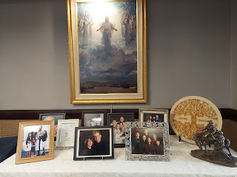

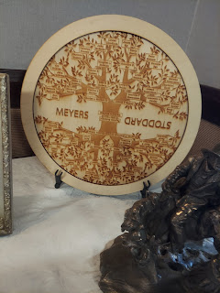

A friend in the neighborhood, Amy Schmutz, asked several of us to contribute any photos that we had of Trish over the years and then she made this beautiful poster, entitled, "Our Friend Trish". I hunted high and low but could only find the one picture that I included in last week's blog post, and seen on the poster below - second row, far right. It was taken last March as several of us ladies were visiting outside the door one day after church.

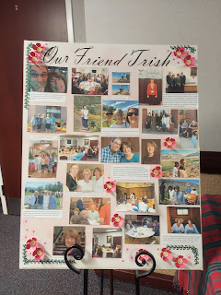

Her casket was a gorgeous light pink in color, lovingly loaded with many, many colorful flowers.

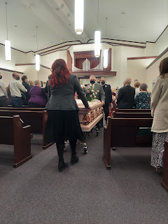

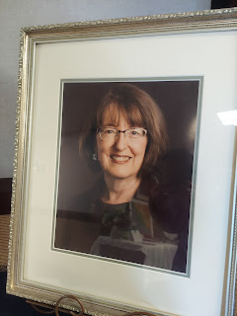

She had several books made over the years, with photo journeys of the trips they had been on, family reunions, and even collections of her grandchildren's photos.

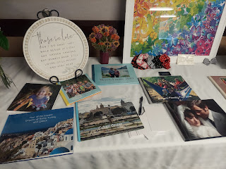

One of the many things they enjoyed doing as a large and extended family (5 kids plus 23 grandchildren) was to get together each year and make gingerbread houses. As all the kids came from all over the country this past week in preparation for the funeral, they made and decorated a large gingerbread house together in their mother's honor, and it was on display in the foyer.

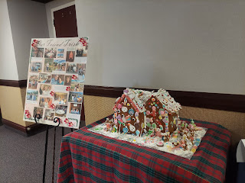

This missionary name badge of Trish's was on display on one of the tables. This is when it really hit me! She has worn this badge for so many years, but now it is retired and will be a family memento for generations to come. Even though it made me sad to see it just laying there on the table, I also know deep down inside that she will continue to be a missionary and a light to those around her in the spirit world. I will miss her very much and I have made a promise to myself to step up in my family history contributions to the world in her memory.

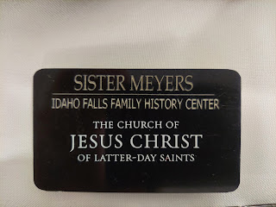

Later that evening, Scott and I were able to go to the temple and do an endowment session. It was particularly poignant for me to be there, as I was still on my roller coaster ride of emotions from the funeral and thinking about Trish and all that I want and need to do in my life. Just the tiniest and seemingly insignificant words spoken could be the catalyst for a fresh round of tears to start tumbling down my cheeks all day long. But peace and comfort came to me in the temple, and I was able to go to sleep that night feeling more uplifted and encouraged than I had all day.

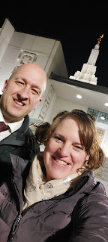

Abby was named a "Star Student" at school! No surprise to me there, because she's an amazing student!

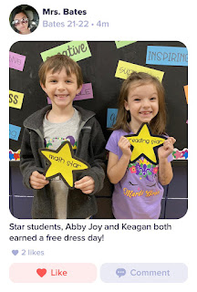

And here's Jack, with some cute little joke in his mind that he's thinking about sharing with the rest of us some day . . .

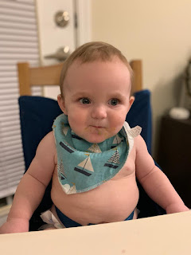

Saturday:
We picked up Phil and Coy, Scott's parents, at 11:00 a.m. to go on a day trip over to Star Valley, Wyoming, about 2 hours to our east. The weather was perfect, even though it was just roughly 40 degrees or so. When the sun shines strong and bright, it makes the 30's feel like 40's, and makes the 40's feel like 50's. So we relished in the warmth of the sun as it streamed into the car all afternoon.



Swan Valley, Idaho



Palisades Dam

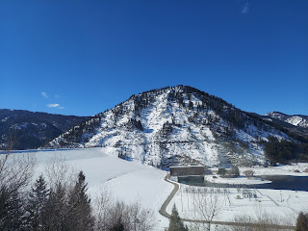

Palisades Reservoir was all frozen over and goes on for miles. We saw some snowmobile tracks heading out across the lake, and we also saw a few warming huts of some brave ice-fishermen. I hope they had success on such a beautiful day!



We finally made it to Afton, Wyoming, part of Star Valley. Star Valley has several small towns sprinkled throughout the long valley. We chose to go all the way to Afton because it's where Coy's mom was born and raised until she was about 8 years old, when their family moved down to Utah.

We pulled into the parking lot of the Star Valley Temple to take some pictures, since none of us had seen it before. It was small, but quite lovely with the snowy mountains behind it.

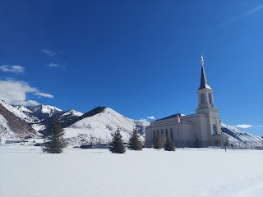

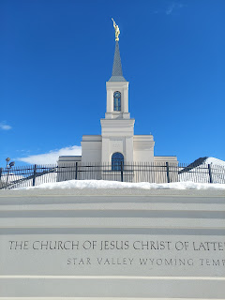

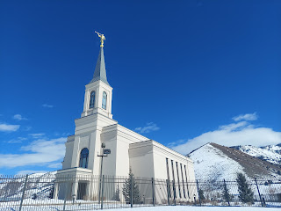

On the main street through town was a little restaurant called Fathom. We chose it because it had a nice variety for everyone's different tastes. It happened to be located right next to the World's Largest Elk-Antler Arch! (more on that below)

Coy, Scott, and Phil

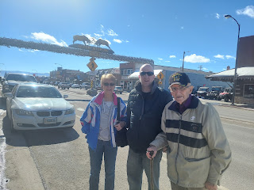

L to R: Me, Scott, Phil, and Coy

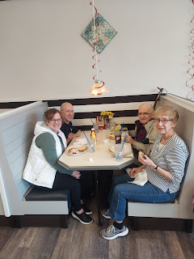

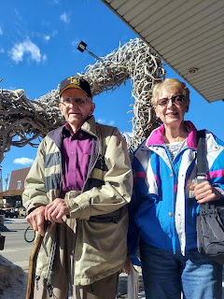

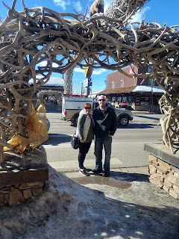

Transcription for the photo below: "Afton's Elkhorn Arch. This beautiful structure is 18 feet high and made of 3000 Elk (Wapiti) antlers. The arch was finished in 1958, taking 2 years to complete, at a cost of $2500 plus many hours of volunteer time. The antlers, shed by elk every spring, were gathered at a nearby elk preserve."

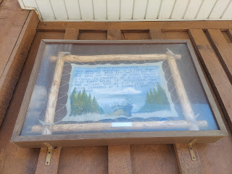

Lots of cute wildlife to see right in the middle of town . . .

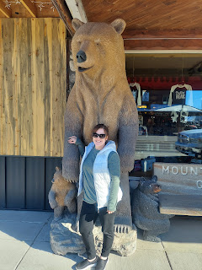

Here is the elk preserve, close to Etna, Wyoming and seen on our way home.

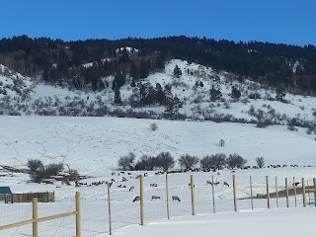

It was lovely to spend a few hours in the car together, talking about this or that, and commenting on the beautiful mountains, rivers, lakes and all that nature had to offer on the way. Our time is precious with Scott's parents, especially as he is preparing to leave in just a few weeks.

Last, but not least, here is Abby, practicing the concept of gravity as she balances on the side of their couch.

