From 79 Degrees to Subzero
Happy New Year!!!!
I hope everyone is off to a good start . . . I feel like I'm still trying to figure out what I want to do this year. And that's okay. I made it a matter of fasting and prayer today and I feel like I'm being guided in a general direction at this point, just nothing specific yet. There's no rush. I just want to do things that are the most meaningful and impactful, and right now I'm just barely rounding up some "ingredients" for 2022 that sound good. Soon I'll know what I'm actually going to "make".
Some ideas I'm tossing around:
Learning a new language or two this year (German is at the top of my list, and I want to brush up on my Spanish too)
Diving more diligently into my family history research - using information that I've gathered over the past 1.5 years and dissecting it all
Adding strength training to my exercise regimen
Eating more "clean" foods (ones that don't come in a package, bag, or box)
Spending more time studying the scriptures, using outside materials to supplement my study
Painting the entire downstairs of my house, one room at a time
Research the how/what/where/why/when of doing a humanitarian aid mission somewhere in the world within the next couple of years
Plan my next family history trip for somewhere in the U.S. for 2022 (probably Tennessee)
Label and organize all the family history items that I have stored in large tubs downstairs (like what if I die and nobody knows what the stuff is or where it came from?)
As you can see, there are a lot of ideas swirling around in my brain. I just need time to organize them and prioritize accordingly.
We went from 79 degrees and sticky down in Louisiana on Monday to -4 degrees when we woke up this morning. BRRRRR!! It feels like forever ago when we were down south with our kids . . . That was seriously SO FUN!! I can't wait to go back down again later in the spring. I'll be babysitting the girls in April while Amber and Weston go on a cruise together. How fun for me! :)
Last Sunday:
Amber took me on an adventure to downtown Shreveport in the evening, where we walked along the river and boardwalk that borders Bossier City. (pronounced Boh-zhier)
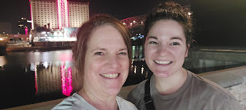

There were beautiful bridges and lights everywhere. And we were in short sleeves!! It felt amazing.



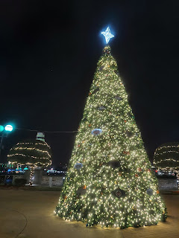

At the boardwalk, tucked in the middle of all the outlet stores and shops, they have a beautiful fountain that lights up at night.

Click to watch a little bit of the light show: (17 seconds)
https://photos.app.goo.gl/PKsnwreJP5AaVyTRA

Earlier that morning, Amber made her famous Beet Crepes for everyone. You basically just use a regular recipe for crepes, but you add in some previously boiled beets (maybe 1/2 cup or so) and throw it all in the blender. The girls LOVE eating crepes, especially these bright and cheery Beet Crepes.

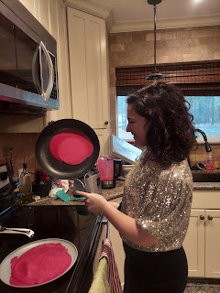

Monday:
Amber and I had a lengthy and intimate discussion about life while sitting in her beautiful studio. We talked about her issues with adult ADD and how to simplify some things, as well as what steps she can take to gain better control over the things that currently feel out of control. We also talked about our church callings, which happen to be the exact same job! We both serve as the 2nd counselor in Young Women. The biggest difference is that I have 11 girls in my class this year, and she has zero!! Their ward is much smaller than ours, and they only have about 4 young women total. In my ward, we have about 30 young women. She is thinking of talking to the YW president and asking if she would like Amber to double up and help out as secretary, since they don't currently have one.

It was a leisurely morning, where Scott alternated between entertaining the girls while Amber and I chatted and working on a computer program that he's building. He's always got something he's working on!
He had fun pushing Gwennie on the swing out back.
Video here: (20 seconds)
https://photos.app.goo.gl/XMN2UV9xRJWwkB548
And then he ended up trying out the swing for himself . . .
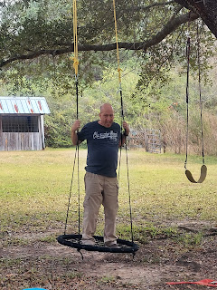

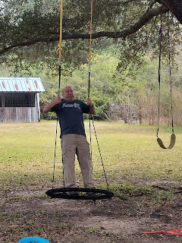

We took the girls out to lunch with us - to Torchy's Tacos, which is always a delicious favorite down in the south. Something interesting is that down in the Bible Belt of the South, where many Christians passionately live their faith, Amber says that she knows of several people who won't eat at Torchy's Tacos because on their logo it has a cartoon devil. They take things very literally and very seriously down there. I have to admire them for that, even though sometimes it can get in the way of learning new things and adding to your faith, as I have seen firsthand myself.

I remember when I was traveling through Georgia and South Carolina, all the way up to Virginia during February 2020. Twice I was imprisoned in a way-too-lengthy conversation with individuals who got so hyper-focused on a specific Bible verse that they could not fathom that it might have multiple meanings. What I might get out of a scripture can differ from what you get out of the same scripture. That's what we call personal revelation. For many, however, they lock onto one interpretation of something and they cannot be moved. I think it's important to be firm in your faith, but flexible in how that faith might be interpreted or defined. Each person is different, therefore our thoughts and feelings will differ. Some doctrine is eternal and doesn't change, but scriptures can have multiple interpretations.

Here Scott is holding onto Gwen after we finished eating, so she wouldn't randomly jump out into the traffic lane of the adjacent parking lot. She's a squirrely one, that girl . . .

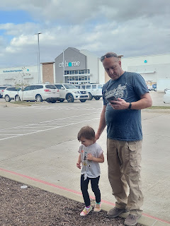

Next, we drove over to the same boardwalk that Amber and I had visited the night before. Only this time it was sunny and bright! Almost too bright for the photo . . .





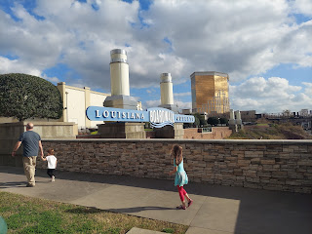

We took the girls over to the Carousel right next to the river.

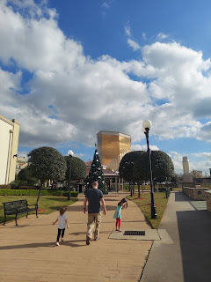

Gwen knew immediately which animal she wanted to ride on: a giant red crawfish!!

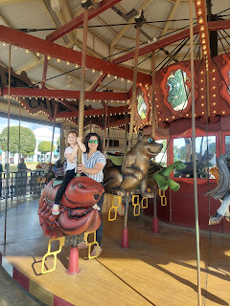

Meanwhile, Abby chose a majestic horse that she fell instantly in love with.

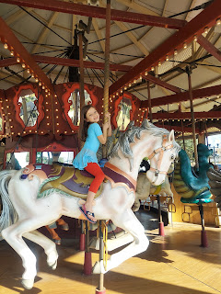

We took the girls over to see the water fountains, only this time there was no evening light show. But they didn't mind.

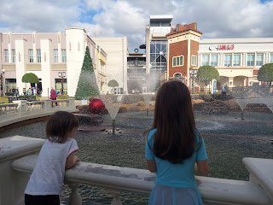

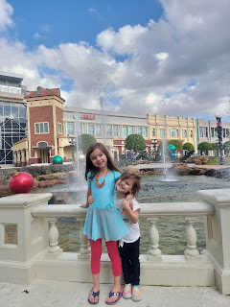

We also made a stop at the Pepper Palace, a store where you can buy all degrees of hot sauce and spice rubs, as well as salsas and other items. The girls were quick to voice how they really felt about hot sauce - - - by making disgusted faces!

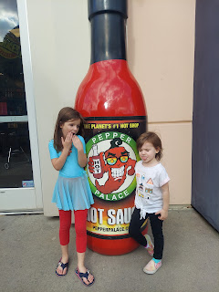

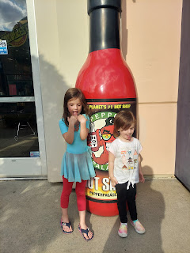

Anyone brave enough to try this horseradish that they sell?

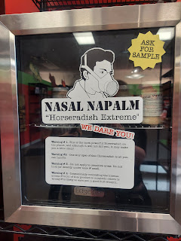

At long last, Amber and I ditched Scott and the girls (pre-planned of course) to do some grown-up shopping on our own. Scott took the girls over to Sam's Club and bought them each a giant pretzel before taking them home to watch a movie and relax. Amber and I stopped in the Nike outlet store so she could buy some new running shorts and some other attire at 50% off, and then we dashed over to Old Navy a few miles away to grab a couple shirts for ourselves. Then she dropped me off at Weston's optometry office so he could do an eye exam on me at the end of his work day, and then I came home with him afterwards. Recently he was given a lighthearted award for being the "Dreamiest Doctor". On the award it mentioned how he is basically young, handsome and well-dressed, which brings in more business, ha ha.

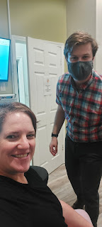

Weston had the bright idea to try to outfit me with some contacts instead of glasses. They're more expensive, but more convenient, and he's going to help me get them at cost. What a great son-in-law! He spent quite a bit of time with me the night before I came into his office, helping me put contacts in my eyes for the first time while we sat at the kitchen table. He held the mirror and talked me through what to do, and then I did my best trying to get the first contact in. It took me a while, but I was undeterred. It just takes practice to get it in properly, and then I had to learn how to take them out. He was soooo patient . . . what a good guy.

I just love how the Christian faith permeates every possible nook and cranny down in the South. There's no other part of our country that lives what they believe in such an open way. It's just part of everything they do! Like this little whiteboard note that one of the receptionists had stored behind the front desk in Weston's practice.

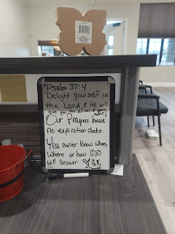

Another example is when Scott and I were driving towards Dallas the following day, I saw a huge splash park next to the freeway called "Splash Kingdom". And right underneath the name of the park on their giant sign was also a subtitle: "Seek the Kingdom" with Matthew 6:33 as the reference!!



Meanwhile, back in Utah, Jack was enraptured with seeing himself on video . . .

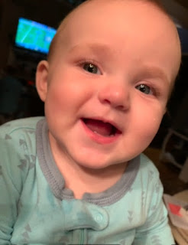

Here's the full video of him: (20 seconds)
https://photos.app.goo.gl/RYdwAu3zrD14AfcZ6

He's finally got the tiniest of evidence of a bottom tooth coming through the gums now. What a fun time it is, to watch your baby grow up and reach a new milestone!

Tuesday:
We had to say our goodbyes and hit the road towards home. It was a blast to be down there and spend time with the Whitworth family. We miss them so much already! But it was time to get on home . . .

Abby is such a tenderhearted little girl. As we pulled out of the driveway, she burst into tears, bless her heart. I will miss those little girlies. Abby has grown so much and matured so much since she started school. And Gwen is still spunky and spicy and hilarious Gwen.

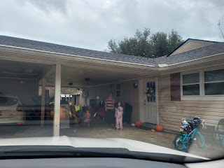

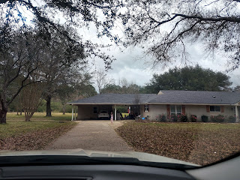

I enjoyed seeing giant bales of cotton on a semi truck for the first time. Having seen cotton growing in the fields down in Georgia for the first time in 2020, then seeing more fields of cotton on our way to Louisiana, this was very interesting to see as well. It's fascinating to learn how cotton gets from a seed in some dirt all the way to the pajamas I'm wearing right now.

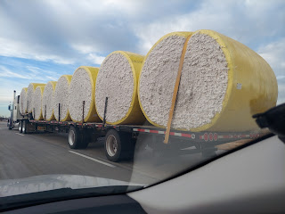

We made excellent time driving across Texas. It was humid and warm on the east side of the state, but boy was it cold by the time we arrived in Amarillo on the western edge.

I love those beautiful Texas skies . . . so big and luscious.

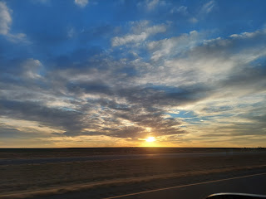

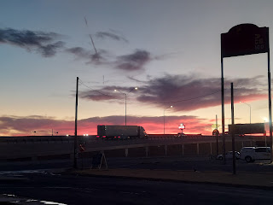

After we checked into our hotel, we went for a walk to get some dinner. We shivered all the way to the Schlotsky's Deli and McDonald's that were next door to each other just a short distance away. I ordered soup and a grilled cheese sandwich at the deli, and Scott got a burger and fries next door. We had noticed a man sitting on the curb at the edge of the McDonald's parking lot as we walked by. He may or may not have been homeless, but he certainly looked a little down on his luck. Plus it was VERY cold outside. (It was 54 degrees with a stiff breeze, but it felt like 35 to us) We decided to get him a nice hot burger as well. He thanked us when we handed it to him, and while we waited for the light to let us cross the street, I snuck a glance over at him. He was eating that burger right away, and seemed happy to let it warm his heart and his tummy. It felt really good to do what seemed like such a small thing.

Wednesday:
This was our super long day of travel. Just over 10 hours of driving time, not including any stops. We drove from Amarillo, Texas, all the way across New Mexico through Albuquerque and Farmington, up to Cortez, Colorado (again), and then up to Moab, Utah.

We had a variety of weather patterns throughout the day, and a beautiful assortment of scenery along the way.

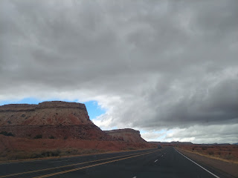

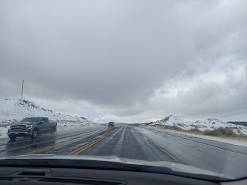

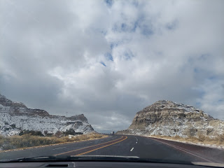

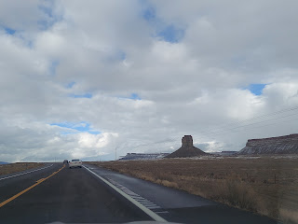

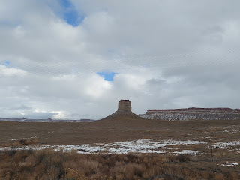

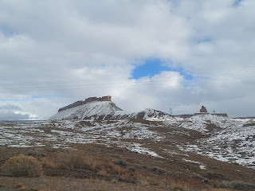

This was Wilson Arch, just a few miles south of Moab. There's a little turnout to park your car, and then we changed into some boots to climb up to the arch. It felt AMAZING to get out of the car!! We had only made two very short pitstops the entire day - maybe 5-10 minutes each.

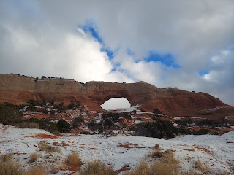

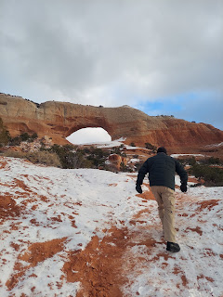

The view partway up to the Arch.

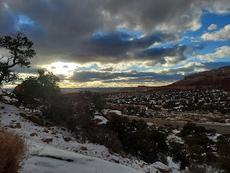

You can just barely see us in the shadow of the arch below, as the sun was getting ready to tuck in for the night.

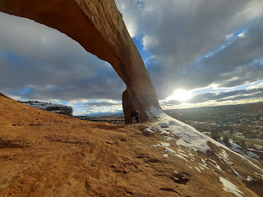

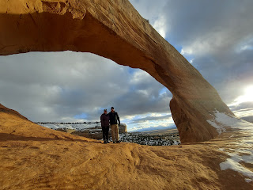

We took turns with a couple other hiking groups in taking photos of each other. It's nice when other humans are so cooperative - as well as being appreciative. People are pretty good wherever you go. I really love that.

Thursday:
We didn't have to leave at the crack of dawn, so that was nice. We took our time before leaving because we wanted to arrive around noon in Scipio to see Jacob, Hannah and Jack. If we came any earlier, Jacob would still be working and Jack would have been deep into his morning nap still.

We saw the most beautiful landscapes on our way from Moab to Scipio. Turns out that the drive along I-70 is a scenic byway! I'll say . . .!!

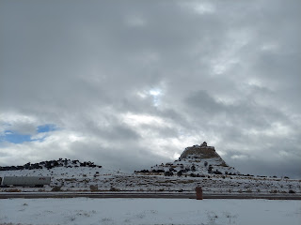

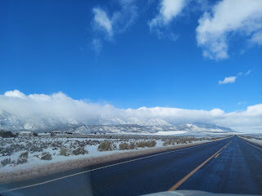

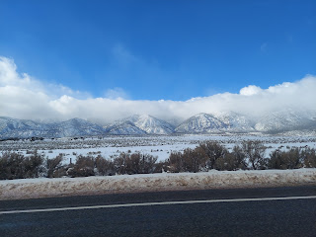

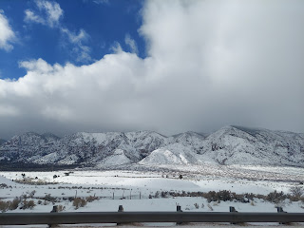

We arrived at Hannah's mom's house just after noon. Jack was still sleeping, but they went and woke him up a little early so we could see him. It takes him a few minutes to acclimate when he's so sleepy, and he's also a little reserved to begin with. I love this photo because it shows Jack and Pop-Pop sizing each other up, ha ha.

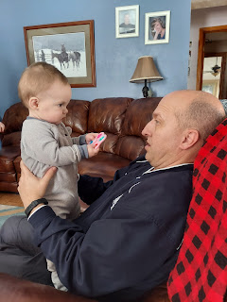

It didn't take long, though, for Jack to warm up. He's such a cheery little guy. And he loves seeing himself on a phone!! It's both cute and hilarious to watch him watching himself!!

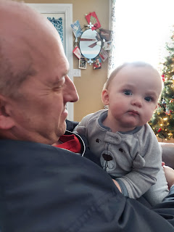

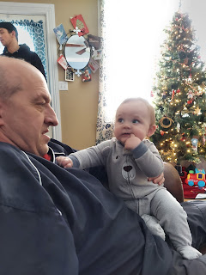

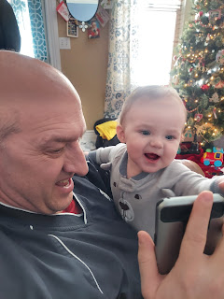

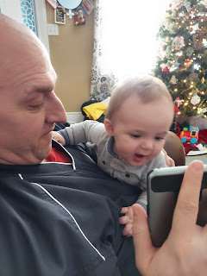

We weren't the only ones stopping by to visit. Hannah's mom, Michelle, had a visit from her sister (below in the background) and her husband and their 20-something year old son, who were passing through on their way to St. George. We didn't get to see Michelle's husband, Bob, who was at work that day. He's a really nice guy, with a perpetual twinkle in his eyes.

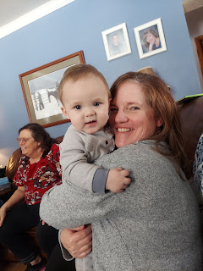

Mmm, I could just sit cheek to cheek with Jack forever. He is the best.



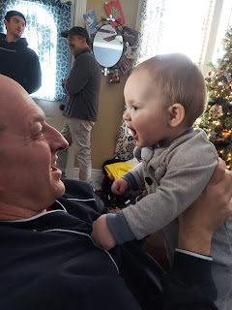

Jack loves sitting on his daddy's shoulders. He giggles and gets all excited up there. He especially loves to ruffle up Jacob's thick head of hair, and then laugh.

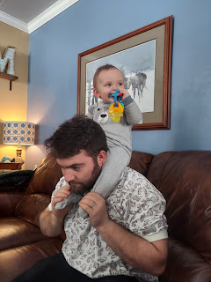

But when Scott put him up on his shoulders a few minutes later, Jack looked thoroughly confused. Where's all the hair to play with???

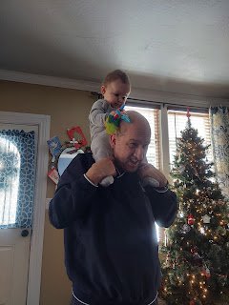

He loved the book I gave him for Christmas, complete with photos of him during his first year, and all the ABC's arranged in rhyming verse.

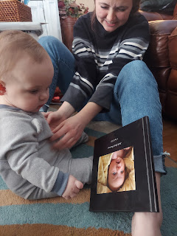

After a 2 hour visit and some lunch, it was time to hit the road again. Sad, but necessary. But sad . . .

Scott, Me, Jacob holding Jack, and Hannah

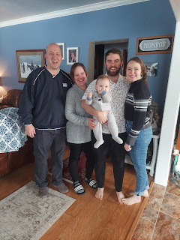

We knew we had a rough road ahead before getting home that night. The drive from Scipio to Idaho Falls is about 5 hours. We left around 2:00 p.m. and we got home a little before 7:30 p.m. It was really windy from Scipio to Provo. And then it snowed off and on from that point on as we made our way north on I-15. The roads were fine until we got to maybe Tremonton, where it was starting to get slushy on the surface.

The roads were worse south of Malad than they were going up and over Malad Pass, which was surprising. Still, the snow plows helped to keep the roads cleaned up along the way, which was very helpful.

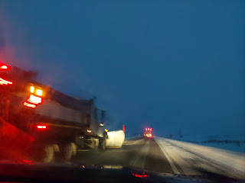

When we finally got into our neighborhood, it was obvious that they had A) gotten a lot of snow in our absence, and B) the snow plows hadn't been through there yet.

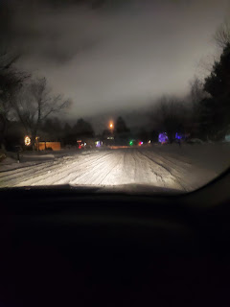

Here is a video of us driving through our neighborhood and then turning onto our street. We just tried to keep the momentum going so we didn't get stuck.

Video: (45 seconds)
https://photos.app.goo.gl/ezQJgVRa2xac8RKT9

Unfortunately, Scott decided he wanted to back into the garage so we could unload the trunk a little easier. That meant we had to stop in the deep snow to shift into reverse, and that's when we lost all our momentum . . . and got stuck.

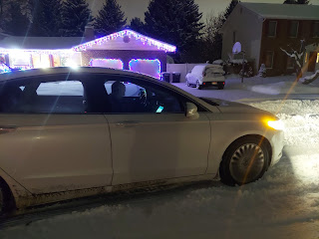

Video of the car stuck right in front of our house: (13 seconds)
https://photos.app.goo.gl/G7wwkrzwvAEiXneX6

Thankfully, the Parkinsons were home so I called them and told of them of our predicament. They sent Ben and their two boys over to help us push the car into the driveway. Thank goodness for helpful neighbors or we might still be parked out in the street today!!

This is approximately how much snow we got over the Christmas break. We estimated about 8-10 inches worth.

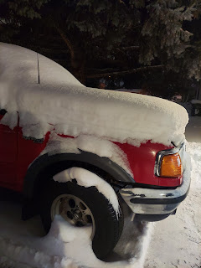

In the garage, safe at last. Scott was waving to the Parkinsons and thanking them again. They took good care of our house while we were gone. The boys would hop on their 4-wheeler (with a snow plow attachment on the front) several times a day to keep our driveway clear, as well as Ellen's driveway next door, which I had asked them to please do before we left. We have kept her driveway and walks clear of snow for the past 15 years. Those boys truly earned all the money we gave them the following day.

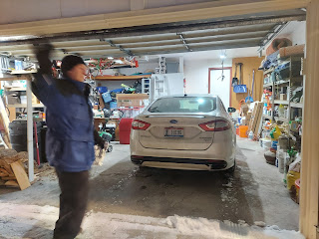

Friday:
I woke up with an earache and didn't feel that great. Meanwhile, Scott cheerfully donned several layers of winter wear and went outside to finish the process of getting us unburied. It had snowed during the night and was still snowing while he took the snow blower up and down all the sidewalks, clearing not only our section but other neighbors' as well. What a good guy!

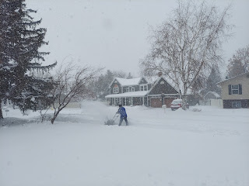

Later in the day, the snow plows came through - Hooray!! - and we watched them through the front window. They are very skilled at pushing the snow in such a way as to scoot it and push it along, at the same time as leaving the driveway clear and carving a nice area for the mailman to pull up to each mailbox.

Video of the snow plow: (40 seconds)
https://photos.app.goo.gl/VckWw1zpMfrN7Liy6

For dinner that night, I baked some spaghetti squash, intending to substitute the squash instead of pasta to make a healthier version of Mac & Cheese Casserole. This is one of those times that living in a sub-arctic climate is very helpful: you can set your hot items outside to cool off VERRRY quickly. :)

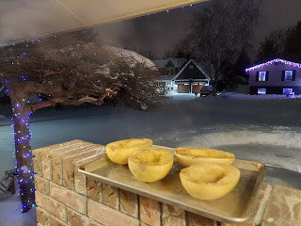

Yummm - it turned out quite delicious!! (I added some baby spinach)

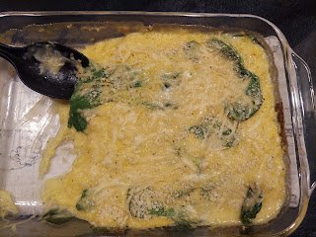

Here's the recipe I used:
https://www.skinnytaste.com/baked-spaghetti-squash-and-cheese/

*Note: I used 1/2 cup less on the chicken broth, just so it didn't get too liquidy.

Saturday:
My ear still hurt when I woke up, and I was worried that I had an ear infection. When it's only about 10 degrees for the high, being out in the cold was a concern. I put a cotton ball in my left ear, and drove over to Community Care down the street.

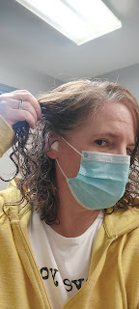

It turned out to NOT be an ear infection. The Doctor thought it was a simple case of TMJ irritation instead. TMJ is when the joint where your jaw meets up with your cranium (just below your ear) gets inflamed and can cause pain. I have had some issues over the past couple of years where if I sleep on my left side and my jaw alignment is just a little bit off, my mouth doesn't want to open (even to yawn) in the morning. After a little bit of patience and massaging of that joint area below my ear, then I can usually open my mouth - even though I hear a loud pop when it does finally engage. That's not good!

When I worked for Dr. Elison, an oral surgeon, I learned a few tricks to combat TMJ, such as how to massage down from the joint and going along the jawline. It feels really good and helps to remedy the stiffness or discomfort. In my case this weekend, though, the joint area was a little swollen, which wasn't typical. It actually hurts for me to touch it. Not only did my ear hurt, but inside my mouth - back where my wisdom tooth was removed - it was also a little swollen and sore. The doctor prescribed some Prednisone, a steroid, to help bring the swelling down. It's better now, thankfully. At least my ear isn't throbbing in pain anymore, too. I hate that kind of pain! He also said that chewing gum can aggravate TMJ . . . good to know, since I chewed a lot of gum as we drove across the country and back. I get bored in the car sometimes, and rather than eating nonstop, I would plop some gum in my mouth instead. Maybe I did it a little too much though . . .

In the afternoon, I had a lovely conversation with my niece, Mari, on the phone. While we chatted for over an hour, I took a photo of the sunset out my front window. I'm telling you, these nightly sunsets are such a loving and thoughtful gift from a loving and kind Father in Heaven!!

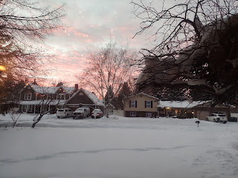

I shared a story with Mari from the December Guideposts magazine about a guy who went from being a drug addict, an alcoholic and a convicted felon to a clean and sober fitness instructor. It was a story of humility and hard times, and a story of overcoming negative self-talk and feelings of worthlessness. I love how he said, "It was an exercise class. But it was also a place where people, including me, could trade their self-deceptions and negative self-talk for an hour's worth of pure grit."

Mari connected to his story in many ways, and we talked at length about how she can get motivated in her self-care and how to find something productive that can bring her some true joy right now. She was eager to share the story with her mom, Charmaine, so I sent her photos of each page of the story.

Here it is, in case you're interested in reading it as well.

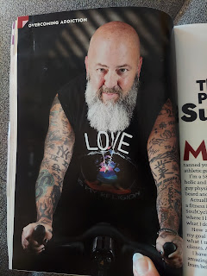

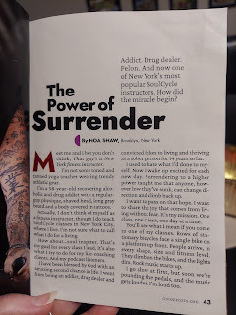

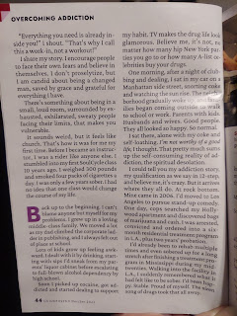

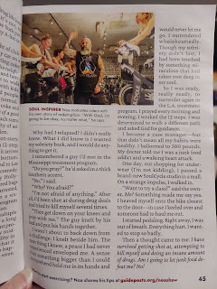

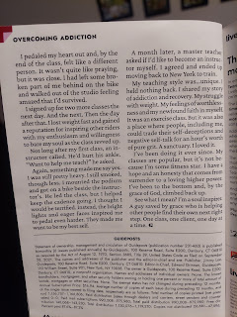

Later in the evening, Scott helped me hang some frames I've been meaning to get up on the wall for a while now. He is so kind and patient, and is always cheerful in helping me.

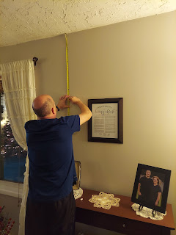

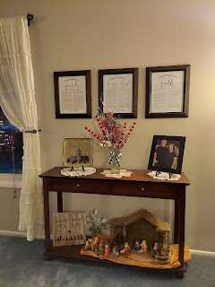

Last, but not least . . . GRANDBABIES

Not sure what Jack is thinking about here . . .

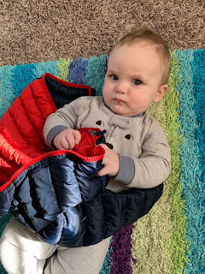

And sweet little Avery Mae (These are screenshots from a darling video that Kylie sent me yesterday)



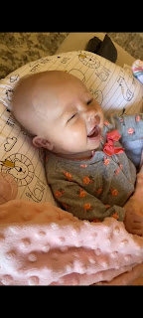

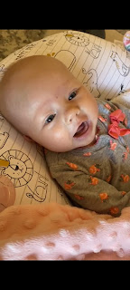

Video of Avery, talking a little, and smiling and cooing: (1 min, 21 seconds)
https://photos.app.goo.gl/uFsmF8dKrNw4snLa7

