Getting Caught Up: A Tribute to the Bassanos & A TEMPLE!!
There are still a few things that I haven't written about yet from a month ago! So now is finally the time to get all caught up . . .

First, though, Gwen's cute toothless grin deserves to be at the top of the blog post this week. She is always SO PROUD of herself whenever she loses another tooth, like she is one more solid step up on the Ladder of Success and growing up. XOXO

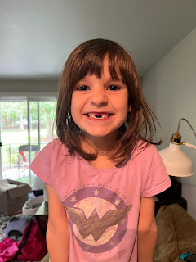

I'm gonna jump back in time a little bit, to September 13th, when I visited Bassano del Grappa a second time with my sister, Charmaine and her husband, Scott. She felt like we didn't have enough time there on our first visit, so we cleared a little bit of extra time for a return trip.

We were supposed to go paragliding that same morning, off the nearby Italian Alps that overlook Bassano and a few other towns, but the fall weather has been so volatile and this particular day was no exception. I had been in daily contact with the paragliding team, as we checked the weather religiously leading up to our scheduled time slot. Unfortunately, even though we were due to have a break from the rain, the wind was the bigger concern. They have some fancy weather and wind-pattern apps that they use, and the verdict came back as a No-Go . . . So, another epic plan went disappointingly down the toilet.

We decided to fill the void with a few hours in the town of our heritage.

Goal #1: Fill our bellies. This was deliciously accomplished with a burger and fries at Al Saiso, a pub restaurant just north of the Ponte Vecchio Bridge.

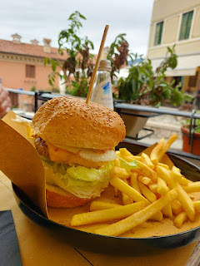

Goal #2: Walk along the Brenta River.

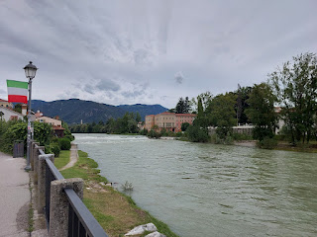

Charmaine loves to collect rocks, especially from meaningful places such as this. She had a good time hunting for a couple of rocks that could travel well back to San Diego.

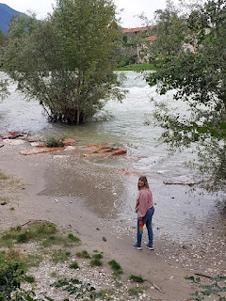

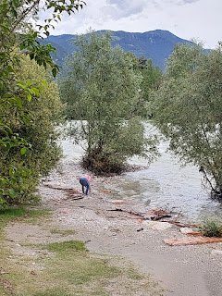

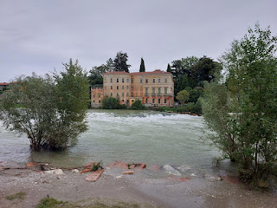

With all of the rain we've received this fall, the river was quite swollen. When I brought Amber, Abby, and Gwen here last September and again in October (2023), it was nowhere near this flooded along the banks.

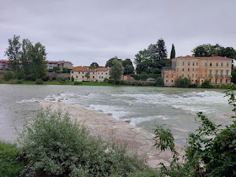

In fact, we climbed out onto those same flat limestone slabs that are now completely underwater . . . Here are the girls at the end of September in roughly the same spot . . .

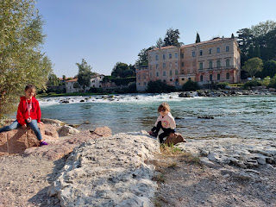

There's no way we would have let them come that close to the water's edge this September! Not only is it flooded and gushing downstream, but it would be a real nightmare for any parent (or grandparent) of small children.

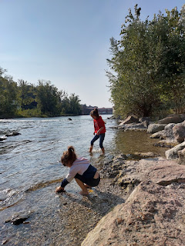

Brief glimpse of the rushing waters of the Brenta this fall: (9 seconds)
https://photos.app.goo.gl/oMGWsYa6uVUXFuBz8

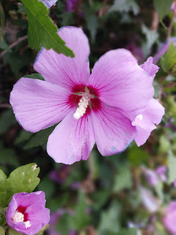

Charmaine, Scott, and I walked down the river path for some ways . . .

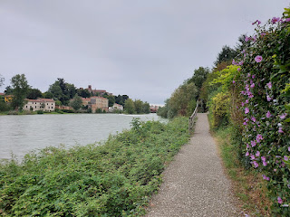

Charmaine has a gift for being able to identify just about any plant, tree, shrub, or flower. And if she can't for some reason, she takes a picture anyway so she can research it later using Google Lens.

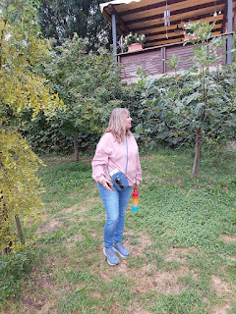

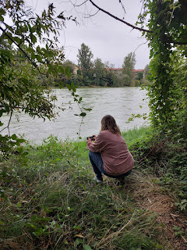

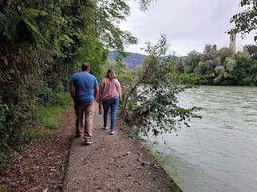

Someone arranged a tiny Nativity scene and nestled it into the vines of a tree on the path . . .

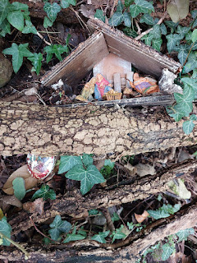

Charmaine and Scott, on our way back into town . . .

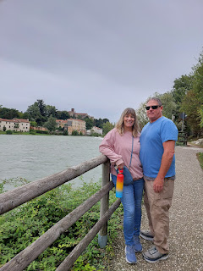

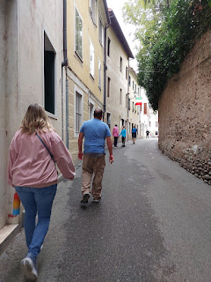

We walked into the center of Bassano to visit the Chiesa di San Francesco and the Museo Civico next door.

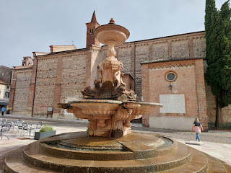

The Chiesa di San Francesco was built between 1200 and 1206 . . .

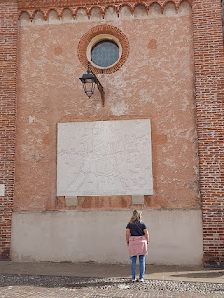

In the Piazza to the west of the Church is a handsome fountain, as well as a small-scale replica of the town of Bassano del Grappa.

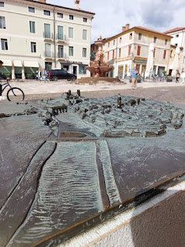

I am always on the lookout for these chunky cross symbols in Italian churches, especially ones like these that are connected to my heritage. They are often, but not always, associated with the Knights of the Templar. Are you ready to go down a fascinating rabbit-hole? If so, then carry on . . .

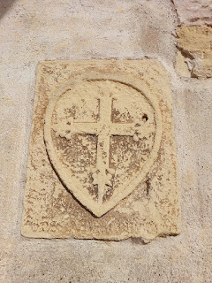

In a nutshell (with help from Chat GPT)
: The Knights of the Templar were a Catholic military order founded in 1119 during the Crusades. They were established to protect Christian pilgrims traveling to Jerusalem and other holy sites in the Holy Land. They quickly grew into one of the most powerful and wealthy organizations in medieval Europe.

The order was founded by a group of 9 knights who vowed to protect pilgrims visiting Jerusalem following the First Crusade. They gained significant support from prominent European leaders and, most importantly, from the Catholic Church, which granted them special privileges, including - exemption from local laws, direct accountability only to the Pope, and permission to raise funds independently.

The Templars were known for their unique role as both warriors and monks. They took vows of poverty, chastity, and obedience, similar to other monastic orders. Their emblem, a red cross on a white background, symbolized their mission to protect Christianity, and the cross became a recognizable symbol of the order. Their attire was distinct as well: white mantles for knights, which signified purity, and black or brown garments for sergeants.

Initially focused on guarding pilgrimage routes, the Templars soon expanded their role, defending and managing fortresses throughout the Holy Land. They developed innovative military tactics and built an extensive network of castles and fortifications from Jerusalem to Europe.

Their wealth grew through donations, land grants, and banking activities. The Templars also pioneered an early form of banking by establishing a system where pilgrims could deposit money in one Templar stronghold and withdraw it at another.

By the early 14th century, the Knights had amassed considerable power and wealth, arousing envy and suspicion among some European leaders. Many Templars were executed, imprisoned, or forced to renounce their vows. The mystery surrounding the Templars grew after their dissolution, leading to legends about hidden treasures, secret rituals, and even connections to the Holy Grail. Some organizations today, including the Freemasons, claim historic or symbolic ties to the Templars, though they are not directly linked to the original order.

(I'm thinking it's time to watch "National Treasure" again . . .)

The link between the Knights of the Templar and my Bassano ancestors is basically this:
One of my relatives, Jeronimo de Bassan (same name as my 17th great grandfather, but I think this is a different Jeronimo) was born around 1465-1470 to Don Andrea de Bassan, or Don Andres de Bassano. Don Andres was the son of Diego de Bassan (Bazan in Spanish).
Don Andres de Bazan was a courtier in the Spanish court as well as a Knight of the Order of Santiago. So was his father, Diego.
Along the pilgrimage route, there is a small town called Hospital de Orbigo in Leon. There is a bridge there called Calle el Paso Honroso, with a plaque commemorating 10 Knights of the Order of Santiago who battled in a tournament to St. James. This tournament took place on 24 July 1434 where 10 Knights of Santiago defeated 68 knights from across Europe.
Diego de Bassan is recognized as one of the greatest Knights of Santiago, along with his nephew Don Alvaro de Bassan I (a naval admiral). The nephew would later accompany Christopher Columbus!
*The first 4 points above can be attributed to the research of Dr. Peter D. Matthews in his book,
Shakespeare Exhumed: The Bassano Chronicles
(pages 47-48).

*The next 6 points are given with the help of Chat GPT:
The Knights Templar and the Order of Santiago were separate units, but they did overlap in their service at times.
Knights Templar: Founded in 1119, primarily in the Holy Land, their focus was protecting pilgrims in Jerusalem and defending Crusader states.
Order of Santiago: Founded around 1170 in the Kingdom of Leon (now Spain), their focus was to protect Christian territories from Moorish incursions on the Iberian Peninsula and to secure pilgrimage routes, especially to the shrine of St. James (Santiago) in Compostela.
They sometimes fought together in campaigns, sharing resources, strategies, and fortifications, particularly in regions where Islamic and Christian territories met.
Differences were: The Order of Santiago had a devotion to St. James (Santiago), the patron saint of Spain. The Templars, however, were more associated with the Crusades in the Holy Land.
After the Templars were disbanded in 1312, their Spanish and Portuguese properties were often transferred to other military orders, including the Order of Santiago. Some former Templars may have also joined these orders.
WOW. That was a bit of a rabbit-hole, but such an exciting one! This is how my brain works most of the time - if I come across a nugget of information that I don't know much about, I am super curious and I want to know more. I hop on my phone or my laptop to delve a little deeper. Since I make repeated references to the chunky cross that I see in many of the churches and basilicas throughout Italy, I thought I should pause and explain it a little more. :)

Inside the Chiesa di San Francesco, the decor is very simple, yet expansive and thoughtful.

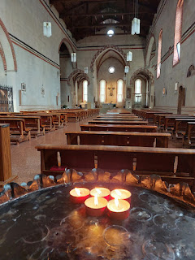

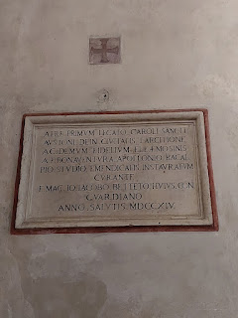

Above and below: There is a wall inside the church with a memorial to Jacopo da Ponte (the famous artist who is also known as Jacopo Bassano). He was actually buried here, too, I just recently learned.

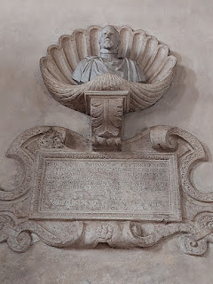

In the cloister area that connects the church to what is now used as a Civic Museum, there are hallways around an outdoor central green space. Lined along the hallways are dozens of artifacts that have been preserved, including coats of arms, headstone epitaphs, and other memorabilia.

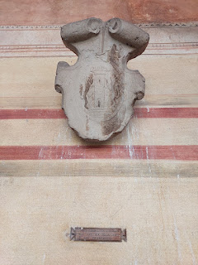

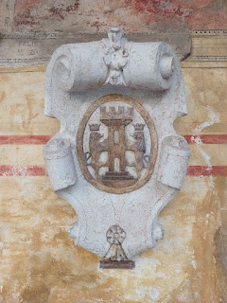

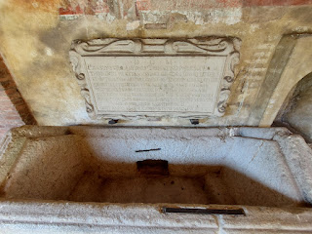

Above and below: what used to be someone's burial tomb . . . now sits empty . . .

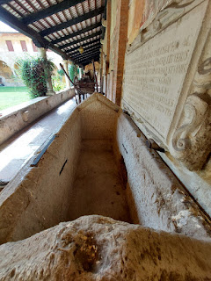

This was the ACTUAL memorial that was placed on top of Jacopo da Ponte's tomb in the church next door, miraculously preserved all these years . . . (click photo to enlarge and see the details)

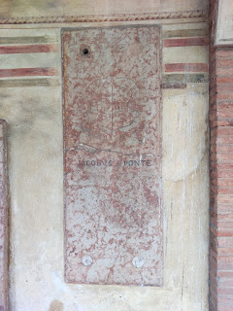

This wooden marker explains that the above memorial was for Jacopo da Ponte, who died in 1592 and was buried in the Chiesa di San Francesco.

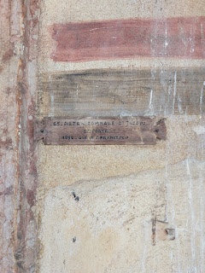

The green space in the center of the cloister . . .

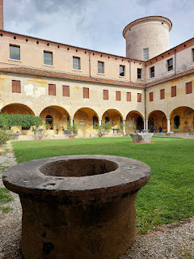

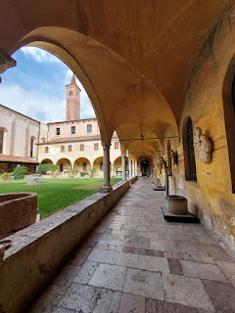

Inside the Civic Museum, there are numerous signs with information about what happened in Bassano del Grappa during WWII, and during other conflicts. The sign below talks about how, after the war was over (WWII), special efforts were made to create a space within the museum to honor Jacopo da Ponte. (click photo to enlarge)

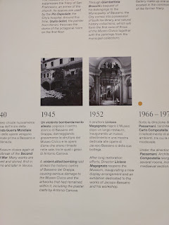

This long hallway with beautiful white marble statues is just inside the entrance to the museum, after you show your ticket . . .

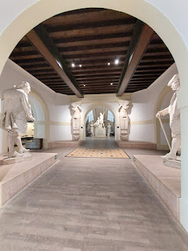

In one exhibit, there are several items that were unearthed from the 11th-9th centuries BC, including men's belt buckles and razors, and some women's hair accessories.

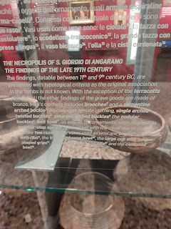

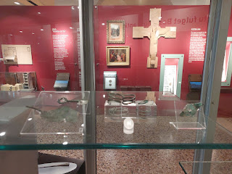

Below is an old sculpted map of the River Brenta, flowing through Bassano in the year 1352. The words are in Latin, but they essentially give tribute to "Patavina Franciscus de Carrara", the "prince and lord patron of the fort and turret of Bassani".

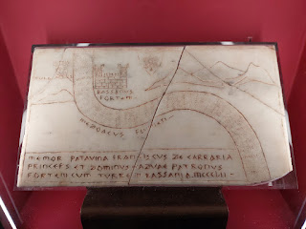

A small-scale model of the Ponte Vecchio Bridge and the town of Bassano on either side of the bank . . .

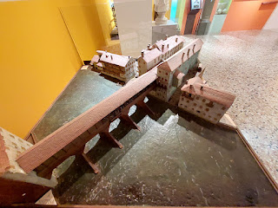

With tiny tales of wars so long ago . . .

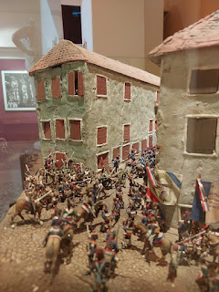

There is a large area completely devoted to Jacopo da Ponte (Bassano) and his talented sons within the Civic Museum.

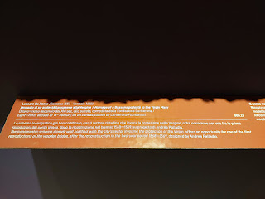

Above and below: A description of a painting made by Leandro da Ponte, son of Jacopo. The painting is entitled, "Homage of a Bassano mayor to the Virgin Mary". Created in 1589.

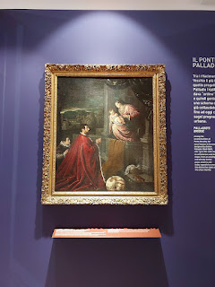

Below: a description of Jacopo da Ponte and how one of his signature moves was to incorporate his beloved city of Bassano, and also his namesake, into the background of his paintings.

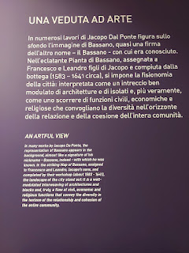

An artistic rendering of Bassano del Grappa by (I believe) Leandro da Ponte (Jacopo's son) . . . I'm sorry I didn't note the description on the plaque next to it . . . I must have been really entranced by the map.

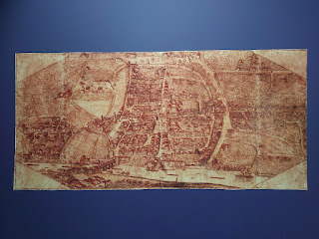

It is very hard to see, but I did take a closeup of what I think was a signature by Leandro at the bottom.

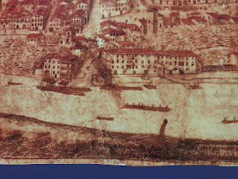

Description is below - but these paintings were made by Jacopo da Ponte. The first one is entitled: "Head of the Virgin", dated 1589, just a few years before his death.

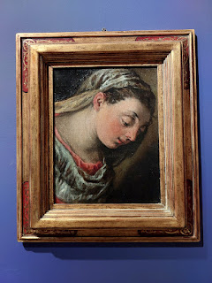

This one is entitled: "Head of a Shepherd", also by Jacopo in 1589.

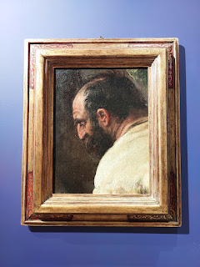

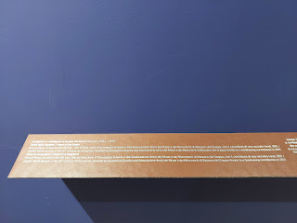

This next painting was a collaboration between Jacopo and his son, Leandro, no date given. It is entitled, "The Conversion of Saint Paul".

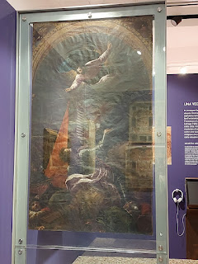

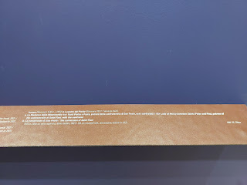

And this one, also a collaboration between Jacopo and Leandro, is entitled, "Our Lady of Mercy between Saints Peter and Paul, patrons of the confraternity of Saint Paul." Dated 1592, shortly before Jacopo's death.

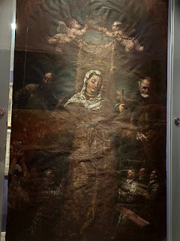

Long ago, to distinguish yourself from another person with the same name, often you would resort to calling yourself something like, "Michele of Idaho Falls", or "Michele by the Hospital" (we live right by a large hospital back in Idaho Falls). In this case, Jacopo's father, Francesco il Vecchio referred to himself as Francesco (or Frank) the Old Man. (il vecchio = the old man)

Frank the Old Man opened a workshop near the Ponte Vecchio Bridge that spanned 3 generations, about 200 years. This is also where his son, Jacopo, emerged as the artist that he became. (click photo below for more info)

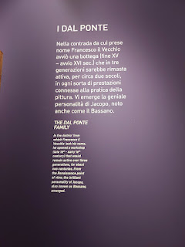

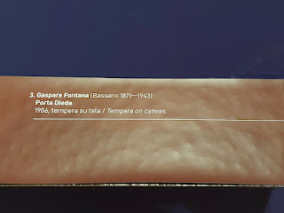

Above and below: An artist named Gaspara Fontana created a couple of paintings of the neighborhood where the Bassano Family lived, including Porta Dieda (more information on this below). 1906.

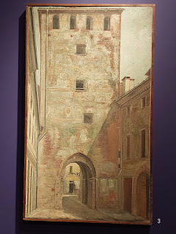

Another set of paintings by the same artist, "Casa Dal Corno" (House with a Horn) and "Casa Michieli" (Michieli House - probably a surname). 1904. I think the Casa Dal Corno is the Bassano House, which has several frescoes on the front facade with references to both music and musical instruments.

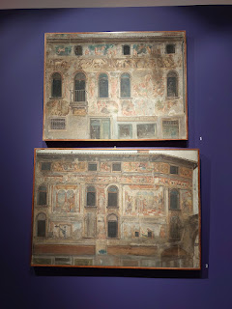

Bassano del Grappa has several buildings to this day with remnants of frescoes that were painted onto exterior walls, including the home of the Bassanos. The da Ponte family weren't the only painters in town, though.

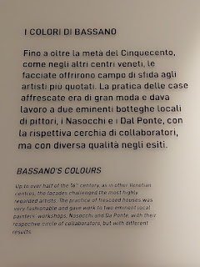

Here is a long video - but fascinating - that shows all of the artwork around Bassano that has survived all these years: (7 minutes, 26 seconds)
*I tried to hold my hands so still for the whole time . . . lol. (It's also a video without sound because the sound would have been through the headphones, but 100% in Italian)
https://photos.app.goo.gl/rAc5ho24H57UzHNh7

At 2:35 into the video, you'll see Porta Dieda, with the huge Venetian Lion. This Porta is next to the old Bassano Home.

At 4:16 into the video, you'll see the actual Bassano Home, with its several musical references on the front. I find it interesting that art and music go hand-in-hand here, with one branch of the family as the artists that
paint
, and the other branch (mine) as
musical
artists.

At 5:16 into the video, you'll see a self-portrait of Jacopo da Ponte (Bassano).

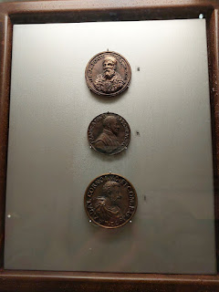

Above and below: Three bronze medals of restitution, made locally. The top one is of Jacopo da Ponte. (click photos to enlarge) The word "restitution" may have been lost in translation, and may have meant "memorialized" instead.

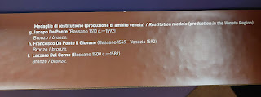

As indicated in the description below, a painting was made in 1879 by the artist Federico Moja, representing what is believed to be the home where Jacopo da Ponte was born in Bassano del Grappa.

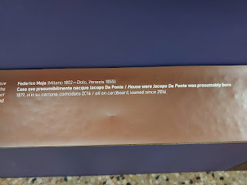

At first, when I studied this painting inside the museum, I was pretty sure that the street scene was the same one that exists today near the memorial statue for Jacopo da Ponte in a nearby shopping area. But on further examination, I am wondering if this street is actually a section where it slopes steeply down and leads toward the east side of the Ponte Vecchio Bridge. This would make a lot more sense, too, since his father (Frank the Old Man) lived by the bridge. I will need to go back and look a little more closely in person . . .

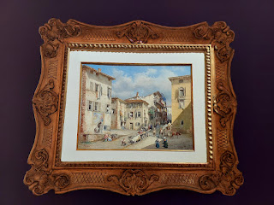

Some of you may recognize this map, because I first visited the Civic Museum back in the fall of 2021 when I was traveling solo for a month. Well, here it is again. :) It is a map of Bassano del Grappa, dated 1392.

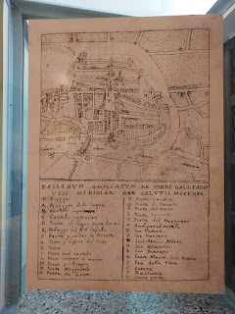

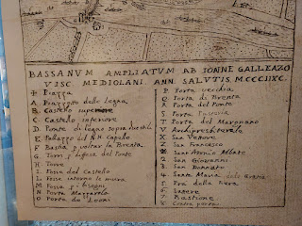

Above and below: closeups of the bottom and top portions of the map. Note the location for "O", listed then as Porta de Leoni. This was later changed to Porta Dieda, and where the old Bassano Family Home (that we recently discovered) is right next to the arch of the Porta today. "Porta" means gate or door in Italian, and was usually an arched brick entrance that allowed citizens to come and go through the city walls that surrounded the medieval towns.

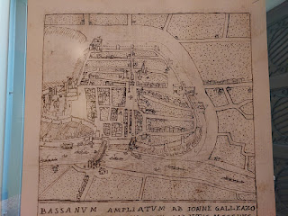

In a different room of the museum, I watched a video that showed some scenes of Bassano del Grappa during the occupation of WWII. One of those scenes was a map showing the military fronts - (click photo to enlarge) - if you look closely, you'll see several places that I've mentioned in my blog posts over the past few years. These include: Bassano of course, Vicenza, Cittadella, Marostica, Asiago, Verona, Soave, Lake Garda, Riva del Garda, Trento, Bolzano, Brixen, Aviano, Pordenone, Trieste, and Venezia (Venice).

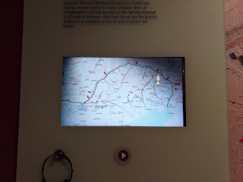

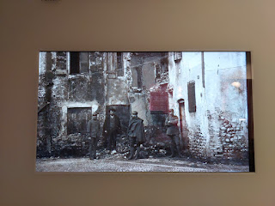

Above and below: Poignant scenes that are both somber and dramatic, showing the wearied faces of the soldiers, and huge tanks that filled one of the piazzas that I've walked through a number of times in recent months. I can't even imagine what it would have been like for the townspeople during war time.

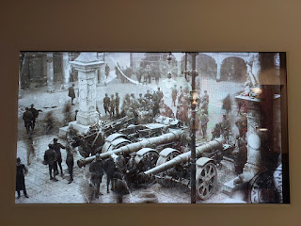

I don't believe this next photo was of the old Ponte Vecchio Bridge, but I think it's actually another bridge called Ponte Nuovo. (The arches don't match on the Ponte Vecchio) They both sustained major damage during WWII and had to have some extensive work done to repair them.

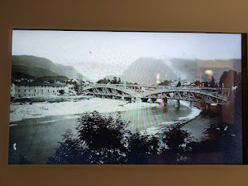

I had to stand there and watch the whole video again so that I could grab this next photo - it shows the plaza next to the old Bassano House. The memorial statue was the identifier for me . . . as soon as I saw it, with the Porta on the left, I knew this was the plaza in front of the Bassano Home. In the photo below, while you won't see an artillery unit, you will see a moment frozen in time with locals both walking by and standing still. You'll see cows gathered at the far end - for what reason, I dunno. This was a snapshot of a moment in wartime, in a community that tried to have some semblance of "normal" even though it was anything but.

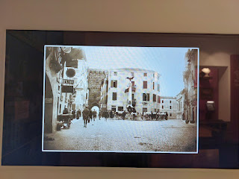

Here is a comparison photo of the same plaza - although the angle of the photo is a bit wonky. You can see the bronze circular plaque of Vittorio Emanuele II on the slender marble "steeple" in both photos. In both photos, you can just make out the church steeple, as well. The church is right next door to the Bassano House.

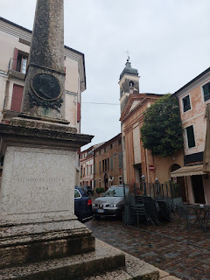

After packing our brains full inside the museum, Charmaine wanted to wander the streets a little bit before we left Bassano to head home. There is a street near the museum that is named after Jacopo da Ponte, so we made our way over there first.

Charmaine and I laughed as we simultaneously took pictures of each other standing in the street . . .

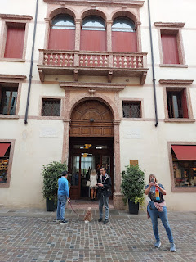

On Via Jacopo da Ponte is a current-day library, although in centuries past it used to be a palace. Built in the 17th century, it is known today as: Libreria Palazzo Roberti. There is a plaque on the front of the building that (when translated) says: In this house lodged Napoleon Bonaparte, from 8 September 1796 - 10 March 1797. It is a beautiful 3-story bookstore with gorgeous restored frescoes all throughout. There are a lot of booklovers out there that have pinned this bookstore/library as a favorite of theirs.

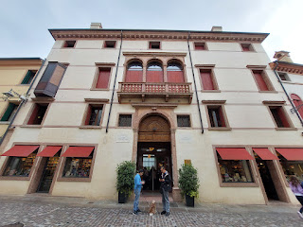

Next door to the old palace sits the memorial statue of Jacopo da Ponte . . .

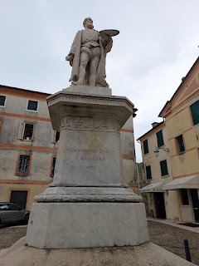

Here is that painting again, of the house/neighborhood where Jacopo was allegedly born . . .

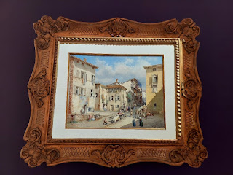

My initial thoughts were that he was born in the neighborhood where his statue proudly stands, because why else did they put his statue THERE of all places? Even the colors of the buildings seemed to match the colors in the painting . . .

Across the street from the statue of Jacopo is an arched entrance that leads into a courtyard. An interesting note about this particular photo: I used the photo editor on my phone for the first time to essentially erase a blue garbage dumpster next to the arch, and I also erased a street sign that blocked the view of the statue from where I stood. SO COOL!!

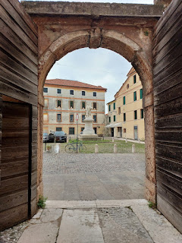

Looking around, left to right, up and down the street, I felt confident that this was the neighborhood depicted in the painting.

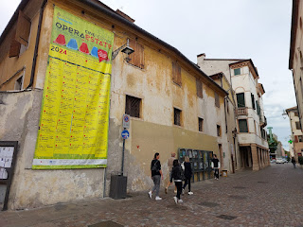

But as I've been typing this post, my confidence has been shaken as I noticed the marked slope of the street (on the painting) that looks exactly like the same steep slope that leads down to the Ponte Vecchio Bridge. Either way, whether I solve the mystery or not, we know Jacopo came from Bassano del Grappa.

The arched entryway across from the statue of Jacopo da Ponte leads into a courtyard with a cafe, as well as several business that are associated with local military units. It reminded me of a recruiting office, where you could sign up for the Coast Guard, the Army, the Navy, the Air Force, or the Marines. Each door had a different insignia on it.

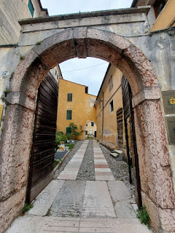

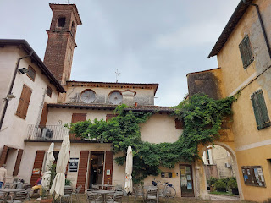

This was a powerful sculpture on a wall within that same courtyard. It was especially powerful if this was, indeed, a recruiting location. The words underneath the distraught faces say: "The pain of mothers, wives, and children of the fallen in war." The artist was Fabbian Michelino (2015).

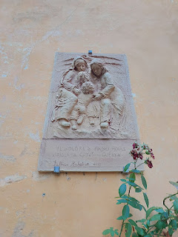

Charmaine and I spent some time trying to figure out what the nature of these offices were, and eventually we resorted to Google Translate to help us read what some of the signs said. This is the building that felt like a recruiter's office.

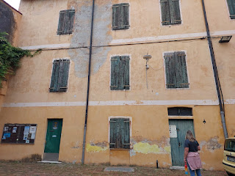

Bright and early the next morning, Scott and I drove Charmaine and (her) Scott to the Venice Airport. They flew home with nary a hitch and settled back into their life in San Diego. It was sure fun to have them come for a visit, though! I'm glad we were able to spend that time together and that they could come experience a bit of Northern Italy with us. :)

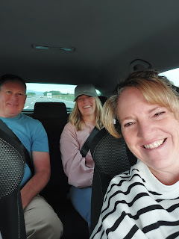

Arreviderci! Buon viaggio! Ciao! XOXO

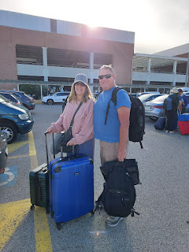

Charmaine took a bunch of photos with me in them, which she then shared with me later. This one shows that very special and bright blue dumpster that I was able to erase out of my own photo, ha ha.

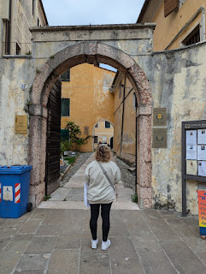

This one was pretty funny, lol. Scott and I were on our phones for quite a while at one point, trying to identify a tower that was across the River Brenta from where we stood. Charmaine couldn't resist capturing that moment, ha ha.

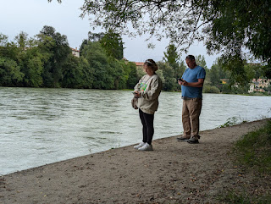

I hung out here for a while as Charmaine and Scott toured the Grappa factory next door to where we ate in Bassano del Grappa. It was very comfy and quiet. The thing I liked the most was that the bench was low enough to the ground to where I could place my feet FLAT for once. Usually, because of my very short stature, I struggle to reach the ground wherever I sit, and it can make my lower back a little grumpy. But not in this comfy little spot! It was perfect!

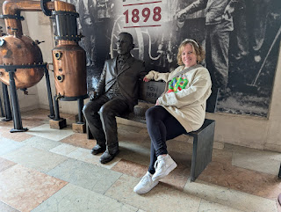

In this photo, I was pointing to the little ceramic shop where I bought my mother a Christmas gift last November. (in Bassano del Grappa)

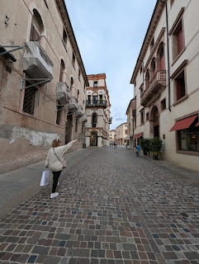

Our feet on a street in Bassano (mine are white, Scott's are tan, and Charmaine's are the blue) . . .

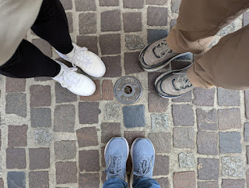

Charmaine took this photo of me when we got our appetizer tray in Umag, Croatia . . .

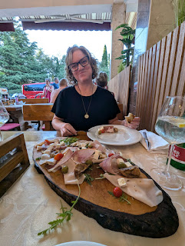

This was taken in Piran, Slovenia as we walked up a steep alley to visit St. George's Church . . .

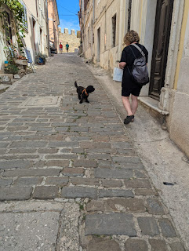

Our cute little summery feet in Groznjan, Croatia . . .

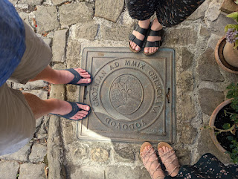

And Charmaine and me on the beach at Sottomarina, with the Adriatic Sea behind us . . .

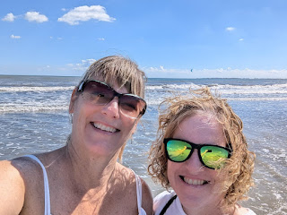

A few more random photos and then I'll share some pictures of our grandchildren . . .

This is a photo of my dear friend, Lauren Parker, who is now serving a mission in Bristol, England. She is currently assigned in Poole, which is a cute town on the southern coast near Bournemouth (in the province of Dorset).

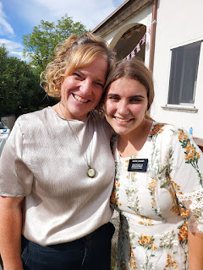

She sends out a regular email with stories from the past week and I devour everything with excitement. Last week's email had a jaw-dropping story that I would like to share with you.

"This week was full of joyful, spritual experiences, but we also had quite a scary one! Poole is a very safe area, but parts of it are quite wealthy making it more susceptible to crime. One evening, Sister Frenckel and I were walking along the High Street (main street). It was dark and no one else was out. It was the end to a long day and we were excited to get home. We did start to notice, however a man. He had a hoodie on and his hands in his pockets, and he was following us. Everytime we turned around, he was closer and closer to us. Suddenly, I heard Sister Frenckel say, "Run." Never have I run so fast in my entire life. It felt as if someone was pulling me forward. We ran for about five minutes, until we were brave enough to turn around again. He was gone. Spooked, but thinking running away was a bit dramatic, I asked Sister Frenckel why she thought we needed to run away. She looked at me puzzled and said, "No, you were the one who told ME to run." Neither one of us told the other to run, but we both loudly and clearly heard a voice say, "Run." Angels were with us that night. I do not know what would have happened without them or without that direction from the spirit, but I am eternally grateful that we were kept safe. Later that night, once we had made it home safe, we did a final sweep of the flat, before going to bed. There he was, the man who had chased us just thirty minutes earlier, standing outside of our gate. Sister Frenckel and I were hysterical. Our flatmates (slightly less spooked because they were not the ones who had been chased) comforted us and took action. We called our leaders and neighbor and eventually the man left. Our sweet neighbor came down, made sure we were alright and even sent us a comforting scripture from the bible. I did not share this to scare anyone. We are safe! No incident happened previosuly and nothing has happened since. The Lord protects his missionaries! Instead, it was such a strong reminder of the importance of being aware of our surroundings and in tune with the spirit."

Oh my goodness!
I am so grateful that she was okay and that they were protected from harm. She mentioned in last night's weekly email that ward members are now driving them home every evening, just as an added precaution.

A few days ago, the Chocolate Festival returned to downtown Vicenza. Last year, I visited the Festival with Amber and Weston and my two little granddaughters, Abby and Gwen. We had a lot of fun looking at everything together and buying way too much chocolate, ha ha. This year, I stumbled upon it by accident as I was already downtown on a different errand. I only bought a few items, but everything sure looked pretty!

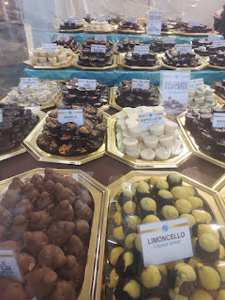

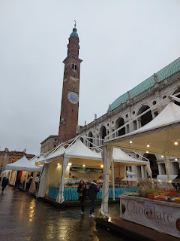

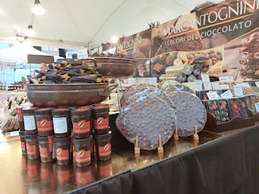

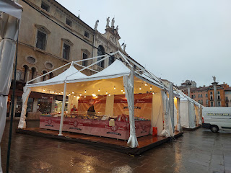

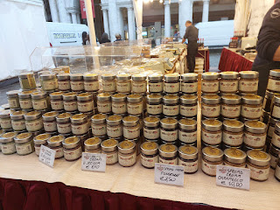

This fall it has rained over here SO MUCH!! I think that in the past 2 months, it has rained more days than it has NOT rained. It's either been overcast and thinking about raining, overcast and preparing to rain, actually raining, or overcast as it recovers from another round of rain.

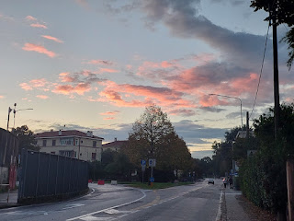

Scott and I took a walk one evening after he got home from work, so we could check out the water levels in the river and nearby canals. They were VERY FULL . . .

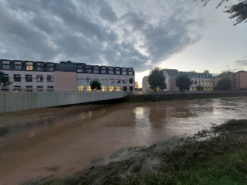

This week is possibly the first full week where there is NO RAIN. Hallelujah! I've been out on some walks and I'm enjoying the sunshine today.

We recently joined our friends, the Parkers, for a delicious dinner at their beautiful home south of Vicenza. (Their daughter, Lauren, is the missionary serving in Poole, England) Marnie and I coordinated the menu, splitting the food assignments to make Poke Bowls for all of us, including the missionaries currently serving in Vicenza. It was all so yummy!!

Below, Scott was telling Marnie a funny story right before we were about to bless the food. Marnie's daughter, Olivia, was not grumpy at all - she was just folding her arms to get ready for the prayer, lol.

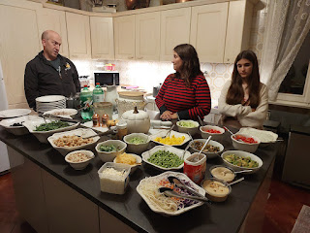

Marnie's homemade tzatziki sauce was SO GOOD!! I need to get the recipe from her . . .

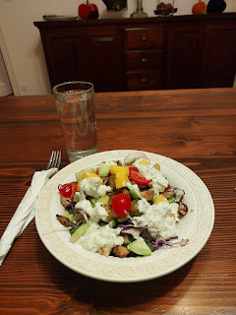

OKAY - finally, here are the grandchildren . . .

Avery:
We drove up to Aviano on Saturday morning to spend the morning with her and Kylie. We brought some squishy building blocks from our personal stash in Vicenza to share with her. We built lots of things together and Avery loved every minute!

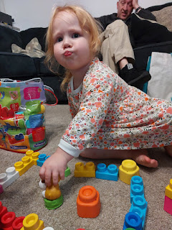

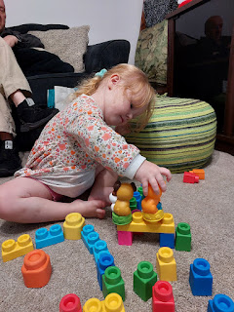

She sure is growing up! She's not quite 3 years old and is remarkably adept on her scooter . . .

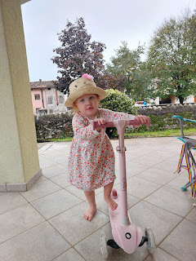

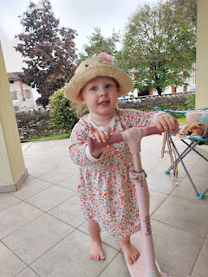

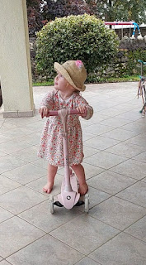

Video #1 of Avery riding her scooter: (36 seconds)
https://photos.app.goo.gl/M6965Hc2MvtCrNo86

She has the eyes of a HAWK when it comes to bugs and tiny things that she spots on the ground.

Video #2 of Avery on her scooter: (26 seconds)
https://photos.app.goo.gl/TKbzpN2sGCNWjiPp7

Video of Avery almost having a Sandra Bullock "Miss Congeniality" moment while walking in her high heels: (22 seconds)
https://photos.app.goo.gl/rEgkRWKgoStGebFk7

Video of Avery showing me all of her accessories: (21 seconds)
https://photos.app.goo.gl/fcb4dQ4Q4Q1cmp6u9

We had a wonderful morning hanging out with her and Kylie, and we are looking forward to seeing them again in a few weeks when it's closer to Avery's birthday. XOXO

Jack and Maisie:
While Maisie is busy growing super fast and starting to show a little personality, Jack is busy going to preschool and riding his bike and doing all the little boy stuff.

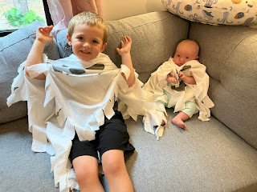

Video of Jack racing around their apartment complex on his bike w/ training wheels: (24 seconds)
https://photos.app.goo.gl/sxPDKjpY1uZjCViL8

Video that Jake shared with us, with the caption, "Jack, can you watch Maisie for 2 seconds while I unlock the door?" (8 seconds) *Jack is either talking to his little sister, or singing to her . . .
https://photos.app.goo.gl/mKMBeutPT1r9CR1D6

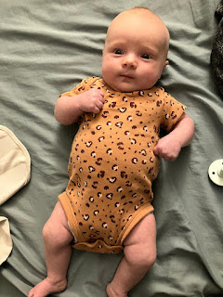

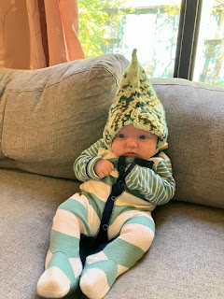

"Folding her arms" for a blessing on the dinner . . . XOXO

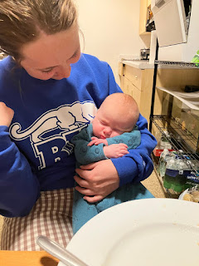

Recently, I sent a news article to Jacob because I saw that there was a protest that led to some arrests on the University of Minnesota campus. I asked him if it had affected him in any way . . . and this was his response. (a picture of a barricaded door from INSIDE . . .) Yikes. I'm glad everything is okay and that he wasn't injured or directly in any harm's way.

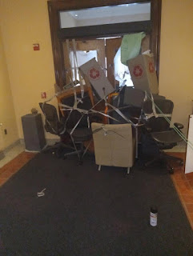

Abby and Gwen:
They are doing great up in the Pacific Northwest. Abby let me know that she hauled in a record 4.5 lbs of candy at their recent Trunk or Treat . . . holy cannoli.

Abby as Little Red . . .

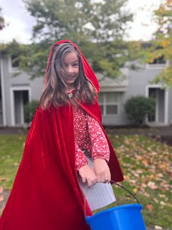

Gwen as a magical witch (with only one leg . . .)

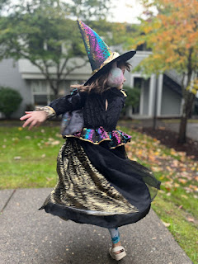

They recently drove over to Tillamook and Oceanside Beach together as a family and had a wonderful afternoon exploring the shoreline, caves, and rocky paths . . .

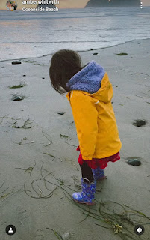

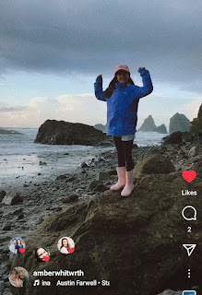

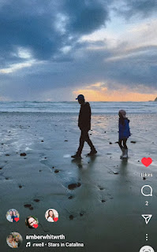

SPECIAL VIDEO: Recently we participated in our church's semi-annual General Conference as best as we could with the time difference of 8 hours. For example, the last session of the conference was aired from 2-4 p.m. MST in Utah, but that was simultaneously 12-2 a.m. here in Italy. Scott and I were fast asleep, but we've been catching up in the days ever since, listening to the online talks that are available on the wonderful internet.

HOWEVER, the missionaries in Northern Italy had been praying and even held a 40-day fast (where different individuals would rotate who was fasting on what day) in the hopes that a temple would soon be announced for Milan, Italy. They have been having a lot of success in their missionary efforts as a whole, and the Mission President told all the missionaries that they could stay up late to watch the final session of conference, because he just "had a feeling" that a temple would BE ANNOUNCED . . .

The sister missionaries currently serving in our ward, Sister Gunther and Sister Hart, shared this video with me. They said they were having trouble staying awake after midnight, and had even dozed off for a bit. During our Prophet President Russell M. Nelson's talk, and JUST BEFORE he began announcing 17 new temples that will be built, the Holy Ghost did a subtle "pssssst" to wake them both up. They started recording a video as they watched . . . JUST IN CASE . . . and here you can watch their reaction as YES, INDEED, A TEMPLE WAS ANNOUNCED FOR MILAN, ITALY!!!

Video of the announcement: (1 minute, 28 seconds) Bless their hearts, they were so sleepy and yet - they truly felt the JOY of this momentous occasion. (I get chills every time I watch this . . .)
https://photos.app.goo.gl/84TWsmhMJcXo1bJy5

What this will mean is that members of the church won't have to drive as many hours to get to the nearest temple in the near future!! Take Vicenza, for example. The closest temple is in Rome, about 5 hours south. The next closest temple is in Bern, Switzerland, roughly 6 hours to our northwest. What a monumental blessing this will be for church members in Northern Italy and the surrounding areas, probably including parts of Switzerland and Austria, as well. I am so happy and giddy and grateful!!

Typically, before a Temple is dedicated and open for ordinance work to be performed by members of The Church of Jesus Christ of Latter-day Saints, there is an Open House for several weeks where the general public can come and quietly walk through the rooms of the Temple and feel the beautiful spirit that exists in the House of the Lord. I hope to be able to come back for the Open House when that day comes. It will probably be a couple of years from now . . .

And lastly, in case you love doggies, you'll also love this video. We always look out the kitchen window multiple times a day to see if our neighbor's dog is outside and waiting for a playmate. Usually she'll sit for long periods of time next to the gate on the opposite side of the yard (where we cannot access). She always has her tennis ball handy for anyone that is walking by. All of the tenants that live in the building next to us, whether old, middle-aged, or just a few years old, will stop to play catch with her every day. If someone is doing chores, such as mowing their grass or sweeping the sidewalk, she will bark to remind them that she is waiting for them to chuck the ball. She always brings it back and drops it where they can reach through the gate to grab it. What a thoughtful doggie.

Video of Scott playing fetch with her: (1 minute, 12 seconds)
https://photos.app.goo.gl/nkE3Nbq3TwKXYhEw5

For some weird reason, whenever he goes down to play fetch, the mosquitoes have a heyday trying to bite Scott's exposed head . . . but he doesn't let that stop him.

