Hiking in the Italian Alps
I made it to Italy this week! And what a joyous reunion it was with my sweetheart, Scott.
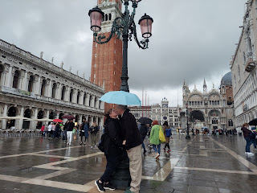
Our friends, Rich and Andrea Garner, are here visiting us right now, so this blog post will probably be less detailed than usual . . . but it has been a whirlwind of fun so far.
Monday:
I did a self-guided tour around the National Mall in Washington DC. Hannah dropped me off and I walked for hours and had a lot of fun. I saw the Martin Luther King Jr. Memorial, the Lincoln Memorial, the FDR Memorial, the Jefferson Memorial, and a portion of the Holocaust Museum.

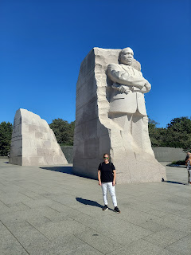

Abraham Lincoln

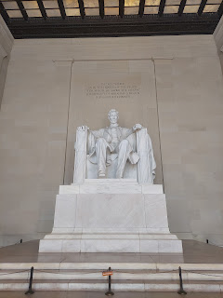

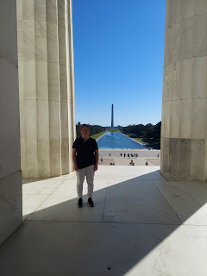

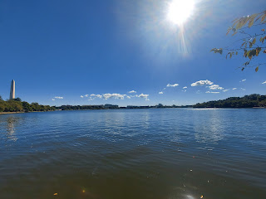

Franklin D. Roosevelt was such a good and wise man, at least according to the quotes that were engraved into numerous exhibits in his large memorial.

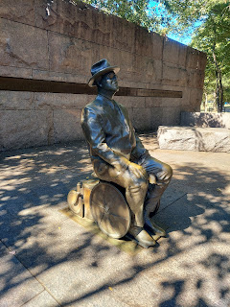

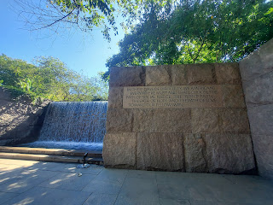

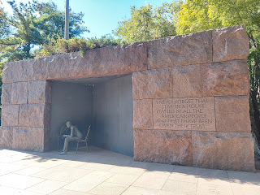

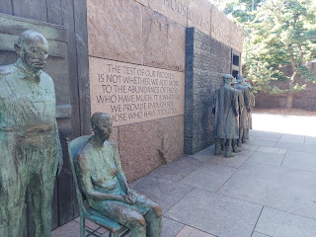

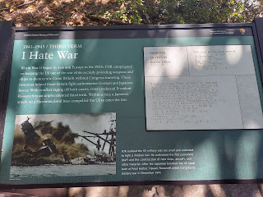

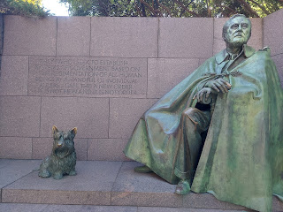

There is a trail around the lake, which I enjoyed very much, that goes from monument to monument.

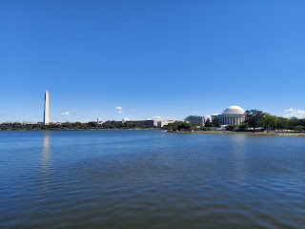

Thomas Jefferson

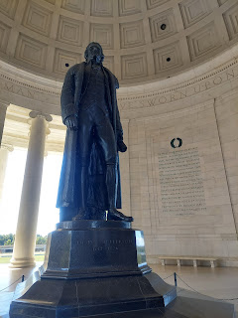

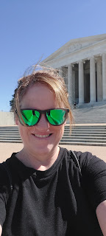

The Holocaust Museum

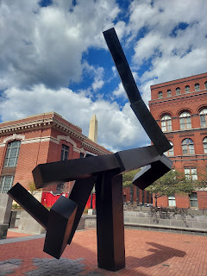

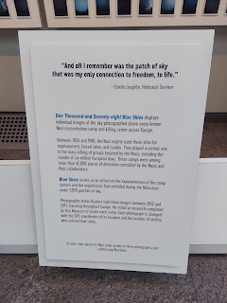

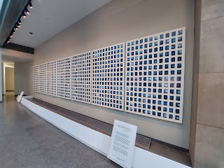

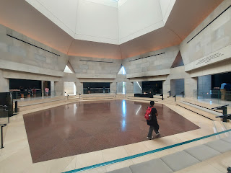

I lit a couple of candles for those individuals who lost their lives at Auschwitz . . .

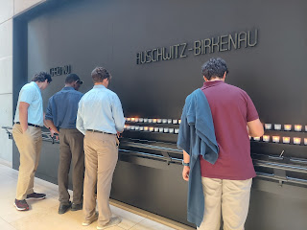

In one area, you can choose to take an ID card before you enter. There are female ID cards on the left, and male ID cards on the right. It has a detailed photo and description of a real person that ended up in a concentration camp, detailing what happened to them in the end. Very powerful.

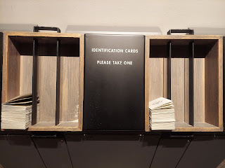

Some interesting things that I found in this area of the museum. (you can click on the photo to enlarge)

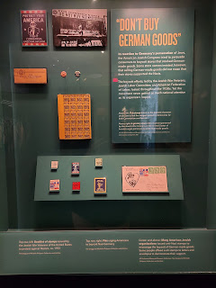

So many people applied to be able to immigrate to the United States. Not nearly enough people were granted an entry.

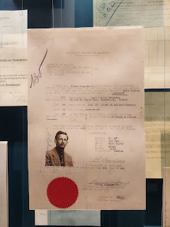

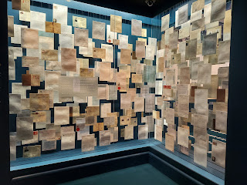

This was an amazing story of one couple from the U.S. who helped to rescue 50 children.

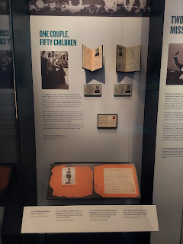

A close-up of the postcard from the photo above.

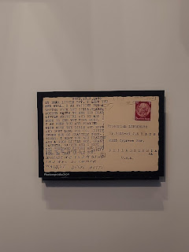

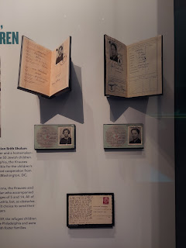

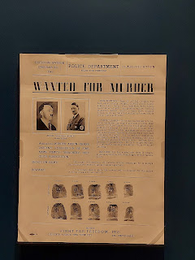

There was another huge section of the museum that I didn't have time to see. I will have to come back another time and learn even more. We need to spend time learning about the mistakes in our past so that we don't make those same mistakes again.

We took Jack to the park every single day. Sometimes twice a day. He loves any and all offerings at the parks. Especially some dirt.

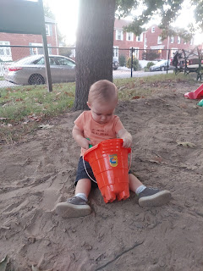

Tuesday:
I went into Washington DC one final time because I wanted to walk around the block surrounding the White House.

View of the White House from the South Lawn

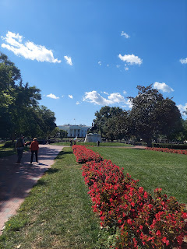

The White House Visitor Center is really informative. I really enjoyed the things they had on display there. It's across the street from the west side of the White House.

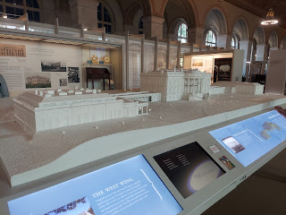

These letters that some kids wrote YEARS ago are so cute!

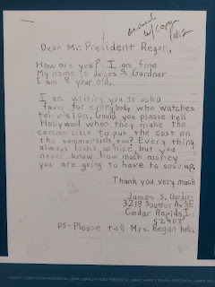

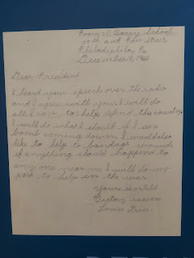

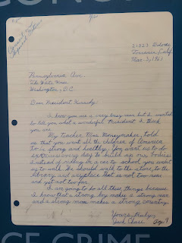

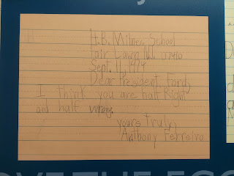

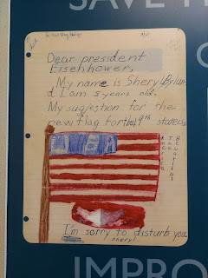

They used to have some cards on hand that you could fill out and answer the question, "What would you do?" (...if you could be President and make important decisions for our country) Now there are no more cards available, but these previous ones were on display.

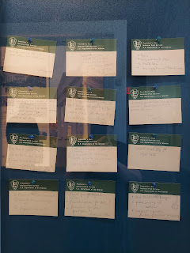

A sewing machine that was used during WWII to make blackout curtains for the White House.

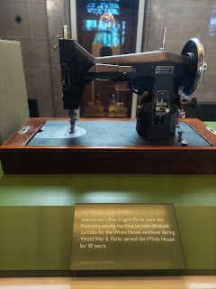

A cute area for kids (and grownups) to see some of the fun/interesting things that previous presidents have eaten during their presidency.

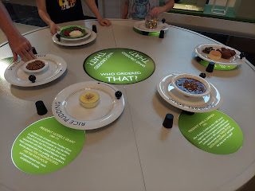

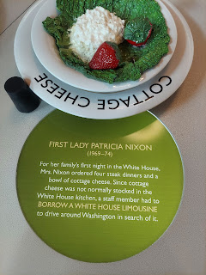

This is the area where the annual Christmas Tree will be displayed outside the White House on the lawn.

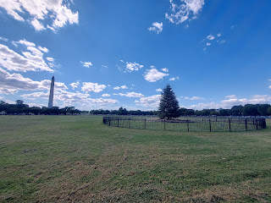

The White House from the north side.

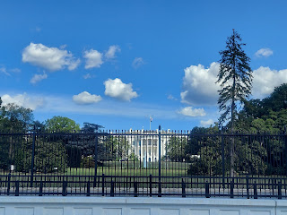

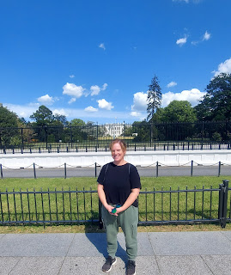

I didn't have any views of the White House from the east side, because it was all enshrouded by trees. But here is a nice view of the Washington Monument from the south lawn of the White House.

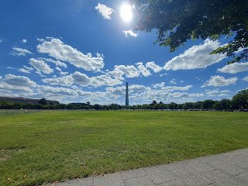

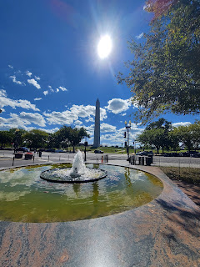

Hannah picked me up when I was done gallavanting around. I ate a quick lunch and said goodbye to Jack. He was getting ready for his afternoon nap. He wears what is called a "sleep sack", which acts as a blanket that zips up. It is super convenient and much safer than an actual blanket.

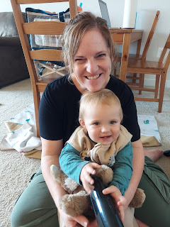

Jacob drove me out to Dulles Airport and a short time later I was on my flight to Dublin and then on to Venice.

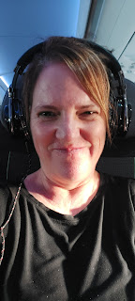

The in-flight dinner meal consisted of beef chunks with mashed potatoes and gravy, a tiny little roll, a greek salad, water, and a chocolate mousse. It was all very tasty!

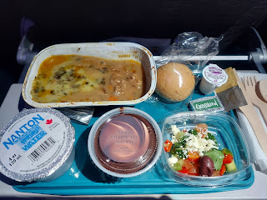

I watched Top Gun (for the 2nd time) and then closed my eyes for the rest of the flight. I was surprised at how well I was able to get some rest this time. I usually have zero capability to sleep when I'm vertical! Maybe I'm getting used to these overseas flights now . . .

After going through customs in Dublin and then waiting for almost 2 hours, I was finally boarding my last flight.

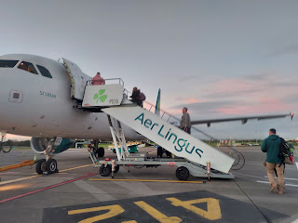

The sun was just coming up as we took off.

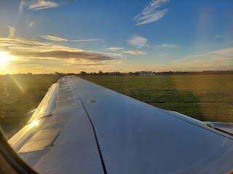

I think I slept for the entire 3 hours. Again, I'm super impressed at myself, ha ha. Here is the view as we flew into Venice, with the water off in the distance.

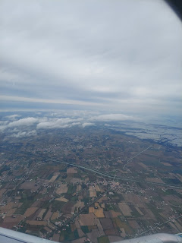

I got some lunch in the Venice Airport and then caught the military shuttle bus to Vicenza, another hour of travel. The reason Scott didn't come to pick me up is because he needed to save his days of leave for when our friends would be coming in to visit us for a week, and also for when we travel back to the U.S. after Christmas. The shuttle bus takes me directly from the airport to the Ederle Base in Vicenza, and that is where Scott picked me up. He was able to work for 2/3 of the day and then just sneak out a little early . . .

It was so nice to be back together once again.

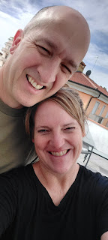

Thursday:
I launched into an all day cleaning frenzy to get the house ready for company. I swept the floors, mopped, did laundry, cleaned the kitchen, dusted, and made a menu plan. I got all unpacked and settled in, and later Scott and I got some groceries and made dinner together.

The house was looking good, everything was sparkly clean and ready for company. We even cleaned two out of the 3 bathrooms together that night before watching a show and going to bed.

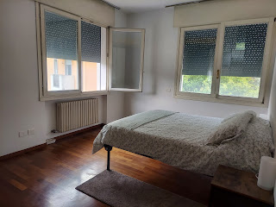

Friday:
I finished cleaning the upstairs bathroom and shower and got a few more groceries before Scott came home and we headed off to Venice. Rich and Andrea were landing at 2:00 p.m. so we needed to leave by 1:00.

And happy day when they arrived!!!

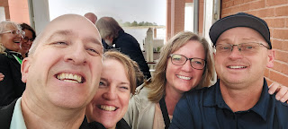

They really wanted to see Venice and this was the best day to do it, so we hopped on a waterbus and went out to the lagoon right away.

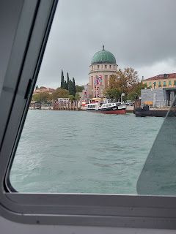

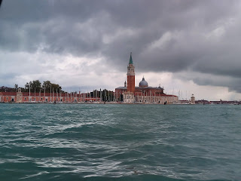

We only had about 2 hours to spend out there, because it was already getting late in the day. From the airport it takes about 70-80 minutes by waterbus to get to San Marcos (St. Mark's Square) out on the island of Venice. Add in 2 hours of wandering and enjoying, then we'd have to hop on the waterbus for another 75 minutes back to the airport, plus another 45 minutes to drive back to our house in Vicenza. (We ended up getting home around 9:30 p.m.)

You obviously can't see everything you want to see in Venice in just 2 hours, but you can still take some cute pictures and try to absorb one or two things.

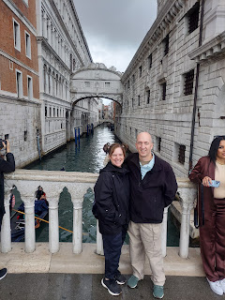

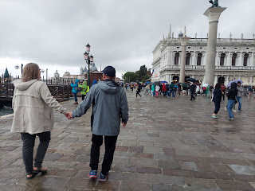

Rich and Andrea Garner

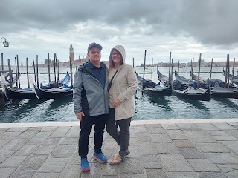

Video of a mini-orchestra in St. Mark's Piazza: (39 seconds)
https://photos.app.goo.gl/qPJ6DBtjp5REhYEs9

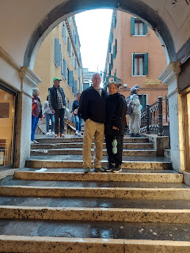

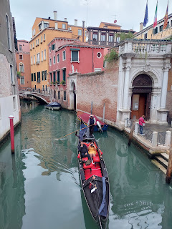

We grabbed some pizza for dinner and were lucky to find a spot to sit down under an umbrella and out of the rain . . .

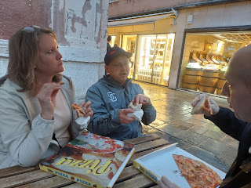

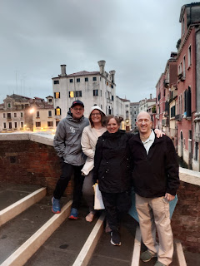

On the waterbus back to the airport, Rich couldn't keep his eyes open . . . bless his heart . . .

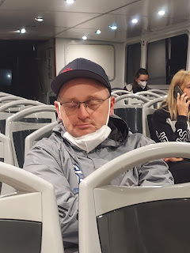

Saturday:
We got out the door by 9:30 a.m. and drove up into the mountains near Vicenza. In just about one hour, you will be in the Dolomites (Italian Alps). We chose two locations to spend the bulk of our day: Ponte Avis and the Road of the 52 Tunnels (that Scott has already been on twice now).

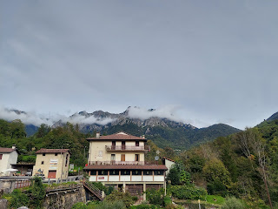

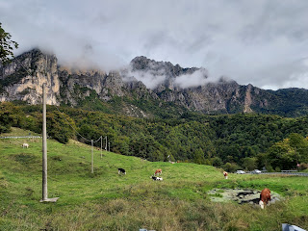

Next to the trail of Ponte Avis, we accidentally found this monument to WWI at the end of the road.

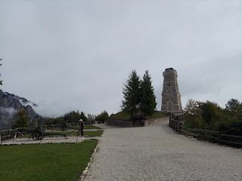

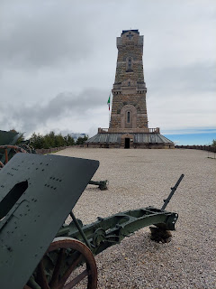

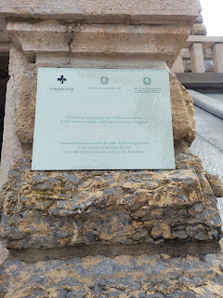

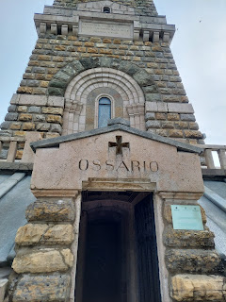

Inside the tower is a mausoleum of sorts, a crypt bearing several tombs of skeletons of those who lost their lives during WWI up in these mountains. It was definitely a little unnerving seeing all those skulls just piled in and sitting there . . .

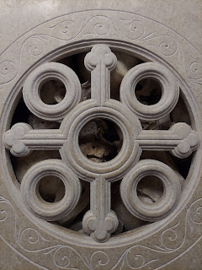

In beauty, in peace, in glory.

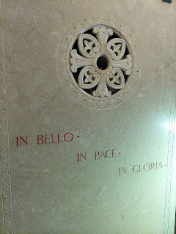

Views from the backside of the tower . . .

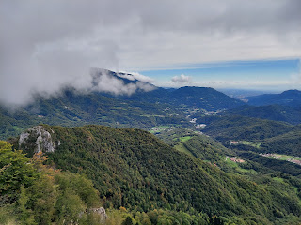

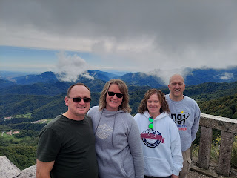

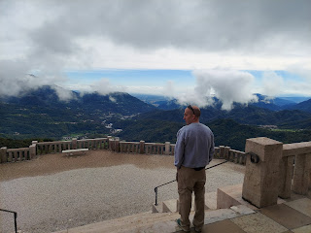

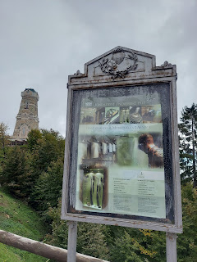

Then is was on to Ponte Avis . . .

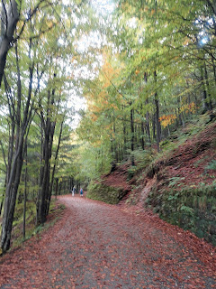

Lots of fog covered our trail, even though it was mid-day by this time.

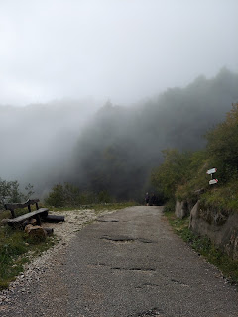

The main attraction of Avis Point is this suspension bridge. The trail is a loop that is approximately 3 hours total, but we chose to just walk across the bridge this time. It was a 20 minute walk uphill from where we parked the car to get to the bridge, and then 20 minutes back.

When we got to the bridge, it was enshrouded in fog which made it even more mysterious and beautiful. For Andrea it was a bit more difficult, as she has a fear of falling. As long as we kept moving, she did okay.

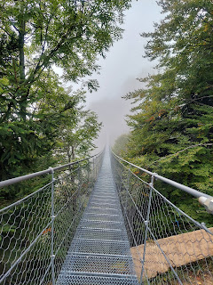

This picture was proof for her kids that she conquered a fear . . .

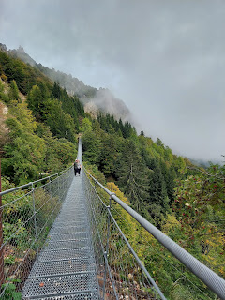

Avis Point is named for the volunteers that helped with a catastrophe that happened in 1956.

Brief History of the AVIS Bridge
^
The AVIS Tibetan Bridge bears this name in homage to the association of Italian blood volunteers, in memory of a tragic event that occurred on this road on September 1, 1956.
It was mid-afternoon when severe weather, combined with a risky maneuver of the driver, made
a bus coming from Recoaro Terme fall into the ravine.
There were 27 people on board and 15 people died in the accident due to the innumerable capsizing of the bus during the descent into the escarpment.
Another 11 suffered serious injuries
and were promptly transported to the hospital in Schio.
Fortunately, in fact, work was being carried out on the road surface and the workers who witnessed the scene promptly gave the alarm, mobilizing the help that arrived quickly: firefighters, Alpine troops, carabinieri, but also simple private individuals.
The people who arrived at the hospital were in serious condition and a lot of blood was needed to be able to intervene.
There was not enough available on site and so
the doctors appealed to the citizens to urgently collect it.
In a few hours the local AVIS donors were mobilized and many others became so on the same day, thus saving the lives of the unfortunate.
It was on that occasion that the donors united and gave life on May 26, 1957 to the AVIS municipal section of Schio.
For this reason, in memory of the tragic event but above all of the great generosity of the locals, the bridge was entitled to the AVIS.

Very cool!!

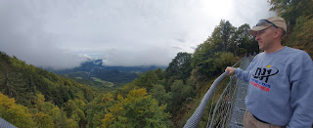

Video of me walking out on the suspension bridge: (16 seconds)
https://photos.app.goo.gl/NGCBbt7XSC5tLsgt7

Video of a two minute clearing of the fog so we could see the views of the valley below: (20 seconds)
https://photos.app.goo.gl/AnKRpp6CuFa38WGH9

Then it was on to the Road of the 52 Tunnels.

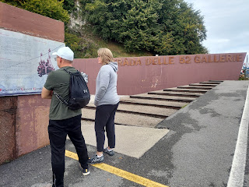

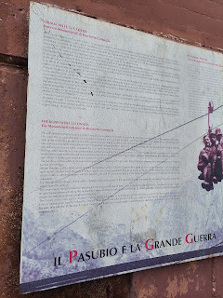

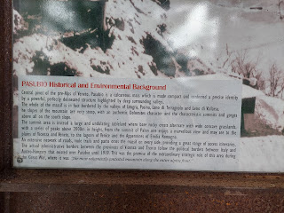

The trail was a steady uphill incline, steep in places, but doable. Our goal was 16 tunnels out of the total 52, but we ended up just doing 15. The trail from tunnel 15 to tunnel 16 was forever long and involved some seriously steep switchbacks so we decided that 15 was enough. ha ha

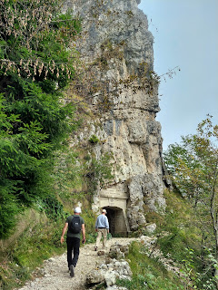

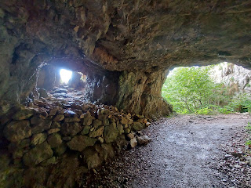

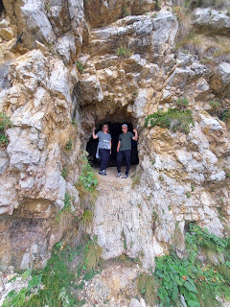

This road of tunnels was created during WWI. Pack mules hauled gear and ammunition up these steep mountains all those years ago . . . I find all of that pretty amazing.

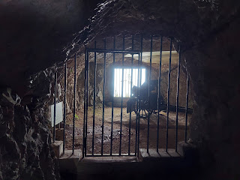

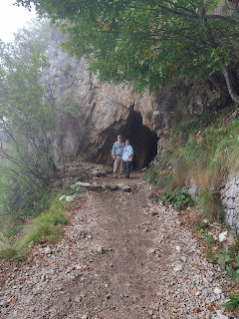

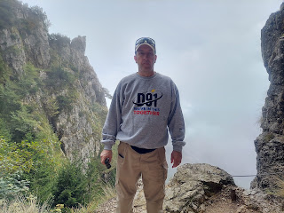

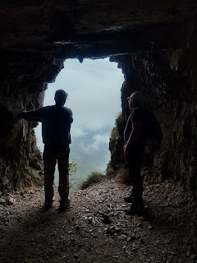

Those views . . .

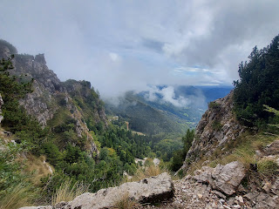

Video as we walked through Tunnel #8: (37 seconds)
https://photos.app.goo.gl/yKPkZUZMHBL6FfQR8

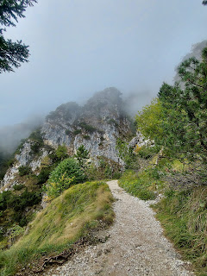

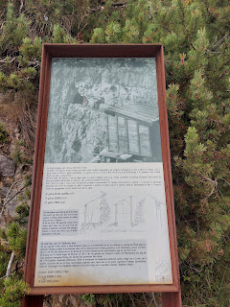

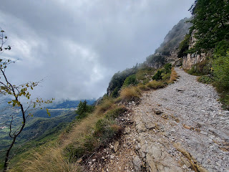

After Tunnel #15, we paused to make some hoodoos before heading back down the mountain . . .

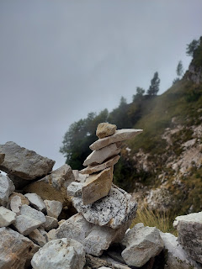

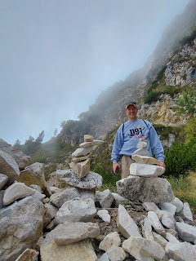

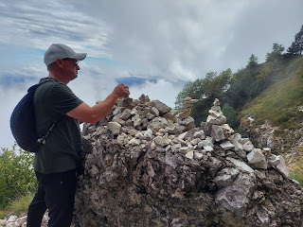

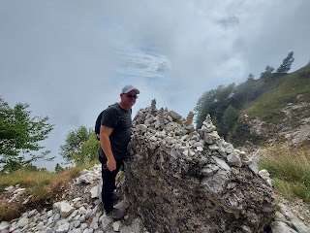

What a SUPER great day in the Italian Alps!!!

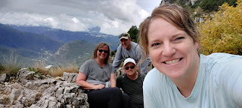

Much more to come next week! Our plans over the next few days include: Cinque Terre and the Leaning Tower of Pisa, Sienna, Rome (including the Colosseum, Pantheon, and Roman Forum), and Vatican City.

Have a wonderful week everyone! :)

