Is One Hour Enough at the Beach??
Cities listed in this post:
Molina, Italy
Chioggia, Italy
This week started out nice and slow and then gradually picked up some speed in the middle, before a final crescendo at the end. As always, birthdays are pretty constant in our family during the month of April. This past week, we celebrated Jasmine's birthday on April 7th and Weston's birthday on April 10th. Jasmine and her family enjoyed a relaxing day together down in NE Arizona, where they currently live. Weston and his family enjoyed some good food at home in Louisiana, in spite of the power being out for a day or so and then the lovely "boil order" for their water supply that followed. They've had some doozy storms down in the South this spring, and it ain't over yet, y'all. We are so grateful that they are all safe and doing well.
Spring comes in many forms throughout the world. While it is often hot, stormy and volatile in the Southern U.S., the weather is unpredictable and bipolar up in Eastern Idaho, with a mixture of very convincing sunshine and then a surprise snowstorm and freezing temperatures to keep everyone in "check". Over here in Italy, it's been a slow start to a typical spring, with lots and lots of rain and cooler than usual temperatures.

My "Wednesdays in Italy" group had to postpone our most recent outing TWICE because of the weather. I was in charge of this adventure because I was the only one who had been there before out of our group. As I kept an eye on the weather, both of the past two Wednesdays were predicted to be "garbage" and were not conducive to this hike. I was worried that the Molina Waterfall Park might even close down on those days due to the weather: very cold (upper 40s) with substantial rain.

But none of that was the case when we finally went on FRIDAY, instead of our usual Wednesday. It was the beginning of another 4-day weekend for some portions of the military in Vicenza, which happened to include Scott. Yay! Three couples went on this adventure, plus one extra lady (without her husband). The weather was perfect!! It was warm and sunny, but not too hot, and we headed out first thing in the morning.

It's roughly a one hour drive WNW of Vicenza to get to Molina. It is a very tiny town up in the mountains and canyons north of Verona. The Parco delle Cascate di Molina costs 8 euros to get into the park and then you can spend all day there if you want. There are many places with picnic tables and there are restrooms strategically located around the park, as well, which is so handy.
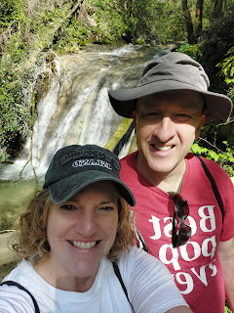

Scott and I visited the Molina Waterfalls last April with his brother, Gordon and his wife, Pam. While it was definitely beautiful a year ago, the waterfalls were visibly more full and robust this year because of all the recent rains.
Also, last year the tiny village of Molina was pretty much deserted as we walked through to get to the park entrance. But this time, we saw a few people out sweeping, using a leaf blower, trimming olive trees, etc. It was reassuring to see that people actually do exist here, ha ha.

Chiesa di Sant´Urbano in Molina di Fumane (The St Urban Church in Molina, built in the early 1900's)

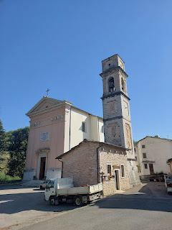

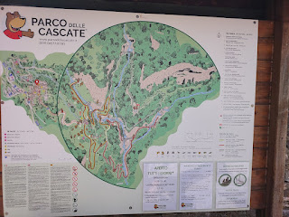

Andrea Miguel led the way as we started down the path down to the ticket office, after passing through town.

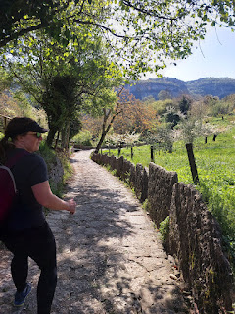

The wildflowers were everywhere and just so darn cute . . .

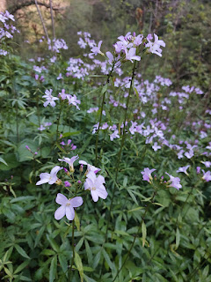

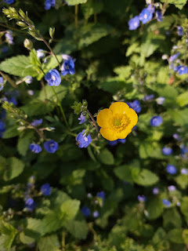

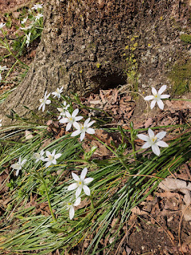

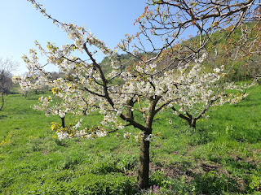

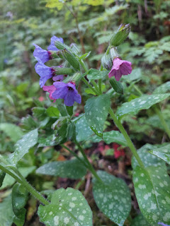

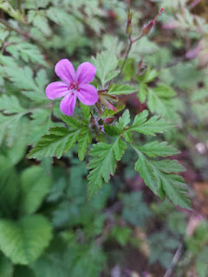

Video of the water rushing by and downstream to Scott: (7 seconds)
https://photos.app.goo.gl/15yuDXDkejNjqgj16

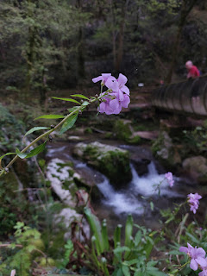

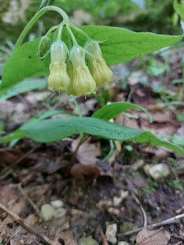

Short video of Scott waiting for me to catch up on the trail: (4 seconds) *You can hear Josh Lloyd behind me talking about a book that he loves, ha ha.
https://photos.app.goo.gl/xQvZ4gcmoPshrSZu9

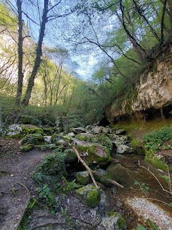

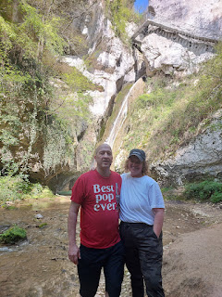

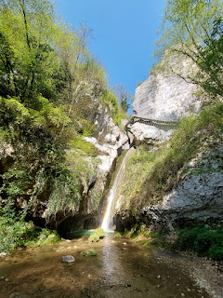

While we were at this "watering hole", Scott launched his drone to get a bird's eye view of the waterfall and the world above us. It is such a cool video to watch!! He even added some music this time.

Drone footage: (3 min, 49 seconds)
https://photos.app.goo.gl/7fn5eMkoWRnDU43Y7

In the photo below, see if you can find the drone . . . (click the photo to zoom in)

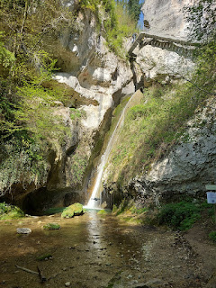

A lovely speckled flowering plant that I wish I knew the name of . . .

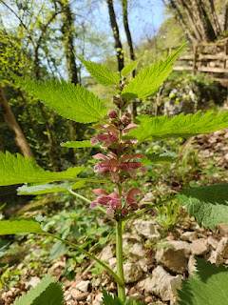

Above the previous waterfall was a pretty little pool that forms at the top and then spills over the edge.

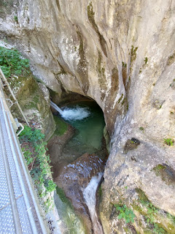

Video of the pool flowing into the waterfall: (9 seconds)
https://photos.app.goo.gl/TN27JR3Ai4Th46R36

There were several happy little cascades throughout the forest.

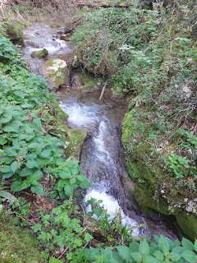

Scott is across from me below . . . you can barely see his red t-shirt.

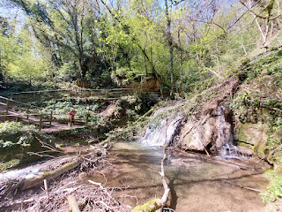

Video of Scott, enjoying a quiet moment next to the waterfall above: (5 seconds)
https://photos.app.goo.gl/gPqcSHDSGiMWjGTw8

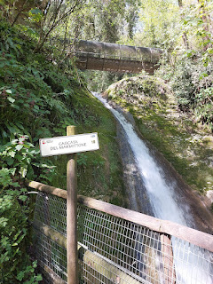

Video of one of the most impressive waterfalls along the trail: (11 seconds)
https://photos.app.goo.gl/EvopTw9dCngmxkAJ6

Video of that same waterfall, but from the bridge above it: (15 seconds)
https://photos.app.goo.gl/B8rAMutf3FSK5ZVZ8

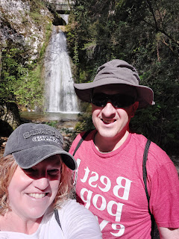

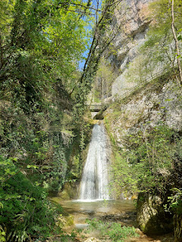

Video of the waterfall above: (5 seconds)
https://photos.app.goo.gl/bruCQY3nKr1vXzti6

*I tried to get videos of all the waterfalls (especially for my mom, who LOVES waterfalls), but I had to also keep them short so I could make a video montage on Instagram.

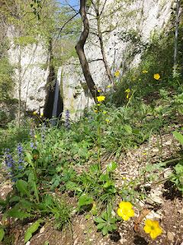

Video of one of the last waterfalls we saw: (6 seconds)
https://photos.app.goo.gl/Fw2By6DdAWqZbS5KA

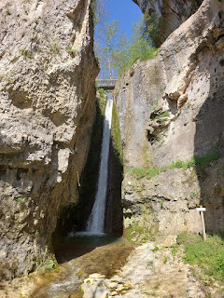

There were a couple of large groups of high school students on a field trip that same day. They had a guide, or perhaps a science teacher, explaining several geological features and flora and fauna to them at various points along the trail. We tried to stay out in front of them so we didn't get too crowded at the prettiest observation points.

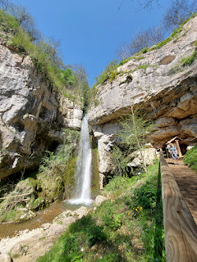

In the middle of the red loop trail, there is a zipline if you're feeling adventurous. Most of us were, ha ha. Scott is averse to heights, so he opted out, but the rest of us had a great time! There is no additional cost for the zipline, which makes sense because YOU end up being the slave labor in exchange for a few moments of fun.

First, you have to hike up a small hill to get to the beginning of the line. There, the attendant hands you a "leash" that is attached to the swing and instructs you to walk over to the opposite end of the zipline, up the stairs and to the starting point. The tether is much like a retractable leash for your dog. It extends as you walk down the first hill and retracts as you walk up the other hill. Because I'm very short, I needed the entire length of the leash in the middle section of the path, ha ha.

Video of Andrea pulling the swing up the stairs: (5 seconds) She went first.
https://photos.app.goo.gl/n6Lp6i715Xz1Gg6m8

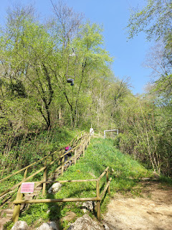

Once you're at the top of the starting hill, you just lift up the front bar on the swing, climb in, clip the safety chain in place, and when you're ready, then off you go!

Video of me flying above Scott on the zipline: (13 seconds)
https://photos.app.goo.gl/Yh5UEz8b8gPZ5fsD8

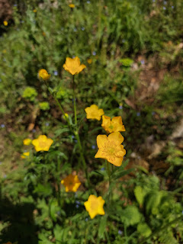

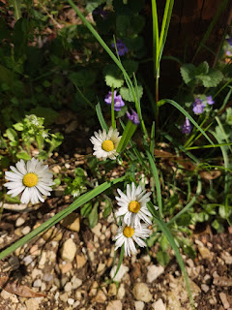

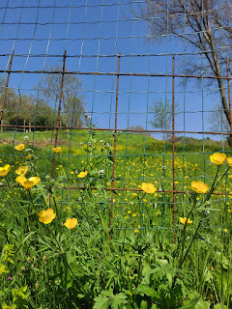

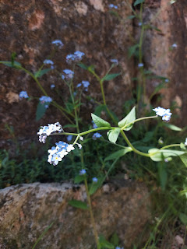

After a couple hours of walking up and down steep inclines and marveling at all the beautiful waterfalls, we trudged back up the super steep pathway to Molina once again. It levels out once you get into the little town, and then there are a few more steep sections and stairs to get back up to the parking lot.

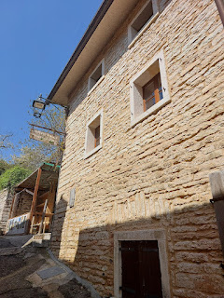

Whenever I needed some oxygen, I'd pause to rest and take a photo or two from wherever I was standing.

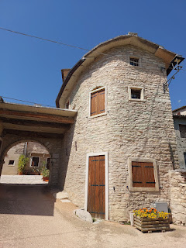

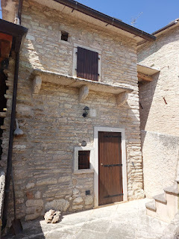

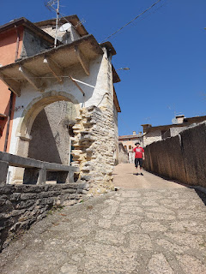

My calves were burning near the end, so it helped to turn around and face down the path to give them a much needed rest. It's always satisfying to see how far you've come . . .

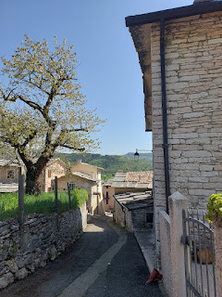

Video of a charming courtyard of homes as we walked back through town at the end: (9 seconds)
https://photos.app.goo.gl/vnkp73pLmUDUvbLU6

L to R: Lauren & Josh Lloyd, Andrea Miguel (behind us), Me & Scott, Rick Brown & Mary Carraway

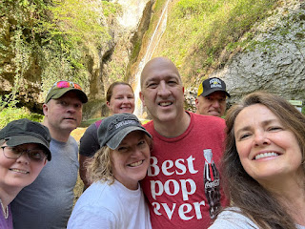

L to R: Mary in the front, Lauren & Josh, Andrea, Me & Scott, Rick

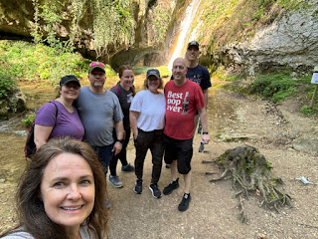

We all thoroughly enjoyed being in nature and smelling the clean forest air, feeling the mist from some of the waterfalls on our faces, and getting a satisfying workout in.

In the middle of the week, I got a surprise video call from Abdo, down in Morocco. I had just finished exercising and I looked terrible, but I answered the phone anyway. He and his family had been to the mosque for morning prayers and were about to eat breakfast. He introduced me to his mom and day, his uncle, and his twin sister and younger brother. I was embarrassed at how I looked, but nobody seemed to mind. Then, Abdo stepped outside to chat with me some more, and I got to see several of his friends and neighbors walking by as they returned home from the mosque, too.



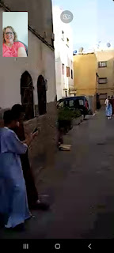

At one point, Abdo had two young twin boys come over to say hello to me. He wanted me to see their traditional Moroccan dress for the mosque, but they were a little shy, ha ha.



We made some plans for when I come down to Agadir next month, and I am really excited! I still have yet to ride a camel in Morocco, so Abdo and I will do this together while Scott is at work. I also asked if Abdo could accompany me to the Souk Market, since I've never been to one before and I would prefer to have a friend with me, especially someone who knows the culture and the language. He wants me to meet his family in person, too, so I am especially looking forward to that.

Here is a YouTube video of the Souk Market in Agadir:
https://youtu.be/mCvWA94orRM?si=RJEdmhk2nEqVVfXS

On Wednesday evening, after I taught another family history class on the base, I drove south to Marnie Parker's house just as the sun was setting.

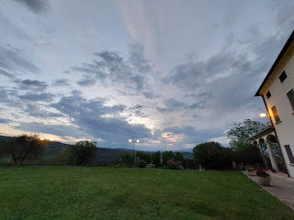

I am heading down south of Florence on Sunday to help out at a friend's "retreat". She is an interior design major (with a minor in Italian) and owns her own company. This retreat is called "Beauty & Connections". She will be teaching classes each morning to help everyone connect to how we design our personal spaces. She will incorporate the Italian culture into these classes, too, especially on how the Italians generally live in the present and they strive to make those moments count.

On one of the evenings, everyone has been asked to dress up "fancy", whatever that is for each person. I don't have anything fancy here in Italy, but I knew that Marnie does!! She's been to many Military Balls over the years . . .

Marnie had several dresses for me to choose from, but many of them were too small (they were her daughter Lauren's from several Proms), so I really only had a handful to choose from. Thank goodness I found one that made me feel like a million bucks!

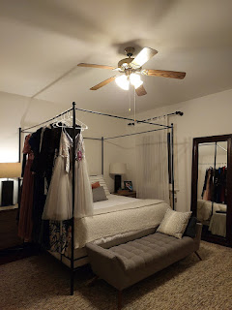

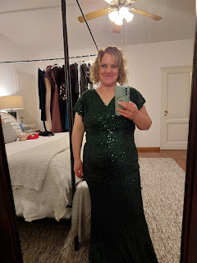

In packing for this retreat, I did a Google search to learn how to pack a sequined gown for travel so that the sequins don't catch on each other. You carefully fold the dress in between layers of tissue paper! How perfectly genius. And I even had some on hand already from all the packages I've sent to people from Italy.

Because we are friends from my neighborhood back in Idaho Falls and because I have a grasp on what it takes to live in Italy, Aubrey has asked me to be her "personal assistant" during the retreat. If someone needs something from the Farmacia (pharmacy), or has a question, etc. then I will be the one handling those tasks. I won't be working "hard" because after all, it is a retreat. We will be staying at an old Italian villa south of Florence in a tiny town called Greve in Chianti. I will be driving down after church today (Sunday). It takes just over 3 hours to get there by car. But I won't be traveling alone. A lady is coming down from Austria and meeting me at the train station here in Vicenza this afternoon, and then we will be picking up one more passenger from the Florence Airport on our way down. I hope it will be a fun week and that I will learn some interesting things!

Scott and I walked down the street to get some black thread for a sewing project on Thursday. The trees are starting to bloom outside the walls of Caserma Ederle (the Army base) and they are so pretty!

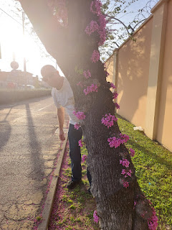

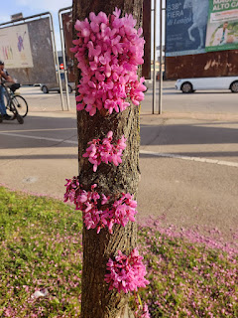

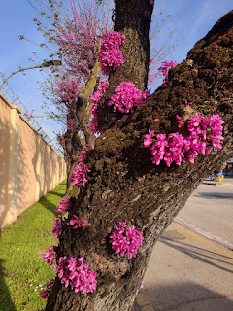

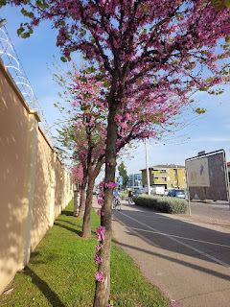

After we found the thread that we needed, we stopped in at the Vaniglia Gelateria next door. I've been whining that I've been here for almost a month and haven't had any gelato . . . Life is good, so we must eat some gelato whenever possible.

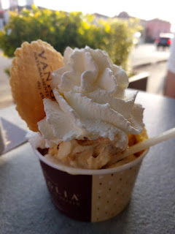

Now it is time to answer the question that is the title of this blog post: "Is one hour enough at the beach??"

Scott and I had planned to spend a portion of Saturday at the beach near Chioggia, but things were piling up as the weekend drew closer. We had to slim down our expectations and leave earlier than I wanted to, so that we could get back in time for my 4:00 haircut.

It is usually one hour to get to Chioggia and the beaches at Sottomarina, but this time it took us 1.5 hours instead. We think it was because not only was it a SATURDAY, but it was the first WARM Saturday so far this spring. That meant that a LOT of people were thinking the same as us - what a fine day to be at the beach! Traffic was slow and congested, which was tiring at times. But we made it.

As we walked from the car to the water, we discussed how much time we would actually have there, and it would only be ONE HOUR. We had time for one hour at the beach and then one hour for lunch back in Chioggia (the islands have a long connecting bridge), before we had to drive back to Vicenza. Well, this was one of those times when you get what you get and you don't throw a fit . . .

Scott, sitting down to remove his shoes before we hit the sand . . .

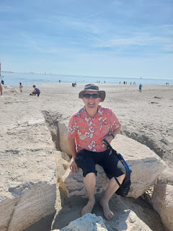

The Adriatic Sea at Sottomarina . . .

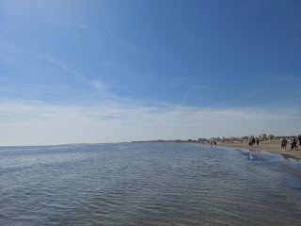

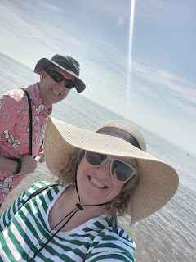

The water felt amazing. We slowly walked along the shallows for quite a ways, holding hands and just taking our time. When we needed to head back, we just slowly wandered back the same way, as we sloshed through the lukewarm water and waves. It was really nice, even though we didn't have much time.

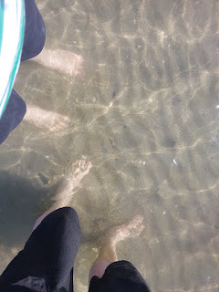

I made a couple of videos specifically for my sister, Melanie, and my mom. They both love the sound of the water, as I do, and I thought they would especially enjoy hearing it from the other side of the world.

Video #1 of the waves at my feet: (32 seconds)
https://photos.app.goo.gl/1cKzR7e3nqrcLGqDA

Video #2 of the waves at my feet: (33 seconds)
https://photos.app.goo.gl/TxSfAqaRUx2J8w8X9

As we drove to our usual parking garage in Chioggia, we navigated through some GNARLY traffic on the way there. We just crawled along, trying not to run over all the bicyclists and pedestrians that were everywhere. As we arrived at the garage, we learned that it was completely full. That was a surprise, and disappointing. We had passed another parking garage on the way to this one, so we turned around and went back through the gnarly traffic to get to the second one. But it, too, was now full. That's when we decided to just go home . . .

A little over 3 hours of driving to spend one hour at the beach. Was it enough? Not really. But was it still satisfying and meaningful? You bet.

I am always leery as I go to get my hair cut here in Italy, because of the language barrier. I have had an A-line cut for the past several months and I have loved it. But I also really miss being able to pull my hair UP when it gets hot, and it's been too short in the back to pull it up lately. I typed up what I needed in Google Translate before I went to the salon . . .



The lady cutting my hair conferred wtih another hairstylist that knows some English, to make sure she understood and that we were all on the same page, and then she proceeded to chop my hair super short . . .

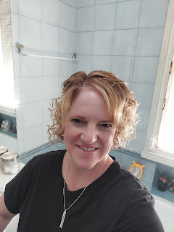

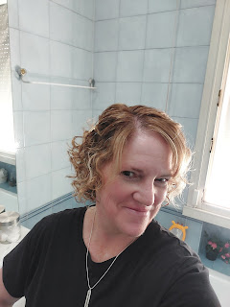

Okay, it's kinda cute. But my goodness, it is SO SHORT now. Apparently, to get rid of the A-line where it's shorter in the back and longer in the front, they had to cut everything to be equal with the shortest hair in the back. If Tessa were cutting my hair, she would not have done it in such an extreme way, but I do understand why they did what they did. It will take some getting used to, that's for sure. On the bright side, I won't need a haircut for a while . . . And I know how to trim my bangs and blend them in, so I'll just do that until I can get back to Tessa in the U.S.

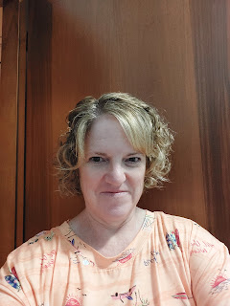

Scott took me out to dinner Saturday night since we didn't get to have that special lunch in Chioggia. I always love to eat a giant bowl of mussels so we found a local restaurant where my dreams could all come true. The restaurant is called Regina and it's close to the base in Vicenza.

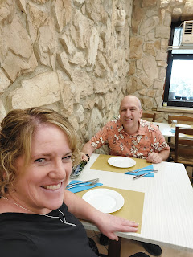

Mussels in a tomato-garlic broth, with crusty bread on top for dipping . . . SO GOOD!!

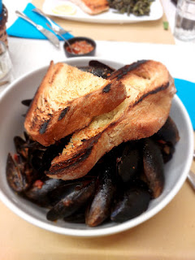

This time, I scooped out all the meat in the shells first, and then I could eat them with the broth down below. I like to use one of the shell halves for a spoon. A restaurant owner down in Rome taught us that technique and it works really well!

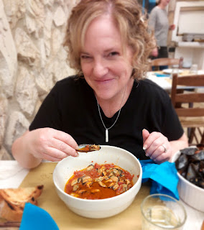

Scott ordered a beautifully crusted salmon fillet with his favorite vegetable on the side: green beans.

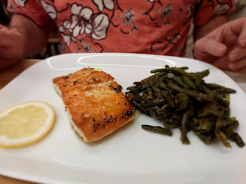

As for the rest of our family . . .

Amber and Weston drove an hour or so from Stonewall to Texarkana to watch the eclipse. While they watched it "live", Scott and I watched it online. We messaged back and forth with Amber throughout the experience.

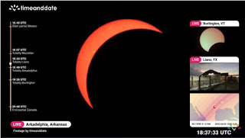

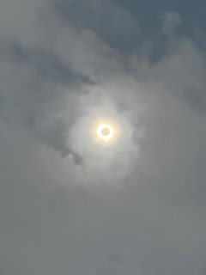

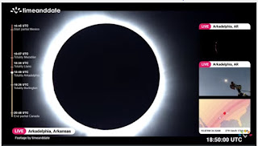

Gwen and Abby . . .

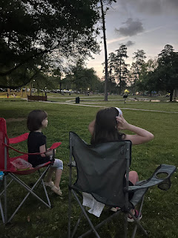

What a cool picture of the tiny crescent moons on their arms during the eclipse . . .

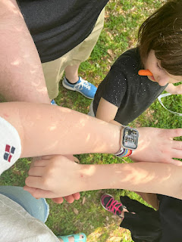

Scott and I noticed what appeared to be solar flares near the bottom edge of the sun, and Amber had noticed the same thing while seeing it "live". We have some amazing technology to be able to see something like this online and in person!

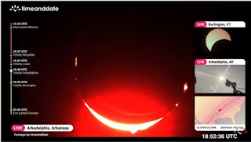

Abby had a birthday party this weekend, even though her birthday was on April 1st. She had a wonderful time with her friends, and instead of buying new gifts, Abby asked them to bring something secondhand. Amber said this is their new favorite birthday tradition and that it was so fun to see what each girl brought. There were 5 or 6 friends that came to the party, I believe.

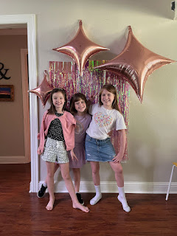

Meanwhile, Jack has been having lots of fun, as usual, up in Minneappolis.

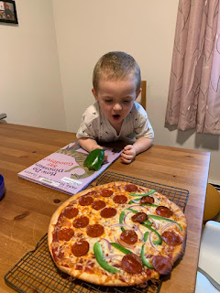

We got this video of him trying to blow out a trick candle for his birthday on April 6th. What a cute laugh he has!!

Video of Jack: (41 seconds)
https://photos.app.goo.gl/rkyEj4BzQZdTYp3v8

He also got to go bowling this weekend with his parents! Watch his talented his efforts as he sends the ball down the "helper": (16 seconds)
https://photos.app.goo.gl/pzYjQh4io7wuaTCT8

Look at those darling bowling shoes . . .

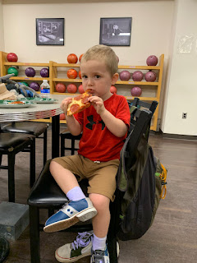

Jack and Jake . . .

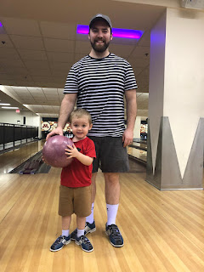

Jack and Hannah at the University of Minnesota, where she's about to graduate from . . .

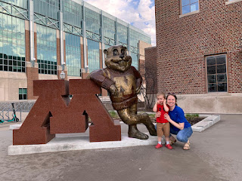

Everyone is doing fine. I still haven't heard from Benson and we still haven't seen Avery. Hopefully that will change very soon.

And lastly: I love this photo of my two sisters, Melanie (left) and Charmaine (right). Melanie and her family recently spent a few days in the San Diego area, which is where Charmaine also lives. They look a lot alike, even with different hair colors!

