Kate - Loving Mother of Seven
The spirit of Elijah has been so strong this week . . . every little thing I do that connects me to my ancestors has been so profound and almost tangible. I've cried more this week than I have in a long, long time.

Monday and Tuesday I was able to spend time with my cousin, Loreena Hester, who lives in Petaluma, CA. She is the daughter of Eugene Carlton Rawles, Jr., also known as "Gene". He was my Grandma Zoe's younger brother. That makes Loreena my 1st cousin, once removed, since she is my Dad's first cousin.

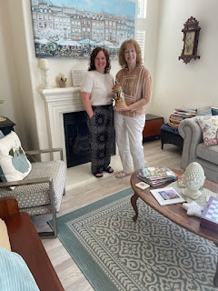

Here she is, holding a treasured tribute she helped to make in honor of her grandfather, Ernest Eichin, a German immigrant. The Eichin family lived in Schopfheim, Germany, close to Basel, Switzerland, and wow, Loreena knows ALL the family stories! She is definitely my counterpart and I learned a lot from her, including a few ideas I would like to pursue with my own family history.

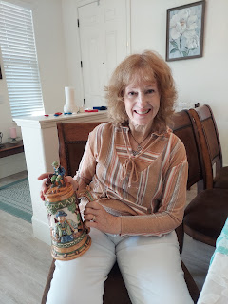

She had a friend create this beer stein for her, and then Loreena hand painted every single detail herself!

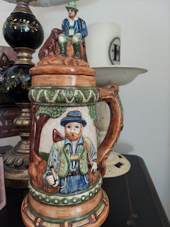

On the bottom of the beer stein it says:
To Mom & Dad
In memory of Grandpa Eichin
October '78
Loreena Hester

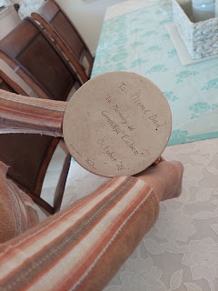

When I arrived around 5:00 p.m. on Monday, Loreena was working on a beautiful meal for us. She showed me how she makes "Cheesy Bread".

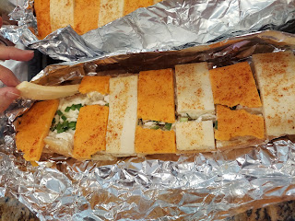

First, you slather an entire cube of butter onto two french bread halves, half of the butter on each one. Then you take an 8 oz. package of cream cheese and slather a layer over the top of the butter, half on each one. Sprinkle on some Lawry's seasoning salt and some sliced green onions. Then top it all off with alternating slices of cheddar and Monterey Jack cheese. My oh my, the calories, but oh my goodness, the flavor!!

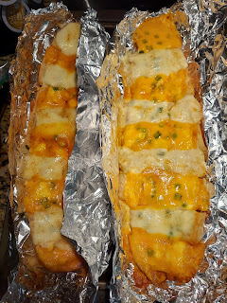

She cooked up some spinach filled ravioli and added a hearty side salad to complete the meal. It was lovely!

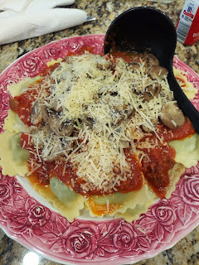

Her husband, Jim, took me outside to get a tour of their backyard garden area. He is a sweet man, quiet and soft-spoken, and a man of few words. But his smile is kind and welcoming. I remember him from my childhood being such a kind man.

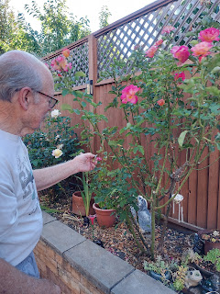

Their flowers were absolutely stunning! This one is a fuchsia I learned.

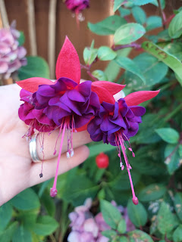

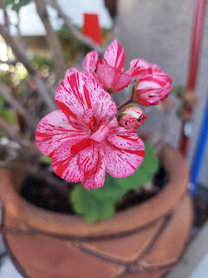

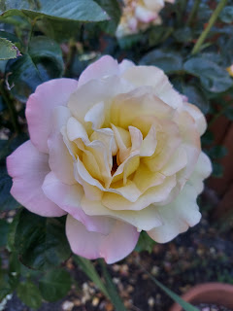

After dinner, we sat down to visit for a while, and then we opened up the Rawles Big Book that I had brought with me from my Dad's house. Loreena was excited to revisit the photos and newspaper clippings that have been added into this giant scrapbook for the past 60 or 70 years . . .

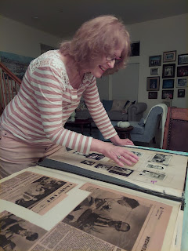

This is my great grandfather, Eugene Carlton "Bob" Rawles and his oldest son, Darrel Rawles.

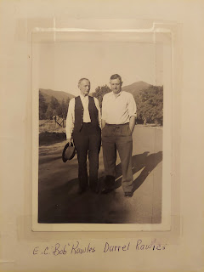

Upstairs in Loreena's house she has a large display of family photos. She knew who each person was and at least one story associated with them. I suggested that she type up a little something for the backs of each photo frame so that when she is gone, her children and grandchildren will continue to have that precious information. She thought that was the most brilliant idea - and hadn't even considered it before! It's so true though. Like my Dad, I also have a million stories in my head about my ancestors. But unless those stories get recorded somehow, then they die when I die.

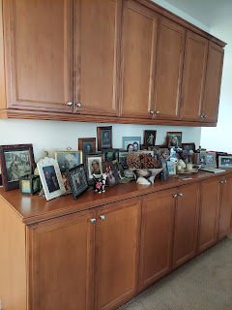

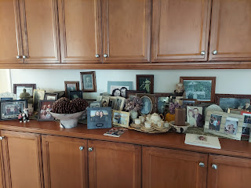

We went to bed way too late, but somehow I managed to peel myself out of bed in the morning and get my brain in gear for another day of fun and stories and swapping of information.

I also had the honor and privilege of helping Loreena to register an account on FamilySearch for the first time. She took careful notes of every single thing we did.

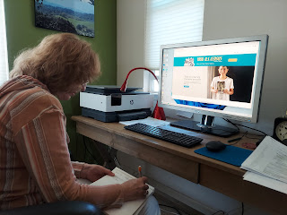

When we got her logged in, I noticed that her father was in the tree, but not her mother. I had already added her father, "Gene" Rawles, several years ago, because he is a sibling of my grandmother. But how exciting that she was able to add in her mother! Then we noticed that her mother's parents, the Eichins from Germany, were not in the tree yet either, so she was able to add their names in. It was a powerful feeling to be a part of that, sitting next to her and helping her to understand the significance of what she just did. I said to her, "You just added your mother and your grandparents to the WORLD WIDE TREE! You just did that!" She felt so happy and I could tell that it had an effect on her.

Once we added her grandparents, then we were able to connect to the rest of the world wide collaborative tree. She even discovered a German cousin named Erika, who has been contributing to her Eichin line. I showed her how to send a message and an email to Erika, which she excitedly did.

On her coffee table upstairs in the den, she has several family history books that family members have made. One of them was this (below) - made by her granddaughter as an elementary school project. That is so cool that a teacher would have the kids do something like this!!

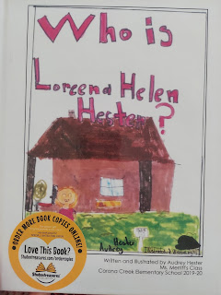

As part of the project, the grandchild could invite their grandparent to a Tea Party at the school, where they were presented with the special book made in their honor.

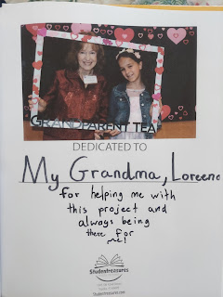

Here are a couple of the many meaningful pages that were in the book.

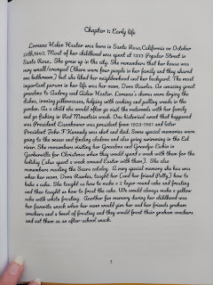

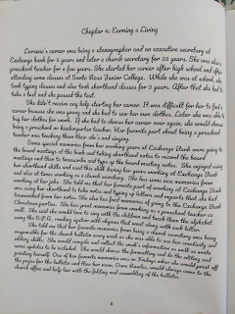

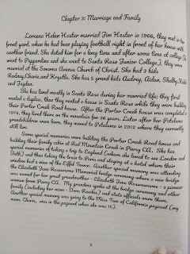

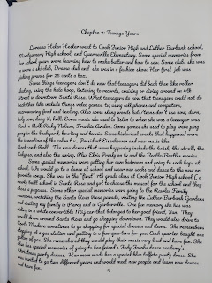

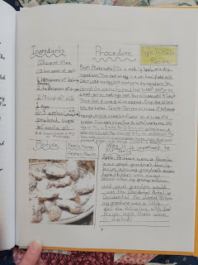

I also got a picture of the back page where the books were published.

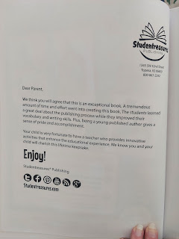

We coordinated with our other cousin, Cara Anstead, to meet her and her husband, Bill, for lunch at a restaurant in Santa Rosa called Crepevine. They serve delicious crepes, sandwiches, salads, pancakes, etc.

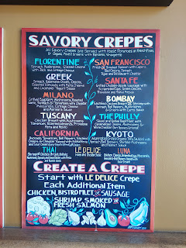

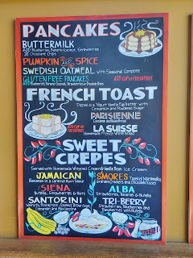

While our food was being prepared, Cara and Bill were able to peruse the Rawles Big Book. Cara is in her 80's now, and has colon cancer. She is doing well, but is also suffering from dementia and has trouble remembering some things, like a word she's trying to express mid-sentence.

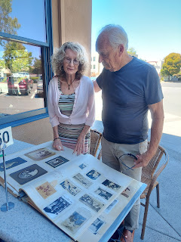

I ordered the Thai crepe with chicken and the Santorini crepe with pistachios and mascarpone on the side.
It was delicious!

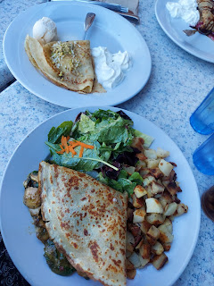

It was so special to visit and hug my cousin Cara. She has always been such a sweet and loving influence and is always gushing with kind words and compliments. She is the daughter of Norma Rawles, my grandma Zoe's older sister.

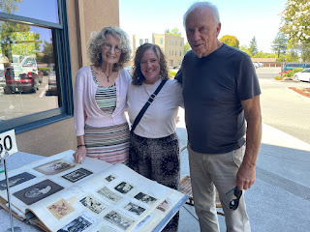

Cara Anstead, Loreena Hester, Bill Anstead

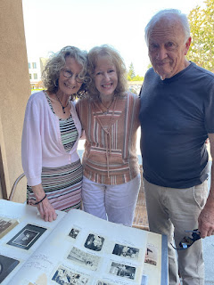

This is one of the many tangible family history items that Loreena has in her home. It's a large chalkboard sign with several words that represent their happy family. The boys and girls names are her grandchildren, while Hester is their last name. Red Mountain is the name of the area where her mother grew up and where they now have a family cabin. Loreena's husband, Jim, was a lineman in high school and college. Mountain Momma was her nickname when they used walkie talkies while up on their previous ranch, which sat on a hill and was pretty remote as far as communication was concerned. The words "wow" and "yea" are words that come out of Loreena's mouth often, as she put it, ha ha. When I see the word "yea", I think it is pronounced "yeah", as in "yes". But in this case, it's supposed to be pronounced "yay", which is definitely something she often says. She is a very joyful person and is always excited about everything and everyone! :)

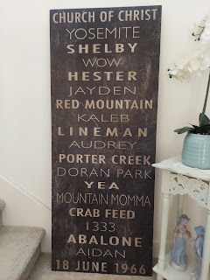

This rather fat book is a scrapbook of photos and stories that Loreena put together about her mother's life. This is the last thing we did together before I had to leave. We didn't have time to go through the entire book, but she just wanted to show me some things so we thumbed through it pretty quickly. There are several stories and memoirs that her mother, Dora, wrote in her own words before she passed away a couple years ago. There are also dozens and dozens of family photos and other mementos included in this book.

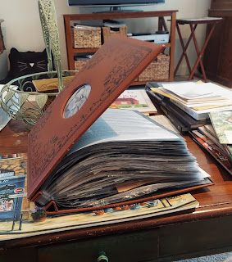

Loreena paused excitedly on one particular page, because tucked into the sheet protector were a couple of small yellowed envelopes. She pulled them out and when I realized what they were, I couldn't hardly believe it! They were HANDWRITTEN letters that my great grandmother, Kate Orr Rawles, wrote to her daughter-in-law, Dora Eichin Rawles. WOW.

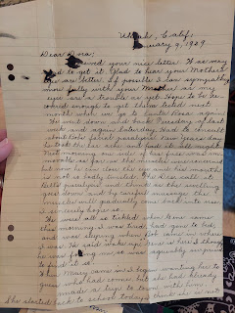

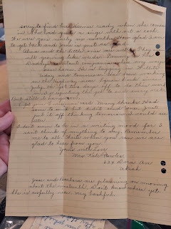

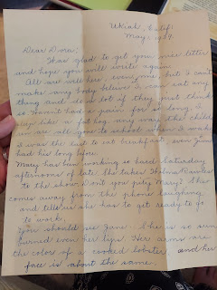

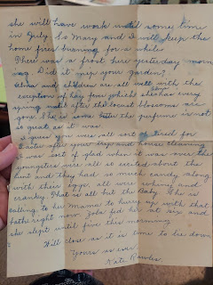

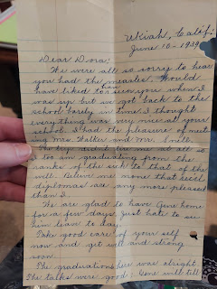

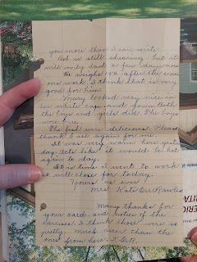

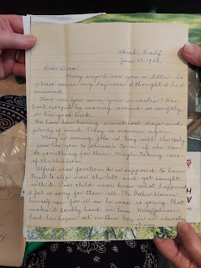

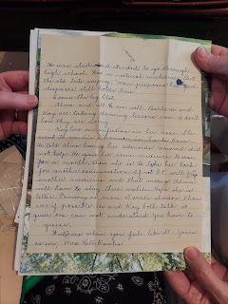

What a treasure these letters are!!!

Something that really struck me as I drove home and tried to process everything that I experienced while visiting with Loreena (and really just this whole trip to CA so far), is that I believe Kate is behind everything and is very involved in my life right now.

Before I even left to come out to CA, I felt impressed to try to find out more and connect to my Orr family, Kate's family. My ideas were to try to find land that they used to live on and take pictures of those places, as well as to try to visit the Orr Hot Springs Resort, a place that my ancestors built around some natural hot springs in the area. Well, I struck out on both of those endeavors. I reached out to the Historical Society in Ukiah, a place that I have visited in the past and gotten a lot of information from, but they have not responded to my messages at all this time. I also reached out to the Orr Hot Springs Resort, but they have not responded either. Hmmm . . . very interesting.

INSTEAD, what has been happening is that Kate has been guiding me to visit and make connections with each of her 7 children's descendants. One at a time and in a remarkable way.

Here are the children of Eugene C. Rawles ("Bob") and Kate Orr - -

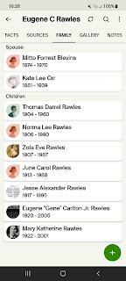

So far, I have been able to connect with:

Kathy Rawles - a granddaughter of Thomas Darrel Rawles
Cara Anstead - daughter of Norma Lee Rawles
My dad (and myself) - son and granddaughter of Zola Eve Rawles
Angela Martyn - granddaughter of Jesse Alexander Rawles
Loreena Hester - daughter of "Gene" Rawles Jr.

I have plans to visit the gravesite of my Great-Aunt June Carol Rawles, otherwise known as Aunt Naynee. And on my way home to Idaho in a few days, I will be stopping in Portola, CA to visit my cousin Valorie Sappingfield, daughter of Mary Katherine Rawles.

So I will have connected with all 7 of Kate's children - through the descendants of those 7 children. And I didn't even realize that that's what I was doing all along . . . but after I got home from Loreena's house and was just so filled with the Spirit and feeling weepy, that's when I started to put it all together. Simply amazing.

The thing that I just keep coming back to is just how much Kate loved her children. I am getting a broader sense of the love and connection and tight family relationships that the Rawles family had in those days. It was my cousin, Valorie, that told me several months ago that she felt a spiritual urging for the Rawles family to gather somehow - from far and wide - and to have a way to connect. After she discussed this at length with the other "elder" Rawles cousins - - Loreena, Daphne Martyn, Cara, Barbara McCulloch (Darrel Rawles' daughter), etc. - - they thought that maybe a Rawles Family Newsletter could be created, where stories and photos could be shared and enjoyed to bring us all together when we could not meet together in person. They eventually nominated ME to create this newsletter, which I did back in February of this year, even taking it a step further and creating a Rawles Roots Blog.

In recent months, it has become the consensus of the "elder" cousins that we want the focus of the next Rawles Blog and Newsletter to be on Kate and also on her oldest son, Darrel Rawles. As I have been gathering stories and impressions of Kate, it has just snowballed and grown and grown into where I currently sit, marveling at this love that Kate has for all of her descendants. I feel that she wants us to be close, she wants us to feel loved, and more specifically - to feel of HER love.

It was not coincidental that Cara Anstead, who suffers from dementia, decided to mail her mother Norma's biography to me a month or so ago. In the first couple of pages, I learned more about Kate than I have ever come across in any other writings. It was not coincidental that Valorie felt inspired to have someone create a family newsletter. It was not coincidental that Loreena noticed those yellowed envelopes tucked into ONE page out of the hundred pages in that huge book dedicated to her mother. And it was not coincidental that the two ideas that I had before coming to CA didn't pan out. Perhaps those things didn't matter to Kate as much as just connecting with the PEOPLE themselves. Wow. Just wow.

On Wednesday, I drove up to Willits to meet with my Dad and Michelle to help them work on Troy's house, something I've missed doing. They are so close to being able to paint the walls! While Michelle worked on mudding the seams on the walls and in places where the drywall meets up with the ceiling, I got to sand everything down from a previous layer of "mud". It was a really fun day, as always, and we got to visit while we worked together.

I love this picture of my Dad. :)

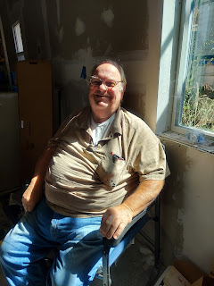

My dad snuck in a couple of pictures of me while I was sanding. Sneaky guy . . .

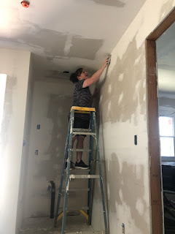

And while I was talking . . .

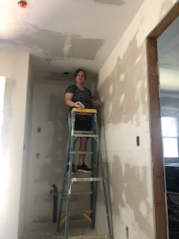

Dad had also set up an appointment for my car to get checked again, since it was still having the occasional "jerk" when I hit 25 mph. At lunchtime, when we went into town to pick up our pizza, we dropped off my car at my dad's favorite Fixer Guy Shop. We got a call a couple hours later with some good information.

Apparently it is a computer communication issue, not so much a car-isn't-safe-to-drive issue. Thank goodness!! We are working with Geico insurance, who handled the original claim last August, to make the assignment on who gets to fix the problem. The fixer guy in Willits was confident that it was a faulty wire and that the task ahead is to isolate which wire is the bad one. He reassured me that my car IS safe to drive all the way back to Idaho in a few days. He said it is simply a communication issue - and an intermittent one at that. If it were truly a safety issue, I would be getting a check engine light, he told me. So that was VERY reassuring!! When we weren't sure if I would be able to drive back to Idaho in this condition or not, my dad jumped right in to offer his help. We discussed options together, but ultimately it sounds like I'll be just fine.

After I came down the hill from Willits at the end of the afternoon, I took a quick shower to get all the sandy dust off of me, and then I went to YW with my mom. She is the YW secretary but also fills in as an extra counselor in the YW presidency. They don't have a lot of YW in their ward, maybe 10 girls or so, so they just group them all together into one class, instead of the typical three age levels.

The girls helped to tie a quilt that is being donated to a girl in Haiti, as she graduates from school. The ward here is doing several humanitarian projects such as this. They are also making dozens of sock monkey stuffed animals to donate to children who show up at the local domestic abuse and violence shelter. Sometimes all the child has is the clothes on his/her back and nothing else.

My mom is in the pink shirt in the photo below.

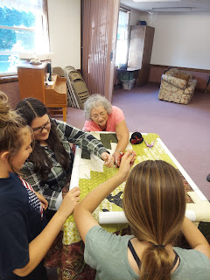

On Thursday, my mom and I drove over to the coast together. Ana, my niece, was supposed to come with us, but she woke up not feeling so well and wasn't able to go. My cousin, Kathy Rawles, told me that the Anderson Valley Museum has a lot of things relating to the Rawles family, so we decided to stop in there on our way to Mendocino. It used to be a little one room schoolhouse back in the 1800's and still has some of the original desks on display.

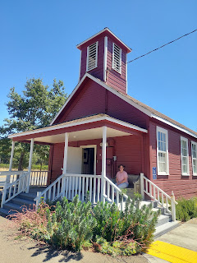

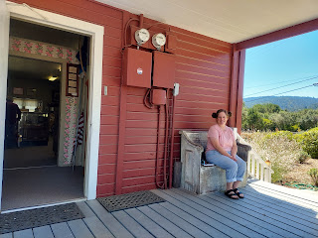

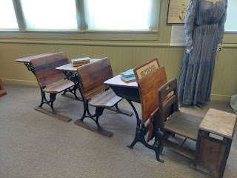

I made contact with the docents at the Museum ahead of time and arranged for someone to meet us there at noon, since they are normally just open on Saturdays and Sundays from 1-4 p.m. Sandra met us at the appointed time and had already prepared a couple of things to point out to us.

They put together some very large protected pages that hang (like giant posters) and you just flip through them. This page was dedicated to the Joseph Rawles Family, who moved into Boonville (part of the Anderson Valley) in 1858.

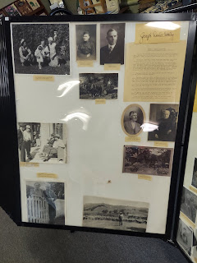

One of the photos on that page stood out to me. Alexander Nathan Rawles. He was the brother of my 2nd great grandfather, Thomas Edward Rawles, but I have never seen a photo of him before! So that was very cool.

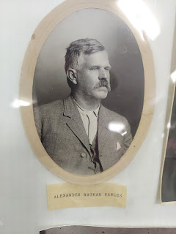

I know some additional details about Joseph Rawles that I was able to share with the docent, but I've been thinking that I should probably put something together and send it to them in writing so they can keep it on display for all the visitors that come through the Museum.

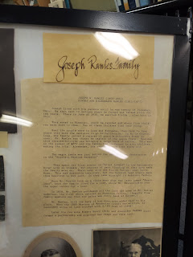

And then we saw this charcoal drawing of Tommie Tarwater. I couldn't stop looking at it!! His real name is Henry Edward Tarwater, but he went by the nickname of "Tommie". He was the younger brother of my 2nd great grandmother, Louisa Jane Tarwater. Louisa was born in 1849, but "Tommie" was born in 1865.

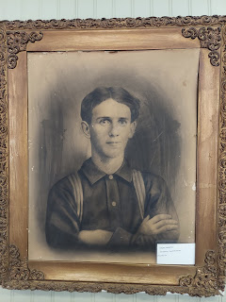

And here is a photo of Joseph W. Rawles III, getting a shave.

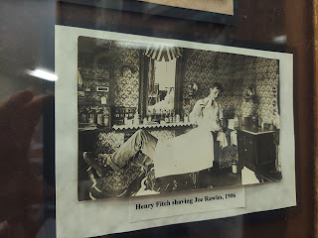

His
father
, Joseph W. Rawles Jr, died at 29 years old. He was shot several times because it was rumored that he was trying to "seduce" the perpetrator's niece. He somehow survived and was expected to recover from his wounds, but as he lay in bed resting, a breeze caught the curtain and blew it toward the candle burning nearby. As he lept out of bed trying to douse the fire, he injured himself further, and soon after died. Wow. What a way to go! There were other rumors circulating about him during that time, including one that he was part of - or at least harbored or assisted - a robbery gang which may have included Jesse James. A newspaper clipping refutes that claim, saying that: "The report that Rawles was killed because he was an important witness against the stage robbers is generally discredited." Well, any way you look at it, he led a colorful life!

This large photo is of William Francis Ornbaun and several of his family and friends. I'm not sure which one is him in this large group though . . .

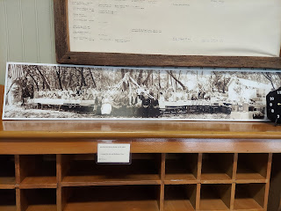

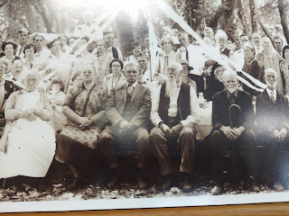

But the Ornbaun/Ornbaum family is of great interest to me (and I plan to research them further when I get home) because I am related to them through my 2nd great aunt, Margaret Susan Rawles. She was the younger sister to my 2nd great grandfather, Thomas Edward Rawles. Margaret married William Francis Ornbaun and they had a large family, with too many descendants to count! I don't have much info on their family, so that will be a huge next focus area for me.

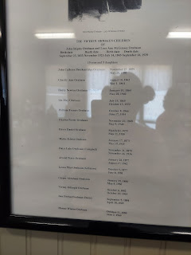

We continued on our way - stopping briefly at Gowan's Oak Tree (a mom & pop farmstand that's been there for decades and is the traditional place to stop for a snack on the way over), winding through the Redwoods, and made it safely to Mendocino over on the coast.

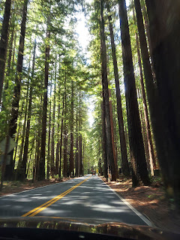

This is the bend in the road near Navarro where you can see the ocean for the first time, as the river meets the sea. I took the photo just prior to being able to see the ocean . . . oops.

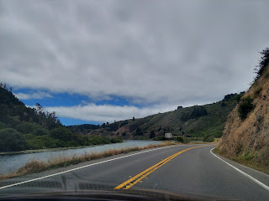

Once we arrived in Mendocino, we ordered lunch at a place that my Mom has enjoyed in the past with Frank. It was a busy summer's day with plenty of customers to serve, so we entertained ourselves with conversation while we waited. Mom ordered fish & chips, which looked amazing. I didn't want all the "chips", or fries, so I opted to order a Caesar salad with prawns on top. It was shockingly small for being overly expensive, so I ended up ordering a cup of soup a few minutes later.

This bowl was about the size of my hand, with THREE shrimp on it, plus one delicious anchovy. Together with the 1/2 cup of Rock Cod soup that they brought out for me, I paid about $22. (can you see me frowning?)

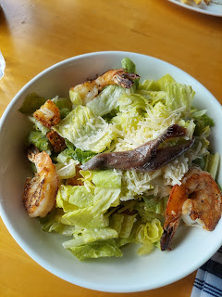

From there, we headed next door to get some locally made chocolates before heading off on an explore. We walked along a cliff trail where the views were so fantastic!!

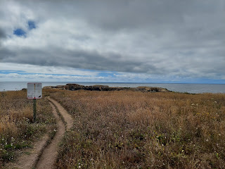

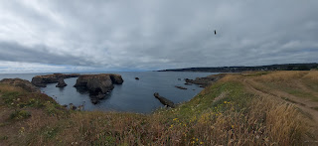

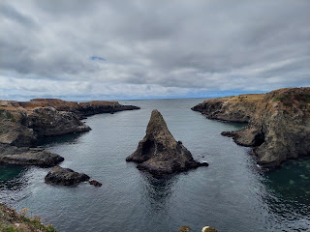

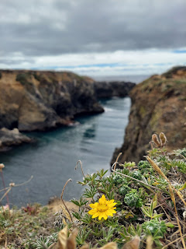

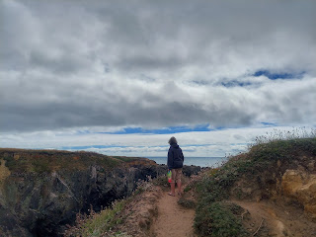

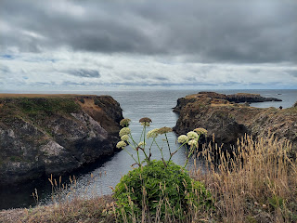

It was a bit breezy but it felt wonderful.

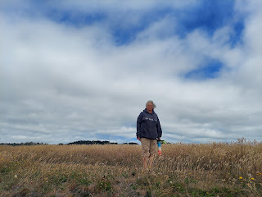

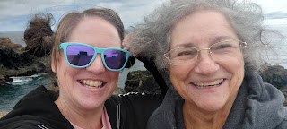

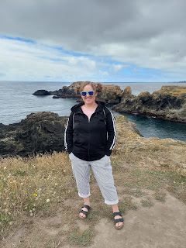

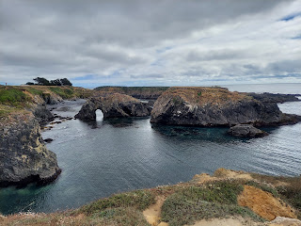

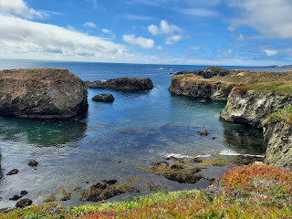

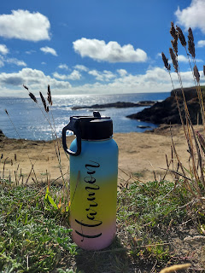

Video of the views: (28 seconds)
https://photos.app.goo.gl/UCYBfrZAkkMjerPW8

Our next stop was at Big River Beach, a short 3 minute (or so) drive south from the Mendocino Headlands State Park where we just were. Someday I just might do a little write-up of the porta-potties that I've experienced in recent years. The one at Big River gets a 3/10, but really it should get less than that. In its favor, the inside was large and spacious and was conveniently located adjacent to the parking lot. But it was so full that you barely had room to do your business and hope that it didn't touch you from underneath.

On the short walk out to the beach area, we passed several wild blackberry bushes. I couldn't resist picking one to eat (just one because there weren't too many that were ripe yet), remembering all the blackberries we picked in my childhood out on Sanford Ranch Road in Ukiah. As we added to our family, Scott and I would drive out in the summertime with the kids to visit my extended family. One of our kids' favorite memories on those trips to CA was picking blackberries on Sanford Ranch Road. We'd pick bowlsful and then someone always made homemade vanilla ice cream to put underneath all the berries.

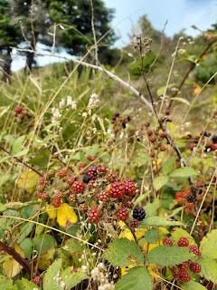

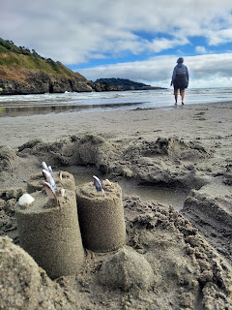

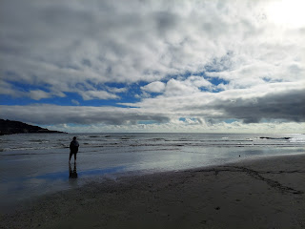

My feet on the left, Mom's feet on the right . . .

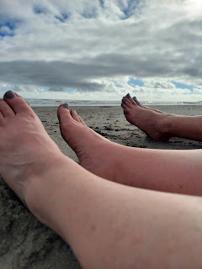

Video of Big River Beach: (22 seconds)
https://photos.app.goo.gl/5uk11gHG2mwFa59H9

Video of some kayakers braving the waves in the shallows near us: (16 seconds)
https://photos.app.goo.gl/vNZorem47A2Uiva36

Meanwhile, Scott was high up in the mountains of Italy, hiking along the Road of the 52 Tunnels again. This time he brought a powerful flashlight and had more gumption to go further than he did last time. He somehow had enough service to call me from the trail, too!

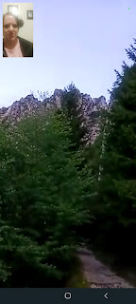

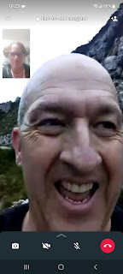

Here is a link to a few photos and a video that he took on top of the mountain:

https://photos.app.goo.gl/mTNkK5ZPjqWWvYpXA

Friday was a day of visiting friends here in Ukiah. I spent 3 hours with my childhood friend, Jill Millward, again. She came over to my mom's house first, where we sat out back on the patio swing and talked about life and growing up. After a while, she took me over to see the house that they're building on the north end of town, near Parducci Winery. It's a slow process . . . they've been working on it steadily for 2 years already and there's a long way to go still. The 1-acre lot is on a parcel of land right next to Jill's younger sister Sara. I always wished I could live next door to family - such as my sister. That would be so fun! (Hey, ya got any eggs I can borrow?)

We walked through the bones of the house together while she pointed out what each room would be eventually. A small portion of the house is still being used, while the rest of it was gutted and then expanded from there.

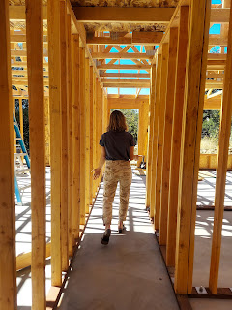

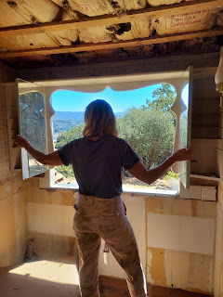

They found this darling square seafoam green tub that fits perfectly upstairs for Jill's daughter to have in her own bathroom.

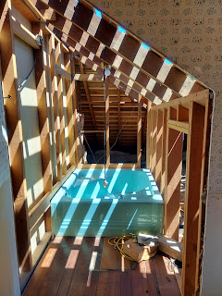

Following the house tour, we dropped Jill's daughter off at dance, which just happened to be right next door to the Center Gallery where she has her own space to hang her art. She just sold a huge painting (6 ft x 8 ft) for $7500 to a couple visiting Ukiah from Los Angeles. It was a painting of some orange California Poppies on a white background, with other contributing colors of gold, grey, yellow, and green. The couple said it was the exact pallette of colors that were in their newly updated living room, but for Jill - - it was a powerful answer to her prayers.

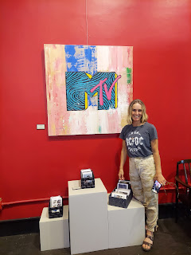

Jill is currently working on a conversation starter on a social issue. She had several dozen cellphone sized pieces of wood cut and sanded to look just like a cellphone shape, and she's been working with her daughter and her daughter's friends at the high school to design each one. They are painting each wooden cellphone to look as though the painting is a phone cover. When the Art Walk in downtown Ukiah has its fall opening in September, Jill will have a handful of teenagers become a part of the exhibit as well. They will pose and pretend to be glued to their phones. (But are they really pretending? ha ha) The social issue at the root of this exhibit is how cellphones have taken over the younger generation and how to open up the dialogue about it. As parents of this young generation, we have experienced frustration in the many times we can't pry their glassy eyes from the screen in their hands and all of the secondary issues that result from it. Anxiety, depression, social awkwardness and the inability to look people in the eye or have an in-person conversation, the rampant availability of viewing pornography, and many many other problems. She is a deep thinker and I love that it's coming out in art form.

Eventually we drove back to my mom's house, where we sat out front and talked some more. We talked about life after death, and what would happen if she wants to marry again someday. We talked about temple sealings and how will that all work out if she finds someone to marry at some point. I encouraged her to read the book that I sent her last year after her husband died. It's called "
The Message
", by Lance Richardson. In the recent update, Lance's widow, Jozet, adds her own voice to the grief process and what she went through in the years after her husband died. It's a powerful witness of life after death, love that never ends, and an authentic look into the emotions that are raw and difficult in those circumstances. Lance and Jozet used to live in our ward many years ago - almost 20 years ago now, and I think Lance died about 18 years ago now. Jozet has since remarried and is currently in school to become a marriage and family therapist. Anywho, I think Jill is feeling very close to being ready to open up that book and dig in.

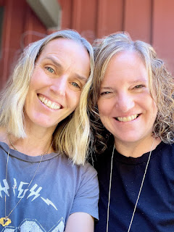

We have one more friend date before I leave to go back up to Idaho. We will be meeting for lunch on Monday (tomorrow). I can't wait!

I also got to visit my friend, Jenn, again that same afternoon. What a treat! I always love visiting her and I love her amazing twin teens, too. It just feels so comfortable at their house, like I'm part of the family. I'm praying that she can find a new job soon, since the job she's been doing for a long time now is becoming more of a depressing and frustrating one and that sure makes it hard to want to go to work.

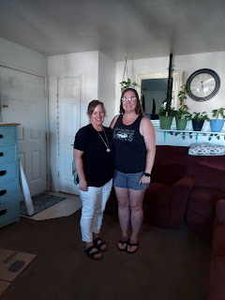

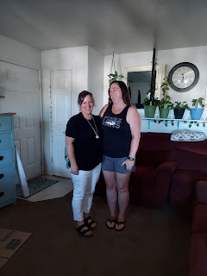

I also went to the best bookstore here in town to get some books for my grandchildren. It's called The Mendocino Book Company. I love their selection of children's books and boy did I hit the jackpot this time. :)

Saturday, Mom and I drove down to Napa to spend the day with my brother, Ryan, and his family. It was HOT down in Napa, and when we drove 30 minutes outside of town and into the hills to go to Lake Berryessa, it was even hotter! About 10 degrees hotter. By the time we picked up Ryan's boat and got down to the boat ramp, it was 95 degrees at 1:00 p.m.

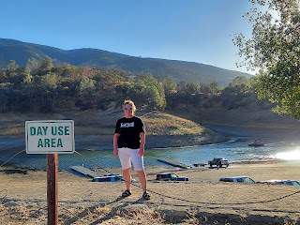

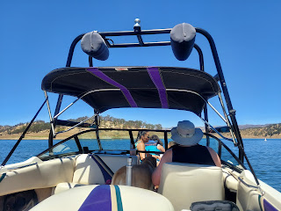

My brother, Ryan, was great to invite his children, one at a time, to come help drive the boat. This time it was Lily's turn. She is 7 years old and is such a cutie. She LOVES babies and has a couple of realistic looking dolls that she lovingly cares for all day long.

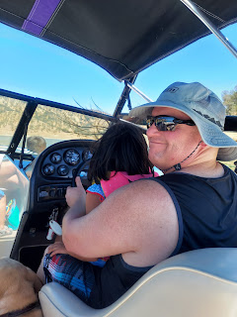

Thank goodness I brought this hat with me from Idaho - it has a chin strap to cinch up so it doesn't go flying off when we're zipping across the lake.

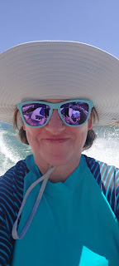

Video of when we first headed out into the main body of the lake at a high rate of speed: (15 seconds)
https://photos.app.goo.gl/bLoY6EHy6TZgbcxv6

After we cruised around for a bit, Ryan found us a quiet cove to put in anchor for a while. We ate our lunch and hopped into the lake to swim. The water temperature was so refreshing! It wasn't ice cold like Idaho lakes can be . . .

Ryan's daughter, Emily, will turn 9 years old next weekend. It seems like she's grown a foot since I last saw her . . . and she is so sweet. She loves reading books, most especially the Babysitter's Club series, but is also very kind and thoughtful. She seems to be intuitive at reading the people around her and is a sensitive child.

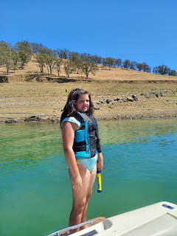

My mom got better and better at climbing back up into the boat each time, and by the end of the afternoon, she didn't need any assistance at all! Today she is sore (as I am) but thoroughly enjoyed our time with Ryan and his family.

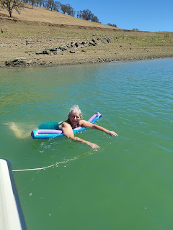

Mom and I both tried tubing for the first time yesterday. I did 3 rounds of bouncing along behind the boat like a rag doll before throwing in the towel, ha ha. Emily stayed with me all 3 rounds as well. She's a trooper! Blake and Lily were firm in their decision to NOT go on the tube this time, since they still remembered the stress of all the bouncing and flailing from the last time they went out on the lake.

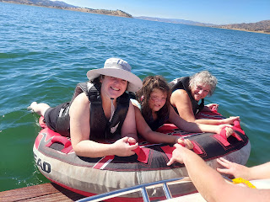

I also tried the knee board but couldn't quite get all the way up on my knees. Karen demonstrated the process for me first, and of course she looked elegant and made it look easy. But when my turn came, I thought I was going to die. The boat is pulling you while you're holding on to a short surfboard looking shape. You're holding on at the 10 and 2 position but the goal is to pull yourself forward enough to get your knees up under you. Once you get your knees up and under, then you secure the strap across your thighs to hold you in place. And then you can finally grab the handle and just enjoy getting pulled along while the breeze blows through your beautiful hair. Yeah right . . .

I tried with all my might for a LONG time just to move one inch forward on the knee board without any success. I could feel my arms tiring and I yelled out to Karen in the back of the boat, "I CAN'T!" To which she reponded back, "YES YOU CAN!!!" I kept at it for several more minutes, and finally had some success in ALMOST pulling my knees up underneath. That's when Ryan turned the boat and we started going across all the waves and wake that he had created. I was getting bounced up and down like a basketball and lost every inch that I had fought so hard to gain. I thought at one point I was going to fly off, but I didn't. So I guess that is my success story. I held on the entire time and never let go. So yeah, we'll go with that version. But man, today, I am extremely sore . . . my forearms, my triceps, my shoulders, my abs, my ribs, and my lower back.

It really was worth it. I tried something new and I had fun doing it with family. :)

Video of Ryan giving us instructions as we prepared for the tubing adventures: (1 min, 4 seconds)
https://photos.app.goo.gl/83JikcsgRSbUKWtt6

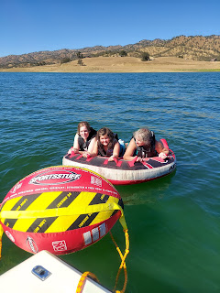

Ryan's dog, Cooper, thoroughly enjoyed jumping off the back of the boat numerous times. But he couldn't get up on the ledge at the back and required assistance each time. You have to pull up on his collar - almost straight up, otherwise you might pull the collar completely off and then he could drown if you don't have something to heft him up with. One time his collar did come off when Karen was trying to heft him up, but thankfully Ryan was down in the water and worked quickly to get Cooper up safely onto the boat.

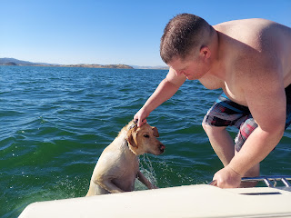

From the left: Ryan, me in the turquoise shirt at the back, Emily in the way back, Blake in front of her, Lily, Karen, and Mom.

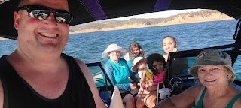

Me, Emily, Blake, and Karen

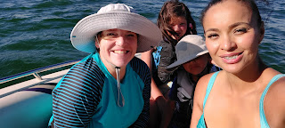

Lily and Blake on the back ledge, Emily and Grandma Linda in the water

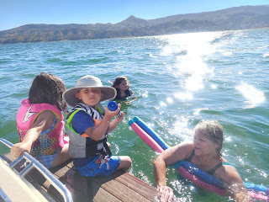

By the time we got off the water and back onto dry land, it was around 5:30 p.m. Time went so fast and I was sad we had to get out of the lake. We changed our clothes, got the boat cleaned up, and prepared to say our goodbyes.

From the left: Blake, Emily in the back, Lily, Mom, and Me

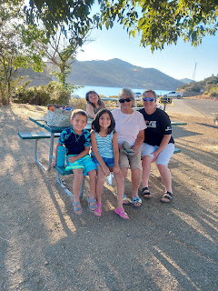

Kids and their funny faces ha ha - Blake and Lily

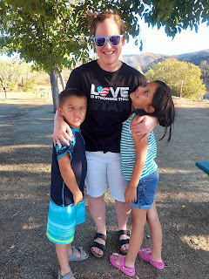

Snapped to attention and perfectly posed in the next moment - their mother, Karen, has taught them well!

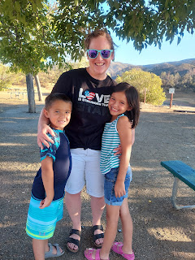

Ryan also has a silly side.

Video of us preparing to take a brother/sister photo: (10 seconds)
https://photos.app.goo.gl/z4b6XzDom7uu1q4s5

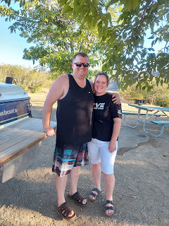

Me, Ryan, and Mom

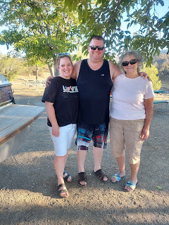

On our 2 hour drive home, we very narrowly avoided 2 potential disasters . . . while I was driving through the hills between Lake Berryessa and the Silverado Trail (that leads out to Hwy. 101), I came around a curve and almost killed Bambi AND his mother! Thankfully I wasn't going very fast because the curves were pretty sharp, so I was able to brake quickly and just barely missed hitting Bambi's back leg as he tried to catch up to his mother. We breathed a huge sigh of relief afterward . . .

Later, as we came into Hopland, a few miles from my mom's house, it was dark and approximately 9:00 p.m., when I noticed at the last second that two people were slowly crossing the main road that goes through town right in front of me!! They were in the crosswalk, but the crosswalk did not have any flashing lights and was completely dark. If I hadn't been paying close attention, I would have certainly hit them both! They were going slowly because they were trying to make sure that the other lane of traffic was going to stop as well. Man, that would have been horrible if I had hit them! But thank goodness I didn't. We got home safe and sound just as few minutes later.

Sunday morning we went to Stake Conference, which takes place about twice a year. I went early to save some seats for my Dad and Michelle to sit with my mom and me. The conference was wonderful and I left feeling motivated to do a few things, which is always nice.

After the conference was done, I asked my Dad to take a photo of me with Jim and Marie McKell, whom I already mentioned in last week's blog. They had such a loving influence on me in my turbulent years and I am forever grateful to them.

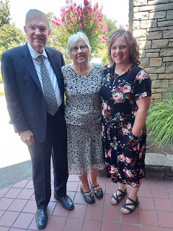

Time to catch up on Grandbabies . . .

Avery:
Scott was able to go up and visit her today after church in Italy. She is practically walking now! He reported seeing her several times just free-standing with a toy in her hands, not even realizing that she was standing on her own without any support. Wow, she is getting so big!!

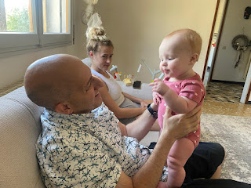

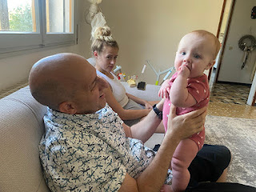

Video of Avery crawling and then climbing up toward her papa, Benson: (16 seconds)
https://photos.app.goo.gl/zGFKhYg5VupiQu1z6

Video of Scott holding Avery: (19 seconds)
https://photos.app.goo.gl/bRXG868NCRddi7GHA

Jack:
As far as I know they are still out in Utah visiting Hannah's family.

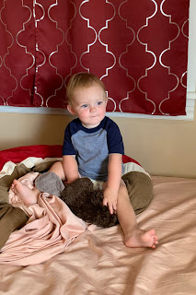

Video: Jack is a pro at going down the slide unassisted . . . (5 seconds)

https://photos.app.goo.gl/LukqDx1KmkhEamf56

Abby and Gwen:
Abby started school a week ahead of Gwen, but now they are both in school. They love it and are very happy so far!!

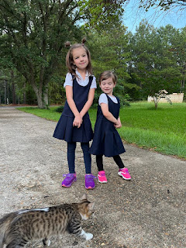

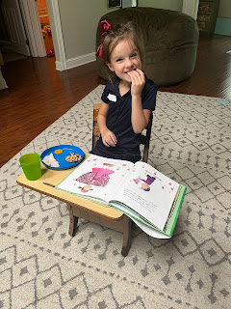

And last weekend, Amber's ward had arranged for all the Primary children to go to the Dallas Temple. They met with the temple matron and got a tour of the grounds, along with getting their picture taken. What a wonderful thing to do with the children!

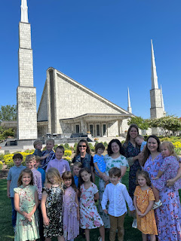

Amber is in the back row holding Gwen. (Amber is the 3rd mom from the right)
Abby is in the front row, 3rd from the right as well. :)

By the time I put together my next blog post, I will be back home in Idaho. It's been so amazing here in California. But at the same time, there's no place like home. :)

