Philip Milton Harmon (1931 - 2024)
A true gentleman, my father-in-law, Phil Harmon, passed away on Leap Day 2024. (Feb 29th) It was a surprise, but then it wasn't a surprise. He had been steadily declining in health since last May, when his wife, Coy, passed away. He had lived a wonderful and full life, 92 years' worth. I would like to share a few of my thoughts, as well as some of the details that happened leading up to his death.

Link to the obituary:
https://www.eckersellfuneralhome.com/obituary/philip-harmon

Philip Milton Harmon was born on 18 October 1931 in San Jose, CA. He was the first child born to Wesley and Helen Gordon Harmon, followed by a younger brother, Donald, approximately 18 months later.

He sure was a cute baby!

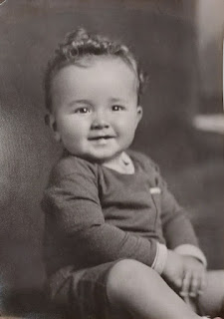

Helen Gordon Harmon is holding her son Don, while Wesley Harmon is holding his son Phil.
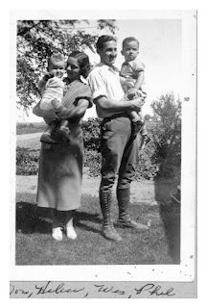

Phil and his beautiful mother, Helen

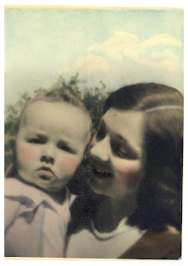
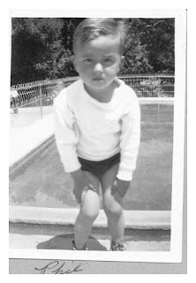

Phil later joined the Navy and eventually signed up with the Army Reserves, too, after his Naval career was completed.

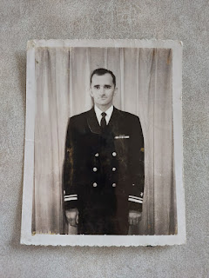

In the U.S. Navy, he was a musician. He played the clarinet.

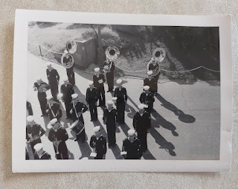

He served during the Korean War, traveling to faraway places like Japan. In the photo below, Phil is on the left.

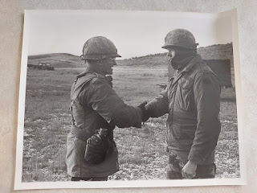

Phil always enjoyed exercising during his entire life. Even at 92 years old, he would make his way downstairs to the exercise room to lift some weights and walk on the treadmill for a few minutes.

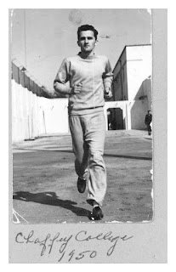

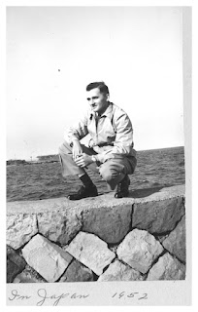

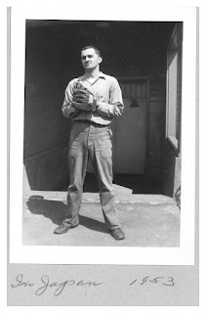

He was a handsome young man, for sure. I see a few similarities at times between Phil and my son, Benson. Those eyebrows, especially, ha ha.

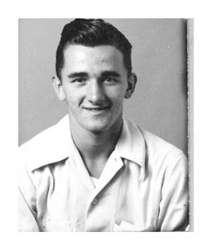

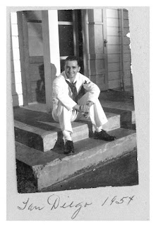

Phil (left) and his brother, Don. 1950.

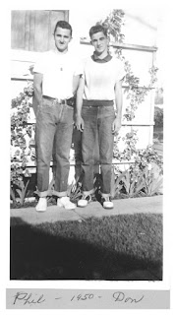

Christmas family photo in 1948. Wes, Phil, Don, and Helen Harmon.

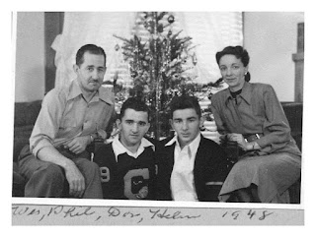

Phil in his Navy days.

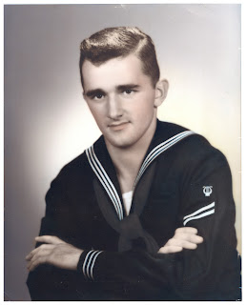

After his military career, he became a teacher. First, he taught math briefly in Southern CA at an area high school. Then later, he taught for approximately 27 years at Ricks College (now BYU-Idaho) as a Professor of English, Literature, and Shakespeare. He spent a lot of time reading and studying for his classes, two things he enjoyed very much.

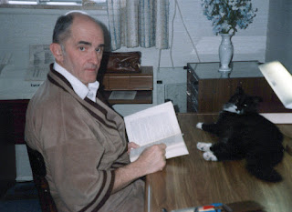

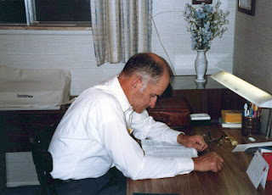

He married the love of his life, Coy Michie, on St. Patrick's Day in 1955. Together, they raised 3 girls and 3 boys. Below: Coy and Phil with their daughters: Carol, Bev, and Sharon.

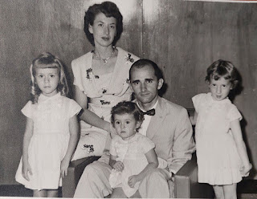

In the summers, Phil was a Park Ranger at Yellowstone National Park. He loved to immerse himself into nature, going on hikes and becoming one with the Great Outdoors. He did this for about 10 years, if my memory is correct.

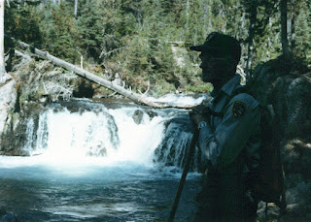

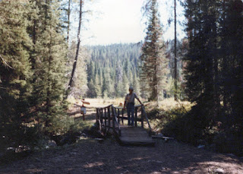

Here are some of the military coins in his collection. Some of them he earned, and others were gifted to him by sons and sons-in-law who served in the military as well.

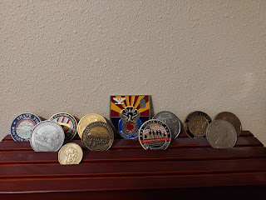

He was honorably discharged from the U.S. Navy in 1954, after his service in the Korean War.

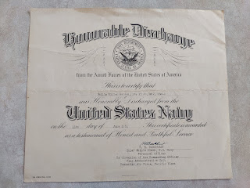

Phil was always aware of looking his best. He wore a suit most days, and always had one of his fedora hats on (or sometimes a ballcap if he was dressed more casually).

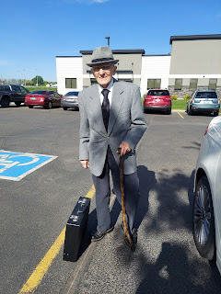

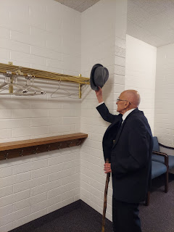

The last moments we spent together were on the day before he passed. He hadn't slept well the night before, and Bev was worried about leaving him alone while she had to run an errand to get her work laptop fixed. I drove up to Rigby on Wednesday, Feb. 28th, and spent a few hours with him.

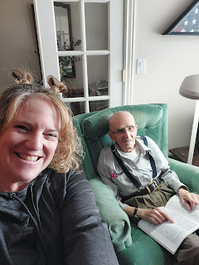

Even though he had spent the entire morning unconscious and sleeping soundly, when I arrived he was awake and alert, reading in his large-print Book of Mormon and studying this week's Come Follow Me lesson. I noted that he was a few chapters ahead of me, and we discussed how the words of the prophet, Isaiah, are sometimes difficult to interpret and understand.

We discussed other books that we were both currently reading. He was reading Flag of Our Fathers, about the military servicemen who placed the iconic flag on Iwo Jima. I told him how I am reading a book about my Bassano ancestors and how one of them, Emilia Bassano, is likely the actual author of all of the Shakespeare-attributed plays and other works. Shocking, I know. I'm only about 1/4 of the way into the book, making tons of notes in the margins, as I work my way through. I promise it's a fascinating read! (It's called, "Shakespeare Exhumed: The Bassano Chronicles", by Dr Peter D. Matthews and a few illustrations by Maria Bassano.)

We discussed all of my children and what they're each up to. He was pleased that they are all doing well. He always asks about each person, wanting to know details and seeking reassurances that they are all okay. He also asked if I could find him a pair of white suspenders so he could keep his pants up at the temple, ha ha. He was looking forward to the next time he could go and wanted to be better prepared.

I made him some cream of mushroom soup for his lunch, and we chatted some more while he ate. He watched an episode of his favorite show, Adam-12, a police drama from the 1960's. He tried to take a nap on the couch, but struggled to sleep there, so when he retired to his bed to lay down for a while, I left, since Bev had already returned some time before.

The following day, Thursday, Feb. 29th, Bev called me around lunchtime to say that Dad wasn't doing well. He was coughing a lot, and it was worsening. He was shivering and couldn't get warm, even with the electric blanket Bev had tucked around him. He was feeling fatigued and weak, not having enough energy to sit up and sip some water. She felt like he was having symptoms of distress related to congestive heart failure and arranged for a Tele-Doc appointment that afternoon because he didn't want to go to the ER.

I contacted Scott, who was finishing up at his soiree in England with all the other military officers and was heading off to bed soon. I told him I would give him updates as I received them.

Only a couple hours later, Bev called me in tears, saying "He's gone! He's gone!"

They had the Tele-Doc appointment an hour or so before, where Dr. Potter tried to assess if Phil had a virus or an infection of some kind, asking if Phil would like to have some antibiotics prescribed. But he didn't want to be bothered in his exhausted state. Dr. Potter offered to reach out to Hospice and have them come check on him and see what could be done to make him more comfortable, to which he accepted.

Bev was able to feed Dad a few bites of leftover cream of mushroom soup, and then he wanted to get into his pajamas and climb into bed. Bev slowly and carefully assisted him from the kitchen to the back bedroom, which took some time since he was in such a weakened state. She was in the process of getting him into his pajamas as he sat on the edge of the bed, when all of a sudden, he gasped and his eyes rolled back and then he was gone. Just like that.

His pacemaker kept ticking a few minutes longer, even though Bev knew that he was truly gone. That's when she called me.

Let me back up for a minute to last Sunday, February 25th. Scott's oldest sister, Carol, sent out an email to the whole family, after she and Bev had discussed Dad's weakening health in recent days. Carol invited us all to fast and pray that Daddy could go Home to be with Mom, if it was God's will for him to do so. She felt that with Dad's greatest desire to be reunited with his sweetheart, combined with his increasing loss of dignity as his body began failing in more and more ways, that maybe we could pray that Heavenly Father, in His kindness and mercy, would allow Dad to return Home. In His own due time, of course.

Many family members participated in this special fast for Dad/Grandpa, including Scott on the other side of the world. I, too, participated, although I found myself somewhat conflicted at first.

I was hung up on some details and logistics because of our current circumstances:
Scott is on the other side of the world.
He doesn't have many leave days. He's still trying to accumulate some leave after using everything last May when his mom died.
What if Dad passes away shortly after I get over to Italy, since I will be leaving in 2 weeks.
The plane tickets will cost a lot.
Maybe it would be better if the timing could wait until Scott comes home in June, since he already planned for that and has a plane ticket already.
But that would mean several more months of sacrifice and difficulties for both Dad and Bev.
Etc. Etc. Etc.
After I had said my initial prayer, but felt this turmoil going on in my brain, I recognized that it was hard to be sincere in what I was asking in my prayer when I was hung up on so many details and concerns. The Holy Ghost began to step in and helped me find solutions, answers, and peace to my every worry. As I let those comforting reassurances fill my conflicted heart, I felt more at peace over the course of a couple hours that morning. I finally felt like I could let all of those inconsequential details go, and just submit to whatever God's will might be. I felt calmed and comforted enough to go kneel by my bed once more, this time offering my whole soul and feeling willing to submit to His will and His timing. I felt like everything would be okay. And that was enough.

Little did I expect that just FOUR days later, Heavenly Father would take Dad home to be with Him, and to be reunited with all of his other family members who were already there. Coy. Their son, Philip. His parents, Wes and Helen. His younger brother, Don. And so many more. He would be able to step out of that failing body and just rest. What a beautiful gift.

I have probably mentioned this before, but it is so important to make sure that whatever you pray for is the RIGHT THING to pray for. Sometimes we pray and we ask for the wrong things. Not intentionally, of course, but we have to align our will with God's and figure out what is the RIGHT THING to ask Him for. When we do ask for the right thing, in accordance with His will, He will then give us the thing we are asking for.

There have been times when I didn't know WHAT to pray for. I wanted to ask for the right thing, but what exactly is the right thing? I have learned to spend time praying to know what IS the right thing to pray for. It may take a few days, but when it comes through the Holy Ghost to my mind and to my heart, that's when I eventually know what to ask for.

I love the scripture verses found in the New Testament. 1 John 5:14-15. They say the following:

"And this is the confidence that we have in him, that, if we ask any thing
according to his will
, he heareth us. And
if we know that he hear us
, whatsoever we ask,
we know that we have the petitions that we desired of him
." (Italics added)

In this case, it was a righteous prayer that we all offered in faith on Dad's behalf. That he could return home to Mom and be at peace there. This was something that our Loving Father in Heaven was already willing to give us, and so He did just that. What a beautiful testament to the power of prayer, especially united prayer and fasting by a whole extended family.

I'm grateful that I received the answers and the peace that I needed in order to contribute to those faith-filled petitions to God. That is human nature. We are conflicted sometimes, torn, or hung up with worries about logistics and details. We don't understand how this could possibly all work out. At the same time that He is willing to help us, He is also willing to help us PREPARE to receive the answers we seek. What an amazing concept.

I told Bev I would hurry up to Rigby to come be with her. I arrived about 30 minutes later. I called my daughter, Amber, while I drove and cried at the same time. I asked her to please send Scott a message that his father had passed, since I knew he was sleeping and I had left in such a hurry. I also asked her to please let her two brothers know (Jacob and Benson). She was a welcome voice on the other end of that call, and I appreciate her so much for that. She had been there when Grandma Coy had passed away, and had been through the steps that I was about to become a part of.

This was my first time being in attendance with a deceased body, immediately after they had passed. It wasn't as uncomfortable as I thought it might be. The room was quiet and peaceful, and it felt good to be there with Bev as we waited for someone to come and declare Dad's official time of death.

The police arrived a short time later, after a bit of a mixup with what the procedure should have been. With Mom's passing last May, Hospice had been the ones to come and declare her time of death. Bev had reached out to Dr. Potter's office this time, but they didn't answer. Dr. Potter had said earlier that they would arrange for Hospice to come over, so Bev waited a little longer for a response. Eventually, she called Hospice directly. They responded by saying that Phil wasn't technically a patient of theirs yet, since they had not come to the house at all. They directed her to call 911 and report his death to them.

Two officers came and conducted a brief investigation to make sure there was no foul play, which there wasn't. They just had one question: why did it take us an hour to report his death? That's when Bev explained about the mixup between Dr. Potter's office and Hospice. That satisfied them.

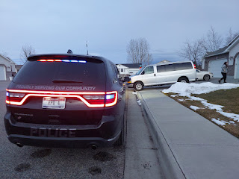

The officers reached out to Eckersell Funeral Home and then we waited another little while for them to come, since they were in the middle of setting up for a funeral. A father and daughter from Eckersell eventually arrived and Bev shared the details of Dad's passing with them.

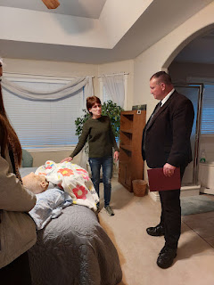

Dad's body looked so frail and tiny on the end of the bed. Bev kept him covered in the same blanket that the Primary children made for Coy last spring. It has also been his prefered blanket for numerous naps all these past months since her passing.

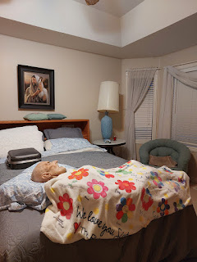

It felt a little surreal seeing his favorite cane standing next to his dresser, never to be used in this life again. Made by a distant cousin, David Harmon, it will be placed next to him in the casket when the time comes.

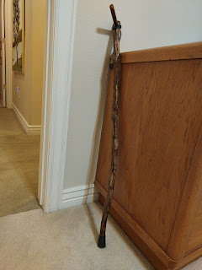

The father and daughter were so sweet and gentle with everything they did. When they spoke, it was generally in a hushed voice or a whisper, especially as they carefully and lovingly moved his body onto the gurney for transport.

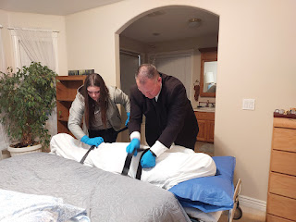

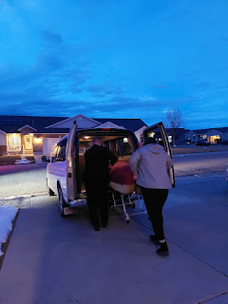

I spent a little time that evening before I left, taking a few photos of things exactly as they were, before they got moved or put away. His desk, for example, where he kept meticulous notes every day about what needed to be done and then checking them off once completed. His inch of room-temperature prune juice still sitting in the small green cup . . . his pills for bedtime . . . etc.

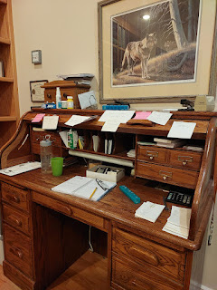

His glasses and daily agenda . . . no longer needed now.

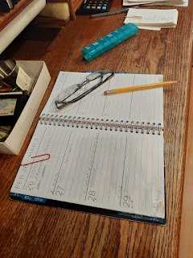

The most recent books he had been reading . . .

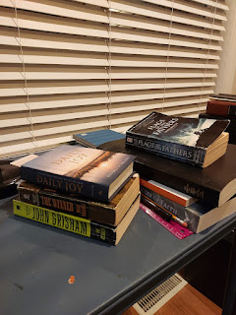

His favorite reading spot . . .

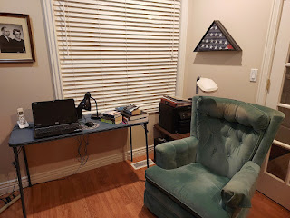

As I drove home a few minutes later, I reached out to Scott's brother, Gordon, and his sister, Carol. And not too long after I got home, Scott finally woke up. He wasn't supposed to be awake yet, but he had woken up anyway. I'm glad he did, though, because it brought me a lot of relief to know that he finally knew. Benson had also called me while I was in Rigby. He had gotten the message from Amber and wanted to check in. He was a bit emotional, perhaps because he wasn't able to participate in any part of Grandma's funeral last year (he was in Italy serving in the Air Force), but also he was probably emotional simply because he loved Grandpa.

Scott told me later that as he sent out some treasured photos of his parents that night to a variety of family members (including us), he cried. Not so much out of sadness, but out of joy that his parents were now back together in heaven, rejoicing. How precious.

I stayed up late texting back and forth with him as he packed up and then headed off to the Bristol Airport with his colleagues to fly back to Italy. We finally had a chance to do a video call while he sat in the airport for several hours. He had me try to call the Red Cross so he could start the process to line up a plane ticket to get home, but no matter which number I called, they always ended up hanging up on me, announcing that they were currently closed (even though their website says they are available 24 hours a day, 7 days a week). He said he would take care of it himself while I slept during the night. And sure enough, by the time I woke up the next morning, he had everything all taken care of.

I drove up to Rigby again that next morning, after some phone calls and details were taken care of from home, because I told Bev I would come and help do some cleaning so she didn't have to. The March 1st Snowmageddon had begun in Eastern Idaho, but that didn't stop me, ha ha. I wanted to DO something, especially since I hadn't been there when Mom died. Everyone else had to do the hard stuff back then. This was my turn to do something helpful.

I vacuumed, dusted, and swept. I cleaned the bathrooms and wiped down the kitchen counters. I sorted through Dad's office, stopping to read and enjoy some things along the way.

Dad was a list maker and as his memory started to fade, he kept careful notecards of all of the family groupings. Whenever family members would stop by for a visit, he could put that particular notecard in his shirt pocket to refer to. Family was important to him, especially keeping the details of their lives straight.

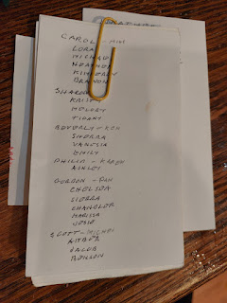

While Dad was most likely on the autism spectrum, he also came from an era where the wife did all the cooking and the husband read the newspaper or watched TV or, in his case, corrected papers in his office. He didn't know how to do much in the kitchen at all, and I found a few notecards with step-by-step instructions on how to make things like: toast, French toast, scrambled eggs, oatmeal, etc.

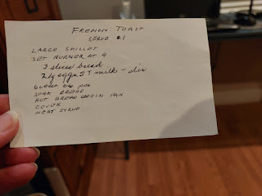

While I cleaned a little here and a little there, I was always looking for something to photograph, to capture moments and a little essence of his life and his personality.

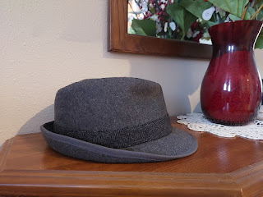

He had a secret stash of Oreo cookies and chocolates in his office. But I didn't know that he had such an attachment to wafer cookies! He had several packages stacked up on the bookshelves next to his desk, with plenty of crumby evidence that he had been enjoying them immensely.

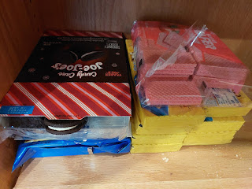

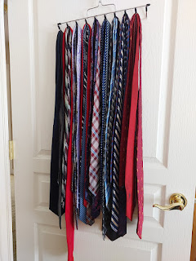

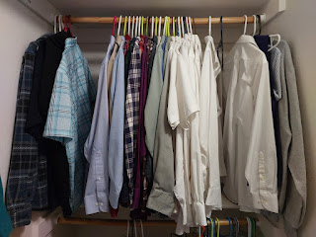

His napping couch . . .

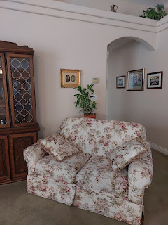

He loved to play chess many times with his grandchildren when he had a little more energy to do so in younger years.

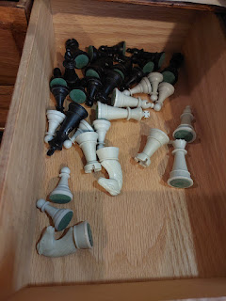

In his top right desk drawer, amongst the cough drops and eyeglass cleaner, was his treasured pocket watch . . .

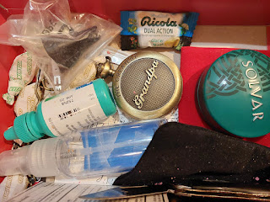

I took this sweet photo of him holding it last summer. He loved that watch, although he couldn't remember which of his grandchildren had given it to him . . .

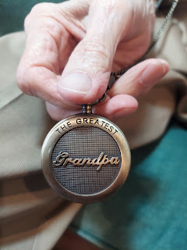

He diligently wrote in his journal every single day. For DECADES. There are so many volumes of his journals that we will have to figure out what to do with all of them. Perhaps we will scan them. Or perhaps not. I'll see what his kids would like to do, and if they want them scanned, I can take care of that. Here are the brief notes he made during the last few days of his life. (click photos to enlarge)

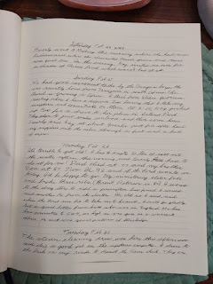

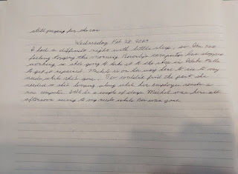

Music meant a great deal to him, most likely because his father, Wesley, was an accomplished musician, music teacher, and symphony conductor. Wes played every musical instrument, it seemed, including the piano, violin, oboe, French horn, and many others. I found this note card listing some of Dad's favorite violinists and pianists.

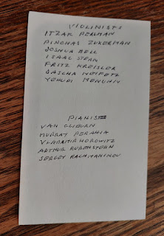

He loved poetry and pretty much all literature, especially English literature. When I say English, I mean, writers from England. Here is a small list of his favorite romantic poets.

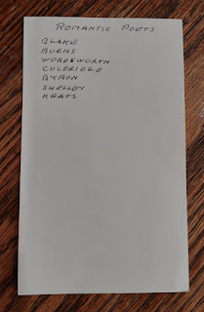

Other note cards with references to the likes of Plato and Socrates . . .

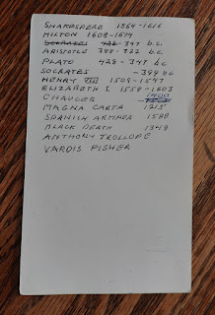

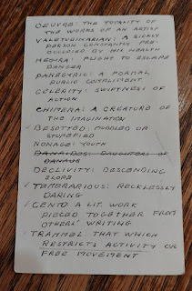

This is his Priesthood Line of Authority. It lists who ordained him to the office of the Melchizedek Priesthood, and who ordained that person, and who ordained that person, etc. All the way back to the Savior Jesus Christ, Himself.

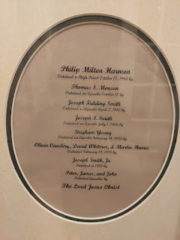

And here is where his story ends. Or begins, rather. The next phase of eternity has commenced for my wonderful father-in-law. He is certainly as joyful as this photo conveys, we know that for a fact. He is reunited with his best friend, he is at peace, and he is out of his failing body. He can now move on with his gospel education and pursue many great and wonderful things in heaven.

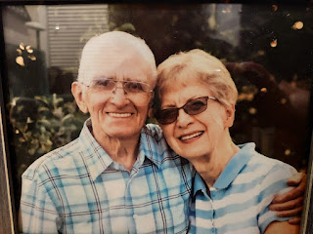
I will miss him a great deal. He was always a true gentleman to me. Whenever I came over, he would always offer to take my coat and even helped me take it off so he could hang it in the closet for me. He was always curious about where everyone was in my family, and how they were each doing. Education was important to him, and he inspired me to want to try harder in all of my endeavors.
He had a profound love for the Gospel of Jesus Christ, and he set a good example of diligence, personal study, and following God's commandments. He had a strong sense of justice and to him, choosing the right was a no-brainer. His love for beautiful music and beautiful walks in nature I will always remember. I loved his ability to organize his thoughts, how he kept track of his to-do lists, and then how he always kept his word. He had a lot of love in his heart for his family, even if he had a hard time showing it at times. We all knew deep down that he did love us, in his own special way.

I will miss his cute smile, the occasional twinkle in his eye, and the stories he would share of his younger years. I will miss his kindness and concern over all of us, his beloved family. He was a good man.

Funeral services are pending, but the date will be Saturday, March 9th at Eckersell Funeral Home in Rigby, Idaho.

