Romeo & Juliet, Fish Heads, and a Paper Museum
Last Sunday
, Scott and I had the pleasure of exploring the castles that inspired the story of Romeo and Juliet. They are both only about 25 minutes away from our house in Vicenza, and was an easy evening escape.
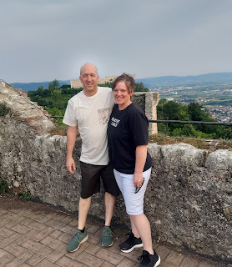

This is the gorgeous view from atop Romeo's Castle in Montecchio Maggiore.

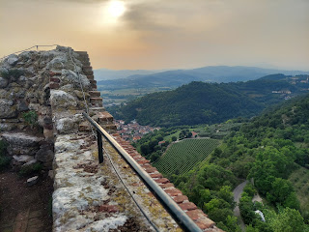

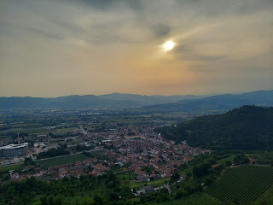

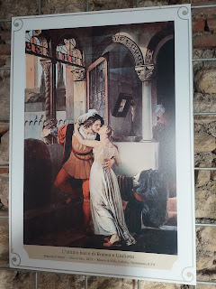

The majestic view as we walked from the short distance from our car to the castle - -

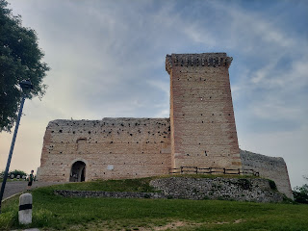

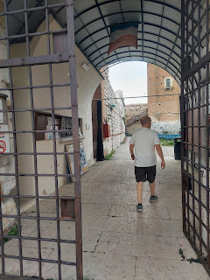

"Castles of Juliet and Romeo"

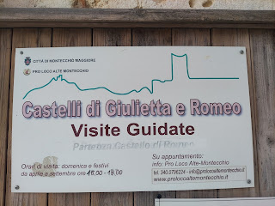

It was exciting to see that they have a large open amphitheater area with a stage and several rows of seating. I think they have a few presentations throughout the year. I'll have to see when their next performance will be . . .

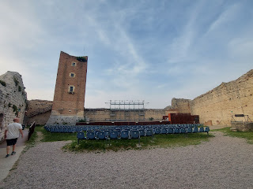

Video of the stage and amphitheater: (17 seconds)
https://photos.app.goo.gl/6AduKCWoi3JUgE1Z7

A steep set of stairs led us up to the entrance of the tower.

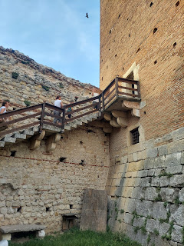

My own handsome Romeo, professing his "undying love and affliction" for me, ha ha. (Remember the quote from the movie "Little Rascals"?)

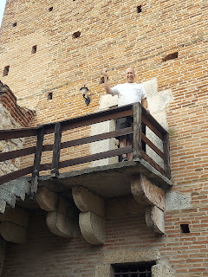

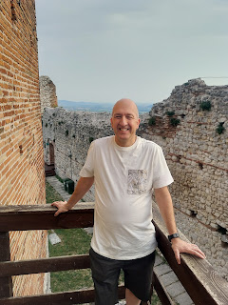

Partway up the several flights of teeny-tiny stairs - the view looking down at the amphitheater (I just needed a place to catch my breath)

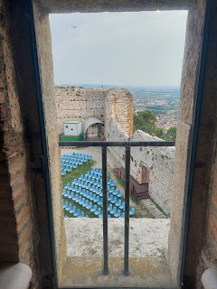

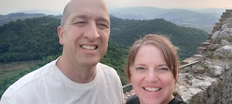

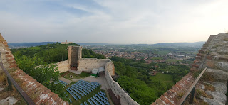

Video of the valley from atop Romeo's Tower: (27 seconds) *At the end you'll see Juliet's Castle not too far away.
https://photos.app.goo.gl/ZVYVdgakctXDdqGp8

After the steep descent down all the numerous wooden stairwells, we went down the road to see Juliet's Castle, about a 5 minute walk.

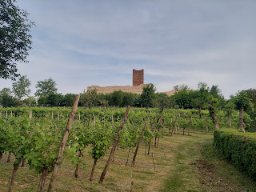

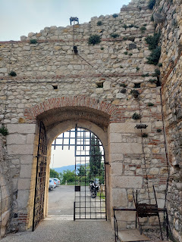

From atop Juliet's Castle, you can see Romeo's Castle and all the splendor of the valley for miles and miles.

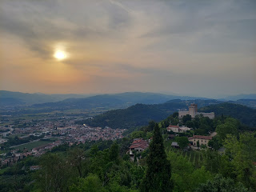

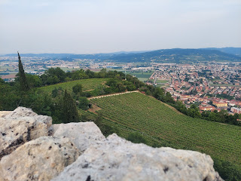

Interestingly, there is at least one restaurant in Juliet's Castle, and it was filled with lively music and conversations. I suppose if you wanted to, you could reserve the entire space for a wedding reception. Wow.

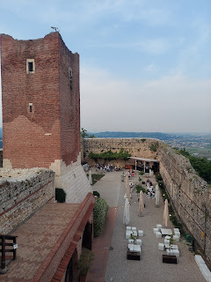

Video #1 from the top - SORRY for my heavy breathing, ha ha. I had just arrived at the top of the stairs and was taking it all in . . . (40 seconds)
https://photos.app.goo.gl/spU89o3fykkrSThB7

Video #2 from the top: (25 seconds) *Completing the view from the top, and ending with seeing Romeo's Castle off in the distance.
https://photos.app.goo.gl/LHoomaaU6xspW366A

I was in symmetry heaven with this photo heading back to where we parked. I just love vineyards and how perfectly each row is laid out, not to mention how beautiful they are during each season of the year.

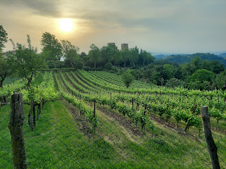

There is a man named Luigi Da Porto who is purported to have written a story that inspired the famous tale of "Romeo & Juliet" later on. He was born in Vicenza in 1485, served in a war at some point where he was injured and paralyzed, and lived in a villa in Montecchio Maggiore where he could see the two nearby castles from his window. He, himself, was in love with a woman named Lucina, but when he came home disabled from the war, she married someone else. You can read more about him on Wikipedia or Google, but what a fascinating, yet tragic, story of his own life.

Here is a website with some compelling behind-the-scenes information regarding the life and love of Luigi Da Porto:

http://www.veronissima.com/en/romeo-juliet-true-story.html

Monday:
I had the privilege of attending a brunch and a floral arranging class offered by Marnie Parker, a lady in our military ward here. Her husband is in the new bishopric and now serves with my husband. Her house is up on a steep hill south of Vicenza and wow, the views alone are to die for.

See the church tower at the top of this hill below? She lives "spitting distance" from that beautiful church.

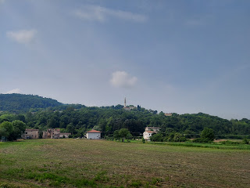

Back in the U.S., Marnie has worked as a florist and wanted to teach us some of the skills that she has learned. We each chipped in $20 to pay for supplies, and she bought everything ahead of time for us. Flowers, flowers, and more flowers, as well as all the beautiful vases to arrange them in.

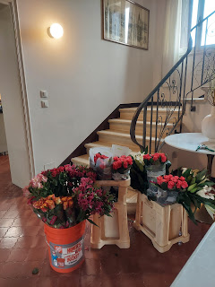

Instantly, my eyes were drawn to these beautiful yellow roses, and I was lucky to be able to work with them to make my flower arrangement.

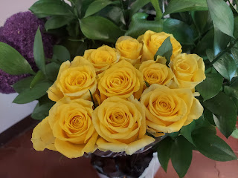

But first - the FOOD. Everyone brought something to share and it was so lovely. There were so many things to choose from: French toast casserole, pasta salad, crescent rolls with chicken salad, strawberry salad, pumpkin scones, brownies, cinnamon rolls, and fresh fruit. I brought the big yellow bowl full of fruit - it almost didn't make the photo.

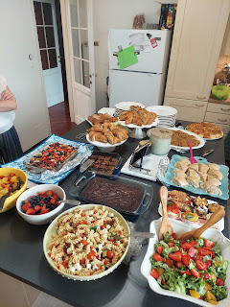

I had a wonderful time visiting with the ladies at my brunch table indoors, while the rest of the ladies sat together outside. There were about 16 of us in all. I got to know some new faces in my group. Several of them are married to military servicemen here in Vicenza and Marnie knows them through other social groups. They are sweet and kind and strong and amazing. I am so grateful that I got to meet them.

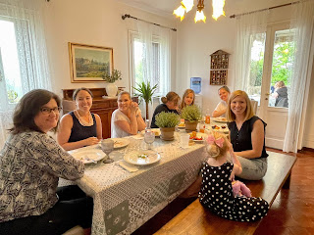

Once we finished eating and got the kitchen tidied up a bit, Marnie began helping us to pick out our flowers, one person at a time. She had us choose a grouping of roses, something else for the focus (such as iris or lilies), and then she added some "fillers" that would compliment the colors we had already chosen.

This is Marnie. She is such a delight and is always so positive and cheerful every time I see her.

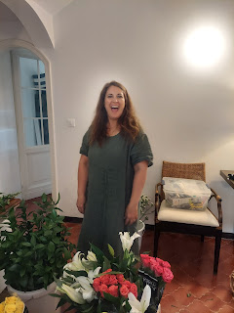

Here we are, all lined up with our flower bunches and ready to get started.

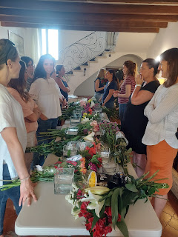

I've done my own flower arranging many times over the years, but I learned a few new things from Marnie. I learned that as you place your flowers in the vase, you need to criss-cross the stems as you set each one in, to form sort of a braided or weaving technique. This helps everything to stay put as you add more and more stems.

Snip the stems at an angle so they can drink the water more efficiently.

Trim the flowers to the same height to make them all uniform and to be just slightly above the top edge of the vase.

You can pack a lot of flowers in a square vase. Just do one bunch at a time, one stem at a time.

Here are a few of us with our completed floral arrangements.

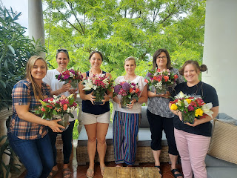

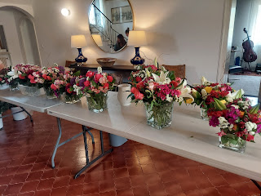

This is my beautiful arrangement that made it home safe and sound, and now sits in my living room.

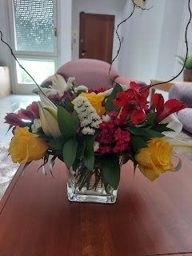

Another tip: because the flower stems are all interwoven, when it comes time to change out the water each day, all you have to do is gently gather the entire bunch to lift it out. Have someone else dump out the water and fill it with fresh water, then you can gently place the entire bunch back into the vase. Only minimal touch-ups are needed at this point, making sure that each stem is submerged in the water. Voila!

What a wonderful way to start the week! I'm so glad I was able to be a part of this whole experience. When I told Amber about it the next day, she said that this is something on her wish list of experiences to do in Europe someday. I had no idea! Well, now I know someone who can help her to check this off her list! :)

Tuesday:
I did a little bit of shopping, including visiting the Bimbo Toy Store for the first time, ha ha.

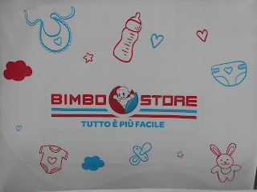

It's like a Toys R Us store, Italian style.

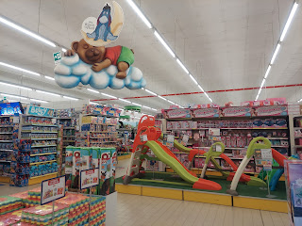

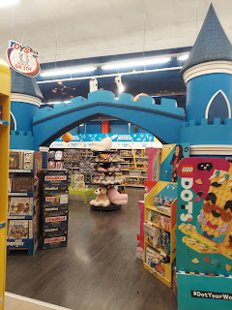

I bought a floor puzzle, along with some cars and trucks for the rug upstairs when my grandchildren finally come for a visit.

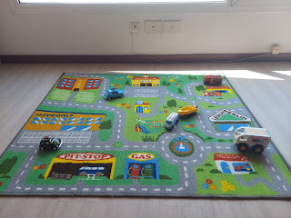

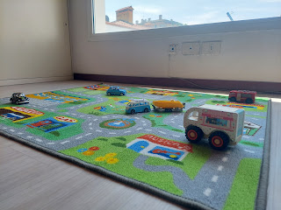

I had a HEART-BREAKING experience as I was paying for my things and leaving the store. There was a little girl, maybe 10 years old, near the exit while I was at the register. She indicated to the cashier that the vending machine wasn't working and she couldn't get her bottle of water to come out. The cashier, in a frustrated tone of voice, spoke rapidly to her in Italian, but didn't offer in any way to go over and help the girl. I thought, maybe the cashier was tired or in a bad mood or something . . .

As I finished paying for my things and started to walk out of the store, the girl indicated to
me
that she needed help. The language barrier was real. She began doing a charades sort of thing, acting out with several rapid motions that she needed money, that her mom was hungry, etc. I reached into my little coin purse to see what I could offer. As I pulled out a small palmful of euros with various values, she instantly began picking out all the European coins and left the American quarter, dime, and pennies that I also pulled out. She didn't even hesitate! I was going to choose some to give to her, but she plucked them all out of my hand herself. Then she indicated - using gestures - that she wanted paper money. I told her I was sorry, but all I had was American money. That's when the cashier lady came over and scolded the girl in Italian and basically sent her on her way.

I walked out to my car, wondering if there was anything more I could or should do. As I started up the motor, I heard a tapping on my driver side window. This same little girl was right there next to me, indicating again with actions and gestures that she wanted paper money from me. As I shyly shook my head, telling her I didn't have anything more to give her, the cashier lady came out of the store and stood there, imposingly, and said a few more words to the girl, loud enough for her to hear across the parking lot. The girl ran away and I sat there for a moment, in awe of the whole situation.

As I slowly drove out of the parking lot and down the street, one more time the girl appeared. She was running down the sidewalk after me, asking me for money still!! My heart was breaking!! I knew enough about the culture here in Italy to understand at this point that the girl was most likely a Roma, or a gypsy girl. They are despised here, and have been for generations. It is so sad.

The Roma came to Italy a long time ago and I think they were refugees of some sort, coming from Romania and Eastern Europe. As you can imagine, if a people live in poverty for a long time, it is hard to break that cycle unless they catch some sort of break. The reputation they have had after all these years is that they are nothing more than thieves. They are seen as annoyances, uneducated, deceitful, and vagrants. As soon as I heard the cashier speaking to this girl in that annoyed tone of voice, I had an inkling that the girl was Roma.

I am not sure to what extent the girl was being deceitful, and it doesn't really matter. It was powerfully crushing to my heart to have to drive away from a CHILD who was asking for help. I've never been faced with that kind of situation in my entire life. I've had adults ask me for money all over the world, some I am able to help, some I don't feel right about helping, but I always try to say a little prayer for each person, whether I am able to help them with money or not. I recognize that money is not the best answer in many cases, and that there are a variety of local agencies and programs to help the homeless and destitute. But a CHILD??? Wow. This whole experience affected me very deeply.

At one point, I was trying to pull up Google Translate on my phone so I could communicate better with the girl, but that was when the cashier basically chased her away with her angry tone of voice and I didn't even get the chance. I would have liked to know more about the situation and why she was begging for money. Yes, maybe she had been taught to beg for the family, knowing that someone like me (an American woman with a soft heart) would likely provide some assistance. But I was so torn, wondering what the right thing to do actually was. I still don't have any firm answers yet.

Wednesday:
My Uncle Andy Rosetta emailed me a picture of my Grandma Zoe that I had never seen before. It was in a picture frame, so there is a slight glare, but my goodness what a beautiful woman she was!! He didn't know where the photo was originally taken or what year it was taken. She looks to be quite young, though.

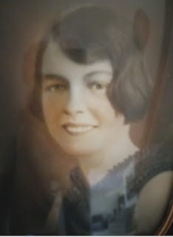

The Sister Missionaries over here in Vicenza texted me first thing in the morning and asked if could pick them up at the train station at 2:00. Of course I could! Transfers had just taken place, with Sister Wilding heading out to another area in Italy and Sister Dansie coming in. When I met them at the station, I learned that Sister Stephenson had crashed her bike the day before and was pretty banged up. Her wrist was quite sore and she had limited ability to move it, so we decided to take her to the medical clinic on base. She has her own military ID and would therefore be able to access the services on base.

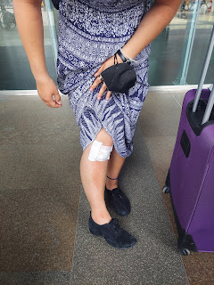

She tried to appear as cheery as possible, even though I'm sure she was in more pain than she wanted to admit. We sent this photo (below) to her parents so they wouldn't worry as much, and then we headed over to the base across town. Sister Dansie doesn't have a military ID, so we had to stop at the office just inside the gate and then wait in line for a while to get her a pass. Then we could proceed to the clinic from there.

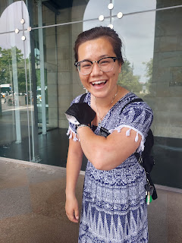

The nurse wanted Sister Stephenson to get a couple of x-rays and then see the doctor in the morning, since they were finishing up at the clinic at this point. We got the x-rays and then I offered to take them to get a few things at the PX (such as a wrist brace) and some groceries at the Commissary, which we did, and then I took them home for the night.

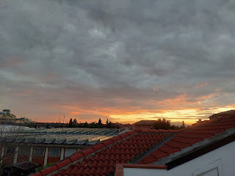

Thursday:
I hustled across town just after 8:00 a.m. so I could pick the sister missionaries up and get them back to the base by 9:00 a.m. for Sister Stephenson's follow-up appointment. It didn't take quite as long this time to get Sister Dansie a pass to be on the base, which was nice, especially since we were in a hurry.

I dropped them off at the clinic and then ran a couple errands of my own while they saw the doctor. It turned out that she did, indeed, have a fracture in her wrist. Poor thing! Meanwhile, I drove a few kilometers north of the base to try to make a haircut appointment at Salone Dimensione. The salon, and the owner (Antoinella), were highly recommended to me because she does such a great job and she speaks really good English! That's an important element when you're about to entrust your hairdo to a total stranger, ha ha. I was able to make the appointment, but unfortunately it's not until June 10th . . .

As I pulled out of the salon parking lot, I noticed this beautiful park across the street and decided to go investigate while I waited for a text from the sister missionaries.

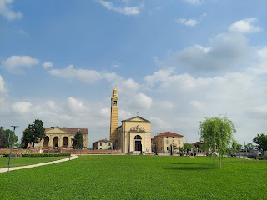

I got about this far when the text came in, letting me know they were all done. I didn't get to find out what this beautiful building was, but I know where it is for the next time I go out that way. :)

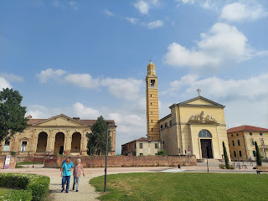

I did, however, get a photo opportunity that I've been waiting a long time for. One of my favorite things about Italy is to see the sweet, elderly people that are always out walking everywhere. I am just so impressed with how adventurous and capable they are at their age. They are on bicycles, they are carrying bags of groceries down the street, they are hopping on and off buses, and some are just out for a leisurely stroll to get some exercise or to get today's paper down at the corner vendor.

These three were arm in arm, helping each other enjoy a nice walk in the morning sunshine. I think the lady in the turquoise shirt might have been a caregiver to the older man and woman. They were very cheery and responded enthusiastically to my greeting of "Buon giorno!"

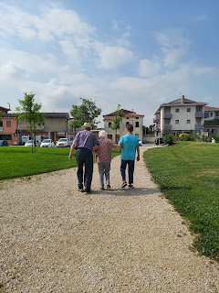

I picked the sisters up and delivered them across town to their apartment just in time before they had a training meeting on Zoom. Sister Stephenson needed a splint for her wrist, but the person to take care of that wouldn't be available until after 1:00 p.m.

I drove home, had a light lunch, and worked on some upcoming travel plans before heading back to pick the missionaries up again. When I went down to the courtyard to get into the car, this cute little guy was hanging out on the wall next to me. :)

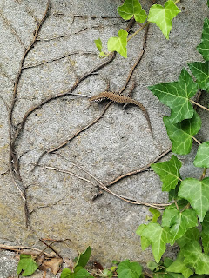

I have gotten MUCH more comfortable with driving around Italy over the past week. It feels more normal to me to run errands and I don't feel anxious at all anymore. Hooray! I zipped and zinged through all the roundabouts, twists, and turns to get across town and back multiple times without any problems. :)

While the sisters were getting the splint taken care of, I stopped at the post office on base to mail a package to Avery. You may have heard about the baby formula shortage that's been going on for the past several months . . . first there were some production issues due to Covid, and then there were some contamination issues at a couple of formula plants and they had to be shut down until the problem could be resolved. Moms have been struggling to find specific brands of baby formula to feed their babies, some even having to drive several hours to get a couple of canisters in another city because there weren't any of that kind in their hometown. Well, Avery is sensitive to a few brands of formula, and the kind that she tolerates well has been in short supply in Aviano for a while now.

I offered to look for some in our Commissary and sure enough, the shelf was substantially stocked with the kind she needs, so I picked up several cans (per Kylie's advice) to get to them somehow. Kylie and I discussed some options on how to meet up for the exchange, but since Scott and I were going out of town for the weekend, I decided to just mail them.

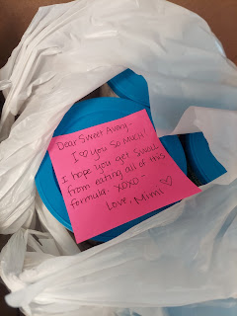

Funny story:
First, I learned that I could mail a box from an APO address to another APO address for FREE!! The postal workers directed me to the library next door where I could choose a previously shipped brown box and get it all taped shut (picture a huge stack of Amazon boxes to choose from). When I went back to the post office around the corner and got it all taken care of, I asked one last question before I left. "So, how long will this take to get up to Aviano? A day or two?" Umm, about one and a half to two weeks was the answer . . .

Apparently, in order for the Italians to get paid for their mail courier services, the package has to LEAVE the country and then RE-ENTER the country. So my little box of formula has to go from Vicenza to Milan, Milan to London, then London back to Milan, and then finally Milan to Aviano. WOW.

Thankfully Kylie has enough formula to feed Avery while she waits for this package to arrive.

I chatted with her for a few minutes to let her know about the package coming. They are doing well. Benson had to work during the 4-day weekend, so unfortunately this didn't allow them to get out and do much.

Kylie sent us a cute video of Avery nonchalantly slurping on a clothing tag, while Kylie tries to convince her to stop. She is completely unfazed. (1 min, 6 sec)
https://photos.app.goo.gl/7dwzxwEeXSvqXWX26

I was happy to see that Avery enjoys being on her tummy now, something she used to hate with a passion, according to her mother. She seemed quite comfortable on her belly in the video. :)

After I picked up the missionaries again, I took them to get some gelato before taking them home. We had the BEST time talking and sharing life stories for a long time together. They are pretty awesome young ladies and I'm so grateful that we had that time to spend over those two days. :)

Me, Sister Dansie, and Sister Stephenson

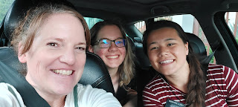

Friday:
Scott and I headed off for a weekend adventure to Lake Garda, Italy. It's about 90 minutes west of Vicenza and is the largest lake in all of Italy. The area is exquisite and beautiful and charming, with all of its quant little villages sprinkled along the edge of the lake. The southern tip of the Dolomites can be seen from the Lake as well.

Video coming into Toscolano-Maderno (a peninsula on the SW side of Lake Garda): (27 seconds)
https://photos.app.goo.gl/eM8VoMDJKvqhmLHc7

Video along the Promenade - or boardwalk - also coming into the town where we stayed: (27 seconds)
https://photos.app.goo.gl/bPsT8DGLWmrG18LX9
(*We explored this same Promenade on Memorial Day before heading back to Vicenza)

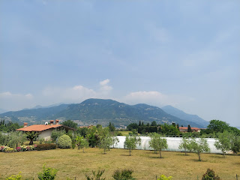

As we got closer to our AirBnB, we had a little bit of trouble navigating through the NARROW "streets" in our car. Honestly, can they even be called streets??

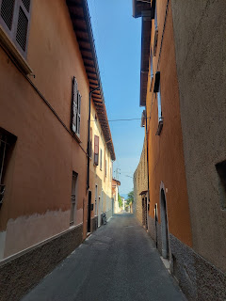

At one point, the GPS wanted him to turn down this "alley" (below), but um, I think not, ha ha. As you can see, it's barely wider than Scott's wing span . . .

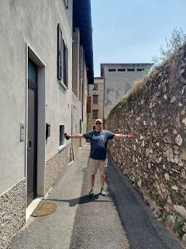

We found another way. A much better way. After we lugged all our belongings up 3 flights of stairs, we had a little snack to rest and cool off for a bit before heading out on a walk.

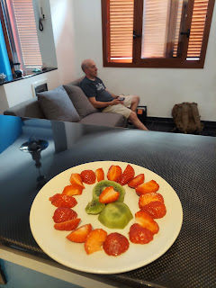

A video tour of the AirBnB: (1 min, 27 seconds)
https://photos.app.goo.gl/Bv14xyvVbpYuh8i6A

View from our terrace looking out to the Lake - - (it was a hazy and very warm day)

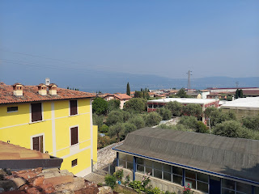

View from our kitchen window looking toward the Dolomites (barely seen on the right) - -

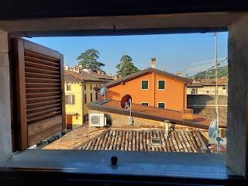

On our walk down to the Lake, I couldn't help but take a photo of this cute little vintage car.

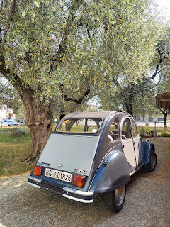

Bau Beach - at Toscolano-Maderno

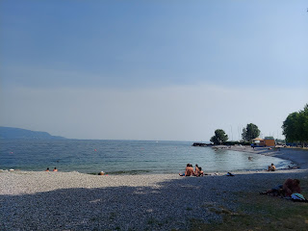

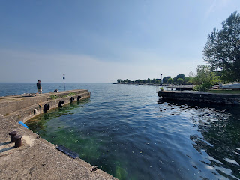

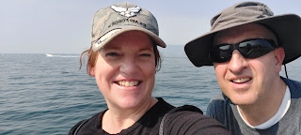

It was a toasty 85 degrees with who knows how much humidity. Sweat was literally dripping down my back, ha ha. We stopped at one point to get some gelato and just sit in a chair for a bit to watch the passersby.

Video (27 seconds)
https://photos.app.goo.gl/bRGujqxmVdFReiSP9

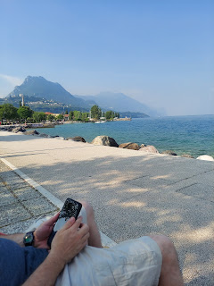

I just love the jolly older generation who walk everywhere, ride bicycles everywhere, and just keep on going. :)

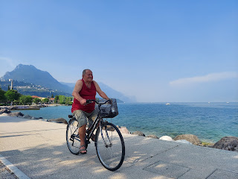

We walked through the main gate at the huge RV park and campground on our way back into town so we could get a few groceries. I liked the view looking toward the mountains.

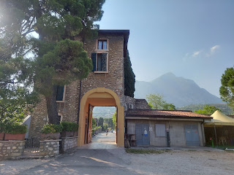

Scott helped me identify these gorgeous flowers we saw along the way by using Google Assistant and the camera on our smartphone.

This is a French Hydrangea - (perhaps my new #1 favorite flower)

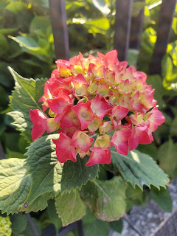

Oleander

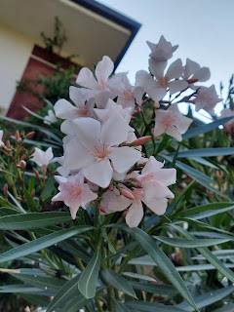

Beautiful old doors on the main road back to our AirBnB . . .

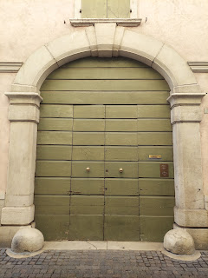

Something I noticed for the first time was that all over town there are obituary posters plastered on the ancient walls. People stop to read them and see who died and when their funeral or memorial will be. The posters usually have a photo of the deceased, along with their age. We noted that most of the people on the posters all died at a good old age: mostly in their 80's and 90's. This town only has a population of 7,877, so I would imagine they keep pretty good tabs on each other.

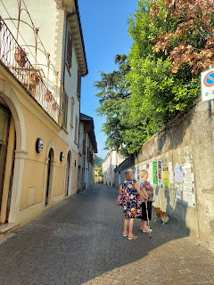

Ohh, the bright red Vespas of Italy. If only they could talk . . . what stories they could tell.

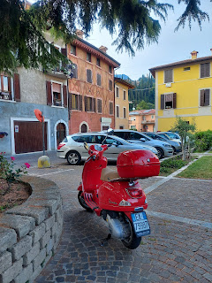

In the photo above, you can see our car parked closest to the Vespa, and the entrance to our AirBnB is the little arched brown door across the street. We stayed up at the very top of that building.

After dropping off our groceries, we headed out again (on foot) to find the restaurant where we had made reservations for dinner. It is common to need a reservation here in Italy. It is uncommon to NOT need one. We walked about 17 minutes to get to the restaurant that was tucked into a series of alleys and narrow "streets". It's called Ristorante Pizzeria Gatto Giallo.

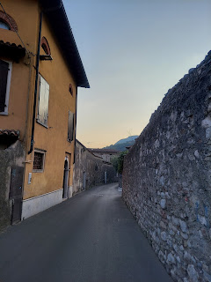

Not sure what this place was along our way, but it was certainly impressive . . .

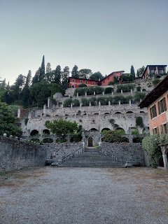

Scott - waiting for a car to come around the blind corner before we proceed on foot. You really have to hug the walls in these skinny streets if you want to live, ha ha.

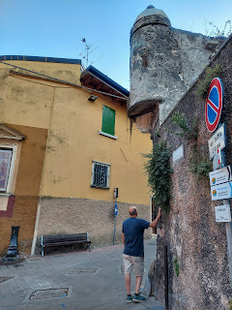

We ordered a shared fish platter, with salmon, tuna, whole prawns, and some type of lake fish . . .

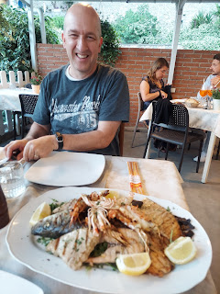

We did a good job of eating all that we could, and then we brought most of the fish home for the following day. It was all really tasty! The grilled eggplant, zucchini, and roasted potatoes were delicious on the side.

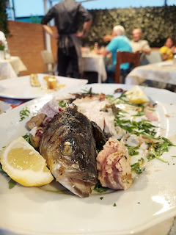

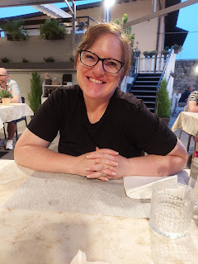

Italians love to eat late in the day. From what I gather, they really don't eat much for breakfast, maybe a pastry or something light with their morning coffee. They get pretty hungry for lunch, though. For dinner, they tend to eat late - maybe 7:00 or 8:00 p.m., and it's a slow and social affair. They have the antipasti - or appetizer. Then the first course - usually something with pasta. Then the second course - or the main dish. Eventually, a dessert. And finally a coffee to finish it all off. It takes about 2 hours if you choose all of the steps.

Well, we are American, and we usually just get right to it, ha ha. We just order the second course and call it good. It still takes a while to finish the meal, though, because everyone is just more relaxed here and there isn't such a rush to hurry and move on to the next thing.

By the time we did finish our meal, it was getting quite dark. Luckily, we made it home before it was pitch black, so that's good. :)

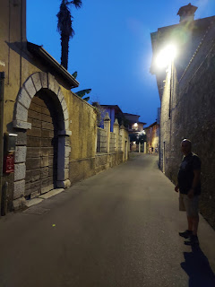

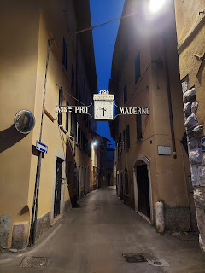

The view from our terrace, looking out toward Lake Garda and to the towns on the opposite side. What a beautiful sight!

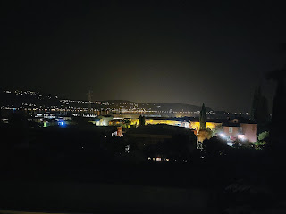

Saturday:
We woke up to some cooler weather, which was FABULOUS, since we would be doing a longer walk up to the Museo della Carta (Paper Museum), about a 20 minute walk up the hill from our AirBnB.

We passed an almost fully ripe apricot tree on the left. It reminded me of how glad I am that we cut down the biggest apricot tree in our front yard back home before Scott left in March. I won't have 3 million apricots to pick up off the sidewalk this summer - what a treat!

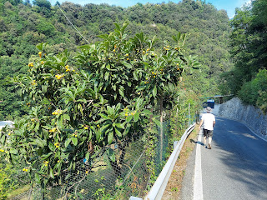

Valle Delle Cartiere = Valley of the Paper Mills

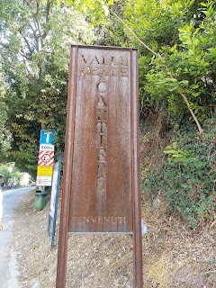

Mills and homes were contructed in this gorge, along the Toscolano River, as far back as the 1300's.

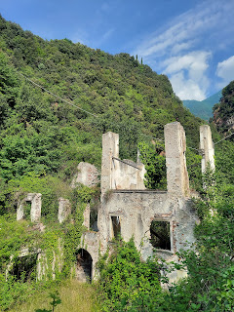

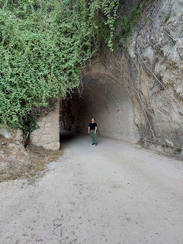

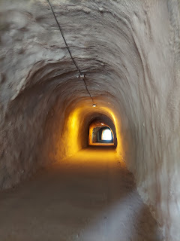

The Paper Museum is housed inside the last paper mill that ceased production in 1962, and is open to the public for tours.

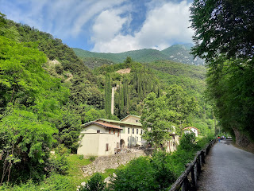

Here are a few bits of information about the history of the Paper Mills, from signs found along the outdoor trail leading to the Museum.

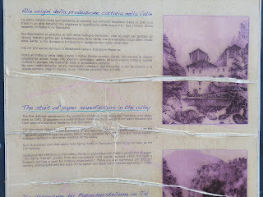

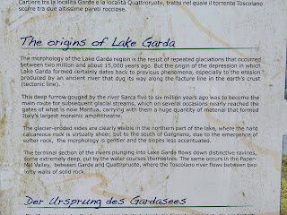

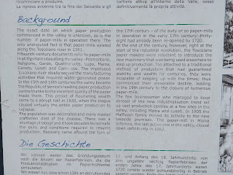

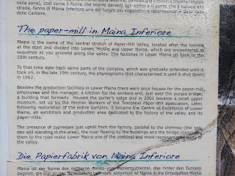

Crossing the bridge over the stream to get to the Museum.

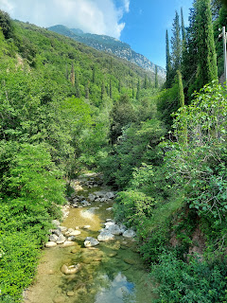

Scott, my adventurous and curious companion, was way out in front of me. I am usually slower, because I'm the one taking all the pictures. :)

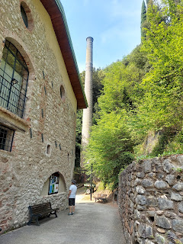

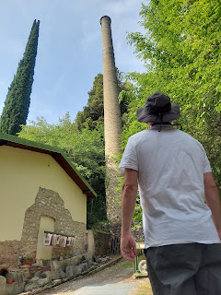

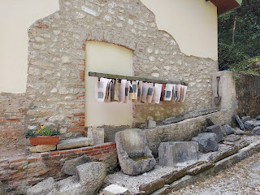

Admission was only 7 euros per person and the tour is self-guided. We spent about an hour, or maybe slightly more in all, and it felt just right for us.

I took a LOT of photos - so if you'd like to know more, they can all be found here in a Google photo album:

https://photos.app.goo.gl/GQxbRYVtxTG3KsRC8

As we toured the Paper Museum, I had a couple of people on my mind as I took all of the photos:
My niece Ashley Reese, who loves books and has her own ancient printing press that she cleaned and fixed up all on her own. She also just recently opened up a bookstore in Spokane.
My father-in-law, Phil, who also loves books and was an English and Shakespeare professor for most of his career. He loves geology and has a natural curiosity for many things that exist in this world. :)
Myself. Ha ha, this might throw you off, but I have trouble processing what I'm reading on the signage when I'm actually right there reading it. I struggle with the desire to learn and understand and retain all the info, at the same time as I am eager to press on and see what the next thing is. If someone is waiting to read the sign that I'm standing in front of, it adds to the problem and all I can think about is the need to hurry up and get out of their way. So, for me it's best to take the photos and then when it's quiet later on, I go back and read all of the information at my own pace while sitting at my computer. It really does help.
Anyone else who might be interested in this sort of thing but isn't able to travel to this little corner of the world to see it with their own eyeballs.
Here are a few additional photos that I enjoyed capturing throughout our tour.

Rags were sorted by color and soaked to form a gooey pulp that helped to form the paper. Whites, lights, and colored. Just like sorting the laundry!

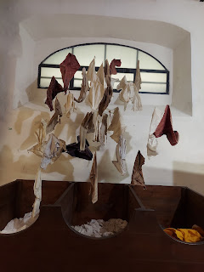

The thick pulp was moved along through a series of vats and tunnels as part of the process.

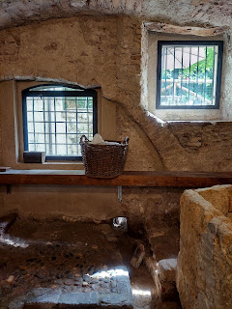

After it was formed and cut, it needed to be hung for a period of time in order to dry.

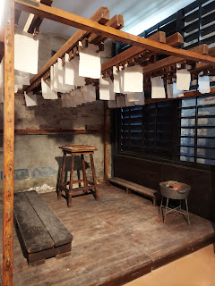

This was a miniature cutout of what the mill would have been like in ancient times.

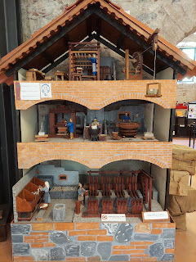

A document from 1495. Oddly, the year was right-side up at the top, but the paper appears to be upside down under the glass.

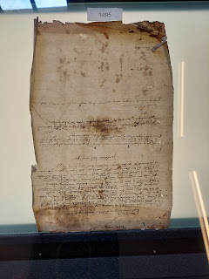

They made the TINIEST and CUTEST books in the Middle Ages. It was helpful, I guess, for people to be able to carry their book in a pocket, so it needed to be small enough to fit.

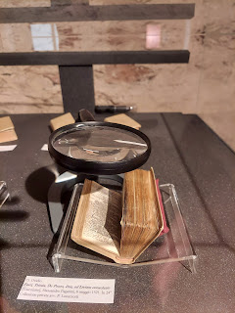

Outside the Museum was a sign that indicated "Toilet". Scott went in to use it, but decided to not use it after all, ha ha. He then DARED me to go use it.

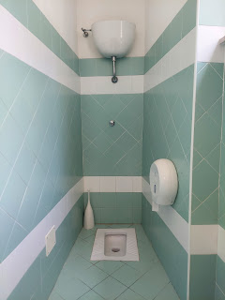

This is a VERY unusual style of toilet . . . OBVIOUSLY!! I learned that they use this style of floor toilet in the Middle East, because Scott saw them pretty often in Saudi Arabia. Jacob also encountered floor toilets when he served his mission in the Philippines. You have to squat to use it, and if you start young, then it's still a piece of cake when you're old. I do not come close to having conditioned knees to be able to accomplish such a feat, so I did not want to try it. For a girl, how do you keep your clothes clean?? There aren't even any handlebars to hold onto either . . . I found it to be quite strange and decided it was not something that I was adventurous enough to try.

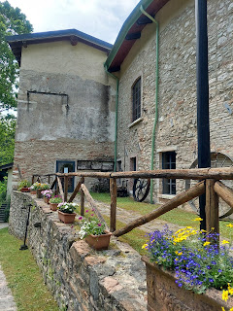

Goodbye beautiful Paper Mill from centuries ago! It was wonderful to learn all about your history and how paper is made!

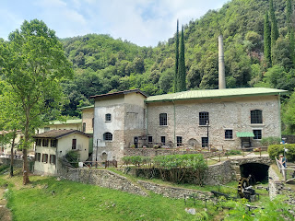

We walked back to our AirBnB and had a snack and a little rest for part of the afternoon. We also spent some time studying for the Sunday School lesson that we were in charge of teaching the next day. Scott was the only member of the bishopric within range to be at church, and due to so many people being gone for the 4-day weekend, no one would be there to teach the youth or the adults in Sunday School. It was decided that the Harmons would teach all of the youth and adults together, whoever showed up for church that day.

The lesson in the Come Follow Me study guide for this year (the Old Testament) was from Joshua 1-8 and chapters 23-24. Wow, there is a lot to digest from those chapters. The miracles, the destruction, the precision in following God's commands, etc. Scott took the largest portion of preparing the lesson and I focused on a smaller part - something that really spoke to me from Joshua 4.

As the Israelites witnessed the amazing miracle of being able to cross over the River Jordan, similar to when Moses parted the Red Sea, they were asked to gather 12 stones (twice). The first 12 stones were taken from the dry river bed and were intended to go with them to their lodging for the night. The second group of 12 stones were placed in the center of the dry river in the place where the priests had stood with the ark of the covenant, and where the people were able to cross over to the other side.

Joshua 4:6-7 (referring to why the stones were needed)

6
That this may be a sign among you,
that
when your
a
children
ask
their fathers
in time to come, saying, What
mean
ye by these stones?
7
Then ye shall answer them, That the waters of Jordan were cut off before the
a
ark
of the covenant of the
Lord
; when it passed over Jordan, the waters of Jordan were cut off: and these stones shall be for a
b
memorial
unto the children of Israel for ever.

They were asked to make a physical memorial to help them remember this loving and miraculous act by God in their behalf, and to ensure that future generations would remember this day forever. It really spoke to my heart because I love family history so much, and I also love mementos and souvenirs of special moments and happenings in my own life and in the lives of my ancestors.

I decided that for my portion of the lesson, I wanted to walk back down to the lake (even though it was stormy and rain was coming) so I could find a rock. I hunted and carefully kept watch for a rock that spoke to me somehow.

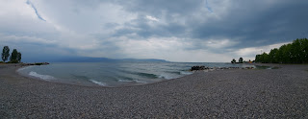

I found one that appeared to be the shape of a large heart. Yep, that was the one I chose.

The next morning when we drove back to Vicenza to attend church, I found a permanent marker to write this message on the back:

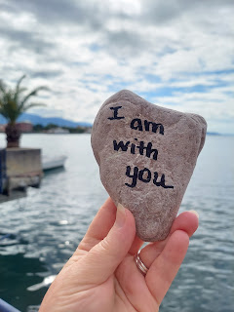

I invited the class members (there were about 40) to think of a time when God had done something special for them. It could have been something miraculous or something subtle. It might have been a time when God comforted them, or taught them something important, or helped them in some way. Then I invited them to find a way to memorialize that experience, not only so that THEY would never forget, but also for future generations, so they could know about that special blessing or miracle as well.

I told them about how when I was young, around 11 years old, our family was going through a difficult time. I remember us all kneeling for family prayer one day, and during the prayer, I felt as though arms were gently surrounding me in a big, yet comforting hug. I knew that my Father in Heaven loved me and that everything would be alright.

I shared how a few years later, when I was about 16, I received my patriarchal blessing. (This is a special blessing that is given by a patriarch who has the gift of prophecy and can declare promises, cautions, or admonitions that apply specifically to each person.) During my patriarchal blessing, he told me, "Your Heavenly Father loves you and there will be times in your life that as you seek Him in prayer, you will feel His love, even almost to the point of feeling His arms around you." He did not know about my special experience that happened when I was 11 years old. But God did. And He wanted me to know and understand the depth of His great love for me.

I wrote on my rock, "I am with you", words that are spoken often in the scriptures. I know that God is with me through every step of my journey through life, and that He loves me in a very profound way. I invited the class, again, to think of something in their life that has demonstrated God's love for them, and to find a way to memorialize it. They could write about the experience in a journal, share something on social media, or create something tangible like I did.

I didn't know that I would cry as I shared this with the class, but I did. I could see that it affected them deeply, too. I hope that they found time later to ponder some of the ways that God has shown them His great love for them and to memorialize that somehow.

After our walk down to the lake, we stopped by the grocery store again to get a couple things for our dinner. We had passed over the river multiple times by now, but this time it was particularly beautiful with the stormy skies off in the distance. Behind the large building, you can see a canyon where the hills are split apart. That's where we walked up the trail to the Paper Museum that morning.

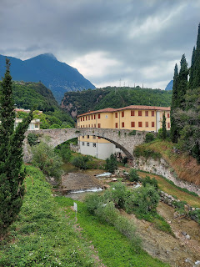

Sunday:
We got up early and left town by 6:45 a.m. to drive back to Vicenza for church. Scott wanted to be there early . . .

Oh, we got there early all right. We unlocked the main door and turned on all the lights.

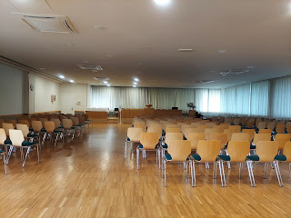

Thankfully, even though we were very short-staffed at church, everything went wonderfully. The talks given during Sacrament meeting were wonderful. And our Sunday School class was wonderful, too. Scott did a great job sharing some historical background and context for the conquests of Joshua and his people.

Something that had been troubling Scott as he prepared for the lesson, was how Joshua had been instructed to take the cities of Jericho and Ai, and then they were told to kill every single person as well. It wasn't enough to just take over the city, but it had to be a
brutal
takeover. It was all very shocking to us. Why would God want something like that to happen?

Some reasons we came up with were:
First of all, these lands had originally belonged to the Israelites. Yes, they had left them a long time ago and went to Egypt during the great famine, and had been gone for about 400 years by this point. But God wanted to give them their land back.
Maybe it wouldn't have been enough to just take the land and try to live simultaneously with the people that had occupied the land for the last 400 years. It would have certainly been problematic and a huge source of contention.
But the best answer of all came from a young serviceman sitting in the back row of the class. He read to us out of 1 Nephi 17:35-38 (in the Book of Mormon, Another Testament of Jesus Christ).

35
Behold, the Lord esteemeth all
a
flesh
in one; he that is
b
righteous
is
c
favored
of God. But behold, this
d
people
had rejected every word of God, and they were ripe in iniquity; and the fulness of the wrath of God was upon them; and the Lord did curse the land against them, and bless it unto our fathers; yea, he did curse it against them unto their destruction, and he did bless it unto our fathers unto their obtaining power over it.
36
Behold, the Lord hath created the
a
earth
that it should be
b
inhabited
; and he hath created his children that they should possess it.
37
And he
a
raiseth
up a righteous nation, and destroyeth the nations of the wicked.
38
And he leadeth away the righteous into precious
a
lands
, and the wicked he
b
destroyeth
, and curseth the land unto them for their sakes.

When he was done reading these verses, Scott very quietly said to the class, "That actually helps me a lot. Thank you." It's still hard to stomach the thought of men, women, AND children being massacred, but we also recognize that God's ways are not our ways, nor our ways His ways. Someday we will understand more fully what His purposes are. Right now we just have to trust in Him, knowing that He has our best interests at heart.

After church we stopped by our house to pick up a few things and make some popcorn. We had been craving popcorn at our AirBnB, but even though we brought our own supplies to make some, there was NO MICROWAVE!! We made 3 batches at our house and put them into a giant grocery sack to take with us. Yay!

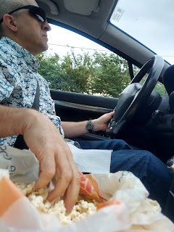

We relaxed for the rest of the day, including me getting to take a short nap, and also chatting with some of our children and grandchildren.

Jack is THE BEST!! He has such a cute personality and laughs so easily. Jacob thoughtfully sent me a photo of Jack in the Italian overalls that I had mailed to them recently.

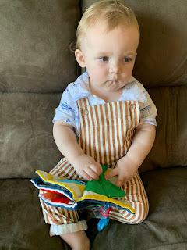

As we talked to Jack, he would just crack up from time to time and laugh out loud. :) XOXO

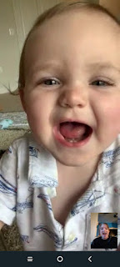

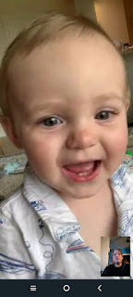

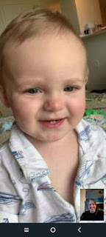

Jack - helping to tune the piano at church in those cute little overalls :)

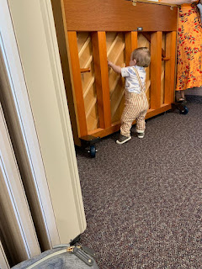

And sitting out in the grass with clothes that match his toy lawnmower.

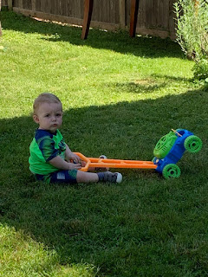

We also spoke to Amber for a little bit, too. She and Weston are figuring out which new refrigerator to get this weekend while things are on sale for Memorial Day. They have had a lot of problems with their fridge ever since they moved in a year ago. It's also 11 years old now and the replacement parts are getting less available and more expensive.

They've been enjoying the start of summer and the girls being out of school. They've also been accomplishing a lot in the yard by clearing things out and hauling the old stuff away. They LOVE having the red truck to take care of things, too!

Gwen always loves to ride around with her dad on the lawn mower. (10 seconds)
https://photos.app.goo.gl/sTEzVvNKY8pXvCPY7

And apparently she's found her new favorite outdoor chore. LOL (15 seconds)
https://photos.app.goo.gl/Xdyp3J4BpqCePmvm8

We also enjoyed a video chat with our friends, the Garners, back in Idaho. They were babysitting their new grandson, who is 3 months old now. We chatted about plans for the fall, since they want to come to Italy for about 10 days in October. Not only did we bless and share a meal together at opposite ends of the world (breakfast for them, dinner for us), but it was raining in Idaho and in Italy, too!!

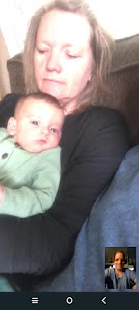

Monday:
Memorial Day. This was the end of our getaway weekend, but we didn't leave town until we saw a few more things first.

A walk along the Promenade next to Lake Garda

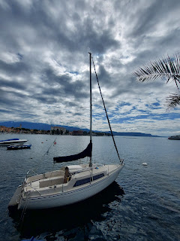

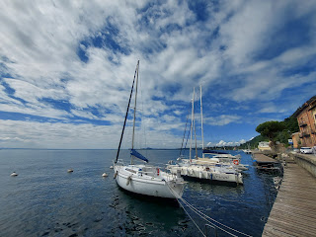

*Those clouds* XOXO

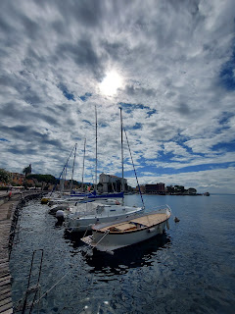

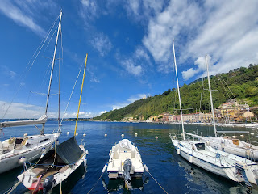

The town of Toscolano-Maderno across the harbor

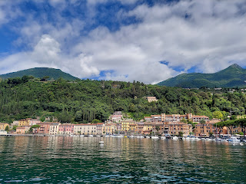

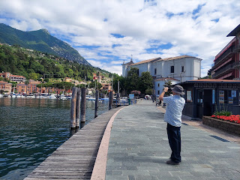

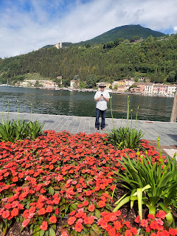

A retired couple heading out to sea . . .

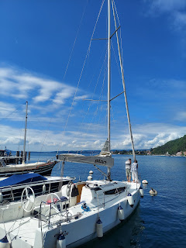

Short video of them leaving the dock: (25 seconds)
https://photos.app.goo.gl/HWEQLhrKhxB4xb4d6

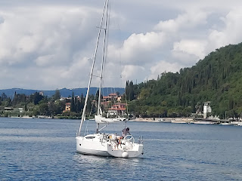

Our last stop was to the Chiesa Parrochiale dei Santo Pietro e Paolo (Catholic Church of St. Peter & Paul). It dates back to the 16th century and has some GORGEOUS paintings on the ceiling by the famous Italian artist, Andrea Celesti.

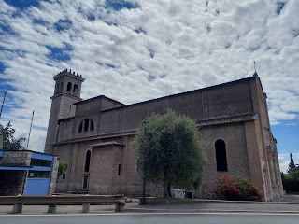

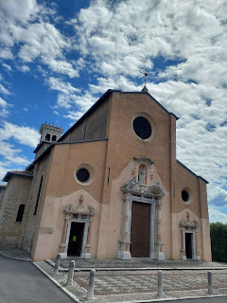

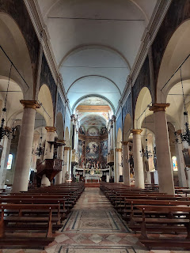

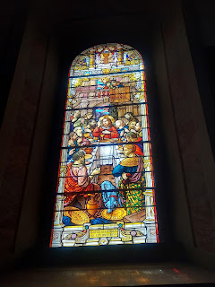

Video showing the work of Andrea Celesti: (16 seconds)
https://photos.app.goo.gl/MP4ftz3TtEZcEgYj9

Wow.

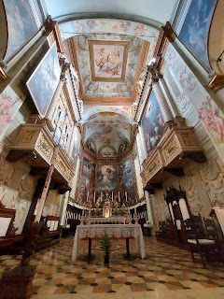

Me, standing by the tower behind the church

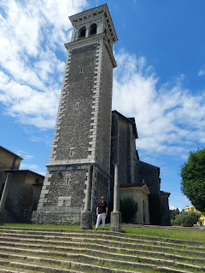

And that's it. That was our week. Hope you had a good one, too!

