Santa, Some Sickos, and Christmas Traditions
While there has been another round of sickness plundering through our house, taking me captive yet again, these sweet photos of Gwen have carried me through a very long week.
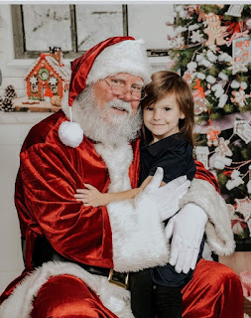

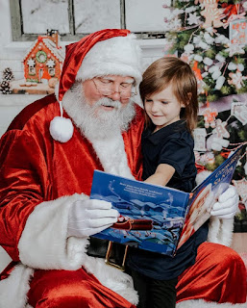

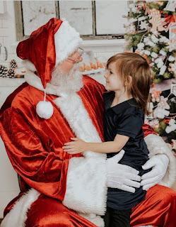

She just looks so happy, so comfortable, and so perfectly at home hanging out with Santa Claus. When Amber asked us a few days ago if she should pay the extra money to keep these photos, I said, "YES!! Go ahead and splurge . . . you won't be sorry several years from now." Sometimes you just need a little something like Gwen and Santa Claus to warm your heart. XOXO

The rest of the week was a blur with a new sickness for me, and in fact, a very strange one. Tuesday evening, while Scott was at the youth activity, I started coughing. Pretty hard. I couldn't stop for the most part, and at times I thought I was going to throw up or crack a rib. I didn't know if it was a sickness at the time, or just some weird fluke.

Wednesday morning, I began canceling all of my fun plans, and made an appointment to see the doctor instead. Scott walked over to the clinic with me to see Dr. Novek (an American doctor with a second clinic within about 3-4 minutes' walk from our house).

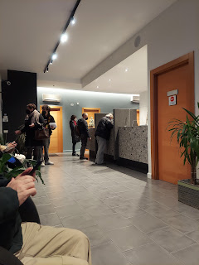

I was diagnosed with Acute Exacerbation of Intermittent Asthma, and was given 2 prescriptions for an inhaler and an additional steroid to help clear things up. He also wrote me an Rx for an antibiotic, advising me to wait a couple of days to see if I felt better first. There was a huge Italian holiday weekend coming up, and things would be closed up for several days, so thankfully he was thinking ahead.

Scott agreed to wait in line at the pharmacy around the corner afterwards, while I went home to get out of the cold and where I could cough to my heart's content within the walls of my own home.

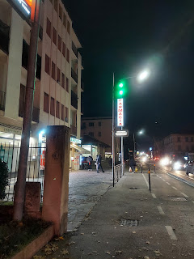

I was extremely disappointed that I could not go to the Relief Society Christmas Dinner Party at Marnie Parker's home that evening. She always makes everything extra special and I knew it was going to be magical and amazing and wonderful. There was going to be a white elephant gift exchange as well, which I haven't done in years. I really love these women, too. They are so amazing and have so many gifts and talents. I really love to rub shoulders and learn what I can as I spend precious time with them. Oh well. Maybe next year . . .

I was supposed to bake some cookies that morning to bring with me, but I had to excuse myself from that too. Sigh.

Thursday, I was supposed to go to lunch with my friend Lasina, but I had to ask for a rain check on that, too. Sigh.

I did, however, get to go to lunch with my friend, Andrea, on Tuesday (before I started getting sick). I hadn't met with her in some time, as our schedules have been too conflicted, so it was especially nice to spend some time with her again. We met at the Mensa Italian cafeteria on base again. They make pretty good Italian food there. I haven't been disappointed yet. :)

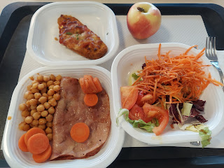

I was pretty hungry this time, and surprisingly I ate all my food for once. I chose a breaded Italian pork cutlet, seasoned chickpeas, carrots, a slice of thick prosciutto ham, and a small salad. Oh, and I always grab an apple for later in the day.

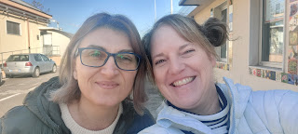

Andrea was able to take her 2 daughters and travel up to Germany for Thanksgiving to visit her husband. She said they spent all day every day at one Christmas Market after another. They would just walk around and enjoy looking at all the booths, eat different samples of foods, and then walk some more. They love the German Christmas Markets, she said. I would love to go one day myself.

My sickness got more strange by Thursday night (2 days after I had lunch with Andrea). In the late afternoon, heading into dinner time, I started shivering and couldn't stop. I had 2 blankets tucked around me on the couch, warm tea to drink, and just couldn't stop shaking. When it was time to get up from my little nest on the couch, I shuddered and shook the entire time while I got ready for bed. Scott got creative and made me 2 little sock bags filled with dried pinto beans, microwaved them until they were good and toasty, and then tucked them into the guest bed while I brushed my teeth. What a sweetheart.

My heroes: a pair of heated bean-bag socks . . .

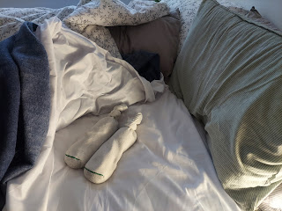

I wore sweats to bed, along with a thick fleece top, socks, and multiple blankets piled on top of me to help me go to sleep. The only body aches I had were from being all curled up while shivering for hours. And NO FEVER. Scott checked my forehead multiple times, but he said I felt normal.

Friday, I woke up feeling pretty decent, as I had the previous morning. It seems that the back half of each day is when all the yuck would come back. I was somehow able to babysit at the Preece home for a few hours, something that had been arranged weeks in advance. I let Stacie know that I wasn't feeling 100% and wouldn't be able to stay for the entire day, but she said it would be fine to just come for a little while. Her kids are roughly 16, 13, and maybe 9, and she said they could handle being by themselves for little periods of time. (The Italian holiday = no school for the day) So I arrived at 10:30 a.m. and I stayed until just after 1:00 p.m. (Their main babysitter was at work until 2:00) I wore a mask the whole time, except when I was eating my lunch.

We had a good time. Those are some really good kids! Cordell, the oldest, is super cheerful, chatty, and upbeat. Everett (13) was remarkably agile in the kitchen. He could multi-task better than most people his age! He was simultaneously cooking a pot of ramen noodles, frying up some bacon in a separate pan, unloading the dishwasher to put all the clean dishes away, and then loading it up again with all the dirty dishes from the sink. Wow. Very impressive. Lillian, the youngest, was excited to build a fort with me in the living room.

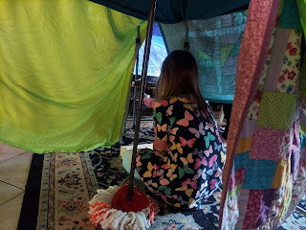

She even used a mop to boost up the "ceiling" in the center. We played Candyland and other games in the fort, and she enjoyed coloring some Christmas pages in between. She is very spunky and fun. I enjoyed my time with her.

The kids all knew exactly what their chores and responsibilities were for the day, and they also kept good track of their designated "screen time". I complimented Stacie after I got home to let her know I thought they were doing a solid job of parenting and how impressed I was.

On the fridge in the kitchen, I enjoyed this very democratic process of how the two boys chose to work out sharing the bunk bed in their room. (Who gets the top bunk, and for how long, etc.)

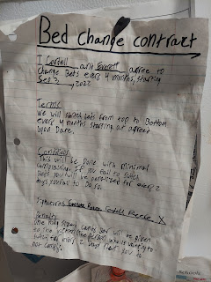

Later that evening, as if right on cue, when the dinner hour came, I began shivering again. We immediately deployed the bean-bag socks and some extra blankets. Scott worked on making the soup that I had been hoping to make all week. He did a fantastic job and it really hit the spot.

It's called Creamy Chicken and Vegetable Chowder. It's from one of the "Best Bites" cookbooks.

Recipe can be found here:
https://photos.app.goo.gl/jW3oaEphhuWDizVk9
https://photos.app.goo.gl/3HjLFZz1EXzdogcV8

This is how much help I was while dinner was being prepared . . .

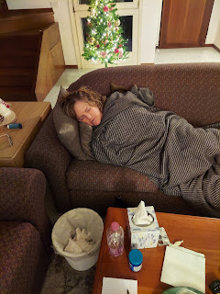

My entourage of supplies this week was to always having the following nearby at any given moment: tissues, water, cough drops, my inhaler, and the occasional herbal tea with honey.

Later that same evening, the fever finally hit. We don't have a thermometer, so I have no idea what my temperature was. But I was burning up. My eyes were stinging and burning and bloodshot. I went to bed around 8:00 p.m. and woke up a few times drenched in sweat, even though I had kicked the covers off long before.

I was pretty discouraged by this point, because two more important things were on deck for Sunday: The Primary Program, and I was supposed to teach a family history lesson in Relief Society to all the ladies. I have been practicing with all the kids to prepare for the program for several weeks, and had even hunted down a few quiet "fidget toys" to keep the 3 kids in my class reverently occupied when they were done with their speaking parts.

As for the family history lesson, well . . . this is my favorite thing to do in the whole world and I didn't want to duck out of this opportunity. I poured out my heart to my Father in Heaven in prayer as I settled into bed Friday night, fever and all. I told Him how much this meant to me and that I knew that if He wanted me to be there, He could heal me. I expressed my desire to follow His will and that if He wanted me to go, then it was His choice to help me get better. But if not . . . I would humbly accept His will and try to make other arrangements.

I sent a text to one of the RS leaders and let them know what was going on. We came up with a couple of back-up plans just in case, and agreed to check in on Saturday for an update.

Saturday morning, I woke up feeling a little better. I was still very cautious, however, because the past few days I felt reasonably well in the morning and early afternoon, but then things always turned south later in the day. As the day progressed, and I didn't get the anticipated shivers, that was a good sign. But I was still coughing way too much, and I felt like I shouldn't go to church.

Thankfully, Scott is extremely capable in doing family history, and we collaborate often on things we're working on. He agreed to teach the class in my place, even though it meant he'd have to juggle a couple other responsibilities to make it all happen. I let the RS leaders know and they were very pleased that someone could still teach. So, in the end, Scott and I sat down Saturday evening and I shared with him all that I had already prepared, with the option, of course, for him to add some thoughts of his own. I am so grateful that he was willing to do this for me, even though I am still super disappointed that I wasn't able to do it myself.

Saturday afternoon, Scott accompanied me on a much-needed walk. I told him I wanted some fresh air and just to slowly walk around for a while.

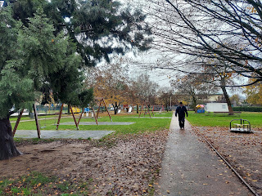

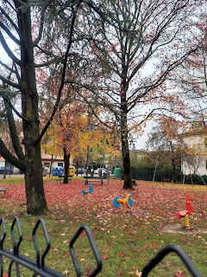

This morning, Sunday, I woke up early because I heard Scott getting ready for church. He's usually very quiet, but this time I noticed he had a little "annoying" cough starting up . . . He said he felt fine, but I was worried about that cough . . . I had him take plenty of cough drops and some water with him to church, and now I'm waiting for him to get home and tell me all about the Primary Program and the family history lesson.

And then he'll probably need a nice long nap. If there's ever a good time to be sick, I suppose now would be the time. I am feeling a little better so I can take care of him this coming week if he needs anything. And it's important for him to get it done and over with before we travel back to the U.S. in TWO WEEKS!!! He has the immune system of an ox, so whatever he might have, he'll probably be done in 1/3 the time it takes me . . .



*Update after church:
The Primary program went splendidly. Scott sat with my primary class and helped them to participate and stay reverent. :) And the family history class went marvelously, as well. I'm so glad!

On the better days this week, I would drive him to work in the morning so I could have the car for any errands during the day, and then I would pick him up around 4:00 each afternoon.

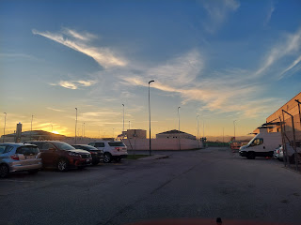

One of those errands was to find some Christmas cards for a few family members. Every day that I take Scott to work, we always pass by this little stationery store, so I decided to go in to see what they had. I did a pretty good job of communicating in Italian as to what I was looking for, how much do these cost, and that I needed five of them. :) They are very small, and very simple, but they at least say Merry Christmas and Happy New Year in Italian!!

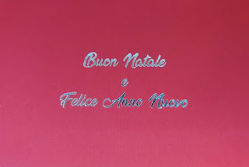

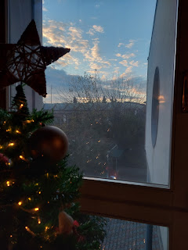

I asked several family members early this week what some of their favorite childhood Christmas traditions are. Here are their responses.

Favorite Childhood Christmas Traditions

Amber:
Spending Christmas Eve with Grandma and Grandpa Harmon. Dinner together, singing carols, playing games like mousetrap, both when we were little and when we were older. Then driving home and seeing all the lights on the way. It was the epicenter of the magic for me.

Jacob:
Clementines. Breakfast Casserole. Benson and I going downstairs at Grandma and Grandpa's house while everyone sings upstairs. Benson and I finding [a way] how to escape the Christmas program. Benson and I goofing off when we couldn't escape the Christmas program. Driving around looking at lights. Christmas music in the car on the way to Rigby. And a new sled.

Hannah:
Playing games with the family. Mafia, catch phrase, poker, etc. Also pulling the sled behind the four wheeler.

Kylie:
Every Christmas Eve the family would get together and do the present pass thingy while she would read a story, like pass left every time left was said, and then right . . .

Melanie (sister):
For sure the Nativity. I loved putting up one piece a night and then placing baby Jesus in on Christmas morning. I also enjoyed going to Grandma Doris' on Christmas Eve. I loved playing dominoes and uno, watching figure skating or a Christmas musical special, opening one present, and looking at all the lights on the way home. Such fond memories of that!

Dad:
[Cousin] Jeff and I doing the Christmas Eve dishes and then opening some presents. Christmas Day, mom usually made ham for dinner. One of my favorite things was driving around and viewing the Christmas lights. The blinking star in Regina Heights (until Christmas Day). And the peace sign at Dr. Werra's. And last minute assemblies for the Santa gifts. Sometimes up until 3:00 a.m. And trying to find a hiding place for the gifts that you kids wouldn't find.

Mom:
Two favorite memories. 1) I remember being in bed, but not asleep yet on Christmas Eve. I still believed in Santa Claus. All of a sudden, I heard a "Ho!Ho!Ho!" with the front door opening. I recognized it was my father's voice!! I recall thinking that he was the giver of Santa's gifts. 2) Around this same time (in Redwood Valley), I was enthralled with a huge box under the tree from my brother, Wayne. It rattled a little and I sure couldn't figure out what it could be. When I opened it, I was delighted to find a Chipmunks record album! How fun was that! I remember we always had a tall Christmas tree and we decorated it as a family. I always loved the smell of the live tree. We hung the old fashioned tinsel on our tree every year, and we were taught how to separate them to hang one skinny tinsel at a time. I enjoyed our family time together. I also enjoyed our tradition of being able to open one gift on Christmas Eve. Another favorite memory I have is my mother's love of Christmas music. Her favorite song was and still is Silver Bells. I remember specifically one year we went caroling, just the two of us, to the Ukiah Christmas Tree Lighting ceremony. We both knew nearly all the words of the carols. I loved that experience. Enjoying the music was a sort of tradition.

Ryan (brother):
I liked going to Grandma's on Christmas Eve (Gma Doris), having hot cider, and picking one gift to open. I also enjoyed driving around to look at Christmas lights.

Michael (brother):
Definitely Grandma Doris' house with the games and opening up a present there. I remember making the trip to her Windsor [CA] apartment. It was always so cozy! The Chipmunks Christmas album playing at home whenever we wrapped presents. Also, driving around looking at Christmas lights and the Christmas Truck Light Parade! [in Ukiah, CA]

Charmaine (sister):
Some of my favorite memories are doing Secret Santa, baking goodies and then doing the ding-dong ditch thing. Also definitely decorating the tree to Andy Williams and the Chipmunks.

Me:
Setting up the Nativity and putting up one figurine each night. Then putting baby Jesus in the manger on Christmas morning before we opened up any gifts. I loved decorating the tree as we listened to Andy Williams and the Chipmunks. I loved having those special brass ornaments that Grandma Zoe gave each of us annually, personalized with our name etched on it. I still have all of mine, and they always go at the top of our tree. Definitely driving around and looking at all the Christmas lights. To this day, I always get choked up as I remember that fond memory from my childhood. I enjoyed hanging out at Grandma Zoe's house on Christmas Eve. I remember coloring while watching some Christmas special like Rudolph the Red-nosed Reindeer, or Charlie Brown's Christmas. I also loved going to the Sky Ranch [in Ukiah] to pick out a live tree. Grandma Lillian worked there. We'd get hot chocolate and I remember enjoying all the magical Christmas decorations and smelling all the wonderful Christmas smells (cinnamon, pine, peppermint, vanilla, etc.). It was fun to pick out a tree as a family. And one more - I love that time when I brought my kids to CA (when Scott deployed to Iraq in 2004). Dad took us all on an adventure into the forest near his current home in Willits to find just the right Christmas tree. We walked along the RR tracks until we found the perfect one. Dad cut it down with a hand saw and we strapped it up on top of our minivan and brought it back to his house to decorate. My kids talked about that experience for years! They only grew up having an artificial tree in the Harmon family. Scott was always very practical and didn't want to chop down a perfectly good tree and then let it die after the holidays. I tried to convince him that we were helping prevent forest fires by thinning out the forests, but he would not change his mind. It's a good thing I love him as much as I do . . .

I hope you are enjoying some wonderful holiday traditions of your own. And it's never too late to start, if you haven't already. :)

Even though this blog post started off a little dreary, because of all the sickness and gumbo, I'd like to end on a more positive note.

If life gives you lemons, make some lemonade.
Look for the good in each day, even if it takes you a while to find it.
Don't let a little rain stop you from living your life. (as seen below) Feel free to wear a plastic bag over your hair to keep it dry.

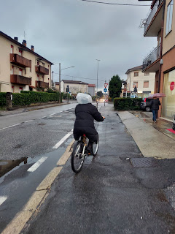

A little rain never hurt anyone. We walked through a downpour to get some groceries and it was pretty fun!

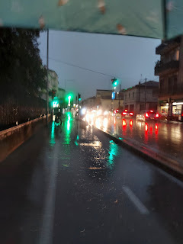

And if you're scared or sad, look to your family members for support and the reassurances you need.
Like this sweet little girl did. (She is so precious she made me cry!)

https://abcnews.go.com/GMA/Family/girls-pure-joy-spotting-family-crowd-melting-hearts/story?id=94860100

Time for Grandbabies . . .

Kylie sent me another sweet video of Avery early this week. It will melt your heart. (36 seconds)

https://photos.app.goo.gl/AuwiGkJJXsM35QDz6

Meanwhile, Jack and his parents in the Northeast have successfully navigated through a lengthy bout of Covid. They are feeling their energy come back and will be back to church today for the first time in 2 weeks.

Jack loves to be outside on his little nature perch. No matter the weather.

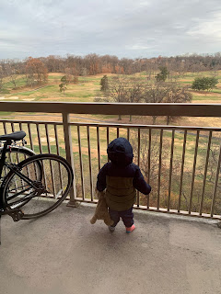

And he even called me yesterday to see how I was feeling. XOXO

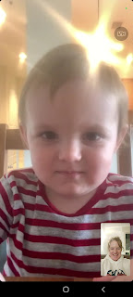

He was gulping down spoonsful of green peas as he smiled and played tilt-our-heads-back-and-forth with me. I even somehow managed to capture a reflection of Jacob in Jack's spoon! ha ha

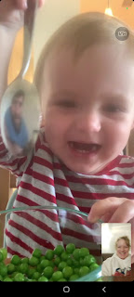

He is learning so much right now and each time we do a video chat I am just trying to keep up, ha ha. He can sign a few things that he needs, like "all done" or "I need help". If you ask him: where are your eyes, nose, tongue, etc., he knows right where they are. When it was time to say goodbye on our video call yesterday, he was laying down drinking a bottle just prior to his nap, but right on cue, he waved bye bye to me. What a cutie!

Video of Jack "helping" - or wanting to help expedite getting the food out of the oven: (15 seconds)

https://photos.app.goo.gl/7ue9gc9fUbZuhfhS6

Abby fought valiantly and eventually won the battle of whatever sickness she had this past week. She had several days of high fever, most days around 103, and one day it shot up to 105. But she was able to sleep and rest at home for several days, and by the end of the week she was well enough to participate in her Christmas Choir concert at school. The choir was comprised of 2nd and 4th graders who did well enough in school that they have earned some extracurricular activites.

Video of them singing, "I'm Getting Nothin' for Christmas": Abby is in the front row wearing a red shirt and white pants. (2 min, 14 sec)

https://photos.app.goo.gl/XKaRGsPLKAvt5Wud9

I thought she did a fantastic job! She kept a great rhythm and seemed to really be enjoying herself.

I recently shared a fun video with Abby and Gwen, where the musical artist, "Pink", is singing an upbeat and fun song, entitled, "I'm Never Gonna (Not) Dance Again." It shows Pink on her roller skates, dancing around with her entourage through town and then onto the stage at the recent American Music Awards.

https://www.youtube.com/watch?v=Armvb4s6TNU&ab_channel=PinkVEVO

They only watched a few seconds of the video before they paused the TV so they could run and get their own roller skates on!!

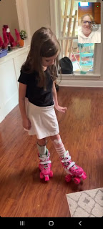

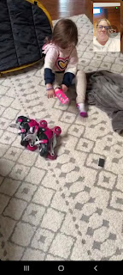

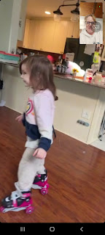

Abby did laps around the living room, while Gwen stood briefly inside her baby-sized tent and announced that she was a "speaker". ha ha ha

