Sardinia: Part Two
Waking up in Porto Torres on our second full day in Sardinia was much calmer than the day before, mainly because the aggressive winds had calmed down into more of a simple and beachy breeze.

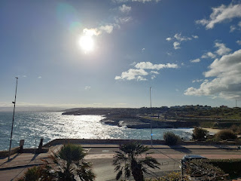

Even with the calmer winds, the waves were still pretty substantial: (8 second video)
https://photos.app.goo.gl/toAowbHo8oeG3qhw5

Scott commented that this might be the most beautiful view out of a bathroom window that he's ever seen. I think I'd have to agree . . .

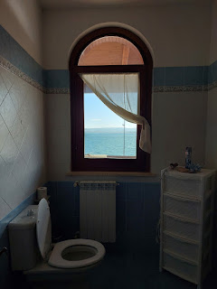

Saturday, February 15th:
With a full day ahead, we ate a simple breakfast before heading off to see several sights. Our first stop was known as Santuario Prenuragico Monte d'Accoddi, or Monte d'Accoddi for short. It's located a few kilometers south of Porto Torres and was very easy to get to.

It's a Neolithic archaelogical site that consists of a very large raised stone platform, thought to have been an altar. The oldest parts have been dated back to roughly 4000-3650 BC. It was only "recently" discovered in 1954 in a field owned by the Segni family, but the original structure was built by the Ozieri culture or an earlier civilization. No chambers or entrances have been found underneath, leading to the notion that it was an altar, a temple, or a step pyramid.

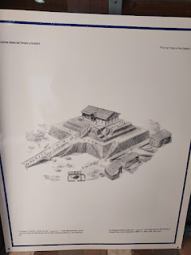

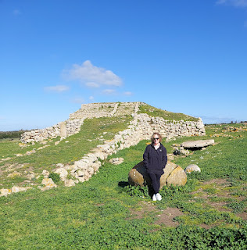

We received a packet of information in English from the ticket office to help us understand the history and significance of what we were seeing on our self-guided tour. (click each one to read better)

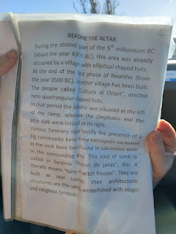

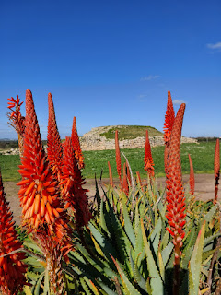

There is a path that leads up to the highest surface, with a very large stone slab on the right that may have been where animals were sacrificed as part of a religious ceremony.

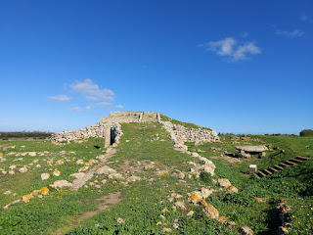

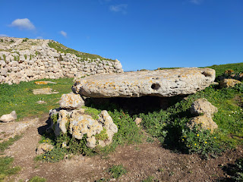

Archaeological excavations indicate that animal sacrifice took place here, with the remains of sheep, cattle and swine that were recovered in near equal proportions. It is among the earliest known sacrificial sites in Western Europe.

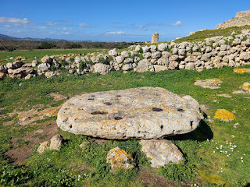

Here is a little background for the Altar . . .

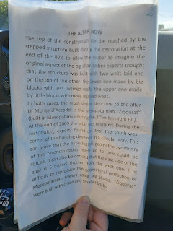

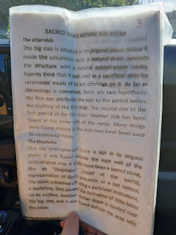

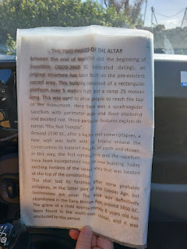

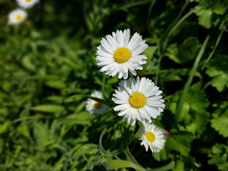

Looking down from the top of the structure toward the very fertile lands in every direction . . .

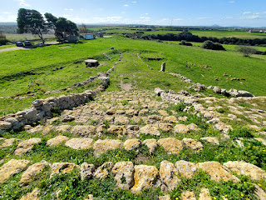

Video of 360 degrees from the top: (30 seconds)
https://photos.app.goo.gl/f1Temb2YY2nNAg2d7

The Menhir is explained in the photo below . . .

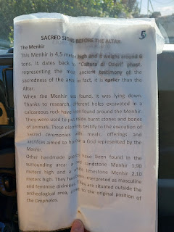

Video of the Menhir: (8 seconds)
https://photos.app.goo.gl/LJDYBYRErkKpcjE58

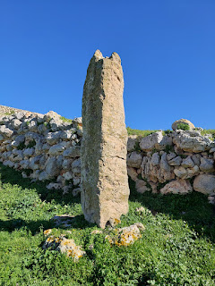

The whole time we were here, I felt a calm and peaceful feeling. Even when I stood over near the circular stone where it is believed that animals were sacrificed thousands of years ago, I felt nothing but good feelings. I did not get any sense that evil or atrocities had taken place at this site. Everything just felt peaceful and good to me.

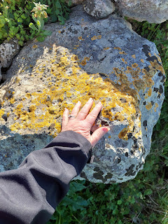

This was an intriguing piece of stonework. There was a sign nearby (in Italian) that I used Google Translate to help me understand further, but I cannot find a screenshot of what I thought I had saved in regards to this. What I do remember, though vaguely, is that this was meant to represent a feminine form. There was another stone nearby to represent the male form, but it had less detailed work. Go figure, ha ha.

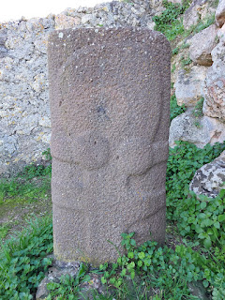

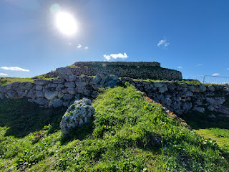

A description of "Other Sacred Symbols" . . .

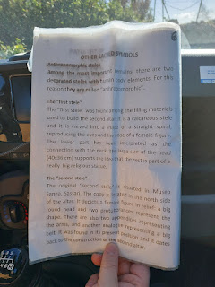

There are still visible outlines of what used to be "huts" . . .

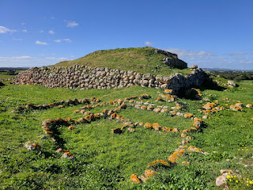

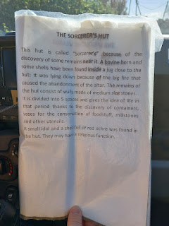

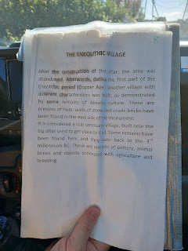

I took a photo of our entry tickets so that ultimately I don't need to save them somewhere. I have too many memorabilia items to deal with already, and I don't even know what to do with them at this point. *nervous laugh*

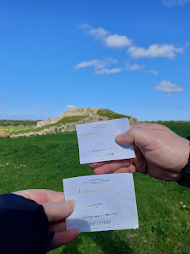

The handmade rock walls all over Sardinia were beautiful to me. All that hard work. Can you imagine?

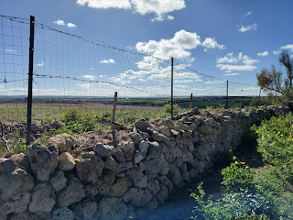

Our next stop was to a place called Necropolis of Su Crucifissu Mannu. Oddly, the literal translation is: Necropolis on crucifixion of man. I think it basically means an old cemetery. :)

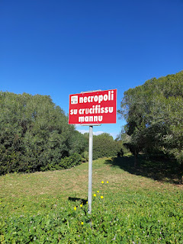

As we parked the car, we saw a herd of sheep over at the farm next door. We walked down the lane and asked a young man - who was on his phone and sitting in his tractor - if we could take a few photos. He waved his hand to indicate, sure, go ahead.

We took a few cautious steps at a time, pausing for a minute in between so we didn't alarm them.

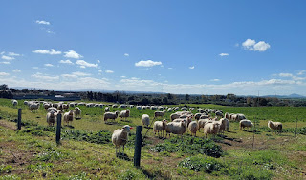

Even still, they got spooked and started trotting off in the opposite direction anyway. Darn it. I guess sheep really do know who their shepherd is. And it wasn't us!

Video of the sheep with their cute little jingly bells: (7 seconds)
https://photos.app.goo.gl/6zyBirpx1f6m459A8

On the website,
www.sardegnaturismo.it
we learn a little bit more about this next archaeological place.

In Porto Torres, in the northwest of Sardinia, a complex and mysterious maze was dug out of the limestone. It is a prehistoric 'cemetery' reused over thousands of years.

The Nurra is a 'mine' of heritage from the past, with a concentration of dozens of archaeological sites spread over a few square kilometers. One of the most fascinating is located just outside the town of Porto Torres and is partially hidden, maybe to continue to protect the secrets it has been keeping for thousands of years.

It is the necropolis of su Crucifissu Mannu, a complex of domus de Janas dug out of a bank of limestone rock. 22 tombs have been found so far. Their construction began in the Late Neolithic period (3200-2800 BC) and were used continuously until the Early Bronze Age, around 1600 BC.

The hypogea are all multi-cellular, meaning that they are composed of several rooms, which can be accessed via a vertical well
(did they mean wall?)
or descending dromos (corridor) entrance. The structure is typical of the domus found in the Sassari area, with an anteroom, a cell and rooms that open up in the walls of the main cell.

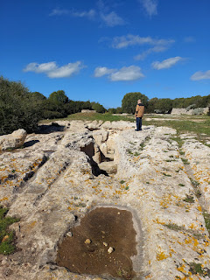

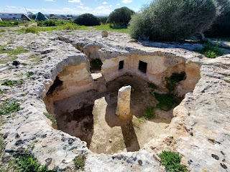

I decided to find a way to go down inside this first "hypogea" or underground chamber.

Video of what it looked like inside one of the rooms: (7 seconds)
https://photos.app.goo.gl/1Jdet1jbzpXVWTpdA

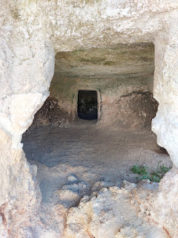

The limestone had some shells and a variety of other tiny fossils incorporated into what constituted the walls.

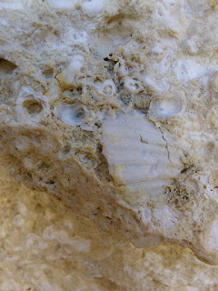

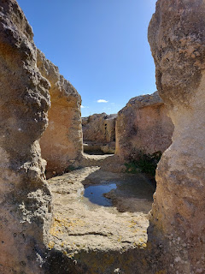

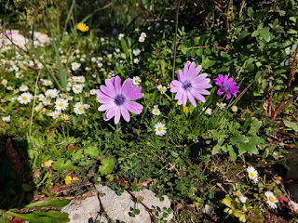

We spent about 30-40 minutes wandering the area. There is a lot of overgrowth, but there are some clear and distinct paths as well. There was a young Italian family taking their time exploring every single area. The kids were super cute - at one point they all dog-piled on top of one of the younger brothers and then wanted their mom to take a photo. Classic, ha ha.

Both the flag of Sardinia and the license plates on all the cars have this interesting ninja-like picture. I did a little research to learn more about the story behind it.

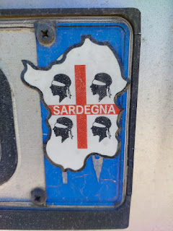

What historians DO agree on is that these are the Four Moors. But there are differing hypotheses as to the origin of the Four Moors.

This is a very short read and helps to shed a little light on my question:
https://www.hotelgabbianoazzurro.com/en/Blog/The-Sardinian-Flag-Meaning-Of-The-Four-Moors-

We drove a short distance from the necropolis to eat lunch at a place that our AirBnB host had recommended, called Mama Giu's. (Giu - pronounced like Jew - is short for Giuliana) The restaurant was very beautiful, which was surprising because it was so far out in the middle of nowhere that we didn't even know if it would be open or what we would find inside.

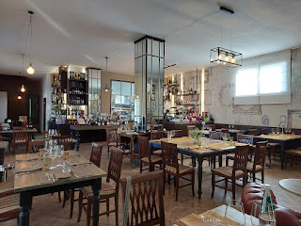

They had a nice warm fire going next to where we were seated . . . Scott is almost fully camouflaged with all the art on the wall behind him, ha ha.

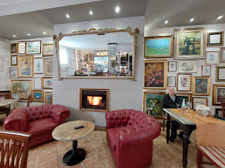

This is Mama Giu, the mother of the current chef and owner of the restaurant.

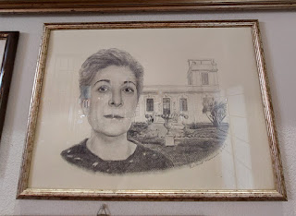

We were served these little "cracker" things at two different places in Sardinia, which leads me to believe that maybe they're a local item? They are large like a crepe, but very thin and crispy. They taste a little bit like a saltine cracker and they're fun to munch on while you wait for the entrees to arrive.

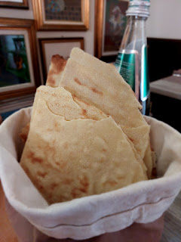

I ordered one of my favorites - a bowl of mussels (along with a few clams this time, too.) It was delightful, as always. There's usually a tomato-y chicken broth down in the bottom of the bowl that goes so perfectly with the shellfish meat.

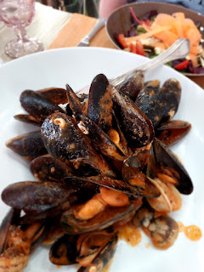

Next up was a platter of lightly battered shrimp, octopus, and calamari - along with a few vegetables, too, which was unexpected. Usually in Italy, if you order an entree, that's it. That's all you get. If you want a side dish of salad, soup, veggies, fries, whatever, you have to order that separately. So I wasn't expecting any vegetables at all, which is why I had also ordered the grilled veggies . . .

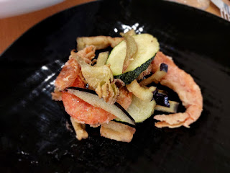

The grilled veggies . . . standard fare comes with red bell pepper, zucchini, and eggplant.

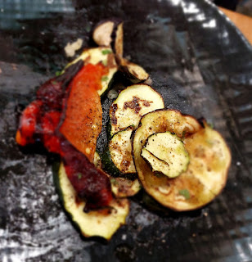

For once, I saved enough room for a little dessert. We shared most of the entrees this time, which meant I could have enough space for a serving of "cheesecake". It was more like a light and airy whipped cream in the middle, not so much the dense cream cheese version we are used to in the U.S. But it was tasty with the berries on top and the graham-cracker crusty equivalent on the bottom.

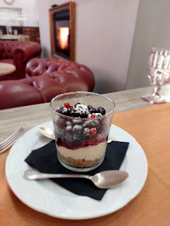

Next stop:
La Pelosetta Beach. I found it online before our trip because it was mentioned as one of the most beautiful beaches in all of Sardinia (and in the world). It was about 35 minutes from the restaurant on the south side of Porto Torres all the way out to a very northwestern point of Sardinia. If you can find Stintino on a map, then you're super close to where we were.

I was pleasantly surprised on the drive up to the beach because we passed numerous windmill farms and solar farms. They have figured out how to be self-sustaining as far as energy goes. Very commendable.

We parked right next to the water and we really lucked out, probably because it was so off-season. When we drove away later that afternoon, we saw that there were multiple terraced parking lots and edge-of-the-road parking all the way up the curvy hill and down the other side. That gave us a clue as to what it must be like in the summer time . . .

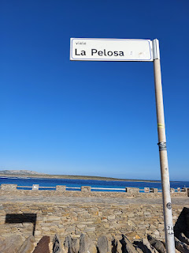

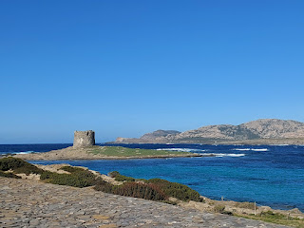

The Pelosa Tower is a distinctive landmark of this beachy area. It was built by the Spanish Aragonese in the 1500's, as a way to monitor traffic and to protect the shore from invasions. The Stintino region also has a long history of fishing, including tuna, crab, and lobster.

Check out some stunning photos in the following links:

https://www.italia.it/en/sardinia/sassari/stintino-la-pelosa-beach

https://lapelosa-tickets.com/blogs/news/history-of-spiaggia-la-pelosa

Apparently, the water color changes throughout the course of the day, but I didn't know this until after we left. It was incredibly beautiful while we were there, and I would have to say that nothing I've seen has even come close to how beautiful this water was - not in all of my travels.

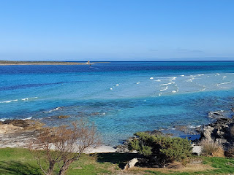

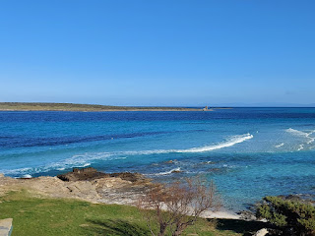

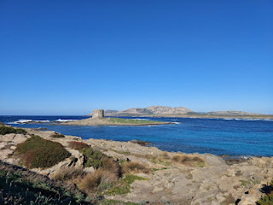

We clambored along the rocky shoreline for a while, pausing from time to time to just take it all in. The chunky rocks belong more to La Pelosetta Beach than the sandier shoreline of the adjacent La Pelosa Beach.

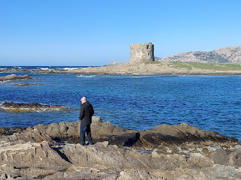

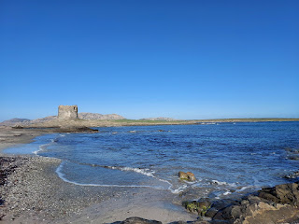

The rock was clearly from old lava flows, but we couldn't figure out where the volcano was.

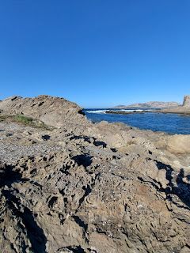

I found a website with one LONG and ginormous paragraph to answer my question. Essentially, Sardinia used to be part of France millions of years ago. A series of earthquakes and volcanic eruptions caused Sardinia and Corsica to separate from the mainland. There have been numerous geologic studies done in Sardinia, and findings include evidence of crocodiles sunning themselves on the shores and also massive Megalodons in the sea.

Megalodons were from the dinosaur era, and while they looked vaguely like a shark, they were much, much larger. A shark might reach 7-8 meters in length, but a Megalodon was typically 18 meters long, with teeth that measured 20 cm. Yikes.

Anyhoo, it was very peaceful and safe while we were there.

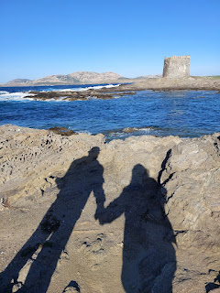

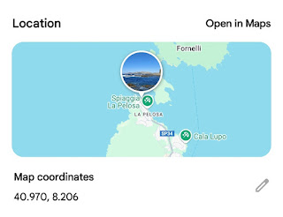

I sat down for a while on a large smooth rock, patiently waiting with my camera ready for a few photos of the waves crashing up and over the rocks in front of me.

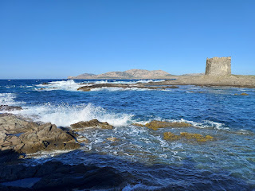

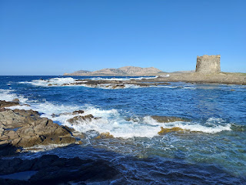

It was a short drive back to our AirBnB, maybe 30 minutes tops. We took one last walk before the sun went down, following the paved walking trail that curves around the cove that was visible from our windows and off the balcony each day.

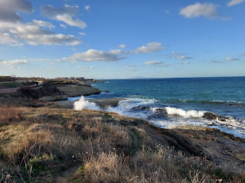

I always love to go on a walk-and-talk with Scott. We hold hands and talk about lots of stuff. Sometimes we don't talk at all, but mostly we do. I love walk-and-talks because we are not distracted (at least not too much) by other things. There are no chores to take care of and no emails or phone messages to check. It is more about just being together and connecting, and I'm all for Quality Time. In fact, it's my #1 Love Language. (The 5 Love Languages, by Gary Chapman, include: quality time, acts of service, words of affirmation, physical touch, and gifts.)

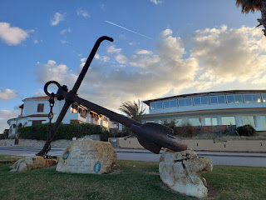

Sunday, February 16th:
We woke up to a beautiful sunrise to begin our Sabbath Day.

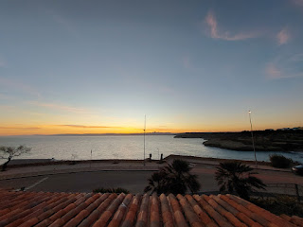

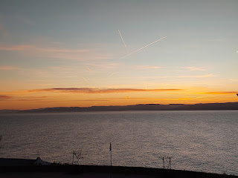

After packing up all of our things, we checked out of the AirBnB and drove about 30 minutes south to Sassari. (Emphasis on the first half of the word "Sass" = SASS-ar-ee) This is the second largest city in Sardinia and has an established University that was founded in 1562.

Church began at 10:00 a.m. and surprisingly, it was in an actual church building! It looked like it could have been one of our meetinghouses in the U.S.

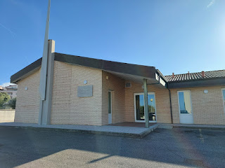

Inside, the chapel was very simple and small.

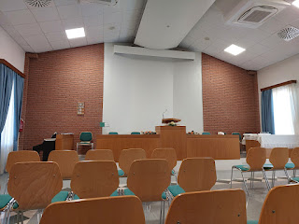

Many people came over to talk to us and to introduce themselves, including the missionaries who were from Georgia and Washington (I think). An older lady who spoke really good English ended up moving over to sit by me so we could visit a bit more. She is a general doctor and received her degree at the University in Sassari many years ago. She even gave me her phone number so that if we return to Sardinia someday (crossing our fingers), she would love for us to stay with her! Her adult son also speaks excellent English and ended up interpreting for us throughout the Sacrament meeting (we love those little devices that hang around your neck with an earpiece to listen through). He also played the piano for all the hymns.

It was lovely to sit by my new friend, Paola Ortu, and sing the hymns with her. She has a beautiful soprano voice, and it was also helpful to hear how she pronounced some of the words and phrases. Like in this hymn for example, only in English we know it as: "Joseph Smith's First Prayer". The literal translation in their hymnbook means, "The morning was clear."

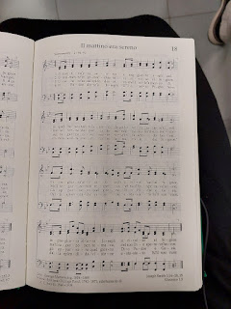

After church was over, we drove to a nearby cemetery (cimitero = chimmy-terrow), known as Tempio Crematorio. It was a HUGE cemetery, one of the largest I've ever seen anywhere in Italy.

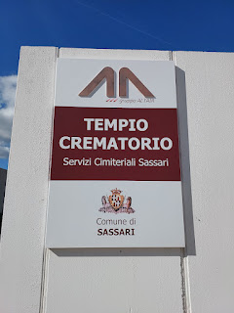

We only visited maybe 1/8 of the entire cemetery because it was so massive. Plus, we were getting hungry for some lunch.

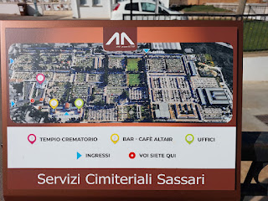

The first section we visited was the typical Italian cemetery that we are familiar with: a long aisle of vaults stacked up high and the only way to "visit" your loved one or to freshen up the flowers is to climb up a tall ladder that rolls along. My favorite thing is always seeing the faces of everyone on the memorials. I think that I would like a photo of me and Scott on our headstone someday, too, so everyone will know what we looked like in this life.

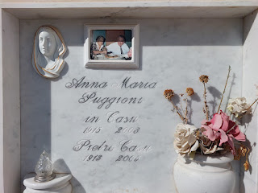

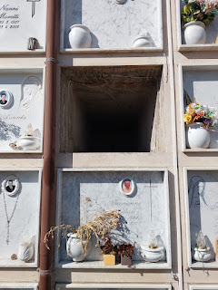

The burial spaces are definitely long enough to fit a body (or two), not just cremated ashes. Scott was tall enough to take a photo of this empty space for me . . .

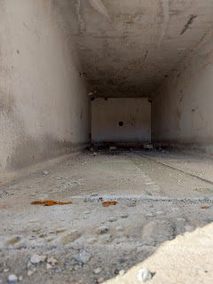

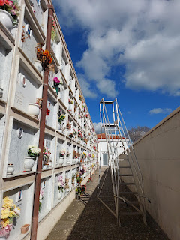

These two look so happy. I think I would have liked them very much, had I known them.

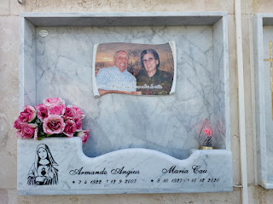

One of the back sections of the cemetery that we visited was filled with very old memorials. We played a little game of "Let's find the oldest person in here." The winner was someone who was born in 1752 and died in 1848. One of the things I wanted to see was some evidence of people who had lived to be at least 100 years old, but mostly I just found a lot of people who lived to be in their upper 90's instead, which is still quite an accomplishment.

I watched an episode a while ago of "Down to Earth with Zac Efron" (Netflix: the Sardinia episode in Season 1) where they were trying to uncover the reasons for why Sardinia has the highest concentration of centenarians in the world (people who live to be 100).

Here are some interesting facts from the internet about Sardinia being one of the 5 Blue Zones:

Yes, Sardinia, Italy has the highest concentration of male centenarians in the world
.
Sardinia is one of five Blue Zones, areas with the highest concentrations of people who live to be 100 years old.
Why does Sardinia have so many centenarians?
Diet
:
Sardinian longevity is linked to their diet, which includes famine foods like acorn bread, cheese ripened in goat abomasum, and soft cheese with worms.
Lifestyle
:
Sardinians have a low-stress lifestyle and are physically active all day.
They perform everyday tasks like farming, gardening, and walking, which helps keep their bodies strong.
Community
:
Sardinians have a strong sense of community.
Other Blue Zones:
Loma Linda, CA, USA
Nicoya, Costa Rica
Ikaria, Greece
Okinawa, Japan
In the episode of Down To Earth with Zac Efron, I remember that they were surprised to learn that the diet in Sardinia is almost the opposite of our diet here in the United States. They eat mostly carbohydrates and very little protein. And the protein they eat is typical of a Mediterranean diet: fish, sardines, snails, crab, basically anything that comes out of the ocean. They also pass down very specific DNA from generation to generation, particularly DNA that is healthy and strong. Not a lot of diabetics in Sardinia, ha ha.

They eat modestly and healthfully, they exercise and work hard, they find time to relax regularly, and then they pass down those genetics to the next generation. It all sounds so simple . . .

Here are a few photos from the oldest part of the cemetery . . .

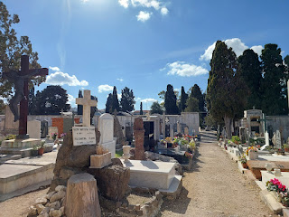

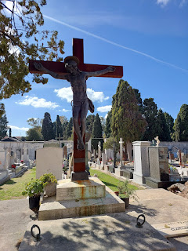

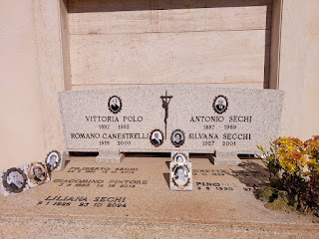

Look at these sweet faces . . . His name was Giacomino Pintore (b. 1923 d. 2013). Her name was Liliana Sechi (b. 1926 d. 2024).

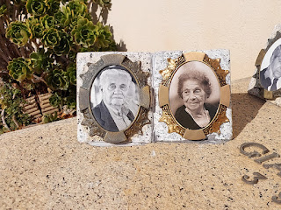

The two men on the bottom portion of this memorial looked to me like they belonged in an Old Western movie or something. Wearing gauchos . . .

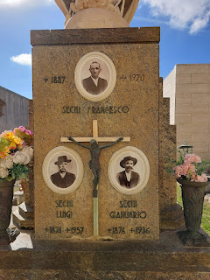

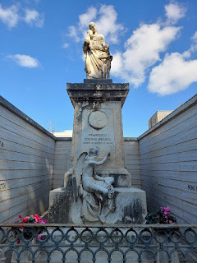

This was an interesting memorial . . . it was completely engulfed by succulent plants! And Scott noticed that the last person listed on the memorial hasn't died yet. He was worried about how they would be able to give her a proper burial with so much overgrowth . . .

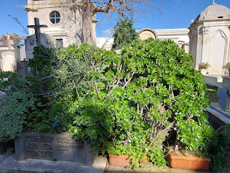

This memorial paid tribute to a member of the Italian military named Giovanni Maria Lay. He was a lieutenant pilot and received the Gold Medal of Honor for military valor during his service in Sassari in 1915 during WWI, and then later for his service in Russia during WWII in 1941.

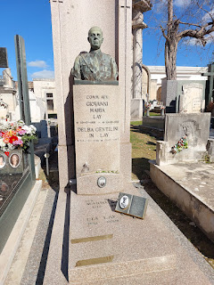

We had a great time wandering around the cemetery for about an hour, soaking up the warm sunshine for the first time in a WHILE.

Next, we went to a hopping restaurant in Sassari, called Black Stone. It was highly rated, but we had no idea beforehand just how busy this place was. There was barely enough room for people to shimmy past our table, including the servers. But the food was SO GOOD.

I ordered the fried fish plate with fries. It included calamari, of course, and was the freshest I've ever had. It was all perfectly salted, and it didn't even need any sauce to dip it in.

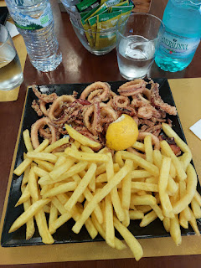

Their foccaccia bread was unlike any foccaccia I've ever seen. It wasn't flat with dimples in it at all. Instead, it was puffy and airy and cut into triangular shapes, with a hint of rosemary and salt. It was also WARM. Yum, it was so good.

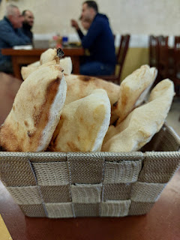

Scott ordered a hamburger, LOL.

On our way across the northern part of Sardinia back to Olbia for our last night, I saw that there was one more place we could stop to see along the way. It's called the Chiesa della SS Trinita di Saccargia and was built in 1116 AD.

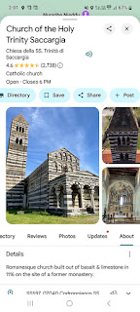

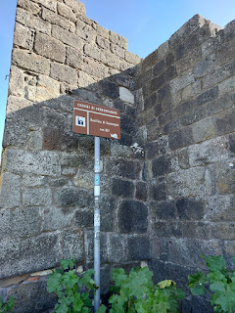

As the story goes, a couple named Costantino I de Torres and his wife, Marcusa de Lacon Ganale were visiting in the area. They made a vow to Madonna that when they had a son, they would donate a church in this place, which they did. The building was completed in 1116 and was entrusted to the Camaldolese monks, who already had an Abbey in the area.

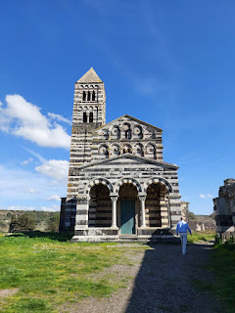

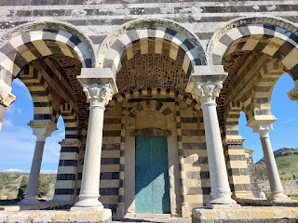

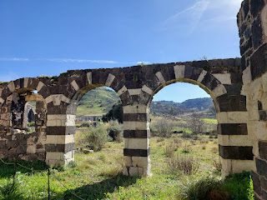

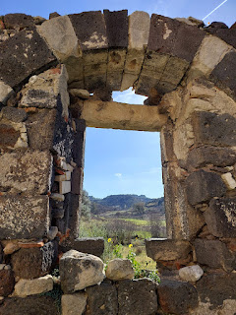

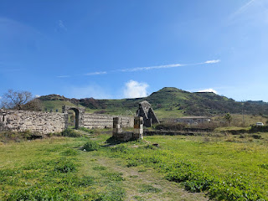

We paid $3 a piece to enter the old church. Even though it's kind of out in the middle of nowhere, it's still only 5 minutes from the main highway. The ticket counter consisted of a man and a woman sitting inside with several space heaters blowing all around them. They were trying their best to stay warm in such a drafty place. I wondered how they make it through so many hours with hardly any visitors to pass the time . . . But also, Italians are a little dramatic about thinking that it's cold, when it's actually quite nice and comfortable. I can go outside in short sleeves and be just fine, and at the same time I'll see one Italian after the next wearing a winter coat, gloves, and a scarf around their neck, like winter is trying to extinguish them or something!

I saw a remnant of an old sketch - or maybe the beginnings of a fresco - on the wall next to the ticket counter.

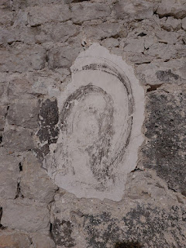

An English translation of some of the history of the church . . . (click to enlarge)

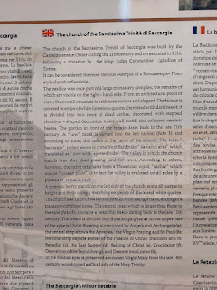

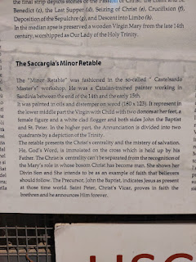

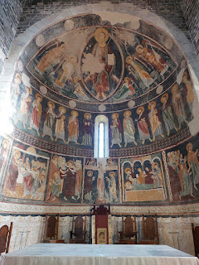

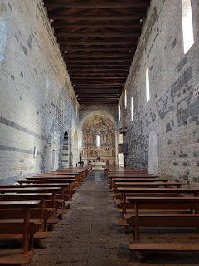

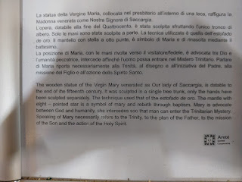

In the English translation above, there is a typo on when this wooden statue of Mary was actually made. In two other places, it mentions that it was dated to the end of the 14th century, not the 15th. I love the idea that the entire piece came from ONE piece of wood, with the exception of her hands.

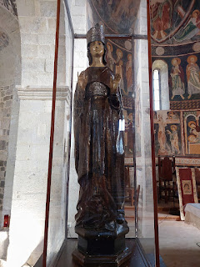

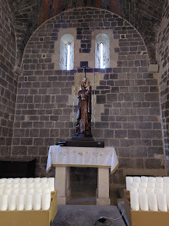

Something I wish to clarify is that in the description of the wooden statue of Mary above, it states that she is meant to be the Advocate between God and humanity. While we believe that she holds a revered and sacred role as the earthly mother of our Savior, Jesus Christ, it is HE who is the Advocate between God and humanity. He, alone, is our Mediator and Intercessor and Advocate with the Father. This is where we differ with many other religions in the world. (We = The Church of Jesus Christ of Latter-day Saints)

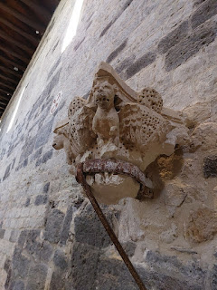

We didn't stay too long, mostly because it was a small church and there wasn't a whole lot to see. But I was still glad we stopped. I will always hit the brakes to see something that was built over a thousand years ago!

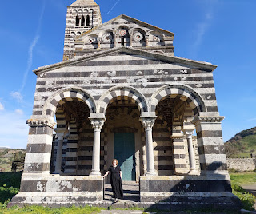

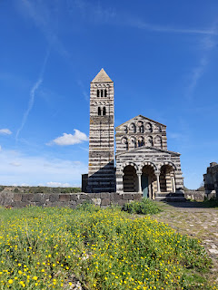

One of my cousins, Sabrina Godfrey, noticed that this bright fuschia flower has a heart-shaped center (when I shared some photos on Facebook recently). I hadn't picked up on that at all, until she messaged me. I'm glad she was paying such close attention.

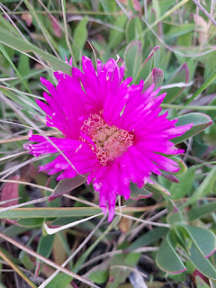

About an hour later, we made it to our hotel in Olbia. Earlier that afternoon, as we were preparing to leave the cemetery in Sassari, we made a last-minute decision to switch hotels for that night. I had been receiving some messages from the first hotel over the previous couple of days in regards to filling out their online registration form (something that is required by law in Italy), but their website was not cooperating at all. Then I received several LENGTHY texts about how to navigate to their hotel in Olbia. It was unbelievably complicated!!! How did we not know this before, when we booked the hotel in the first place!??

First of all, the hotel is in what's known as a ZTL, or a pedestrian-only zone. You have to have a special permit to even drive in a ZTL or you could be substantially fined. In these messages, we were told all the specific step-by-step directions on how to get there, including where to park. It was all so fussy and over-the-top. We had no desire to try to follow such detailed instructions, and in a ZTL, no less. Plus, they mentioned in another text that the water was not even drinkable in our room. Like, what?

So we made a unanimous decision to bail and just find another hotel, knowing that it was too late to cancel and get any money back from the first one. It was worth it, in our opinion. And it was only $50 or so that went down the toilet . . .

We used our favorite app (Hotels.com) and quickly found another hotel in Olbia that was closer to the airport, highly rated, and not very expensive. (I think it was $70)

The only hiccup we experienced was that when we got to the new hotel, the receptionist had not seen that we had booked a room just a couple hours earlier, and therefore wasn't expecting anyone to arrive. So he went home for a nice long lunch break . . . Meanwhile, the housekeeper, Barbara, spoke really good English and made us comfortable in the breakfast area while we waited. And waited. And waited. She was a hard worker, and was furiously sweeping and mopping, carrying buckets and cleaning supplies back and forth and all around while we sat and waited. Finally, over an hour later, he eventually returned and was able to get us checked in.

We decided to go for a nice long walk before the sun went down, so off we went. It was only about 5 minutes to get to the water from our hotel.

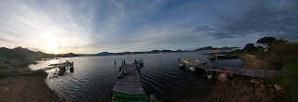

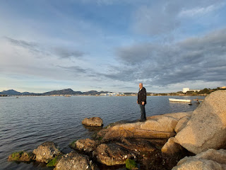

We waited for the sun to set (one of us waited more patiently than the other - wink, wink). I sat calmly on a rock and just relaxed for a while, while Scott climbed around on the rocks closeby. He was apprehensive about waiting for a WHOLE 30 MINUTES, but I won the battle and it was worth the wait.

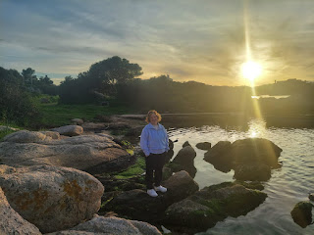

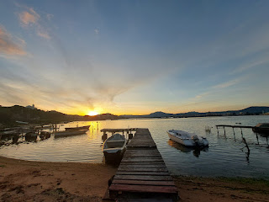

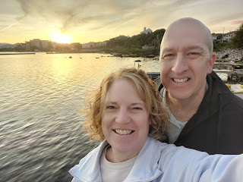

Walking back into town, we passed by some cherry blossoms in full bloom on our way to the Lidl to dig up something for dinner. I didn't want to think about the fact that in a little over 24 hours I would be back in the land of the arctic cold, where everything was still white and frozen solid.

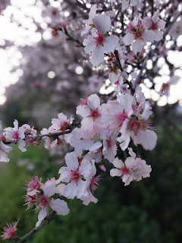

Never before have we seen this big of a package of eggs in Italy. Usually they are sold in increments of 4, 6, or 10 eggs in a package. Never a dozen. But they are consistently about 20 cents a piece, way cheaper than what we're seeing in the U.S. these days . . . This display was for an XXL package of eggs (30) for $5.99.

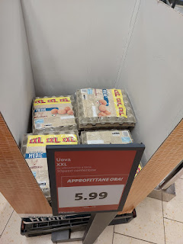

We got some snacky dinner items, like sliced cheese, lunchmeat, yogurts, and some fruit to satisfy our tummies before going to bed early.

Of course my brain woke up way before it needed to. It always does. Whenever I know that something big is happening first thing in the morning, my brain ends up being on high alert instead of relaxing and sleeping until my alarm goes off. My alarm was set for 5:15 a.m. so that we could be out the door by 5:45 a.m. to fuel up the rental car and return it shortly after 6:00 a.m.

But no . . . I woke up at 3:00 a.m. instead. Yay . . . I got about 6 hours of sleep that night.

The sky was so pretty, though, as we boarded our flight back up to Milan. So far, our experience using EasyJet has been great. Milan is one of their bigger hubs, so the customer service there has been wonderful and we've had no complaints so far. Flights are super cheap on this discounted airline, so you never know . . .

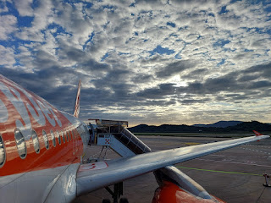

It was a nice and short one-hour flight over Corsica and up north to Milan.

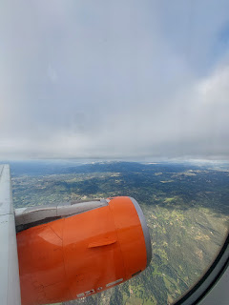

Arriving home to our new house about 2.5 hours later, I got unpacked and then repacked, showered, scrounged us up something for dinner using things we had on hand (potatoes, a giant can of chili, cheese, sour cream, green onions), and then we watched a show before going to bed EARLY. (I was asleep by 9:00)

I set my alarm for 3:15 a.m. (gross) so that we could be out the door by 3:45 a.m. to drive to the Venice Airport, where I would begin flying all the way back to Idaho Falls. Only my brain woke up at 12:30 a.m. and I couldn't go back to sleep. How delightful. I got about 3.5 hours of sleep that night.

Scott drove me to the airport and dropped me off around 4:45 a.m., then drove back in time to make it to his early-morning formation. He's so awesome. He never complains about having to drive me to the airport in the craziest times of the night.

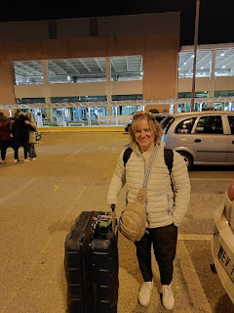

Over the course of the next 24 hours, I flew from Venice to Frankfurt, then Frankfurt to Denver, then Denver to Idaho Falls. My longest flight was 10.5 hours on the way to Denver. I sat by the nicest lady, named Kathy Barrett, from Cheyenne, Wyoming. We had an empty seat in between us and we talked and talked and talked. She is so cool. She used to be the secretary for some members of the Wyoming legislature for many years, and we had a very hushed - but lively - discussion about everything that's going on in our country right now. We were very much on the same page as far as our concerns. But that's not all we talked about . . .

I was happy to bring the conversation around at one point to family history, my favorite hobby in the world, and she wanted to know how to get started on her family tree. I made several notes for her on a pad of paper from my backpack, along with my contact information. She was super pumped about tackling some important family history projects that she's been meaning to get to for some time, but hasn't yet. I'm really excited for her!

She had been visiting her son and his family at the largest European military base, Ramstein, for the past couple of weeks. So, we chatted about life in the military, places in Germany, and our grandchildren. She really helped to pass the time on that looooong flight. :)

This is Kathy, right before we exited the plane in Denver . . . I will miss her.

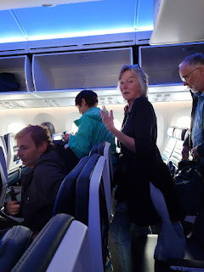

I got to put my new Global Entry membership to the test in the Denver Airport, which was the whole reason I decided to get Global Entry in the first place. Denver is the worst airport I have ever been in and I always dread any layover here. It's especially anxiety-producing when I fly in from overseas and I have to go through customs and still try to make my next flight. They are so disorganized and sloppy, and I have missed many connecting flights in Denver because of how poorly they run things.

This time, however, it went pretty well. I didn't have to run two miles to then arrive at my gate wheezing and coughing and out of breath, so I'll say it was a success. Are there still some things they could improve on and do differently? Absolutely. Was Global Entry a good purchase? You better believe it.

I was so happy to see the sign pointing me toward Global Entry, even though technically there weren't very many people in the other main line this time.

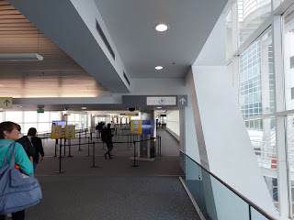

I stood on the designated footprints on the floor and then the screen in front of my face captured a photo of me. Within one second, I was approved, and the computer monitor told me to advance over to the security agent to show him my Global Entry card. He gave me a laminated "exit card" and motioned me over to the baggage claim carousel. Everyone else from the main customs line caught up to me at this point, as we all stood around for about 25 minutes, waiting for our luggage to arrive.

This is what I will never understand. Why do we need to grab our checked bag that has already been screened for the international flight I was just on, and then re-check it again? And why do we need an "exit card" in order to exit the baggage claim area? And why do I then need to go through security all over again? I haven't been anywhere except for on my previous plane and then through customs. Also, why do I need to dump out my water again? Honestly, what kind of terroristic trouble could I be capable of causing when I haven't been anywhere yet . . . ??? It's all just so stupid.

But of course, I always comply. Eventually, I headed underground and caught a train to a different terminal and proceeded to walk a mile to get to my next gate. At least I didn't have to huff and puff and run as fast as my little legs could carry me this time. I've had to do that so many times before.

By the time I got HOME, I was bushed. I only slept maybe one hour on that long flight from Frankfurt to Denver, so that meant that in total, I got about 10 hours of sleep over the course of 3 days. I couldn't wait to get into bed and crash. HARD.

Over the next couple of days, I slowly caught up on sleep again. I had a horrible headache for two straight days, but the combination of caffeine + ibuprofen fixed it on both days. Nothing else even came close.

My nephew, Caleb Schwendiman, came over last Friday night with his roommate, Daniel (from Ecuador). We ate dinner together and watched an amazing movie called, Escape from Germany. It's about how 80-something missionaries safely escaped from Germany within hours of WWII starting up. Caleb had indicated that he might be bringing a larger group of friends from BYU-Idaho, so I loaded up on some snacks and set it all out on a table downstairs. However, now I have way too much junk food left over, ha ha, since it was only the 3 of us. But we had a great evening together.

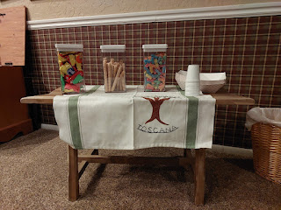

Meanwhile, Scott has been receiving all of the things that I ordered on Amazon a while ago for our new house. He referred to it as "Christmas" when he stopped by the post office on base after work one day. He had to borrow a cart just to transport everything out to the car . . . and then he got to haul everything up all the flights of stairs, too. He's so awesome. I had ordered area rugs, bathroom rugs, an entry table, and a few other smaller items, too. So far, this is what our living room looks like - with the one little loveseat that Scott found on Facebook Marketplace in Vicenza. We are using two barstools as "side tables" to set a drink or a snack on while we watch TV for now. Eventually, we will have a sectional couch and then we'll figure out what kind of tables will fit in the remaining space.

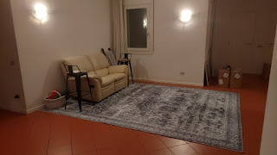

I was so sad to miss the baptism of Morgan Keithley, a young man that we have grown really fond of in Vicenza. He works in the same building as Scott and has been attending church for a few years now, but wasn't ready to commit to baptism until just a few weeks ago.

Morgan shared the story of his conversion with everyone who attended the baptism on 22 February. Scott texted me some notes and I will attempt to piece them together into actual sentences, ha ha.

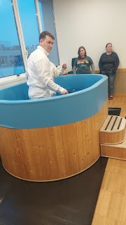

He (Morgan) was invited to attend some YSA (Young Single Adult) activities when he was stationed in Monterrey, CA back in 2021. He made some good friendships there. And as he moved on to Fort Huachuca (Arizona) in 2022, and then over to Vicenza, Italy in 2023, he consistently sought out any missionaries that he could find and continued going to young adult activities (such as volleyball, dinners, etc.) with the friends that he met in each place.

The missionaries became like family to him, and I was a witness to this. It was so cute to see Morgan interacting with the Elders because it was all so natural and fun, like he was their actual brother or something. They'd joke and tease and have a great time at all the activities. But he was never quite ready for baptism. And that's okay. We don't force anyone to do anything, and usually we are prettty good about letting people choose their own timeline. :)

Recently, he felt like God was telling him to "stop resisting the love of Christ" and to "get serious about the Book of Mormon." So he did.

He had never actually read the Book of Mormon until now. And that's when everything changed. He prayed and asked God if this additional book of scripture was true, and he received a powerful witness that it was. He told the missionaries that he was ready to be baptized now, and they almost fainted in shock, ha ha. After 4 years, he was finally ready.

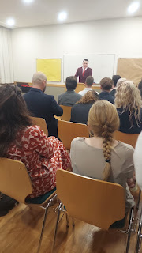

I'm so proud of him for being patient, yet diligent and consistent in his efforts. He didn't jump into anything until he knew he was ready, but when he was ready he was very committed. I hugged him several times before I left Italy, and I'll hug him several more times when I return.

I have just a few more tidbits before I wrap up this blog post. I've been up to my eyeballs in lots of big projects and tasks lately. That's why I'm a little late in getting this one published . . .

My current list includes:
My weekly blog (of course)
A very in-depth blog about my Rawles ancestors that should be ready in about 10 days or so
Working with my former foster daughter, Jasmine, to determine what they need before their baby is born very soon, helping her get some costly items, and finding the right fabric to make her a baby blanket
Spending time regularly with my niece, Mari and my nephew, Caleb
Working with my Dr in determining a plan for my gut & digestive issues, getting labwork done, and then researching various supplements and finding the ones that I need
Networking with various cousins in my Rawles family for the upcoming blog, plus summertime family reunion plans (= lots and lots of phone calls)
Keeping up with my kids and everything they are working through - - -
Jake was in an economic competition this week and won 3rd place with his teammate + they will be moving in a few months to a different apartment + new job and new baby
Amber reports that Weston will be changing jobs in the next couple of weeks. His current employer seems to think that Weston needs to be the acting doctor, administrator, secretary, and do everything to run the entire optometry company in Oregon without any additional help and no additional pay.
And Benson . . . well, I did finally get him to respond to me yesterday after weeks of trying. I played a little prank on him and it worked! I texted: I'm so excited to see you tomorrow!! and he responded about an hour later, completely befuddled, ha ha. He already had plans for this weekend, but I'll probably be going to see him next weekend. He laughed that I was so clever in getting his attention.
I've been organizing and gathering items that need to make their way over to Italy, when we ship over our household goods sometime in April
Trying to go to the gym a few times a week and exercise at home most mornings
Prepping, organizing, and then beginning to scan a whole new round of slides over at the FamilySearch Center. These are slides from Scott's parents that I inherited and have been meaning to get to for some time . . . In the past 2 days I've scanned almost 1,000 slides so far.
I need to find a sectional couch locally that can be delivered to our house temporarily. It will be sent in the household goods shipment to Italy in April, and then whenever we're done overseas, it can come home to Idaho Falls and live with us happily ever after.
Getting together with a friend at least once a week for lunch. It's hard keeping up on friendships on both sides of the world, and I'm running out of time to catch up with people here.
Haven't even started on this yet, but I need to start planning and figuring out what I'm gonna need to make a Quiet Book for Maisie in the next few months. It takes a few months to complete a project this size, and I need to start on it here so I know what to haul with me to Italy to finish it up over there. I need to finish the project by the beginning of July because I'll be coming back to the States for part of July and most of August and I won't have any time for sewing then. Her 1st birthday is the first week of September, so I need to get going on this right away. It's a tradition that I started several years ago with my grandchildren and it really does bring me a great deal of joy to create.
Basic housekeeping tasks: laundry, menu planning, cooking and cleaning up, etc.
Things that have popped up unexpectedly lately include:
Sometimes, when I pick up my niece to do 1-2 things, it ends up taking 4x as long as I thought it would
When I picked her up yesterday (along with her dog Ducky Momo), they inadvertently had to trudge through some mud to get to the car (I didn't see the mud when I parked in the only spot on the street that was available), which meant lots of muddy footprints and muck all over in the passenger side of the car. So today, I stopped at the car wash and vacuumed everything out and buffed the seats and doors with a cleaning rag to get all the crusty residue off.
My elderly cousin Barbara (92 years old) keeps calling me every couple of days and wants to tell me stories of yesteryear. If I weren't feeling like I was already drowning with so many things to do, I would love to just chat away with her. But right now, it's very taxing. I know I shouldn't feel this way, and I feel guilty for being annoyed. I still need to return a phone call that I missed from her 2 days ago . . .
My nephew Caleb texted and asked if he and his roommate could come hang out with me Saturday afternoon. Like all afternoon. When I asked what he would like to do, he said play games and watch a movie. I asked if he and Daniel would like to help me clean all the windows first. I had already put that on my calendar for Saturday since it will be sunny and "warm" outside. (46 degrees) He happily agreed, bless his heart. I told him I'd be happy to play 1-2 games, but I wouldn't be watching a movie because I have too much to do. I did offer to make them some popcorn, though. :)
I wish I just had more time and more of me to throw around. I don't need sympathy, I just need more time to put my head down and get all of these things done. More work. Less play. And more sleep.

Scott will be here in 3 WEEKS and then we leave for Portland and San Francisco a few days later. That's partly why I feel so rushed right now, like that all I have is 3 weeks to get
everything
done. I know this isn't exactly accurate or true, because I'll probably be able to do a few more things once we get back from our appointment with the Italian Consulate in San Francisco. But I don't want to procrastinate anything, because WHO KNOWS what will actually be the case at that point. In fact, we will probably be up to our eyeballs in getting the house ready to leave behind, and getting things packed up and ready to send that shipment of household goods to Italy. Not to mention that Scott will be trying to take care of a couple of medium/big home improvement projects while he's home for a minute, and I'll need to be on hand to help, and at the very least I'll be on the clean-up crew.

Sunrises and sunsets remind me that EVERYTHING IS GOING TO BE OKAY.

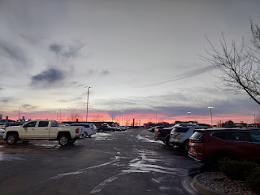

While doing some research for my 3rd great grandfather, Joseph William Rawles, for the next in-depth Rawles Family blog post, I came across this 1880 Census record and it made me laugh so hard . . .

I've never seen a bunch of first-names-only on a census record before, so I'm not sure what that's all about. But take a look at the 80 year old man's name where I've pointed with the arrow below . . .

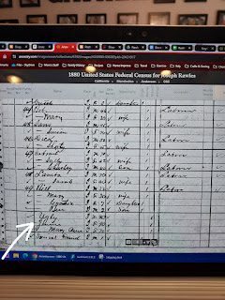

Having regular video calls with my grandchildren always make my day. No matter what I'm doing, or how busy or frantic I feel, when they call, it's like a big exhale for me. Everything else melts away and I am reminded of how important my family is to me.

Maisie is "chawing" on a giant celery stick here . . . I'm telling you, the way to this girl's heart is through her tummy!!

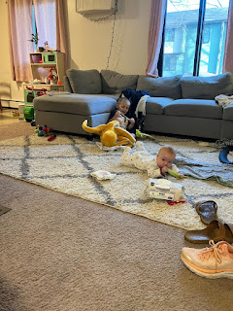

Video of Maisie trying to slurp the life out of each blueberry that Jake is feeding to her: (47 seconds)
https://photos.app.goo.gl/Nx9GxZHABfj5aiiA9

*Plus, we get to hear Hannah and Jack having an animated discussion about monster truck drivers. :)

I saw this in a store recently and it applies to Scott and me so much! We are always saying things like, "I love you."
"I love you more."
"It's not a competition you know."
"Nevertheless, I love you the most."

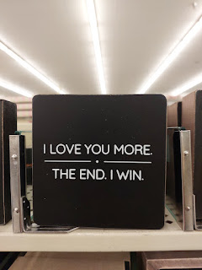

Have a wonderful weekend and a fabulous upcoming week. Take care. XOXO

