Snowmageddon & A Funeral
I'm no meteorologist, but I'd say we got about 15-16 inches of snow in about 48 hours, starting on Leap Day. I shoveled about 7-8 inches of snow on Friday afternoon (March 1), and then another 7-8 inches on Saturday. It was the heaviest, wettest (is that even a word?) snow that I've seen in several years!! Perfect for making a giant snowman, but I was not in the mood for that this time around.
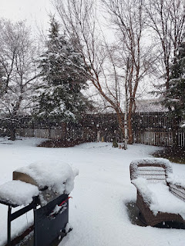

A day or two before Snowmageddon, I was outside pulling weeds, pruning my fruit trees, and cleaning things up before I leave for another 90 days. This same time last year, we still had about a foot of snow on the ground, so there were no weeds to be seen. They were all still asleep . . . and buried. But this winter has been milder (except for this recent humdinger), which has allowed all of the sleeping weeds plenty of time to wake up and start multiplying. I knew that if I didn't do something right then, there would be the thickest jungle imagineable when I got back in June.

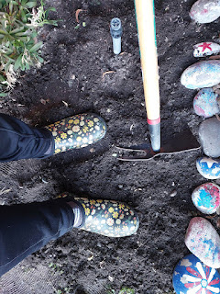

I pulled weeds in this flowerbed until it was too dark to see them anymore.

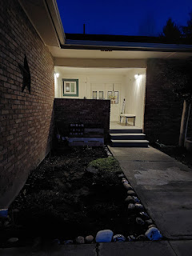

The next morning, I began right where I had left off the night before, getting everything all tidied up for spring . . . someday.

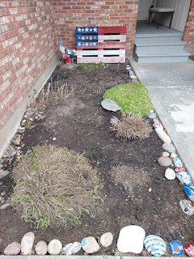

In another flower bed, I saw the beginnings of my spring bulbs trying to find their way out from the dark underground and up toward the light above.

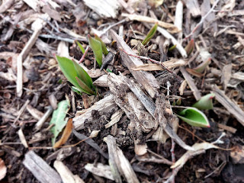

I found myself thinking about the symbolism in front of me, as I cleared away the debris so that the leaves were unobstructed in their growth. Sometimes we do need to clear away the clutter and the things that don't matter so much in our lives, and especially the things that are holding us back from our true potential.

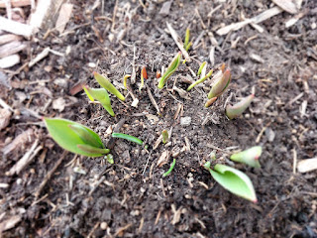

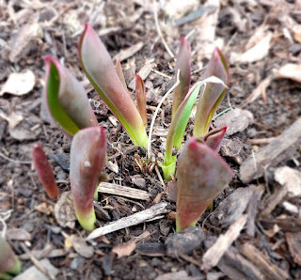

But also, sometimes we just need to see ourselves as strong and capable in spite of what is trying to hold us down or back. We can still emerge triumphant and joyful, even while there is clutter, or debris, or an obstacle in our way. We are strong enough to emerge, conquer, and grow! We are, we can, and we must.

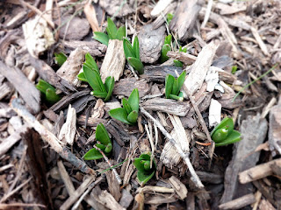

With that profound thought ringing in my brain, I began pruning my peach tree, my apricot tree, and lastly, my apple tree. I hope they liked what I did to them and that they will repay me by bearing fruit this summer.

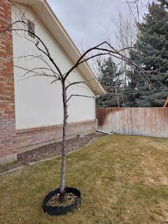

The quiet (and green) backyard . . . before the impending snowstorm . . .

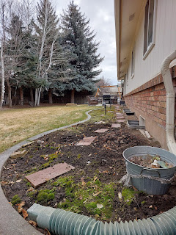

I drove up to Rigby the day before my father-in-law, Phil, passed away. We spent a lovely afternoon together, chatting about this and that. I am so glad that I got to have that special time with him before he was gone from this life.

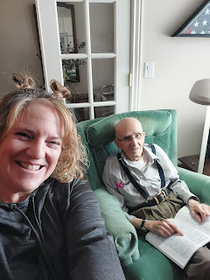

This book about the Bassano Family and how they were connected to William Shakespeare is a FASCINATING read. I have been immersing myself into each page from time to time, making notes and placing sticky notes on each page that has something profound to mark. The book is called: "Shakespeare Exhumed: The Bassano Chronicles", by Dr. Peter D. Matthews, with a few illustrations by Maria Bassano.

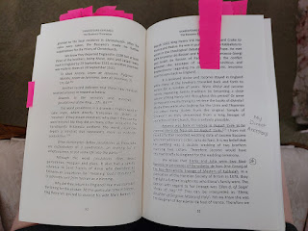

I may not have a lot of time in the next 2 weeks to dig into the book further, but I will definitely bring it on the plane to Italy and continue my studies over there. There are several places that I want to visit, especially in Venice, that have significant connections to my ancestors. I am very excited about this undertaking, but it is very slow-going and painstaking because there is SO MUCH information on every single page.

It took a while for Scott to catch up on the news of his father's passing, but the next day, as he was sitting in the Amsterdam Airport waiting to fly back to Italy, we finally had a video call. He was in good spirits then, and I'm sure he was being blessed.

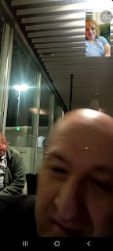

Meanwhile, Snowmageddon had begun and was in full swing. Everything that had just been green and itching for spring, was trodden down with all the heavy white stuff.

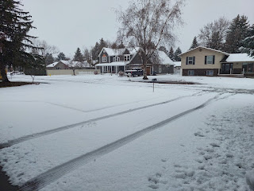

Branches on the trees were inundated with the amount of heavy snow and they subsequently sagged down, sometimes even touching the ground because of all the weight.

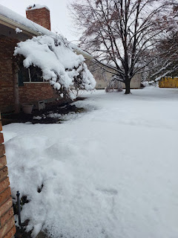

I went from tree to tree, shoveling snow off the sagging branches until they began to spring up with joy. All except for one big branch next to my driveway. This one needed to be trimmed up once Scott got home.

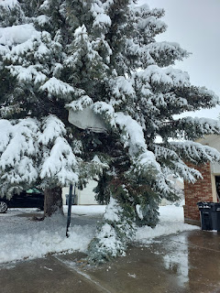

I was worried that the snow was going to be too heavy for the snowblower, but it did a pretty good job.

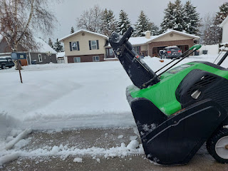

Yep. I'd say we got a bit of snow.

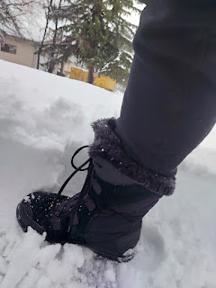

Just as I was finishing up with Round 1 of the snow removal, the thunder and lightning returned with a downpour of hail.

Video here: (16 seconds)
https://photos.app.goo.gl/2zeRmBv2BRQmDirS9

*Note the sheer wall of snow at the end of my driveway in the video. That's why I couldn't go anywhere for 4 days!

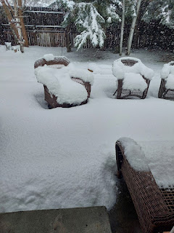

My neighbor, Ellen, got stuck in the road right in front her her house next door to me. Thankfully, Ben Parkinson and his two boys, Jackson and William, came to her rescue. They coached her on going forwards, backwards, gun it, brake, etc. until they got her safely into her driveway.

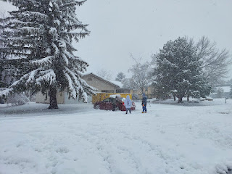

I got a video of their final moments: (28 seconds)
https://photos.app.goo.gl/u6uYYSqScfuHroKYA

While the Parkinson boys went home to rest, Kim Parkinson hauled me and our neighbor, Maria Kloak, to the grocery store in their very hardy Suburban with 4-wheel drive. Kim was a boss as she muscled her way through the deep snow so we could all get food for our families. (or in my case, for ME) We all chatted about what soup we wanted to make for dinner that night, and laughed that we all had the same idea for a SOUP DAY.

Maria (back left), Me, and Kim (on the right) . . .

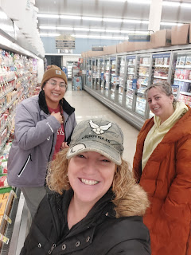

What a beautiful thing . . . neighbors helping neighbors and women helping women. I love it!

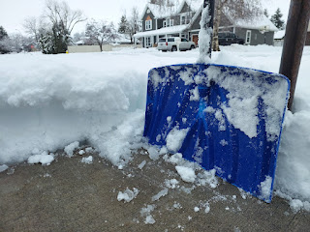

I couldn't get the snowblower to fling any snow past my mailbox, it was just too heavy and deep, and I didn't want to shovel it all by hand either. I was so grateful when Ben came across the street to help with Ellen's driveway and our shared sidewalks out front.

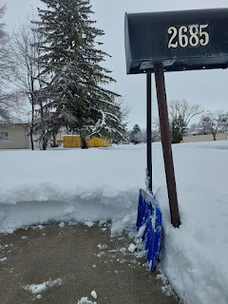

While Ben ran his more powerful snowblower, I took my shovel and started unburying the lower branches that were about to break on this tree. I was able to scoop enough snow off to allow the branch to raise itself up to a normal stature.

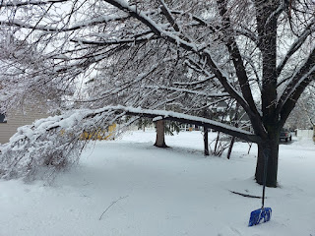

I also assisted Ben with some peripheral snow clearing using my shovel while he worked with the snowblower in Ellen's driveway. We got it all taken care of pretty quickly as a team.

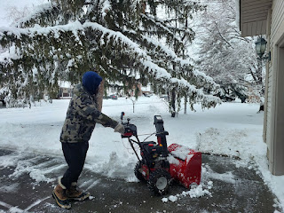

Just as we finished the driveway and were starting on the sidewalk leading back to my mailbox, the mailman got stuck in the deep snow right next to us!!

Video of the mailman trying his best, but not making any headway: (3 min 10 sec)
https://photos.app.goo.gl/3FWTyg1Mi2PFW7TD8

Ben offered to help him, but he said, "Nah . . . I got this. I've been getting stuck all over the neighborhood, I just need to rock it back and forth a bit." After watching his futile attempts from a couple houses north, Brent Dixon came over to assist, even though the mailman said not to help. (We think it was probably a liability issue, like what if someone got hurt while trying to help . . .)

Video of Brent trying to help the mailman: (46 seconds)
https://photos.app.goo.gl/NLLgZccBcN14P5jW6

Then, Ben AND Brent were trying to help him further: (18 seconds)
https://photos.app.goo.gl/o8Gfxrd6DSeH5HKdA

Finally, after a solid 10 minutes of attempts and failures, they got him on his way. (9 seconds)
https://photos.app.goo.gl/KpKZzV5GkQLSYWrH9

He did hand me my mail from where he was stuck, though, ha ha. Guess what it was . . . LOL



Something I had been waiting my whole life for . . . JUNK MAIL!!

In between all the rounds of snow, I worked mightily on Jack's upcoming birthday gift.

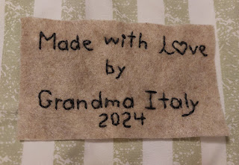

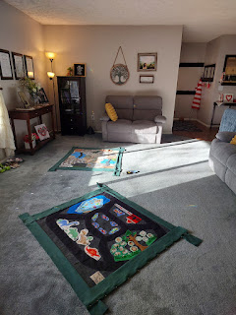

I sewed the two panels together into one, and then turned it inside out.

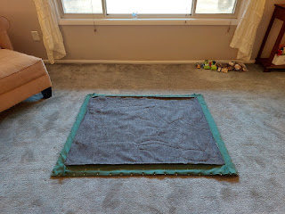

Final pictures are further down in the blog.

I also finished the Rawles Blog - which was 10x the undertaking compared to the tribute I made for my father-in-law, Phil, last week. Here is a link to the Rawles post, if you are interested:

https://rawlesroots7.blogspot.com/2024/03/june-carol-rawles-louisa-jane-tarwater.html

I got all the letters mailed to those that don't have email addresses on file, and then I relished in the relief that it was finally done. :) I got several texts and emails about how much the family enjoyed reading it. I was so grateful that all of this effort was being appreciated.

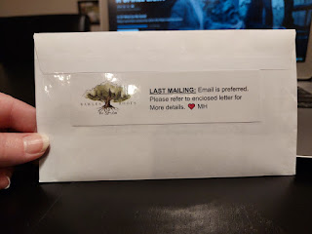

My cousin, Loreena Hester, shared a recipe with me from my great-aunt Naynee for her famous banana bread, which I included in the Rawles Blog. I decided to make it for myself and it turned out perfectly! I loved all the extra walnuts in the bread this time. I think Aunt Naynee (and Loreena) would have been the perfect company to share it with, too.

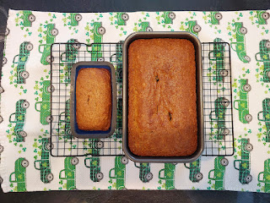

One afternoon, after more shoveling outside, Ben Parkinson called and asked if I would like to join him and Kim for dinner that evening. Absolutely!! I had been cooped up for a few days and was excited to get out and do something with friends. We went to a restaurant called Fuji, a Hibachi grill with sushi, too. I hadn't been there in a while, so that was fun. They seat you around a large grilling area with people you most likely don't know, and then you all join in the fun together. Eventually, the chef arrives with all his fancy knife and spatula throwing tricks to entertain you.



Video of the hibachi chef: (13 seconds)
https://photos.app.goo.gl/cpnQEfW5VF2vX7Vp6

Video of him throwing pieces of broccoli out to Ben to catch in his mouth: (13 seconds)
https://photos.app.goo.gl/SYCB6m8P7pgyeDMm7

Video of the chef stacking up raw onion slices to make a tower of flames: (15 seconds)
https://photos.app.goo.gl/bcdXhCoKUkjQV9ad8

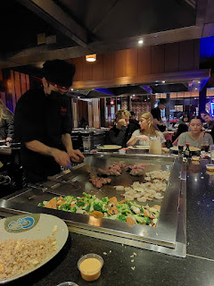

Kim and I both ordered a chicken and shrimp combo, and the veggies were included, too. Everything was really tasty and I'm so glad they invited me. It had been a stressful day and it was nice to talk it out with Ben and Kim.

Kim, Ben, and Me . . .

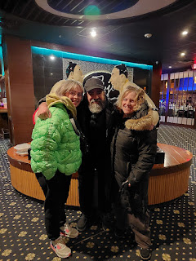

Our next stop was at Kneaders, a bakery and cafe, to pick out a dessert to take home. Our tummies were too full to eat it right then, ha ha. I chose a layered carrot cake that looked so pretty behind the glass.

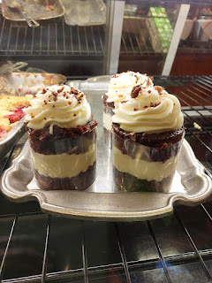

While it was beautiful, it was a little too sweet for my liking. I was hoping for something closer to what my mom used to make for my dad's birthday each year - her carrot cake always had the perfect cream cheese frosting that complimented the cake. Maybe I could talk her into making it again sometime this summer when I come out to CA for my next visit . . .

Jumping back in time for a minute . . . when Scott was in England for a week, shmoozing with all the other officers, he was getting photos from his buddies in Italy where there was some localized flooding. Tons of rain and saturated earth meant full canals and waterways throughout the city of Vicenza.
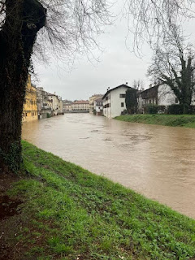

Scott attended a fancy soiree dinner for all of the Army officers on their last night, where they met in an on-base military hotel at Warminster Garrison. (In between Bristol, England and Stonehenge)

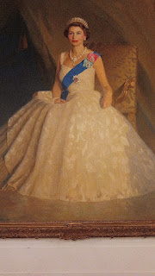

Scott obliging me with a photo . . .

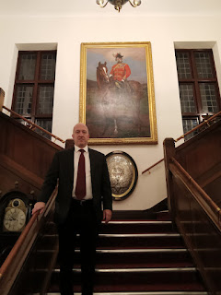

Scott (on the right) with some of his colleagues . . .

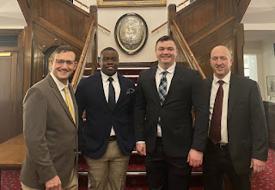

Please forgive me . . . I feel like this blog post is jumping all over the place . . . but right around the time Scott was going to sleep after this big soiree in England, was when his father passed away in Rigby, Idaho. So many things have transpired in the past 2 weeks since, and I am trying to get my thoughts in order at the same time.

Scott flew home to Idaho Falls on March 7th. It took him 30 hours to get here through Paris and Salt Lake City. He arrived in really good spirits, though. What a trooper! I picked him up at the local airport and brought him home, where Gordon (his brother) and Pam joined us for dinner. They had arrived the night before. I made a chicken chili in the crockpot with cornbread muffins on the side.

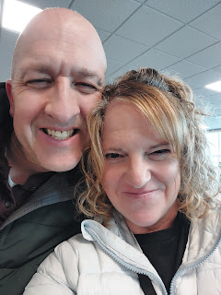

Our dear friends, Peter and Barbara Vance, delivered a beautiful arrangement of white flowers for the funeral, along with a thoughtful card and condolences.

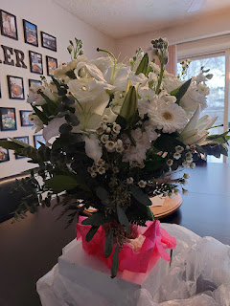

For the next few days, Scott and Gordon were inseparable. They teamed up in the cluttery office (filled with numerous boxes and totes of family history from Coy and Phil's house) to put together a video that could be played during the funeral luncheon. It included various Naval videos on YouTube, as well as a slideshow of photos from Phil's life. They did a great job putting it together!

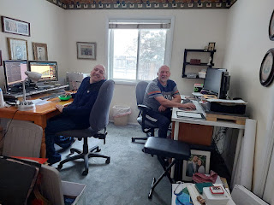

On the morning of the funeral, March 9th, Benson caught a ride bright and early with his cousins, Robert and Heather Aston. They scooped him up on their way from Boise to Rigby, bringing Daisy in the truck with them, too. Benson and I had previously discussed and settled on an outfit for him to wear (over the phone), with me picking through clothes from his younger days that are still hanging in his bedroom closet. I hauled everything up to Rigby so he could change at the house before the funeral.

While Benson got all gussied up, Abby happily entertained Daisy in the back yard for a bit. Abby is NEVER afraid of the cold or any depth of snow. In her mind, it is always inviting and entertaining to go out into the wintry wonderland, and she is never annoyed to have to get layers of coats, mittens, hats, snowpants, boots, etc. on.

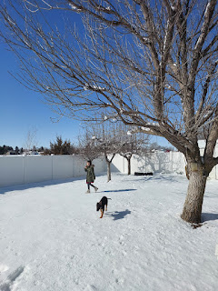

Amber and her family had just arrived the night before from attending a funeral down in Manti, Utah for Weston's Grandma Bone (his mother's mother), who passed away the day before Grandpa Phil did. Gwen didn't fare so well during the funeral proceedings on Friday, so we all went to a lot more effort to prep her and keep her informed as to what we were doing throughout the day on Saturday. That helped a lot!

We had a family song practice at 10:30 a.m. at the church, followed by the family viewing at 11:30. The funeral began at 1:00 in the church building where Phil and Coy had attended church for about 25 years.

Scott's sisters, Carol and Bev, had arranged several photos and awards to display in the church foyer, just outside the chapel. Several people commented about how full a life Phil had lived: he was in the military, he was a musician, he served as a Scoutmaster, he was a professor, he was a park ranger, he was even a policeman for a few years in Rexburg, Idaho! (He never received any formal training for his police work, he was more like a citizen's watch policeman.)

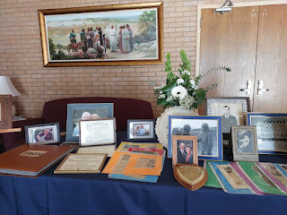

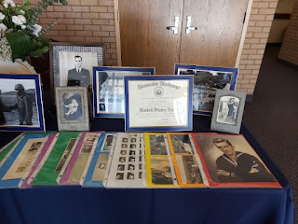

I was surprised at the amount of extra effort Scott's sisters put into the funeral luncheon - to decorate the tables - because usually it is a very simple affair. Local ward members typically contribute the food and the tables are set with no extra frills. But Carol and Bev ordered some special Navy napkins, centerpieces of red/white/blue, nautical confetti to sprinkle along the tables, and even purchased brand new copies of some of Phil's favorite books to place here and there. The books would go home with whoever wanted them at the end of the luncheon.

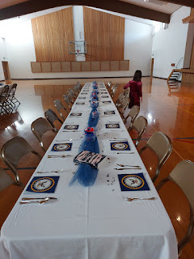

My job was to provide some M&M's, one of Phil's favorite treats. I ordered some red/white/blue ones on Amazon, since it would have been impossible to find them in local stores right now, especially since everything in the stores is pretty much all Easter pastels.

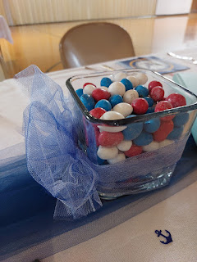

On one of our phone calls while Amber and the girls were driving across the country, I asked Abby and Gwen if they could help me set out all the candy jars. They happily agreed and they were perfect little assistants when the time came. We all took turns retrieving them from my big laundry basket on the floor, placing them carefully on the tables, and then peeling off the plastic covers and fluffing the tulle bows to spruce them up a bit. Not only was I delighted to have my two oldest granddaughters by my side, but I think it helped them to feel important and needed, too. :)

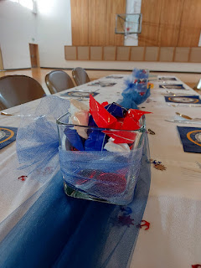

Some of the books that were Phil's favorites . . .



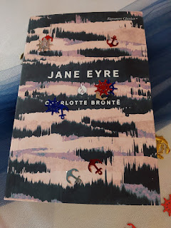

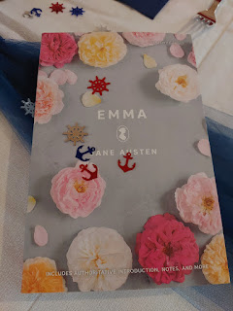

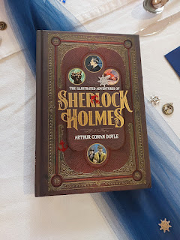

During the family viewing, the Relief Society room filled up with children, grandchildren, great-grandchildren, nieces and nephews, in-laws, and some cousins of both Phil and Coy. Everyone seemed content with having small clusters of conversations and giving hugs before moving on to the next group of relatives. I'd estimate there were about 60 family members in attendance.

Phil and Coy's five remaining children (not in birth order): (L to R) Carol, Sharon, Gordon, Scott, and Bev. The one missing in this photo was Philip, who was just older than Gordon and who died in 1984.

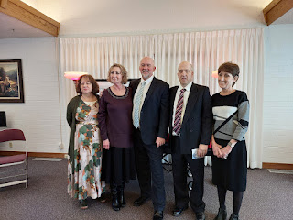

One more layer, adding in the spouses:
(L to R) Sharon Harmon, Mike and Carol Whitten, Pam and Gordon Harmon, Bev and Ken Vian, Michele and Scott Harmon, and Ashley Reese (daughter of Philip Harmon Jr., who died a little over a week before she was born).

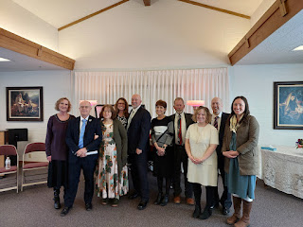

Bishop Stowell gathered us together shortly before the funeral service was to begin, and said a few words before turning the time over to Gordon for a family prayer. Gordon was very emotional during the prayer, and it was very heartfelt and beautiful as he gave thanks for a father who taught his children so many good things and set a good example for them all.

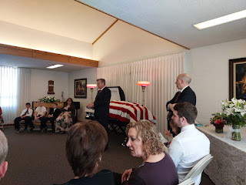

We followed the casket into the chapel and had a lovely funeral service. It was recorded, so we look forward to having copies of that in the near future. The music was especially beautiful, and how wonderful it was to sing once again as a numerous Harmon Family Chorus. We filled that entire chapel with our voices, our hearts, and whole souls. XOXO

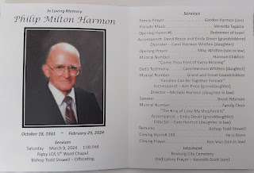

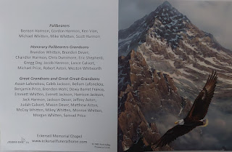

I snuck a picture of Carol leading the closing song, with David Reese (Ashley's husband) on the piano and Vernetta on the organ.

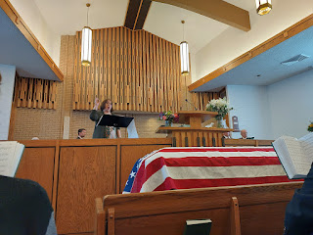

David and Ashley had driven up with their 3 children from Heber, Utah the night before. David and the kids hung out with me so he could practice on our piano while Ashley attended a special sibling meeting up in Rigby. She has always been treated as though she were an equal sibling in her father's place. The meeting was to discuss how the estate would be settled and what the next steps will be going forward. Spouses were not invited, and even though I was a little bit sad about that, I was happy to entertain Mia (14), June (12), and Edmund (9), while David practiced for hours in the living room. He plays so beautifully and the music filled our home with a sweet spirit.

After the funeral was over, the pallbearers were invited to exit first, which included Scott and Benson (seen hugging on their way out the door below).

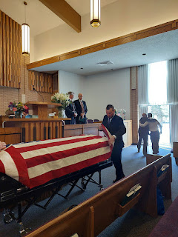

Soon after, the rest of us filed out behind them and then made our way to our parked cars behind the hearse.

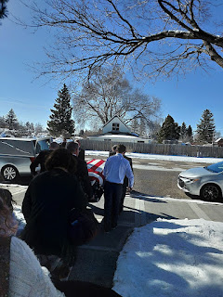

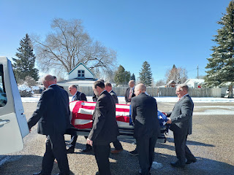

Retrieving the casket at the Rexburg Cemetery . . .

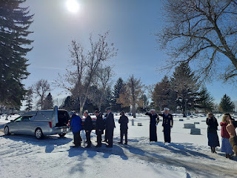

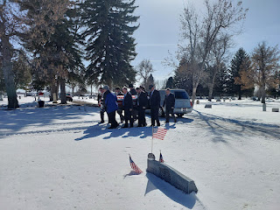

A path had been cleared for the pallbearers, with a separate path for the rest of the family members nearby. I'm sure it wasn't easy carrying a heavy coffin through the treacherous snow, but they managed to do it safely.

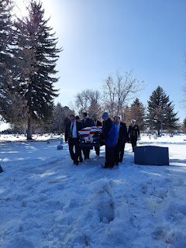

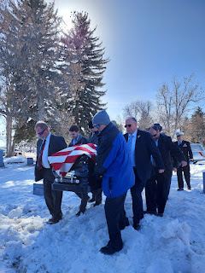

The VFW had been invited to be in attendance, which ended up being such an amazing experience for all of us. (VFW = Veterans of Foreign Wars)

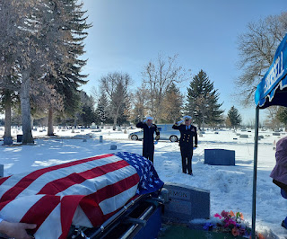

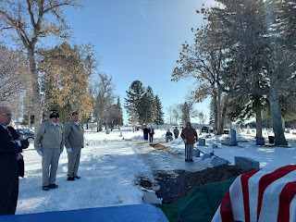

After they made sure the flag was just right and correctly draped on top of the coffin, the VFW had a little program in store.

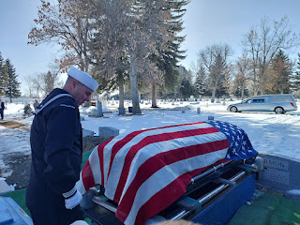

Note the elderly (and disabled) veteran in the wheelchair . . . after a few religious and patriotic words were read by his comrades, he then played the most gorgeous version of "Taps" that I have ever heard.

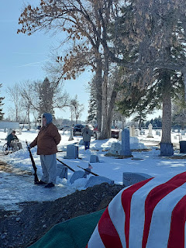

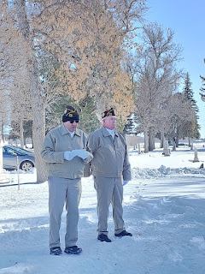

Video of the gun salute (fired 3x) and Taps: (1 min, 50 seconds)
https://photos.app.goo.gl/uVvnJ7iAhDDzDShi6

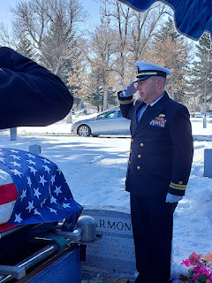

Video of the flag being carefully folded and inspected: (2 min, 11 seconds)
https://photos.app.goo.gl/VoYavaNS96Wu7cqw8

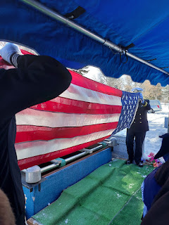

Video of the flag being presented to Scott: (22 seconds)
https://photos.app.goo.gl/MokDcjqJubsmjnjt7

The presenter can barely be heard saying: "On behalf of the United States Navy, and a grateful nation, please accept this flag as a symbol of our appreciation for your loved one's honorable and faithful service."

Then, the script-readers and prayer-givers came over and gave Scott an envelope with a card inside, along with all 9 empty casings from the bullets that were fired moments earlier.

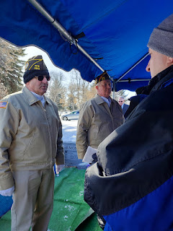

Their thoughtful message inside the card reads: "As members of Veterans of Foreign Wars Post 3012 and US Navy Honor Guard, we express our condolences at the passing of Philip Milton Harmon. We have the highest regard for his devoted service to his faith, family, community and country. At a time of trial for our nation and its allies, he stepped forward and served with devotion to his duty."
~ Joseph D. Law, Commander VFW Post 3012

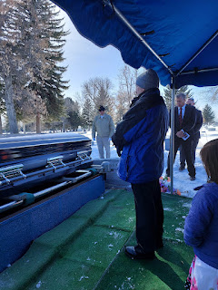

Scott dedicated the gravesite with a beautiful priesthood prayer and then it was all done.

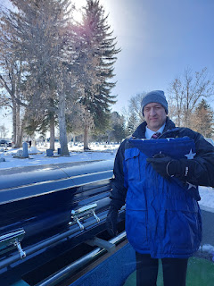

There are several Harmon family graves all right next to each other: Ashley's dad, Philip, is on the far left, Jonny has a flat headstone next to Philip, then Coy & Phil, and then Phil's parents, Helen and Wesley Harmon are on the far right.

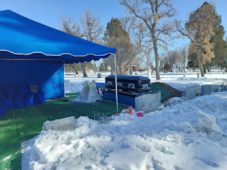

Scott and his brother, Gordon . . .

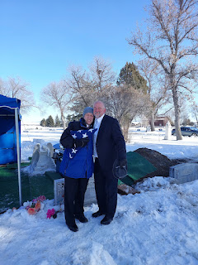

Gordon's more stylish look, wearing his dad's fedora hat . . .

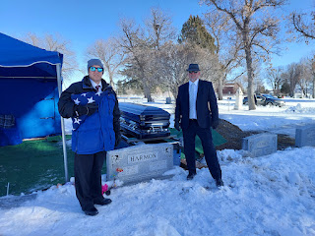

Our family: Weston, Amber, Me, Scott, and Benson

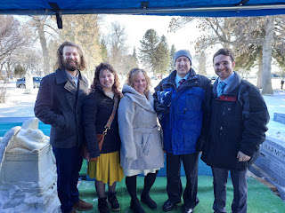

The luncheon was great, once we got back to the church. We had fried chicken, Greek salad (tomatoes, bell peppers, feta cheese, and Bev's homemade dressing), funeral potatoes, rolls, and way too many desserts, ha ha. There were cupcakes, chocolates, and all the candies that the girls and I set out on the tables, as well. A carbolicious spread!

Ashley Reese, Amber, Weston, Scott, and Abby were sitting closest to me . . .
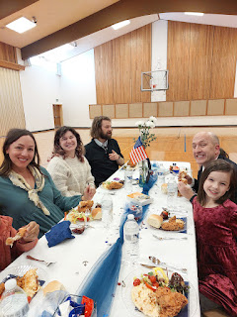

Amber and Weston were getting some helpful info and tips from their cousin, Ashley, regarding Spokane, Washington. Weston was eyeballing a possible job in Spokane, and Ashley and her family used to live there for several years before recently moving to Heber, Utah (south of Park City).

Weston and Amber have been considering a possible move to either Minneapolis, Spokane, or Portland, Oregon. While they loved Minneapolis, the two other jobs are more exciting and lucrative out west, so I think Minneapolis is out of the mix right now. Portland is currently at the top of the list because the Spokane employers might already have someone in mind who is working there right now. We have several family members and friends who were able to give Amber and Weston valuable feedback about the Portland area, so we will see what takes shape in the coming days. If all goes well, they will accept the job and move up there in May or June.

The Portland job would involve Weston driving from rest home to rest home in the Portland area to give eye exams to the elderly patients living at each place. The Whitworths aren't looking to live in Portland itself, but rather in a nearby community without some of the significant problems that the city faces right now (homelessness and drug issues being up at the top of the list of concerns).

The Relief Society of Phil and Coy's ward put together these darling patriotic vases with TIES on the jars. How cute!!!

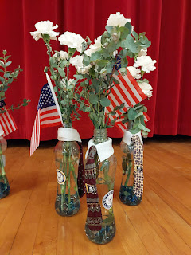

Everything was pretty crazy at the Rigby house after the luncheon was all cleaned up. Carol's kids and grandkids were there (about 20 of them), and furniture was being moved out to Robert's truck and trailer to haul back to the Boise area. They even unhooked the washer and dryer to haul away, too. Unfortunately, the washer still had a fair amount of water in the hose, so then the laundry room got flooded a bit . . . and when you mix some water with old cat food and cat litter and even a little bit of cat hair from Coy and Phil's cat named Fluffy (who died a few years ago), then you've got yourself a real mess to clean up. The cat "supplies" were behind and underneath the washer from who knows when . . .

Because it was so crazy and chaotic at the house in Rigby, Scott and Benson and I opted to head home to Idaho Falls and relish in a quieter environment. After all, everyone had things under control back in Rigby and our muscles weren't exactly needed.

Daisy benefitted from some calm and quiet, too. While she had enjoyed all the activities and kids running around, she was also happy to come home and just chew on her toys while we chatted.

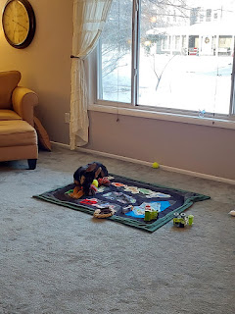

Scott, Benson, and Gordon . . .

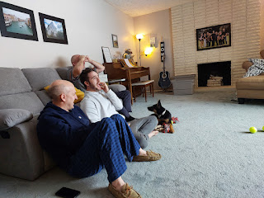

Amber worked on some knitting, while Benson coaxed Daisy into taking a nap.

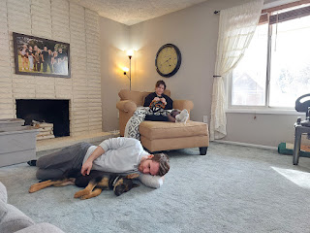

Daisy loves sticks. Whenever Benson takes her for a walk, she is always on the lookout for the perfect stick to bring home as a souvenir.

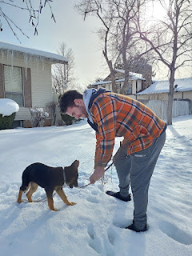

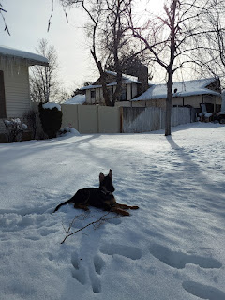

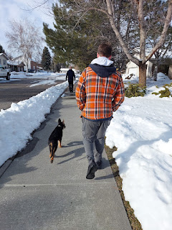

On Monday (March 11th), the day before Amber would begin her drive back across the U.S. to Louisiana, the girls and I made a little crafty project together. It was actually Abby's idea, and a good one at that. We had some massive bouquets of flowers leftover from the funeral, so she asked if we could make some smaller handheld bouquets. I had some floral tape on hand still, from when I used to make wrist corsages for my boys' dates whenever there was a fancy dance at the high school. I let Abby and Gwen each choose whatever flowers they wanted from the vases on my dining table (did I mention they were massive?).

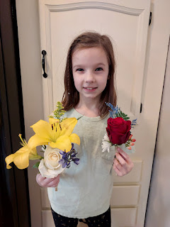

Abby holding her creations (above), and some closeups below.

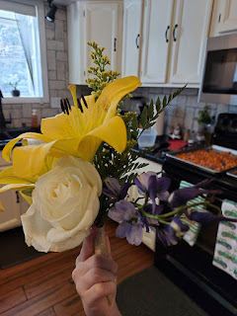

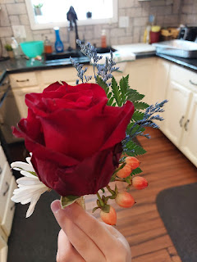

Gwen holding her creations . . .

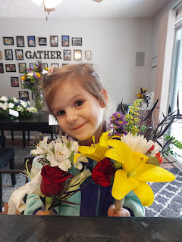

Closeups of Gwen's cheery little bouquets.

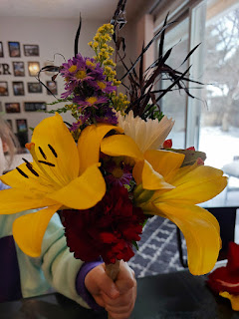

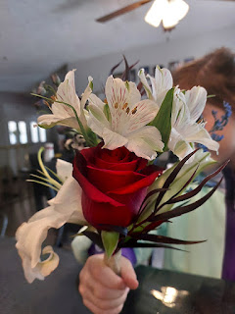

Amber and I spent a little mother-daughter time by going to Seagull Book and Walmart. She wanted to find a couple of spring dresses and Seagull Book always has a great selection, including several on the clearance racks. She found what she wanted and then could not tear her eyes away from this painting by J. Kirk Richards . . . she ended up buying it. (It's the 11x14 size with the gentle and quieter tones that she's staring at below.)

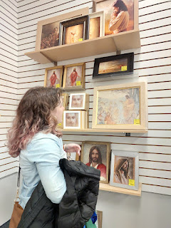

We partnered up back at the house to get dinner ready for company by making all the fixings for a Quesadilla Bar. Four different cheeses, carmelized red onions, sauteed mushrooms, spinach, pulled pork, black beans, sweet corn, tomatoes, bacon bits, salsa, sour cream, cilantro, roasted sweet potatoes, and sliced red bell peppers. We had a griddle and two frying pans on the stove for everyone to cook up their creations.

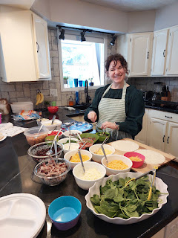

Abby and Gwen were happy to just have simple cheese quesadillas. (while also reading Calvin & Hobbes)

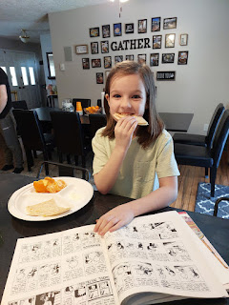

While Amber and I finished up the dinner prep in the kitchen, Gordon entertained his siblings in the living room by playing the guitar.

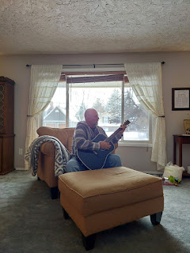

Bev brought some paint & countertop samples for everyone to look at and help make some decisions on how to spruce up the house in Rigby before they list it for sale.

Bev and Scott . . .

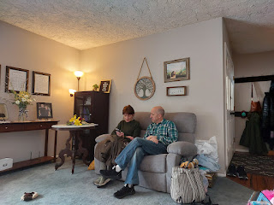

Lined up in birth order: Carol is the oldest, then Sharon (she wasn't able to come), then Bev, then Philip (deceased), then Gordon and Scott.

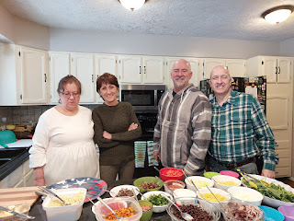

I may have overfilled my bottom tortilla . . . once I laid the top tortilla on, it settled down a "little" bit, but man, was that thing messy when it came time to flip it!! LOL

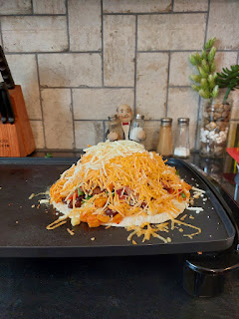

While many people like to go back and make a second quesadilla, I can't have that many carbs, so I usually load up more substantially on the first go and then it fills me up. In this case, I could only eat half of my quesadilla and had to store the leftovers for lunch the following day, ha ha.

Video just before bedtime on Monday night, where Daisy was learning how to fetch: (43 seconds)
https://photos.app.goo.gl/gxt6HfKZCnWqGD627

Tuesday morning, Amber and the girls stopped by for a final goodbye before they began their 3-day drive home. They had been staying with Weston's parents in Rigby over the weekend. I got more teary as it got closer to when they needed to leave. It never feels like I get enough time with Amber. Ever. But I am so grateful that she made it safely to Idaho and Utah, even with a flat tire along the way. I'm glad that we had the time that we had. XOXO

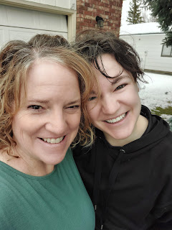

After they drove away, Scott and I went to the temple with Gordon and Pam and had a wonderful session together. It felt so amazing to feel close to God and His Son Jesus Christ right after a funeral. It sure brings closure when you do it that way, reminding you that death is not the end and that our loved ones aren't far away.

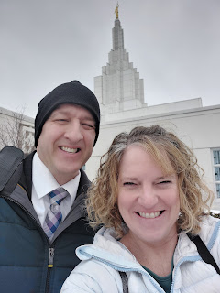

On Scott's last full day (Tuesday), he fired up the new chainsaw (the old one had died a couple days earlier) to chop up the huge branch that had fallen under the weight of all the snow during Snowmageddon. What a good husband. :)

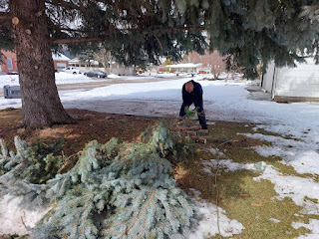

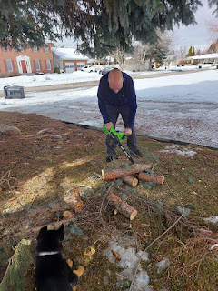

We also organized most of the boxes of family history stuff that we had inherited from Phil and Coy.

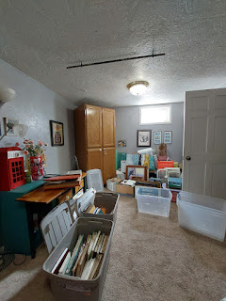

And we tried a new chicken shawarma recipe.

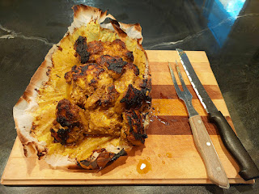

Recipe link here:
https://myfoodstory.com/chicken-shawarma-recipe/#recipe

Basically, you marinate some boneless, skinless chicken thighs and then layer them tightly into a loaf pan. It took a little longer than the recipe suggested, probably because we used a little bit more chicken than it called for and they weren't 100% thawed either . . . But the spices were AMAZING and both Scott and Benson said they could eat it for DAYS . . .

Tuesday night I went to bed with a hint of a sore throat and I wasn't feeling that great. I woke up slowly and I was grateful that I felt adequate enough to get out of bed. Scott and I visited the headstone monument store to get some information about ordering a headstone for my 2nd great grandfather, James Baugh, who is buried in Laytonville, CA but has no marker. We got the info that we needed and now we will be shopping for a nice memorial that can be placed there this summer. I'm so excited!!

We went out to lunch at Morenitas on our way to the IF Airport and then, just like that, he was gone.

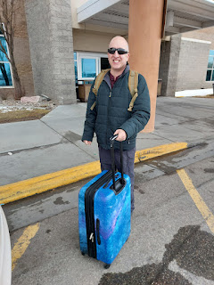

Benson was feeling a little under the weather, too, so we laid low for the rest of the day. I watched some TV shows and rested in bed before feeling a little perkier by dinnertime. By the next day, I felt great again, thank goodness, and could work on some things around the house.

Benson and I visited Cafe Sabor, one of his oldtime favorites. I still like Jalisco's better, but it was pretty good. The company was better than the food, though. :)

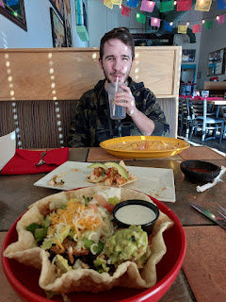

And in the past couple of days, I finally finished up Jack's birthday projects!! Hooray!! I had ordered some special fabric clear back in January so that I could make him a little lap-sized quilt with fun construction scenes. It all came together in just 24 hours.

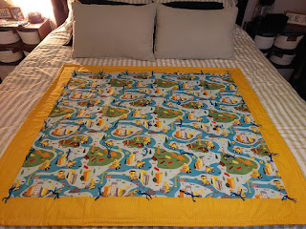

Here is one side of his playmat - this scene has roads that lead to a variety of places: the beach, dinosaur land, a fire station, and a jungle with zoo animals.

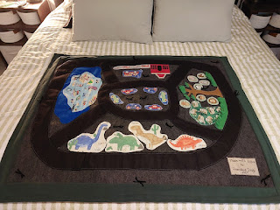

My "autograph" in the lower right corner . . .

And the back side, which was the original idea all along, is the construction zone. It has roads leading to different job sites and 4 "pockets" to dump or store stuff, like rocks or whatever he wants.

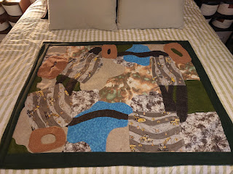

In the box, I included a few supplies to get him started. Pompoms that look like rocks, wooden geometrical beads, and actual pebbles, plus a few construction vehicles to do the heavy lifting.

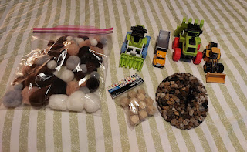

My hair has been getting long and I decided to try straightening it before I take off to the land of HUMID, where straight hair doesn't exist for me.

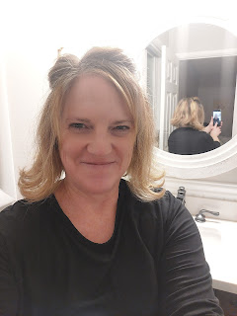

It actually helped to have it straight for when Tessa colored my hair with a weave technique. Curly hair is a little more fussy to work with, she said.

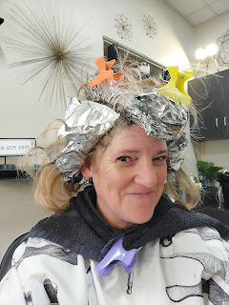

Below: Tessa, my dear friend and conversationalist about religion and everything going on in the world.

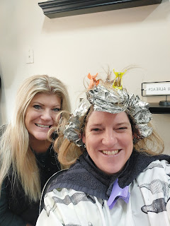

Final day with company was on Saturday . . . Benson wanted some Wendy's before he hit the road to go back to Mountain Home. He also got a haircut to look a little more sharp before he goes back to work on Monday. Looking good, my friend.

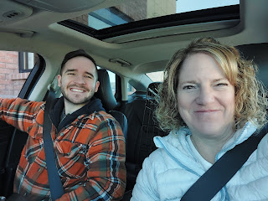

The weather has been so nice these past few days. The sun has been shining, blue skies have been abundant, and the temps have been creeping up and over 50 degrees. DEE-lightful. We sat on the front porch and while Benson ate his lunch, Daisy found some bark to munch on, and we had a video call with Jake and Jack.

Hannah says the baby is dong just great, she can feel him/her moving around now, and they will get an ultrasound in 2 weeks to find out the gender. I'm feeling like it might be a girl. :)

Jack informed me that he was eating a deviled egg. "Me eating a deviled egg!" When in fact, he hadn't even tried it yet. I convinced him to lick it and then he liked it enough to eat some of it, ha ha.

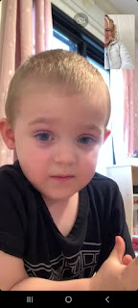

With Daisy all loaded up into her kennel in the back seat, Benson drove off with my car for the next 90 days. Hopefully, he will get his taxes done soon so that he can have the extra dollars he needs to get a new engine for his Audi and get it running before we get back in June.

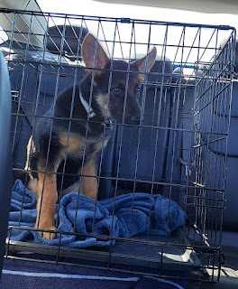

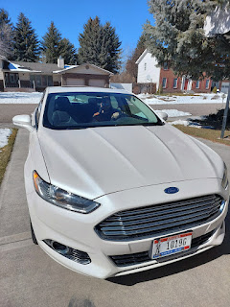

Now I am carless, but happy. I have been cleaning and getting the house all spruced up after several days of company and good times. I am finally excited to go to Italy. Two weeks ago I was not excited. One week ago I was not excited. But now I am. :) I fly over on Tuesday afternoon, arriving in Venice at 4:15 pm the following day (Wednesday). That would be 7:15 a.m. for all you Californians . . .

Ciao y'all.

